OxyGEN

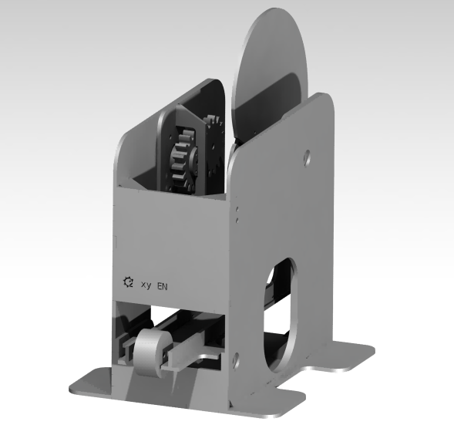

|  |  |  |  |  |  |  |  |
| --- | --- | --- | --- | --- | --- | --- | --- |
| S # | File | Image | Brief | Printing Time | Qty. | Bore | Fastener |
| 1 | Base |  |  |  | 01 |  |  |
| 2 | Contrapeso |  |  |  | 06 |  |  |
| 3 | Coupling |  |  |  | 03 |  |  |
| 4 | Coupling Dentado |  |  |  | 03 |  |  |
| 5 | Coupling Inferior |  |  |  | 01 |  |  |
| 6 | Engranaje |  |  |  | 02 |  |  |
| 7 | Escuadra Base |  |  |  | 04 |  |  |
| 8 | Escuadra Frontal |  |  |  | 04 |  |  |
| 9 | Escuadra Trasera |  |  |  | 02 |  |  |
| 10 | Frontal Inferior Exterior |  |  |  | 01 |  |  |
| 11 | Frontal Superior |  |  |  | 01 |  |  |
| 12 | Lateral Derecho Exterior |  |  |  | 01 |  |  |
| 13 | Lateral Derecho Interior |  |  |  | 01 |  |  |
| 14 | Lateral Lzquierdo Exterior |  |  |  | 01 |  |  |
| 15 | Lateral Lzquierdo Interior |  |  |  | 01 |  |  |
| 16 | Leva1 Entallada |  |  |  | 01 |  |  |
| 17 | Leva2 Entallada |  |  |  | 01 |  |  |
| 18 | Leva3 Entallada |  |  |  | 01 |  |  |
| 19 | Leva4 Entallada |  |  |  | 01 |  |  |
| 20 | Nervio Plancha Derecho |  |  |  | 02 |  |  |
| 21 | Pasador |  |  |  | 01 |  |  |
| 22 | Plancha |  |  |  | 01 |  |  |
| 23 | Soporte Pasador |  |  |  | 02 |  |  |
| 24 | Tope Coupling |  |  |  | 01 |  |  |

Total Parts = 43