Intel Video Super Resolution SDK

User Guide

Copyright @ Intel Corporation
All rights reserved.
Revision 0.1

Revision History
Revision Number | Description | Revision Data
0.1 | Initial version | Dec-2022

SDK Design Architecture
Figure 1 shows the architecture of Intel Video Super Resolution development kit. It mainly consists of three parts, API, core implementation and backend framework.
The SDI API is designed thread-safely. Below is the API introduction:
ivsr_init API is used to initialize the software development kit.
ivsr_process API is used to inference one task. It will return a handle for application to query the inference result.
ivsr_deinit API is used to de-initialize the resource allocated the SDK.
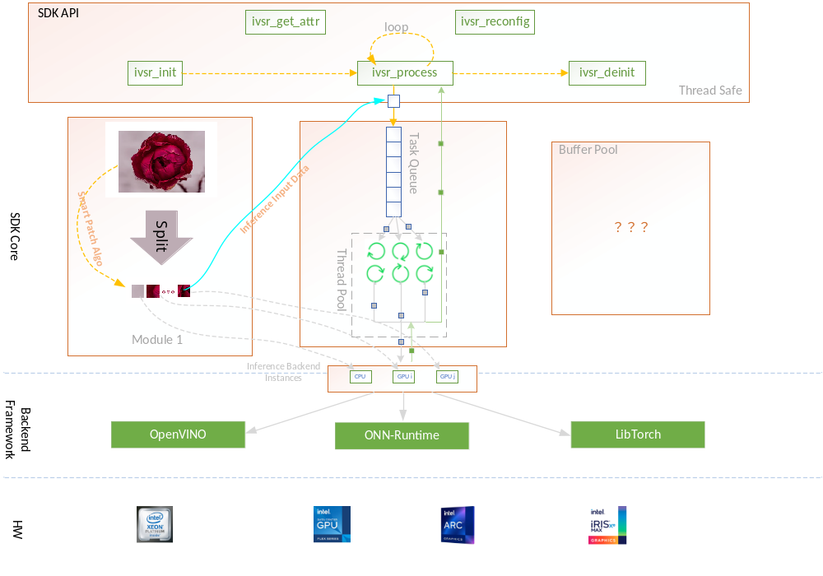
Figure 1. Intel Video Super Resolution Design Architecture
The SDK core mainly consists of two parts, one is the smart patch solution part, the other is the task scheduler part. The patch solution part will split the large images into small ones, then the smaller patch is wrapped as one inference task and put it in the task queue in the scheduler module. By the way, each small patch will have a flag to indicate which kind of platform it will be used for inference. The second module is the task scheduler module, it will fetch task from the task queue and send the task to the corresponding hardware according to the flag set by each small patch.
The backend framework can be OpenVINO, ONNX-Runtime, LibTorch and etc. In the current implementation, it will only support OpenVINO.

Build & Install

Samples

