Enable SPI bus on Raspberry Pi:

1. sudo nano /etc/modprobe.d/raspi-blacklist.conf
2. Add a comment at the beginning of this line:   
   #blacklist spi-bcm2708
3. Save file
4. Reboot Raspberry Pi: sudo reboot

Install applications on Raspberry Pi:

1. MySQL

Install MySQL server/client with development client:

#sudo apt-get install mysql-client mysql-server libmysqlclient-dev

root user , password sql123

create another sql user, wise password wise123

1. Install Apache and PHP5

#sudo apt-get install apache2 php5

1. Install PHPMyAdmin

#sudo apt-get install phpmyadmin

Choose “Apache2” when asked:

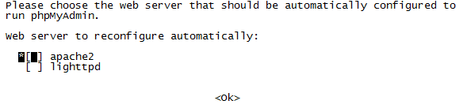

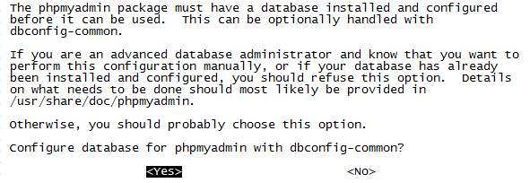

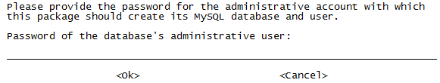

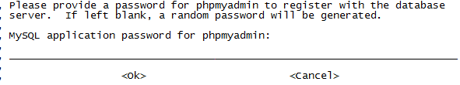

1. Edit apache configuration file to add the PHPMyAdmin

#sudo nano /etc/apache2/apache2.conf

Add this at the end of the file:

include /etc/phpmyadmin/apache.conf

1. Restart apache service:

sudo /etc/init.d/apache2 restart

1. Install cmake

#sudo apt-get install cmake

Enable SSL for apache server

<http://hallard.me/enable-ssl-for-apache-server-in-5-minutes/>

Arduino pin layout

**Arduino code**:

wise_sensors_TLM.ino

wise_rfcomm.h

**Arduino Libraries:**

Instruction on how to install additional Arduino libraries - <http://arduino.cc/en/Guide/Libraries>

Needed libraries:

* One wire
* nRF24L01
* SPInterfaces -

**Setting up MySQL**

1. Connect to MySQL web gui at http://ip_address_of_server/ phpmyadmin/
2. 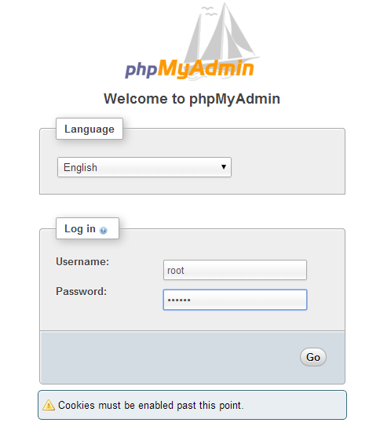

,

,

wiseup/src/wiseup.sql

1. 



1. sudo chmod -R 777 /var/www
2. git clone <https://username@bitbucket.org/borisKadaner/wiseup.git>
3. cp -r wiseup/src/php/websites/ /var/www/
4. mkdir wiseup/src/linux/build
5. cd wiseup/src/linux/build
6. cmake ..
7. make
8. sudo /home/pi/wiseup/src/linux/build/src/wise-dbd (Press enter when ends)
9. sudo /home/pi/wiseup/src/linux/build/src/wise-nrfd (currently not a daemon)
10. sudo /home/pi/wiseup/src/linux/build/src/wise-stdout-pipe

Connect to website on server: at http:// ip_address_of_server /websites/wiseup-dev/web/app.php

Update Arduino libraries:

1. Copy the following libraries to your /Arduino/libraries/ directory:  
   nRFModule, SPInterface, WiseUp