1. Install Open Worship app

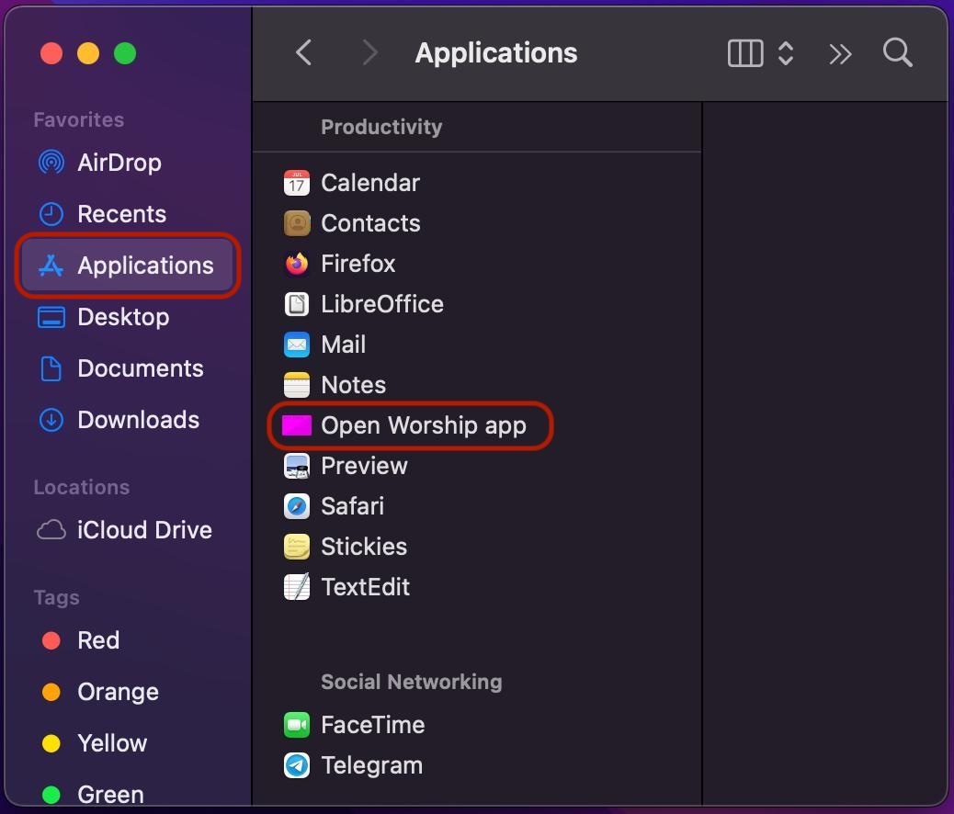
2. It is blocked when open
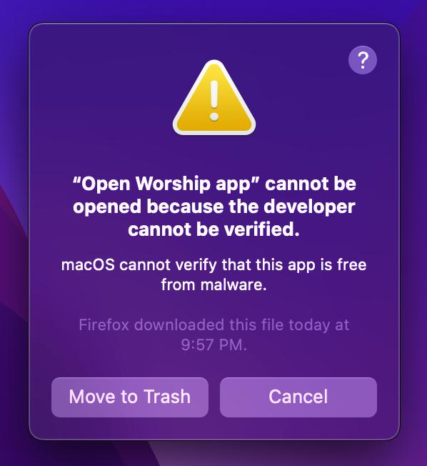
3. Open Termina

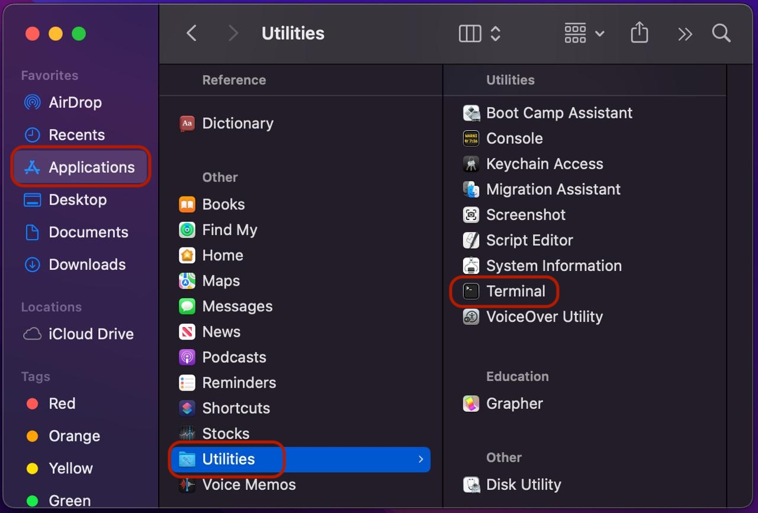
4. Execute command: xattr -dr com.apple.quarantine "/Applications/Open Worship app.app"

- copy xattr -dr com.apple.quarantine "/Applications/Open Worship app.app"
- paste to Terminal
- type Enter key

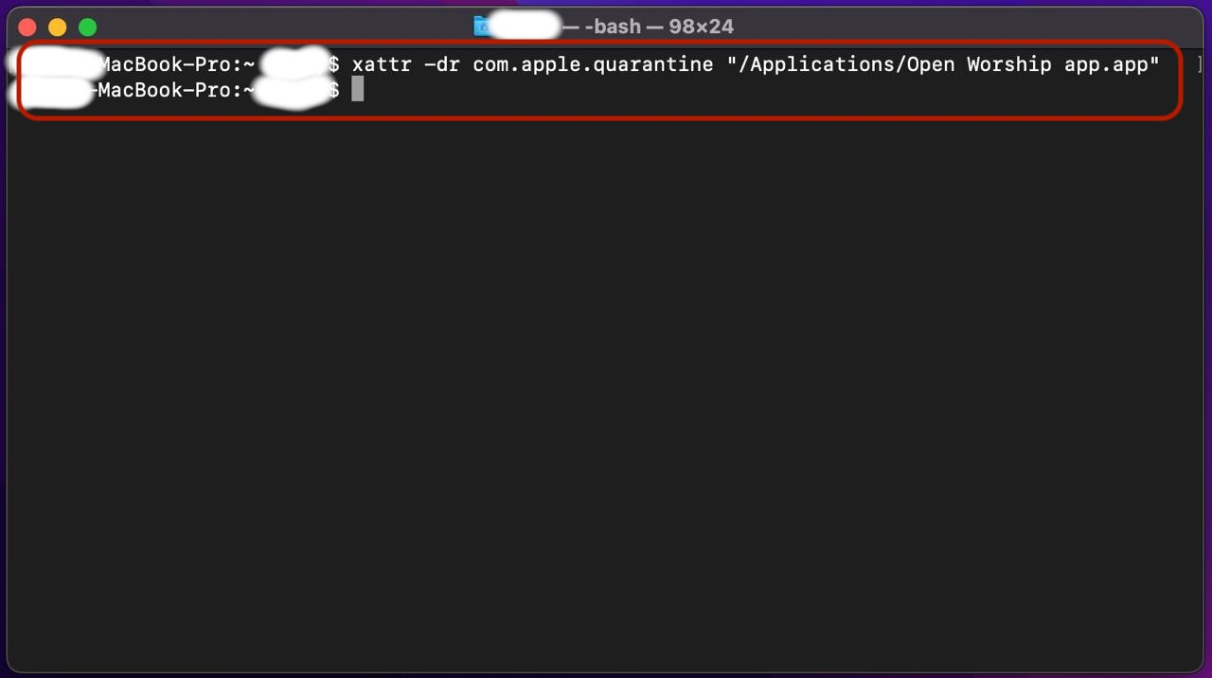
5. App should working fine

