Overview

Xip provides a way for applying shader computations on 3D (or 2D) input textures and rendering the result into another 3D (or 2D) output texture. The resulting texture can be used for various further computations.

A basic example

Following is a simple example:
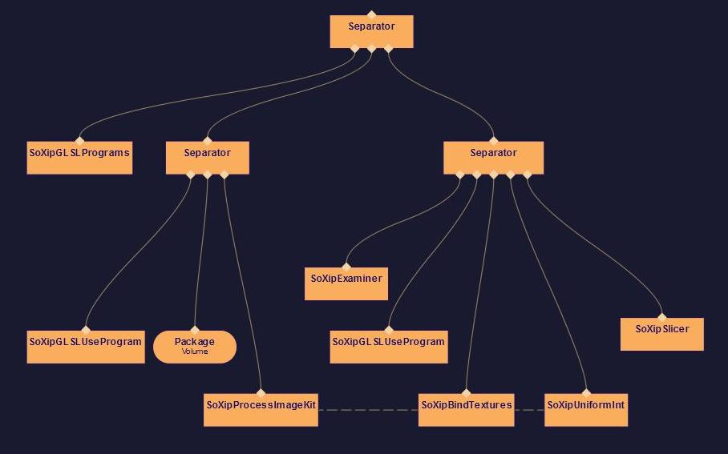

The required nodes are combined in the nodekit SoXipProcessImageKit. This nodekit renders the slices of the input texture into a 3D output texture that is attached to a Framebuffer Object while applying shaderbased computations on it. The shader is defined by the user.

The first node you will need is a SoXipProcessImageKit. When setting the texture Dimension to ‘AUTO’ and using ‘autoSize’, the output texture, which we want to render to will have the same size and dimension as the input texture.
The field ‘detail’ can be used to lower the resolution of the output volume.

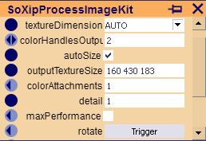

We will have to define which texture will provide the input data for the shader. In our case we use a 8 bit CT-volume loaded through the node SoXipLoadRaw. The volume is bound as a texture by connecting the output of SoXipLoadRaw to the input field of SoXipTexture.
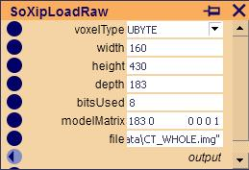

We want to process the input volume by using a shader which we specify through SoXipGLSLPrograms and SoXipGLSLUseProgram. The shader in this example is very basic, and used just to show the required steps.

After the SoXipProcessImageKit has processed the input volume, we want to see our resulting output volume, by implementing a simple volume rendering under another separator.
To render the output volume on screen we need to bind it first. Therefore we connect the colorHandlesOutput field of SoXipProcessImageKit to the attachmentHandles field of SoXipBindTexture. SoXipUniformInt provides the output volume as a uniform variable to the volume rendering shader.

SoXipSlicer renders the various slices of the output volume to the screen using blending functions for the slices which can be set by the user.
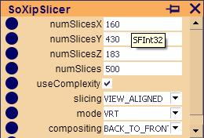

Using a SoXipExaminer we can also rotate the output volume.

Using a Geometry Shader

In the previous example the SoXipProcessImageKit rendered into the output volume each slice consecutively.
By using a geometry shader, however, it is possible to render into all the slices once (in one call to glDrawArrays()). This can enhance rendering time about 5 times.
If we want to use a geometry shader, then we also need a vertex shader which transfers the texture coordinates and positions of the vertices.
Now we need to bind a geometry shader in the SoXipSLSLUseProgram node:

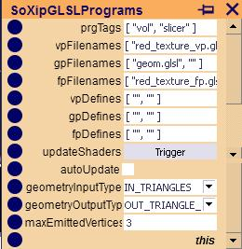

The fields geometryInputType, geometryOutputType and maxEmittedVertices are related to the use of a geometry shader. Since we render into triangles the value in the field maxEmittedVertices has to be at least 3. Each slice of the volume consists of two triangles.

This is the geometry shader we are using:

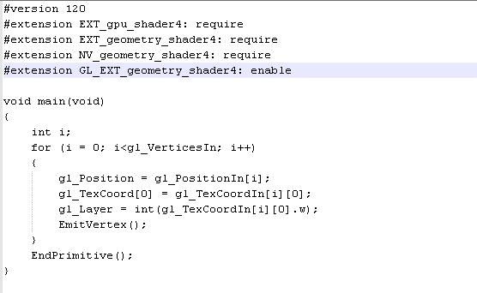

The shader gets all the vertices and texture coordinates in one command through a vertex pointer and a texture coordinates pointer. It renders into the output volume in one step.
The primitives it processes in this case are triangles, so the loop is processed for each triangle.
We put the vertex value into gl_Position and the texture coordinates into glTexCoord[0].
gl_Layer specifies the slices of the output volume. These values are given in the fourth column of every texture coordinate.

In the SoXipProcessImageKit we set the field maxPerformance to allow the use of geometry shaders.

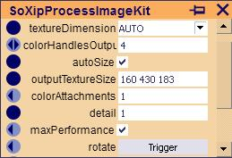

An advanced example:

A more complicated example is used for applying local ambient occlusion and scattering operations on our input volume.

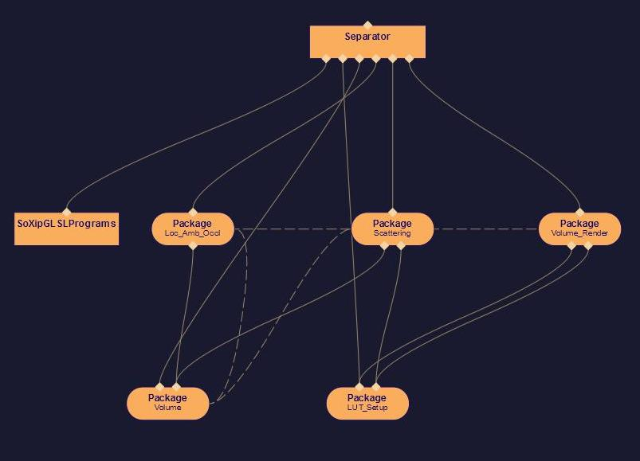

Under the first rendering step our shader processes the amount of light arriving at each voxel through local ambient occlusion. The resulting volume and the original input volume can be used for a scattering filter operation afterwards. This step produces a second output volume.
In the last step the second output volume and the original volume are used to render the final picture:
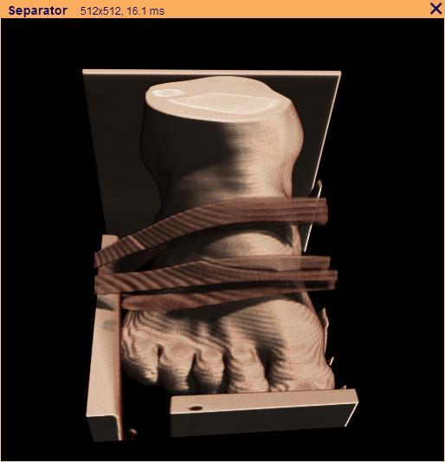

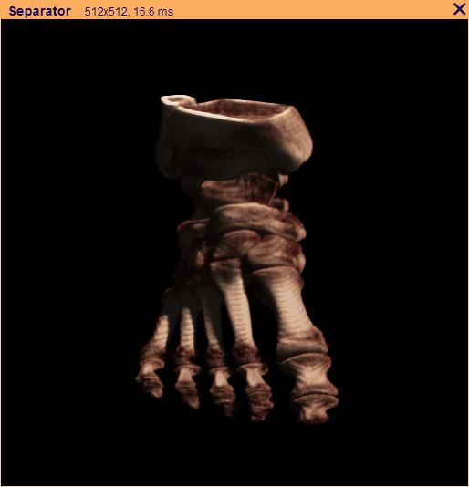

Note: Using a geometry shader enhances rendering time about 4 times in this example.

