VTK

Overview
This project is the integration of VTK in Xip. VTK objects have been wrapped into 2 main modules: nodes that have been wrapped manually and engines that have been generated automatically.

Prerequisite
The following installations are required:
- CMake 2.4 or later version (to be able to install VTK)
- VTK 5.0.3 or later version
- SGI Open Inventor
- Xip

How to build and run
Here is a description of what should be done to make the VTK project work.
- Install CMake and download VTK sources on www.vtk.org
- Open CMake:
  - indicate the VTK source code directory
  - indicate where to build the binaries
  - switch BUILD_SHARED_LIBS to ON
  - switch VTK_USE_RENDERING to ON
  - indicate the CMAKE_INSTALL_PREFIX
  - click on configure
  - when configure is finished, click on OK
  - close CMake when the generation of the project is finished
- Go to your VTK source code directory and open the VTK project
- Build your project in release mode, then go to CMAKE_INSTALL_PREFIX/lib and create a release directory, finally move the release libs to the release directory
- Build your project in debug mode, then go to CMAKE_INSTALL_PREFIX/lib and create a debug directory, finally move the debug libs to the debug directory
- Set the following environment variables:
  - OIV_PATH to point to the Inventor libs and includes
  - VTK_PATH to point to the CMAKE_INSTALL_PREFIX
- Open xipivvtk project and build it in release and debug mode.
- Do not forget to move the VTK dlls (CMAKE_INSTALL_PREFIX/bin) to the directory where XipBuilder is.

Description
Class | Inventor type | Description
SoSFVtkAlgorithmOutput |  | VTK data field
SoSFVtkObject |  | VTK data field
SoVtkActor2D | Node | Wrapping of a vtkActor2D
SoVtkActor | Node | Wrapping of a vtkActor
SoVtkAlgorithmOutput |  | VTK data class
SoVtkAssembly | Group | Wrapping of a vtkAssembly
SoVtkConvertXipImageToVtkAlgorithmOutput |  | Converter from a Xip data image to a VTK algorithm output.
SoVtkImageActor | Node | Wrapping of a vtkImageActor
SoVtkImageViewer2 | Node | Rendering node to view one image in a 2D scene.
SoVtkLODActor | Node | Wrapping of a vtkLODActor
SoVtkMatrix4x4 | Engine | Should be generated automatically
SoVtkObject |  | VTK data class
SoVtkPolyData | Engine | Should be generated automatically
SoVtkRenderer | Group | Rendering node to view any objects in a 3D scene.
SoVtkVolume | Node | Wrapping of a vtkVolume

Remarks
- Interactors are not wrapped, so use the SoXipExaminer to manipulate the data. You should always put an examiner in your scene because the VTK camera is set according to the configuration of the examiner.
- Transfer functions like SoVtkColorTransferFunction or SoVtkPiecewiseFunction do not wrap the convenience method RemoveAllPoints() so you need to be careful when adding points to the function and perhaps use the add segment option that covers the whole data, suppressing any point in between.

Screenshots
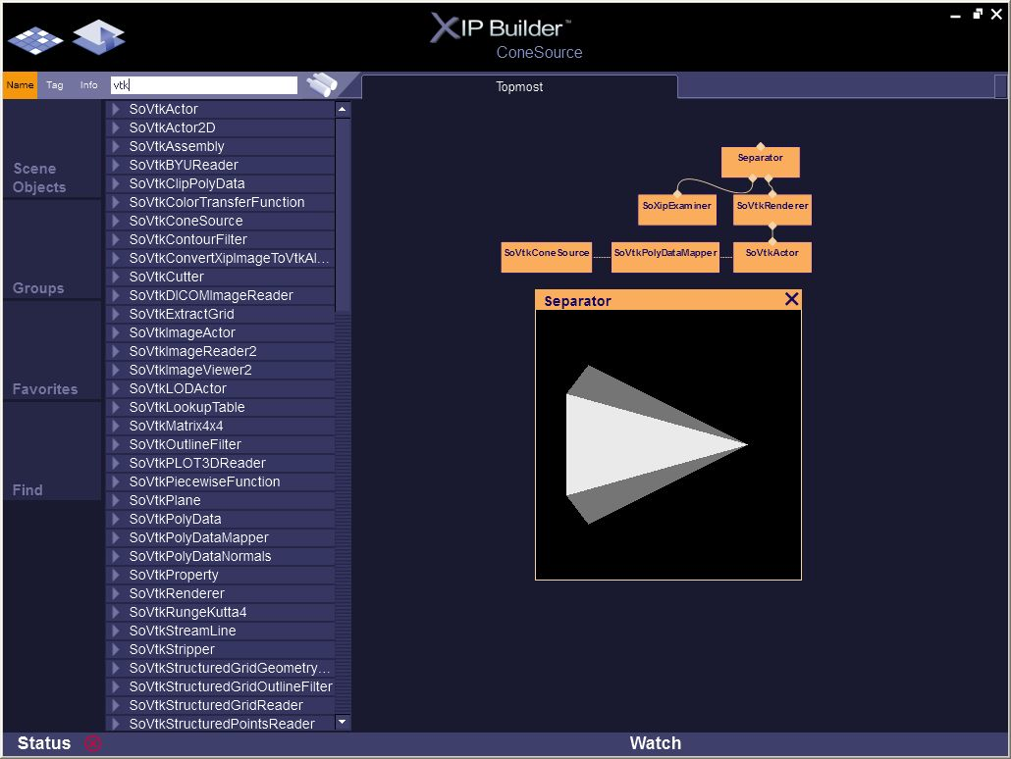
Figure 1: Cone Source

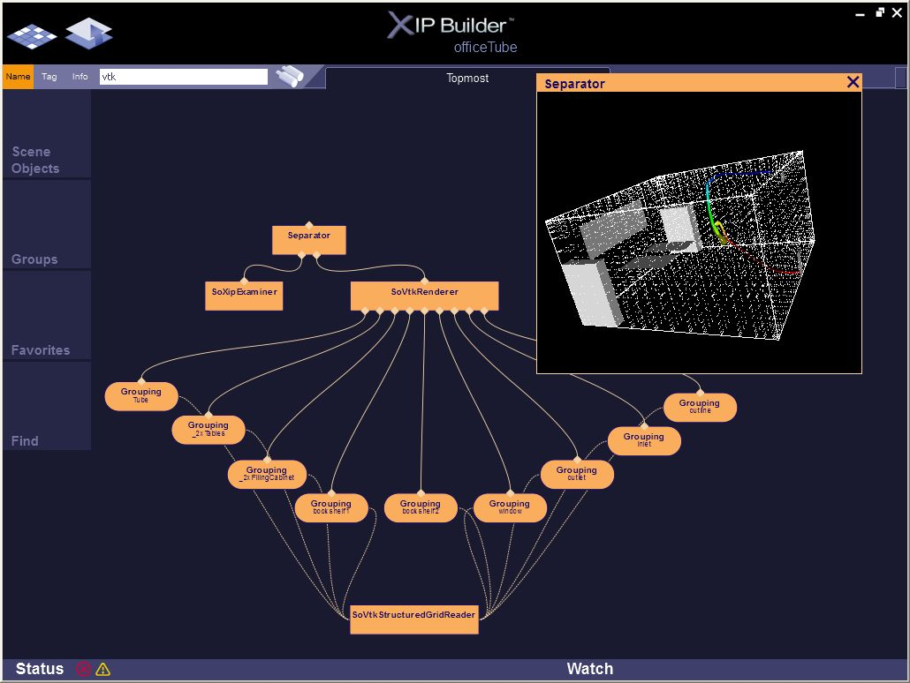
Figure 2: Office Tube

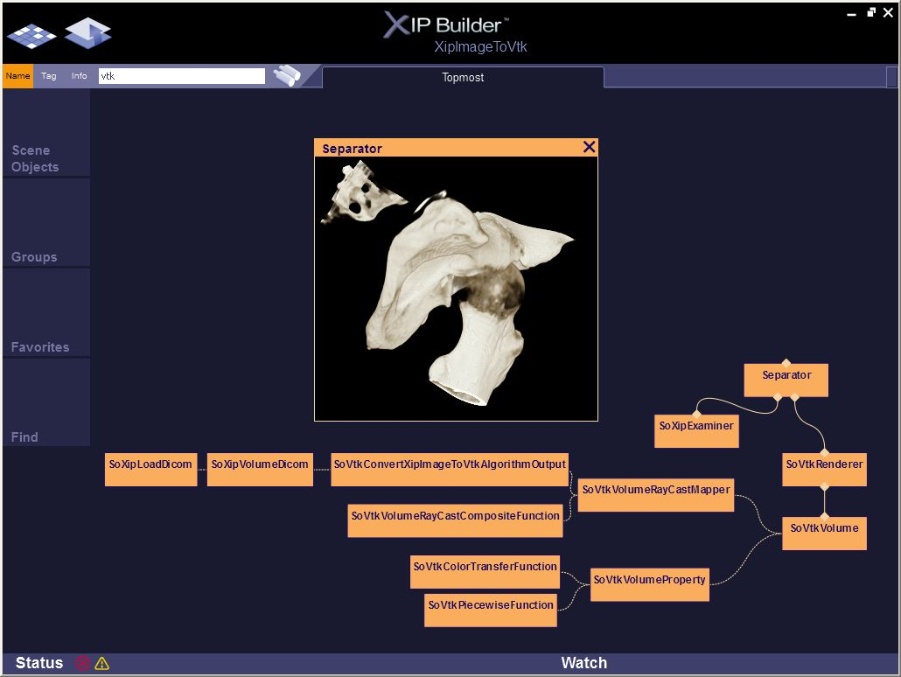
Figure 3: Converter

