Drop-off Locker
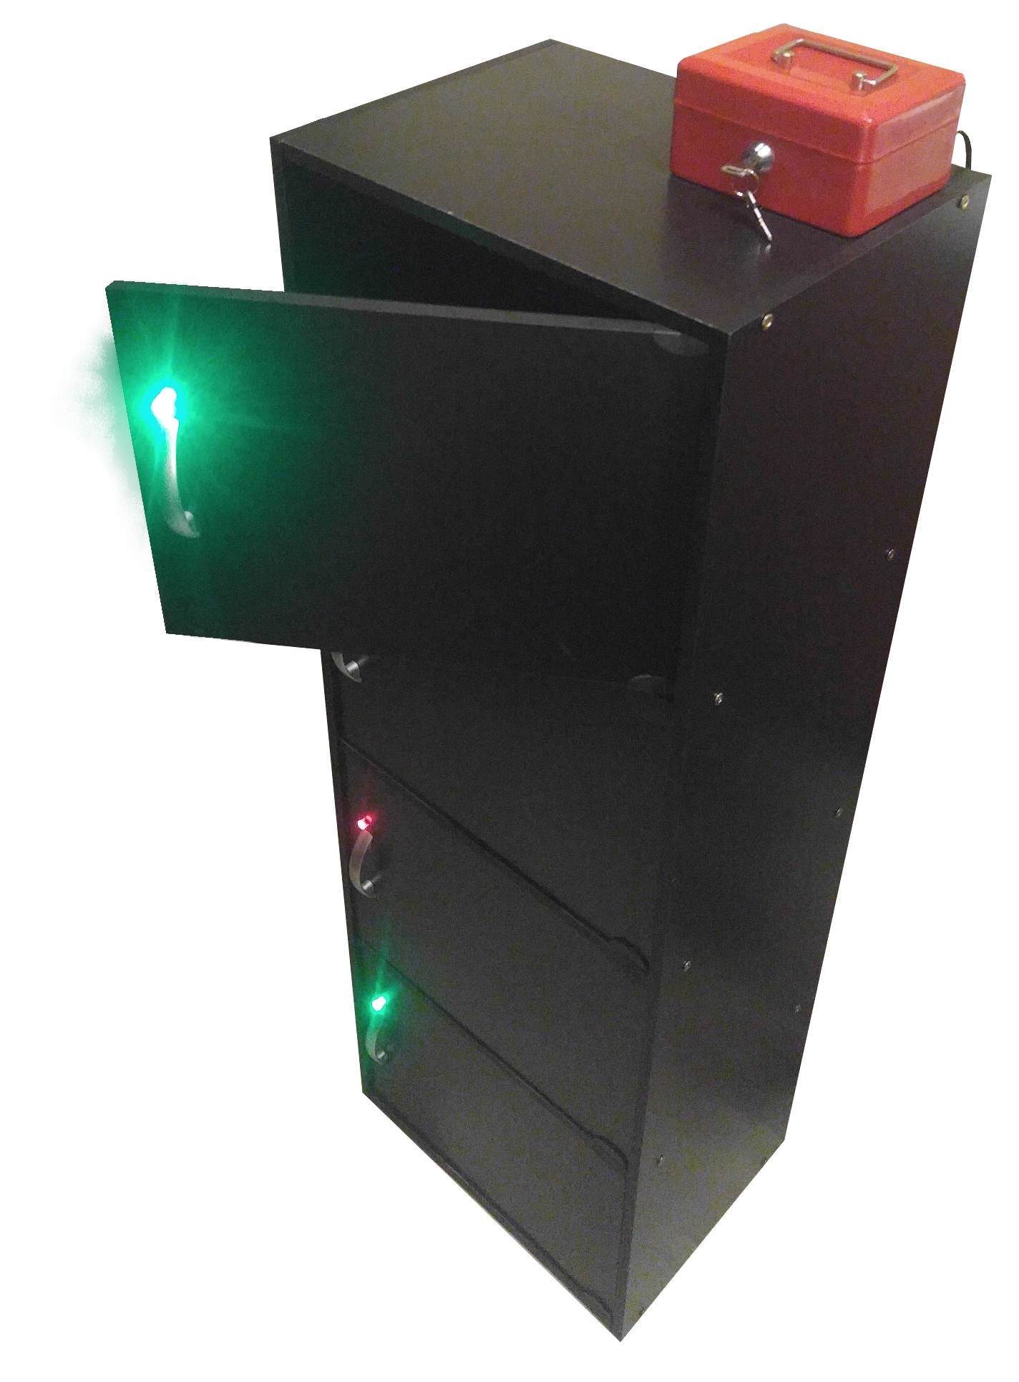
User Manual and Design Schematic
Index
About Drop-off Locker…………. 1
General use guide………………. 1
Administrator guide……………. 2
Troubleshoot and repair guide…. 3
Circuit Design………………….. 4
Source Code……………………. 5
Fabrication Notes………………. 12
Upgrade Notes…………………. 13
Contact Info……………………. 14

k

#define LED_D 13 //bottom
#define LED_C 12
#define LED_B 11
#define LED_A 10 //top
#define B_EN_D 9
#define B_EN_C 8 //back button
#define B_EN_B 7 //front button
#define B_EN_A 6 //priority set(control panel)

#define LCK_D 5 //bottom
#define LCK_C 4
#define LCK_B 3
#define LCK_A 2 //top
#define B_IN_D 3
#define B_IN_C 2
#define B_IN_B 1
#define B_IN_A 0
#define LOCKED 0
#define UNLOCKED 1
#define TAKEN 1
#define OPEN 0
#define LOOPS_TO_HR 36000
#define WATHCHDOG_LIMIT 50 //5 seconds limit

#define ACTIVE_LOW_RELAY

struct QuadState
{
bool s[4];
};
struct QuadCount
{
int c[4];
};

//lock access (TAKEN/OPEN)
QuadState gLockLed;
//current state of lock(LOCKED/UNLOCKED)
QuadState gLock;
//button state (per poll per set)
QuadState gBtn;

//avoid holding solenoid lock if button jams in
QuadState gWatchDogHit;
QuadCount gWatchDogCnt;

//how many hours till locking
unsigned short gLkTmr;
//no available pins to allow for interupt based timer.
//keep track of hours by counting loops
unsigned int gHrTmr;
//perserve last state of button/switch to trigger event on changed state
bool gLastTToggle; //for changing time
bool gLastLToggle; //for locking/unlocking all in admin mode
bool gLastAMode; //check if admin mode was just entered

//TODO: add watchdog timer for held lock buttons

void setup()
{
// Initialize the digital pin as an output.
for(int i = 6; i < 14; i++)
{
pinMode(i, OUTPUT);
digitalWrite(i, 0);
}
for(int i = 0; i < 4; i++)
{
pinMode(i+LCK_A, OUTPUT);
#ifdef ACTIVE_LOW_RELAY
digitalWrite(i+LCK_A, 1);
#else
digitalWrite(i+LCK_A, 0);
#endif
}

Serial.begin(9600);
Serial.println("LOCKER STARTING UP....");

/* Debug code
//startup debug blink
for(int d = 0; d < 4; d++)
{
for(int t = 0; t < 4; t++)
{
delay(500);
for(int i = LED_A; i <= LED_D; i++) { digitalWrite(i, LOCKED); }
delay(500);
debugBtnShow(d);
//for(int i = LED_A; i <= LED_D; i++) { digitalWrite(i, UNLOCKED); }
}
}
*/

//set default values
for(int i = 0; i < 4; i++)
{
gLock.s[i] = LOCKED;
gLockLed.s[i] = TAKEN;
}

gLkTmr = 4;

gLastTToggle = false;
gLastLToggle = false;
gLastAMode = false;

gHrTmr = LOOPS_TO_HR;

//start watchdog with clean slate (no open locks)
watchdogTick();

showLockState();
Serial.println("SYSTEM INITIALIZED....");
}

void loop()
{
bool adminMode = false;
bool activeTimer = false;
bool toggleLock = false;

//button routines=================================================================
//admin setup-------------------------------------------------------------------
delay(25);
readBtn(0);
adminMode = gBtn.s[0];
activeTimer = gBtn.s[1];
toggleLock = gBtn.s[2];

if(activeTimer && adminMode && (gLkTmr == 0))
{
gLkTmr = 4;
}
else if(!activeTimer)
{
gLkTmr = 0;
}

if((adminMode) && (toggleLock != gLastLToggle) && gLastAMode)
{
setAllState(toggleLock ? TAKEN : OPEN);
}
gLastLToggle = toggleLock;
gLastAMode = adminMode;

//front button------------------------------------------------------------------
delay(25);
readBtn(1);
if(adminMode)
{
for(int i = 0; i < 4; i++)
{
gLock.s[i] = gBtn.s[i];
}
}
else
{
for(int i = 0; i < 4; i++)
{
gLock.s[i] = gBtn.s[i] && (gLockLed.s[i] == OPEN);
}
}

//rear button-------------------------------------------------------------------
delay(25);
readBtn(2);
for(int i = 0; i < 4; i++)
{
if(adminMode) { gLockLed.s[i] &= !gBtn.s[i]; }
else { gLockLed.s[i] |= gBtn.s[i]; }
}
if(adminMode)
{
if(activeTimer && !gLastTToggle && gBtn.s[0])
{
toggleTimer();
}
gLastTToggle = gBtn.s[0];
}
else { gLastTToggle = false; }

//for future improvements/debug ------------------------------------------------
delay(25);
readBtn(3);
//add code as needed

//show results ===================================================================
//display state
if(adminMode)
{
showTimerState();
}
else
{
showLockState();
}

watchdogTick();
triggerLock();

//check for timer event (reaching an hour)
gHrTmr--;
if(!gHrTmr)
{
hrHit();
}
}

void watchdogTick()
{
for(int i = 0; i < 4; i++)
{
if(gWatchDogHit.s[i])
{
if(!gLock.s[i]) { gWatchDogCnt.c[i] = 0; }
}
else
{
gWatchDogCnt.c[i] = gLock.s[i] ? gWatchDogCnt.c[i]+1 : 0;
}

gWatchDogHit.s[i] = (gWatchDogCnt.c[i] >= WATHCHDOG_LIMIT);
}
}

void showTimerState()
{
for(int i = 0; i < 4; i++)
{
digitalWrite(i+LED_A, gLkTmr > i ? LOW : HIGH);
}
}

void showLockState()
{
for(int i = 0; i < 4; i++)
{
digitalWrite(i+LED_A, gLockLed.s[i]);
}
}

void debugBtnShow(unsigned int set)
{
readBtn(set);
gLockLed = gBtn;
showLockState();
}

void triggerLock()
{
for(int i = 0; i < 4; i++)
{
#ifdef ACTIVE_LOW_RELAY
digitalWrite(i+LCK_A, !(gLock.s[i] && !gWatchDogHit.s[i]));
#else
digitalWrite(i+LCK_A, (gLock.s[i] && !gWatchDogHit.s[i]));
#endif
}
}

void readBtn(unsigned int set)
{
//disable all sets and reset state
for(int i = 0; i < 4; i++)
{
digitalWrite(B_EN_A+i, 0);
gBtn.s[i] = false;
}

//if valid set, read in buttons
if(set < 4)
{
digitalWrite(B_EN_A+set, 1);
for(int i = 0; i < 4; i++) { gBtn.s[i] = analogRead(i+B_IN_A) > 111; }
}
}

void toggleTimer()
{
gLkTmr = (gLkTmr + 4) % 5;
}

void enableTimer(bool en)
{
if(en)
{
gLkTmr = 4;
}
else
{
gLkTmr = 0;
}
}

void setAllState(bool takenState)
{
for(int i = 0; i < 4; i++)
{
gLockLed.s[i] = takenState;
}
}

void hrHit()
{
gHrTmr = LOOPS_TO_HR;

if(gLkTmr)
{
gLkTmr--;
if(!gLkTmr)
{
setAllState(TAKEN);
}
}
}

