CONFIDENTIAL — OpenZeppelin internal · non-public reference design · not for external distribution

Architectural Overview Report: Cross-Chain Stablecoin Payment Orchestration on Canton
Status: reviewed reference-design report, non-public, outside the committed M1 public-library surface. This is RI #3 of four — see the suite-level view in 00-portfolio.md and the index README.md. It describes a reference design grounded in the real OpenZeppelin Canton components in this workspace; it is not a claim of M1/M4 acceptance, conformance, audit readiness, or production readiness.
Google Docs import: File → Open this .md in Docs (or paste with Edit → Paste). H1/H2/H3 headings drive the Docs outline pane; the tables import cleanly; apply a monospace paragraph style to fenced code blocks after import. Mermaid blocks do not render in Docs — render them with canton-settlement-explorer and paste the image, keeping the fenced source.
Source-grounding tags (used throughout): [IMPLEMENTED] real code in the M1 library base (canton-specs / canton-contracts) · [EVIDENCE] real code in an evidence repo (canton-token-template, canton-stablecoin, zk-credential-gateway), not the M1 surface · [UPSTREAM] Splice / CIP / external-ecosystem reference, not vendored here · [FUTURE] proposed RI-level design, not built in M1 scope.
Design priority order governs every interface and snippet, in this exact order: 1) Readability → 2) Simplicity → 3) Security → 4) Auditability.
Grant alignment (source of truth: ../research/canton-ecosystem-grant-proposal.md, scope lock: ../../M4_STABLECOIN_SCOPE.md): this is RI #3 (Cross-Chain Stablecoin Payment Orchestration). This document is the Architecture Documentation deliverable, authored in grant M1 (research & design) for the implementation in grant M4 (Q4 2026, end Year 1, alongside RI 4). Companion deliverables — working reference code, demo front-end, threat model — are named here but delivered in M4 (MIT-licensed). Two components are planned / external, not present in this workspace: the Standardized Messaging Gateway ([FUTURE], Contracts- Library component) and USDCx (external ecosystem stablecoin) — both flagged throughout and in Open Questions. The report honors the CIP-56 → CIP-0112 / Token Standard V2 retarget.

1. Product Definition
This Reference Implementation (RI) is an architectural blueprint for private, atomic settlement on Canton of stablecoin payments originating on external blockchains. It resolves the tension between cross-chain liquidity and the privacy requirements of enterprise compliance: institutional participants can accept an inbound asset representation (e.g. USDCx) while keeping the settlement amount, payer/payee identities, and compliance markers projected only to explicitly authorized parties.
The design uses a Standardized Messaging Gateway [FUTURE] (modeled as a bounded mock) on top of the CIP-0112 / Token Standard V2 settlement spine [IMPLEMENTED] (OpenZeppelin.Experimental.Settlement.Cip112).

Educational Framing: "How to think about building this on Canton"
On public EVM networks, a bridge mints tokens into a globally visible state ledger any observer can trace. Canton operates on per-party projection: a contract is visible only to its signatories/observers. So the inbound message from the gateway does not mint-and-broadcast an asset in one global update. Instead the gateway drives an isolated, recipient-targeted allocation on the spine; because Daml-LF 2.1 is keyless (archive-and-recreate, not mutation), the atomic delivery-vs-payment archives the inbound request and creates a SettlementReceipt visible only to the recipient, the relayer, and the required compliance verifiers. Cross-chain settlement thereby inherits Canton's data compartmentalization.

Target Users
Regulated financial institutions, multinational corporate treasuries, and compliance-first DeFi platforms on Canton that need to accept inbound liquidity from public networks without exposing internal treasury flows, payment detail, or counterparty relationships to competitors or on-chain analytics.

Scope
The bias favors simplicity and a demonstrably correct core; everything else is an explicit extension point or out-of-scope.
Feature Category | In-Scope | Out-of-Scope (Excluded)
Atomic Settlement | Private on-Canton settlement of inbound stablecoin payments via SettlementFactory_SettleBatch (atomic DvP). | Custom settlement primitives, fallback matching engines, fragmented parallel liquidity pools.
Cross-Chain Bridge | An inbound/outbound bridge interface (the Standardized Messaging Gateway) as a bounded, verifiable mock. | Production bridge/relayer nodes, external oracle infra, validator networks, cryptographic light-client proofs.
Compliance & Control | D1 fail-closed verification on every leg (CredentialGatedActionRequest + TrustedIssuerRegistry); D2 lock-and-sweep via BurnerCapability. | Off-ledger caching of compliance status, probabilistic risk scoring, heuristic filtering.
Identity Framework | Single-domain v1, issuer-held KYC, deterministic claims. | Cross-domain identity resolution (ONCHAINID / ERC-3643 / Chainlink CCID) — deferred, SCU-forward-compatible only.
Asset Issuance | The integration shape for an existing Canton stablecoin (USDCx) as the settled instrument. | The stablecoin issuance / peg / CDP mechanism itself.
Narrowing scope to the standardized interface boundary means a production gateway can be swapped in later without modifying the settlement spine or the compliance logic.

2. Architecture Overview
A modular, multi-party topology isolates external messaging, compliance verification, asset allocation, and atomic settlement. roleId wrappers manage node boundaries and capability grants so no participant can unilaterally force a state transition without the required co-authorization.
When a cross-chain locking event occurs externally, the gateway (holding a RoleGrant as relayer) emits an InboundMessage on Canton. Rather than a direct transfer — which would violate Canton's co-authorization model — the relayer drives the spine: SettlementFactory_CreateAllocationInstruction → (recipient accept) AllocationInstruction_Accept → Allocation, plus a recipient-targeted AllocationRequest.

Party and Role Model
Operational Role | roleId wrapper | Responsibilities / trust boundary
BridgeRelayer | Relayer | Monitors the external chain; submits InboundMessage; operates the gateway mock; acts as settlement executor.
ComplianceVerifier | Verifier | Maintains the TrustedIssuerRegistry; issues the KycClaim for D1 attestation.
Custodian | Seizer | Holds the BurnerCapability for D2 lock-and-sweep to a preset destination under mandate.
StablecoinAdmin | Issuer | Single-admin authority for the settled asset (USDCx); oversees SimpleTokenRules.
Recipient | Implicit (end-user) | Treasury receiving funds; may use TransferPreapproval to accept compliance-gated inflows without a live signature.

Trust and Topology
Topology is defined per contract by which nodes participate. Because Daml uses per-party projection, the settlement is fractured into bilateral requests: the BridgeRelayer and Recipient are the only initial observers of the AllocationRequest; the StablecoinAdmin and Custodian stay blind to intent until needed. At SettlementFactory_SettleBatch, the StablecoinAdmin's node is enlisted only to validate fund conservation and run the SimpleTokenRules 3-way dispatch.
The topology also provides economic security: a committed allocation (RequestedAllocation.committed = True, set by the relayer) locks the bridging funds until the settlement deadline, so the recipient has cryptographic certainty the liquidity is reserved and cannot be double-spent or arbitrarily withdrawn before the DvP concludes.

3. How We Implement It
A deterministic sequence of keyless Daml-LF 2.1 state transitions on the CIP-0112 spine.
- Inbound message. The external chain finalizes a locked deposit. The gateway (relayer role) creates an InboundMessage carrying the hashed payload, external sender id, and Canton recipient. Keyless archive-and-recreate makes it a one-time consumed artifact (replay protection).
- Allocate + D1 check. The relayer drives SettlementFactory_CreateAllocationInstruction toward the recipient. Before it can target the recipient it must pass the D1 compliance check. The RI selects Shape B (signed node attestation) over Shape A (off-ledger gate): off-ledger gates add async caching vulnerabilities and break atomic composability within one Daml transaction. The on-ledger D1ComplianceHook requires referencing a valid MockVerificationResult / CredentialGatedActionRequest signed by a party in the TrustedIssuerRegistry. Without a valid, unexpired KycClaim, the hook fails closed, node-applied — full rollback.
- Recipient co-authorization via TransferPreapproval. A recipient cannot be bound unilaterally; a new signatory must co-authorize. For an offline corporate treasury that cannot provide a live interactive signature, the recipient's wallet pre-establishes a TransferPreapproval for the USDCx instrument. The relayer leverages it to complete the recipient's required accept in a single atomic submission, converting the AllocationInstruction into a committed Allocation. (This delegated-accept pattern is what makes the flow work for cold/offline recipients; it is not a workaround for any fixed transaction-timeout.)
- Atomic DvP. The relayer packages the Allocation into the single SettlementFactory_SettleBatch entrypoint. The factory enforces funding conservation via nextIterationFunding and verifies inputs match the required transfer legs; remaining balance returns as a single new holding (reducing fragmentation). On success the Allocation is archived and a SettlementReceipt + SimpleHolding are created for the recipient only.

D1–D4 Attachment
- D1 — compliance. Node-applied, fail-closed, every leg; Shape B as above. (Open, non-blocking: contract-oblivious vs on-ledger attestation verification.)
- D2 — seizure (lock-and-sweep). Under mandate, the Custodian uses the single-admin BurnerCapability to sweep a targeted holding to an admin-preset custodianDestination. For in-flight allocations this is the spine's Allocation_MarkD2InFlightSeizure → Allocation_SweepD2InFlightSeizure; for settled holdings the forced-burn-to-custodian path (LockedSimpleHolding_ForcedBurn evidence). It does not burn the asset and does not return it to the sender. Ordinary transfer failures do return to sender.
- D3 — identity. Single-domain v1, issuer-held KYC; cross-domain deferred but forward-compatible via additive SCU.
- D4 — authority. Single-admin capability for M1 (multi-sig → M3).

The SCU Extension Story
Never mutate an existing choice's args to require a new field; extend via Optional fields, new types, and new choices. New interfaces are added by new templates/choices implementing them, not by retroactive interface instances — a mechanism Daml 3.x removed [UPSTREAM] because it broke clean upgrade paths. Today the settlement validates a single-domain KycClaim. To add cross-domain identity (D3) later, a new choice (e.g. …SettleBatchWithCrossDomainProof) is appended that accepts an Optional CrossDomainProof; existing relayers calling the legacy SettlementFactory_SettleBatch keep working. This is the additive path proven in the canton-specs identity-hook upgrade spike.

4. Interfaces & Usage Examples
Names map to real workspace components; RI-level modules (the gateway and orchestrator) are tagged [FUTURE]. Import paths use the real module names: OpenZeppelin.AccessControl, OpenZeppelin.Experimental.Settlement.Cip112, canton-token-template SimpleToken.*; KycClaim/TrustedIssuerRegistry are the canton-specs identity-hook Shape-B types (not zk-credential-gateway).

4.1 Standardized Messaging Gateway (bounded mock) [FUTURE]
module CrossChain.Gateway where
import OpenZeppelin.AccessControl (RoleGrant, requireRole)
import OpenZeppelin.Experimental.Settlement.Cip112 (SettlementFactory)
import ZkCredentialGateway.GatedAction (CredentialGatedActionRequest)
-- KycClaim / TrustedIssuerRegistry: canton-specs identity-hook Shape-B
import IdentityHook.ShapeB (KycClaim, TrustedIssuerRegistry)
data GatewayRole = Relayer | Seizer deriving (Eq, Show)
roleId : GatewayRole -> Text
roleId Relayer = "BRIDGE_RELAYER_ROLE"
roleId Seizer = "CUSTODIAN_SEIZER_ROLE"
-- [FUTURE] bounded mock of the planned Contracts-Library gateway.
template StandardizedMessagingGateway
with
admin : Party
operator : Party
registry : ContractId TrustedIssuerRegistry
where
signatory admin, operator
nonconsuming choice Gateway_ProcessInbound : ContractId AllocationInstruction
with
relayerGrant : ContractId RoleGrant
inboundAmount : Decimal
recipient : Party
kycClaim : ContractId KycClaim
settlementFactory : ContractId SettlementFactory
controller operator
do
-- 1. Authority: validate the relayer grant against the AL-7 primitive.
g <- fetch relayerGrant
requireRole operator (roleId Relayer) admin g
-- 2. D1 (Shape B, fail-closed): the KycClaim's subjectParty must match
-- the recipient; verified node-applied, no off-ledger oracle.
claim <- fetch kycClaim
assertMsg "D1: recipient identity mismatch" (claim.subjectParty == recipient)
-- 3. Drive the spine: create the (committed) allocation instruction.
exercise settlementFactory SettlementFactory_CreateAllocationInstruction with ..

4.2 Inbound DvP via SettleBatch + delegated accept [FUTURE]
module CrossChain.Orchestrator where
import OpenZeppelin.Experimental.Settlement.Cip112
-- TransferPreapproval is canton-token-template (SimpleToken.Preapproval)
import SimpleToken.Preapproval (TransferPreapproval)
template CrossChainDvP
with
executor : Party -- the relayer, acting as authorized settlement executor
where
signatory executor
choice Execute_Inbound_Settlement : ContractId SettlementReceipt
with
allocationRequestId : ContractId AllocationRequest
instructionId : ContractId AllocationInstruction
batchFactory : ContractId SettlementFactory
controller executor
do
-- Recipient's required co-authorization is satisfied via their standing
-- TransferPreapproval (delegated accept for an offline treasury).
allocationId <- exercise instructionId AllocationInstruction_Accept
-- Atomic DvP via the single spine entrypoint. Funding is conserved by
-- the factory; a failed batch returns holdings to the sender.
receipt <- exercise batchFactory SettlementFactory_SettleBatch with
allocations = [allocationId]
requests = [allocationRequestId]
return receipt

4.3 D2 lock-and-sweep [FUTURE] (real mechanism, no bespoke template)
-- D2SeizureHook is a SPINE DATA RECORD (seizureCaseRef, custodianDestination,
-- inFlightHandlingStatus) — NOT a template, and there is no "BurnerCapability_Seize"
-- (BurnerCapability has no choices). Seizure runs on the Allocation / holding:
--
-- in-flight allocation:
-- exercise allocationId Allocation_MarkD2InFlightSeizure with seizureHook = ...
-- exercise allocationId Allocation_SweepD2InFlightSeizure with burnerCap = burnerCapId
-- settled / locked holding:
-- exercise lockedHoldingId LockedSimpleHolding_ForcedBurn with
-- burner = custodian; burnerCap = burnerCapId -- swept to preset custodianDestination
--
-- Never burns the asset to nothing; never returns seized funds to sender.

5. Diagrams
Maps to canton-settlement-explorer presets Cross-chain Bridge + Batch DvP. Render externally for Docs.

5.1 Interface / Component Diagram
Diagram 1 (rendered locally; editable Mermaid source in the canonical 03-cross-chain-stablecoin.md).
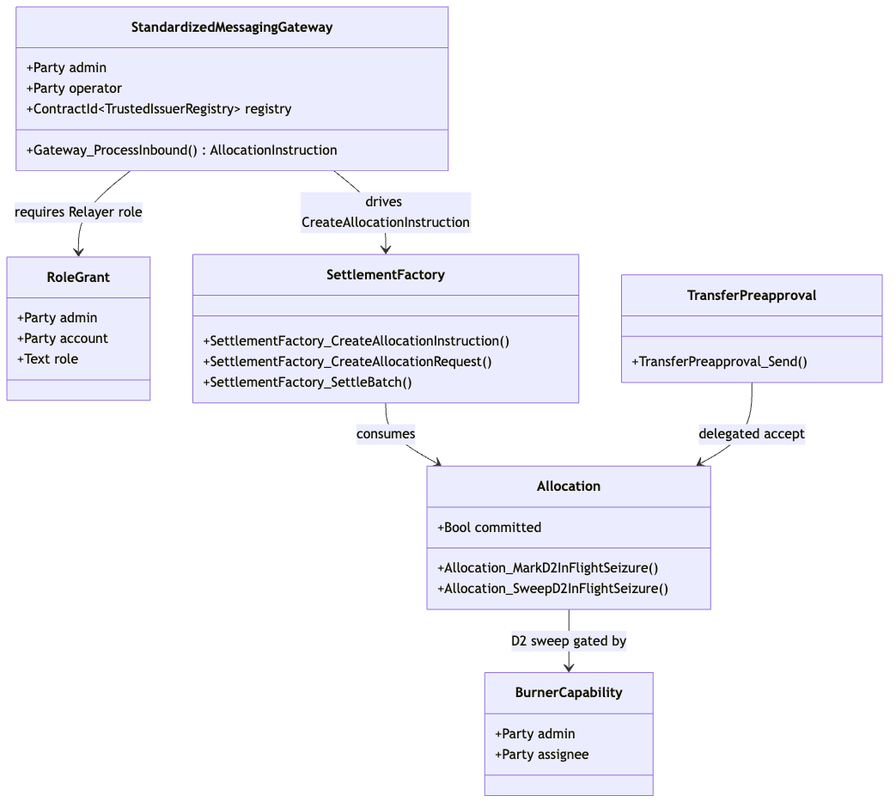{width=6.3in}

5.2 Flow-of-Funds / Settlement Diagram (Cross-chain Bridge + Batch DvP)
Diagram 2 (rendered locally; editable Mermaid source in the canonical 03-cross-chain-stablecoin.md).
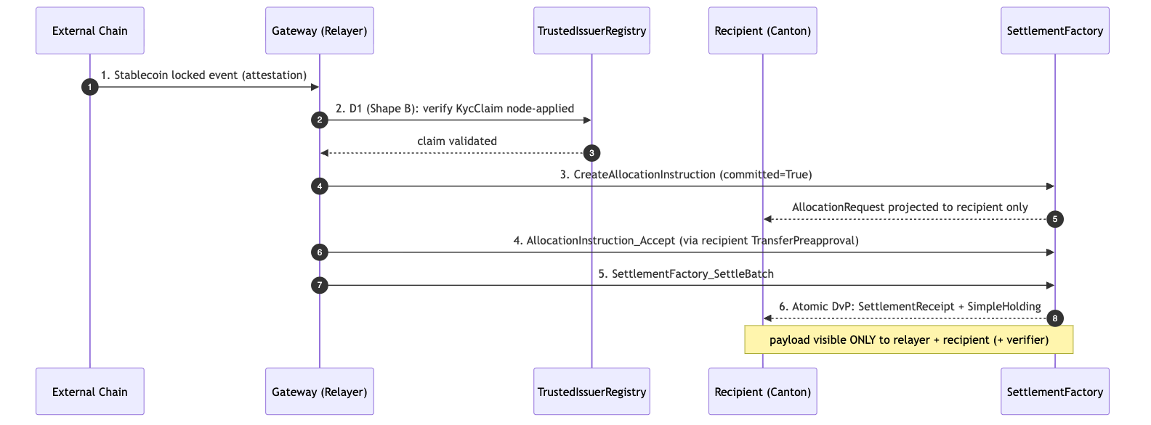{width=6.3in}

6. Library Dependencies

6.1 Internal Dependencies (present in workspace)
Component | Source Package | Usage | Tag
oz-access-control | canton-specs / canton-contracts | AL-7 RoleGrant/requireRole gating the gateway; D4 single-admin authority. | [IMPLEMENTED]
oz-ownable | canton-specs / canton-contracts | Ownership over hooks/factories; secure handoff. | [IMPLEMENTED]
oz-pausable | canton-specs / canton-contracts | PauseState halts inbound requests during anomalies. | [IMPLEMENTED]
SettlementFactory (CIP-0112 spine) | canton-specs | Allocation generation + SettleBatch DvP. | [IMPLEMENTED] (experimental)
TransferPreapproval | canton-token-template (SimpleToken.Preapproval) | Delegated recipient accept for offline treasuries. | [EVIDENCE]
SimpleHolding / SimpleTokenRules / LockedSimpleHolding / *_ForcedBurn | canton-token-template | Asset representation, 3-way dispatch, D2 evidence. | [EVIDENCE]
CredentialGatedActionRequest / MockVerificationResult | zk-credential-gateway | D1 credential gating. | [EVIDENCE]
KycClaim / TrustedIssuerRegistry | canton-specs identity-hook Shape-B | Typed D3 identity for D1 Shape-B node attestation. | [IMPLEMENTED] (experimental)
Attribution note: KycClaim / TrustedIssuerRegistry are canton-specs identity-hook-shape-b types, not zk-credential-gateway templates. The gateway supplies the gating/verification primitives.

6.2 External / Planned Dependencies
Component | Role / Provider | Status | Note
Standardized Messaging Gateway | Cross-chain messaging (OpenZeppelin Contracts Library) | Planned [FUTURE] | Not present in this workspace. Modeled as a bounded mock (StandardizedMessagingGateway); to be swapped for a production CCIP/LayerZero-style integration. Build only its Daml-facing interface.
Splice Token Standard V2 DARs | V2 settlement rules | Planned [UPSTREAM] | Local stand-ins designed to maximally match the V2 interfaces; source-of-record hyperledger-labs/splice @ token-standard-v2-upcoming @ 1e34121b… (historical preview …-daml-preview @ b91de5d4…). Import gated (PLAN.md; M4_STABLECOIN_SCOPE.md §A).
USDCx | Settled instrument admin | External | Consumed via interface only; issuance + peg handled off-architecture.

7. Security & Auditability
Security relies on Daml's structural rigidity and deterministic state transitions, not obscure cryptography.

7.1 Invariants
- Conservation of funds. SettlementFactory_SettleBatch cannot output more value than its input Allocations; sum of inputs = sum of receipts + returned change, enforced via nextIterationFunding. Any mismatch is rejected by the Daml engine — no counterfeiting.
- Privacy partitioning. Amount, payer, and payload memo are projected only to the relayer, recipient, and designated compliance verifier. If the StablecoinAdmin could observe the memo without authorization, the invariant is broken.

7.2 Threat Model
Vector | Description | Mitigation
Malicious relayer | Routes valid inbound funds to an unauthorized/sanctioned account. | D1 hook requires a node-applied KycClaim whose subjectParty matches the exact recipient; the relayer cannot spoof the destination (fail-closed).
Malicious sender | Triggers spam/toxic settlement to an unwilling recipient. | Without a configured TransferPreapproval or explicit accept, the allocation is not settled and funds return to sender (transfer-failure semantics).
Compromised admin | Attempts arbitrary expropriation. | D4 single-admin is a structural boundary; even a compromised admin's D2 sweep is hardcoded to the preset custodianDestination (no arbitrary burn, no return-to-sender).
UTXO fragmentation | Many small transfers accumulate holding dust. | Iterated settlement merges inputs; remaining balance returns as a single new holding, reducing fragmentation during the batch.

7.3 Validation Ladder
Tier | Tooling | Purpose
Static analysis | daml-lint | Validates SCU rules (no illegal field mutation; only Optional extensions), decimal bounds, archive-before-execute, roleId wrapper, whenNotPaused.
Generative testing | daml-props | Property-based testing with shrinking over SettleBatch: fuzzed extra-transfer-leg scenarios verify funding conservation never breaks.
Formal verification | daml-verify | Z3 proofs over D1–D4 mappings — e.g. Gateway_ProcessInbound is unreachable unless a valid KycClaim path exists, sealing the D1 gate on-ledger.
(Tooling exists in the workspace; no benchmark latencies are claimed.)

7.4 Off-ledger reconciliation [UPSTREAM]
A treasury operating this flow reconciles its private Canton settlement against the inbound external-chain event without parsing raw transaction trees: the Token Standard V2 transfer-events API (Splice.Api.Token.TransferEventsV2, imported in the canton-token-template evidence) emits holdings-change events the recipient can correlate with the gateway's inbound message id, giving a 1:1 audit linkage between the external lock/burn and the Canton credit. This is an upstream API surface, not vendored here, and the linkage is a reference pattern — the report makes no reconciliation-completeness, accounting-standard, or audit-readiness claim.

8. Cross-Synchronizer Domain Extension (Planned) [FUTURE]
Shared model: the cross-synchronizer mechanism (per-synchronizer assignment + unassign/assign reassignment, and the SCU-compliant additive path) is identical across all four RIs and is owned in 00-portfolio.md §5. This section elaborates only the RI-specific topology (including the cross-chain vs cross-synchronizer distinction below).
Status: out of scope for the initial M1 design; deferred and planned. Note the distinction: this RI is cross-chain (bridging from external L1s/L2s via the gateway) but still single-synchronizer on Canton today. Operating the Canton-side settlement across multiple Canton synchronizer domains is a separate, deferred capability (D3 cross-domain identity is also deferred). This section plans it per Canton's per-synchronizer assignment + unassign/assign reassignment model and the SCU rule.

8.1 Cross-chain vs cross-synchronizer
- Cross-chain (in scope as a mock): external chain → gateway attestation → Canton settlement on one synchronizer.
- Cross-synchronizer (planned): the Canton-side recipient, stablecoin instrument, and compliance registry may live on different Canton synchronizers; settlement then requires reassigning the relevant contracts onto one synchronizer before SettleBatch.

8.2 Where it touches the boundary
Element | Single-synchronizer (today) | Cross-synchronizer (planned)
Inbound Allocation / SettlementReceipt | Created/settled on the recipient's synchronizer. | Reassignable: inbound allocation assigned to the synchronizer hosting the recipient's USDCx holding before SettleBatch.
USDCx instrument admin | Same synchronizer as settlement. | If USDCx is administered on another synchronizer, the settled instrument must be reachable there or reassigned in.
D1 TrustedIssuerRegistry | One synchronizer. | Synchronizer-aware registry; compliance re-checked on the settling synchronizer (no stale cross-domain attestation reuse).
D3 identity | Single-domain KycClaim. | Cross-domain proof (ONCHAINID / ERC-3643 / CCID) resolved into a synchronizer-aware registry — the deferred D3 work.

8.3 The additive, non-breaking path (SCU-compliant)
- Append Optional SynchronizerScope to the RI gateway/orchestrator templates; older contracts read None.
- Add a new parallel choice (e.g. Execute_Inbound_Settlement_CrossDomain) alongside the unchanged single-synchronizer choice.
- Model reassignment as workflow: reassign the inbound allocation onto the settling synchronizer → SettleBatch there → reassign the receipt/holding back. Atomicity stays at the single-synchronizer batch boundary.

8.4 Open questions specific to cross-synchronizer operation
- Reassignment-vs-settlement atomicity (rollback vs re-home-able allocation on SettleBatch failure) — maps to the return-to-sender rule.
- Which synchronizer's TrustedIssuerRegistry and verifier set govern a cross-domain inflow.
- Cross-domain D1 freshness (re-check on the settling synchronizer; never reuse across a reassignment).
- Reassignment tooling maturity (evolving Canton/DA stack; assumes drop-in).

9. Open Questions
- Standardized Messaging Gateway (planned, absent). The gateway is a Contracts-Library component not yet present in this workspace. When the production gateway lands, how are inbound attestations sequenced if the origin chain (Ethereum/Polygon) deep-reorgs? Does the gateway manage confirmation delays internally, or must the relayer Daml contract use a time-locked AllocationInstruction to mitigate cross-chain rollback risk?
- USDCx forced upgrades. Active holdings upgrade-on-use via factory routing, but a forced upgrade for passive holders raises a question: how does the relayer detect a recipient holding a deprecated TransferPreapproval, and what is the fallback from delegated-accept to an interactive two-step offer?
- Expired / unsettled inbound-allocation lifecycle. A committed inbound Allocation locks bridging funds until settlement; if the DvP never completes (recipient never finalizes, origin reorg, deadline lapses), the local CIP-0112 scaffold has no cancel/withdraw/reject path — the choices today are Allocation_Settle and the two D2 seizure choices. The upstream Token Standard V2 Allocation lifecycle [UPSTREAM] separates an allocation's expiry from its settlement deadline and adds cancel/withdraw/reject semantics, which would let an automated handler reclaim dead capital without the original signer. Whether M1 reserves this via an additive [FUTURE] cancel choice on the RI orchestrator (return-to-sender on expiry) or defers entirely to the upstream lifecycle once imported is open. (Maps to the transfer-failure return-to-sender rule.)
- Cross-domain identity proof injection (D3). When ONCHAINID / ERC-3643 equivalents are supported, does the TrustedIssuerRegistry ingest external state proofs via an oracle, or rely on a CCID protocol synchronized across the global synchronizer? The cross-domain proof-injection trust model must be audited.
- Cross-synchronizer operation (see §8) — deferred; tracked there.
- Composability with the other RIs (forward-compatibility; suite view 00-portfolio.md §3): recipients holding USDCx settled here can provide liquidity to the DEX RI (01) pools or collateralize a Lending RI (02) vault — all over the same SettlementFactory_SettleBatch spine, with no parallel settlement path.

References
All interface, template, choice, and field names are grounded in real source in this workspace (verified 2026-06-24), except components explicitly marked planned/external.
- Settlement spine [IMPLEMENTED] — canton-specs/experiments/cip112-settlement/daml/OpenZeppelin/Experimental/Settlement/Cip112.daml.
- Holdings / rules / preapproval / forced-burn [EVIDENCE] — canton-token-template/simple-token/daml/SimpleToken/{Holding,Rules,Preapproval}.daml (TransferPreapproval + TransferPreapproval_Send/_MintInto; LockedSimpleHolding_ForcedBurn).
- Credential gating / verification [EVIDENCE] — zk-credential-gateway/daml/src/ZkCredentialGateway/{GatedAction,Verification,Types}.daml.
- Typed D3 identity (KycClaim, TrustedIssuerRegistry) [IMPLEMENTED] — canton-specs/experiments/identity-hook-shape-b/ and identity-hook-upgrade-*/.
- AL-7 primitives [IMPLEMENTED] — canton-specs access-control/, ownable/, pausable/.
- Decision authority (D1–D4), scope, SCU rule — root PLAN.md, AGENTS.md, briefing docs/research/RI_RESEARCH_BRIEFING.md.
- Grant scope / milestones / deliverables (source of truth) — docs/research/canton-ecosystem-grant-proposal.md (PR #298, approved; CIP-56→CIP-0112 retarget) and the distilled M4_STABLECOIN_SCOPE.md.
- Token Standard V2 upstream [UPSTREAM] — hyperledger-labs/splice token-standard-v2-upcoming (import gated per PLAN.md).
- Planned / external (not in workspace): the Standardized Messaging Gateway (OpenZeppelin Contracts-Library component) and USDCx (external Canton ecosystem stablecoin). See §6.2 and Open Questions.
Removed in review: the original draft cited external/non-workspace URLs (a CoinStats "fundamental analysis" page, srikanth-bitdynamics GitHub, Medium posts, cantonecosystem.com, a jobs board, BitGo/DFNS docs, a universal-verify/trusted-issuer-registry repo, QuillAudits, and others) as authoritative sources, and an inaccurate "10-minute mining-round = transaction signing timeout" claim. None of the URLs are part of this workspace or an authoritative spec; they were removed and replaced with the workspace-grounded references above, and the TransferPreapproval rationale was restated as delegated accept for offline recipients (not a timeout workaround). See the review record in ../reviews/2026-06-24T22-57-44Z_REVIEW.md.
Re-review 2026-06-25 (expert "blueprint" pass): the second expert draft's §9 (Cross-Chain Stablecoin) was assessed. Integrated: the §7.4 V2 transfer-events reconciliation note (Splice.Api.Token.TransferEventsV2, [UPSTREAM]), the §9 expired/unsettled-allocation lifecycle open question (upstream cancel/withdraw/reject vs. the local scaffold's absence of one), and the §3 retroactive-interface-instance [UPSTREAM] note (suite-consistent with RI 1/2). Rejected: CIP-86 as an "Ethereum JSON-RPC / MetaMask facade" (CIP-86 is an ERC-20 middleware & distributed indexer per cip0086-cip0103-cip0104-m1-acceptance.md, and is out of this RI's scope — the report does not adopt the facade framing); fabricated AmuletAllocationV2 / TransferInstructionV2 (only AllocationV2 / AllocationRequestV2 / HoldingV2 exist, as upstream Splice.Api.Token.* imports — the RI uses the local spine Allocation); the claim that Wormhole / LayerZero "exist as SVs on the Canton Network" (unverifiable; the gateway stays a [FUTURE] mock); the BatchingUtility_MergeHoldings utility (fabricated; the report's fragmentation mitigation is the spine's iterated-settlement change-merge, not a named utility); and the OCC / FDICIA / SOX external-citation set. Record: ../reviews/2026-06-25T02-29-08Z_REVIEW.md.

