CONFIDENTIAL — OpenZeppelin internal · non-public reference design · not for external distribution

Architectural Overview Report: Confidential Auction Launchpad on Canton
Status: reviewed reference-design report, non-public, outside the committed M1 public-library surface. This is RI #4 of four — see the suite-level view in 00-portfolio.md and the index README.md. It describes a reference design grounded in the real OpenZeppelin Canton components in this workspace; it is not a claim of M1/M4 acceptance, conformance, audit readiness, or production readiness.
Google Docs import: File → Open this .md in Docs (or paste with Edit → Paste). H1/H2/H3 headings drive the Docs outline pane; the tables import cleanly; apply a monospace paragraph style to fenced code blocks after import. Mermaid blocks do not render in Docs — render them with canton-settlement-explorer and paste the image, keeping the fenced source.
Source-grounding tags (used throughout): [IMPLEMENTED] real code in the M1 library base (canton-specs / canton-contracts) · [EVIDENCE] real code in an evidence repo (canton-token-template, canton-stablecoin, zk-credential-gateway), not the M1 surface · [UPSTREAM] Splice / CIP reference, not vendored here · [FUTURE] proposed RI-level design, not built in M1 scope.
Design priority order governs every interface and snippet, in this exact order: 1) Readability → 2) Simplicity → 3) Security → 4) Auditability.
Grant alignment (source of truth: ../research/canton-ecosystem-grant-proposal.md, scope lock: ../../M4_AUCTION_SCOPE.md): this is RI #4 (Confidential Auction Launchpad). This document is the Architecture Documentation deliverable, authored in grant M1 (research & design) for the implementation in grant M4 (Q4 2026, end Year 1, alongside RI 3). Companion deliverables — working reference code, demo front-end, threat model — are named here but delivered in M4 (MIT-licensed). The report honors the CIP-56 → CIP-0112 / Token Standard V2 retarget.

1. Product Definition
The Confidential Auction Launchpad is a reference implementation for institutional, regulated, confidential token distribution (ICOs) on Canton. It leverages Canton's sub-transaction privacy and the CIP-0112 / Token Standard V2 settlement spine [IMPLEMENTED] to establish a sealed-bid environment by protocol design rather than cryptographic obfuscation: bids, allocations, and settlement details are visible only to explicitly authorized parties via native ledger projection.

1.1 Educational Framing: Sealed-bid via projection, not commit-reveal
On public ledgers, sealed-bid auctions use a commit-reveal pattern: publish a hash of the bid to a globally visible mempool/ledger, then reveal the plaintext later — adding UX friction, non-revelation risk, and exposure to metadata/timing analysis. On Canton, privacy is per-party projection: a contract is visible only to its signatories/observers, and a BidRequest with signatory bidder, observer auctioneer materializes only on those two parties' nodes. The synchronizer's sequencer orders the transaction by its confirmation-tree shape but does not see the bid plaintext, so the sealed-bid property is achieved without commit-reveal and front-running is structurally prevented. If an institution wants protection against the auctioneer too, a commit-reveal hash can be layered onto BidRequest as a non-breaking SCU extension — but native projection privacy suffices for the stated scope.

1.2 In-Scope vs. Out-of-Scope
The bias favors a clean, singular sealed-bid core over expansive market mechanics.
Feature Category | In-Scope
Auction mechanism | Single-round sealed-bid; first-price default, second-price as a parameterization computed by the auctioneer's off-ledger pricing engine.
Confidentiality | Bid isolation via per-party projection — bidder, issuer/auctioneer, and the credential verifier only; no bidder projects competitor bids.
Escrow | Locked escrow via LockedSimpleHolding / Allocation; funds cryptographically bound to the settlement outcome.
Atomic settlement | Token-for-payment exchange only via SettlementFactory_SettleBatch (atomic DvP, single transaction).
Access gating | Credential-gated participation via zk-credential-gateway (CredentialGatedActionRequest, MockVerificationResult).
Authority | Single-admin capability via oz-access-control (mint/burn/seizure).
Compliance | D1 node-applied checks (Shape B) on every settlement leg, fail-closed.

Feature Category | Out-of-Scope (Excluded)
Continuous issuance | Streaming launches, continuous funding, persistent issuance — discrete finalized rounds only.
Algorithmic pricing | Bonding curves, dynamic-price Dutch auctions (settlement spine could host them later, not core).
Secondary market | AMM / order-book / post-auction liquidity — that is the DEX RI.
Derivatives & synthetics | Options/futures/synthetics of the launched token.
On-ledger clearing math | Sorting/clearing runs off-ledger; only finalized, conservation-sound match legs settle on-ledger.

1.3 Target Users
Institutional asset issuers, regulated launchpad operators, and accredited investors in compliant jurisdictions. Issuers get fair distribution free of front-running / bid manipulation / MEV, with KYC/AML/accreditation enforced via zk-credential-gateway. Bidders get confidentiality of intent, atomic return-to-sender for losing bids (no counterparty credit risk), and capital that can move only per their signed AllocationInstruction.

2. Architecture Overview
Strictly modular: access control, asset semantics, auction logic, and terminal settlement are distinct layers, so the settlement spine stays sealed while auction mechanics can be upgraded or substituted.

2.1 Component Utilization
- Authority — oz-access-control [IMPLEMENTED] (RoleGrant, RoleAdmin, DefaultAdminTransferOffer, requireRole; roleId : MyRole -> Text closed-sum wrapper) for Issuer/Auctioneer roles; oz-ownable [IMPLEMENTED] (Ownership/OwnershipOffer) for two-step handoff; oz-pausable [IMPLEMENTED] (PauseState/whenNotPaused) for the emergency halt.
- Settlement spine — OpenZeppelin.Experimental.Settlement.Cip112 [IMPLEMENTED] (SettlementFactory, AllocationRequest, AllocationInstruction, Allocation, SettlementReceipt). Atomic DvP routes only through SettlementFactory_SettleBatch; direct Allocation_Settle is bypassed for the exchange (it proves authorization, not multi-party atomic co-settlement).
- Assets — canton-token-template [EVIDENCE] (SimpleHolding, LockedSimpleHolding, SimpleTokenRules 3-way dispatch); the launched token is minted via Rules_Mint / MintProposal (cold recipient → propose → accept, honoring Canton co-authorization). canton-stablecoin's Vault / VaultFactory / Vault_Liquidate / PriceOracle are excluded (CDP mechanics, not primary issuance).
- Compliance/identity — zk-credential-gateway [EVIDENCE] (CredentialGatedActionRequest, MockVerificationResult, CredentialRevocationStatus); typed D3 KycClaim + TrustedIssuerRegistry from the canton-specs identity-hook Shape-B experiment [IMPLEMENTED].
Attribution note: KycClaim / TrustedIssuerRegistry are canton-specs identity-hook-shape-b types, not zk-credential-gateway templates. The gateway supplies the gating/verification primitives.

2.2 Party and Role Topology
- Operator — deploys the launchpad contracts and manages the SettlementFactory; operational, not financial, authority.
- Issuer — launches the token; single-admin authority; holds the BurnerCapability (D2 seizure) and authorizes Rules_Mint via MintProposal.
- Auctioneer — delegated by the Issuer via RoleGrant; observes BidRequests, runs the off-ledger clearing engine, and builds the SettleBatch payload; cannot misdirect funds (constrained by the spine's conservation invariants).
- Bidder — needs a valid KycClaim from a TrustedIssuerRegistry; retains control of payment assets until atomic settlement.
- Verifier — off-chain compliance entity; issues a MockVerificationResult attesting credential validity, green-lighting participation.

2.3 Trust and Topology
Each contract configures the nodes that validate it. The BidRequest's signatory bidder, observer auctioneer definition routes its data only to those parties' nodes, shielding bids from the network. Daml-LF 2.1 is keyless (archive-and-recreate, not in-place mutation), and any new signatory must co-authorize — so the Auctioneer cannot push a minted token into a Bidder's wallet: the Issuer creates a MintProposal and the Bidder actively accepts it. Synchronizer sequencers order transactions by confirmation-tree shape while remaining blinded to bid plaintext, eliminating sequencer front-running / MEV.

3. How We Implement It
An invariant-bound lifecycle: configuration + gating → confidential bidding → off-ledger clearing → atomic on-ledger settlement.

3.1 The Settlement-Spine Flow
- Configuration + access gating. The Issuer instantiates AuctionLaunchpad (payment instrument id, launched instrument id, the SettlementFactory reference, the governing TrustedIssuerRegistry) and delegates the Auctioneer role via RoleGrant.
- Credential verification. The Bidder obtains a KycClaim and submits a CredentialGatedActionRequest; the Verifier issues a MockVerificationResult on-ledger, unlocking participation.
- Escrow + confidential bid. The Bidder commits payment capital by creating an AllocationInstruction (via SettlementFactory_CreateAllocationInstruction) and accepting it (AllocationInstruction_Accept), producing a committed Allocation that locks the funds under the Bidder's authority while delegating settlement execution to the SettlementFactory. Simultaneously the Bidder creates a BidRequest (signatory bidder, observer auctioneer) carrying the Allocation reference, bid amount, and price — projected only to bidder and auctioneer.
- Closure + clearing. The Auctioneer halts new submissions via oz-pausable (PauseState), queries its node for active BidRequests, and runs the off-ledger clearing engine to determine the clearing price, winners, and exact asset routing.
- Atomic co-settlement. For each winner the Auctioneer creates token AllocationInstructions (token minted/transferred from the Issuer's treasury holding) and builds the final batch — winners' payment Allocations + the Issuer's token Allocations + the routing legs — then submits a single SettlementFactory_SettleBatch. The factory validates conservation (payment in = payment owed; tokens out = tokens owed) and runs the D1 hooks; on success it commits atomically, delivering tokens to bidders, payment to the Issuer, and SettlementReceipts.
- Return to sender (losing bids). The Auctioneer archives losing BidRequests and cancels the corresponding payment Allocation (Allocation_Cancel / _Withdraw), releasing the lock back to the bidder. This honors the D2 rule: non-matching bids return to sender — never seized or burned by the launchpad.

3.2 D1 Compliance: Shape B node attestation
Compliance is checked on every settlement leg, fail-closed, node-applied — no on-ledger caching. The RI uses Shape B (signed node attestation) over Shape A (off-ledger gate): the optional D1ComplianceHook on SettleBatch requires fresh, cryptographically signed attestations from the relevant compliance nodes; if any are missing/expired/invalid, the entire batch fails. (Open, non-blocking: contract-oblivious vs on-ledger attestation verification.)

3.3 D2 Seizure: lock-and-sweep
Seizure is isolated from the auction flow and gated by the single-admin BurnerCapability. It is not a burn: a targeted Allocation / holding is swept to an admin-preset custodianDestination, via the real spine mechanism (Allocation_MarkD2InFlightSeizure → Allocation_SweepD2InFlightSeizure for in-flight allocations; LockedSimpleHolding_ForcedBurn to the custodian for locked holdings). The spine's D2SeizureHook is a config data record (seizureCaseRef, custodianDestination, inFlightHandlingStatus), not an invokable template. Value is preserved; chain of custody is maintained; nothing is returned to a flagged sender (ordinary transfer failures do return to sender).

3.4 SCU upgrade rule + D3 forward compatibility
Never mutate an existing choice's args to require a new field; extend via Optional fields, new types, and new choices. D3 today is single-domain v1 (TrustedIssuerRegistry + KycClaim). To add cross-domain identity (ONCHAINID / ERC-3643 / CCID) later: define a new CrossDomainIdentity type, append crossDomainRef : Optional CrossDomainIdentity to BidRequest, and add a new choice BidRequest_UpdateIdentity (archive + recreate with the field populated). Legacy bid choices stay untouched and functional. This is the additive path proven in the canton-specs identity-hook upgrade spike.

4. Interfaces & Usage Examples
Names map to real workspace components; RI-level templates are tagged [FUTURE]. Imports use real module names (OpenZeppelin.AccessControl, OpenZeppelin.Pausable, OpenZeppelin.Experimental.Settlement.Cip112).

4.1 Access control [FUTURE]
module ConfidentialAuction.AccessControl where
import OpenZeppelin.AccessControl (RoleGrant, requireRole)
data AuctionRole = IssuerRole | AuctioneerRole deriving (Eq, Show)
roleId : AuctionRole -> Text
roleId IssuerRole = "ISSUER"
roleId AuctioneerRole = "AUCTIONEER"

4.2 Launchpad configuration [FUTURE]
module ConfidentialAuction.Launchpad where
import OpenZeppelin.Pausable (PauseState, whenNotPaused)
import OpenZeppelin.Experimental.Settlement.Cip112 (SettlementFactory)
template AuctionLaunchpad
with
operator : Party
issuer : Party
paymentInstrumentId : Text
launchedInstrumentId : Text
settlementFactoryCid : ContractId SettlementFactory
pauseStateCid : ContractId PauseState -- oz-pausable kill-switch
minBidPrice : Decimal
where
signatory operator, issuer
ensure (minBidPrice > 0.0)
-- Halt/resume route through oz-pausable PauseState_Set (controller = issuer,
-- validated via requireRole IssuerRole), not via a mutated local flag.

4.3 Confidential bid + policy guards [FUTURE]
module ConfidentialAuction.Bid where
import OpenZeppelin.Experimental.Settlement.Cip112 (Allocation)
template BidRequest
with
bidder : Party
auctioneer : Party
launchpadCid : ContractId AuctionLaunchpad
paymentAllocationCid : ContractId Allocation
bidAmount : Decimal
bidPrice : Decimal
maxAllocationCap : Decimal
-- SCU additive extension point for deferred D3 cross-domain identity.
crossDomainRef : Optional Text
where
-- CONFIDENTIALITY boundary: only bidder + auctioneer project this contract.
signatory bidder
observer auctioneer
-- Policy guard: integrity + per-investor cap.
ensure (bidAmount > 0.0 && bidPrice > 0.0 && bidAmount <= maxAllocationCap)
-- D2 / return-to-sender: bidder withdraws before clearing; the real spine
-- choice unlocks and returns the funds (no auctioneer action needed).
choice BidRequest_Cancel : ContractId Allocation
controller bidder
do exercise paymentAllocationCid Allocation_Withdraw

4.4 Atomic settlement via the spine [FUTURE]
module ConfidentialAuction.Clearing where
import OpenZeppelin.Experimental.Settlement.Cip112
(SettlementFactory, SettlementFactory_SettleBatch, Allocation, AllocationRequest)
template AuctionClearing
with
auctioneer : Party
launchpadCid : ContractId AuctionLaunchpad
where
signatory auctioneer
choice Clearing_ExecuteBatch : [ContractId SettlementReceipt]
with
settlementFactoryCid : ContractId SettlementFactory
paymentAllocations : [ContractId Allocation] -- winners' locked payment
tokenAllocations : [ContractId Allocation] -- issuer's token side
requests : [ContractId AllocationRequest] -- routing legs (bidders ↔ tokens)
controller auctioneer
do
-- Single atomic DvP. If any D1ComplianceHook fails on any leg, or the
-- math violates conservation, the whole batch fails-closed.
exercise settlementFactoryCid SettlementFactory_SettleBatch with
allocations = paymentAllocations ++ tokenAllocations
requests = requests
-- nextIterationFunding empty: terminal single-round settlement.

5. Diagrams
Validatable with canton-settlement-explorer. Render externally for Docs.

5.1 Interface and Component Diagram
Diagram 1 (rendered locally; editable Mermaid source in the canonical 04-confidential-auction.md).
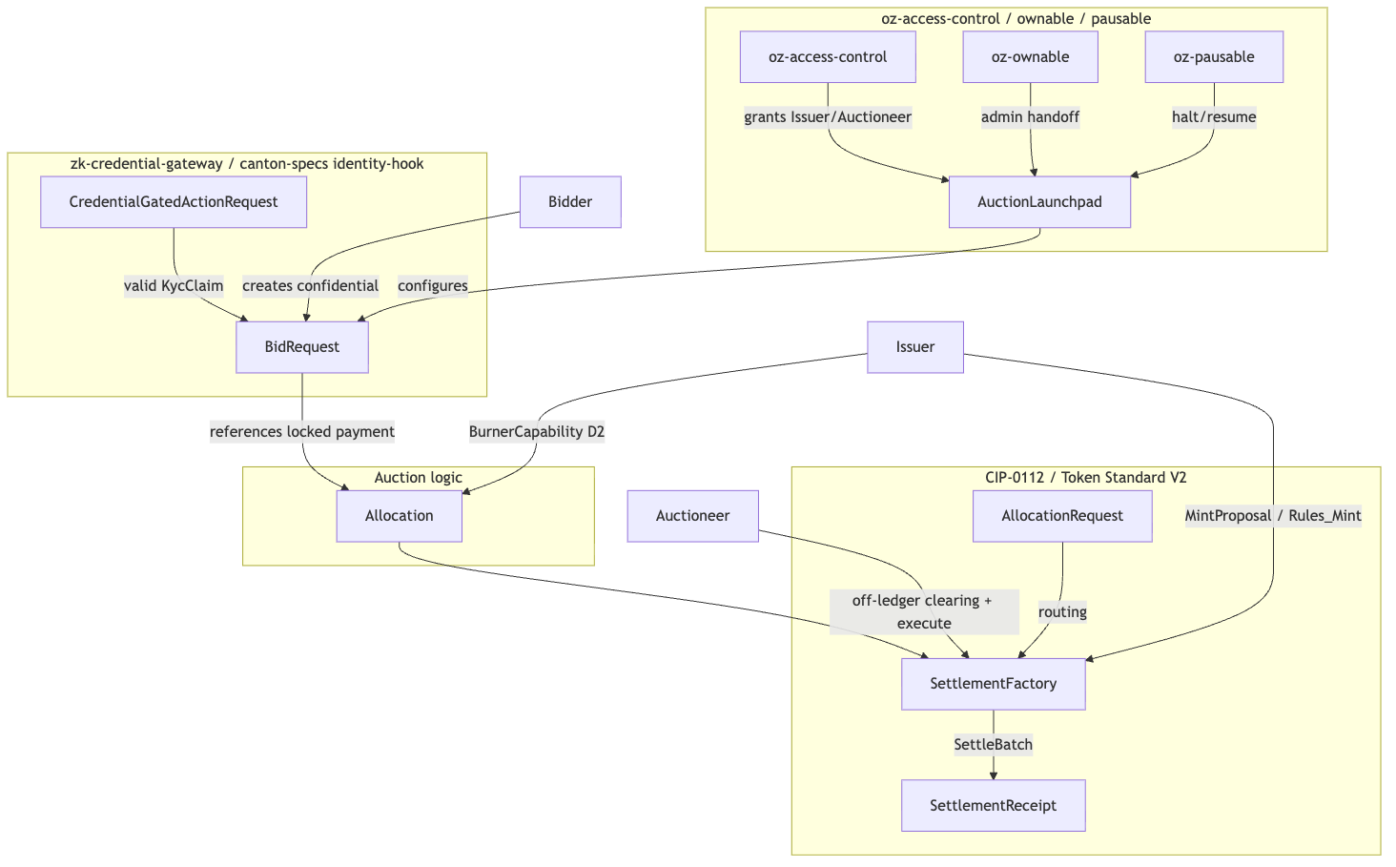{width=6.3in}

5.2 Flow-of-Funds and Settlement Sequence
Diagram 2 (rendered locally; editable Mermaid source in the canonical 04-confidential-auction.md).
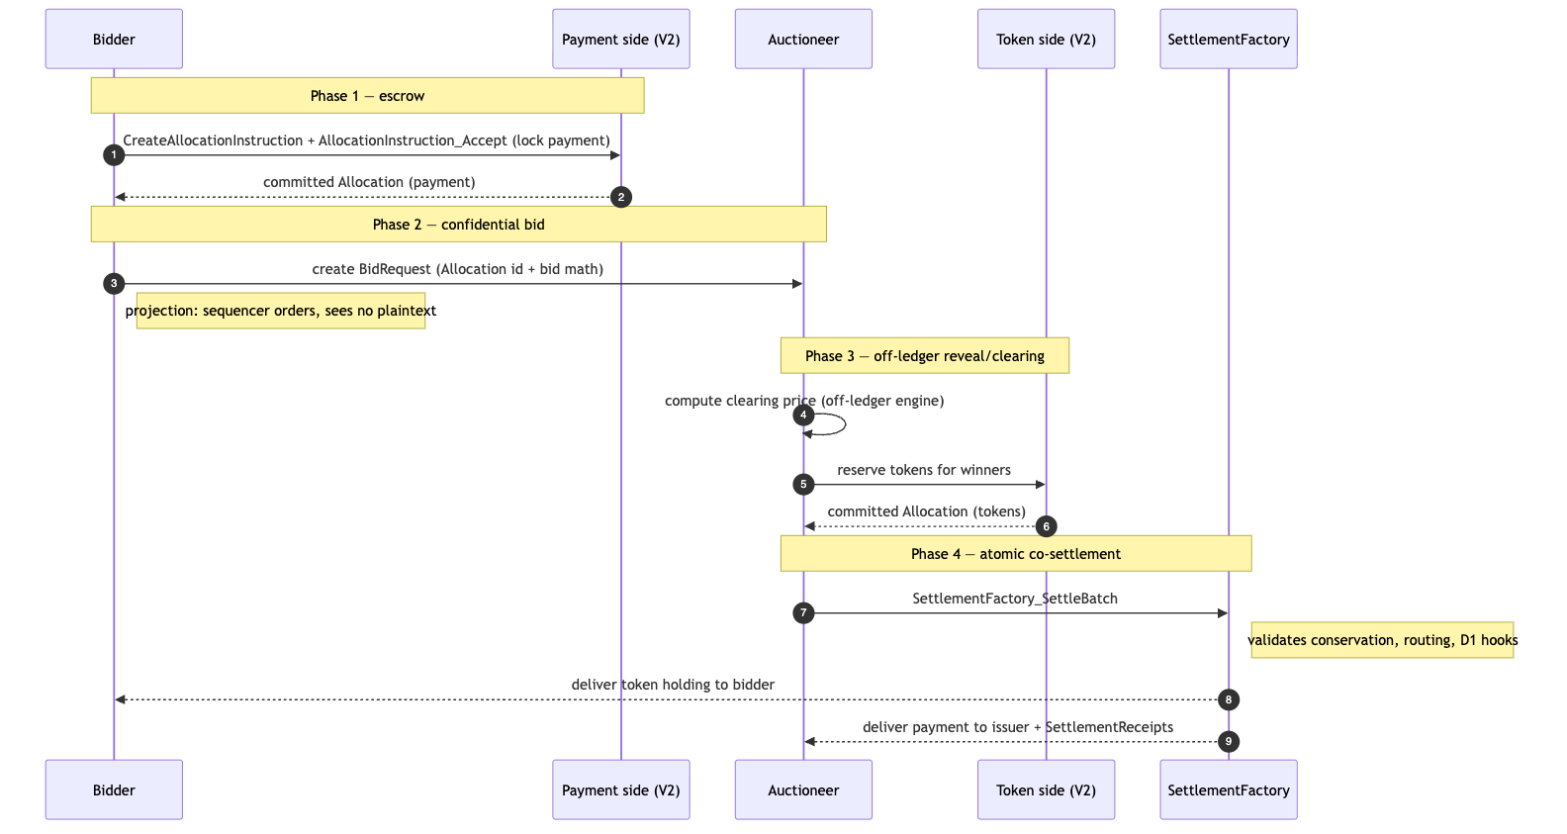{width=6.3in}

6. Library Dependencies

6.1 Internal Dependencies
Package | Consumed Templates / Interfaces | Role | Tag
oz-access-control | RoleGrant, RoleAdmin, DefaultAdminTransferOffer, requireRole | Authority model; closed-sum roleId checks. | [IMPLEMENTED]
oz-ownable | Ownership, OwnershipOffer | Secure admin handoff. | [IMPLEMENTED]
oz-pausable | PauseState, whenNotPaused | Circuit breaker (halt the sale). | [IMPLEMENTED]
canton-token-template | SimpleHolding, LockedSimpleHolding, SimpleTokenRules, TransferPreapproval, RoleCapability, MintProposal, Rules_Mint | Asset structure, 3-way dispatch, cold-recipient mint. | [EVIDENCE]
canton-stablecoin | (none consumed; Vault/VaultFactory/Vault_Liquidate/PriceOracle excluded — CDP, not issuance) | Referenced for contrast only. | [EVIDENCE]
zk-credential-gateway | CredentialGatedActionRequest, MockVerificationResult, CredentialRevocationStatus | D1/D3 credential gating. | [EVIDENCE]
canton-specs identity-hook Shape-B | KycClaim, TrustedIssuerRegistry | Typed D3 identity, layered via SCU. | [IMPLEMENTED] (experimental)
OpenZeppelin.Experimental.Settlement.Cip112 | SettlementFactory, AllocationRequest, AllocationInstruction, Allocation, SettlementReceipt, BurnerCapability, D1ComplianceHook, D2SeizureHook | Atomic DvP spine; D1/D2 seams. | [IMPLEMENTED] (experimental)

6.2 External Dependencies (Splice Token Standard V2)
Built against the CIP-0112 / Splice Token Standard V2 interfaces [UPSTREAM], ignoring DAR/package-ID pins in favor of local stand-ins designed to maximally match the V2 interfaces. Source-of-record pin: hyperledger-labs/splice @ token-standard-v2-upcoming @ 1e34121b… (historical preview …-daml-preview @ b91de5d4…; DARs + checksums in canton-token-template/docs/CIP-0112-EXTENSION-PLAN.md). Import remains gated (PLAN.md; M4_AUCTION_SCOPE.md §A); no public-API stability / conformance / release claim. nextIterationFunding is present in the standard but disabled here (single-round); it is the extension point for multi-round / bonding-curve variants.

7. Security & Auditability

7.1 Threat Model and Invariants
Threat | Mechanism | Mitigation
Privacy leakage / metadata front-running | Adversaries monitor a public mempool to front-run bids. | Canton has no public mempool; per-party projection keeps the BidRequest payload off the network; the sequencer sees the confirmation-tree shape, not contents; blast radius is bounded by a node's authorized visibility.
Unauthorized seizure / unilateral burn | Compromised admin attempts to burn or redirect escrow. | D2 gated by the single BurnerCapability; failure never defaults to seizure — a failed SettleBatch leaves funds in their Allocation, returned to sender.
Auctioneer embezzlement at settlement | Auctioneer manipulates routing to redirect payments. | AllocationRequest/leg routing is explicit; SettlementFactory enforces conservation at the Daml level — net outflow cannot exceed allocation and destinations must match the counter-signed routing; violating transactions are rejected.
Invariants: (a) conservation — SettleBatch cannot output more value than its input Allocations (sum in = sum out + change); (b) confidentiality — bid amount/parties are projected only to bidder, auctioneer, and the designated verifier.

7.2 Validation Ladder
Tier | Tooling | Purpose
Static analysis | daml-lint | Anti-patterns, decimal bounds, archive-before-execute; enforces the SCU Optional-append rule (no breaking field changes) and the roleId wrapper.
Generative testing | daml-props | Property-based fuzzing of SettleBatch over randomized Allocation/BidRequest shapes; attempts to force a conservation violation or orphaned-asset state.
Formal verification | daml-verify | Z3 proofs: no transition projects a BidRequest onto an unauthorized party; the D1 hook cannot be bypassed in the final confirmation tree.
(Tooling exists in the workspace; no benchmark latencies are claimed.)

7.3 D1–D4 Mapping
- D1 — D1ComplianceHook, Shape B signed node attestation every leg, fail-closed.
- D2 — D2SeizureHook config + BurnerCapability-gated lock-and-sweep to a preset custodian; no burn; losing bids return to sender.
- D3 — zk-credential-gateway + Shape-B KycClaim before bid acceptance; cross-domain deferred, SCU-forward-compatible.
- D4 — oz-access-control single-admin capability for M1; multi-sig → M3.

8. Cross-Synchronizer Domain Extension (Planned) [FUTURE]
Shared model: the cross-synchronizer mechanism (per-synchronizer assignment + unassign/assign reassignment, and the SCU-compliant additive path) is identical across all four RIs and is owned in 00-portfolio.md §5. This section elaborates only the RI-specific topology.
Status: out of scope for the initial M1 design; deferred and planned. The auction and the CIP-0112 scaffold are single-synchronizer today; D3 cross-domain identity is deferred. This section plans multi-synchronizer operation per Canton's per-synchronizer assignment + unassign/assign reassignment model and the SCU rule.

8.1 What changes
A cross-synchronizer launchpad is not one global auction. The AuctionLaunchpad, each BidRequest, and the bidders' payment Allocations may sit on different synchronizers; clearing settlement requires reassigning the winning legs onto one synchronizer before SettleBatch.

8.2 Where it touches the boundary
Element | Single-synchronizer (today) | Cross-synchronizer (planned)
BidRequest | Bidder + auctioneer on one synchronizer. | Bid may originate on a bidder's home synchronizer; the auctioneer must be reachable there or the bid reassigned for clearing.
Payment / token Allocation | Created and settled on the launchpad's synchronizer. | Reassignable: winning bids' payment allocations unassigned and assigned to the settling synchronizer before SettleBatch.
D1 compliance | Node-side on the settling synchronizer. | Re-evaluated on whichever synchronizer the leg settles; no cross-domain attestation reuse.
D3 identity | Single-domain KycClaim. | Cross-domain proof (ONCHAINID / ERC-3643 / CCID) into a synchronizer-aware TrustedIssuerRegistry — deferred D3 work.

8.3 The additive, non-breaking path (SCU-compliant)
- Append Optional SynchronizerScope to the RI templates (AuctionLaunchpad, BidRequest); older contracts read None.
- Add a new parallel choice (e.g. Clearing_ExecuteBatchCrossDomain) alongside the unchanged single-synchronizer clearing choice.
- Model reassignment as workflow: reassign winning allocations onto the settling synchronizer → SettleBatch there → reassign token/receipts back. Atomicity stays at the single-synchronizer batch boundary; losing-bid return-to-sender must also work across the reassignment.

8.4 Open questions specific to cross-synchronizer operation
- Reassignment-vs-settlement atomicity (rollback vs re-home-able allocation on SettleBatch failure), and how it composes with losing-bid return-to-sender.
- Which synchronizer's TrustedIssuerRegistry/verifier set governs a cross-domain bidder.
- Cross-domain D1 freshness (re-check on the settling synchronizer).
- Reassignment tooling maturity (evolving Canton/DA stack; assumes drop-in).

9. Open Questions
- Iterated-settlement extensions. nextIterationFunding is disabled in this single-round design. Adapting it for continuous bonding curves / multi-round Dutch auctions requires formalizing how conservation is enforced over many fragmented iterations without race-condition / double-spend exposure.
- D3 identity schema finalization. The future CrossDomainIdentity payload and attribute mapping (ERC-3643 / ONCHAINID equivalents → Canton) depend on components not yet present; the SCU rule guarantees additive layering, but the industry schema is still open.
- Validator-node thresholds for D1 Shape B. The Confirming-Participant-Node threshold for compliance attestations must be issuer-specified, balancing availability against cryptographic security.
- Cross-synchronizer operation (see §8) — deferred; tracked there.
- Composability with the other RIs (forward-compatibility; suite view 00-portfolio.md §3): post-auction secondary trading is the DEX RI (01); participants can collateralize bids by minting stablecoin in the Lending RI (02). Both compose over the shared SettlementFactory_SettleBatch spine.

References
All interface, template, choice, and field names are grounded in real source in this workspace (verified 2026-06-24).
- Settlement spine [IMPLEMENTED] — canton-specs/experiments/cip112-settlement/daml/OpenZeppelin/Experimental/Settlement/Cip112.daml.
- Holdings / rules / mint / preapproval / capability [EVIDENCE] — canton-token-template/simple-token/daml/SimpleToken/{Holding,Rules,Preapproval}.daml (SimpleHolding, LockedSimpleHolding + _ForcedBurn, SimpleTokenRules, Rules_Mint, MintProposal, RoleCapability).
- Credential gating / verification [EVIDENCE] — zk-credential-gateway/daml/src/ZkCredentialGateway/{GatedAction,Verification,Types}.daml.
- Typed D3 identity (KycClaim, TrustedIssuerRegistry) [IMPLEMENTED] — canton-specs/experiments/identity-hook-shape-b/ and identity-hook-upgrade-*/.
- AL-7 primitives [IMPLEMENTED] — canton-specs access-control/, ownable/, pausable/.
- Decision authority (D1–D4), scope, SCU rule — root PLAN.md, AGENTS.md, briefing docs/research/RI_RESEARCH_BRIEFING.md.
- Grant scope / milestones / deliverables (source of truth) — docs/research/canton-ecosystem-grant-proposal.md (PR #298, approved; CIP-56→CIP-0112 retarget) and the distilled M4_AUCTION_SCOPE.md.
- Token Standard V2 upstream [UPSTREAM] — hyperledger-labs/splice token-standard-v2-upcoming (import gated per PLAN.md).
Removed in review: the original draft cited external/non-workspace URLs (iq.wiki, Halborn blog posts, the Canton white paper / digitalasset.com docs, cantonecosystem.com, srikanth-bitdynamics GitHub, and — erroneously — an unrelated 2003 software-engineering workshop paper on mediaTUM) as authoritative sources. None are part of this workspace or an authoritative spec; they were removed and replaced with the workspace-grounded references above. See the review record in ../reviews/2026-06-24T23-05-38Z_REVIEW.md.

