OpenZeppelin Canton — Year-1 Reference Implementation Architecture Reports
CONFIDENTIAL — OpenZeppelin internal · non-public reference designs · not for external distribution
Combined architecture documentation for the four Year-1 Reference Implementations of the OpenZeppelin Canton Ecosystem Stack. Each report is the grant M1 Architecture Documentation deliverable, grounded in the real workspace components; the implementations land in later grant milestones.
Contents
- RI #1 — Privacy-Preserving DEX (implementation: grant M2)
- RI #2 — Institutional Lending Protocol (implementation: grant M3)
- RI #3 — Cross-Chain Stablecoin Payment Orchestration (implementation: grant M4)
- RI #4 — Confidential Auction Launchpad (implementation: grant M4)
Sources of truth: PLAN.md / AGENTS.md (decisions D1–D4), the per-RI scope locks (M2_DEX_SCOPE.md … M4_AUCTION_SCOPE.md), and the approved grant proposal (CIP-56 → CIP-0112 / Token Standard V2 retarget). These are reference designs — not a claim of M1/M2/M3/M4 acceptance, conformance, audit readiness, or production readiness. After import, insert a live table of contents via Insert → Table of contents (the section headings populate it).
Combined build generated 2026-06-24. Diagrams rendered locally (no external service). Editable Mermaid source lives in the canonical per-report .md files.

CONFIDENTIAL — OpenZeppelin internal · non-public reference design · not for external distribution

Architectural Overview Report: Canton Reference Decentralized Exchange (DEX)
Status: reviewed reference-design report, non-public, outside the committed M1 public-library surface. This is RI #1 of four — see the suite-level view in 00-portfolio.md and the index README.md. It describes a reference design grounded in the real OpenZeppelin Canton components in this workspace; it is not a claim of M1 acceptance, conformance, audit readiness, or production readiness.
Google Docs import: File → Open this .md in Docs (or paste with Edit → Paste). H1/H2/H3 headings drive the Docs outline pane; the tables import cleanly; apply a monospace paragraph style to fenced code blocks after import. Mermaid blocks do not render in Docs — render them with canton-settlement-explorer and paste the image, keeping the fenced source.
Source-grounding tags (used throughout): [IMPLEMENTED] real code in the M1 library base (canton-specs / canton-contracts) · [EVIDENCE] real code in an evidence repo (canton-token-template, canton-stablecoin, zk-credential-gateway), not the M1 surface · [UPSTREAM] Splice / CIP reference, not vendored here · [FUTURE] proposed RI-level design, not built in M1 scope.
Design priority order governs every interface and snippet, in this exact order: 1) Readability → 2) Simplicity → 3) Security → 4) Auditability.
Grant alignment (source of truth: ../research/canton-ecosystem-grant-proposal.md, scope lock: ../../M2_DEX_SCOPE.md): this is RI #1 (Privacy-Preserving DEX). This document is the Architecture Documentation deliverable, authored in grant M1 (research & design) for the DEX implementation in grant M2 (Q2 2026). Its companion deliverables — working reference code, demo front-end, threat model, and "how to build DeFi on Canton" educational materials — are named here but delivered in M2 (MIT-licensed). The report honors the CIP-56 → CIP-0112 / Token Standard V2 retarget: CIP-56 is superseded; the DEX builds only on V2 abstractions.

1. Product Definition
The Reference Implementation (RI) documented here is an open-source, fully functional Decentralized Exchange (DEX) engineered for the Canton Network. Drawing on prior architectural experience deploying privacy-preserving DeFi primitives (e.g. the LunarSwap design on Midnight), this RI demonstrates the full lifecycle of a trading venue operating under institutional compliance, privacy, and asset-segregation constraints. The objective is a readable, verifiable, forkable foundation that ecosystem developers can use to construct exchange variations, from Automated Market Makers (AMMs) to Central Limit Order Books (CLOBs).
The architecture is built on the CIP-0112 / Token Standard V2 settlement spine [IMPLEMENTED] (OpenZeppelin.Experimental.Settlement.Cip112 in canton-specs / canton-contracts). Anchoring the DEX to this standardized settlement infrastructure ensures that asset reservations, atomic swaps, and liquidity mechanics execute via standardized allocation and settlement contracts, eliminating any custom, siloed off-ledger balance sheet.

Operational Scope and Boundaries
The RI is deliberately bounded. The scope bias is simplicity and modular extensibility over complexity: ship the small, obviously-correct core and name everything else as an explicit extension point or out-of-scope.
Feature Category | In-Scope Architectural Components
Market Structure | A simple spot exchange. The primary reference is a constant-product AMM with a single liquidity pool (x · y = k) to establish a spot price. The CLOB variation is described as a parameterization of the same settlement core.
Core Flows | The four flows the grant M2 acceptance names, each modeled as settlement over the spine: pool creation (operator + LP registrar + attestor pool instantiate a Pool), liquidity provision / removal (deposit both instruments → mint LP tokens; burn LP tokens → withdraw proportional reserves), swap execution (two-leg DvP), and fee collection (feeBps accrues into reserves, raising LP-token redemption value).
Asset Representation | Fungible digital assets compliant with the CIP-0112 Token Standard V2 holding interfaces. LP tokens represent pool-share ownership and are minted/burned via the spine.
Settlement Mechanics | Atomic delivery-versus-payment (DvP) executed only through SettlementFactory_SettleBatch. The design uses committed allocations and the nextIterationFunding field to support prefunded trading and partial fills.
Compliance & Control | D1 node-applied compliance checking on every settlement leg (Shape B). D2 lock-and-sweep seizure gated by a single-admin BurnerCapability. D3 single-domain v1 issuer-held KYC, forward-compatible with cross-domain models via SCU conventions.
Consensus Topology | Explicit multi-party signatory configuration: a decentralized attestor pool co-authorizes liquidity-pool state transitions, validating trading logic without centralizing execution authority.
Component Integration | Direct reuse of oz-access-control, oz-ownable, oz-pausable, the CIP-0112 settlement spine, and evidence patterns from canton-token-template, canton-stablecoin, and zk-credential-gateway.

Feature Category | Out-of-Scope Architectural Components
Derivative Instruments | Perpetuals, futures, traditional options, and any synthetic asset deriving value from an external non-spot reference. Spot trading only.
Leverage Facilities | Margin trading, undercollateralized lending, dynamic funding rates, and any protocol-enshrined leverage.
External Oracles | Dynamic pricing oracles dictating the pool's internal exchange rate. The AMM invariant dictates the price; PriceOracle [EVIDENCE] is referenced only for boundary analysis or future stable-pool deviation checks.
Legacy Standards | Any reliance on the superseded CIP-56 token standard or legacy V1 allocation paths. The RI operates strictly on V2 abstractions.
Cross-Synchronizer Operation | Multi-synchronizer / cross-domain settlement and identity are deferred (see §8). M1 is single-domain v1; the design is forward-compatible, not multi-domain today.

Target Ecosystem Participants
- Protocol Architects and Engineers — fork the codebase to deploy proprietary trading venues or advanced AMM curves, studying verifiable workflow boundaries.
- Institutional DEX Operators — regulated entities establishing compliant trading facilities that require access controls, KYC identity gating, and D2 asset-seizure capabilities.
- Wallet and Client Integrators — validate user submission flows against a working decentralized application implementing two-step handshakes and per-party allocation requests.
- Security and Assurance Auditors — evaluate explicit authority boundaries, the Daml SCU upgrade narrative, and the validation ladder (daml-lint → daml-props → daml-verify) when assessing readiness.

Educational Framing: How to Think About Building a DEX on Canton
Moving from an EVM ecosystem to Canton requires a paradigm shift in state management, privacy boundaries, and consensus topology.
In traditional EVM AMMs, smart contracts are autonomous, globally visible state machines holding aggregate pool balances. A single trader transaction sequentially updates this global state, with all network nodes validating the invariant math off an identical public state tree. Privacy is non-existent by design, and front-running / MEV extraction via the public mempool is a structural reality.
Canton operates on a privacy-preserving, per-party projection model enforced by the Daml-LF 2.1 execution environment. A Canton contract is a cryptographic commitment agreed by a specific, explicitly configured set of nodes. A DEX on Canton cannot rely on a globally readable pool contract that any anonymous participant can unilaterally mutate. Daml-LF 2.1 is also keyless: state changes by archive-and-recreate, not in-place mutation, and any new signatory must actively co-authorize a state transition — so two-step handshakes are a necessity, not a style choice.
To build a mathematically sound AMM in this privacy-first environment, the architecture reconciles the transparency needed for price discovery and invariant validation with the privacy needed for individual positions. The RI does this by fracturing settlements into per-authorizer allocation requests: a trader's intent interacts with the public logic of a Pool contract, but the actual asset movement rides on per-party AllocationRequest and Allocation contracts on the CIP-0112 spine. Counterparties observe only their own legs — visibility is restricted to a strict need-to-know basis.
To validate the AMM invariant without centralizing trust in a single operator node, the architecture introduces a decentralized attestor pool: a set of node-backed parties configured as required signatories on the Pool contract. They collectively attest to the mathematical correctness of a transition before authorizing settlement — mapping the decentralized-execution paradigm directly onto Canton's per-contract signatory topology.

2. Architecture Overview
The system partitions operations into distinct layers: Market State, Funding & Authorization, Asset Reservation (the Settlement Spine), and Registry Definitions. Orchestration is governed by reused primitives for role management, pausing, and formally verifiable execution paths.

Core Components and Library Mapping
Component Suite | Applied Templates and Libraries | Architectural Function
Access Control [IMPLEMENTED] | oz-access-control: RoleGrant, RoleAdmin, DefaultAdminTransferOffer, requireRole | Role-based permissioning. Uses the roleId : MyRole -> Text closed-sum wrapper to prevent role collision across administrative domains. Governs venue operators, LP registrars, and compliance officers.
Ownership Lifecycle [IMPLEMENTED] | oz-ownable: Ownership, OwnershipOffer | Secure two-step handover of ultimate protocol administration (the single-admin capability authority, D4).
Venue Constraints [IMPLEMENTED] | oz-pausable: PauseState, whenNotPaused | Emergency circuit breaker. whenNotPaused is an origination guard: it blocks new swaps / liquidity additions but does not disturb in-flight settlements.
Settlement Spine [IMPLEMENTED] | OpenZeppelin.Experimental.Settlement.Cip112: SettlementFactory, AllocationRequest, AllocationInstruction, Allocation, SettlementReceipt, ToyHolding, BurnerCapability | Core engine for all asset movement. ToyHolding is the toy unit of value (real assets implement the TSv2 holding interface). The spine makes transfers atomic, multi-lateral, and interface-bound.
Asset Evidence [EVIDENCE] | canton-token-template: SimpleHolding, LockedSimpleHolding, *_ForcedBurn, SimpleTokenRules, TransferPreapproval | Holding and forced-burn/seizure logic. SimpleTokenRules provides the 3-way transfer dispatch; TransferPreapproval manages delegated/standing credit.
Advanced State [EVIDENCE] | canton-stablecoin: Vault, VaultFactory, VaultParams, PriceOracle | Basis for advanced pool types (e.g. stableswaps) and a baseline price reference for oracle-deviation checks in extreme volatility.
Identity Verification [EVIDENCE] / [IMPLEMENTED] | zk-credential-gateway: CredentialGatedActionRequest, MockVerificationResult, MockVerifierAuthorization; D3 Shape-B types KycClaim + TrustedIssuerRegistry from the canton-specs identity-hook experiment | Fulfils the D3 identity and D1 compliance mandates via verifiable data structures for node-applied attestation.
Attribution note: KycClaim and TrustedIssuerRegistry are the typed D3 identity Shape B types demonstrated in the canton-specs identity-hook-shape-b / identity-hook-upgrade experiments, not templates inside zk-credential-gateway. The gateway supplies the gating/verification primitives (CredentialGatedActionRequest, MockVerificationResult); the typed KYC claim shape is the forward-compatible target layered in via SCU.

Party and Role Model Topology
Duties are segregated and mapped to discrete Daml parties:
- Venue Operator (CANTON_OPERATOR) — manages the matching engine, creates PoolRules, and submits batch settlements. Has execution authority to call the settlement factory but never holds custody or unilateral transfer rights over trader funds.
- LP Registrar (CANTON_LP_REGISTRAR) — manages LP-token policy. Separating the registrar from the operator allows future delegation of LP-token issuance to a regulated third-party custodian.
- Asset Administrator (CANTON_ADMIN) — issuer/registrar of the base and quote instruments. Controls instrument configuration and holds the BurnerCapability required for D2 seizure.
- Trader / Liquidity Provider — the end-user authoring Allocation contracts from their wallet. The sole party cryptographically able to lock their own holdings.
- Decentralized Attestor Pool — a consortium of nodes modeled as attestorPool : [Party], acting as joint signatories on the core Pool state.

Trust Topology and Consensus Configuration
Every Canton contract must declare which nodes participate in transaction validation. Unlike EVM (all nodes validate all transitions), Canton restricts validation to nodes hosting the signatories and observers of the involved contracts.
To prevent the Venue Operator from unilaterally manipulating pool reserves, spoofing a price curve, or trading outside slippage bounds, the Pool contract includes attestorPool in its signatories. When a swap occurs, the operator computes the proposed next reserves, but the transition must be co-signed by a programmatic threshold of the attestor pool. The attestor nodes run independent verification against the public Pool state, checking that the constant-product invariant holds (accounting for feeBps) before supplying their cryptographic authorizations.
This maps onto Canton's native node-side compliance model. Because the underlying capability already exists in the ecosystem (e.g. BitSafe cBTC infrastructure [UPSTREAM]) and Digital Asset is building tooling for exactly this pattern, integrating an enterprise-grade node-consensus layer is intended to be a drop-in, not a structural rewrite. The exact membership-rotation and threshold mechanics are an open question (see §9).

3. How We Implement It
The operational lifecycle orchestrates state transitions that culminate in atomic, multi-lateral ledger updates via the CIP-0112 settlement spine. The design prioritizes Readability, Simplicity, Security, and Auditability, in that order.

The Settlement-Spine Flow: Step by Step
The execution of a swap is the primary critical path. The flow guarantees funds are never locked without a resolution path and that execution is atomic.
- Intent and Quotation. A trader requests a quote (swap Token A → Token B). The operator backend reads current Pool state and returns an expected output amount plus an AllocationSpecification.
- Allocation Generation. The trader signs SettlementFactory_CreateAllocationInstruction to create an AllocationInstruction, then AllocationInstruction_Accept locks their Token A holding and creates a committed Allocation designating CANTON_OPERATOR as the authorized executor. The nextIterationFunding field conserves any unfilled remainder so a partial fill (relevant for the CLOB parameterization) rolls forward into a new allocation iteration.
- Request Formulation. The trader formulates an AllocationRequest (via SettlementFactory_CreateAllocationRequest) naming the desired output asset (Token B) and the minimum acceptable amount — enforcing personal slippage bounds.
- Batch Formulation. CANTON_OPERATOR aggregates the trader's Allocation and AllocationRequest with the pool's active state and constructs a SettlementFactory_SettleBatch instruction.
- Attestor Verification. The attestorPool nodes observe the proposed batch, verify the AMM invariants against the proposed state, and append their required signatures.
- Atomic Settlement. SettlementFactory_SettleBatch executes as a single Daml transaction: it consumes the input Allocation, archives the current Pool state, emits a SettlementReceipt for the trader, credits the Token B holding to the trader, and creates a new Pool reflecting updated reserves.
Non-negotiable enforcement: atomic DvP is achieved only through SettlementFactory_SettleBatch (one Daml transaction over many allocations). The direct Allocation_Settle path proves authorization exists (via fetched peer allocations/receipts) but is not atomic multi-lateral co-settlement, so it is intentionally not used for the asset exchange.

Liquidity Provision, Removal, and Fee Accrual
The same spine carries the non-swap flows the grant M2 acceptance requires; all remain atomic via SettlementFactory_SettleBatch.
- Pool creation. CANTON_OPERATOR, CANTON_LP_REGISTRAR, and the attestorPool jointly create the Pool (their joint signature is the configured consensus topology). Initial reserves are seeded by the first liquidity provision.
- Liquidity provision. The LP allocates both instruments (two committed Allocations) and the operator batch-settles them into the pool reserves; in the same transaction the CANTON_LP_REGISTRAR mints LP tokens proportional to the contributed share. The new Pool reflects increased reserves.
- Liquidity removal. The LP burns LP tokens; the batch settles a withdrawal of the proportional share of both reserves back to the LP, and a new Pool with reduced reserves is created.
- Fee accrual / collection. feeBps is retained in the pool on each swap, so reserves grow relative to LP-token supply — fees accrue to LPs implicitly via redemption value rather than a separate claim. A dynamic-fee hook is an explicit SCU extension point (§9), not M1 scope.
All four flows are guarded by whenNotPaused at origination and inherit the same D1 compliance check per settlement leg.

D1 Compliance: Node-Applied Attestation (Shape B)
Compliance is checked on every settlement leg with no caching, on a fail-closed basis (PLAN.md Decision Log; AGENTS.md §Decision Authority). The RI selects Shape B (signed node attestation) for the D1 seam.
Shape A (an off-ledger API gate) would introduce a centralized failure point, add latency to the settlement path, and conflict with the decentralized attestor topology. With Shape B, compliance is pushed to participating nodes: the on-ledger seam is the optional D1ComplianceHook config record (hookRef, requiresPerSettlementReference) carried on the Pool. At SettleBatch time, the node-side check requires a CredentialGatedActionRequest accompanied by a MockVerificationResult (a stand-in for a live zero-knowledge verification result in production) proving the trader has not been flagged within the current ledger-time bounds.
Open D1 clarification (non-blocking): whether the contract stays oblivious to the result (pure off-ledger gate) or verifies a signed node attestation on-ledger at exercise time is still open (PLAN.md Open Questions). The RI builds behind the optional hook and can add typed on-ledger attestation later via the SCU path.

D2 Seizure: Admin-Preset Custodian Lock-and-Sweep
Institutional DeFi requires the ability to seize assets under judicial mandate. The RI implements D2 via a strict lock-and-sweep pattern that forbids arbitrary burning and forbids returning seized funds to the sender.
Seizure uses the real spine choices on Allocation: Allocation_MarkD2InFlightSeizure blocks settlement of a targeted allocation, then Allocation_SweepD2InFlightSeizure (gated by the single-admin BurnerCapability) sweeps the locked holding to the custodianDestination : Account carried in the D2SeizureHook config record. The destination is admin-preset (e.g. a regulated cold-storage vault). By contrast, a standard transfer that fails due to transient faults or invalid parameters returns to sender — assets are never marooned by technical faults. This matches the decided D2 semantics: seizure routes to the preset custodian; transfer failures return to sender.

D3 Identity: Single-Domain V1 to Cross-Domain via SCU
The system uses a single-domain v1 identity architecture. Traders must hold a KycClaim issued by a party present in the TrustedIssuerRegistry to interact with permissioned pools (compliance/identity gating is optional per pool — permissioned vs permissionless).
To stay forward-compatible with cross-domain models (ONCHAINID / ERC-3643 / Chainlink CCID) without breaking existing state, the system relies on SCU conventions: base interfaces declare identity requirements via Optional fields. When cross-domain identity is introduced later, a new serializable type representing the cross-domain proof is appended within the existing Optional parameter, leaving the single-domain KycClaim logic fully functional. This is the same additive path proven in the canton-specs identity-hook upgrade spike.

D4 Authority: Single-Admin Capability
M1 critical actions — LP-token minting, asset burning, seizure execution, and protocol-ownership handoff — are controlled via a single-admin capability authority. CANTON_ADMIN uses oz-access-control primitives. The transition to on-ledger multi-sig or a multi-hosted party is explicitly deferred to M3, keeping the M1 core small, readable, and secure. (The access-control library itself — role-admin delegation and the timelocked admin handoff — is in M1 scope; only the multi-sig signing model is deferred.)
[FUTURE] institutional internal authorization (maker-checker). An institutional trading desk submitting liquidity typically requires a two-tier internal control — a junior trader (maker) proposes, a risk officer (checker) approves — before an order reaches the venue. This is an internal control, not a venue mechanism: it is expressed with the propose-accept (two-step handshake) pattern already native to Canton, gated by distinct oz-access-control role grants for the maker and checker parties, and it leaves the venue's external PoolRules interface unchanged (the venue still sees a single committed Allocation). It is an explicit SCU extension point, not M1 scope, and is not a separate settlement or authority path.

The SCU Extension Story
The non-negotiable SCU rule: an existing choice's arguments must never be mutated to require a new field. Extensions are managed via appended Optional fields, new serializable types, and new, parallel choices.
This also dictates how the RI gains new interfaces. Daml 3.x removed retroactive interface instances [UPSTREAM] (the mechanism that retroactively bolted an interface onto an already-deployed template), because they broke clean upgrade paths. The RI therefore commits to forward-compatible interface hierarchies from day one: a new compliance or reporting facet is added by a new template implementing the interface plus a new choice, never by retroactively re-instancing an existing Pool / PoolRules.
Consider PoolRules_Swap. Initially, identity gating is handled by inclusion in the TrustedIssuerRegistry. To later add granular jurisdictional compliance (e.g. US users may not trade a given security token), PoolRules is not mutated. Instead a new choice PoolRules_SwapWithJurisdiction is introduced. The original PoolRules_Swap remains active and can be softly deprecated by frontend routing. The new choice uses a newly appended Optional JurisdictionalComplianceHook field on the Pool to enforce the advanced logic — layering compliance without disrupting in-flight AllocationRequest contracts, honoring the keyless, non-mutating nature of Daml-LF 2.1.

4. Interfaces & Usage Examples
Interfaces are prioritized by Readability, Simplicity, Security, and Auditability. Code below is idiomatic Daml that composes with the real components above. Templates introduced by the RI (not present in the spine today) are tagged [FUTURE].

4.1 Component: Pool State and Configuration [FUTURE]
The Pool represents the constant-product AMM state. It uses the decentralized attestor pool and the spine's D1ComplianceHook data record as an Optional SCU extension point.
module CantonDex.Dex.Pool where
import OpenZeppelin.Experimental.Settlement.Cip112 -- spine: D1ComplianceHook, etc.
-- | The core state of the constant-product AMM. [FUTURE] RI-level template.
template Pool
with
operator : Party
lpRegistrar : Party
attestorPool : [Party] -- explicitly configured consensus topology
baseInstrumentId : Text
quoteInstrumentId : Text
baseReserves : Decimal
quoteReserves : Decimal
feeBps : Decimal
-- SCU extension point: forward compatibility for D1/D3 overlays.
-- The spine's D1ComplianceHook is a config record (hookRef,
-- requiresPerSettlementReference), not a contract id.
d1ComplianceHook : Optional D1ComplianceHook
where
signatory operator, lpRegistrar
signatory attestorPool -- joint attestor signatories
observer operator -- read visibility for indexer projections
-- Security guard: mathematical sanity of basic pool state.
ensure
baseReserves >= 0.0 &&
quoteReserves >= 0.0 &&
feeBps >= 0.0 && feeBps <= 10000.0

4.2 Component: Swap Execution Rules [FUTURE]
PoolRules decouples dynamic state from static execution permissions, maximizing auditability and preventing state bloat during high-frequency trading.
module CantonDex.Dex.PoolRules where
import OpenZeppelin.Experimental.Settlement.Cip112
import OpenZeppelin.Pausable (PauseState, whenNotPaused)
template PoolRules
with
operator : Party
attestorPool : [Party]
poolId : ContractId Pool
pauseStateId : ContractId PauseState
where
signatory operator
signatory attestorPool
-- SCU adherence: old choice's arguments stay stable.
nonconsuming choice PoolRules_RequestSwap : ContractId AllocationRequest
with
trader : Party
inputInstrumentId : Text
inputAmount : Decimal
minOutputAmount : Decimal
settlementFactoryId : ContractId SettlementFactory
controller trader
do
pause <- fetch pauseStateId
whenNotPaused pause -- block intent if venue halted
-- Create the per-party request on the spine; visibility is the
-- trader's projection only.
exercise settlementFactoryId SettlementFactory_CreateAllocationRequest with ..
-- Atomic DvP executed strictly via SettleBatch.
nonconsuming choice PoolRules_Swap : (ContractId SettlementReceipt, ContractId Pool)
with
allocationId : ContractId Allocation
requestId : ContractId AllocationRequest
settlementFactoryId : ContractId SettlementFactory
controller operator
do
pool <- fetch poolId
-- 1. D1 compliance (Shape B): node-side attestation is required at
-- SettleBatch time; the optional hook records that requirement.
-- (On-ledger attestation verification is a [FUTURE] SCU add-on.)
-- 2. Constant-product invariant (x · y = k) accounting for feeBps is
-- validated by the attestorPool before they sign; the choice also
-- re-checks the proposed reserves as an `assert`.
-- 3. Atomic delivery-vs-payment via the required spine entrypoint.
-- extraTransferLegSides pins the concrete legs to prevent smuggling.
receipt <- exercise settlementFactoryId SettlementFactory_SettleBatch with
allocations = [allocationId]
requests = [requestId]
-- iterated-settlement parameters (extraTransferLegSides,
-- nextIterationFunding) defined here
newPool <- create pool with
baseReserves = pool.baseReserves -- updated per computed swap deltas
quoteReserves = pool.quoteReserves
return (receipt, newPool)

4.3 Component: D2 Seizure and D4 Authority
D2 seizure uses the real spine choices, gated by the single-admin BurnerCapability [IMPLEMENTED]. There is no separate ExecuteSeizure template — the D2SeizureHook is a config record carrying the preset custodianDestination, and the action runs on the Allocation itself.
-- [IMPLEMENTED] spine config record (OpenZeppelin.Experimental.Settlement.Cip112):
-- data D2SeizureHook = D2SeizureHook with
-- seizureCaseRef : Text
-- custodianDestination : Account -- admin-preset; never burn, never return-to-sender
-- inFlightHandlingStatus : Text
--
-- [IMPLEMENTED] capability (single-admin authority, D4):
-- template BurnerCapability with
-- admin : Party; assignee : Party
-- instrumentScope : Optional InstrumentId; featureFlag : Text
-- Seizure of an in-flight allocation (two real choices on `Allocation`):
-- 1. Block settlement of the targeted allocation:
-- exercise allocationId Allocation_MarkD2InFlightSeizure with seizureHook = ...
-- 2. Lock-and-sweep to the preset custodian (BurnerCapability-gated):
-- exercise allocationId Allocation_SweepD2InFlightSeizure with
-- burnerCap = burnerCapId -- proves D4 single-admin authority
-- -- destination is the hook's custodianDestination; the choice fails
-- -- closed if parameters are tampered with.

5. Diagrams
The following Mermaid diagrams are structurally compatible with the canton-settlement-explorer validation tool (presets: Privacy DEX, Batch DvP). Render externally for Google Docs.

5.1 Interface and Component Diagram
Diagram 1 (rendered locally; editable Mermaid source in the canonical 01-dex.md).
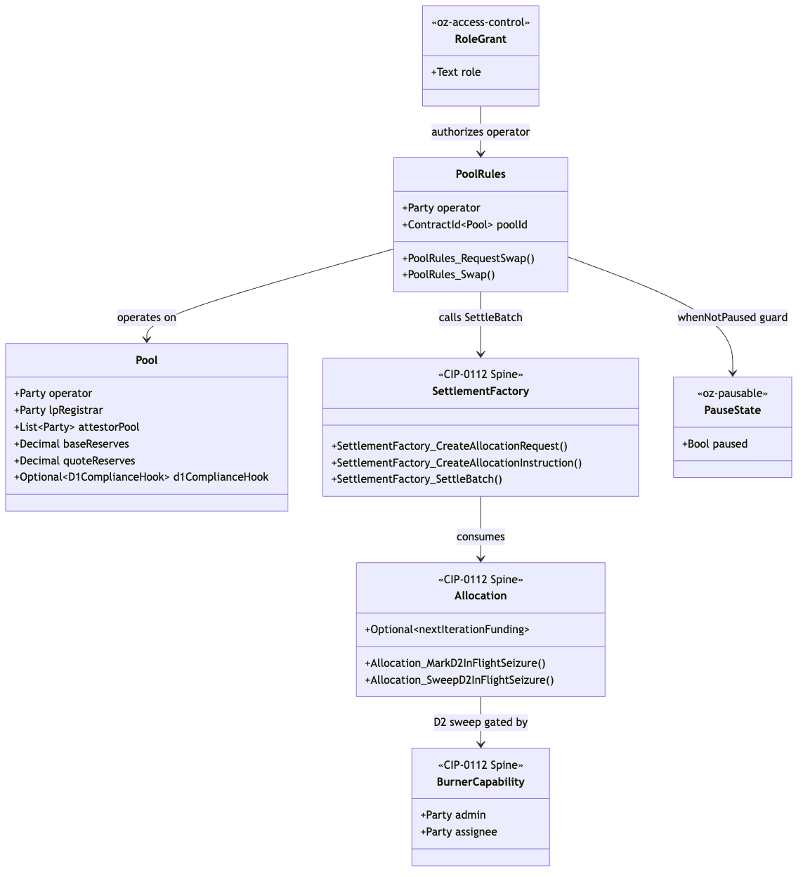{width=6.3in}

5.2 Flow-of-Funds Settlement Diagram (Privacy DEX Preset)
Demonstrates per-authorizer allocation requests and atomic co-settlement via SettlementFactory_SettleBatch. The privacy boundary: the trader sees their allocation and receipt, not the backend pool routing or attestor verification.
Diagram 2 (rendered locally; editable Mermaid source in the canonical 01-dex.md).
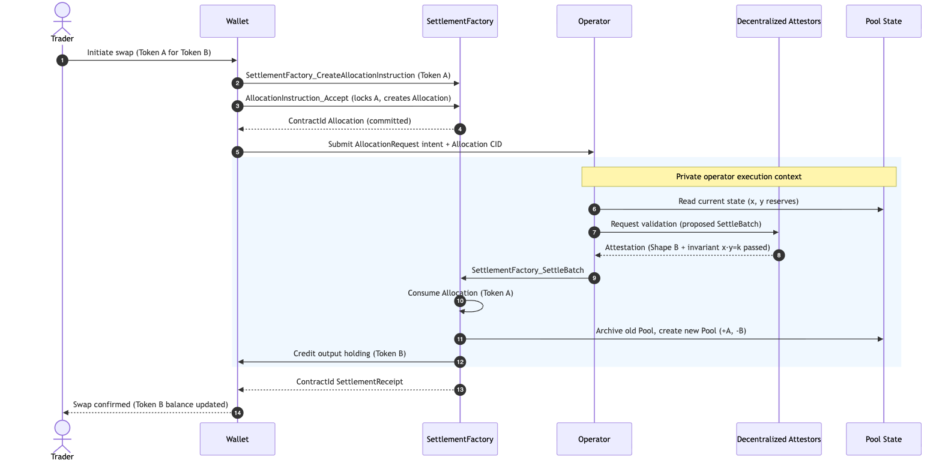{width=6.3in}

6. Library Dependencies

6.1 Internal Dependencies
Internal Package | Consumed Templates / Types | Application Context | Tag
oz-access-control | RoleGrant, RoleAdmin, DefaultAdminTransferOffer, requireRole | D4 single-admin authority and role administration. | [IMPLEMENTED]
oz-ownable | Ownership, OwnershipOffer | Lifecycle management and two-step transfer of protocol ownership. | [IMPLEMENTED]
oz-pausable | PauseState, whenNotPaused | Emergency circuit breaker in PoolRules. | [IMPLEMENTED]
OpenZeppelin.Experimental.Settlement.Cip112 | SettlementFactory, AllocationRequest, AllocationInstruction, Allocation, SettlementReceipt, ToyHolding, BurnerCapability, D1ComplianceHook, D2SeizureHook | The shared settlement engine. | [IMPLEMENTED] (experimental)
canton-token-template | SimpleHolding, LockedSimpleHolding, SimpleTokenRules, TransferPreapproval, *_ForcedBurn | Underlying token logic and forced-burn/seizure evidence. | [EVIDENCE]
canton-stablecoin | VaultFactory, PriceOracle | Baseline for future stable-pool extensions and slippage circuit-breaker price feeds. | [EVIDENCE]
zk-credential-gateway | CredentialGatedActionRequest, MockVerificationResult, MockVerifierAuthorization | D1/D3 credential gating and verification. | [EVIDENCE]
canton-specs identity-hook experiment | KycClaim, TrustedIssuerRegistry | Typed D3 Shape-B identity, layered via SCU. | [IMPLEMENTED] (experimental)

6.2 External Dependencies
The architecture operates against the Splice Token Standard V2 interfaces for interoperability [UPSTREAM].
- Present implementation: local mocks / stand-ins designed to maximally match the Splice V2 standard interfaces. Source-of-record pin: hyperledger-labs/splice @ token-standard-v2-upcoming @ 1e34121b… (the literal canton-network/splice @ token-standard-v2-daml-preview @ b91de5d4… "preview" branch is demoted to historical evidence; its V2 DAR set and checksums are catalogued in canton-token-template/docs/CIP-0112-EXTENSION-PLAN.md). This is the workspace-standing decision (RI_RESEARCH_BRIEFING.md): design against interfaces, not DAR/package-ID pins. The RI interfaces directly against the OpenZeppelin.Experimental.Settlement.Cip112 spine.
- Planned migration: once published Splice Token Standard V2 DARs ship and the import gate is cleared (PLAN.md; M2_DEX_SCOPE.md §A), the local stand-ins are swapped for the published DARs. Interface-based design is intended to make this a thin substitution. Note: import remains gated; this report makes no public-API stability, conformance, or release-readiness claim.

7. Security & Auditability
The RI prioritizes verifiable security. Simplicity over complexity minimizes the surface for logic exploits, and Canton's per-party projections create natural containment boundaries.

7.1 Security Invariants
- Non-custodial venue (no unilateral execution). The venue operator never holds custody of, nor any unilateral right to move, trader funds. The trader is the sole party cryptographically able to lock their own holding (via AllocationInstruction_Accept), and the operator can only drive SettlementFactory_SettleBatch over the exact committed Allocation and the trader's own AllocationRequest (min-output bound) — it cannot deviate from the authorized leg, fabricate a transfer the trader did not commit, or indefinitely freeze a trader's own holding (the trader can always settle or reclaim it independently). This is Daml's non-transitive authorization model: a choice authorizes only its declared consequences. It is the property that keeps the reference venue a settlement/matching layer rather than a custodial intermediary, and it is what extraTransferLegSides pinning and the attestorPool co-signature jointly enforce.
- AMM Conservation (x · y = k). After a swap (minus applied fees), the product of base and quote reserves must be >= the product before the swap: (baseReserves + Δin · (1 − feeBps/10000)) · (quoteReserves − Δout) ≥ baseReserves · quoteReserves. Enforced in PoolRules_Swap and verified off-ledger by the attestor pool before signature.
- Funding Conservation (nextIterationFunding). Essential for prefunded orders and the CLOB parameterization. The settlement implementation guarantees the per-instrument net outflow from an authorizer never exceeds nextIterationFunding, and extraTransferLegSides blocks smuggling unrelated transfer legs into an authorizer's allocation — preventing liquidity-drain attacks.

7.2 The Validation Ladder
The Daml code is run through a three-tier validation ladder. (Tooling exists in the workspace; the latency figures below are illustrative, not benchmarked.)
Tier | Tooling | Purpose and Scope
Level 1: Static analysis | daml-lint | AST checks: decimal bounds, unguarded division, positivity, archive-before-execute, anti-patterns, naming conventions.
Level 2: Generative testing | daml-props | Property-based testing with shrinking: thousands of fuzzed state transitions to ensure conservation/supply/balance invariants hold under extreme inputs.
Level 3: Formal verification | daml-verify | Z3-backed proofs (conservation C1–C3, division-safety D1–D3, temporal T1–T3): proves unauthorized transitions (e.g. swapping while paused, or bypassing a D1 hook) are logically impossible within the contract graph.

7.3 Threat Model and Failure Modes
Vector | Attack | Mitigation
Malicious operator state manipulation | Operator submits a SettleBatch favoring their own holdings, bypassing the price curve or extracting excessive slippage. | attestorPool signatories on Pool block the transition. Without their Shape-B attestation that the math is sound, the transaction fails Canton consensus at the synchronizer level.
Compliance evasion (D1) | A sanctioned user routes through a secondary contract to obscure origin and bypass the D1ComplianceHook. | Shape-B compliance evaluates the true fund origin at the SettleBatch layer; fail-closed. Without a fresh, valid MockVerificationResult signed by a compliance node, the batch is invalid.
Rogue seizure / asset burning (D2) | A compromised admin key attempts to maliciously burn user assets or return seized funds to unverified actors. | Allocation_SweepD2InFlightSeizure hardcodes the destination to the preset custodianDestination; arbitrary burn is forbidden. A compromised admin can only sweep to the pre-approved, monitored custodian.
Forced upgrades breaking in-flight allocations (SCU) | A poorly executed upgrade mutates fields, rendering existing Allocation contracts un-settleable. | Programmatic adherence to the SCU rule (Optional appends + new choices only). Existing PoolRules stay operable; in-flight transactions conclude before users transition.

8. Cross-Synchronizer Domain Extension (Planned) [FUTURE]
Shared model: the cross-synchronizer mechanism (per-synchronizer assignment + unassign/assign reassignment, and the SCU-compliant additive path) is identical across all four RIs and is owned in 00-portfolio.md §5. This section elaborates only the RI-specific topology.
Status: out of scope for the initial M1 design; deferred and planned for eventual development. The CIP-0112 settlement scaffold in this workspace is single-synchronizer only — there is no cross-domain / multi-synchronizer machinery today, and D3 cross-domain identity is deferred (PLAN.md Decision Log, AGENTS.md §Decision Authority). This section plans the extension so it can be added later without re-architecting the settlement core, following Canton's real cross-synchronizer model and the SCU forward-compatibility rule.

8.1 What "cross-synchronizer" means on Canton
On Canton, every contract is assigned to exactly one synchronizer domain at a time; a transaction can only use contracts on the same synchronizer. Moving a contract between synchronizers is done by the reassignment protocol (unassign on the source synchronizer → assign on the target), not by mutation. A cross-synchronizer DEX therefore is not "one global pool seen everywhere"; it is a set of per-synchronizer contracts plus a disciplined reassignment workflow that preserves atomicity and privacy across domains.
This is the topology-layer analogue of the per-party projection mindset shift in §1: just as privacy is a function of who is a signatory/observer, cross-domain reach is a function of which synchronizer each contract is assigned to and how it is reassigned.

8.2 Where the DEX touches the synchronizer boundary
Element | Single-domain v1 (today) | Cross-synchronizer extension (planned)
Pool state | One Pool on one synchronizer; attestorPool nodes all reachable there. | The Pool stays on a home synchronizer; cross-domain swaps reassign the trader's Allocation to the home synchronizer for the duration of SettleBatch, then reassign change/output back.
Allocation / AllocationInstruction | Created and settled on the same synchronizer as the Pool. | Must become reassignable: created on the trader's home synchronizer, unassigned, and assigned to the pool's synchronizer before SettleBatch.
attestorPool consensus | All attestor parties hosted on the pool's synchronizer. | Attestor set must be reachable on the synchronizer where settlement occurs; cross-domain pools imply per-synchronizer attestor membership and a reassignment-aware threshold.
D1 compliance | Node-side check on the settlement synchronizer. | Compliance must be re-evaluated on the synchronizer where the leg actually settles; a leg cannot "carry" a stale attestation across a reassignment (fail-closed still holds).
D3 identity | Single-domain KycClaim from a trusted issuer on one synchronizer. | Cross-domain identity (ONCHAINID / ERC-3643 / Chainlink CCID) resolved into a synchronizer-aware TrustedIssuerRegistry; this is the deferred D3 work.

8.3 The additive, non-breaking path (SCU-compliant)
Following the non-negotiable SCU rule (never mutate an existing choice's args; extend via Optional appends, new serializable types, and new choices):
- Append an Optional home-synchronizer descriptor. Add Optional SynchronizerScope fields to Pool and the RI-level allocation wrappers. Older single-domain contracts read None and behave exactly as today.
- Add a new, parallel cross-domain choice. Introduce PoolRules_SwapCrossDomain alongside the unchanged PoolRules_Swap. The new choice orchestrates the reassignment-aware flow; the original stays valid for single-domain swaps and in-flight allocations.
- Model reassignment explicitly as workflow, not mutation. Cross-domain settlement is: reassign trader Allocation to the pool synchronizer → SettleBatch there → reassign output/change holdings back. Each step is an archive-and-recreate-style assignment, consistent with Daml-LF 2.1.
- Keep atomicity at the batch boundary. True DvP remains SettlementFactory_SettleBatch on a single synchronizer; cross-domain atomicity is achieved by reassigning all required legs onto that synchronizer before the batch, never by splitting one DvP across two synchronizers.

8.4 Open questions specific to cross-synchronizer operation
- Reassignment atomicity vs. settlement atomicity. What is the failure model if an Allocation is assigned to the pool synchronizer but SettleBatch then fails — is the reassignment rolled back, or does the trader retain a re-home-able allocation? (Maps to the transfer-failure return-to-sender rule.)
- Attestor pool across synchronizers. How is attestor membership and the signing threshold defined when settlement can occur on more than one synchronizer? Does each synchronizer carry its own attestor sub-pool?
- Cross-domain D1 freshness. Confirm that compliance is always re-checked on the settling synchronizer and that no attestation is reused across a reassignment boundary.
- Tooling maturity. Cross-synchronizer reassignment tooling is part of the evolving Canton/Digital Asset stack; this section assumes drop-in integration as that tooling matures (consistent with the §2 attestor-pool assumption).

9. Open Questions
- Node rotation in the attestor pool. attestorPool : [Party] is currently a static array. Dynamic add/remove of attestor nodes — slashing conditions for malicious attestations and threshold/multi-signature requirements for membership changes — needs definition, dependent on forthcoming governance tooling.
- Cross-domain identity resolution. The architecture supports single-domain v1 identity with forward compatibility (D3). The off-ledger resolution mechanics for syncing external ONCHAINID / ERC-3643 attributes into the Canton TrustedIssuerRegistry remain to be standardized (see §8).
- D1 attestation shape. Whether the contract stays oblivious (off-ledger gate) or verifies a signed node attestation on-ledger at exercise time is open (PLAN.md Open Questions); non-blocking via the optional hook + SCU path.
- Dynamic fee hooks. The current feeBps is static. Volatility-adjusted fee hooks (using PriceOracle deviation metrics) are feasible within the SCU framework but require modeling to avoid latency-arbitrage vectors and oracle congestion of the settlement spine.
- LP token force-upgrade semantics. Active holdings upgrade-on-use during factory routing, but passive LP tokens held idly do not trigger an upgrade cycle. The threshold criteria and off-ledger events for an issuer to invoke a force-upgrade on passive assets remain an operational policy decision for the CANTON_LP_REGISTRAR.
- Composability with the other RIs (forward-compatibility; suite view 00-portfolio.md §3): DEX pools can be seeded with base/quote liquidity from cross-chain stablecoin inflows settled via the Stablecoin RI (03), and the DEX is the secondary market for tokens distributed by the Auction RI (04) — both over the same SettlementFactory_SettleBatch spine, with no parallel settlement path.

References
All interface, template, choice, and field names in this report are grounded in real source in this workspace (verified 2026-06-24). Authoritative sources:
- Settlement spine [IMPLEMENTED] — canton-specs/experiments/cip112-settlement/daml/OpenZeppelin/Experimental/Settlement/Cip112.daml (mirrored byte-identically in canton-contracts/experiments/cip112-settlement/).
- AL-7 primitives [IMPLEMENTED] — canton-specs access-control/, ownable/, pausable/ (OpenZeppelin.AccessControl, OpenZeppelin.Ownable, OpenZeppelin.Pausable).
- Holdings / forced-burn / rules / preapproval [EVIDENCE] — canton-token-template/simple-token/daml/SimpleToken/{Holding,Rules,Preapproval}.daml.
- Vault / oracle [EVIDENCE] — canton-stablecoin/stablecoin/daml/Stablecoin/{Vault,Oracle}.daml.
- Credential gating / verification [EVIDENCE] — zk-credential-gateway/daml/src/ZkCredentialGateway/{GatedAction,Verification,Types}.daml.
- Typed D3 identity (KycClaim, TrustedIssuerRegistry) [IMPLEMENTED] — canton-specs/experiments/identity-hook-shape-b/ and identity-hook-upgrade-*/.
- Decision authority (D1–D4), scope, SCU rule — root PLAN.md (Decision Log) and AGENTS.md (§Decision Authority); briefing in docs/research/RI_RESEARCH_BRIEFING.md.
- Grant scope / milestones / deliverables (source of truth) — docs/research/canton-ecosystem-grant-proposal.md (PR #298, approved; CIP-56→CIP-0112 retarget) and the distilled M2_DEX_SCOPE.md.
- Existing RI/settlement architecture spec — canton-specs/docs/architecture/cip0112-m1-ri-spec.md.
- Diagram tooling [IMPLEMENTED] — canton-settlement-explorer (presets: Privacy DEX, Batch DvP, Multi-leg Settlement).
- Validation ladder [IMPLEMENTED] — daml-lint, daml-props, daml-verify.
- Token Standard V2 upstream [UPSTREAM] — hyperledger-labs/splice token-standard-v2-upcoming (source-evidence pin; import gated per PLAN.md).
- BitSafe cBTC node-side capability [UPSTREAM] — cited as ecosystem precedent for node-side attestation; not vendored here.
Removed in review: the original draft cited external/non-workspace URLs (a srikanth-bitdynamics/Canton-Dex-Reference-Implementation GitHub repo, Medium ecosystem round-ups, and a CoinStats "fundamental analysis" page) as authoritative sources. None are part of this workspace or an authoritative spec; they were removed and replaced with the workspace-grounded references above. See the review record in ../reviews/2026-06-24T21-54-54Z_REVIEW.md.
Re-review 2026-06-24 (expert "blueprint" pass): a second expert draft (a US-financial-regulation-framed blueprint) was assessed against this report. Its verifiable signal — the non-custodial / no-unilateral-execution property (§7.1), an institutional maker-checker extension (§3), and the Daml-3.x retroactive-interface-instance removal (§3) — was integrated. Its non-verifiable content was rejected: an order-book-first reframe and the fabricated templates Market / Order / MatchedPair / OraclePrice (contradicts the grant's AMM-lead / CLOB-as-parameterization framing); fabricated MakerChecker / GiveProposed choices; FROST signatures (absent from the workspace); ComplianceRegistry / BlacklistValidator / ClaimsValidator; "Lock by State / Lock by Archiving" terminology (the real mechanism is archive-and-recreate, already described); and the entire OCC / Espinoza / FDICIA / SOX citation set with its external "Works cited" URLs (non-workspace, non-spec — house conventions bar them). Record: ../reviews/2026-06-24T23-29-57Z_REVIEW.md.

CONFIDENTIAL — OpenZeppelin internal · non-public reference design · not for external distribution

Architectural Overview Report: Institutional Lending Protocol on Canton
Status: reviewed reference-design report, non-public, outside the committed M1 public-library surface. This is RI #2 of four — see the suite-level view in 00-portfolio.md and the index README.md. It describes a reference design grounded in the real OpenZeppelin Canton components in this workspace; it is not a claim of M1/M3 acceptance, conformance, audit readiness, or production readiness.
Google Docs import: File → Open this .md in Docs (or paste with Edit → Paste). H1/H2/H3 headings drive the Docs outline pane; the tables import cleanly; apply a monospace paragraph style to fenced code blocks after import. Mermaid blocks do not render in Docs — render them with canton-settlement-explorer and paste the image, keeping the fenced source.
Source-grounding tags (used throughout): [IMPLEMENTED] real code in the M1 library base (canton-specs / canton-contracts) · [EVIDENCE] real code in an evidence repo (canton-token-template, canton-stablecoin, zk-credential-gateway), not the M1 surface · [UPSTREAM] Splice / CIP reference, not vendored here · [FUTURE] proposed RI-level design, not built in M1 scope.
Design priority order governs every interface and snippet, in this exact order: 1) Readability → 2) Simplicity → 3) Security → 4) Auditability.
Grant alignment (source of truth: ../research/canton-ecosystem-grant-proposal.md, scope lock: ../../M3_LENDING_SCOPE.md): this is RI #2 (Lending Protocol). This document is the Architecture Documentation deliverable, authored in grant M1 (research & design) for the Lending implementation in grant M3 (Q3 2026). Its companion deliverables — working reference code, demo front-end, threat model, and (where relevant) an FI evaluation guide — are named here but delivered in M3 (MIT-licensed). The report honors the CIP-56 → CIP-0112 / Token Standard V2 retarget: settlement builds only on V2 abstractions.

1. Product Definition
This Reference Implementation (RI) is a fixed-rate, overcollateralized, permissioned lending protocol designed for the Canton Network. It is a blueprint for regulated DeFi lending workflows built around the Vault — an isolated collateralized debt position (CDP) mapped onto Canton's privacy and settlement primitives.
The architecture adapts the canton-stablecoin codebase [EVIDENCE] and wires it onto the CIP-0112 / Token Standard V2 settlement spine [IMPLEMENTED] (OpenZeppelin.Experimental.Settlement.Cip112). It embeds credential gating via zk-credential-gateway [EVIDENCE] and capability-based access control via oz-access-control [IMPLEMENTED], combining DeFi composability with institutional compliance prerequisites. The target utility is tokenized treasury operations, collateral mobility, and stablecoin issuance for institutional actors who require deterministic outcomes with operational privacy.

Educational Framing: Contract-per-Vault vs. Share-Accounting
Canton's structural paradigm diverges sharply from Ethereum's ERC-4626. Under ERC-4626, a single globally visible contract manages pooled liquidity, debt shares, and dynamic interest accrual for all participants — a monolithic state that broadcasts every participant's collateral balance and liquidation threshold publicly.
Canton operates on a UTXO-like model driven by Daml. The vault-as-contract model deploys a discrete, isolated Vault contract for each borrower-issuer relationship. This enforces Canton's per-party-projection privacy: a borrower's collateral, debt, and liquidation threshold are concealed from the broader network — observable only to the borrower, the vault issuer, and any regulatory nodes explicitly placed in the contract's observer set. Replacing dynamic, algorithmic rate curves with fixed-rate, term-locked parameters radically simplifies auditability and yields a predictable primitive that is verifiable by formal methods, avoiding the exploit vectors of utilization-based rate curves.
This is a deliberate departure from OpenZeppelin's own ERC-4626 tokenized-vault lineage (which the grant cites as cross-ecosystem experience): a share-accounting vault — one contract tracking a pooled underlying-to-share exchange rate, updated by a UpdateSharePrice-style choice — is an EVM-shaped pattern, not a Canton-idiomatic one, and it would broadcast pooled positions. The reference design is also explicitly keyless: there is no (operator, vaultId)-keyed VaultState / VaultConfig singleton resolved by fetchByKey. Daml-LF 2.1 has no contract keys; configuration (VaultParams) and state (Vault) are separate contracts referenced by ContractId, and every state change is archive-and-recreate. Routing the protocol through pooled shares or contract-key lookups would break both the per-borrower privacy model and the keyless settlement semantics the spine depends on.

Scope Definition
The bias favors simplicity, modular extensibility, and a demonstrably correct core over feature complexity.
Capability Domain | IN SCOPE (Reference design) | OUT OF SCOPE (Excluded)
Interest Model | Fixed-rate, fixed-term lending. stabilityFeeRate is an immutable, term-locked parameter in VaultParams. | Dynamic / variable / algorithmic rates, utilization rate curves, floating-rate oracles.
Collateralization | Overcollateralized borrowing against on-ledger assets; collateral deposit, withdrawal, debt repayment. | Undercollateralized loans, flash loans, recursive leverage, rehypothecation.
Liquidation | Vault_Liquidate on undercollateralization — fixed-discount collateral seizure with a fixed liquidationBonus. | Dynamic liquidation auctions, fractional liquidations, market-driven bidding wars.
Settlement | Atomic DvP only via SettlementFactory_SettleBatch. | Direct un-batched Allocation_Settle for co-settlement.
Pricing | PriceOracle mapping a single collateral asset to debt units for solvency thresholds. | Multi-asset dynamic oracles, external off-chain TWAP aggregators.
Identity & Compliance | D1 Shape B (signed node attestation) using KycClaim + TrustedIssuerRegistry; credential gating via zk-credential-gateway. | Cross-domain identity aggregation (ERC-3643, ONCHAINID, Chainlink CCID) — deferred, SCU-forward-compatible only.
Authority & Access | Single-admin capability (oz-access-control) for mint/burn/seizure/handoff. Multi-party attestation is a named M3 extension. | On-ledger multi-sig / DAO execution.

Target Users
Institutional asset managers, tokenized-fund issuers, and regulated stablecoin operators that need high-value collateralized transactions, robust risk parameters, and integration with compliance registries over decentralized, resilient rails — without public data leakage.

2. Architecture Overview
The protocol decomposes into modular Daml templates mapped to life-cycle stages, with strict role-based access control and a clean separation across collateral custody, debt issuance, economic parameterization, and liquidation.

System Components and Library Integration
Component | Library Origin | Responsibility | Tag
VaultParams | canton-stablecoin | Immutable risk config: minCollateralRatio, liquidationRatio, liquidationBonus, fixed stabilityFeeRate. | [EVIDENCE]
VaultFactory | canton-stablecoin | Vault creation entry point (VaultFactory_OpenVault); the RI layers an initial compliance check before opening. | [EVIDENCE]
Vault | canton-stablecoin | Stateful CDP: collateralAmount, debtAmount, params, lastAccrualTime; choices Vault_DepositCollateral, Vault_WithdrawCollateral, Vault_MintStablecoin, Vault_BurnStablecoin, Vault_Liquidate, Vault_Close; helpers accrueDebt, collateralRatio. | [EVIDENCE]
PriceOracle | canton-stablecoin | Trusted feed: collateralInstrumentId, price, updatedAt, observers; updated via PriceOracle_UpdatePrice. | [EVIDENCE]
SettlementFactory | OpenZeppelin.Experimental.Settlement.Cip112 | Atomic multi-leg settlement: SettlementFactory_CreateAllocationRequest, …_CreateAllocationInstruction, …_SettleBatch. | [IMPLEMENTED]
Role management | oz-access-control | RoleGrant, RoleAdmin, requireRole; roleId : MyRole -> Text closed-sum wrapper prevents string-matching role collisions. | [IMPLEMENTED]
Admin flow | oz-ownable / oz-pausable | Ownership/OwnershipOffer for handoff; PauseState/whenNotPaused kill-switch. | [IMPLEMENTED]
Credentials | zk-credential-gateway | CredentialGatedActionRequest, MockVerificationResult, MockVerifierAuthorization, CredentialRevocationStatus for KYC gating. | [EVIDENCE]
Typed D3 identity | canton-specs identity-hook Shape-B | KycClaim, TrustedIssuerRegistry — the forward-compatible D3 shape, layered via SCU. | [IMPLEMENTED] (experimental)
Attribution note: KycClaim and TrustedIssuerRegistry are the typed D3 identity Shape-B types demonstrated in the canton-specs identity-hook-shape-b / identity-hook-upgrade experiments, not templates inside zk-credential-gateway. The gateway supplies the gating/verification primitives; the typed KYC claim shape is the forward-compatible target.

Party and Role Model
Data visibility is bounded by contract participation (signatory/observer).
- Admin / Issuer — primary underwriter of the stablecoin and debt tokens. Assigned via RoleAdmin; holds the BurnerCapability and configures the TrustedIssuerRegistry. Guarantor of economic integrity.
- Borrower — institutional entity locking collateral. Must present a valid MockVerificationResult derived from a KycClaim to interact with the VaultFactory. Visibility limited to their own Vaults and public config.
- Liquidator — specialized role granted via oz-access-control. Runs off-ledger monitoring of PriceOracle and vault solvency; authorized to exercise Vault_Liquidate on a breach.
- Oracle Provider — authorized via a specific RoleGrant to call PriceOracle_UpdatePrice. Tightly guarded given oracle-manipulation risk.

Trust and Topology
The topology separates public market data from private positions. PriceOracle and VaultParams are highly visible (signatory admin, broad observer set), so participants can independently verify the governing parameters. The Vault minimizes its observer set — admin, the specific borrower, and designated regulatory nodes only. Because Canton applies transaction execution at the hosting participant node, compliance checks run locally, fail-closed, on every settlement leg before global finalization — no external API calls, no caching.
M1 uses single-admin capability authority for mint/burn/seizure. The architecture anticipates Multi-Party Attestation as a named M3 extension: a vault issuer that is multiply attested, where several independent attestors hold distinct MockVerifierAuthorization roles and a vault is compliant only when the required attestors' credentials overlap — decentralizing the trust anchor without an on-ledger multi-sig execution bottleneck.

3. How We Implement It
The CDP model is expressed as a sequence of atomic Canton transactions under Daml-LF 2.1 keyless semantics: every state change archives the prior contract and recreates an updated instance with a new Contract ID.

The Settlement-Spine Flow
All value transfers to/from the Vault route through SettlementFactory_SettleBatch for atomic DvP. The direct Allocation_Settle path is not used for DvP — it proves authorization of a single leg, not atomic co-settlement of interdependent legs.
- Vault origination + collateral deposit. The borrower creates an AllocationInstruction (via SettlementFactory_CreateAllocationInstruction, accepted to lock the collateral into an Allocation) and presents a CredentialGatedActionRequest + MockVerificationResult to the VaultFactory. On successful compliance verification, VaultFactory_OpenVault batch-settles the collateral into custody and instantiates the Vault with a verified collateralAmount. (Subsequent top-ups use Vault_DepositCollateral; reductions use Vault_WithdrawCollateral, both solvency-checked.)
- Borrow (debt disbursement). The borrower exercises Vault_MintStablecoin. The vault runs a deterministic solvency check — requested debt plus existing debt must keep collateralRatio at or above VaultParams.minCollateralRatio priced by PriceOracle. On success the admin mints stablecoin holdings delivered to the borrower via a SettleBatch leg; the old Vault is archived and recreated with the updated debtAmount.
- Repay. The borrower allocates debt tokens and exercises Vault_BurnStablecoin; a batch settlement transfers the debt tokens to the admin (burned via BurnerCapability) and reduces debtAmount. Collateral is released proportionally via Vault_WithdrawCollateral when the loan closes (Vault_Close).
- Liquidation. If PriceOracle shows the vault below liquidationRatio, an authorized liquidator exercises Vault_Liquidate, providing an Allocation of stablecoin covering the debt plus the liquidationBonus. SettleBatch atomically burns the liquidator's debt tokens, clears the position, and sweeps the collateral to the liquidator; any residual collateral is recreated in a new Vault for the borrower.

D1–D4 Attachment Strategy
- D1 — compliance (node-applied). Checked on every leg. The RI selects Shape B (signed node attestation) over Shape A (off-ledger gate): a KycClaim from a TrustedIssuerRegistry is submitted as a native contract payload, so the engine enforces compliance deterministically at the participant node with no external calls. A CredentialRevocationStatus of revoked triggers fail-closed rejection via the optional D1ComplianceHook. (Open, non-blocking: whether the contract stays oblivious or verifies the attestation on-ledger at exercise time.)
- D2 — seizure (lock-and-sweep). Under legal mandate the admin sweeps collateral to an admin-preset custodianDestination (carried in the spine's D2SeizureHook config record), gated by the single-admin BurnerCapability. In-flight allocations use the real spine choices Allocation_MarkD2InFlightSeizure → Allocation_SweepD2InFlightSeizure; locked vault collateral uses the forced-burn-to-custodian path (LockedSimpleHolding_ForcedBurn evidence). Seized assets are never burned and never returned to sender; ordinary transfer failures do return to sender.
- D3 — identity. Single-domain v1 with issuer-held KYC. Cross-domain (ERC-3643 / ONCHAINID / Chainlink CCID) deferred but forward-compatible via additive SCU.
- D4 — authority. Single-admin capability via oz-access-control (RoleAdmin) for pause, parameter updates, and seizure. On-ledger multi-sig is an M3 extension.

The SCU Extension Story
The SCU rule: never mutate an existing choice's arguments to require a new field. Extend via appended Optional fields, new serializable types, and new choices. New interfaces are likewise added by new templates/choices implementing them, not by retroactively re-instancing the deployed Vault — Daml 3.x removed retroactive interface instances [UPSTREAM] precisely because they broke clean upgrade paths.
Example — adding a cross-chain identity hash for future regulation: the Vault template gains crossDomainIdentity : Optional Text (read None by older contracts), and a new choice Vault_UpdateIdentity records it. The existing Vault_MintStablecoin / Vault_BurnStablecoin choices keep their type signatures untouched, so older clients keep working — compliance is layered over time without a network-wide breaking upgrade. This is the same additive path proven in the canton-specs identity-hook upgrade spike.

4. Interfaces & Usage Examples
Interfaces are prioritized by Readability, Simplicity, Security, Auditability. RI-level templates that adapt or extend canton-stablecoin are tagged [FUTURE]; field/choice names match real canton-stablecoin source.

4.1 Role wrappers [FUTURE]
module Lending.Types where
import OpenZeppelin.AccessControl (RoleGrant)
-- Closed-sum wrapper: precise role ids, no raw-string matching.
data VaultRole = VaultAdmin | Liquidator | OracleProvider | Pauser
deriving (Eq, Show)
roleId : VaultRole -> Text
roleId VaultAdmin = "VAULT_ADMIN"
roleId Liquidator = "LIQUIDATOR"
roleId OracleProvider = "ORACLE_PROVIDER"
roleId Pauser = "PAUSER"

4.2 Configuration and pricing [EVIDENCE] (canton-stablecoin shapes)
-- Real canton-stablecoin shapes (field names exact); shown for grounding.
template VaultParams
with
admin : Party
collateralInstrumentId : Text
stablecoinInstrumentId : Text
minCollateralRatio : Decimal -- e.g. 1.50 (150%)
liquidationRatio : Decimal -- triggers Vault_Liquidate below this
liquidationBonus : Decimal -- fixed-discount penalty, e.g. 0.10
stabilityFeeRate : Decimal -- FIXED, term-locked (no variable accrual)
where
signatory admin
observer admin -- extendable to public observers
template PriceOracle
with
admin : Party
collateralInstrumentId : Text
price : Decimal -- collateral valued in stablecoin units
updatedAt : Time
observers : [Party]
where
signatory admin
observer observers
-- choice PriceOracle_UpdatePrice (controller admin / oracle-provider role)

4.3 Vault opening with identity gating [FUTURE] (RI adapter over VaultFactory_OpenVault)
module Lending.Vault where
import OpenZeppelin.Experimental.Settlement.Cip112 (SettlementFactory)
import ZkCredentialGateway.GatedAction (CredentialGatedActionRequest)
import ZkCredentialGateway.Verification (MockVerificationResult)
-- KycClaim / TrustedIssuerRegistry: canton-specs identity-hook Shape-B
import IdentityHook.ShapeB (KycClaim, TrustedIssuerRegistry)
template LendingVaultFactory
with
admin : Party
registryCid : ContractId TrustedIssuerRegistry
paramsCid : ContractId VaultParams
where
signatory admin
-- New RI choice wrapping the canton-stablecoin VaultFactory_OpenVault path.
nonconsuming choice LendingVaultFactory_OpenGatedVault : ContractId Vault
with
borrower : Party
complianceRequest : CredentialGatedActionRequest
verificationResult : MockVerificationResult
kycClaim : KycClaim
controller borrower -- two-step handshake: borrower co-authorizes
do
-- D1 Shape B: deterministic, node-applied validation (no external calls).
assertMsg "KYC issuer not trusted" (kycClaim.declaredIssuer == admin)
assertMsg "verification not accepted" (isAccepted verificationResult)
-- Delegate to the real factory choice to open the Vault.
-- exercise vaultFactoryCid VaultFactory_OpenVault with ..
create Vault with .. -- (canton-stablecoin Vault; see 4.4)

4.4 Liquidation + D2 seizure [FUTURE] (adapting Vault_Liquidate [EVIDENCE])
-- canton-stablecoin Vault fields (exact): admin, owner, collateralInstrumentId,
-- stablecoinInstrumentId, collateralAmount, debtAmount, params, lastAccrualTime.
-- Vault_Liquidate is a real choice; the RI routes its DvP through SettleBatch.
choice Vault_Liquidate_ViaSpine : (ContractId Vault, ContractId SettlementReceipt)
with
liquidator : Party
oracleCid : ContractId PriceOracle
settlementFactoryCid : ContractId SettlementFactory
debtAllocationId : ContractId Allocation -- liquidator's committed stablecoin
controller liquidator
do
params <- fetch paramsCid
oracle <- fetch oracleCid
-- Solvency: must be below liquidationRatio to liquidate.
let ratio = (collateralAmount * oracle.price) / debtAmount
assertMsg "vault is solvent" (ratio < params.liquidationRatio)
-- Atomic DvP: liquidator pays debt + liquidationBonus, receives collateral.
-- Atomicity is solely via SettlementFactory_SettleBatch.
receipt <- exercise settlementFactoryCid SettlementFactory_SettleBatch with
allocations = [debtAllocationId]
requests = [] -- collateral delivery leg(s) configured here
-- residual collateral recreated in a new Vault for the borrower.
newVault <- create this with debtAmount = 0.0
return (newVault, receipt)
-- D2 lock-and-sweep: NO bespoke "D2SeizureHook_Sweep" template — D2SeizureHook
-- is a spine config record (seizureCaseRef, custodianDestination,
-- inFlightHandlingStatus). Seizure is gated by BurnerCapability and routes to
-- the preset custodianDestination; never burn, never return-to-sender.

5. Diagrams
Mermaid below maps to scenarios validatable in canton-settlement-explorer (presets: Batch DvP, Multi-leg Settlement). Render externally for Docs.

5.1 Interface and Component Diagram
Diagram 1 (rendered locally; editable Mermaid source in the canonical 02-lending.md).
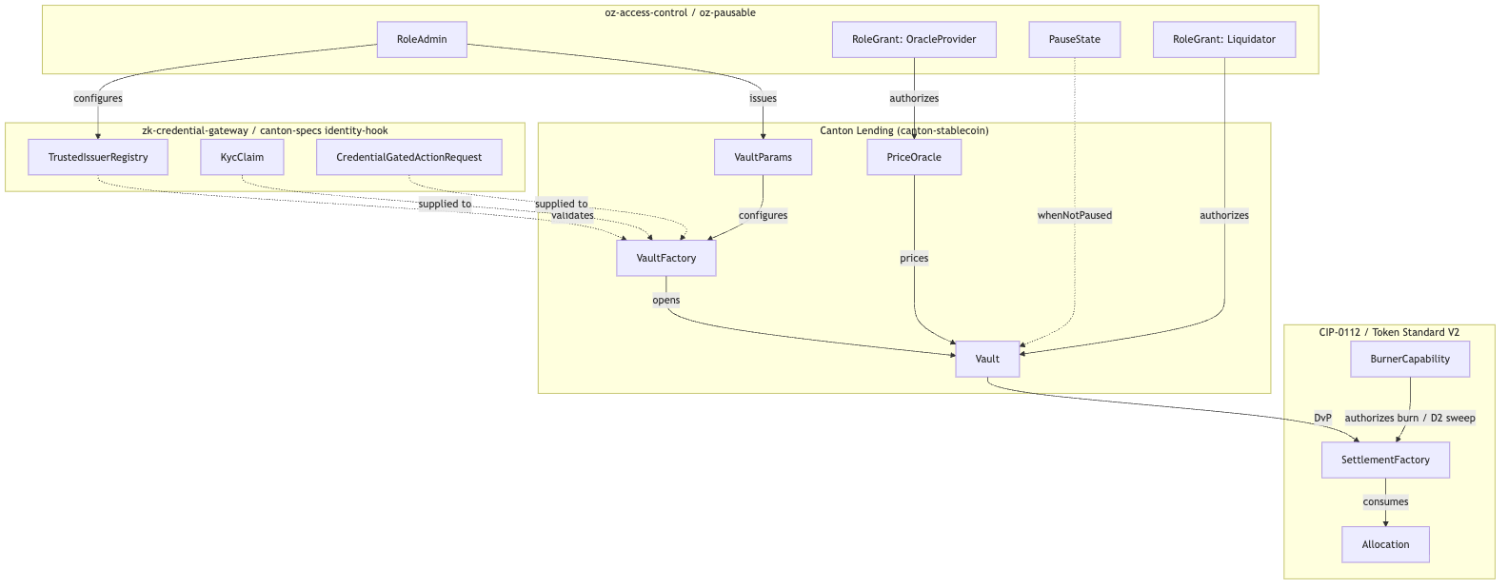{width=6.3in}

5.2 Flow-of-Funds and Settlement Diagram (Liquidation)
Diagram 2 (rendered locally; editable Mermaid source in the canonical 02-lending.md).
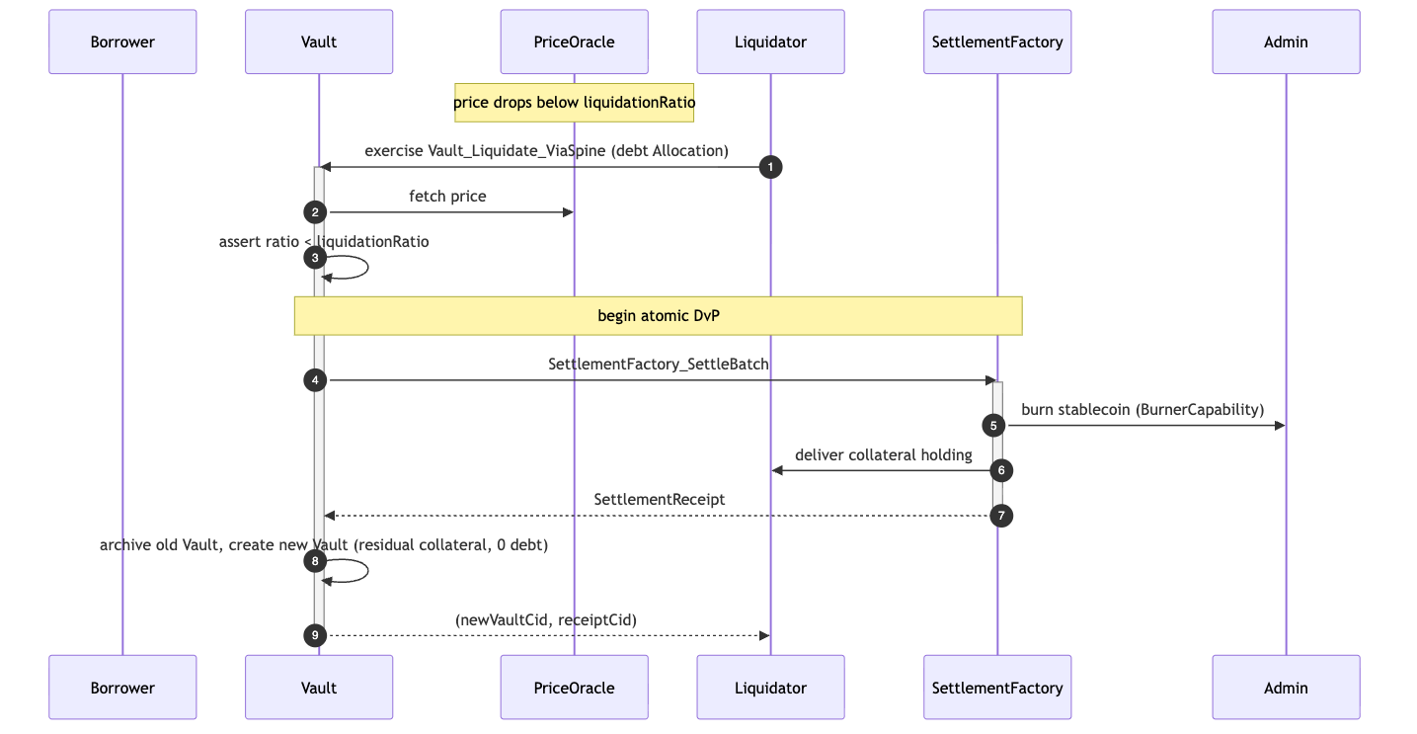{width=6.3in}

6. Library Dependencies

6.1 Internal Dependencies
Package | Consumed Templates / Primitives | Rationale | Tag
canton-token-template | SimpleHolding, LockedSimpleHolding, SimpleTokenRules, TransferPreapproval, *_ForcedBurn | Asset representation + forced-burn/seizure evidence (D2 collateral sweep). | [EVIDENCE]
canton-stablecoin | Vault, VaultFactory, VaultParams, PriceOracle, Vault_Liquidate | Core CDP mechanics — the lending operational logic. | [EVIDENCE]
oz-access-control | RoleGrant, RoleAdmin, DefaultAdminTransferOffer, requireRole | Capability-based authority and the party/role model. | [IMPLEMENTED]
oz-ownable | Ownership, OwnershipOffer | Administrative handoff between legal entities. | [IMPLEMENTED]
oz-pausable | PauseState, whenNotPaused | Emergency protocol freeze. | [IMPLEMENTED]
zk-credential-gateway | CredentialGatedActionRequest, MockVerificationResult, MockVerifierAuthorization, CredentialRevocationStatus | D1 compliance / KYC gating without on-chain data leakage. | [EVIDENCE]
OpenZeppelin.Experimental.Settlement.Cip112 | SettlementFactory, Allocation, AllocationInstruction, AllocationRequest, SettlementReceipt, BurnerCapability, D1ComplianceHook, D2SeizureHook | Atomic DvP spine; D1/D2 seams. | [IMPLEMENTED] (experimental)
canton-specs identity-hook Shape-B | KycClaim, TrustedIssuerRegistry | Typed D3 identity, layered via SCU. | [IMPLEMENTED] (experimental)

6.2 External Dependencies
The settlement mechanics rely on the Splice Token Standard V2 interfaces [UPSTREAM], superseding CIP-0056.
- Present implementation: local mocks/stand-ins designed to maximally match the Splice V2 standard interfaces. Source-of-record pin: hyperledger-labs/splice @ token-standard-v2-upcoming @ 1e34121b… (the literal canton-network/splice @ token-standard-v2-daml-preview @ b91de5d4… "preview" branch is demoted to historical evidence; its V2 DAR set and checksums are catalogued in canton-token-template/docs/CIP-0112-EXTENSION-PLAN.md). Design against interfaces, not DAR/package-ID pins (RI_RESEARCH_BRIEFING.md).
- Planned migration: once published Splice Token Standard V2 DARs ship and the import gate clears (PLAN.md; M3_LENDING_SCOPE.md §A), local stand-ins are swapped for the published DARs — intended as a thin substitution. Note: import remains gated; no public-API stability, conformance, or release-readiness claim.

7. Security & Auditability
Security relies on Daml ledger immutability, the absence of global state, and node-applied execution. The validation ladder spans static analysis, generative property testing, and formal proofs.

7.1 Security Invariants
- Solvency conservation. Collateral can never be withdrawn (or a borrow succeed) if it would push collateralRatio below VaultParams.minCollateralRatio; Vault_Liquidate is bounded by ratio < liquidationRatio.
- Debt conservation. Stablecoin minted on borrow equals debt recorded; debt burned on repay equals debt cleared. No unbacked issuance — minting requires the admin's authority and a solvency-passing vault.
- Settlement atomicity. Liquidation and repayment are single SettleBatch transactions: they either complete fully or revert — no partial liquidation.

7.2 The Validation Ladder
Tier | Tooling | Purpose and Scope
Level 1: Static analysis | daml-lint | Decimal bounds, unguarded division, positivity, archive-before-execute; verifies the roleId closed-sum wrapper and whenNotPaused guards on state-altering choices.
Level 2: Generative testing | daml-props | Property-based testing with shrinking: conservation/supply/balance invariants under fuzzed inputs; verifies unauthorized parties cannot reach admin functions (D4).
Level 3: Formal verification | daml-verify | Z3-backed proofs: collateral cannot be extracted below minCollateralRatio; Vault_Liquidate is bounded by the solvency assertion; pause/compliance bypass is impossible.
(Tooling exists in the workspace; no benchmark latencies are claimed.)

7.3 Threat Model and Failure Modes
Vector | Failure Mode | Mitigation
Oracle manipulation | PriceOracle manipulated or stalled → unjust liquidations or bad-debt accrual. | Updates restricted via oz-access-control RoleGrant to trusted providers; bound max price deviation per update and reject anomalous spikes.
Settlement-leg failure | Liquidator under-funds the batch → attempted partial/broken liquidation. | Daml atomicity: the SettleBatch reverts entirely; partial liquidation is impossible; collateral stays locked, no debt cleared.
Compliance evasion (D1) | Borrower attempts to bypass KYC. | Shape B requires a statically-provided KycClaim validated against the TrustedIssuerRegistry; a protected choice cannot execute without valid credentials in the payload (fail-closed).
Unauthorized admin action | Attacker tries to mint unbacked debt or invoke D2 seizure. | Requires a valid BurnerCapability / RoleAdmin contract id, unforgeable under Daml-LF semantics; D2 sweep is hardcoded to the preset custodianDestination.

8. Cross-Synchronizer Domain Extension (Planned) [FUTURE]
Shared model: the cross-synchronizer mechanism (per-synchronizer assignment + unassign/assign reassignment, and the SCU-compliant additive path) is identical across all four RIs and is owned in 00-portfolio.md §5. This section elaborates only the RI-specific topology.
Status: out of scope for the initial M1 design; deferred and planned for eventual development. Today the protocol and the CIP-0112 scaffold are single-synchronizer, and D3 cross-domain identity is deferred (PLAN.md Decision Log; AGENTS.md §Decision Authority). This section plans the extension following Canton's real cross-synchronizer model (per-synchronizer contract assignment + the unassign/assign reassignment protocol) and the SCU rule.

8.1 What "cross-synchronizer" means for a lending vault
Each contract is assigned to exactly one synchronizer; a transaction uses only contracts on the same synchronizer. A cross-synchronizer lending protocol is not one globally visible vault — it is per-synchronizer Vault, PriceOracle, and VaultParams contracts plus a disciplined reassignment workflow that preserves atomicity and privacy across domains.

8.2 Where the protocol touches the synchronizer boundary
Element | Single-domain v1 (today) | Cross-synchronizer extension (planned)
Vault | One vault on the home synchronizer. | Vault stays on its home synchronizer; cross-domain collateral is reassigned in for the settling transaction, then results reassigned back.
Collateral / debt Allocation | Created and settled on the vault's synchronizer. | Must be reassignable: collateral on the borrower's home synchronizer is unassigned, assigned to the vault's synchronizer before SettleBatch.
PriceOracle | One oracle per synchronizer. | Liquidation must price against the oracle on the settling synchronizer; no stale cross-domain price reuse.
D1 compliance | Node-side check on the settling synchronizer. | Re-evaluated on whichever synchronizer the leg settles; no attestation carried across a reassignment (fail-closed holds).
D3 identity | Single-domain KycClaim. | Cross-domain identity (ONCHAINID / ERC-3643 / CCID) resolved into a synchronizer-aware TrustedIssuerRegistry — the deferred D3 work.

8.3 The additive, non-breaking path (SCU-compliant)
- Append Optional SynchronizerScope to Vault / RI allocation wrappers; older contracts read None and behave as today.
- Add a new parallel choice (e.g. Vault_LiquidateCrossDomain) alongside the unchanged single-domain choice.
- Model reassignment as workflow, not mutation: reassign collateral/debt allocations onto the vault's synchronizer → SettleBatch there → reassign results back. Each step is an archive-and-recreate-style assignment.
- Keep atomicity at the batch boundary: true DvP stays a single SettleBatch on one synchronizer; cross-domain atomicity is achieved by reassigning all legs onto that synchronizer before the batch.

8.4 Open questions specific to cross-synchronizer operation
- Reassignment-vs-settlement atomicity: if collateral is assigned to the vault's synchronizer but SettleBatch then fails, is the reassignment rolled back, or does the borrower retain a re-home-able allocation? (Maps to return-to-sender.)
- Cross-domain liquidation: which synchronizer's PriceOracle and liquidator set govern a vault whose collateral lives on another synchronizer?
- Cross-domain D1 freshness: confirm compliance is re-checked on the settling synchronizer, never reused across a reassignment.
- Reassignment tooling maturity (evolving Canton/Digital Asset stack); assumes drop-in integration as it matures.

9. Open Questions
- Multi-party attestation scaling (M3). Multi-attestation can be expressed by stacking oz-access-control grants, but threshold mechanics (e.g. 2-of-3 compliance verifiers) are undecided: native in the VaultFactory vs an intermediary authorization contract (separation of concerns).
- Cross-domain identity sub-systems. When ERC-3643 / ONCHAINID are added via SCU, the on-chain mapping equating an external CCID with a Canton KycClaim needs formal specification.
- Iterated-settlement edge cases. If a borrower commits funds via nextIterationFunding but lets the time-lock expire without finalizing, how is the automated return orchestrated without manual admin intervention?
- Oracle update economics. PriceOracle has no inherent on-chain incentive; whether high-frequency updates need a fee carve-out from stabilityFeeRate to offset node-attestation costs is open.
- Cross-synchronizer operation (see §8) — deferred; tracked there until ecosystem reassignment tooling matures.
- Composability with the other RIs (forward-compatibility; suite view 00-portfolio.md §3): seized collateral from Vault_Liquidate could be routed to the Auction RI (04) for confidential fair-value recovery; conversely, a borrower can mint stablecoin here and bid in the Auction RI. Lending shares the vault / oracle / credential stack with the Stablecoin RI (03) — all over the shared SettlementFactory_SettleBatch spine.

References
All interface, template, choice, and field names are grounded in real source in this workspace (verified 2026-06-24). Authoritative sources:
- Vault / CDP / oracle [EVIDENCE] — canton-stablecoin/stablecoin/daml/Stablecoin/{Vault,Oracle}.daml (VaultParams, VaultFactory + VaultFactory_OpenVault, Vault + Vault_{DepositCollateral,WithdrawCollateral,MintStablecoin,BurnStablecoin,Liquidate,Close}, PriceOracle + PriceOracle_UpdatePrice).
- Settlement spine [IMPLEMENTED] — canton-specs/experiments/cip112-settlement/daml/OpenZeppelin/Experimental/Settlement/Cip112.daml.
- Holdings / forced-burn / rules / preapproval [EVIDENCE] — canton-token-template/simple-token/daml/SimpleToken/{Holding,Rules,Preapproval}.daml.
- Credential gating / verification [EVIDENCE] — zk-credential-gateway/daml/src/ZkCredentialGateway/{GatedAction,Verification,Types}.daml.
- Typed D3 identity (KycClaim, TrustedIssuerRegistry) [IMPLEMENTED] — canton-specs/experiments/identity-hook-shape-b/ and identity-hook-upgrade-*/.
- AL-7 primitives [IMPLEMENTED] — canton-specs access-control/, ownable/, pausable/.
- Decision authority (D1–D4), scope, SCU rule — root PLAN.md, AGENTS.md, briefing docs/research/RI_RESEARCH_BRIEFING.md.
- Grant scope / milestones / deliverables (source of truth) — docs/research/canton-ecosystem-grant-proposal.md (PR #298, approved; CIP-56→CIP-0112 retarget) and the distilled M3_LENDING_SCOPE.md.
- Diagram tooling [IMPLEMENTED] — canton-settlement-explorer.
- Validation ladder [IMPLEMENTED] — daml-lint, daml-props, daml-verify.
- Token Standard V2 upstream [UPSTREAM] — hyperledger-labs/splice token-standard-v2-upcoming (import gated per PLAN.md).
Removed in review: the original draft cited external/non-workspace URLs (a srikanth-bitdynamics/Canton-Dex-Reference-Implementation GitHub repo, peektism GitHub, Medium ecosystem round-ups, and assorted unrelated GitHub repos / news pages — Fidelity, Cantor8, MarketsMedia, TokenIQ, FlowYieldVaults, minimalist-dex, defi-oracles, a Sherlock audit issue) as authoritative sources. None are part of this workspace or an authoritative spec; they were removed and replaced with the workspace-grounded references above. See the review record in ../reviews/2026-06-24T22-38-29Z_REVIEW.md.
Re-review 2026-06-25 (expert "blueprint" pass): a second expert draft (a US-financial-regulation-framed blueprint, §8 Lending) was assessed. Its central proposal — a Daml-native ERC-4626 share-accounting vault with a (operator, vaultId)-keyed VaultState / VaultConfig resolved by fetchByKey and an UpdateSharePrice oracle choice — contradicts the locked CDP scope (M3_LENDING_SCOPE.md: "contract-per-vault, NOT ERC-4626 share-accounting") and is built on identifiers that do not exist (VaultState and VaultConfig appear only in a test/model file; there are no contract keys anywhere in canton-stablecoin; the real choices are Vault_*-prefixed with PriceOracle_UpdatePrice). It was rejected, and §1 was hardened to name and exclude that model explicitly. Also rejected: TransferInstructionV2 / AmuletAllocationV2 (fabricated; only AllocationV2 / AllocationRequestV2 / HoldingV2 exist, as upstream Splice.Api.Token.* imports), ComplianceRegistry / BlacklistValidator / ClaimsValidator (the decided D1 model is the node-applied D1ComplianceHook, already in §3), and the entire OCC / FDICIA / SOX external-citation set. Integrated: the §1 CDP-vs-share-vault hardening and a [UPSTREAM] retroactive-interface-instance note (§3). Record: ../reviews/2026-06-25T01-57-36Z_REVIEW.md.

CONFIDENTIAL — OpenZeppelin internal · non-public reference design · not for external distribution

Architectural Overview Report: Cross-Chain Stablecoin Payment Orchestration on Canton
Status: reviewed reference-design report, non-public, outside the committed M1 public-library surface. This is RI #3 of four — see the suite-level view in 00-portfolio.md and the index README.md. It describes a reference design grounded in the real OpenZeppelin Canton components in this workspace; it is not a claim of M1/M4 acceptance, conformance, audit readiness, or production readiness.
Google Docs import: File → Open this .md in Docs (or paste with Edit → Paste). H1/H2/H3 headings drive the Docs outline pane; the tables import cleanly; apply a monospace paragraph style to fenced code blocks after import. Mermaid blocks do not render in Docs — render them with canton-settlement-explorer and paste the image, keeping the fenced source.
Source-grounding tags (used throughout): [IMPLEMENTED] real code in the M1 library base (canton-specs / canton-contracts) · [EVIDENCE] real code in an evidence repo (canton-token-template, canton-stablecoin, zk-credential-gateway), not the M1 surface · [UPSTREAM] Splice / CIP / external-ecosystem reference, not vendored here · [FUTURE] proposed RI-level design, not built in M1 scope.
Design priority order governs every interface and snippet, in this exact order: 1) Readability → 2) Simplicity → 3) Security → 4) Auditability.
Grant alignment (source of truth: ../research/canton-ecosystem-grant-proposal.md, scope lock: ../../M4_STABLECOIN_SCOPE.md): this is RI #3 (Cross-Chain Stablecoin Payment Orchestration). This document is the Architecture Documentation deliverable, authored in grant M1 (research & design) for the implementation in grant M4 (Q4 2026, end Year 1, alongside RI 4). Companion deliverables — working reference code, demo front-end, threat model — are named here but delivered in M4 (MIT-licensed). Two components are planned / external, not present in this workspace: the Standardized Messaging Gateway ([FUTURE], Contracts- Library component) and USDCx (external ecosystem stablecoin) — both flagged throughout and in Open Questions. The report honors the CIP-56 → CIP-0112 / Token Standard V2 retarget.

1. Product Definition
This Reference Implementation (RI) is an architectural blueprint for private, atomic settlement on Canton of stablecoin payments originating on external blockchains. It resolves the tension between cross-chain liquidity and the privacy requirements of enterprise compliance: institutional participants can accept an inbound asset representation (e.g. USDCx) while keeping the settlement amount, payer/payee identities, and compliance markers projected only to explicitly authorized parties.
The design uses a Standardized Messaging Gateway [FUTURE] (modeled as a bounded mock) on top of the CIP-0112 / Token Standard V2 settlement spine [IMPLEMENTED] (OpenZeppelin.Experimental.Settlement.Cip112).

Educational Framing: "How to think about building this on Canton"
On public EVM networks, a bridge mints tokens into a globally visible state ledger any observer can trace. Canton operates on per-party projection: a contract is visible only to its signatories/observers. So the inbound message from the gateway does not mint-and-broadcast an asset in one global update. Instead the gateway drives an isolated, recipient-targeted allocation on the spine; because Daml-LF 2.1 is keyless (archive-and-recreate, not mutation), the atomic delivery-vs-payment archives the inbound request and creates a SettlementReceipt visible only to the recipient, the relayer, and the required compliance verifiers. Cross-chain settlement thereby inherits Canton's data compartmentalization.

Target Users
Regulated financial institutions, multinational corporate treasuries, and compliance-first DeFi platforms on Canton that need to accept inbound liquidity from public networks without exposing internal treasury flows, payment detail, or counterparty relationships to competitors or on-chain analytics.

Scope
The bias favors simplicity and a demonstrably correct core; everything else is an explicit extension point or out-of-scope.
Feature Category | In-Scope | Out-of-Scope (Excluded)
Atomic Settlement | Private on-Canton settlement of inbound stablecoin payments via SettlementFactory_SettleBatch (atomic DvP). | Custom settlement primitives, fallback matching engines, fragmented parallel liquidity pools.
Cross-Chain Bridge | An inbound/outbound bridge interface (the Standardized Messaging Gateway) as a bounded, verifiable mock. | Production bridge/relayer nodes, external oracle infra, validator networks, cryptographic light-client proofs.
Compliance & Control | D1 fail-closed verification on every leg (CredentialGatedActionRequest + TrustedIssuerRegistry); D2 lock-and-sweep via BurnerCapability. | Off-ledger caching of compliance status, probabilistic risk scoring, heuristic filtering.
Identity Framework | Single-domain v1, issuer-held KYC, deterministic claims. | Cross-domain identity resolution (ONCHAINID / ERC-3643 / Chainlink CCID) — deferred, SCU-forward-compatible only.
Asset Issuance | The integration shape for an existing Canton stablecoin (USDCx) as the settled instrument. | The stablecoin issuance / peg / CDP mechanism itself.
Narrowing scope to the standardized interface boundary means a production gateway can be swapped in later without modifying the settlement spine or the compliance logic.

2. Architecture Overview
A modular, multi-party topology isolates external messaging, compliance verification, asset allocation, and atomic settlement. roleId wrappers manage node boundaries and capability grants so no participant can unilaterally force a state transition without the required co-authorization.
When a cross-chain locking event occurs externally, the gateway (holding a RoleGrant as relayer) emits an InboundMessage on Canton. Rather than a direct transfer — which would violate Canton's co-authorization model — the relayer drives the spine: SettlementFactory_CreateAllocationInstruction → (recipient accept) AllocationInstruction_Accept → Allocation, plus a recipient-targeted AllocationRequest.

Party and Role Model
Operational Role | roleId wrapper | Responsibilities / trust boundary
BridgeRelayer | Relayer | Monitors the external chain; submits InboundMessage; operates the gateway mock; acts as settlement executor.
ComplianceVerifier | Verifier | Maintains the TrustedIssuerRegistry; issues the KycClaim for D1 attestation.
Custodian | Seizer | Holds the BurnerCapability for D2 lock-and-sweep to a preset destination under mandate.
StablecoinAdmin | Issuer | Single-admin authority for the settled asset (USDCx); oversees SimpleTokenRules.
Recipient | Implicit (end-user) | Treasury receiving funds; may use TransferPreapproval to accept compliance-gated inflows without a live signature.

Trust and Topology
Topology is defined per contract by which nodes participate. Because Daml uses per-party projection, the settlement is fractured into bilateral requests: the BridgeRelayer and Recipient are the only initial observers of the AllocationRequest; the StablecoinAdmin and Custodian stay blind to intent until needed. At SettlementFactory_SettleBatch, the StablecoinAdmin's node is enlisted only to validate fund conservation and run the SimpleTokenRules 3-way dispatch.
The topology also provides economic security: a committed allocation (RequestedAllocation.committed = True, set by the relayer) locks the bridging funds until the settlement deadline, so the recipient has cryptographic certainty the liquidity is reserved and cannot be double-spent or arbitrarily withdrawn before the DvP concludes.

3. How We Implement It
A deterministic sequence of keyless Daml-LF 2.1 state transitions on the CIP-0112 spine.
- Inbound message. The external chain finalizes a locked deposit. The gateway (relayer role) creates an InboundMessage carrying the hashed payload, external sender id, and Canton recipient. Keyless archive-and-recreate makes it a one-time consumed artifact (replay protection).
- Allocate + D1 check. The relayer drives SettlementFactory_CreateAllocationInstruction toward the recipient. Before it can target the recipient it must pass the D1 compliance check. The RI selects Shape B (signed node attestation) over Shape A (off-ledger gate): off-ledger gates add async caching vulnerabilities and break atomic composability within one Daml transaction. The on-ledger D1ComplianceHook requires referencing a valid MockVerificationResult / CredentialGatedActionRequest signed by a party in the TrustedIssuerRegistry. Without a valid, unexpired KycClaim, the hook fails closed, node-applied — full rollback.
- Recipient co-authorization via TransferPreapproval. A recipient cannot be bound unilaterally; a new signatory must co-authorize. For an offline corporate treasury that cannot provide a live interactive signature, the recipient's wallet pre-establishes a TransferPreapproval for the USDCx instrument. The relayer leverages it to complete the recipient's required accept in a single atomic submission, converting the AllocationInstruction into a committed Allocation. (This delegated-accept pattern is what makes the flow work for cold/offline recipients; it is not a workaround for any fixed transaction-timeout.)
- Atomic DvP. The relayer packages the Allocation into the single SettlementFactory_SettleBatch entrypoint. The factory enforces funding conservation via nextIterationFunding and verifies inputs match the required transfer legs; remaining balance returns as a single new holding (reducing fragmentation). On success the Allocation is archived and a SettlementReceipt + SimpleHolding are created for the recipient only.

D1–D4 Attachment
- D1 — compliance. Node-applied, fail-closed, every leg; Shape B as above. (Open, non-blocking: contract-oblivious vs on-ledger attestation verification.)
- D2 — seizure (lock-and-sweep). Under mandate, the Custodian uses the single-admin BurnerCapability to sweep a targeted holding to an admin-preset custodianDestination. For in-flight allocations this is the spine's Allocation_MarkD2InFlightSeizure → Allocation_SweepD2InFlightSeizure; for settled holdings the forced-burn-to-custodian path (LockedSimpleHolding_ForcedBurn evidence). It does not burn the asset and does not return it to the sender. Ordinary transfer failures do return to sender.
- D3 — identity. Single-domain v1, issuer-held KYC; cross-domain deferred but forward-compatible via additive SCU.
- D4 — authority. Single-admin capability for M1 (multi-sig → M3).

The SCU Extension Story
Never mutate an existing choice's args to require a new field; extend via Optional fields, new types, and new choices. New interfaces are added by new templates/choices implementing them, not by retroactive interface instances — a mechanism Daml 3.x removed [UPSTREAM] because it broke clean upgrade paths. Today the settlement validates a single-domain KycClaim. To add cross-domain identity (D3) later, a new choice (e.g. …SettleBatchWithCrossDomainProof) is appended that accepts an Optional CrossDomainProof; existing relayers calling the legacy SettlementFactory_SettleBatch keep working. This is the additive path proven in the canton-specs identity-hook upgrade spike.

4. Interfaces & Usage Examples
Names map to real workspace components; RI-level modules (the gateway and orchestrator) are tagged [FUTURE]. Import paths use the real module names: OpenZeppelin.AccessControl, OpenZeppelin.Experimental.Settlement.Cip112, canton-token-template SimpleToken.*; KycClaim/TrustedIssuerRegistry are the canton-specs identity-hook Shape-B types (not zk-credential-gateway).

4.1 Standardized Messaging Gateway (bounded mock) [FUTURE]
module CrossChain.Gateway where
import OpenZeppelin.AccessControl (RoleGrant, requireRole)
import OpenZeppelin.Experimental.Settlement.Cip112 (SettlementFactory)
import ZkCredentialGateway.GatedAction (CredentialGatedActionRequest)
-- KycClaim / TrustedIssuerRegistry: canton-specs identity-hook Shape-B
import IdentityHook.ShapeB (KycClaim, TrustedIssuerRegistry)
data GatewayRole = Relayer | Seizer deriving (Eq, Show)
roleId : GatewayRole -> Text
roleId Relayer = "BRIDGE_RELAYER_ROLE"
roleId Seizer = "CUSTODIAN_SEIZER_ROLE"
-- [FUTURE] bounded mock of the planned Contracts-Library gateway.
template StandardizedMessagingGateway
with
admin : Party
operator : Party
registry : ContractId TrustedIssuerRegistry
where
signatory admin, operator
nonconsuming choice Gateway_ProcessInbound : ContractId AllocationInstruction
with
relayerGrant : ContractId RoleGrant
inboundAmount : Decimal
recipient : Party
kycClaim : ContractId KycClaim
settlementFactory : ContractId SettlementFactory
controller operator
do
-- 1. Authority: validate the relayer grant against the AL-7 primitive.
g <- fetch relayerGrant
requireRole operator (roleId Relayer) admin g
-- 2. D1 (Shape B, fail-closed): the KycClaim's subjectParty must match
-- the recipient; verified node-applied, no off-ledger oracle.
claim <- fetch kycClaim
assertMsg "D1: recipient identity mismatch" (claim.subjectParty == recipient)
-- 3. Drive the spine: create the (committed) allocation instruction.
exercise settlementFactory SettlementFactory_CreateAllocationInstruction with ..

4.2 Inbound DvP via SettleBatch + delegated accept [FUTURE]
module CrossChain.Orchestrator where
import OpenZeppelin.Experimental.Settlement.Cip112
-- TransferPreapproval is canton-token-template (SimpleToken.Preapproval)
import SimpleToken.Preapproval (TransferPreapproval)
template CrossChainDvP
with
executor : Party -- the relayer, acting as authorized settlement executor
where
signatory executor
choice Execute_Inbound_Settlement : ContractId SettlementReceipt
with
allocationRequestId : ContractId AllocationRequest
instructionId : ContractId AllocationInstruction
batchFactory : ContractId SettlementFactory
controller executor
do
-- Recipient's required co-authorization is satisfied via their standing
-- TransferPreapproval (delegated accept for an offline treasury).
allocationId <- exercise instructionId AllocationInstruction_Accept
-- Atomic DvP via the single spine entrypoint. Funding is conserved by
-- the factory; a failed batch returns holdings to the sender.
receipt <- exercise batchFactory SettlementFactory_SettleBatch with
allocations = [allocationId]
requests = [allocationRequestId]
return receipt

4.3 D2 lock-and-sweep [FUTURE] (real mechanism, no bespoke template)
-- D2SeizureHook is a SPINE DATA RECORD (seizureCaseRef, custodianDestination,
-- inFlightHandlingStatus) — NOT a template, and there is no "BurnerCapability_Seize"
-- (BurnerCapability has no choices). Seizure runs on the Allocation / holding:
--
-- in-flight allocation:
-- exercise allocationId Allocation_MarkD2InFlightSeizure with seizureHook = ...
-- exercise allocationId Allocation_SweepD2InFlightSeizure with burnerCap = burnerCapId
-- settled / locked holding:
-- exercise lockedHoldingId LockedSimpleHolding_ForcedBurn with
-- burner = custodian; burnerCap = burnerCapId -- swept to preset custodianDestination
--
-- Never burns the asset to nothing; never returns seized funds to sender.

5. Diagrams
Maps to canton-settlement-explorer presets Cross-chain Bridge + Batch DvP. Render externally for Docs.

5.1 Interface / Component Diagram
Diagram 1 (rendered locally; editable Mermaid source in the canonical 03-cross-chain-stablecoin.md).
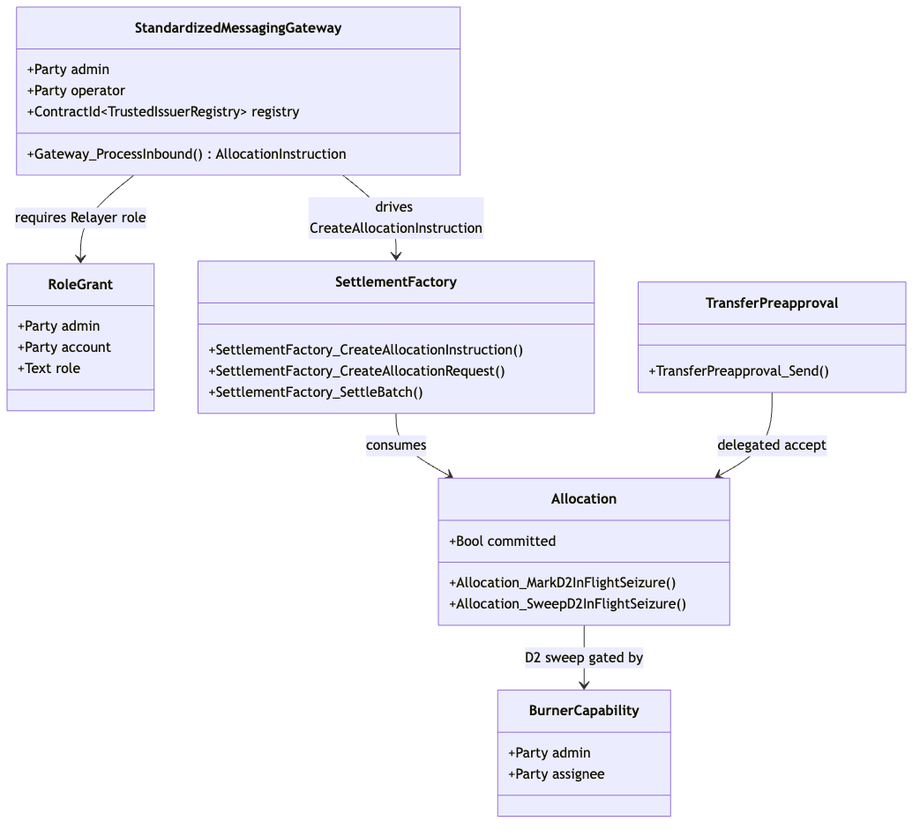{width=6.3in}

5.2 Flow-of-Funds / Settlement Diagram (Cross-chain Bridge + Batch DvP)
Diagram 2 (rendered locally; editable Mermaid source in the canonical 03-cross-chain-stablecoin.md).
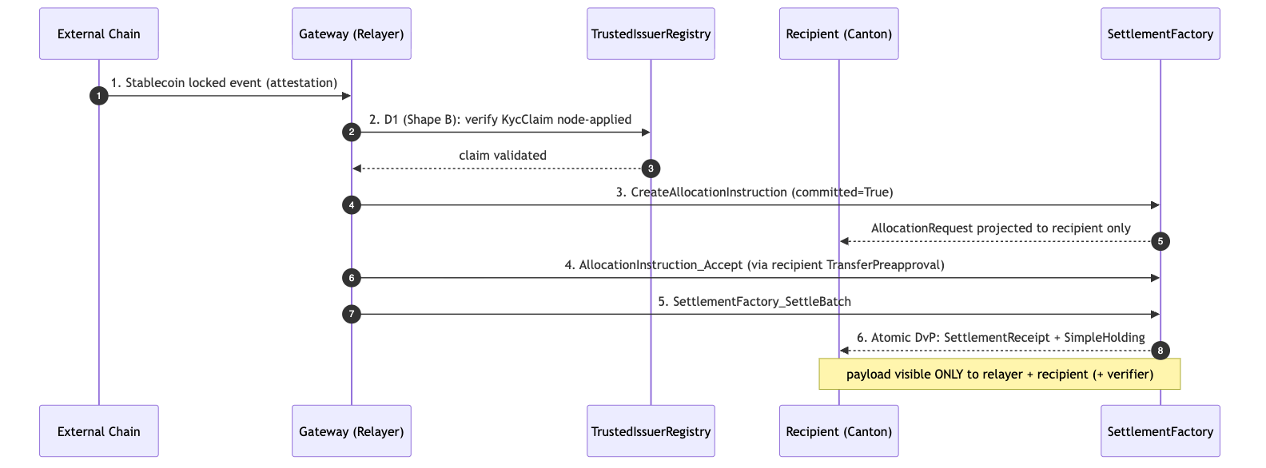{width=6.3in}

6. Library Dependencies

6.1 Internal Dependencies (present in workspace)
Component | Source Package | Usage | Tag
oz-access-control | canton-specs / canton-contracts | AL-7 RoleGrant/requireRole gating the gateway; D4 single-admin authority. | [IMPLEMENTED]
oz-ownable | canton-specs / canton-contracts | Ownership over hooks/factories; secure handoff. | [IMPLEMENTED]
oz-pausable | canton-specs / canton-contracts | PauseState halts inbound requests during anomalies. | [IMPLEMENTED]
SettlementFactory (CIP-0112 spine) | canton-specs | Allocation generation + SettleBatch DvP. | [IMPLEMENTED] (experimental)
TransferPreapproval | canton-token-template (SimpleToken.Preapproval) | Delegated recipient accept for offline treasuries. | [EVIDENCE]
SimpleHolding / SimpleTokenRules / LockedSimpleHolding / *_ForcedBurn | canton-token-template | Asset representation, 3-way dispatch, D2 evidence. | [EVIDENCE]
CredentialGatedActionRequest / MockVerificationResult | zk-credential-gateway | D1 credential gating. | [EVIDENCE]
KycClaim / TrustedIssuerRegistry | canton-specs identity-hook Shape-B | Typed D3 identity for D1 Shape-B node attestation. | [IMPLEMENTED] (experimental)
Attribution note: KycClaim / TrustedIssuerRegistry are canton-specs identity-hook-shape-b types, not zk-credential-gateway templates. The gateway supplies the gating/verification primitives.

6.2 External / Planned Dependencies
Component | Role / Provider | Status | Note
Standardized Messaging Gateway | Cross-chain messaging (OpenZeppelin Contracts Library) | Planned [FUTURE] | Not present in this workspace. Modeled as a bounded mock (StandardizedMessagingGateway); to be swapped for a production CCIP/LayerZero-style integration. Build only its Daml-facing interface.
Splice Token Standard V2 DARs | V2 settlement rules | Planned [UPSTREAM] | Local stand-ins designed to maximally match the V2 interfaces; source-of-record hyperledger-labs/splice @ token-standard-v2-upcoming @ 1e34121b… (historical preview …-daml-preview @ b91de5d4…). Import gated (PLAN.md; M4_STABLECOIN_SCOPE.md §A).
USDCx | Settled instrument admin | External | Consumed via interface only; issuance + peg handled off-architecture.

7. Security & Auditability
Security relies on Daml's structural rigidity and deterministic state transitions, not obscure cryptography.

7.1 Invariants
- Conservation of funds. SettlementFactory_SettleBatch cannot output more value than its input Allocations; sum of inputs = sum of receipts + returned change, enforced via nextIterationFunding. Any mismatch is rejected by the Daml engine — no counterfeiting.
- Privacy partitioning. Amount, payer, and payload memo are projected only to the relayer, recipient, and designated compliance verifier. If the StablecoinAdmin could observe the memo without authorization, the invariant is broken.

7.2 Threat Model
Vector | Description | Mitigation
Malicious relayer | Routes valid inbound funds to an unauthorized/sanctioned account. | D1 hook requires a node-applied KycClaim whose subjectParty matches the exact recipient; the relayer cannot spoof the destination (fail-closed).
Malicious sender | Triggers spam/toxic settlement to an unwilling recipient. | Without a configured TransferPreapproval or explicit accept, the allocation is not settled and funds return to sender (transfer-failure semantics).
Compromised admin | Attempts arbitrary expropriation. | D4 single-admin is a structural boundary; even a compromised admin's D2 sweep is hardcoded to the preset custodianDestination (no arbitrary burn, no return-to-sender).
UTXO fragmentation | Many small transfers accumulate holding dust. | Iterated settlement merges inputs; remaining balance returns as a single new holding, reducing fragmentation during the batch.

7.3 Validation Ladder
Tier | Tooling | Purpose
Static analysis | daml-lint | Validates SCU rules (no illegal field mutation; only Optional extensions), decimal bounds, archive-before-execute, roleId wrapper, whenNotPaused.
Generative testing | daml-props | Property-based testing with shrinking over SettleBatch: fuzzed extra-transfer-leg scenarios verify funding conservation never breaks.
Formal verification | daml-verify | Z3 proofs over D1–D4 mappings — e.g. Gateway_ProcessInbound is unreachable unless a valid KycClaim path exists, sealing the D1 gate on-ledger.
(Tooling exists in the workspace; no benchmark latencies are claimed.)

7.4 Off-ledger reconciliation [UPSTREAM]
A treasury operating this flow reconciles its private Canton settlement against the inbound external-chain event without parsing raw transaction trees: the Token Standard V2 transfer-events API (Splice.Api.Token.TransferEventsV2, imported in the canton-token-template evidence) emits holdings-change events the recipient can correlate with the gateway's inbound message id, giving a 1:1 audit linkage between the external lock/burn and the Canton credit. This is an upstream API surface, not vendored here, and the linkage is a reference pattern — the report makes no reconciliation-completeness, accounting-standard, or audit-readiness claim.

8. Cross-Synchronizer Domain Extension (Planned) [FUTURE]
Shared model: the cross-synchronizer mechanism (per-synchronizer assignment + unassign/assign reassignment, and the SCU-compliant additive path) is identical across all four RIs and is owned in 00-portfolio.md §5. This section elaborates only the RI-specific topology (including the cross-chain vs cross-synchronizer distinction below).
Status: out of scope for the initial M1 design; deferred and planned. Note the distinction: this RI is cross-chain (bridging from external L1s/L2s via the gateway) but still single-synchronizer on Canton today. Operating the Canton-side settlement across multiple Canton synchronizer domains is a separate, deferred capability (D3 cross-domain identity is also deferred). This section plans it per Canton's per-synchronizer assignment + unassign/assign reassignment model and the SCU rule.

8.1 Cross-chain vs cross-synchronizer
- Cross-chain (in scope as a mock): external chain → gateway attestation → Canton settlement on one synchronizer.
- Cross-synchronizer (planned): the Canton-side recipient, stablecoin instrument, and compliance registry may live on different Canton synchronizers; settlement then requires reassigning the relevant contracts onto one synchronizer before SettleBatch.

8.2 Where it touches the boundary
Element | Single-synchronizer (today) | Cross-synchronizer (planned)
Inbound Allocation / SettlementReceipt | Created/settled on the recipient's synchronizer. | Reassignable: inbound allocation assigned to the synchronizer hosting the recipient's USDCx holding before SettleBatch.
USDCx instrument admin | Same synchronizer as settlement. | If USDCx is administered on another synchronizer, the settled instrument must be reachable there or reassigned in.
D1 TrustedIssuerRegistry | One synchronizer. | Synchronizer-aware registry; compliance re-checked on the settling synchronizer (no stale cross-domain attestation reuse).
D3 identity | Single-domain KycClaim. | Cross-domain proof (ONCHAINID / ERC-3643 / CCID) resolved into a synchronizer-aware registry — the deferred D3 work.

8.3 The additive, non-breaking path (SCU-compliant)
- Append Optional SynchronizerScope to the RI gateway/orchestrator templates; older contracts read None.
- Add a new parallel choice (e.g. Execute_Inbound_Settlement_CrossDomain) alongside the unchanged single-synchronizer choice.
- Model reassignment as workflow: reassign the inbound allocation onto the settling synchronizer → SettleBatch there → reassign the receipt/holding back. Atomicity stays at the single-synchronizer batch boundary.

8.4 Open questions specific to cross-synchronizer operation
- Reassignment-vs-settlement atomicity (rollback vs re-home-able allocation on SettleBatch failure) — maps to the return-to-sender rule.
- Which synchronizer's TrustedIssuerRegistry and verifier set govern a cross-domain inflow.
- Cross-domain D1 freshness (re-check on the settling synchronizer; never reuse across a reassignment).
- Reassignment tooling maturity (evolving Canton/DA stack; assumes drop-in).

9. Open Questions
- Standardized Messaging Gateway (planned, absent). The gateway is a Contracts-Library component not yet present in this workspace. When the production gateway lands, how are inbound attestations sequenced if the origin chain (Ethereum/Polygon) deep-reorgs? Does the gateway manage confirmation delays internally, or must the relayer Daml contract use a time-locked AllocationInstruction to mitigate cross-chain rollback risk?
- USDCx forced upgrades. Active holdings upgrade-on-use via factory routing, but a forced upgrade for passive holders raises a question: how does the relayer detect a recipient holding a deprecated TransferPreapproval, and what is the fallback from delegated-accept to an interactive two-step offer?
- Expired / unsettled inbound-allocation lifecycle. A committed inbound Allocation locks bridging funds until settlement; if the DvP never completes (recipient never finalizes, origin reorg, deadline lapses), the local CIP-0112 scaffold has no cancel/withdraw/reject path — the choices today are Allocation_Settle and the two D2 seizure choices. The upstream Token Standard V2 Allocation lifecycle [UPSTREAM] separates an allocation's expiry from its settlement deadline and adds cancel/withdraw/reject semantics, which would let an automated handler reclaim dead capital without the original signer. Whether M1 reserves this via an additive [FUTURE] cancel choice on the RI orchestrator (return-to-sender on expiry) or defers entirely to the upstream lifecycle once imported is open. (Maps to the transfer-failure return-to-sender rule.)
- Cross-domain identity proof injection (D3). When ONCHAINID / ERC-3643 equivalents are supported, does the TrustedIssuerRegistry ingest external state proofs via an oracle, or rely on a CCID protocol synchronized across the global synchronizer? The cross-domain proof-injection trust model must be audited.
- Cross-synchronizer operation (see §8) — deferred; tracked there.
- Composability with the other RIs (forward-compatibility; suite view 00-portfolio.md §3): recipients holding USDCx settled here can provide liquidity to the DEX RI (01) pools or collateralize a Lending RI (02) vault — all over the same SettlementFactory_SettleBatch spine, with no parallel settlement path.

References
All interface, template, choice, and field names are grounded in real source in this workspace (verified 2026-06-24), except components explicitly marked planned/external.
- Settlement spine [IMPLEMENTED] — canton-specs/experiments/cip112-settlement/daml/OpenZeppelin/Experimental/Settlement/Cip112.daml.
- Holdings / rules / preapproval / forced-burn [EVIDENCE] — canton-token-template/simple-token/daml/SimpleToken/{Holding,Rules,Preapproval}.daml (TransferPreapproval + TransferPreapproval_Send/_MintInto; LockedSimpleHolding_ForcedBurn).
- Credential gating / verification [EVIDENCE] — zk-credential-gateway/daml/src/ZkCredentialGateway/{GatedAction,Verification,Types}.daml.
- Typed D3 identity (KycClaim, TrustedIssuerRegistry) [IMPLEMENTED] — canton-specs/experiments/identity-hook-shape-b/ and identity-hook-upgrade-*/.
- AL-7 primitives [IMPLEMENTED] — canton-specs access-control/, ownable/, pausable/.
- Decision authority (D1–D4), scope, SCU rule — root PLAN.md, AGENTS.md, briefing docs/research/RI_RESEARCH_BRIEFING.md.
- Grant scope / milestones / deliverables (source of truth) — docs/research/canton-ecosystem-grant-proposal.md (PR #298, approved; CIP-56→CIP-0112 retarget) and the distilled M4_STABLECOIN_SCOPE.md.
- Token Standard V2 upstream [UPSTREAM] — hyperledger-labs/splice token-standard-v2-upcoming (import gated per PLAN.md).
- Planned / external (not in workspace): the Standardized Messaging Gateway (OpenZeppelin Contracts-Library component) and USDCx (external Canton ecosystem stablecoin). See §6.2 and Open Questions.
Removed in review: the original draft cited external/non-workspace URLs (a CoinStats "fundamental analysis" page, srikanth-bitdynamics GitHub, Medium posts, cantonecosystem.com, a jobs board, BitGo/DFNS docs, a universal-verify/trusted-issuer-registry repo, QuillAudits, and others) as authoritative sources, and an inaccurate "10-minute mining-round = transaction signing timeout" claim. None of the URLs are part of this workspace or an authoritative spec; they were removed and replaced with the workspace-grounded references above, and the TransferPreapproval rationale was restated as delegated accept for offline recipients (not a timeout workaround). See the review record in ../reviews/2026-06-24T22-57-44Z_REVIEW.md.
Re-review 2026-06-25 (expert "blueprint" pass): the second expert draft's §9 (Cross-Chain Stablecoin) was assessed. Integrated: the §7.4 V2 transfer-events reconciliation note (Splice.Api.Token.TransferEventsV2, [UPSTREAM]), the §9 expired/unsettled-allocation lifecycle open question (upstream cancel/withdraw/reject vs. the local scaffold's absence of one), and the §3 retroactive-interface-instance [UPSTREAM] note (suite-consistent with RI 1/2). Rejected: CIP-86 as an "Ethereum JSON-RPC / MetaMask facade" (CIP-86 is an ERC-20 middleware & distributed indexer per cip0086-cip0103-cip0104-m1-acceptance.md, and is out of this RI's scope — the report does not adopt the facade framing); fabricated AmuletAllocationV2 / TransferInstructionV2 (only AllocationV2 / AllocationRequestV2 / HoldingV2 exist, as upstream Splice.Api.Token.* imports — the RI uses the local spine Allocation); the claim that Wormhole / LayerZero "exist as SVs on the Canton Network" (unverifiable; the gateway stays a [FUTURE] mock); the BatchingUtility_MergeHoldings utility (fabricated; the report's fragmentation mitigation is the spine's iterated-settlement change-merge, not a named utility); and the OCC / FDICIA / SOX external-citation set. Record: ../reviews/2026-06-25T02-29-08Z_REVIEW.md.

CONFIDENTIAL — OpenZeppelin internal · non-public reference design · not for external distribution

Architectural Overview Report: Confidential Auction Launchpad on Canton
Status: reviewed reference-design report, non-public, outside the committed M1 public-library surface. This is RI #4 of four — see the suite-level view in 00-portfolio.md and the index README.md. It describes a reference design grounded in the real OpenZeppelin Canton components in this workspace; it is not a claim of M1/M4 acceptance, conformance, audit readiness, or production readiness.
Google Docs import: File → Open this .md in Docs (or paste with Edit → Paste). H1/H2/H3 headings drive the Docs outline pane; the tables import cleanly; apply a monospace paragraph style to fenced code blocks after import. Mermaid blocks do not render in Docs — render them with canton-settlement-explorer and paste the image, keeping the fenced source.
Source-grounding tags (used throughout): [IMPLEMENTED] real code in the M1 library base (canton-specs / canton-contracts) · [EVIDENCE] real code in an evidence repo (canton-token-template, canton-stablecoin, zk-credential-gateway), not the M1 surface · [UPSTREAM] Splice / CIP reference, not vendored here · [FUTURE] proposed RI-level design, not built in M1 scope.
Design priority order governs every interface and snippet, in this exact order: 1) Readability → 2) Simplicity → 3) Security → 4) Auditability.
Grant alignment (source of truth: ../research/canton-ecosystem-grant-proposal.md, scope lock: ../../M4_AUCTION_SCOPE.md): this is RI #4 (Confidential Auction Launchpad). This document is the Architecture Documentation deliverable, authored in grant M1 (research & design) for the implementation in grant M4 (Q4 2026, end Year 1, alongside RI 3). Companion deliverables — working reference code, demo front-end, threat model — are named here but delivered in M4 (MIT-licensed). The report honors the CIP-56 → CIP-0112 / Token Standard V2 retarget.

1. Product Definition
The Confidential Auction Launchpad is a reference implementation for institutional, regulated, confidential token distribution (ICOs) on Canton. It leverages Canton's sub-transaction privacy and the CIP-0112 / Token Standard V2 settlement spine [IMPLEMENTED] to establish a sealed-bid environment by protocol design rather than cryptographic obfuscation: bids, allocations, and settlement details are visible only to explicitly authorized parties via native ledger projection.

1.1 Educational Framing: Sealed-bid via projection, not commit-reveal
On public ledgers, sealed-bid auctions use a commit-reveal pattern: publish a hash of the bid to a globally visible mempool/ledger, then reveal the plaintext later — adding UX friction, non-revelation risk, and exposure to metadata/timing analysis. On Canton, privacy is per-party projection: a contract is visible only to its signatories/observers, and a BidRequest with signatory bidder, observer auctioneer materializes only on those two parties' nodes. The synchronizer's sequencer orders the transaction by its confirmation-tree shape but does not see the bid plaintext, so the sealed-bid property is achieved without commit-reveal and front-running is structurally prevented. If an institution wants protection against the auctioneer too, a commit-reveal hash can be layered onto BidRequest as a non-breaking SCU extension — but native projection privacy suffices for the stated scope.

1.2 In-Scope vs. Out-of-Scope
The bias favors a clean, singular sealed-bid core over expansive market mechanics.
Feature Category | In-Scope
Auction mechanism | Single-round sealed-bid; first-price default, second-price as a parameterization computed by the auctioneer's off-ledger pricing engine.
Confidentiality | Bid isolation via per-party projection — bidder, issuer/auctioneer, and the credential verifier only; no bidder projects competitor bids.
Escrow | Locked escrow via LockedSimpleHolding / Allocation; funds cryptographically bound to the settlement outcome.
Atomic settlement | Token-for-payment exchange only via SettlementFactory_SettleBatch (atomic DvP, single transaction).
Access gating | Credential-gated participation via zk-credential-gateway (CredentialGatedActionRequest, MockVerificationResult).
Authority | Single-admin capability via oz-access-control (mint/burn/seizure).
Compliance | D1 node-applied checks (Shape B) on every settlement leg, fail-closed.

Feature Category | Out-of-Scope (Excluded)
Continuous issuance | Streaming launches, continuous funding, persistent issuance — discrete finalized rounds only.
Algorithmic pricing | Bonding curves, dynamic-price Dutch auctions (settlement spine could host them later, not core).
Secondary market | AMM / order-book / post-auction liquidity — that is the DEX RI.
Derivatives & synthetics | Options/futures/synthetics of the launched token.
On-ledger clearing math | Sorting/clearing runs off-ledger; only finalized, conservation-sound match legs settle on-ledger.

1.3 Target Users
Institutional asset issuers, regulated launchpad operators, and accredited investors in compliant jurisdictions. Issuers get fair distribution free of front-running / bid manipulation / MEV, with KYC/AML/accreditation enforced via zk-credential-gateway. Bidders get confidentiality of intent, atomic return-to-sender for losing bids (no counterparty credit risk), and capital that can move only per their signed AllocationInstruction.

2. Architecture Overview
Strictly modular: access control, asset semantics, auction logic, and terminal settlement are distinct layers, so the settlement spine stays sealed while auction mechanics can be upgraded or substituted.

2.1 Component Utilization
- Authority — oz-access-control [IMPLEMENTED] (RoleGrant, RoleAdmin, DefaultAdminTransferOffer, requireRole; roleId : MyRole -> Text closed-sum wrapper) for Issuer/Auctioneer roles; oz-ownable [IMPLEMENTED] (Ownership/OwnershipOffer) for two-step handoff; oz-pausable [IMPLEMENTED] (PauseState/whenNotPaused) for the emergency halt.
- Settlement spine — OpenZeppelin.Experimental.Settlement.Cip112 [IMPLEMENTED] (SettlementFactory, AllocationRequest, AllocationInstruction, Allocation, SettlementReceipt). Atomic DvP routes only through SettlementFactory_SettleBatch; direct Allocation_Settle is bypassed for the exchange (it proves authorization, not multi-party atomic co-settlement).
- Assets — canton-token-template [EVIDENCE] (SimpleHolding, LockedSimpleHolding, SimpleTokenRules 3-way dispatch); the launched token is minted via Rules_Mint / MintProposal (cold recipient → propose → accept, honoring Canton co-authorization). canton-stablecoin's Vault / VaultFactory / Vault_Liquidate / PriceOracle are excluded (CDP mechanics, not primary issuance).
- Compliance/identity — zk-credential-gateway [EVIDENCE] (CredentialGatedActionRequest, MockVerificationResult, CredentialRevocationStatus); typed D3 KycClaim + TrustedIssuerRegistry from the canton-specs identity-hook Shape-B experiment [IMPLEMENTED].
Attribution note: KycClaim / TrustedIssuerRegistry are canton-specs identity-hook-shape-b types, not zk-credential-gateway templates. The gateway supplies the gating/verification primitives.

2.2 Party and Role Topology
- Operator — deploys the launchpad contracts and manages the SettlementFactory; operational, not financial, authority.
- Issuer — launches the token; single-admin authority; holds the BurnerCapability (D2 seizure) and authorizes Rules_Mint via MintProposal.
- Auctioneer — delegated by the Issuer via RoleGrant; observes BidRequests, runs the off-ledger clearing engine, and builds the SettleBatch payload; cannot misdirect funds (constrained by the spine's conservation invariants).
- Bidder — needs a valid KycClaim from a TrustedIssuerRegistry; retains control of payment assets until atomic settlement.
- Verifier — off-chain compliance entity; issues a MockVerificationResult attesting credential validity, green-lighting participation.

2.3 Trust and Topology
Each contract configures the nodes that validate it. The BidRequest's signatory bidder, observer auctioneer definition routes its data only to those parties' nodes, shielding bids from the network. Daml-LF 2.1 is keyless (archive-and-recreate, not in-place mutation), and any new signatory must co-authorize — so the Auctioneer cannot push a minted token into a Bidder's wallet: the Issuer creates a MintProposal and the Bidder actively accepts it. Synchronizer sequencers order transactions by confirmation-tree shape while remaining blinded to bid plaintext, eliminating sequencer front-running / MEV.

3. How We Implement It
An invariant-bound lifecycle: configuration + gating → confidential bidding → off-ledger clearing → atomic on-ledger settlement.

3.1 The Settlement-Spine Flow
- Configuration + access gating. The Issuer instantiates AuctionLaunchpad (payment instrument id, launched instrument id, the SettlementFactory reference, the governing TrustedIssuerRegistry) and delegates the Auctioneer role via RoleGrant.
- Credential verification. The Bidder obtains a KycClaim and submits a CredentialGatedActionRequest; the Verifier issues a MockVerificationResult on-ledger, unlocking participation.
- Escrow + confidential bid. The Bidder commits payment capital by creating an AllocationInstruction (via SettlementFactory_CreateAllocationInstruction) and accepting it (AllocationInstruction_Accept), producing a committed Allocation that locks the funds under the Bidder's authority while delegating settlement execution to the SettlementFactory. Simultaneously the Bidder creates a BidRequest (signatory bidder, observer auctioneer) carrying the Allocation reference, bid amount, and price — projected only to bidder and auctioneer.
- Closure + clearing. The Auctioneer halts new submissions via oz-pausable (PauseState), queries its node for active BidRequests, and runs the off-ledger clearing engine to determine the clearing price, winners, and exact asset routing.
- Atomic co-settlement. For each winner the Auctioneer creates token AllocationInstructions (token minted/transferred from the Issuer's treasury holding) and builds the final batch — winners' payment Allocations + the Issuer's token Allocations + the routing legs — then submits a single SettlementFactory_SettleBatch. The factory validates conservation (payment in = payment owed; tokens out = tokens owed) and runs the D1 hooks; on success it commits atomically, delivering tokens to bidders, payment to the Issuer, and SettlementReceipts.
- Return to sender (losing bids). The Auctioneer archives losing BidRequests and cancels the corresponding payment Allocation (Allocation_Cancel / _Withdraw), releasing the lock back to the bidder. This honors the D2 rule: non-matching bids return to sender — never seized or burned by the launchpad.

3.2 D1 Compliance: Shape B node attestation
Compliance is checked on every settlement leg, fail-closed, node-applied — no on-ledger caching. The RI uses Shape B (signed node attestation) over Shape A (off-ledger gate): the optional D1ComplianceHook on SettleBatch requires fresh, cryptographically signed attestations from the relevant compliance nodes; if any are missing/expired/invalid, the entire batch fails. (Open, non-blocking: contract-oblivious vs on-ledger attestation verification.)

3.3 D2 Seizure: lock-and-sweep
Seizure is isolated from the auction flow and gated by the single-admin BurnerCapability. It is not a burn: a targeted Allocation / holding is swept to an admin-preset custodianDestination, via the real spine mechanism (Allocation_MarkD2InFlightSeizure → Allocation_SweepD2InFlightSeizure for in-flight allocations; LockedSimpleHolding_ForcedBurn to the custodian for locked holdings). The spine's D2SeizureHook is a config data record (seizureCaseRef, custodianDestination, inFlightHandlingStatus), not an invokable template. Value is preserved; chain of custody is maintained; nothing is returned to a flagged sender (ordinary transfer failures do return to sender).

3.4 SCU upgrade rule + D3 forward compatibility
Never mutate an existing choice's args to require a new field; extend via Optional fields, new types, and new choices. D3 today is single-domain v1 (TrustedIssuerRegistry + KycClaim). To add cross-domain identity (ONCHAINID / ERC-3643 / CCID) later: define a new CrossDomainIdentity type, append crossDomainRef : Optional CrossDomainIdentity to BidRequest, and add a new choice BidRequest_UpdateIdentity (archive + recreate with the field populated). Legacy bid choices stay untouched and functional. This is the additive path proven in the canton-specs identity-hook upgrade spike.

4. Interfaces & Usage Examples
Names map to real workspace components; RI-level templates are tagged [FUTURE]. Imports use real module names (OpenZeppelin.AccessControl, OpenZeppelin.Pausable, OpenZeppelin.Experimental.Settlement.Cip112).

4.1 Access control [FUTURE]
module ConfidentialAuction.AccessControl where
import OpenZeppelin.AccessControl (RoleGrant, requireRole)
data AuctionRole = IssuerRole | AuctioneerRole deriving (Eq, Show)
roleId : AuctionRole -> Text
roleId IssuerRole = "ISSUER"
roleId AuctioneerRole = "AUCTIONEER"

4.2 Launchpad configuration [FUTURE]
module ConfidentialAuction.Launchpad where
import OpenZeppelin.Pausable (PauseState, whenNotPaused)
import OpenZeppelin.Experimental.Settlement.Cip112 (SettlementFactory)
template AuctionLaunchpad
with
operator : Party
issuer : Party
paymentInstrumentId : Text
launchedInstrumentId : Text
settlementFactoryCid : ContractId SettlementFactory
pauseStateCid : ContractId PauseState -- oz-pausable kill-switch
minBidPrice : Decimal
where
signatory operator, issuer
ensure (minBidPrice > 0.0)
-- Halt/resume route through oz-pausable PauseState_Set (controller = issuer,
-- validated via requireRole IssuerRole), not via a mutated local flag.

4.3 Confidential bid + policy guards [FUTURE]
module ConfidentialAuction.Bid where
import OpenZeppelin.Experimental.Settlement.Cip112 (Allocation)
template BidRequest
with
bidder : Party
auctioneer : Party
launchpadCid : ContractId AuctionLaunchpad
paymentAllocationCid : ContractId Allocation
bidAmount : Decimal
bidPrice : Decimal
maxAllocationCap : Decimal
-- SCU additive extension point for deferred D3 cross-domain identity.
crossDomainRef : Optional Text
where
-- CONFIDENTIALITY boundary: only bidder + auctioneer project this contract.
signatory bidder
observer auctioneer
-- Policy guard: integrity + per-investor cap.
ensure (bidAmount > 0.0 && bidPrice > 0.0 && bidAmount <= maxAllocationCap)
-- D2 / return-to-sender: bidder withdraws before clearing; the real spine
-- choice unlocks and returns the funds (no auctioneer action needed).
choice BidRequest_Cancel : ContractId Allocation
controller bidder
do exercise paymentAllocationCid Allocation_Withdraw

4.4 Atomic settlement via the spine [FUTURE]
module ConfidentialAuction.Clearing where
import OpenZeppelin.Experimental.Settlement.Cip112
(SettlementFactory, SettlementFactory_SettleBatch, Allocation, AllocationRequest)
template AuctionClearing
with
auctioneer : Party
launchpadCid : ContractId AuctionLaunchpad
where
signatory auctioneer
choice Clearing_ExecuteBatch : [ContractId SettlementReceipt]
with
settlementFactoryCid : ContractId SettlementFactory
paymentAllocations : [ContractId Allocation] -- winners' locked payment
tokenAllocations : [ContractId Allocation] -- issuer's token side
requests : [ContractId AllocationRequest] -- routing legs (bidders ↔ tokens)
controller auctioneer
do
-- Single atomic DvP. If any D1ComplianceHook fails on any leg, or the
-- math violates conservation, the whole batch fails-closed.
exercise settlementFactoryCid SettlementFactory_SettleBatch with
allocations = paymentAllocations ++ tokenAllocations
requests = requests
-- nextIterationFunding empty: terminal single-round settlement.

5. Diagrams
Validatable with canton-settlement-explorer. Render externally for Docs.

5.1 Interface and Component Diagram
Diagram 1 (rendered locally; editable Mermaid source in the canonical 04-confidential-auction.md).
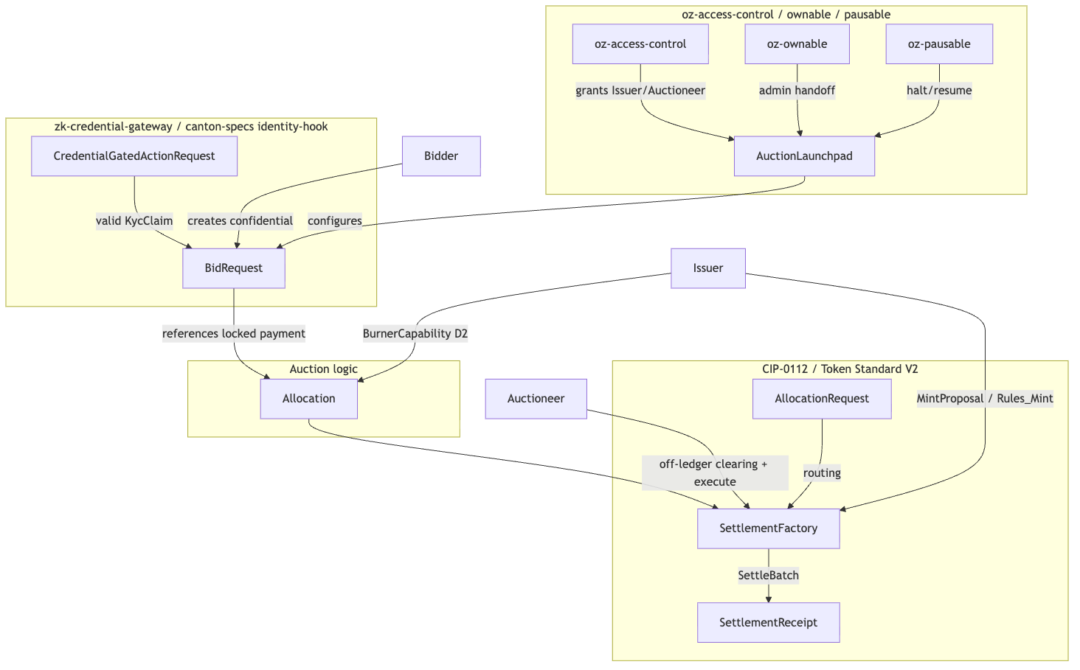{width=6.3in}

5.2 Flow-of-Funds and Settlement Sequence
Diagram 2 (rendered locally; editable Mermaid source in the canonical 04-confidential-auction.md).
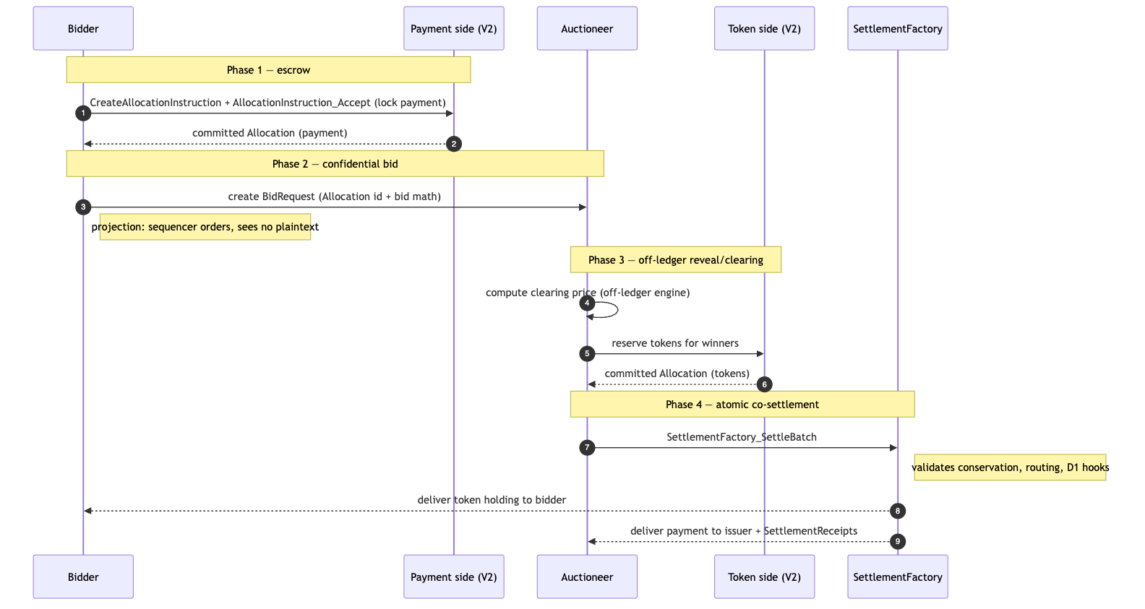{width=6.3in}

6. Library Dependencies

6.1 Internal Dependencies
Package | Consumed Templates / Interfaces | Role | Tag
oz-access-control | RoleGrant, RoleAdmin, DefaultAdminTransferOffer, requireRole | Authority model; closed-sum roleId checks. | [IMPLEMENTED]
oz-ownable | Ownership, OwnershipOffer | Secure admin handoff. | [IMPLEMENTED]
oz-pausable | PauseState, whenNotPaused | Circuit breaker (halt the sale). | [IMPLEMENTED]
canton-token-template | SimpleHolding, LockedSimpleHolding, SimpleTokenRules, TransferPreapproval, RoleCapability, MintProposal, Rules_Mint | Asset structure, 3-way dispatch, cold-recipient mint. | [EVIDENCE]
canton-stablecoin | (none consumed; Vault/VaultFactory/Vault_Liquidate/PriceOracle excluded — CDP, not issuance) | Referenced for contrast only. | [EVIDENCE]
zk-credential-gateway | CredentialGatedActionRequest, MockVerificationResult, CredentialRevocationStatus | D1/D3 credential gating. | [EVIDENCE]
canton-specs identity-hook Shape-B | KycClaim, TrustedIssuerRegistry | Typed D3 identity, layered via SCU. | [IMPLEMENTED] (experimental)
OpenZeppelin.Experimental.Settlement.Cip112 | SettlementFactory, AllocationRequest, AllocationInstruction, Allocation, SettlementReceipt, BurnerCapability, D1ComplianceHook, D2SeizureHook | Atomic DvP spine; D1/D2 seams. | [IMPLEMENTED] (experimental)

6.2 External Dependencies (Splice Token Standard V2)
Built against the CIP-0112 / Splice Token Standard V2 interfaces [UPSTREAM], ignoring DAR/package-ID pins in favor of local stand-ins designed to maximally match the V2 interfaces. Source-of-record pin: hyperledger-labs/splice @ token-standard-v2-upcoming @ 1e34121b… (historical preview …-daml-preview @ b91de5d4…; DARs + checksums in canton-token-template/docs/CIP-0112-EXTENSION-PLAN.md). Import remains gated (PLAN.md; M4_AUCTION_SCOPE.md §A); no public-API stability / conformance / release claim. nextIterationFunding is present in the standard but disabled here (single-round); it is the extension point for multi-round / bonding-curve variants.

7. Security & Auditability

7.1 Threat Model and Invariants
Threat | Mechanism | Mitigation
Privacy leakage / metadata front-running | Adversaries monitor a public mempool to front-run bids. | Canton has no public mempool; per-party projection keeps the BidRequest payload off the network; the sequencer sees the confirmation-tree shape, not contents; blast radius is bounded by a node's authorized visibility.
Unauthorized seizure / unilateral burn | Compromised admin attempts to burn or redirect escrow. | D2 gated by the single BurnerCapability; failure never defaults to seizure — a failed SettleBatch leaves funds in their Allocation, returned to sender.
Auctioneer embezzlement at settlement | Auctioneer manipulates routing to redirect payments. | AllocationRequest/leg routing is explicit; SettlementFactory enforces conservation at the Daml level — net outflow cannot exceed allocation and destinations must match the counter-signed routing; violating transactions are rejected.
Invariants: (a) conservation — SettleBatch cannot output more value than its input Allocations (sum in = sum out + change); (b) confidentiality — bid amount/parties are projected only to bidder, auctioneer, and the designated verifier.

7.2 Validation Ladder
Tier | Tooling | Purpose
Static analysis | daml-lint | Anti-patterns, decimal bounds, archive-before-execute; enforces the SCU Optional-append rule (no breaking field changes) and the roleId wrapper.
Generative testing | daml-props | Property-based fuzzing of SettleBatch over randomized Allocation/BidRequest shapes; attempts to force a conservation violation or orphaned-asset state.
Formal verification | daml-verify | Z3 proofs: no transition projects a BidRequest onto an unauthorized party; the D1 hook cannot be bypassed in the final confirmation tree.
(Tooling exists in the workspace; no benchmark latencies are claimed.)

7.3 D1–D4 Mapping
- D1 — D1ComplianceHook, Shape B signed node attestation every leg, fail-closed.
- D2 — D2SeizureHook config + BurnerCapability-gated lock-and-sweep to a preset custodian; no burn; losing bids return to sender.
- D3 — zk-credential-gateway + Shape-B KycClaim before bid acceptance; cross-domain deferred, SCU-forward-compatible.
- D4 — oz-access-control single-admin capability for M1; multi-sig → M3.

8. Cross-Synchronizer Domain Extension (Planned) [FUTURE]
Shared model: the cross-synchronizer mechanism (per-synchronizer assignment + unassign/assign reassignment, and the SCU-compliant additive path) is identical across all four RIs and is owned in 00-portfolio.md §5. This section elaborates only the RI-specific topology.
Status: out of scope for the initial M1 design; deferred and planned. The auction and the CIP-0112 scaffold are single-synchronizer today; D3 cross-domain identity is deferred. This section plans multi-synchronizer operation per Canton's per-synchronizer assignment + unassign/assign reassignment model and the SCU rule.

8.1 What changes
A cross-synchronizer launchpad is not one global auction. The AuctionLaunchpad, each BidRequest, and the bidders' payment Allocations may sit on different synchronizers; clearing settlement requires reassigning the winning legs onto one synchronizer before SettleBatch.

8.2 Where it touches the boundary
Element | Single-synchronizer (today) | Cross-synchronizer (planned)
BidRequest | Bidder + auctioneer on one synchronizer. | Bid may originate on a bidder's home synchronizer; the auctioneer must be reachable there or the bid reassigned for clearing.
Payment / token Allocation | Created and settled on the launchpad's synchronizer. | Reassignable: winning bids' payment allocations unassigned and assigned to the settling synchronizer before SettleBatch.
D1 compliance | Node-side on the settling synchronizer. | Re-evaluated on whichever synchronizer the leg settles; no cross-domain attestation reuse.
D3 identity | Single-domain KycClaim. | Cross-domain proof (ONCHAINID / ERC-3643 / CCID) into a synchronizer-aware TrustedIssuerRegistry — deferred D3 work.

8.3 The additive, non-breaking path (SCU-compliant)
- Append Optional SynchronizerScope to the RI templates (AuctionLaunchpad, BidRequest); older contracts read None.
- Add a new parallel choice (e.g. Clearing_ExecuteBatchCrossDomain) alongside the unchanged single-synchronizer clearing choice.
- Model reassignment as workflow: reassign winning allocations onto the settling synchronizer → SettleBatch there → reassign token/receipts back. Atomicity stays at the single-synchronizer batch boundary; losing-bid return-to-sender must also work across the reassignment.

8.4 Open questions specific to cross-synchronizer operation
- Reassignment-vs-settlement atomicity (rollback vs re-home-able allocation on SettleBatch failure), and how it composes with losing-bid return-to-sender.
- Which synchronizer's TrustedIssuerRegistry/verifier set governs a cross-domain bidder.
- Cross-domain D1 freshness (re-check on the settling synchronizer).
- Reassignment tooling maturity (evolving Canton/DA stack; assumes drop-in).

9. Open Questions
- Iterated-settlement extensions. nextIterationFunding is disabled in this single-round design. Adapting it for continuous bonding curves / multi-round Dutch auctions requires formalizing how conservation is enforced over many fragmented iterations without race-condition / double-spend exposure.
- D3 identity schema finalization. The future CrossDomainIdentity payload and attribute mapping (ERC-3643 / ONCHAINID equivalents → Canton) depend on components not yet present; the SCU rule guarantees additive layering, but the industry schema is still open.
- Validator-node thresholds for D1 Shape B. The Confirming-Participant-Node threshold for compliance attestations must be issuer-specified, balancing availability against cryptographic security.
- Cross-synchronizer operation (see §8) — deferred; tracked there.
- Composability with the other RIs (forward-compatibility; suite view 00-portfolio.md §3): post-auction secondary trading is the DEX RI (01); participants can collateralize bids by minting stablecoin in the Lending RI (02). Both compose over the shared SettlementFactory_SettleBatch spine.

References
All interface, template, choice, and field names are grounded in real source in this workspace (verified 2026-06-24).
- Settlement spine [IMPLEMENTED] — canton-specs/experiments/cip112-settlement/daml/OpenZeppelin/Experimental/Settlement/Cip112.daml.
- Holdings / rules / mint / preapproval / capability [EVIDENCE] — canton-token-template/simple-token/daml/SimpleToken/{Holding,Rules,Preapproval}.daml (SimpleHolding, LockedSimpleHolding + _ForcedBurn, SimpleTokenRules, Rules_Mint, MintProposal, RoleCapability).
- Credential gating / verification [EVIDENCE] — zk-credential-gateway/daml/src/ZkCredentialGateway/{GatedAction,Verification,Types}.daml.
- Typed D3 identity (KycClaim, TrustedIssuerRegistry) [IMPLEMENTED] — canton-specs/experiments/identity-hook-shape-b/ and identity-hook-upgrade-*/.
- AL-7 primitives [IMPLEMENTED] — canton-specs access-control/, ownable/, pausable/.
- Decision authority (D1–D4), scope, SCU rule — root PLAN.md, AGENTS.md, briefing docs/research/RI_RESEARCH_BRIEFING.md.
- Grant scope / milestones / deliverables (source of truth) — docs/research/canton-ecosystem-grant-proposal.md (PR #298, approved; CIP-56→CIP-0112 retarget) and the distilled M4_AUCTION_SCOPE.md.
- Token Standard V2 upstream [UPSTREAM] — hyperledger-labs/splice token-standard-v2-upcoming (import gated per PLAN.md).
Removed in review: the original draft cited external/non-workspace URLs (iq.wiki, Halborn blog posts, the Canton white paper / digitalasset.com docs, cantonecosystem.com, srikanth-bitdynamics GitHub, and — erroneously — an unrelated 2003 software-engineering workshop paper on mediaTUM) as authoritative sources. None are part of this workspace or an authoritative spec; they were removed and replaced with the workspace-grounded references above. See the review record in ../reviews/2026-06-24T23-05-38Z_REVIEW.md.

