**1. Sketch.**

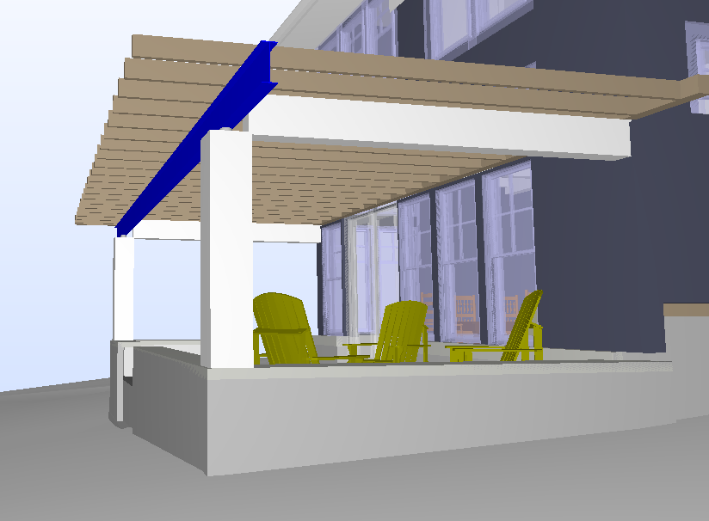

**2. Input Summary.**

2.1. Applicable codes.  
2.1.1. Wisconsin Administrative Code, Chapter SPS 321 – Uniform Dwelling Code  
2.1.2. ASCE 07-05, Minimum Loads on Buildings  
2.1.3. AISC 360-05, Specification for Structural Steel Buildings  
  
2.2. Design considerations.

As per 2.1.1, allowable stress design (ASD) is performed for steel elements using 2.1.3.

2.3. Load values

D = 10 psf as per Rafters calculations 3.2  
S = 27.2 psf as per Rafters calculations 3.2  
W = 20 psf as per 2.1.1 SPS 321.02

**3. Structural Design.**

3.1. Floor 1, Front Porch, Roof Beam Design.

Initial material: A99 Steel ASTM.

Span = 21.6’

Length = 28.25’

Loads Calculation

Load Area = 13.8 x 26.6 = 367 sf.

Dead Load = 367 x 10 / 28.25 = 130 pf = 0.13 kip/ft

Snow Load = 367 x 27.2 /28.25 = 353 pf = 0.353 kip/ft

AISC Check

ASD Design as per 2.1.1. SPS

Initial section = W10X15

Fy = 50 ksi

Fu = 65 ksi

All considered sections are compact, Y and LBW checks apply.

Design Results

Laterally braced at 2 points min: = A992 Steel, W Shape W10X19 (see Calculation 3.1.1.)

Unbraced: = A992 Steel, W Shape W10x26 (see Calculation 3.1.2.)

**Calculation 3.1.1.**



**Calculation 3.1.2.**

