**Column Analysis. Columns at Axis 3, Axis 7**

**1. Sketch.**

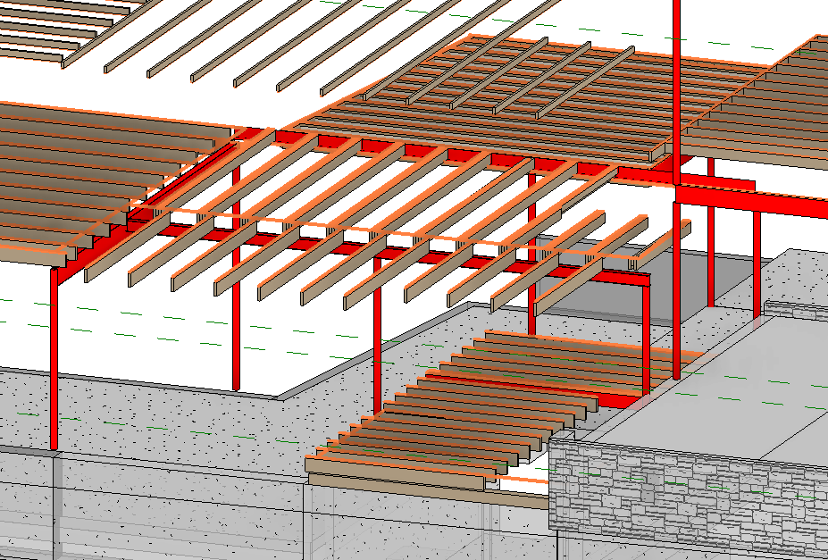

**2. Input Summary.**

2.1. Applicable codes.  
2.1.1. Wisconsin Administrative Code, Chapter SPS 321 – Uniform Dwelling Code  
2.1.2. ASCE 07-05, Minimum Loads on Buildings  
2.1.3. AISC 360-05, Specification for Structural Steel Buildings  
  
2.2. Design considerations.

As per 2.1.1, allowable stress design (ASD) is performed for steel elements using 2.1.3.

2.3. Load values

Dead Load Calculation:

Minimum value: Dmin = 10 psf;

Flooring: Wood Joists w/ Wood flooring D1 = approx. 12 psf;

Walls: light-frame wood walls D2 = approx 6 psf

Max D1+D2+D3 & Dmin **D = D1+D2 = 18 psf**

**D** = 18 psf as per WAC Chapter SPS 321, calculation  
**L** = 40 psf as per WAC Chapter SPS 321 Table 321.02

**3. Structural Design.**

3.1. Columns at Axis 3.

Material: A500 Steel ASTM.

Unbraced length = 8.2’

Loads Calculation (worst case)

Load Area = 13 x 11.5 = 150 sf.

Dead Load = 150 x 18 = 2.7 kip

Live Load = 150 x 40= 6 kip

AISC Check

ASD Design as per 2.1.1. SPS

Section =**HSS3.5X.188**

Fy = 42 ksi

Fu = 58 ksi

Compression/buckling checks apply.

3.1. Columns at Axis 7.

Material: A500 Steel ASTM.

Unbraced length = 11.3’

Loads Calculation (worst case)

Load Area = 14 x 8 = 112 sf.

Dead Load = 112 x 18 = 2.1 kip

Live Load = 112 x 40= 4.5 kip

AISC Check

ASD Design as per 2.1.1. SPS

Section = **HSS3.5X.188**

Fy = 42 ksi

Fu = 58 ksi

Compression/buckling checks apply.

**4. Design Results**

4.1 Columns at Axis 3.

Unbraced: = A500 Gr. B Steel, HSS Shape **HSS3.5X.188** (see Calculation 3.1.)

4.2. Columns at Axis 7.

Unbraced: = A500 Gr. B Steel, HSS Shape **HSS3.5X.188** (see Calculation 3.2.)

**Calculation 3.1.**



**Calculation 3.2.**

