1. Sketch.

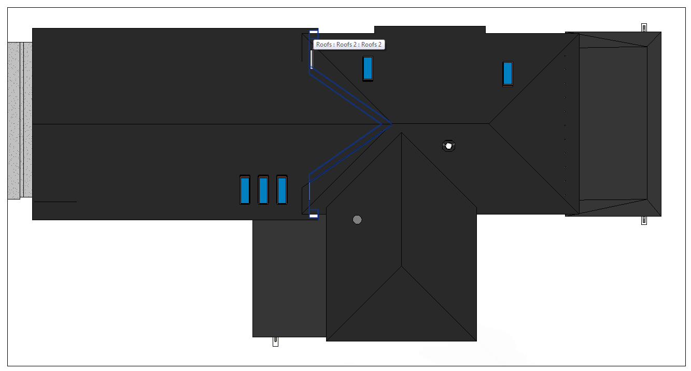

2. Global input data.

2.1. Applicable codes.  
2.1.1. Wisconsin Administrative Code, Chapter SPS 321 – Uniform Dwelling Code  
2.1.2. ASCE 07-05, Minimum Loads on Buildings  
2.1.3. AISC 360-05, Specification for Structural Steel Buildings  
  
2.2. Load combinations.  
As per 2.1.2, Load combinations are:  
1.4D  
1.2D + 1.6L + 0.5Lr  
1.2D + 1.6L + 0.5S  
1.2D + 1.6Lr + L  
1.2D + 1.6S + L  
1.2D + 1.0W + L + 0.5(Lr or S or R)  
0.9D + 1.0W

Span tables design

2.3. Load values

L = 40 psf as per 2.1.1 Table 321.02, 2.1.2 Table 4-1  
LrC = 300 lbs as per 2.1.2 Table 4-1  
S = 30 (22,5) psf as per 2.1.1 SPS 321.27  
W = 20 psf as per 2.1.1 SPS 321.02

**3. Elements subject to design.**

3.1. Roof A-D, Garage storage:  
 Slope 10”/12” = 40°  
 8x2@16” Softwood – Pine, 34.9 pcf.

Span = 11’5”

Span tables check as per SPS 320-325: Table R-2:

Roof rafters 10”/12”,

30 psf Live Load,

10 psf Dead Load,

L/240 Maximum Deflection.

Rafter Bending Design Value Fb = 800 psi;

E = 0.57.

Grade examples that satisfy Fb include:

**Spruce-Pine-Fir No.2 @16”**

**Southern Pine No.2 @16”**

3.2. Roof I-J, Porch 1:  
 6x2@16” Softwood – Pine, density R = 34.9 pcf.

Span = 11’

L/240 Maximum Deflection.

Dead Load Calculation:

Minimum value: Dmin = 10 psf;

Rafters D1 = 2.9 psf;

Plywood & sheathing D2 = 3psf/inch * 0.75 = 2.25 psf

Roofing D3 = 2 psf

Max D1+D2+D3 & Dmin **D = 10 psf**

Snow Load Calculation:

See **calc.3.2.**

**27.2 psf** Live Load (incl. drift),

Span Tables Check as per SPS 320-325:

Rafter Bending Design Value Fb = 950 psi;

E = 0.85.

Grade and spacing examples that satisfy Fb include:

**Spruce-Pine-Fir No.2 6x2 @ 12”**

**Southern Pine No.2 6x2 @ 12”**

3.3. Roof C-D, Porch 2:  
 6x2@16” Softwood – Pine, 34.9 pcf.

Span = 10’4”

L/240 Maximum Deflection.

Dead Load Calculation:

Minimum value: Dmin = 10 psf;

Rafters D1 = 2.9 psf;

Plywood & sheathing D2 = 3psf/inch * 0.75 = 2.25 psf

Roofing D3 = 2 psf

Max D1+D2+D3 & Dmin **D = 10 psf**

Snow Load Calculation:

See **calc.3.3.**

**27.3 psf** Live Load (incl. drift),

Span Tables Check as per SPS 320-325:

Rafter Bending Design Value Fb = 850 psi;

E = 0.75.

Grade and spacing examples that satisfy Fb include:

**Spruce-Pine-Fir No.2 6x2 @ 12”**

**Southern Pine No.2 6x2 @ 12”**

**Calculation for 3.2.**



**Calculation for 3.3.**

