OpenCimetiere: Managing graves the open way
Quick facts
Name | OpenCimetiere
Sector | Public
Start date | 2006
End date | ongoing
Objectives | Improving the management of cemeteries
Target group | Municipality administrations
Scope | National/ International
Budget | N/A
Funding | Internal resources/ public sector
Achievements | Functioning software in three languages, used in over 300 municipalities

For the management of their cemeteries the city of Arles, and its neighbouring municipalities Albi, Tarn and Dadou decided in 2006 that they needed to replace pen and paper with computers and software. The solution had to be secure, adaptable, and fully featured. The IT direction of the city of Arles was in close contact with the open source initiative OpenMairie, which presented many software products for the use in the public sector. It was through this relationship that the four municipalities took the initiative to start OpenCimetiere, an open source management system for cemeteries. This was started with an initialization phase in 2006, followed by a contribution phase in 2007, where the software was further improved and extended. Today, the software is used by over 300 municipalities inside and outside France, and helps an increasing number of municipalities all over the world to manage their citizens' final resting places efficiently.

Introduction
In 2006 the French city of Arles, which is located in the southern Bouches-du-Rhône department, decided that it had to introduce a system for the management of cemeteries. With a population of about 50.000 inhabitants the city is fairly small. Nonetheless, it is the largest community in France in terms of territory, due to its location at the Camargue delta, which spreads between the two river arms of the Petit-Rhone and the Grande-Rhone.
“It is not very interesting from a political point of view, but in fact it is difficult and important to manage cemeteries”, says project manager Francois Raynaud. Although the management of cemeteries appears to be a novel function, it is mostly done in a rather old-fashioned manner using pen and paper. The problem of managing cemeteries in this way is that information is easily lost, which in turn can create confusion, and lead to problems for the future administration of cemeteries.
For Raynaud, who is working as the city of Arles' IT director, the solution to this problem was a software which would enable a city to have full detailed records of all all graves and concessions, so that this information would not be lost if there is a fire, or the relatives of the deceased disappear. But instead of just searching the market for a software solution, Raynaud felt the need to be independent from one proprietary solution. He also wanted to be flexible with regard to the functionalities of a cemetery management software. Beside his work at the city of Arles he is also very engaged in the open source framework project OpenMairie, which offers many open source programsfor a variety of purposes. As the need for a software solution for the management of cemeteries grew larger, Raynaud together with the help of many contributors developed the first version of OpenCimetiere, which was the first open source cemetery management system.

Organisation and political background
Before the development phase of OpenCimetiere started, the city of Arles was in close contact with the neighbouring cities and municipalities of Albi, Tarn and Dadou. Those municipalities faced the same problem as did Arles, regarding their cemeteries. They needed to make sure that information pertaining to the graves and the deceased would be available and accessible for the long term. All these municipalities quickly realised the benefits of having a cemetery management system which would not bring high costs, while offering a secure way of storing information for an unlimited period of time. After agreeing on the framework and a roadmap, Raynaud who by then was appointed as the project manager of OpenCimetiere, consulted with Adullact, a French organisation for the promotion and dissemination of open source software. With their help the initialization phase of OpenCimetiere was launched in 2006. In this phase the first functions of the software were developed, and contributors were invited to include new functionalities to the system.
The project quickly became increasingly popular, especially in the French speaking world, and it is used in about 300 municipalities all over France, in Belgium, Spain, and even as far afield as Santo Domingo. In order to make the software even more useful for a wider public, OpenMairie has launched an English version and a Spanish beta version by the name of OpenCemetery and OpenCementerio, respectively.

Budget and Funding
As OpenCimetiere is a project that is done largely in cooperation of many contributors, there is no single dedicated budget. The financial framework for the project is therefore mostly provided by internal resources and individual dedication. Raynaud says that he does not know the exact amount of money which has been spent on developing OpenCimetiere, but is certain that it is not very large. Like many other open source projects, the development of OpenCimetiere relies heavily on contributions from the community. This means that there is no single party absorbing the costs for development.

Though Raynaud is certain that the solution is much cheaper than proprietary software solutions, he was not able to estimate the savings yet, as the software has not reached full maturity yet. The development is an ongoing process, and although the software is doing what it is supposed to do perfectly, there are still new functions being added continuously.

Technical issues
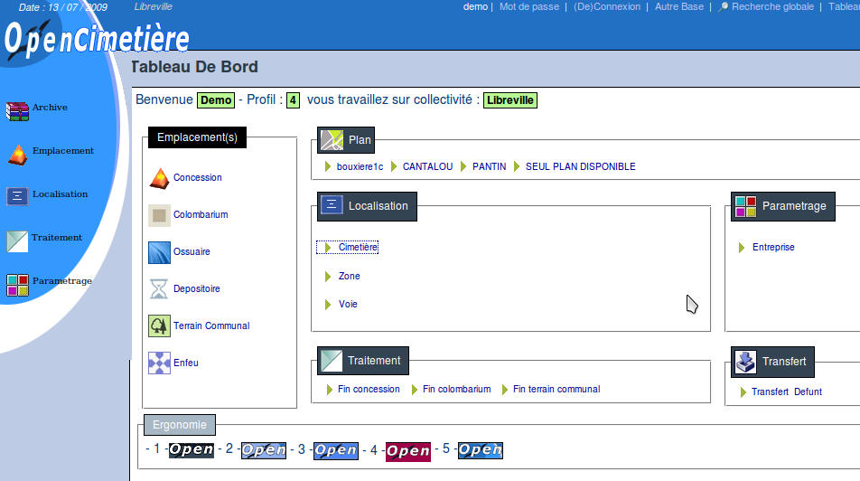Screenshot of OpenCimetiere online demonstration
OpenCimetiere itself is not an entirely new development. Essentially, “ OpenCimetiere is an integration of existing components” says Raynaud. The contributors behind the software follow one credo, as he further explains: “In France we say LAMP technology. L stands for Linux, A stands for Apache, M for MySQL, and P for PHP”. These are the essential tools that are used for the development of the software.
The software's database management system is very flexible, allowing municipalities to adopt the solution without having to deal with a new database format. Initially only MySQL was supported. A year after the initialization phase support for PostgreSQL was added. “Because we use a database abstraction layer, which is DB PEAR, we can use other databases like Oracle or Microsoft SQL”, Raynaud adds. The PostgreSQL support came in the contribution phase, when General Infographique, a French geographic information company, decided to contribute with its core system to OpenCimetiere's functionality.

Change management
OpenMairie at first was only a framework for a total of about 80 contributing developers, which mostly published demonstrations of software solutions that were not mature and only of limited use. It was only shortly before the launch of OpenCimetiere that OpenMairie started to publish a catalogue of applications that were beyond the demonstration status. This helped fundamentally in the promotion of those applications, as an increasing number of people realized their potential and usefulness for their purposes. In total there are today 18 applications in operation, of which OpenCimetiere is one.
For the success of the software it was important to have an initialization phase, which started in the first year, and a contribution phase, that was launched in 2007. This way it was possible to establish the essential requirements of the software, as well as possible packages that would be included in the future. Although the software was lacking in functionality during the initialization phase, it improved continuously with the help of contributors. “With the help of the community we become better and better” explains Raynaud. Additionally he further mentions that it is not necessarily the most important ingredient to success to have many functions, but that the solution “has to function properly”. By planing every step carefully, the software could mature slowly without any significant problems.
Illustration 1: The different steps in the development of OpenCimetiere © OpenMairie, 2009
Users can make contact with Raynaud and other developers through the website of OpenMairie. The most common reason for contact is related to minor issues in the installation process of the software, which could be difficult for a non-technical person. As for most users however this is not the case, Raynaud concludes that there are not many problems occurring.
The software can be downloaded from the websites of Adullact and Osor. So far most downloads have been over the Adullact website, as the project was published there first. For Raynaud however “it is due to the work of Osor that OpenCimetiere is used beyond the borders of France”. As the reach of the Osor project goes far beyond the French speaking world, it attracts a much wider public and this helps in spreading to use of the software greatly.

Effect on government services
With the use of OpenCimetiere the management of cemeteries is greatly facilitated. Managing the concessions into cemeteries and keeping track of existing graves was previously done using pen and paper, or through other non-computerized forms of record keeping. The problem of this method was that these important information could get lost very easily, as for example a fire could damage or completely destroy the entire set of data. The other problem behind this way of handling concessions is that there are only two documents given at a concession: One to the town hall and one to the family of a deceased person. As time goes by the family of a deceased person can move away, or simply forget about a grave. This in turn can create more bureaucratic disorder and confusion within the municipality. The old way of managing concessions can therefore be rather agonizing for municipalities as it can lead to a lot of bureaucratic chaos.
With the help of OpenCimetiere information can be safely stored on a computer or an online database, which – given proper backup procedures - ensures their existence way beyond any possible negative incident that might come up. As graves are often kept for many decades, keeping records safe and accessible is crucial. “It is very dangerous to have only one copy [on paper], and it is necessary to have all information saved on a system” explains Raynaud. The only problem in the past was that information had to be transferred from the old hard copy databases into the new system. For the 9000 graves in Arles alone, this took the municipality about three years from 2006 to 2009.

Cooperation with other public bodies
According to Raynaud “there is a real open source movement in France, and it is more difficult in European countries” to deploy open source solutions in the public sector. This acceptance of open source software is what made the cooperation of the initial four municipalities, Arles, Albi, Tarn and Dadou, so easy. As all of them had a common interest in the software, and all agreed on the benefits of using the Free Sofware model for their cooperation. Combined with the help of Adullact and the developers behind OpenMairie the first version of OpenCimetiere turned out to be successful.
The project also enjoys the support of the mayors association of the 74th department Haut-Savoie. It is with the help of this association, which encompasses about 300 mayor offices, that the software became widely used in the region.
Although it is hardly possible for the OpenMairie team to know where the software is being used outside their region, since it is freely available for download to anyone, they are aware of a few municipalities in Belgium, Spain, and Santo Domingo. There, the software finds similar use as in Arles and contributes to a better management of cemeteries.

Evaluation
The software and the way it was developed were very successful in the eyes of Raynaud. It works as intended, which is essentially what any developer wants from his or her product. Even if some functions are still missing, or at least could be further extended, the software functions very stable and meets basically all requirements.
“The biggest problem is the initialization of data” Raynaud says; “It is a great problem to have the data and bring it into the system”. As there were tons of paper with information about location, state, and even pictures that had to be entered into the system, this process took the team good three years. Of course, once the system is up-to-date it is much easier and more convenient to maintain it that way. Just as with many other migrations from paper to file, this process initially is a large task, but brings many advantages behind once the process is completed.

Achievements / Lessons learned
For Raynaud the most important ingredient to success is to have a public servant in charge of such a project who has no business interest in mind, only the good of the city. This is especially important with regard to open source solutions, as they are often the least costly and most flexible solutions to a problem. “I think it is better to have project chief who works in the municipality, because this position is more neutral and he is not driven by profit”, he explains.

Future plans
For the future of OpenCimetiere the team of OpenMairie hopes to see further development of the software, and a wants to see its use spread further. As the software is already used in several countries beyond the borders of France, more international versions of OpenCimetiere, such as the English or the Spanish version, will hopefully be developed soon. This in turn will extend the community of users, which will help to make the software ever more stable and functional.

Conclusion
For most municipalities making the choice between open source software and proprietary software is not easy, as the expertise or the knowledge of open source software is mostly not available. In the case of OpenCimetiere, the city of Arles together with its neighbouring cities and municipalities had the luck to have OpenMairie and its team directly involved in the administration. This enabled the city to make the choice for more independence, flexibility, and to safe costs.
With the help of an active community of contributors who have quickly understood the potential of such a solution, OpenCimetiere became a software that is used by many other municipalities as far away as Santo Domingo. As the number of users increases it is foreseeable that the number of functionalities increases as well. The fact that an English and a Spanish version exist already now, after only three years of being active, underlines this trend.
With the help of online platforms such as Osor and Adullact it is easy for users from anywhere in the world to find the software, download it and use it for own purposes. As this is supposedly the most common way for open source software to find its way out in the world, this underlines the importance of such platforms in increasing the popularity and use of open source products.

Links
- News article on Osor.eu
- OpenMairie
- Adullact
- Demonstration of software promoted by OpenMairie
- Software download:
  - Osor
  - Adullact




This case study is brought to you by the Open Source Observatory and Repository (OSOR), a project of the European Commission's IDABC project.
Author: Gregor Bicerhals, UNU-MERIT
This study is based on an extensive interview with IT-director of the city of Arles and member of OpenMairie Francois Raynaud, as well as the information provided under the Links section.

