NTTT Developers Document

Overview.
This project is to measure the data traffic using testing tool such as Iperf3 and hping3.

Introduction
Data traffic is the amount of data moving across a network at a given point of time. Network data in computer networks is mostly encapsulated in network packets, which provide the load in the network. Network traffic is the main component for network traffic measurement, network traffic control and simulation.

- Network traffic control - managing, prioritizing, controlling or reducing the network traffic.
- Network traffic measurement - measuring the amount and type of traffic on a particular network.
- Network traffic simulation - to measure the efficiency of a communications network.
- Traffic generation model - is a stochastic model of the traffic flows or data sources in a communication computer network.
Here in NTTT project we are measuring the Network performance.

Github URL

https://github.com/onecloud/ntt_tool_python.git

Note: Refer NTTT installation guide for installing/deploying NTTT

Software Requirements
- Django
- Django Rest Framework
- MySQL
- AngularJS
- Boostrap
- HTML
- Openstack Environment
Note: for detailed information about specific packages and their versions visit requirements.txt present in source code.
Project Directory structure
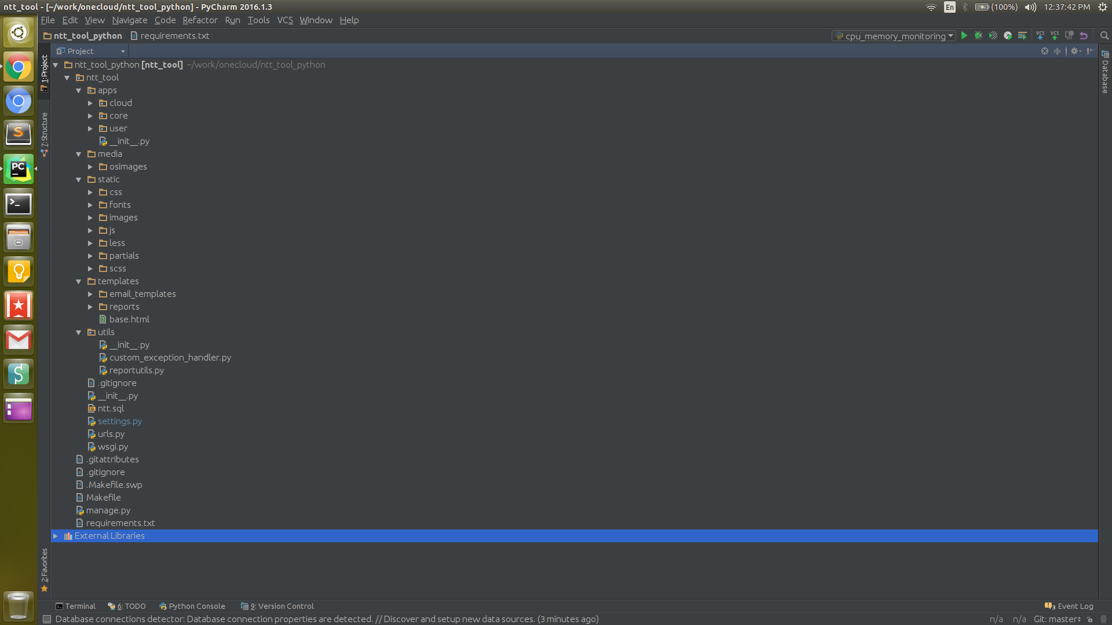

Directory Structure for Apps.
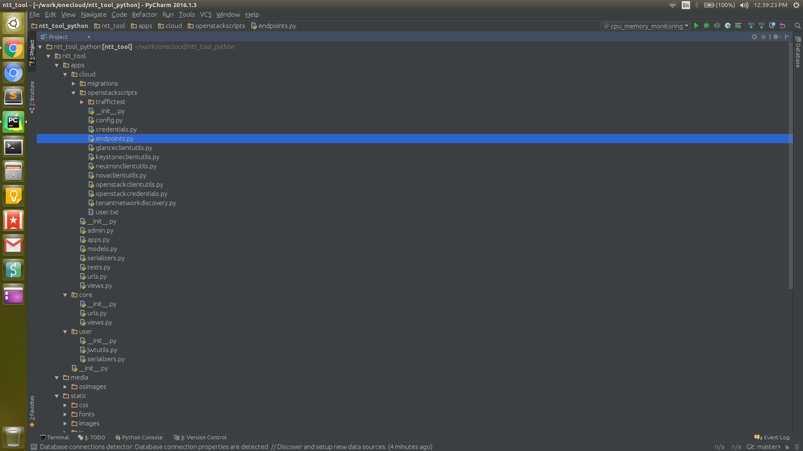

Functionality
- Cloud

Model Class
File Path: ntt_tool/apps/cloud/models.py
class Cloud

Views Class
File Path: ntt_tool/apps/cloud/views.py
class CloudViewSet

Serializer Class
File Path: ntt_tool/apps/cloud/serializers.py
class CloudSerializer

API URL
File Path: ntt_tool/apps/cloud/urls.py
http://localhost:8000/api/cloud

AngularJS controllers file
File Path: ntt_tool/static/js/apps/controllers/cloudcontroller.js

Angular Services
File Path: ntt_tool/static/js/apps/services/cloudservice.js

HTML partials for AngularJS
File Path: ntt_tool/static/partials/cloud/cloud_form.html
File Path: ntt_tool/static/partials/cloud/cloud_list.html
File Path: ntt_tool/static/partials/cloud/cloud_view.html

Operations on cloud.
- List Clouds
Call api http://localhost:8000/api/cloud with GET method
- Add cloud
Submit form to api http://localhost:8000/api/cloud with POST method
- Edit Cloud
Submit form to api http://localhost:8000/api/cloud with PUT method
- View Cloud
Call api http://localhost:8000/api/cloud/{pk} with GET method
- Delete Cloud
Call api http://localhost:8000/api/cloud/{pk} with DELETE method

- Traffic

Model Class
File Path: ntt_tool/apps/cloud/models.py
class Traffic

Views Class
File Path: ntt_tool/apps/cloud/views.py
class TrafficViewSet

Serializer Class
File Path: ntt_tool/apps/cloud/serializers.py
class TrafficSerializer

API URL
File Path: ntt_tool/apps/cloud/urls.py
http://localhost:8000/traffic

AngularJS controllers file
File Path: ntt_tool/static/js/apps/controllers/trafficcontroller.js

Angular Services
File Path: ntt_tool/static/js/apps/services/trafficservice.js

HTML partials for AngularJS
File Path: ntt_tool/static/partials/cloud/traffic/traffic_form.html
File Path: ntt_tool/static/partials/cloud/traffic/traffic_list.html
File Path: ntt_tool/static/partials/cloud/traffic/traffic_view.html
File Path: ntt_tool/static/partials/cloud/traffic/traffic_test.html

Operations on cloud traffic.
- List traffic
Call api http://localhost:8000/api/traffic?cloud_id={cloud_id} with GET method
- Add traffic
Submit form to api http://localhost:8000/api/traffic with POST method
- Edit traffic
Submit form to api http://localhost:8000/api/traffic with PUT method
- View traffic
Call api http://localhost:8000/api/traffic/{pk} with GET method
- Delete Cloud
Call api http://localhost:8000/api/traffic/{pk} with DELETE method
- Run Traffic Test
Call api http://localhost:8000/api/traffic/{pk}/run/test with GET method
- List Traffic Test Reports
Call api http://localhost:8000/api/traffic/reports/{pk} with GET method
- View Traffic Test Report
Call api http://localhost:8000/api/traffic/report/{test_run_id} with GET method
- Download Report
Call api http://localhost:8000/api/traffic/report/download/{test_run_id} with GET method
- Email Report
Call api http://localhost:8000/api/traffic/report/email/{test_run_id} with GET method

- Tenant

Model Class
File Path: ntt_tool/apps/cloud/models.py
class Tenant

Views Class
File Path: ntt_tool/apps/cloud/views.py
class TenantViewSet

Serializer Class
File Path: ntt_tool/apps/cloud/serializers.py
class TenantSerializer

API URL
File Path: ntt_tool/apps/cloud/urls.py
http://localhost:8000/api/tenant

AngularJS controllers file
File Path: ntt_tool/static/js/apps/controllers/tenantcontroller.js

Angular Services
File Path: ntt_tool/static/js/apps/services/tenantservice.js

HTML partials for AngularJS
File Path: ntt_tool/static/partials/cloud/tenants/tenants_discovery.html
File Path: ntt_tool/static/partials/cloud/traffic/tenants_list.html

Operations on cloud traffic.
- Discover Tenants
Call api http://localhost:8000/api/tenant/discover?cloud_id={cloud_id} with GET method
- List Tenants
Submit form to api http://localhost:8000/api/tenant?traffic_id={traffic_id} with POST method
- Select Tenant
Submit form to api http://localhost:8000/api/tenant?tenant_id={tenant_id}&traffic_id={traffic_id} with POST method

- Network

Model Class
File Path: ntt_tool/apps/cloud/models.py
class Network

Views Class
File Path: ntt_tool/apps/cloud/views.py
class NetworkViewSet

Serializer Class
File Path: ntt_tool/apps/cloud/serializers.py
class NetworkSerializer

API URL
File Path: ntt_tool/apps/cloud/urls.py
http://localhost:8000/api/network

AngularJS controllers file
File Path: ntt_tool/static/js/apps/controllers/tenantcontroller.js

Angular Services
File Path: ntt_tool/static/js/apps/services/tenantservice.js

HTML partials for AngularJS
File Path: ntt_tool/static/partials/cloud/tenants/tenants_discovery.html
File Path: ntt_tool/static/partials/cloud/traffic/tenants_list.html

Operations on cloud traffic.
- Discover Networks
Call api http://localhost:8000/api/network/discover?tenant_id={tenant_id} with GET method
- List Networks
Submit form to api http://localhost:8000/api/network?tenant_id={tenant_id} with POST method

- Endpoints

Model Class
File Path: ntt_tool/apps/cloud/models.py
class Endpoint

Views Class
File Path: ntt_tool/apps/cloud/views.py
class EndpointViewSet

Serializer Class
File Path: ntt_tool/apps/cloud/serializers.py
class EndpointSerializer

API URL
File Path: ntt_tool/apps/cloud/urls.py
http://localhost:8000/api/endpoint

AngularJS controllers file
File Path: ntt_tool/static/js/apps/controllers/tenantcontroller.js

Angular Services
File Path: ntt_tool/static/js/apps/services/tenantservice.js

HTML partials for AngularJS
File Path: ntt_tool/static/partials/cloud/tenants/tenants_discovery.html
File Path: ntt_tool/static/partials/cloud/traffic/tenants_list.html

Operations on cloud traffic.
- List Endpoints
Call api http://localhost:8000/api/endpoint/?traffic_id={traffic_id} with GET method
- Discover Endpoints
Submit form to api http://localhost:8000/api/endpoint/discover/{traffic_id}/{params} with POST method
Params Example: {network_id: 1, ip_range_start:192.168.1.10, ip_range_end:192.168.1.100}
- Launch Endpoints
Call api http://localhost:8000/api/endpoint/launch/{traffic_id}/{params} with GET method
Params Example: {network_id: 1,endpoint_count:2}

- Select Endpoint
Call api http://localhost:8000/api/endpoint/{pk}/select/is_selected=true with GET method

