

www.onecloudinc.com

Network Traffic Testing Tool
(NTTT)

Document Version: 0.2
April 2016

Preface

This document describes about the Network Traffic Testing Tool that is used to measure the data traffic using testing tool such as Iperf3 and hping3.

Intended Audience

This document is intended for OpenStack administrators and tenant administrators who wants to measure the data traffic.

Attention

The information contained in this guide is for testing purpose only. This guide contains information and activities that are beneficial for purpose of testing in close, non-production environment, can result in downtime or other severe consequences and therefore is not intended as a reference guide.

No part of this book may be reproduced in any form or by any means (graphic, electronic, mechanical including photocopying, recording or taping, or storage in an electronic retrieval system) without the permission of OneCloud Consulting.

OneCloud Consulting reserves the right to change the content herein without any prior notice.

Table of Contents
Attention 1
1 Overview 3
2 Introduction 3
3 Network Performance 3
3.1 Bandwidth 3
3.2 Throughput 4
3.3 Latency 4
3.4 Jitter 4
3.5 Error rate 5
4 Testing Tools 5
4.1 Introducing IPERF3 5
4.2 Introducing Hping3 6
5 Network Traffic Testing Tool (NTTT) 7
5.1 Prod Environment 9
5.2 Dev Environment 12
6 Feature Enhancements 15
7 References 16

Overview
This project is to measure the data traffic using testing tool such as Iperf3 and hping3.

Introduction
Data traffic is the amount of data moving across a network at a given point of time. Network data in computer networks is mostly encapsulated in network packets, which provide the load in the network. Network traffic is the main component for network traffic measurement, network traffic control and simulation.
- Network traffic control - managing, prioritizing, controlling or reducing the network traffic.
- Network traffic measurement - measuring the amount and type of traffic on a particular network.
- Network traffic simulation - to measure the efficiency of a communications network.
- Traffic generation model - is a stochastic model of the traffic flows or data sources in a communication computer network.
Here in NTTT project we are measuring the Network performance.

Network Performance
Network performance refers to measures of service quality of a network as seen by the customer.
There are many different ways to measure the performance of a network, as each network is different in nature and design.
The following measures are often considered important:
- Bandwidth: It is the commonly measured in bits/second is the maximum rate that information can be transferred
- Throughput: It is the actual rate that information is transferred
- Latency: It is the delay between the sender and the receiver decoding it, this is mainly a function of the signals travel time, and processing time at any nodes the information traverses
- Jitter: The variation in packet delay at the receiver of the information
- Error rate: The number of corrupted bits expressed as a percentage or fraction of the total sent.

Bandwidth
Bandwidth is a widely-used term that usually refers to the data-carrying capacity of a network or data transmission medium. It indicates the maximum amount of data that can pass from one point to another in a unit of time. The term comes from the study of electromagnetic radiation, where it refers to the width of a band of frequencies used to carry data. It is usually given in a theoretical context, though not always.’
Bandwidth is still used in these two senses: “frequency band width” and “data capacity”. For example, radio frequencies are used for wireless technologies, and the bandwidth of such technologies can refer to how wide the RF band is. More commonly, though, it refers to how much data can be sent down a network, and is often used in relative terms. For example, for Internet access, a cable or xDSL is considered “high bandwidth” access; using a regular analog modem is “low bandwidth”.

Throughput
Throughput is the number of messages successfully delivered per unit time. Throughput is controlled by available bandwidth, as well as the available signal-to-noise ratio and hardware limitations. Throughput for the purpose of this article will be understood to be measured from the arrival of the first bit of data at the receiver, to decouple the concept of throughput from the concept of latency. For discussions of this type the terms 'throughput' and 'bandwidth' are often used interchangeably.
The Time Window is the period over which the throughput is measured. Choice of an appropriate time window will often dominate calculations of throughput, and whether latency is taken into account or not will determine whether the latency affects the throughput or not.

Latency
The speed of light imposes a minimum propagation time on all electromagnetic signals. It is not possible to reduce the latency below
where ‘s’ is the distance and ‘cm’ is the speed of light in the medium.
Other delays also occur in intermediate nodes. In packet switched networks delays can occur due to queueing.

Jitter
Jitter is the undesired deviation from true periodicity of an assumed periodic signal in electronics and telecommunications, often in relation to a reference clock source. Jitter may be observed in characteristics such as the frequency of successive pulses, the signal amplitude, or phase of periodic signals. Jitter is a significant, and usually undesired, factor in the design of almost all communications links (e.g., USB, PCI-e, SATA, OC-48). In clock recovery applications it is called timing jitter.

Error rate
In digital transmission, the number of bit errors is the number of received bits of a data stream over a communication channel that have been altered due to noise, interference, distortion or bit synchronization errors.
The bit error rate or bit error ratio (BER) is the number of bit errors divided by the total number of transferred bits during a studied time interval. BER is a unit less performance measure, often expressed as a percentage.
The bit error probability pe is the expectation value of the BER. The BER can be considered as an approximate estimate of the bit error probability. This estimate is accurate for a long time interval and a high number of bit errors.

Testing Tools
There are two types of testing tools used in NTTT project
- IPERF3
- HPING3

Introducing IPERF3
Iperf3 is a simple and very powerful network tool that was developed for measuring TCP and UDP bandwidth performance. By tuning various parameters and characteristics of the TCP/UDP protocol, the engineer is able to perform a number of tests that will provide an insight into the network’s bandwidth availability, delay, jitter and data loss.
Main features of Iperf3 include:
- TCP and SCTP
- Measure bandwidth
- Report MSS/MTU size and observed read sizes
- Support for TCP window size via socket buffers
- UDP
- Client can create UDP streams of specified bandwidth.
- Measure packet loss
- Measure delay jitter
- Multicast capable
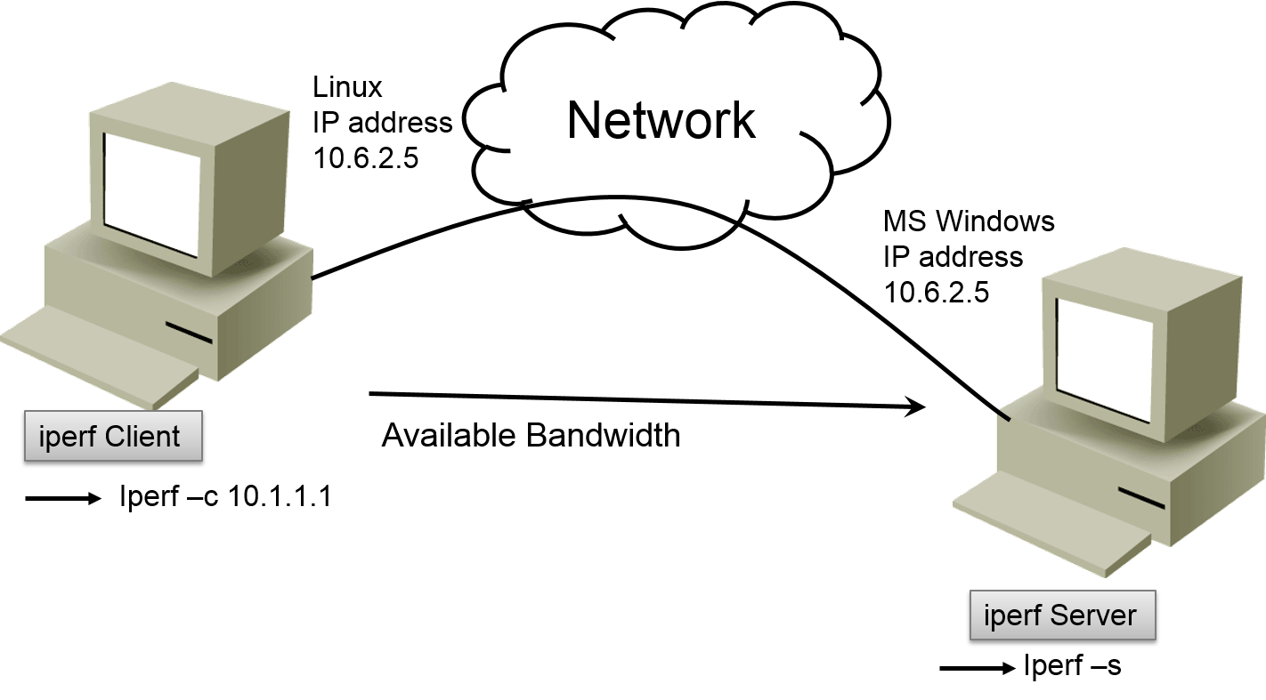
NOTE: Here we are using Iperf3 for TCP and UDP measurement.

Introducing Hping3
Hping3 is a free packet generator and analyzer for the TCP/IP protocol, it is a command-line oriented TCP/IP packet assembler/analyzer.
Features of Hping3:
- Firewall testing
- Advanced port scanning
- Network testing, using different protocols, TOS, fragmentation
- Manual path MTU discovery
- Advanced traceroute, under all the supported protocols
- Remote OS fingerprinting
- Remote uptime guessing
- TCP/IP stacks auditing
- hping can also be useful to students that are learning TCP/IP
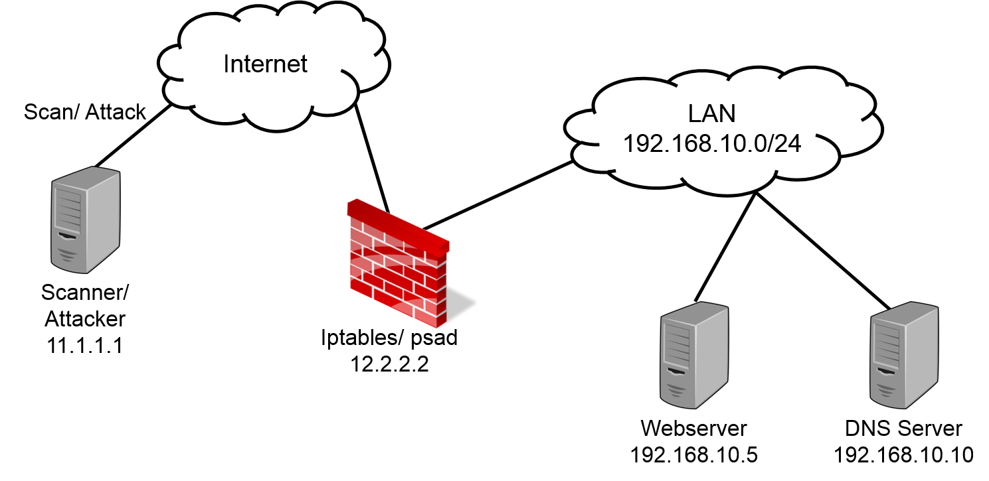
NOTE: Here, Hping3 for ICMP measurement is used.

Network Traffic Testing Tool (NTTT)
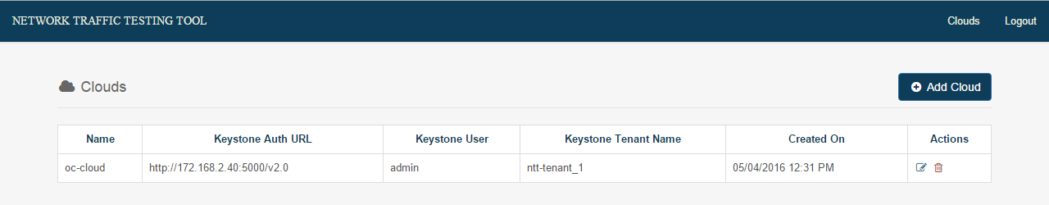
Step1: OpenStack Cloud Log in details.
- Name: oc-cloud
- Auth URL: http://172.168.2.40:5000v2.0
- User: Admin
- Tenant Name: ntt-tenant_1
- Created On: 4/15/2016 12:29pm
- Actions: Edit or delete tenant
Step2: In the Actions field, click Edit to edit the Cloud Credentials.

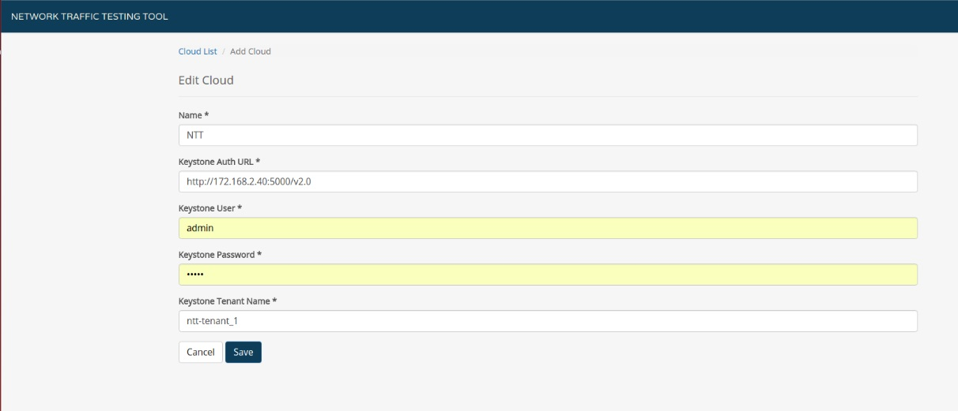
Step3: Edit the required fields and click Save.
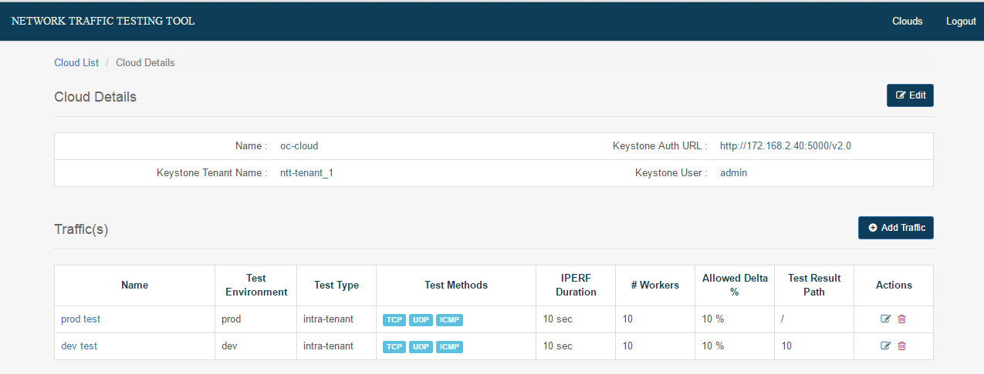
Step4: Once logged in, Cloud details will be displayed. Select traffic.
There are 2 types of traffic testing:
- Prod Test: Traffic testing is done on Production Environment.
- Dev Test: Traffic testing is done on Development Environment.

Prod Environment
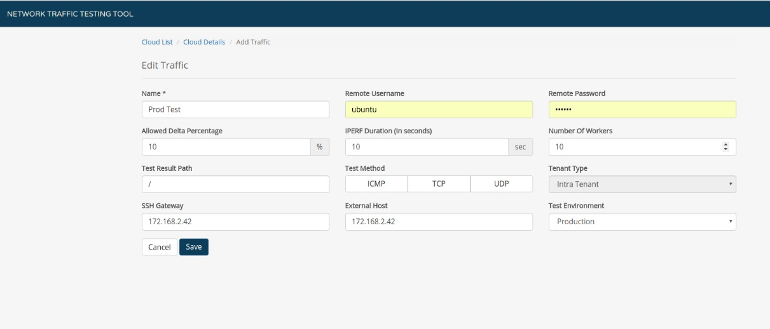
Step1: Click Edit, in the Test Environment field, select Production and click Save.
Note: In the Test Method, select any of the protocols (ICMP, TCP, UDP), that you want to run the traffic test.

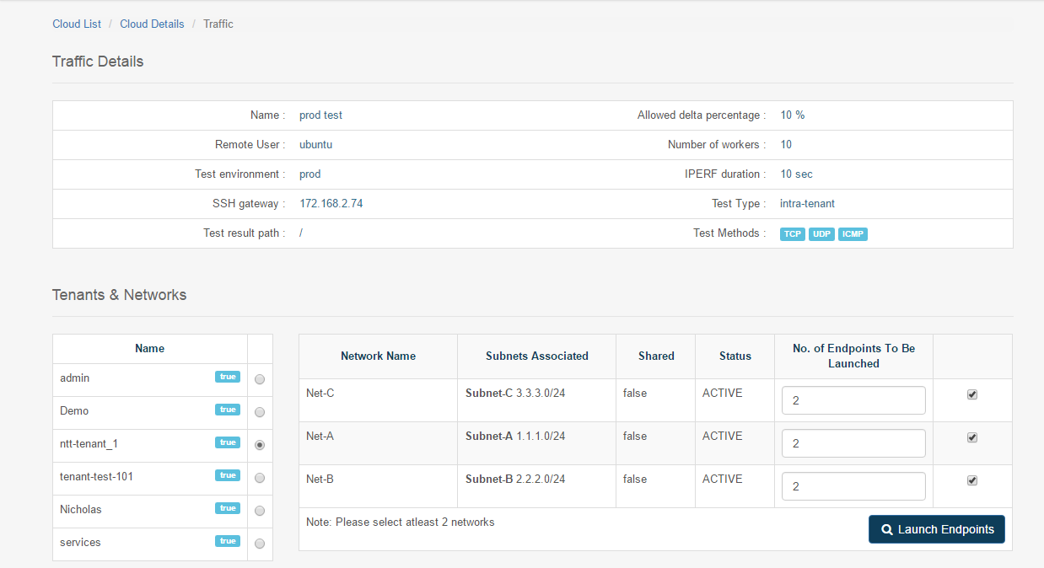
Step2: In Traffic section, in the test environment field, select prod.
Step3: Select Tenant and Network which has subnet associated with it.
Note: Select minimum two networks, one for source and another for destination.

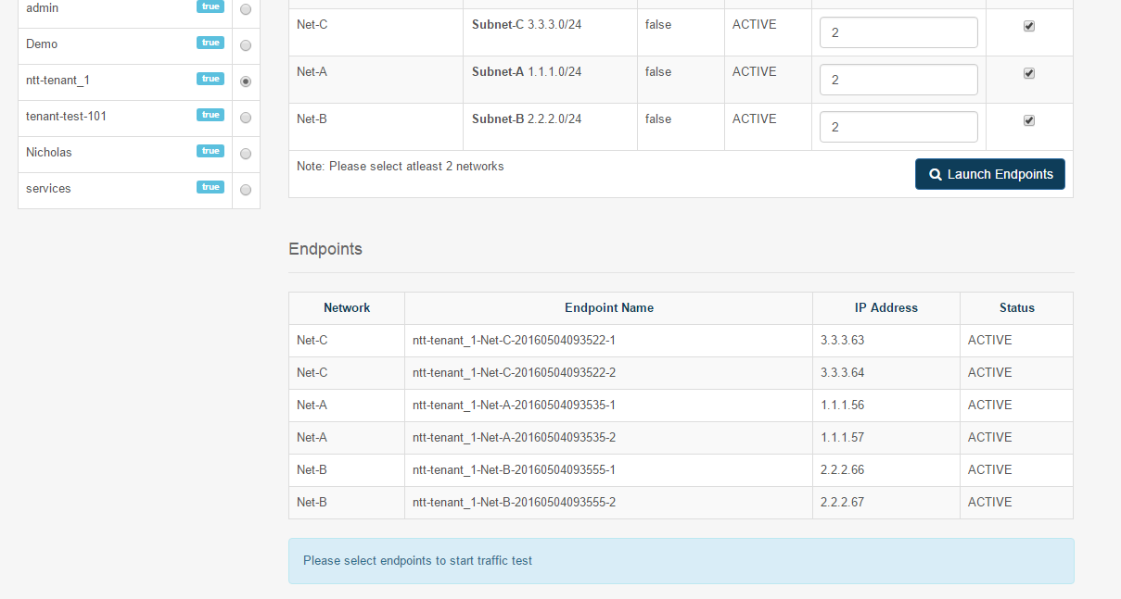
Step4: Select a particular Network, in the Endpoint Count column, enter the number of virtual machines that needs to be launched on this particular network.
Step5: Click Launch Endpoints. It will automatically assign IP addresses between subnet range as mentioned.
Note: Select minimum two networks, one for source and another for destination.
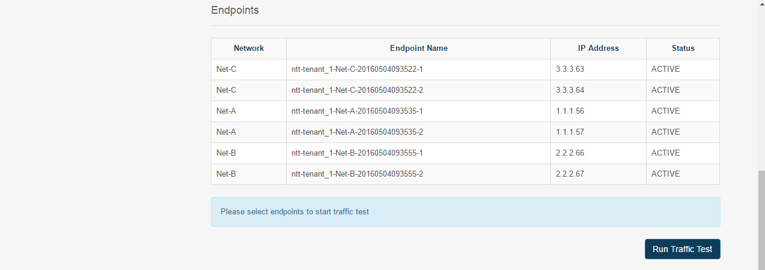
Step6: Click Run Traffic Test.

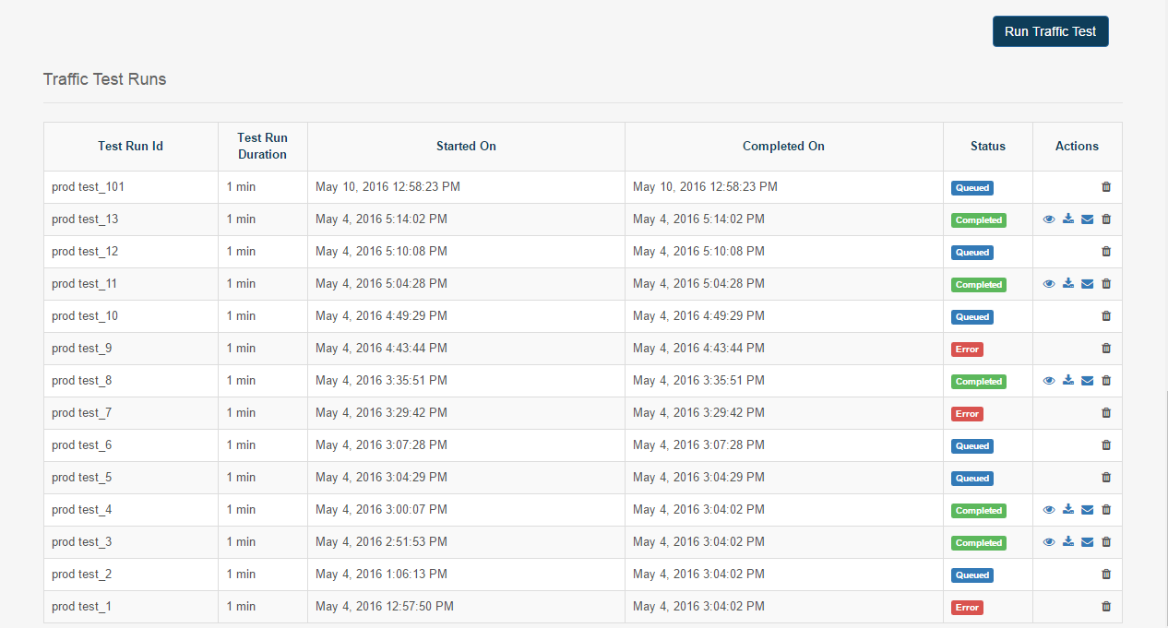
Prod Environment Output.

Dev Environment
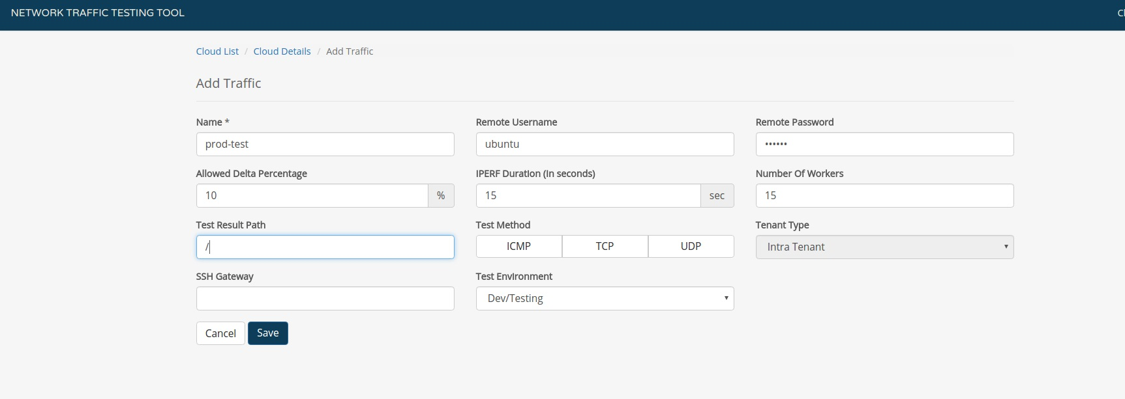
Step1: Click Edit. Enter the required details of the dev Environment and click Save.
Note: In the Test Method, you can select any of the protocols (ICMP, TCP, UDP), that you want to run the traffic test.

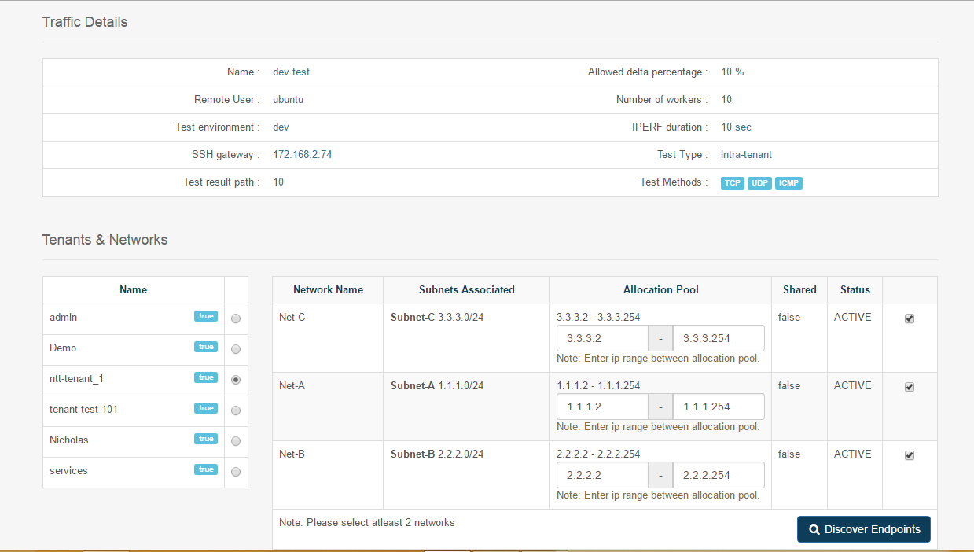
Step2: Select test environment: dev. Select Tenant and Network with the associated subnet.
Note: Select minimum two networks, one for source and another for destination.
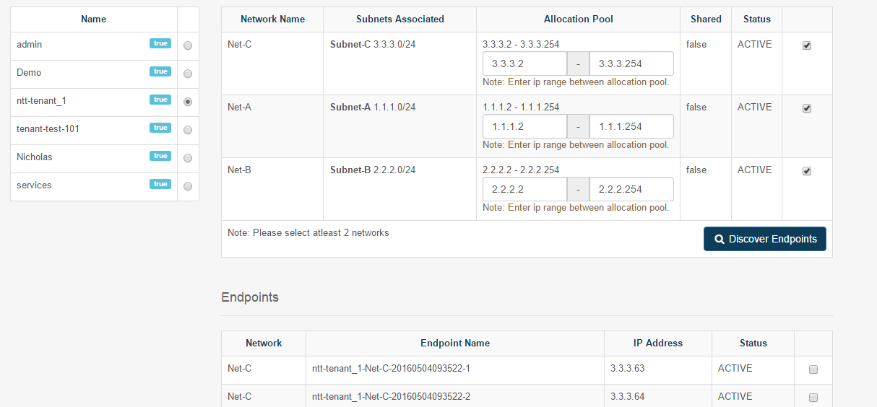
Step3: Click Discover Endpoints, it will automatically assign IP addresses between subnet range as mentioned.
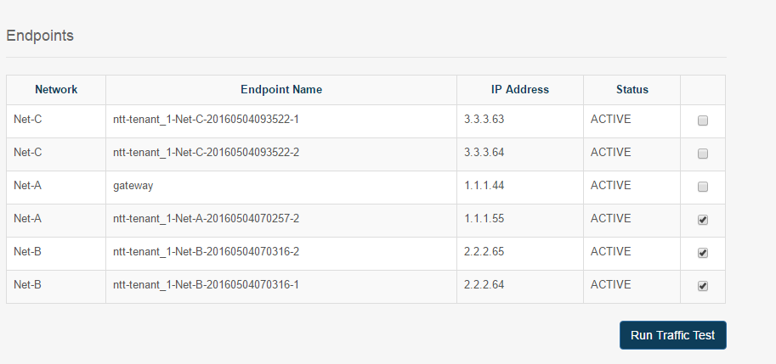
Step4: Select a particular network to run traffic test and click Run Traffic Test.
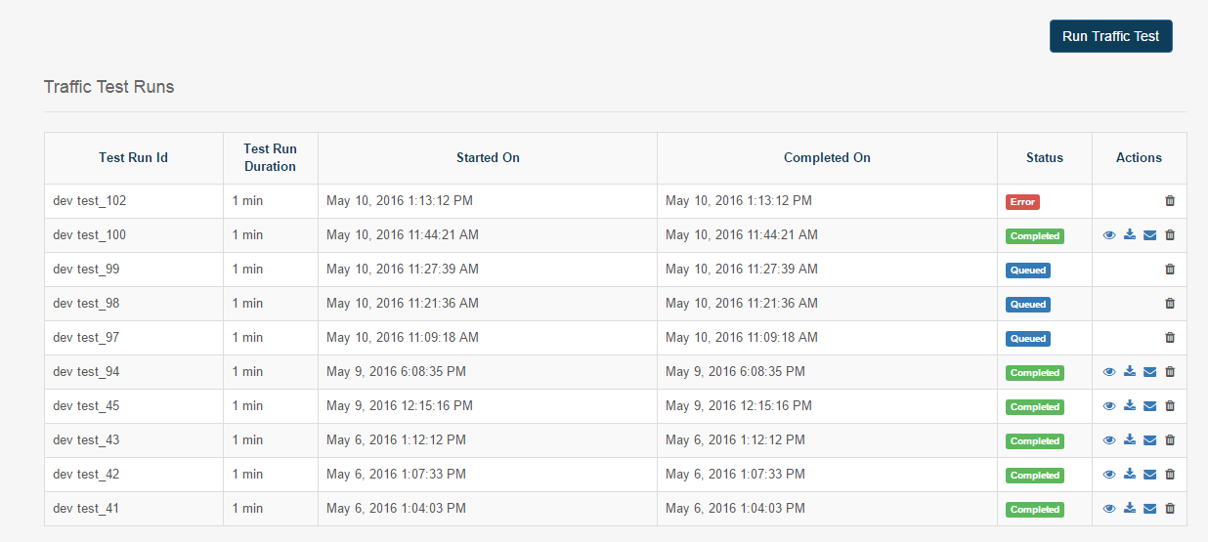
Dev Environment Output.

Feature Enhancements
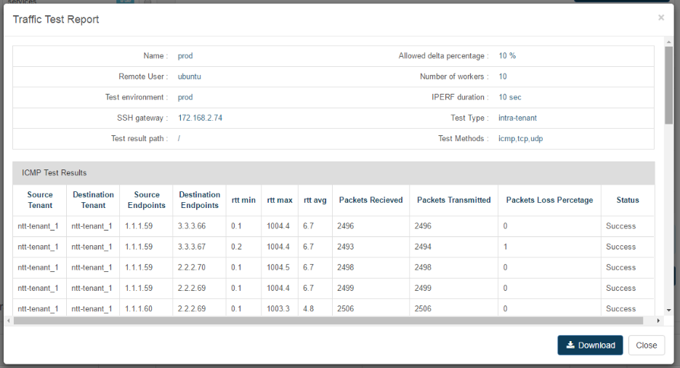

- Detailed Test Report with complete traffic configuration, time taken and test results.
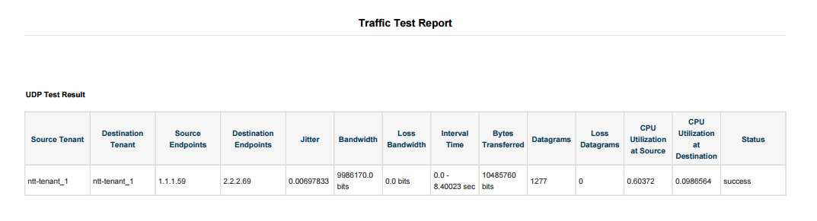
- More iperf parameter options like (packet size, packet rate, cpu utilization, memory consumption etc) are going to be measured for Streaming testing.
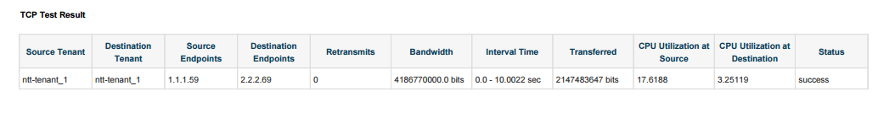
- Real Time Monitoring (cpu utilization, memory consumption etc) during Traffic Generation.
- Enabling other pending Test Types (Inter-tenant, South-North and North-South) with complete functionality.

References

- “Network traffic or Data traffic”
https://en.wikipedia.org/wiki/Network_traffic
- “Network Performance”
https://en.wikipedia.org/wiki/Network_performance
- “Introduction Iperf3”
https://iperf.fr/
- “Introduction hping3”
http://www.hping.org/

