**General Scan Procedure Checklist**

**(1) Turn on laser**

1. Follow manufacturer’s instructions

**(2)** **Turn on all equipment and align optics**

1. Turn on AOM Rigol and amplifiers [settings are below; the SW will set them for a scan, but not during your alignment phase]
   1. Channel 1 Voltage: 240mV
   2. Channel 1 Frequency: 100MHz
   3. Channel 2 Voltage: 240mV
   4. Channel 2 Frequency: 95mHz
2. Turn on Berkeley Nucleonics delay generator
3. Turn on ultrasound Rigol
4. Open Real time FFT Explora program: fftutilExplora.exe located in:

C:/Users/Openwater/scan/opw_acousto-optic_sw/system/util/fftutil/msvc/x64/Release/fftutilExplora.exe

*Troubleshooting:*

* *If the program says “no frame received” for more than ~5 seconds try closing it and opening it again*
* *If that doesn’t work, close it, unplug the camera usbs from the power hub or computer directly, plug them back in, wait ~5 seconds, then try the program again. It should say “firmware downloading”. If it still says “no frame received” for more than ~5 seconds, try closing it and opening it again (without unplugging the cameras)*

Common handy real time fft commands:

id *this will tell you which camera you’re currently looking at*

id <camera ID> *this will switch between cameras [ie: current cameras: id 7 is the sample camera, id 3 is the camera on the bandwidth interferometer arm]*

fft log <min> <max> *this will rescale the fft display; hint: look at the min/max values displayed on the screen to intelligently choose a min/max value; these values will be retained even when you close the program*

roi *this will return the (x_center, y_center, radius) values you need to set in the scan software; you can also set the roi manually by using roi <x_center> <y_center> <radius>*

You can use the mouse scroll wheel to zoom in on the image.

You can click and drag on the FFT side to select a ROI; these are the regions the ROI/ROU are calculated from. If the red/blue circles are annoying, a single click anywhere on the window to make them go away.

1. Close the real time FFT program [make sure both the command line window that opens up when you run the real time FFT program as well as the window with the images/FFT are closed]
2. Turn on the ultrasound amplifier; before you do this, make sure the ultrasound transducer is plugged in and that the face of the transducer is submerged
3. Align the phantom/sample you are scanning. Note: when a scan completes it will leave the stages centered and closest to the sample. If you want to double check this:

X-Stage Center: 24.5mm (should be centered between source/detector)

Y-Stage Center: 13.5mm

Z-Stage Closest: 27.1mm

**(3) Run scan using Python scanUI software**

1. To open the jupyter notebook containing the scanUI:
   1. Open an Anaconda Powershell Prompt [Navigate to: Windows start button > Programs > Anaconda3 > Anaconda Powershell Prompt (Anaconda3)
   2. Type the following commands:

cd ../../Openwater/scan/opw_acousto-optic_sw/system/app

conda activate owi

jupyter notebook

* 1. A jupyter navigation screen should open in your internet browser window. Navigate to the scanUI notebook [scanUI > scanUI.ipynb]
  2. In the jupyter scanUI notebook click on the “Kernel” menu and select “Restart and Run ALL”. A pop-up will ask if you are sure. Click the red box for “Restart and Run All”
  3. Scroll down to the end of the page and you will see the widgets to fill in for the scan parameters
  4. Some notes on the parameters:
     1. If you want a single XY plane, set the Z length to 0 (step size: 1) [this works for any dimension]
        1. Coordinate reference frame

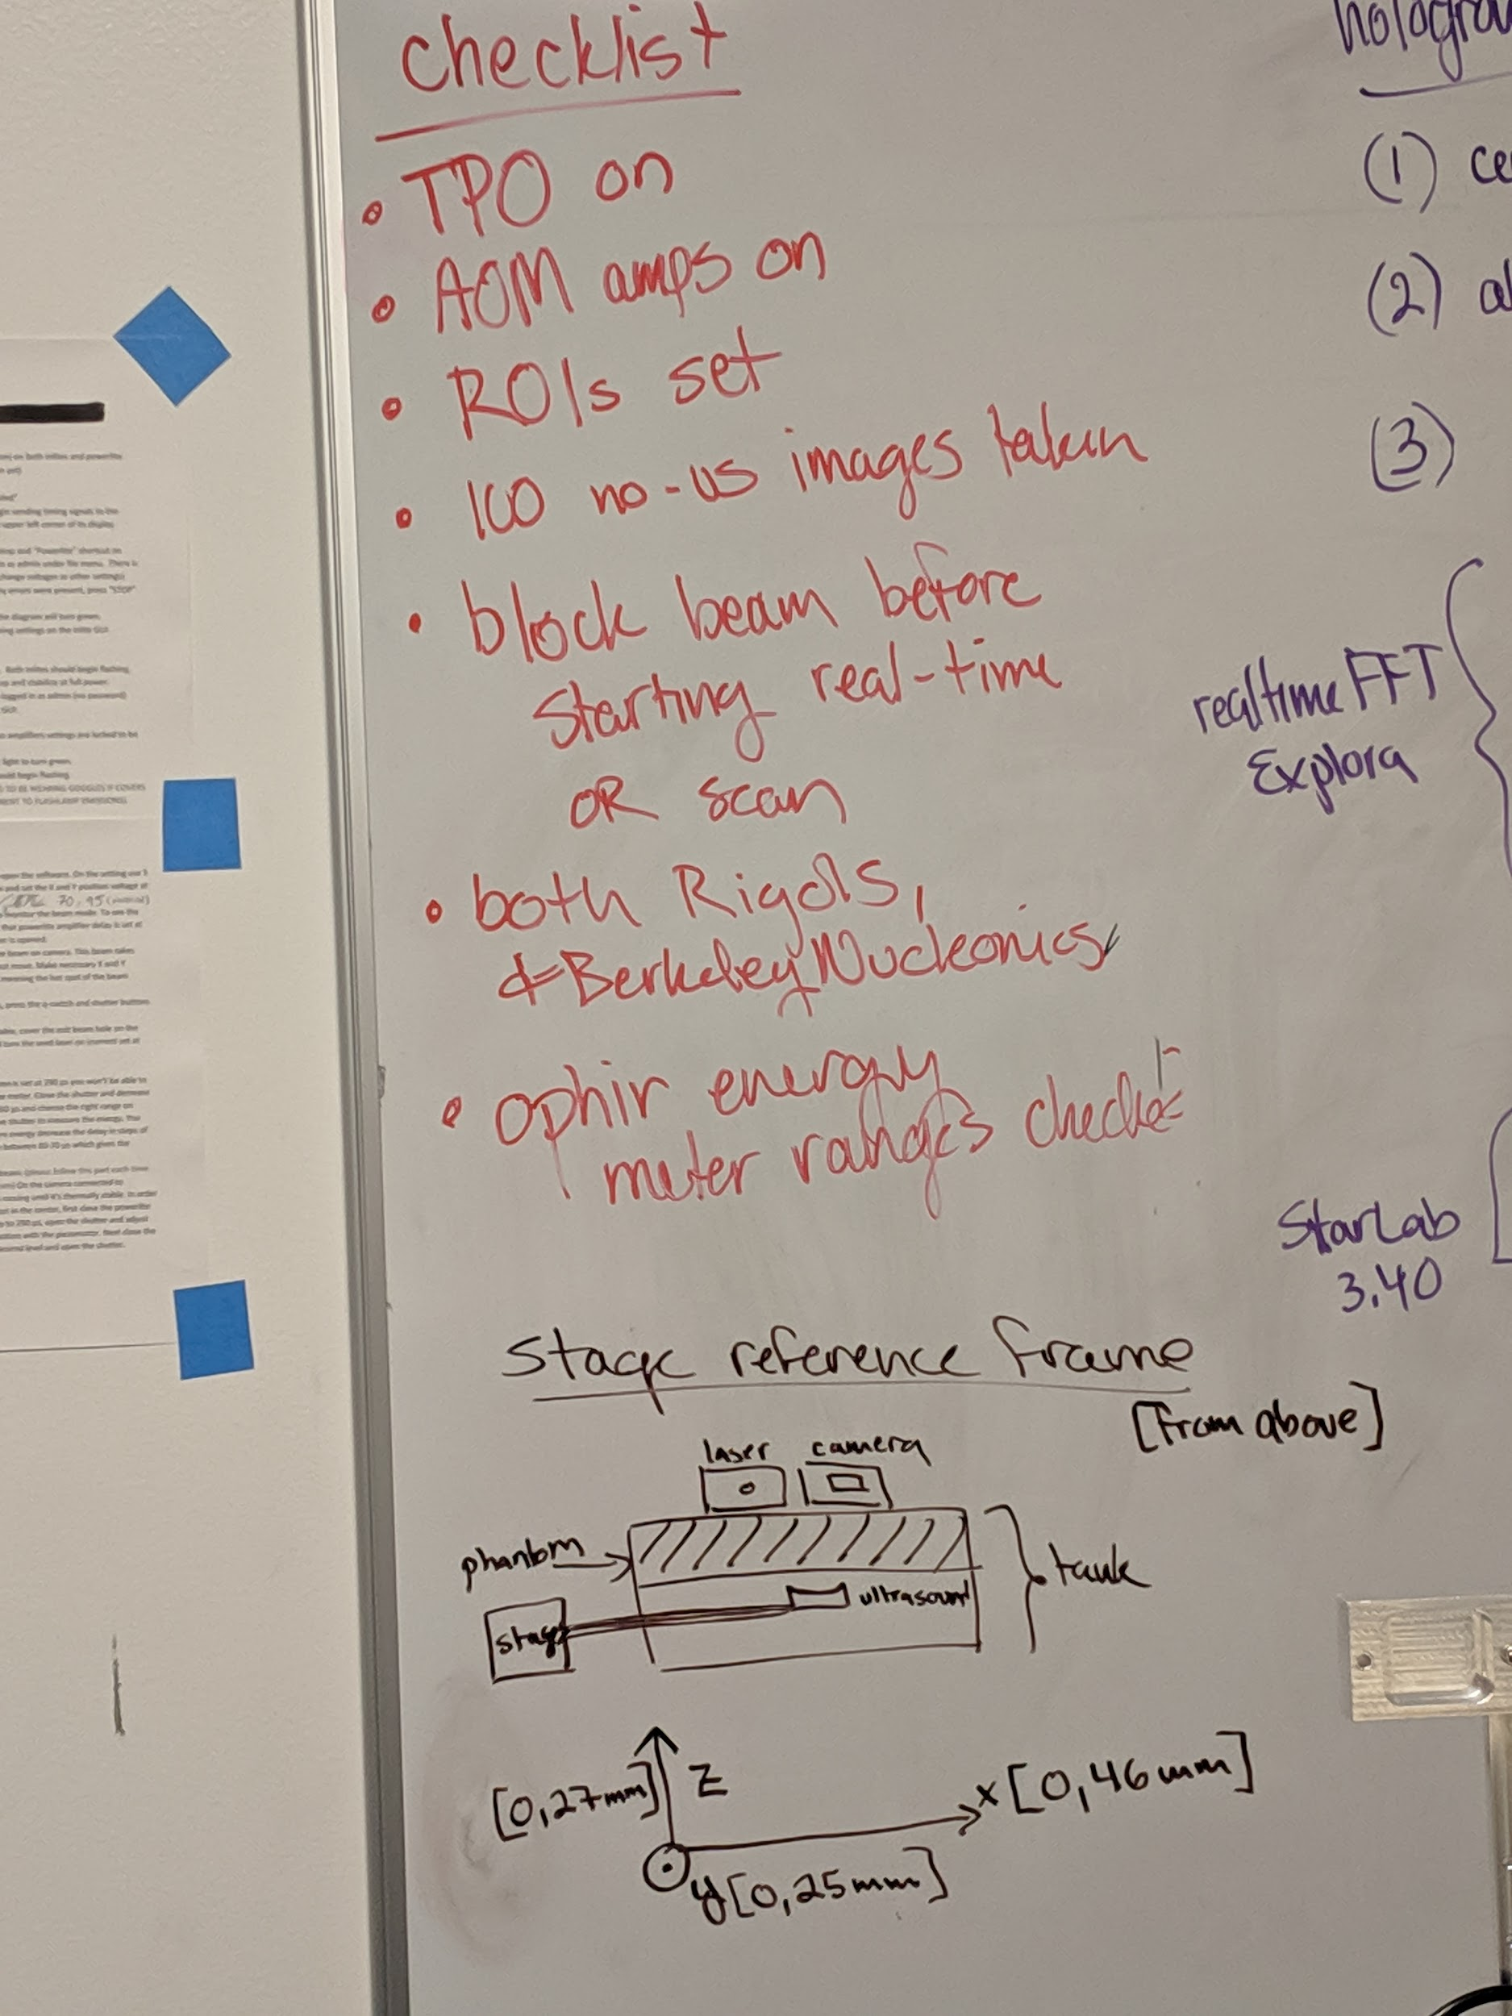

* + 1. You must enter the correct camera id numbers or the scan will not run; in the current system, they are [207 (sample camera) and 209 (bandwidth interferometer arm)]
  1. **Before You Click Scan!**
     1. Are you sure the ultrasound amplifier is on?
     2. Are you sure the ultrasound transducer is underwater [manually lift it to the limit of the stage. Is it still under water?]
  2. Click “Scan”
     1. Note the snazzy display of the FFT energy ROI energy at each voxel for each camera and the progress bar
     2. You can add to the “Experiment Notes” while the scan is running and click “Update Experiment Notes” and it will automatically update in the metadata
  3. How to tell if it’s working and when it’s finished:
     1. In the Anaconda Powershell Prompt it will say:

Num cameras: 2

cam loc: camera3 [if it says no sensor connected this is bad. start over]

cam loc: camera7

connected to camera: lots of numbers

connected to camera: lots of numbers

it will talk about stages / ready to begin

*Troubleshooting:*

* *If it says “unable to connect to comport” you probably forgot to turn on the Berkeley Nucleonics Delay Generator*
* *If it says “image sensor not found” or something like that, the matchstick is not properly connected to either the gumstick or the flex-cable*
  + 1. When the scan is done, it will say scan completed!
    2. Where did my data go?
       1. All raw hologram images are saved in the Resilio drive.
       2. The imageInfo.csv file in D:/data_scans/systemName/syncedScanDataFiles contains all of the processed data for each voxel, it also contains the scan_metadata.json that has the specific configurations for each scan

*Troubleshooting:*

* *In the Jupyter notebook cell, if you see scan completed before any voxels appear, something has gone horribly wrong with the scanning code*
* *To check if images are actually being saved, you can look in the D:/data_scans/*systemName*/rawImages directory for each camera and make sure it’s getting updated*
* *To check if it’s being triggered: The ultrasound rigol will display “instrument triggered” for each voxel that’s collected*
* *Are the stages behaving: The lights on each stage will be green and flashing while the stage is moving, and solid green when it’s stationary. If the lights ever turn red/orange, there was a failure and they will no longer be moving. Often failure is caused by the stages being blocked or told to go beyond their set limits.*
* *Anaconda Powershell prompt says “error” or “flashing, firmware downloaded, camera re-triggered”. This means there was a camera error and the camera was reset. Generally not a problem if it happens once or twice a scan, but if it starts to happen with every voxel, then something is horribly wrong with the camera. Stop the scan, unplug the cameras from the computer, and try again.*

# Software Specific:

1. Open Anaconda Powershell window (usually pinned on taskbar or you can ‘search’ the computer for it)
2. 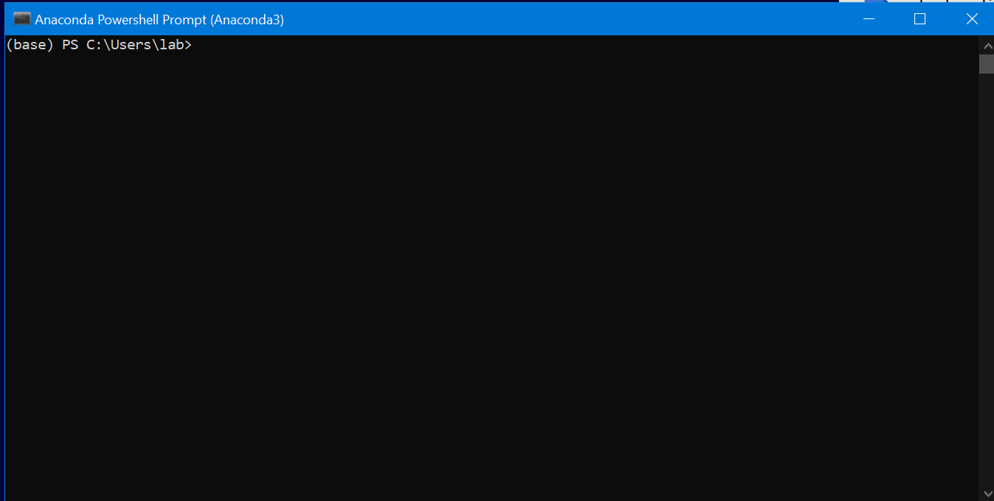
3. Go to C:/Openwater/scan/opw_acousto-optic_sw/system (use ‘cd’ to change directory and ‘cd ..’ to go to the previous directory if needed): ex if you are in ‘C:/Users/lab>’ then type ‘cd ../../Openwater/scan/opw_acousto-optic_sw/system’ (and hit return).
4. Then ‘conda activate owi’ (enter)
5. Then ‘jupyter notebook’ (enter)
6. 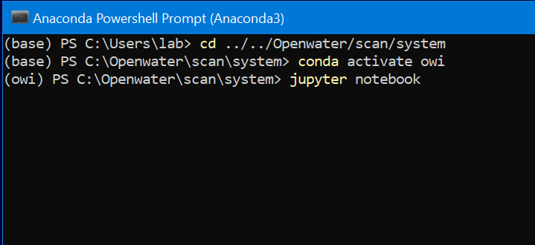
7. This launches the browser.
8. Go to app>scanUI>scanUI.ipynb
9. 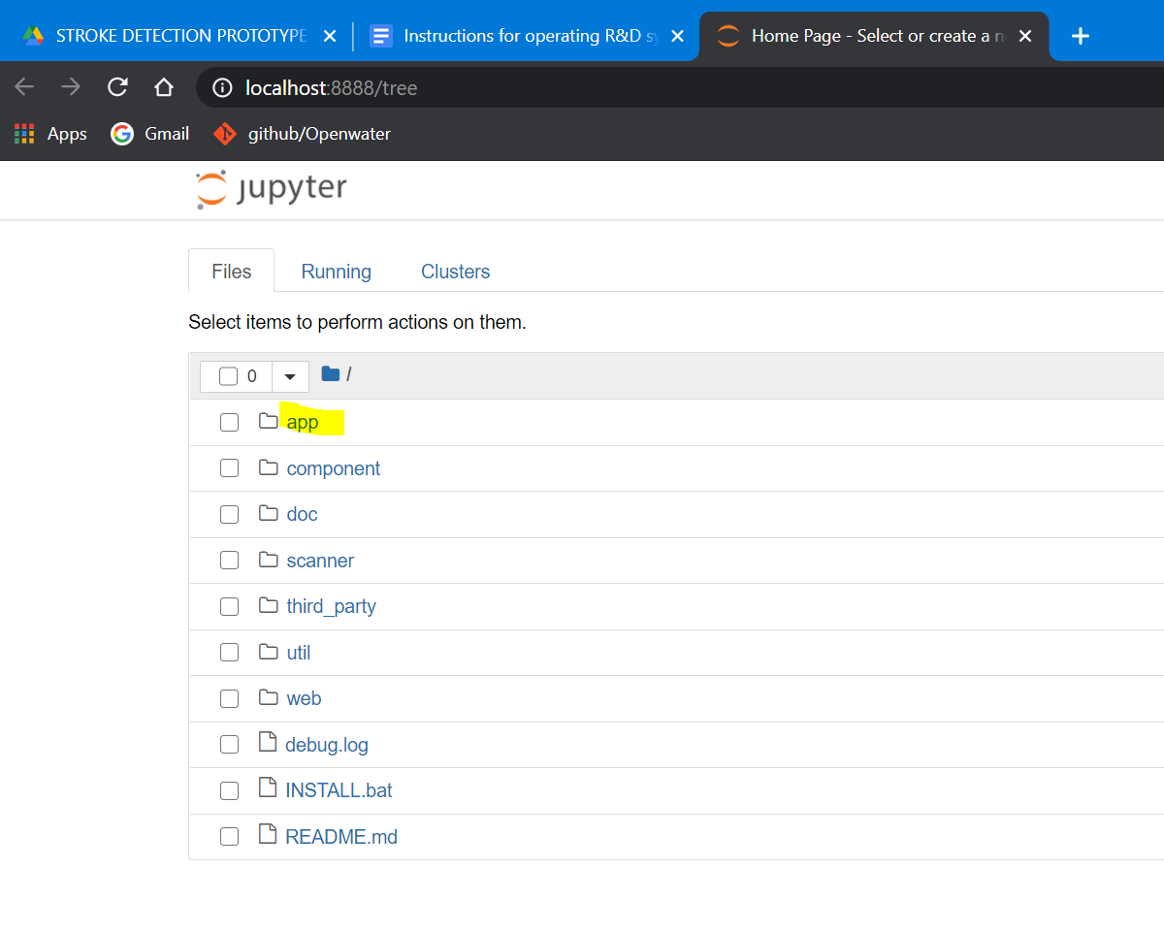
10. 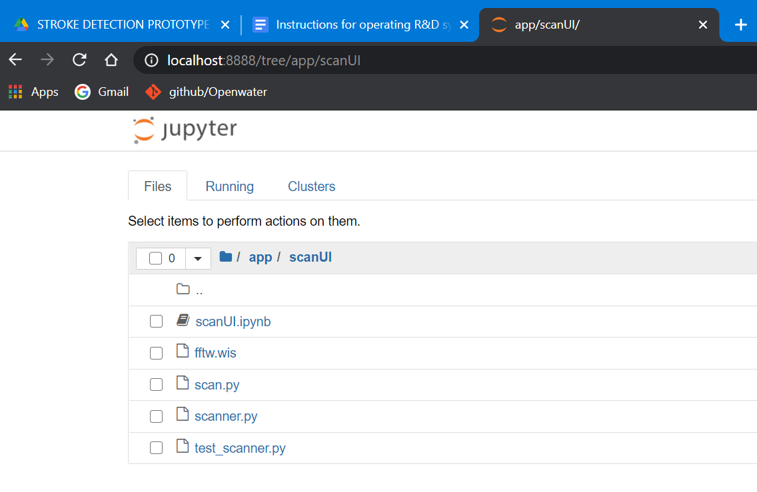
11. Hit ‘restart and run all cells’
12. 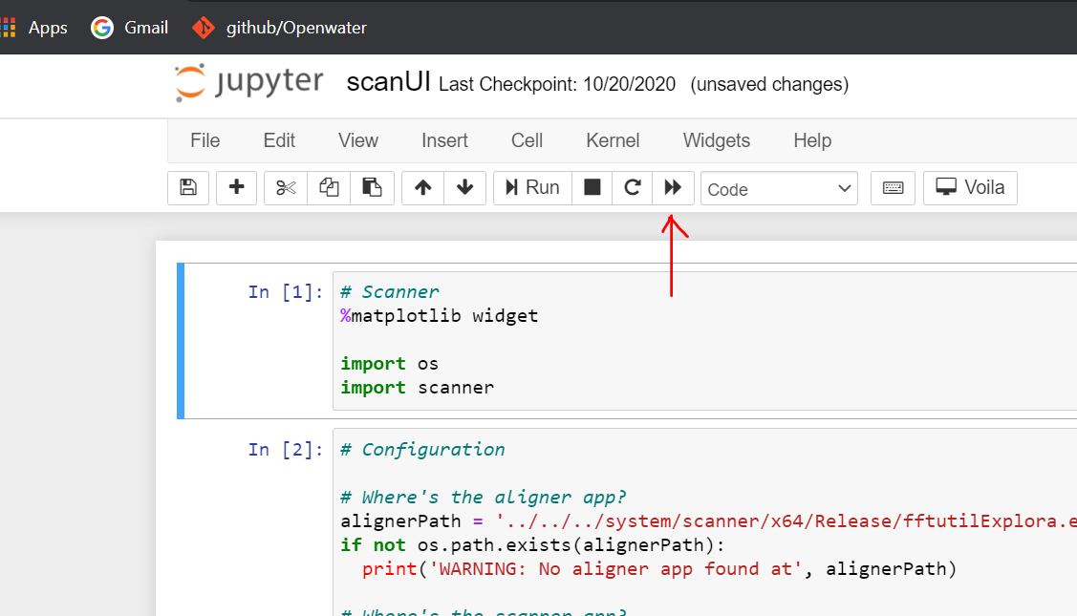
13. After a few seconds it launches the GUI
14. 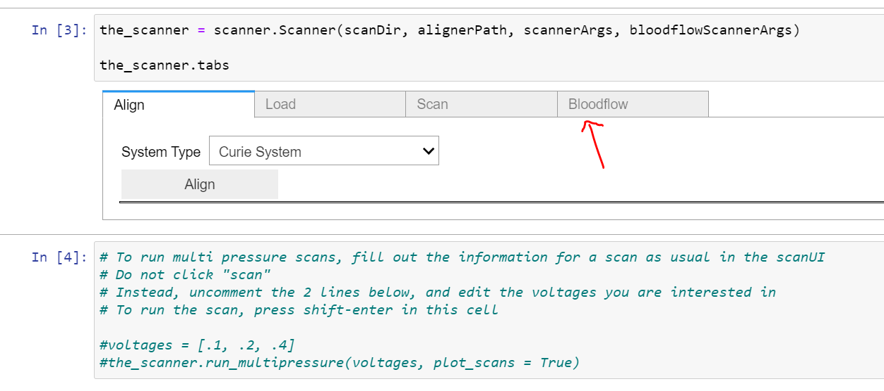
15. Click on Scan
16. Choose the right system that you are working on, from the dropdown menu (System type).
17. Keep an eye on the Powershell window for possible errors.
18. If you get any frame errors, just repeat the scan.
19. When scan is done, the GUI and powershell display messages.