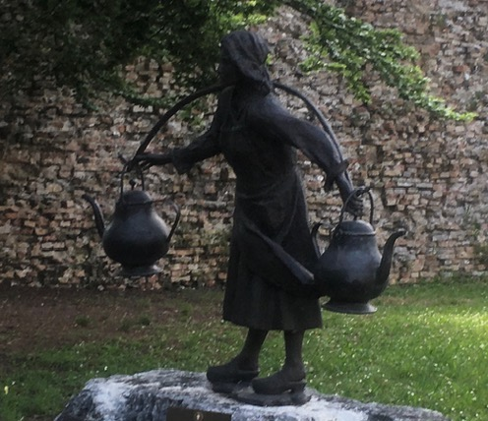

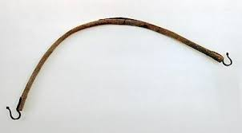

WORKSHOP
BIGÒLO

The bigòlo is a tool made up of a curved wooden stick to the ends of which two hooks were attached, functional for transporting water, or milk, or even fruit and vegetables. It is particularly suitable and useful in the city of Venice or other countries.

Duration: ca 1 ora
Cost: 30 euro

(+49) 0176 5032 55 53
operamania@icloud.com

