Work Breakdown Structure
The WBS divides the healthcare intelligence project into seven work packages, covering data assessment, analysis and model development, solution testing, documentation and presentation, as the brief requires. Every element maps to a scheduled activity ID, a deliverable and a responsible role. The four milestones and the closing milestone are listed after the table.

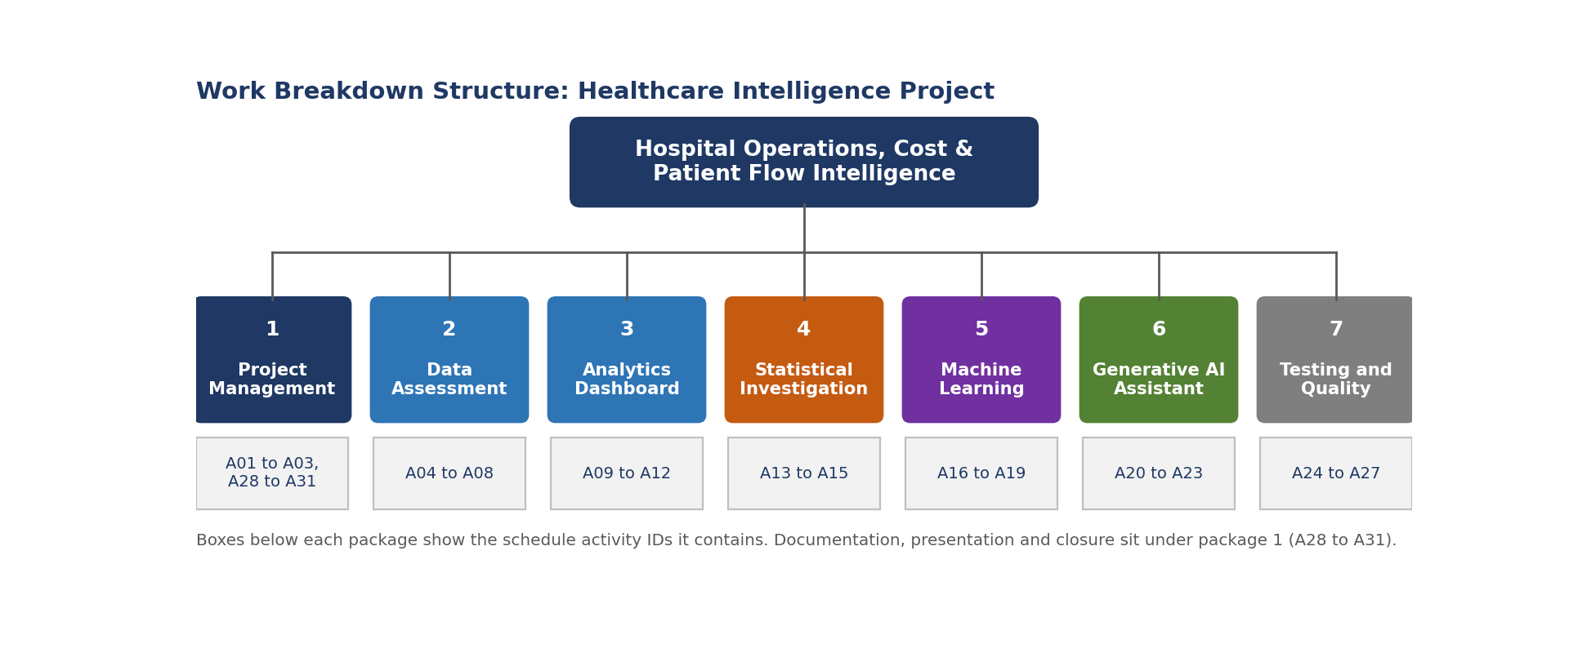
WBS | Work element | ID | Deliverable | Responsible
1 | PROJECT MANAGEMENT
1.1 | Project kick-off and charter approval | A01 | Signed charter | Project Manager
1.2 | Secure workspace, access and isolated practice environment setup | A02 | Secure workspace and isolated practice environment | Project Manager, Data Analyst
1.3 | Privacy and data handling plan (identifier minimization) | A03 | Privacy and data handling plan | Privacy Officer, Project Manager
1.4 | Documentation and reproducibility pack (READMEs, setup guides) | A28 | Documentation and reproducibility pack | Project Manager, Business Analyst
1.5 | Executive summary and final presentation preparation | A29 | Executive summary and presentation | Project Manager, Data Analyst
1.6 | Final presentation and handover session | A30 | Presentation and handover session | Project Manager
1.7 | Handover checklist, lessons learned and project closure | A31 | Completed handover checklist and lessons learned | Project Manager
2 | DATA ASSESSMENT
2.1 | Dataset inspection: records, fields, keys and relationships | A04 | Dataset inspection record and field availability matrix | Data Analyst, Data Scientist
2.2 | Data quality assessment (missing values, duplicates, types, dates) | A05 | Data quality assessment | Data Analyst, Data Scientist
2.3 | SQL script safety review and isolated MySQL database setup | A06 | SQL script safety review and isolated database | Data Analyst, Privacy Officer
2.4 | KPI and metric definitions agreed (zero coverage, duration, repeat encounter, currency) | A07 | Signed KPI and metric definition sheet | Business Analyst, Data Analyst
2.5 | Feasibility check of analysis, prediction targets and knowledge sources | A08 | Feasibility decisions for analysis, target and knowledge sources | Data Scientist, Machine Learning Engineer, Generative AI Engineer
3 | ANALYTICS DASHBOARD
3.1 | Data model and Power Query transformations | A09 | Data model and documented transformations | Data Analyst
3.2 | KPI and DAX measure development | A10 | KPI measures with definitions | Data Analyst
3.3 | Dashboard pages: overview, trends, encounter class, cost and payer, procedures | A11 | Dashboard with overview, trend, class, cost and payer, procedure pages | Data Analyst
3.4 | Dashboard validation against source data | A12 | Validation evidence for the dashboard | Data Analyst, QA Tester
4 | STATISTICAL INVESTIGATION
4.1 | Exploratory analysis and research question definition | A13 | Research question and exploratory findings | Data Scientist
4.2 | Hypothesis testing and limitations analysis | A14 | Hypothesis test results and limitations | Data Scientist
4.3 | Statistical report and visualizations | A15 | Statistical report and visualizations | Data Scientist
5 | MACHINE LEARNING
5.1 | Target and feature definition with leakage check | A16 | Target and feature specification with leakage check | Machine Learning Engineer
5.2 | Baseline and model training pipeline | A17 | Baseline and trained model with workflow | Machine Learning Engineer
5.3 | Model evaluation and error analysis | A18 | Evaluation metrics and error analysis | Machine Learning Engineer, Data Scientist
5.4 | Inference script, input validation and tests | A19 | Inference script, input validation and tests | Machine Learning Engineer, QA Tester
6 | GENERATIVE AI ASSISTANT
6.1 | Knowledge source preparation (data dictionary and validated findings) | A20 | Structured knowledge sources and documented gaps | Generative AI Engineer, Business Analyst
6.2 | Assistant prototype with retrieval and controlled query layer | A21 | Working assistant prototype | Generative AI Engineer
6.3 | Test set creation and assistant evaluation (20 or more questions) | A22 | Test set and evaluation report | Generative AI Engineer, QA Tester
6.4 | Responsible AI and privacy risk assessment | A23 | Privacy and responsible AI risk assessment | Generative AI Engineer, Privacy Officer
7 | TESTING AND QUALITY ASSURANCE
7.1 | Cross deliverable quality review and figure reconciliation | A24 | Reconciliation and quality review record | QA Tester, Business Analyst
7.2 | Privacy and security review of all outputs and repository | A25 | Privacy and security review record | Privacy Officer, QA Tester
7.3 | Stakeholder review and user acceptance testing | A26 | Signed UAT record | Business Analyst, Project Manager
7.4 | Defect fixing and rework | A27 | Closed defect log | Data Analyst, Data Scientist, Machine Learning Engineer, Generative AI Engineer

Milestones
ID | Milestone | Date | Gate
M1 | Project Mobilized | 08 Jan 2027 | QG1
M2 | Data Assessment Approved | 26 Jan 2027 | QG2
M3 | All Solution Components Built | 15 Mar 2027 | QG3
M4 | Deliverables Accepted | 06 Apr 2027 | QG4
M5 | Project Closed | 16 Apr 2027 | QG5
WBS dictionary note. Each work element is complete only when its deliverable meets the acceptance criteria in the Quality and Acceptance Plan (Deliverable 6).

