Gantt Chart and Dependency Analysis

1. Scheduling Approach and Assumptions
The schedule covers 31 activities and 5 milestones over 73 working days, from 04 Jan 2027 to 16 Apr 2027. It was built with the Critical Path Method in Excel (the workbook recalculates dates, float and critical path from the inputs). The assumptions below were used to estimate durations and dependencies:
# | Assumption
1 | The working week is Monday to Friday. Good Friday (26 March 2027) and Easter Monday (29 March 2027) are non-working days. Moveable holidays are not pre-loaded.
2 | All dependencies are Finish to Start with no lag, which is the most cautious simple logic.
3 | Durations are expert estimates in working days for a small team, one person per role, informed by the size of each deliverable. They will be refined once the datasets are inspected in A04.
4 | Each role works on one activity at a time, so the four technical work streams run in parallel only because they use different roles.
5 | Client reviews and approvals take no more than 2 working days and are included in activity durations.
6 | Statistical, ML and assistant knowledge preparation work depends on the approved data assessment (M2), not on each other.
7 | The assistant needs validated metrics from the dashboard (A12) before its controlled query layer is built, which creates a cross work stream dependency.

2. Project Schedule
ID | Activity | Dur. | Start | Finish | Predecessors | Responsible role | Float
P1 | PHASE 1: INITIATION & GOVERNANCE
A01 | Project kick-off and charter approval | 2 | 04 Jan 2027 | 05 Jan 2027 | None | Project Manager | 0 Critical
A02 | Secure workspace, access and isolated practice environment setup | 3 | 06 Jan 2027 | 08 Jan 2027 | A01 | Project Manager, Data Analyst | 0 Critical
A03 | Privacy and data handling plan (identifier minimization) | 3 | 06 Jan 2027 | 08 Jan 2027 | A01 | Privacy Officer, Project Manager | 0 Critical
M1 | Milestone: Project Mobilized | 0 | 08 Jan 2027 | 08 Jan 2027 | A02, A03 | Project Manager | 0 Critical
P2 | PHASE 2: DATA ASSESSMENT
A04 | Dataset inspection: records, fields, keys and relationships | 4 | 11 Jan 2027 | 14 Jan 2027 | M1 | Data Analyst, Data Scientist | 0 Critical
A05 | Data quality assessment (missing values, duplicates, types, dates) | 5 | 15 Jan 2027 | 21 Jan 2027 | A04 | Data Analyst, Data Scientist | 0 Critical
A06 | SQL script safety review and isolated MySQL database setup | 3 | 11 Jan 2027 | 13 Jan 2027 | M1 | Data Analyst, Privacy Officer | 9
A07 | KPI and metric definitions agreed (zero coverage, duration, repeat encounter, currency) | 4 | 15 Jan 2027 | 20 Jan 2027 | A04 | Business Analyst, Data Analyst | 4
A08 | Feasibility check of analysis, prediction targets and knowledge sources | 3 | 22 Jan 2027 | 26 Jan 2027 | A05 | Data Scientist, Machine Learning Engineer, Generative AI Engineer | 0 Critical
M2 | Milestone: Data Assessment Approved | 0 | 26 Jan 2027 | 26 Jan 2027 | A05, A06, A07, A08 | Project Manager | 0 Critical
P3 | PHASE 3: ANALYTICS DASHBOARD
A09 | Data model and Power Query transformations | 5 | 27 Jan 2027 | 02 Feb 2027 | M2 | Data Analyst | 0 Critical
A10 | KPI and DAX measure development | 5 | 03 Feb 2027 | 09 Feb 2027 | A09 | Data Analyst | 0 Critical
A11 | Dashboard pages: overview, trends, encounter class, cost and payer, procedures | 8 | 10 Feb 2027 | 19 Feb 2027 | A10 | Data Analyst | 0 Critical
A12 | Dashboard validation against source data | 3 | 22 Feb 2027 | 24 Feb 2027 | A11 | Data Analyst, QA Tester | 0 Critical
P4 | PHASE 4: STATISTICAL INVESTIGATION
A13 | Exploratory analysis and research question definition | 5 | 27 Jan 2027 | 02 Feb 2027 | M2 | Data Scientist | 19
A14 | Hypothesis testing and limitations analysis | 6 | 03 Feb 2027 | 10 Feb 2027 | A13 | Data Scientist | 19
A15 | Statistical report and visualizations | 4 | 11 Feb 2027 | 16 Feb 2027 | A14 | Data Scientist | 19
P5 | PHASE 5: MACHINE LEARNING
A16 | Target and feature definition with leakage check | 4 | 27 Jan 2027 | 01 Feb 2027 | M2 | Machine Learning Engineer | 14
A17 | Baseline and model training pipeline | 7 | 02 Feb 2027 | 10 Feb 2027 | A16 | Machine Learning Engineer | 14
A18 | Model evaluation and error analysis | 5 | 11 Feb 2027 | 17 Feb 2027 | A17 | Machine Learning Engineer, Data Scientist | 14
A19 | Inference script, input validation and tests | 4 | 18 Feb 2027 | 23 Feb 2027 | A18 | Machine Learning Engineer, QA Tester | 14
P6 | PHASE 6: GENERATIVE AI ASSISTANT
A20 | Knowledge source preparation (data dictionary and validated findings) | 5 | 27 Jan 2027 | 02 Feb 2027 | M2 | Generative AI Engineer, Business Analyst | 16
A21 | Assistant prototype with retrieval and controlled query layer | 8 | 25 Feb 2027 | 08 Mar 2027 | A20, A12 | Generative AI Engineer | 0 Critical
A22 | Test set creation and assistant evaluation (20 or more questions) | 5 | 09 Mar 2027 | 15 Mar 2027 | A21 | Generative AI Engineer, QA Tester | 0 Critical
A23 | Responsible AI and privacy risk assessment | 3 | 09 Mar 2027 | 11 Mar 2027 | A21 | Generative AI Engineer, Privacy Officer | 2
P7 | PHASE 7: TESTING & QUALITY ASSURANCE
M3 | Milestone: All Solution Components Built | 0 | 15 Mar 2027 | 15 Mar 2027 | A12, A15, A19, A22, A23 | Project Manager | 0 Critical
A24 | Cross deliverable quality review and figure reconciliation | 5 | 16 Mar 2027 | 22 Mar 2027 | M3 | QA Tester, Business Analyst | 0 Critical
A25 | Privacy and security review of all outputs and repository | 3 | 16 Mar 2027 | 18 Mar 2027 | M3 | Privacy Officer, QA Tester | 6
A26 | Stakeholder review and user acceptance testing | 4 | 23 Mar 2027 | 30 Mar 2027 | A24 | Business Analyst, Project Manager | 0 Critical
A27 | Defect fixing and rework | 5 | 31 Mar 2027 | 06 Apr 2027 | A26, A25 | Data Analyst, Data Scientist, Machine Learning Engineer, Generative AI Engineer | 0 Critical
M4 | Milestone: Deliverables Accepted | 0 | 06 Apr 2027 | 06 Apr 2027 | A27 | Project Manager | 0 Critical
P8 | PHASE 8: DOCUMENTATION, PRESENTATION & CLOSURE
A28 | Documentation and reproducibility pack (READMEs, setup guides) | 6 | 16 Mar 2027 | 23 Mar 2027 | M3 | Project Manager, Business Analyst | 8
A29 | Executive summary and final presentation preparation | 4 | 07 Apr 2027 | 12 Apr 2027 | M4, A28 | Project Manager, Data Analyst | 0 Critical
A30 | Final presentation and handover session | 1 | 13 Apr 2027 | 13 Apr 2027 | A29 | Project Manager | 0 Critical
A31 | Handover checklist, lessons learned and project closure | 3 | 14 Apr 2027 | 16 Apr 2027 | A30 | Project Manager | 0 Critical
M5 | Milestone: Project Closed | 0 | 16 Apr 2027 | 16 Apr 2027 | A31 | Project Manager | 0 Critical
Dates and floats are produced by the Excel workbook. Float is total float in working days.

3. Gantt Chart
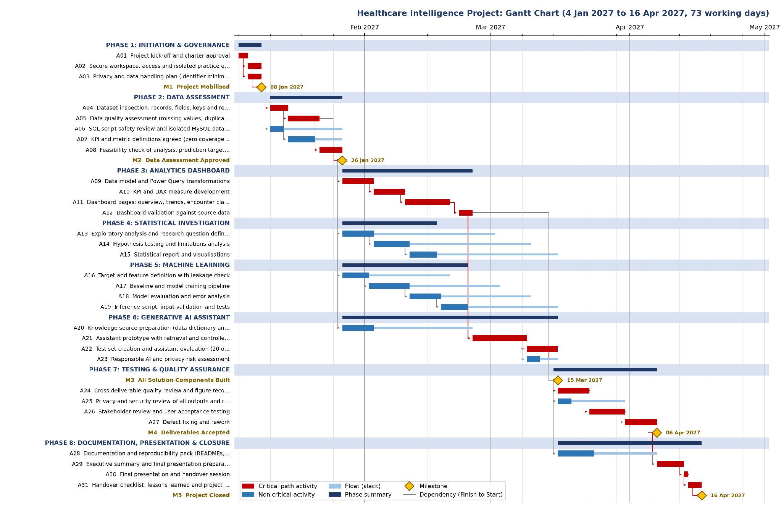
Red bars are critical path activities, blue bars have floats (light blue shows available slack), gold diamonds are milestones and arrows show dependencies. A weekly Gantt view is also in the Excel workbook.

4. Dependency Analysis
The table groups the dependencies that shape the schedule and gives the reason for each.
Link | Why the dependency exists | Type
A02, A03 to M1 | Mobilization needs both the workspace and the privacy plan before any data is opened | Finish to Start
A04 to A05 and A07 | Quality assessment and KPI definitions need the dataset inspection first | Finish to Start
A05 to A08 | Feasibility decisions need the documented data quality results | Finish to Start
A05, A06, A07, A08 to M2 | The data assessment gate needs all four results | Finish to Start
M2 to A09, A13, A16, A20 | All four technical work streams start only after the gate, so none builds on un assessed data | Finish to Start
A09 to A10 to A11 to A12 | Dashboard build runs in sequence: model, measures, pages, validation | Finish to Start
A12 to A21 | The assistant uses validated calculations for numbers, so it must wait for the validated dashboard metrics | Finish to Start (cross work stream)
A21 to A22 and A23 | Testing and the responsible AI assessment need a working prototype | Finish to Start
A12, A15, A19, A22, A23 to M3 | All components must be built before the quality review | Finish to Start
M3 to A24, A25, A28 | Review, privacy check and documentation start once components are complete | Finish to Start
A24 to A26, A26 and A25 to A27 | UAT needs a reconciled set of figures; rework needs UAT findings and the privacy review | Finish to Start
M4 and A28 to A29 | Presentation uses accepted figures and finished documentation | Finish to Start

5. Critical Path Analysis
Total project duration is 73 working days. The critical path has zero float and runs through: A01 > A02 > A03 > M1 > A04 > A05 > A08 > M2 > A09 > A10 > A11 > A12 > A21 > A22 > M3 > A24 > A26 > A27 > M4 > A29 > A30 > A31 > M5. It contains 18 activities. 13 activities have a float.
What the critical path tells us. The finish date is controlled by data assessment (A04, A05, A08), then the Power BI dashboard chain (A09 to A12), then the assistant (A21, A22), then testing, acceptance and presentation. The assistant sits on the critical path only because of its dependency on validated dashboard figures. Statistical work (19 days of float) and machine learning (14 days) can slip without moving the end date.
ID | Activity with float | Dur. | Float (days) | Comment
A06 | SQL script safety review and isolated MySQL database setup | 3 | 9 | Ample slack
A07 | KPI and metric definitions agreed (zero coverage, duration, repeat encounter, currency) | 4 | 4 | Limited slack
A13 | Exploratory analysis and research question definition | 5 | 19 | Ample slack
A14 | Hypothesis testing and limitations analysis | 6 | 19 | Ample slack
A15 | Statistical report and visualizations | 4 | 19 | Ample slack
A16 | Target and feature definition with leakage check | 4 | 14 | Ample slack
A17 | Baseline and model training pipeline | 7 | 14 | Ample slack
A18 | Model evaluation and error analysis | 5 | 14 | Ample slack
A19 | Inference script, input validation and tests | 4 | 14 | Ample slack
A20 | Knowledge source preparation (data dictionary and validated findings) | 5 | 16 | Ample slack
A23 | Responsible AI and privacy risk assessment | 3 | 2 | Near critical, monitor closely
A25 | Privacy and security review of all outputs and repository | 3 | 6 | Limited slack
A28 | Documentation and reproducibility pack (READMEs, setup guides) | 6 | 8 | Limited slack

Schedule risks
- Data assessment (A04, A05). Date problems, missing end timestamps or inconsistent keys could extend these zero float tasks.
- Metric definitions (A07, A10). Unclear definitions could force rework in the dashboard, which drives the assistant.
- Cross work stream dependency (A12 to A21). Any dashboard delay passes straight to the assistant and to testing.
- A23 and A25 are near critical with only 2 and 6 days of float.
- Easter (26 and 29 March 2027) falls during testing and UAT, reducing available working days.

How delays affect completion
Because critical activities have zero float, one working day of delay on any of them moves the finish date by one working day unless time is recovered elsewhere. Float on the other activities is shared along a path, so a delay that uses it reduces what the next task has. Deliverable 7 simulates two delays and a change request and shows the effect on the finish date and the recovery options.

