Risk Register

1. Risk Management Approach
Risks are identified from the assignment brief, the dataset descriptions and the project plan. Each risk is rated for likelihood and impact from 1 (low) to 5 (high). Score = likelihood x impact. A score of 15 to 25 is High, 8 to 14 is Medium and below 8 is Low. Every risk has a mitigation (done now to reduce it), a contingency plan (done if it happens), an owner and a status.
- The register is reviewed weekly with the team and the top risks go to the Sponsor in the weekly status report.
- Statuses used: Open (monitored, mitigation under way), Occurred (the risk has happened), Closed (no longer relevant).
- The contingency reserve of ₦6,839,100 is allocated across data, schedule, privacy and AI risk themes.
- The register covers all eight risk areas named in the brief: data quality, metric definitions, inconsistent fields, privacy and unauthorized access, delays, model or application failure, inaccurate AI responses and inadequate testing. It adds four more: unsafe SQL script execution, scope creep, credential exposure and data volume with the MySQL only setup. Evidence from the dataset sample is built into the descriptions of R01 to R04 and R09.

2. Risk Heat Map
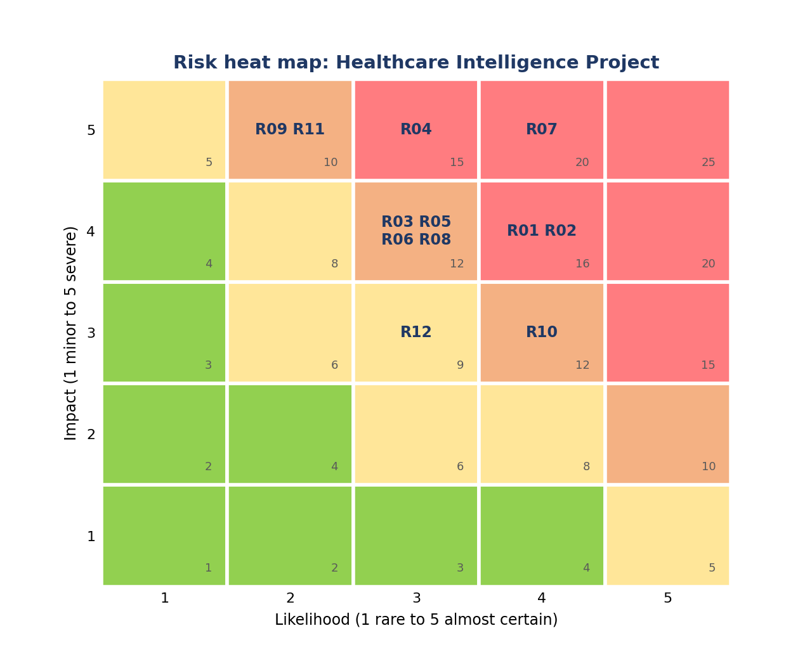
Four risks rate High: R07 inaccurate AI responses (20), R01 poor data quality (16), R02 unclear metric definitions (16) and R04 privacy breach (15). Their owners review them first every week.

3. Risk Register
ID | Risk description | Category | L | I | Score | Rating | Mitigation | Contingency plan | Owner | Status | Linked activities
R01 | Poor data quality: inconsistent descriptions for the same code, lost ZIP leading zeros, blank ZIP values, encoding marks in headers, and possible duplicates in the supplied files | Data | 4 | 4 | 16 | High | Inspect all files before use (A04); run a documented quality assessment (A05); do not delete duplicates or fill gaps until their meaning is understood | Extend A05 using contingency reserve; proceed on the usable subset and state the limitation | Data Analyst | Open | A04, A05
R02 | Unclear metric definitions: base versus total claim cost, zero payer coverage (uninsured or unpaid), the 24 hour boundary, repeat encounter versus readmission, and the unstated currency of cost fields | Data | 4 | 4 | 16 | High | Agree a KPI definition sheet with stakeholders (A07) and align it to the data dictionary; sign off before dashboard build | Hold a clarification workshop within 2 days; log each assumption in the decision log | Business Analyst | Open | A07, A10, A20
R03 | Inconsistent source fields: the dictionary lists patient FIPS County Code but the sample has no such column; the dictionary omits the outpatient class that appears in the data; header casing and encoding differ | Data | 3 | 4 | 12 | Medium | Build a field availability matrix (A04); run the feasibility check before committing to targets or questions (A08) | Narrow the question or target to fields that exist; record the change in the change log | Data Scientist | Open | A04, A08, A16
R04 | Privacy breach or unauthorized access: the patients file holds names, addresses, coordinates, birthplace and birth dates, which could appear in outputs, screenshots, dashboards or the public repository | Privacy | 3 | 5 | 15 | High | Privacy and data handling plan (A03); role based access; identifier fields excluded; privacy review of all outputs and the repository (A25) | Remove the content immediately, rotate access, notify the Sponsor within 24 hours and follow the incident process | Privacy Officer | Open | A03, A25
R05 | Delayed deliverables on the critical path (data assessment, dashboard, assistant, testing) | Schedule | 3 | 4 | 12 | Medium | Weekly critical path and float review; early warning when a task slips 2 days; named owner per activity | Add resource, fast track tasks where logic allows, release contingency reserve | Project Manager | Open | A04 to A12, A21, A24 to A31
R06 | Model or application failure: the model does not beat the baseline, or the dashboard or assistant breaks | Technical | 3 | 4 | 12 | Medium | Baseline comparison, chronological validation, leakage check (A16 to A18); tests and input validation (A19, A22) | Deliver the best supported baseline with clear limits; use screenshots and recorded demonstration as fallback | Machine Learning Engineer | Open | A16 to A19, A21, A22
R07 | Inaccurate AI generated responses: invented figures, unsupported claims or clinical advice from the assistant | AI | 4 | 5 | 20 | High | Approved sources only; numbers from a controlled query layer, not the language model; refusal rules; test set of 20 or more questions (A22) | Disable the failing answer type, add a refusal rule, retest and record the failure in the evaluation report | Generative AI Engineer | Open | A20 to A23
R08 | Inadequate testing or validation of deliverables | Quality | 3 | 4 | 12 | Medium | Quality gates QG1 to QG5; independent QA; at least three dashboard calculations verified; cross deliverable reconciliation (A24) | Extend A24 and A27 using contingency reserve; do not pass the gate until evidence is complete | QA Tester | Open | A12, A19, A22, A24
R09 | Unsafe execution of the MySQL only SQL setup script, which drops and recreates a database named hospital_db | Technical | 2 | 5 | 10 | Medium | Inspect the script first (A06); use an isolated practice environment only; no connection to existing or production databases | Restore the practice environment from backup; stop work until the cause is understood | Data Analyst | Open | A06
R10 | Scope creep from new stakeholder requests such as extra analyses or clinical questions outside the supplied data | Scope | 4 | 3 | 12 | Medium | Baseline scope at M2; formal change control with tiered approval; clinical claims excluded from scope | Move requests to a backlog; Sponsor decides trade offs | Project Manager | Open | A07, A11
R11 | Credentials exposure: API keys or access details committed to the repository | Security | 2 | 5 | 10 | Medium | Keys in environment variables; .gitignore for data and secrets; repository check in A25 | Revoke and replace keys immediately; clean the repository history | Generative AI Engineer | Open | A21, A25
R12 | Large data volume and MySQL only setup cause slow loads, performance problems or environment failures | Technical | 3 | 3 | 9 | Medium | Isolated MySQL instance sized in A02 and A06; load test in A06; aggregate tables for the dashboard, model and assistant; agree a sampling rule if needed | Work from aggregated or sampled tables and state the limitation; extend A06 using contingency reserve | Data Analyst | Open | A02, A06, A09
Status shown is the baseline at project start. Deliverable 7 shows how statuses change in the simulation.

