Simulated Status Report and Change Log
Overall status: AMBER. Would be RED (forecast 7 working days late) without the corrective actions below.

2. Executive Summary
Two critical path activities finished late: A05 data quality assessment (2 days over) and A09 data model (2 days over). The Sponsor's operations manager has also raised a change request CR-01 to add a repeat encounter analysis to the dashboard. Together these would delay the project by 7 working days. Three options were assessed and Option C is recommended: add a second Data Analyst to A11 and start the presentation preparation (A29) after UAT instead of after acceptance. This holds the finish date at 16 Apr 2027 at an estimated extra cost of ₦1,890,000, funded from contingency.

3. Progress at Status Date
Work package | Status | % complete | Comment
Project Management | On track | Ongoing | Weekly reporting running
Initiation (A01 to A03, M1) | Complete | 100% | Done on time
Data Assessment (A04 to A08, M2) | Complete, late | 100% | M2 passed 2 working days late
Analytics Dashboard | Delayed | A09 100%, A10 20% | A09 finished 2 days late
Statistical Investigation | On track | A13 100%, A14 50% | Has 19 days of float
Machine Learning | On track | A16 100%, A17 57% | Has 14 days of float
Generative AI Assistant | On track | A20 100% | A21 waits for validated dashboard figures (A12)
Testing, Documentation, Closure | Not started | 0% | Planned to start after M3

4. Delayed Activities
Activity | Planned | Actual or forecast | Cause | Impact
A05 Data quality assessment (critical) | 5 days | 7 days | The same code carried different descriptions, ZIP codes lost leading zeros, and zero payer coverage needed a rule before any cleaning decision | Pushes A08, M2 and everything after by 2 days
A09 Data model and transformations (critical) | 5 days | 7 days | Joining procedures to encounters repeated encounter costs, so the model needed a different structure, and the large procedures table loaded slowly | Pushes A10 to A12, the assistant and testing by a further 2 days
Both causes were already named in the risk register (R01 poor data quality, R08 testing and validation of joins). Because both activities are on the critical path with zero float, the delays move the finish date from 16 Apr 2027 to 22 Apr 2027 (4 working days).

5. Change Request CR-01
Change request ID | CR-01
Date raised | 9 February 2027 (simulated)
Raised by | Hospital operations manager (client)
Description | Add a repeat encounter analysis page and one KPI to the dashboard, showing patients with another encounter within a defined time window
Reason | Management wants to understand return visits, which the brief names as a topic of interest, and the reference SQL asks about 30 day readmissions
Important definition | A repeat encounter is defined only by recorded encounter dates within an agreed window (for example 30 days). It is not treated as a clinical readmission, although the reference SQL uses that word.
Type and priority | Scope addition, Medium
Decision | Approved by the Sponsor on 10 February 2027 (simulated), on condition that the finish date is held and the cost is met from contingency

Impact assessment
Area | Impact of CR-01
Dependencies | Extends A11, which feeds A12, A21, A22 and M3 on the critical path. The assistant's knowledge sources (A20) must include the new KPI definition.
Schedule | A11 grows from 8 to 11 days. With the two delays, the forecast finish is 27 Apr 2027, 7 working days late.
Cost | Additional effort of about ₦510,000 (3 Data Analyst days, 1 Business Analyst day, 1 QA Tester day).
Scope | Adds one dashboard page and one KPI. Exclusions are unchanged: no clinical claims, no production deployment.
Quality | KPI definition sheet becomes version 1.1; the new KPI needs independent verification; the window and its limits must be documented because return visits are not readmissions.
Risk | R02 (metric definitions) and R10 (scope creep) are triggered and re-rated.

6. Options Assessed
Option | Finish date | Delay vs baseline
Baseline plan | 16 Apr 2027 | None
After the two delays (A05 and A09, 2 days each) | 22 Apr 2027 | 4 working days
After the delays and change request CR-01 (A11 grows by 3 days) | 27 Apr 2027 | 7 working days
Option B: add a second Data Analyst to A11 (crash back to 8 days) | 22 Apr 2027 | 4 working days
Option C (recommended): Option B plus start A29 after A26 (fast tracking) | 16 Apr 2027 | None
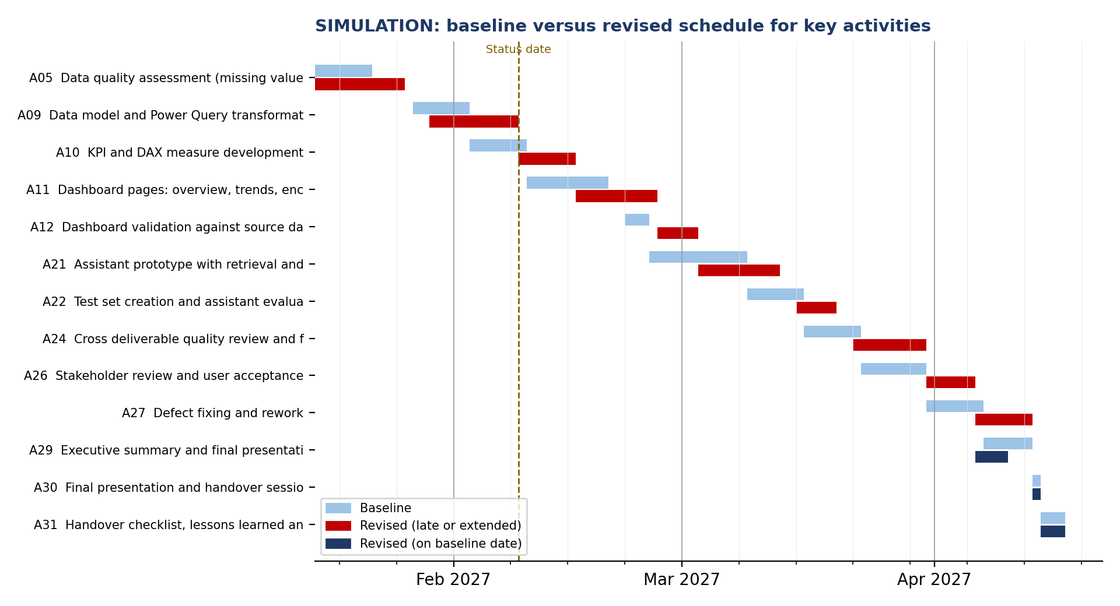

7. Corrective Actions
Action | Owner | Date | Effect | Estimated cost
Add a second Data Analyst to A11 for 5 days to bring it back to 8 days | Project Manager | From 11 Feb 2027 | Recovers 3 days | ₦500,000
Fast track: start A29 presentation preparation after UAT (A26), while defects are fixed in A27; lock figures after QG3 | Project Manager | Plan change now | Recovers up to 4 days | Rework allowance ₦200,000
Hold a 2 hour metric definition session for CR-01 before A11 starts | Business Analyst | 10 Feb 2027 | Avoids further rework | Within existing effort
Weekly critical path review becomes twice weekly until M3 | Project Manager | From this week | Earlier warning | Within existing effort
Risk of Option C. Fast tracking could mean the presentation needs rework if figures change in rework. The allowance and the figure lock after QG3 manage this. If the lock fails, the Sponsor is told within one working day.

8. Cost Position and Budget Impact
Item | Estimate (₦)
Delay 1: A05 data quality assessment ran 2 days over (Data Analyst and Data Scientist) | ₦480,000
Delay 2: A09 data model ran 2 days over (Data Analyst) | ₦200,000
CR-01: 3 extra days to build the repeat encounter page (Data Analyst) | ₦300,000
CR-01: 1 day extra requirements work (Business Analyst) and 1 day extra validation (QA Tester) | ₦210,000
Corrective action: second Data Analyst for 5 days on A11 | ₦500,000
Corrective action: rework allowance for presentation after fast tracking (2 days Data Analyst) | ₦200,000
Total additional cost | ₦1,890,000
Contingency reserve (baseline) | ₦6,839,100
Contingency remaining after this change (27.6% used) | ₦4,949,100
Labor spend to date is estimated at ₦15,404,247 against a planned ₦14,724,247 (a linear spread of the labor estimate over 73 days), a variance of ₦680,000. The total approved estimate of ₦52,433,100 does not change; the extra cost is met from the contingency reserve.

9. Updated Project Records

9.1 Schedule (version 1.1, key dates)
ID | Activity | Baseline finish | Revised finish | Variance (days)
A05 | Data quality assessment (missing values, duplicates, types, dates) | 21 Jan 2027 | 25 Jan 2027 | 2
A08 | Feasibility check of analysis, prediction targets and knowledge sources | 26 Jan 2027 | 28 Jan 2027 | 2
M2 | Milestone: Data Assessment Approved | 26 Jan 2027 | 28 Jan 2027 | 2
A09 | Data model and Power Query transformations | 02 Feb 2027 | 08 Feb 2027 | 4
A10 | KPI and DAX measure development | 09 Feb 2027 | 15 Feb 2027 | 4
A11 | Dashboard pages: overview, trends, encounter class, cost and payer, procedures | 19 Feb 2027 | 25 Feb 2027 | 4
A12 | Dashboard validation against source data | 24 Feb 2027 | 02 Mar 2027 | 4
A21 | Assistant prototype with retrieval and controlled query layer | 08 Mar 2027 | 12 Mar 2027 | 4
A22 | Test set creation and assistant evaluation (20 or more questions) | 15 Mar 2027 | 19 Mar 2027 | 4
M3 | Milestone: All Solution Components Built | 15 Mar 2027 | 19 Mar 2027 | 4
A24 | Cross deliverable quality review and figure reconciliation | 22 Mar 2027 | 30 Mar 2027 | 4
A26 | Stakeholder review and user acceptance testing | 30 Mar 2027 | 05 Apr 2027 | 4
A27 | Defect fixing and rework | 06 Apr 2027 | 12 Apr 2027 | 4
M4 | Milestone: Deliverables Accepted | 06 Apr 2027 | 12 Apr 2027 | 4
A29 | Executive summary and final presentation preparation | 12 Apr 2027 | 09 Apr 2027 | -1
A30 | Final presentation and handover session | 13 Apr 2027 | 13 Apr 2027 | 0
A31 | Handover checklist, lessons learned and project closure | 16 Apr 2027 | 16 Apr 2027 | 0
M5 | Milestone: Project Closed | 16 Apr 2027 | 16 Apr 2027 | 0
Delays pass through M2, M3 and M4 and are recovered by the end of the project through Option C.

9.2 Risk register updates
Risk | Status change | Reason
R01 Poor data quality | Open to Occurred (mitigating) | A05 overran because of description, ZIP and coverage rules
R02 Unclear metric definitions | Open to Occurred (mitigating) | CR-01 needs a new definition; session scheduled
R03 Inconsistent source fields | Open, probability raised to 4 | Join and structure issues seen in A09
R05 Delayed deliverables | Open to Occurred | Two critical activities finished late
R10 Scope creep | Open to Occurred (managed) | Handled through CR-01 under change control
R12 Fast tracking causes rework (new) | New, Open | Score 9 (likelihood 3, impact 3); owner Project Manager; mitigation is the figure lock after QG3

9.3 Change log
ID | Date | Description | Requested by | Impact | Decision | Status
CR-01 | 9 Feb 2027 | Add repeat encounter page and KPI to the dashboard | Hospital operations manager | +3 days on A11; +₦510,000 | Approved 10 Feb 2027 | Implemented through Option C

9.4 Issues and decisions
ID | Issue or decision | Owner | Status
ISS-01 | Same code with different descriptions, ZIP leading zeros lost and blank ZIP values; standardization rules documented, no automatic deletion or filling | Data Analyst | Closed
ISS-02 | Encounter to procedure joins repeat encounter costs; model built with separate fact tables and totals checked against source | Data Analyst | Closed
DEC-01 | Repeat encounter means a later encounter within an agreed window, not a clinical readmission | Sponsor, Business Analyst | Approved
DEC-02 | Option C approved; figures locked after QG3 | Sponsor | Approved

10. Decisions Requested and Next Steps
- Sponsor to confirm the repeat encounter window and the revised KPI definition sheet (version 1.1).
- Sponsor to note the use of ₦1,890,000 of contingency.
- Next report: Tuesday 16 February 2027. Focus: A10, A11 progress and A14, A17 completion.

