ANALYSTLAB AFRICA
Updated Week 1 Project Documents

Document | Week 1 deliverables, reviewed and refined for Week 2
Version | 1.1 (Week 1 baseline was version 1.0)
Date | 26 October 2026
Client | ShopSmart Retail Group
Delivery organization | AnalystLab Africa Consulting
Contents | Review summary; Project Charter; Stakeholder Register, Analysis Matrix, Power Interest Grid and Engagement Plan; Work Breakdown Structure; Risk Register; Communication Plan

Review Summary: What Was Updated and Why
Document | Refinement made | Reason
Project Charter | Added dated objectives from the schedule, the milestone list, the approved budget of ₦71,068,480, and the planned finish date of 01 Mar 2027 | The Charter must match the detailed plan that senior management now reviews
Stakeholder Register | Added influence and interest scores, a power interest grid and an engagement plan linked to the milestone gates and sprint demonstrations | Engagement now ties to real dates in the schedule
Work Breakdown Structure | Numbered every work package to a schedule activity ID, added a deliverable and a responsible role for each | Each WBS item now traces directly to a scheduled activity and resource
Risk Register | Added linked activities, contingency plans and owners; ranked poor data quality as the top risk; linked the 12% contingency reserve of ₦7,614,480 to the risk themes | Supports the critical path analysis and the budget
Communication Plan | Aligned meetings with the 6 milestone gates and fortnightly demonstrations; added an escalation matrix with time limits | Matches the execution strategy and governance

1. Project Charter (Version 1.1)
Project name | ShopSmart Retail Analytics & AI Implementation Project
Business case | ShopSmart Retail Group runs stores across Nigeria and holds its data in several systems. Without one integrated view, management cannot explain swings in sales, stock shortages and rising returns, or use AI to support decisions. The project delivers dashboards, analysis, prediction models and an AI Retail Copilot built on the ShopSmart datasets, so managers can act on evidence and not on guesswork.
Problem statement | ShopSmart currently manages data across multiple systems but lacks an integrated solution for business intelligence and AI driven decision making.
Objectives | 1. Clean and validate the nine ShopSmart datasets by 02 Dec 2026.  2. Deliver the Sales, Customer, Store Performance and Inventory dashboards and the executive report by 30 Dec 2026.  3. Build a feature engineering pipeline, sales forecasting model, customer segmentation model and recommendation prototype by 26 Jan 2027.  4. Deliver the AI Retail Copilot, report generator and prompt library, tested and integrated, by 26 Jan 2027.  5. Obtain acceptance from ShopSmart by 17 Feb 2027 and close the project by 01 Mar 2027, within the budget of ₦71,068,480.
Deliverables | Data Analytics: Sales, Customer, Store Performance and Inventory dashboards; executive report  Data Science: cleaned and validated data, exploratory analysis, feature engineering, statistical insights  Machine Learning: sales prediction model, customer segmentation, recommendation prototype, model evaluation report  Generative AI: AI Retail Copilot, retail report generator, prompt library, business question answering assistant  Final business presentation and project documentation
Scope (in) | Planning and coordination of the four workstreams above, with testing, documentation, training and handover
Scope (out) | ERP implementation; mobile application development; live deployment to production; payment gateway integration; customer loyalty system
Assumptions | ShopSmart supplies the nine datasets and the data dictionary at the start of the project  Store, inventory, sales and IT managers are available for workshops, demonstrations and UAT  OpenAI or Gemini API access is available within the planned usage limits  The team of 8 is assigned for the full duration
Constraints | Fixed budget of ₦71,068,480 and fixed finish date of 01 Mar 2027  Work is limited to the datasets provided  No live production deployment  Customer data must be handled in line with the Nigeria Data Protection Act 2023
Success criteria | All six milestone gates passed on or near the planned dates  Cleaned data reconciles to source totals  Dashboards and models accepted in UAT with no open high severity defects  Copilot answers agreed test questions accurately with no unsupported claims  Final presentation delivered and project closed within budget and tolerance
Key milestones | M1 Project Mobilised: 09 Nov 2026  M2 Clean Dataset and Requirements Baselined: 02 Dec 2026  M3 Analytics and Feature Pipeline Complete: 30 Dec 2026  M4 All Workstream Deliverables Built: 26 Jan 2027  M5 Deliverables Accepted: 17 Feb 2027  M6 Project Closed: 01 Mar 2027
Budget | ₦63,454,000 base budget plus ₦7,614,480 contingency reserve (12%) = ₦71,068,480
Project Sponsor | Chief Executive Officer, ShopSmart Retail Group
Project Manager | Opeyemi Princess Dothan, Junior Project Manager, AnalystLab Africa Consulting
Approval | Sponsor signature: ______________________ Date: ____________  Project Manager signature: ______________________ Date: ____________

2. Stakeholder Register and Analysis

2.1 Stakeholder register and analysis matrix
Power and interest are scored from 1 (low) to 10 (high). Anyone scoring above 5 on power is treated as high power; above 5 on interest as high interest.
ID | Stakeholder | Role and expectation | Power | Interest | Strategy
S01 | CEO (Project Sponsor) | Funds the project, approves gates, expects measurable business value | 9 | 8 | Manage closely
S02 | COO | Wants better operations, stock control and store performance | 8 | 9 | Manage closely
S03 | Sales Manager | Uses sales dashboards and segments to plan promotions | 6 | 8 | Manage closely
S04 | IT Manager | Owns systems and data access; supports integration and security | 7 | 7 | Manage closely
S05 | Finance Manager | Approves spend and monitors budget against results | 8 | 4.5 | Keep satisfied
S06 | Store Managers | Daily users of store and inventory dashboards | 5 | 9 | Keep informed
S07 | Inventory Manager | Uses inventory dashboards and forecasts to avoid stock shortages | 4.2 | 8 | Keep informed
S08 | Customer Service Team | Uses the copilot to answer questions on orders and returns | 3 | 6 | Keep informed
S09 | Store staff (end users) | Affected by new ways of working and reports | 2 | 3.5 | Monitor
S10 | AnalystLab Consulting Team | Delivers the four workstreams to the agreed scope, time and cost | 6.5 | 10 | Manage closely

2.2 Power interest grid
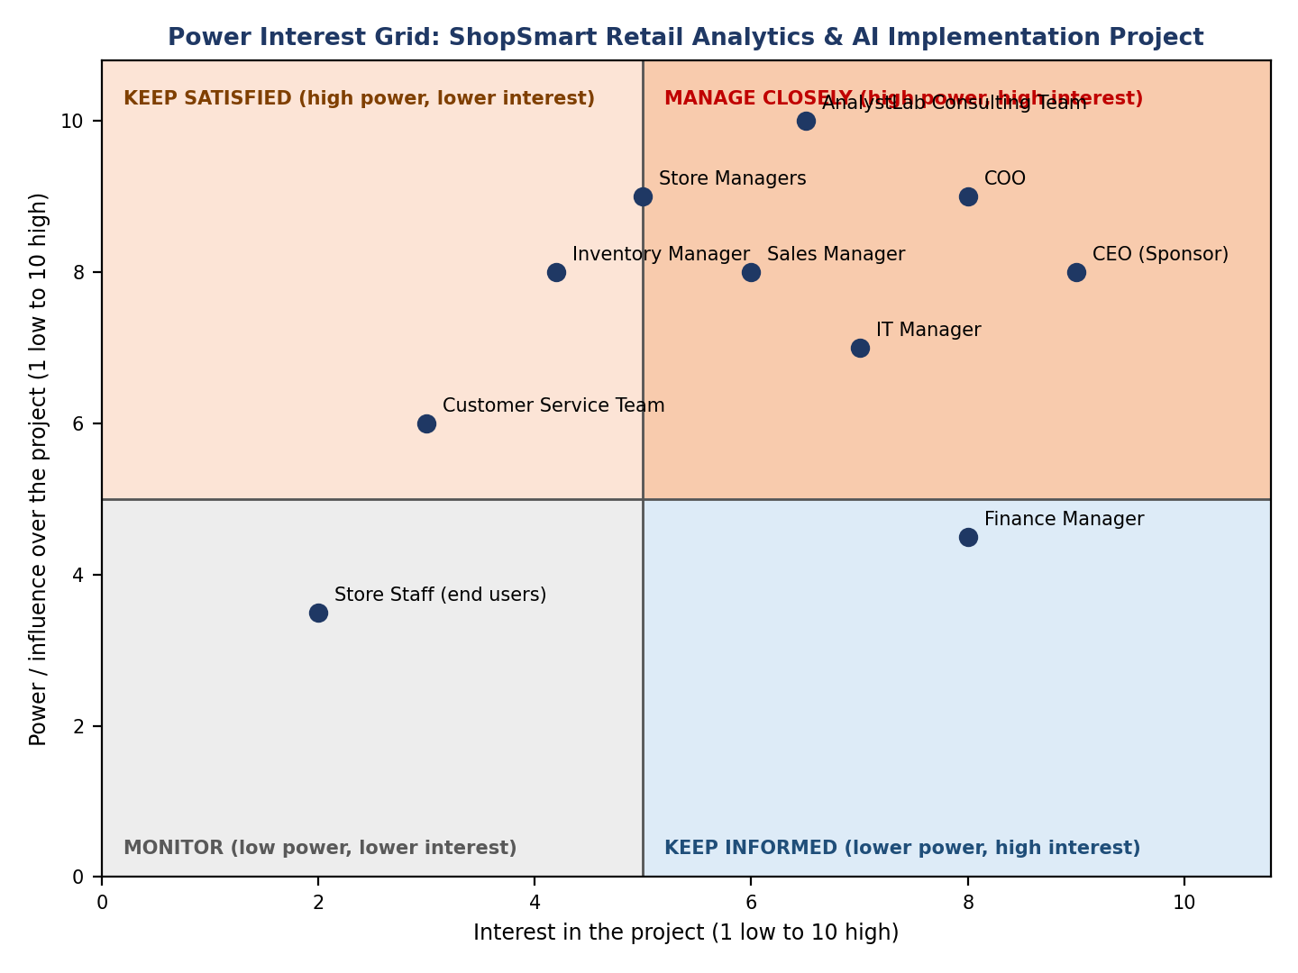

2.3 Stakeholder engagement plan
Stakeholder group | How we engage | Frequency | Owner
CEO and COO | Weekly status report, milestone gate reviews, steering committee, decision requests | Weekly and at M1 to M6 | Project Manager
Sales Manager and IT Manager | Requirements workshops, sprint demonstrations, design and integration reviews | Fortnightly | Business Analyst
Finance Manager | Monthly budget report with spend against the ₦71,068,480 baseline | Monthly | Project Manager
Store Managers, Inventory Manager, Customer Service | Early workshops, dashboard and copilot demonstrations, UAT, training sessions | Fortnightly and at A26, A29 | Business Analyst
Store staff | Updates through managers and short guides after go live | At handover | Business Analyst
AnalystLab team | Daily stand up, sprint planning, weekly critical path review | Daily and weekly | Project Manager

3. Work Breakdown Structure (Version 1.1)

WBS | Work package | ID | Deliverable | Responsible
1 | PROJECT MANAGEMENT (ongoing: Plans, status reports, risk and change logs, budget tracking, requirements)
1.1 | Project kick-off and sign-off of execution plan | A01 | Signed execution plan | Project Manager
1.2 | Tools, access and environment setup (Power BI, Python, GitHub, API keys) | A02 | Working accounts, repository and tools | Project Manager, Data Analyst
1.3 | Requirements workshops with ShopSmart managers | A07 | Requirements log and agreed dashboard and copilot needs | Business Analyst, Project Manager
2 | DATA SCIENCE
2.1 | Dataset handover and file validation (9 CSV files and data dictionary) | A03 | Validated set of 9 CSV files and data dictionary | Business Analyst, Data Analyst
2.2 | Data profiling and quality assessment | A04 | Data profiling and quality report | Data Scientist, Data Analyst
2.3 | Data cleaning and standardization | A05 | Cleaned datasets and cleaning log | Data Scientist, Data Analyst
2.4 | Data validation and reconciliation checks | A06 | Validation and reconciliation report | Data Scientist, QA Tester
2.5 | Exploratory data analysis and statistical insights | A08 | EDA findings and statistical insights | Data Scientist
2.6 | Feature engineering pipeline | A14 | Feature engineering pipeline | Data Scientist
3 | DATA ANALYTICS
3.1 | Sales dashboard development | A09 | Sales dashboard | Data Analyst
3.2 | Customer dashboard development | A10 | Customer dashboard | Data Analyst
3.3 | Store performance dashboard development | A11 | Store performance dashboard | Data Analyst
3.4 | Inventory dashboard development | A12 | Inventory dashboard | Data Analyst
3.5 | Executive analytics report | A13 | Executive analytics report | Business Analyst, Data Analyst
4 | MACHINE LEARNING
4.1 | Sales forecasting model development | A15 | Sales forecasting model | Machine Learning Engineer
4.2 | Customer segmentation model | A16 | Customer segmentation model | Data Scientist
4.3 | Product recommendation prototype | A17 | Product recommendation prototype | Data Scientist, Machine Learning Engineer
4.4 | Model evaluation and evaluation report | A18 | Model evaluation report | Machine Learning Engineer, QA Tester
5 | GENERATIVE AI
5.1 | Prompt library design and testing | A19 | Prompt library | Generative AI Engineer
5.2 | Retail report generator | A20 | Retail report generator | Generative AI Engineer
5.3 | AI Retail Copilot development (Stream lit) | A21 | AI Retail Copilot (Stream lit) | Generative AI Engineer
5.4 | Copilot integration with data and forecasting model | A22 | Copilot connected to cleaned data and forecasting model | Generative AI Engineer, Machine Learning Engineer
6 | TESTING
6.1 | Dashboard quality review and data accuracy testing | A23 | Dashboard test results | QA Tester, Data Analyst
6.2 | Code review and model testing | A24 | Code review and model test results | QA Tester, Machine Learning Engineer
6.3 | Copilot testing and prompt evaluation | A25 | Copilot test and prompt evaluation results | QA Tester, Generative AI Engineer
6.4 | User acceptance testing with ShopSmart managers | A26 | Signed UAT record | Business Analyst, QA Tester
6.5 | Defect fixing and retesting | A27 | Closed defect log | Data Analyst, Machine Learning Engineer, Generative AI Engineer
7 | DOCUMENTATION
7.1 | Project and technical documentation | A28 | Project and technical documentation | Project Manager, Business Analyst
7.2 | User training and handover sessions | A29 | Training sessions and handover pack | Business Analyst, Data Analyst
8 | FINAL PRESENTATION
8.1 | Final business presentation preparation | A30 | Final business presentation | Project Manager, Data Analyst
8.2 | Final presentation to ShopSmart leadership | A31 | Presentation delivered to ShopSmart leadership | Project Manager
9 | PROJECT CLOSURE
9.1 | Project closure, lessons learned and repository finalization | A32 | Closure report, lessons learned, final repository | Project Manager

Milestones
ID | Milestone | Date
M1 | Project Mobilized | 09 Nov 2026
M2 | Clean Dataset and Requirements Baseline | 02 Dec 2026
M3 | Analytics and Feature Pipeline Complete | 30 Dec 2026
M4 | All Work stream Deliverables Built | 26 Jan 2027
M5 | Deliverables Accepted | 17 Feb 2027
M6 | Project Closed | 01 Mar 2027

4. Risk Register (Version 1.1)
Probability (P) and Impact (I) are rated 1 to 5. Score = P x I. Ratings: 15 to 25 High, 8 to 14 Medium, below 8 Low. A contingency reserve of ₦7,614,480 supports the contingency plans below.
ID | Risk description | P | I | Score | Mitigation strategy | Contingency plan | Owner | Linked activities
R01 | Poor data quality: inconsistent dates, duplicate rows, non-numeric currency fields and mismatched codes across the nine datasets | 4 | 5 | 20 High | Profile the data early (A04), document every cleaning rule (A05), reconcile totals back to source (A06), and treat a clean dataset as the gate for M2 | Extend A05 using the contingency reserve and add a second Data Analyst to cleaning; agree with the Sponsor which analyses can proceed on partly cleaned data | Data Scientist | A04, A05, A06
R02 | Missing records: orders without items, customers or products missing from lookup tables, gaps in inventory history | 3 | 4 | 12 Medium | Run completeness and key checks on all primary and foreign keys, agree handling rules for missing values with ShopSmart, record data limits in the documentation | Ask the IT Manager for a fresh extract; exclude affected records and state the limitation in reports | Data Analyst | A03, A04, A06
R03 | Delayed deliverables on one or more work streams | 3 | 4 | 12 Medium | Weekly critical path and float review, early warning when any task slips 2 days, work packages with named owners | Add resource to the late task, run activities in parallel, re prioritize lower value features, release contingency reserve | Project Manager | All
R04 | Scope creep from new requests for dashboards, features or data after the baseline | 4 | 3 | 12 Medium | Baseline scope at M2, signed out of scope list, formal change control with tiered approval | Move requests to a backlog for a later phase; Sponsor decides on tradeoffs against time and budget | Project Manager | A07, A09 to A13
R05 | API limitations: rate limits, usage cost, model availability or changes to the OpenAI or Gemini service | 3 | 4 | 12 Medium | Test quotas and cost in A19, cache responses, set usage caps, design the copilot so the provider can be swapped | Switch provider or use a smaller model, reduce copilot features, use stored sample outputs for the demonstration | Generative AI Engineer | A19 to A25
R06 | Budget constraints or price changes (cloud, API usage, licenses, exchange rate) | 3 | 4 | 12 Medium | Monthly budget review, usage alerts on API and cloud accounts, 12% contingency reserve held and tracked | Sponsor approves release of reserve, or the team drops lower value scope such as the recommendation prototype | Project Manager | A15 to A25
R07 | Communication breakdown between the AnalystLab team and ShopSmart stakeholders, or between work streams | 2 | 4 | 8 Medium | Approved Communication Plan, weekly status report, fortnightly demos, shared repository as single source of truth | Emergency meeting within 24 hours and escalation to the Sponsor under the escalation matrix | Project Manager | All
R08 | Technical integration issues: connecting dashboards, models and the copilot to the cleaned data, and library or version conflicts | 3 | 4 | 12 Medium | Fixed environment list (requirements file), shared GitHub branching rules, early integration test in A22 | Fall back to file based integration using exported datasets and saved models; allow extra time in A27 | Machine Learning Engineer | A15, A21, A22, A27

5. Communication Plan (Version 1.1)
Communication | Purpose | Audience | Frequency | Channel | Owner
Kick off meeting | Align on goals, plan, roles | All stakeholders | Once, 02 Nov 2026 | Meeting | Project Manager
Team stand up | Progress and blockers | AnalystLab team | Daily, 15 minutes | Video call, task board | Project Manager
Weekly status report | Progress, RAG status, risks, decisions | CEO, COO, department heads | Weekly (Friday) | Email, PDF | Project Manager
Critical path and risk review | Check float, update risks | AnalystLab team | Weekly | Team meeting | Project Manager
Sprint demonstration | Show working dashboards, models, copilot; collect feedback | Sales, inventory, store and IT managers | Fortnightly | Demo session | Business Analyst
Steering Committee | Decisions, budget, risk oversight | CEO, COO, Finance, IT, Project Manager | Monthly | Meeting and pack | Project Manager
Milestone gate review | Formal approval to proceed | CEO, COO | 6 gates (M1 to M6) | Gate meeting, sign off | Project Manager
Change request notice | Share change decisions | Affected stakeholders | As needed | Change log, email | Project Manager
Training and handover notices | Prepare managers for use | Store managers, inventory, customer service | A29 | Email, sessions | Business Analyst
Closure communication | Share results and lessons learned | All stakeholders | At M6 | Closure report | Project Manager

5.1 Escalation matrix
Level | Type of issue | Escalate to | Time limit
1 | Task or technical blocker | Work stream owner | Resolve within 1 working day
2 | Risk to a task deadline or quality standard | Project Manager | Respond within 1 working day
3 | Critical path slip, budget variance or scope dispute | Sponsor (CEO) | Within 1 working day of a red status
4 | Threat to the finish date, budget or project objectives | Steering Committee | Decision within 3 working days

5.2 Weekly status report template
Reporting period and date; overall status (red, amber, green); progress against schedule by work stream; milestones achieved and coming up; budget spent against baseline; top five risks and issues; changes requested and decisions made; actions for next week; support needed from stakeholders.

5.3 Meeting agenda template
1. Welcome and objectives. 2. Review of actions from the last meeting. 3. Progress by workstream. 4. Risks and issues. 5. Decisions required. 6. Any other business. 7. Actions, owners and dates. 8. Next meeting.

