IMY 120

Adobe Audition – Script

# Overview

Fill in the script below exactly as indicated in the example. Use the description in the third column to guide you as to what should be included in the dialogue.

**Avoid mature content and swear words.**

*Note: while you are required to stick to the specific pieces of dialogue indicated by the script, you can be creative by changing the way in which the characters speak and the specifics of what they say. Your final exam project will be subject to an impression mark which means it is in your own best interest to put some effort into crafting interesting dialogue.*

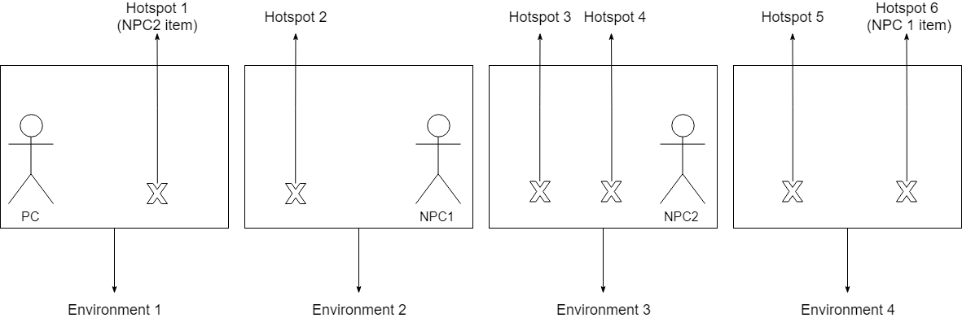

# Your script

Fill in the following information about your final project. For each item, you should write down what theme you plan to follow. Use the diagram above to help you with your planning.

See the example file if you are unsure.

**General theme**

The general theme of the interactive adventure:

**Environments**

Environment 1: Bedroom

Environment 2: Hallway

Environment 3: Kitchen

Environment 4: Office

**Characters**

PC:

NPC 1:

NPC 2:

**Hotspots**Hotspot 1:

Hotspot 2:

Hotspot 3:

Hotspot 4:

Hotspot 5:

Hotspot 6:

|  |  |  |  |
| --- | --- | --- | --- |
|  | **Environment 1** | | |
| **Name of sound file** |  | **Dialogue** | **Description of dialogue content** |
| e1 | PC | Hmmm, now that was a satisfactory night’s sleep. Now to go through the laborious ordeal of preparing breakfast. I feel like some wine and cheese would do me well today, if I can find any in this mess I call home. | The PC introduces their problem by explaining that they are missing **two** items.  *Remember that these items are going to be drawn by you in Illustrator (see project specification)* |
|  | **Environment 2** | | |
| e2_1 | PC | Good morrow to you, Myconius, my fungal friend. Would you perchance know the location of my favoured variety of cheese? I notice the air here is redolent with its powerful aroma. | PC meets the first NPC. Then they describe their problem and ask for help. |
| e2_2 | NPC 1 | Hmm. Snithersnatch. Hmmm. Can’t say I trust you further than I can throw you. Hmmm.  -Yes yes, I have the entire rest of the day to listen to you blather on. Have you seen the cheese that teases me so with its intoxicating odour?  Hmmm. About 4 feet, I reckon. Taking your aerodynamic shape into account, of course. Hmm. So don’t get too close.  -…What?  How far I can throw you. Hmmm.  -Well I don’t really see how that’s relevan-  The cheese yes? Hmm. It’s a beautiful blue I’ve been yeasting inside myself for two weeks now. I’d say it’s finished ripening today. Hmmm. Tell you what, you find me some pro-fungal cream to rub on my itchy feet and I’ll part with the cheese. Hmmm. | The NPC agrees to help and then names their price by explaining that they need an item which the PC must find and bring back to them.  *This is the item that the player will need to find by clicking on the hotspots in the area.* |
| e2_3 | PC | Very well, I’ll do as you bid. Just… don’t expect me to rub it on you. I’m afraid I’d never be able to tolerate being in the same room as my hands ever again. | The PC agrees to find the item. |
| e2_4 | PC | Here you are Myconius, the cream. As *agreed* upon. I do hope you manage to recall that now? | The PC bring the item back to the NPC. |
| e2_5 | NPC 1 | Hmmm. Hmmmm? Yes! This will do very nicely. Here, take your cheese and be off with you.   * *Sniffs deeply* Ah yes, such a pungent and complex bouquet. Just like I used to enjoy at the Country Club beneath old Pompeii. | The NPC responds by giving the PC one item. |
|  | **Environment 3** | | |
| e3_1 | PC | Greetings Turvy, I didn’t expect to find you still up at this hour. A bit early- or, er… late for you, isn’t it? | PC meets the second NPC. Then they describe their problem and ask for help. |
| e3_2 | NPC 2 | Ah, hello Mr. Snithy! No, not up, rather upside down I’d say! Hehe!  -Yes…? And the purpose of that awful excuse for wordplay was?  Oh, eh… sorry Mister. Just thought I’d make a little joke, s’all.  -And the reason you’re still up is…?  Well you know I always sleep with my teddy bear right? Well recently poor old Ted fell apart from being cuddled too much, so I’ve been using this bottle of wine as a replacement Ted, but it just isn’t the *same*, Mr Snithy. I want something soft and cuddly.  -Is that my vintage Merlot? I demand you give it back this instant.  No! Then I’d be even worse off in terms of cuddle partners, Mister! You can’t do this to me…  - Fine, if I find you something softer would you relinquish the Merlot?  Y… yes mister. | The NPC agrees to help and then names their price by explaining that they need an item which the PC must find and bring back to them.  *This is the item that the player will need to find by clicking on the hotspots in the area.* |
| e3_3 | PC | Then it’s decided. Now be a good bat and don’t make me get the broom, yes? | The PC agrees to find the item. |
| e3_4 | PC | Here, Turvy. I found something soft for you. | The PC bring the item back to the NPC. |
| e3_5 | NPC 2 | This is… a dead moth.  -Yes. And it is indeed softer than that bottle of wine. Look how its frayed wings reach out for a gentle hug.  But… I was expecting at least a plush or something.  -Sadly, life is a game of compromises, my dear boy. Perhaps this will teach you to take better care of your toys.  Fine, I guess it’ll do for now. I’ll just pretend it’s a super soft magical moth then! Here’s your wine back, Mister.  -Yes, excellent, I’d thank you if you weren’t essentially holding one of my prized wines hostage because of your own ineptitude.  Snore….  -…It appears he’s already nodded off then. | The NPC responds by giving the PC one item. |
|  | **PC celebration** | | |
| pc_c | PC | Ah, finally. A delectable cheese plate. A heady, aromatic red wine. *Swirls wine around and takes a sip.* This is truly… **satisfying**. | The PC has retrieved both items and the story is over.  They celebrate before the game ends. |

## Fill in your hotspot names and dialogue below:

|  |  |  |  |
| --- | --- | --- | --- |
|  | **Hotspots** | | |
| **Name of sound file** | **Hotspot** | **Dialogue** | **Description of dialogue content** |
| H6_pc | Pro-fungal cream | A jar of spoilt mayonnaise. I can barely see the white through the rainbow of fungus infesting it. I should’ve thrown this away weeks ago. | The PC finds the item required by NPC 1. |
| H1_pc | Moth in drawer | A desiccated moth among my unmentionables. Amusing. | The PC finds the item required by NPC 2. |
| h2_pc | Mouse hole. | Looks like that’s where my edam has gone. Come out, little friend, I could use a **snack.** | The hotspot contains nothing. |
| h3_pc | Poison bottle | An empty bottle of anti-fungal poison. Quite ineffectual in the case of my unfortunate houseguest, sadly. | The hotspot contains nothing. |
| h4_pc | Tattered Teddy | An empty skin of a teddy bear. All the stuffing seems to have spilt out the back from excessive squeezing. It reminds me of one of my own shed skins. | The hotspot contains nothing. |
| h5_pc | Window | Ah, the pleasant air of a new morning beckons me to a lazy day spent reading in the garden. | The hotspot contains nothing. |