GRAPHICAL
CHART
OPINIONYTICS
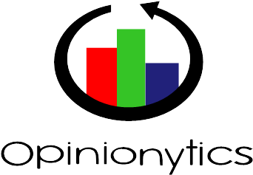

Summary

Logo
Colors
Typography
Graphical Elements

Logo

Main logo :

Secondary logo :

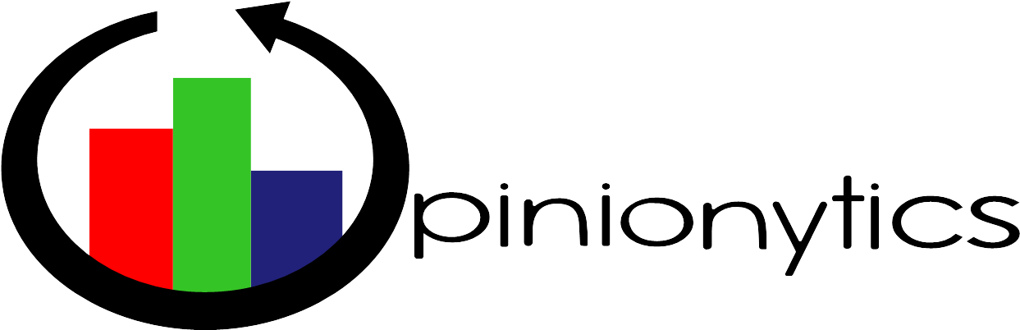

The Opinionytics logos are formed of a circular arrow and of three colored bar placed at the center of the circle formed by the arrow.
The main logo is used in the website’s homepage and the secondary logo is used in the header of the Analytics page.

Colors

The Opinionytics Logo has 3 colors : red, green and blue, to make it look simple. The red color chosen is a primary red, the other couple of colors have been adapted to the red color for more harmony.

Red : 255 0 0 #ff0000
Green : 53 196 38 #35c426
Blue : 33 33 122 #21217a

The logo’s colors are reused in the chromatic universe of the Opinionytics application. They are used as soon as a touch of color is added to the website and also for the graphs.





TYPOGRAPHY

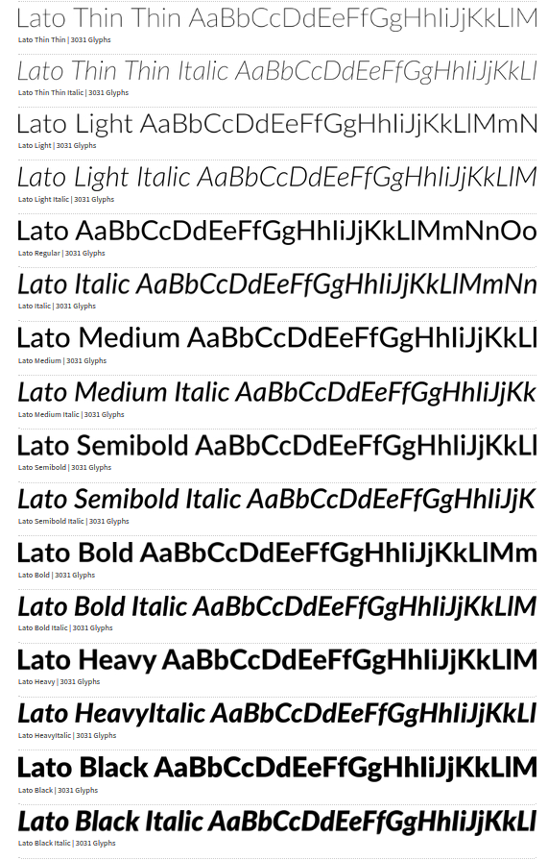
The Lato font has been used for all texts in the website.

