MAKERERE UNIVERSITY
College of Computing and Information Sciences (CoCIS)
Programmes: BSE III Academic Year 2026/2027
SMART CONTROL AND MONITORING SYSTEM
FOR THE COLLEGE OF COMPUTING AND INFORMATION SCIENCES
Project Requirements and Design Specification
ESP32, ESP-IDF and Wokwi Embedded Systems Coursework
Version 1.0 Date: 27 October 2026
Status: Approved baseline for team use
Submission deadline: 2 November 2026
Group details
Group name / number | Member name | Registration number | Student number | Role
Document control
Version | Date | Description | Author
1.0 | 27 Oct 2026 | Initial complete requirements and design baseline | Project team
Table of Contents
1. Introduction 5
1.1 Purpose of this document 5
1.2 Scope 5
1.3 Intended audience and how to use it 5
1.4 Conventions 5
2. Project Overview 7
2.1 Background and problem statement 7
2.2 Objectives 7
2.3 Scope of the pilot 7
2.4 Constraints 8
2.5 Assumptions 8
2.6 Deliverables and assessment alignment 8
3. Stakeholders and System Actors 10
4. Functional Requirements 11
4.1 Access control and identification 11
4.2 Occupancy monitoring 11
4.3 Automated lighting control 12
4.4 Distributed control with ESP32 terminals 12
4.5 Data storage and management 13
4.6 Serial interface and management menus 13
4.7 Configurable building access schedule 14
4.8 Resource synchronisation and reliability 14
5. Non-Functional Requirements 15
6. Innovative Features 16
6.1 Innovation catalogue 16
6.2 Detailed description of Tier 1 features 17
7. System Architecture 19
7.1 Architecture overview 19
7.2 Responsibilities of each terminal 19
7.3 Key design decisions 20
7.4 Deployment topology on Wokwi 20
7.5 Layered software architecture 21
7.6 Operating modes 21
8. Hardware Design 22
8.1 Bill of components 22
8.2 Entrance Hub wiring and pin map 23
8.3 Lecture room wiring and pin map 24
8.4 Wokwi part availability and substitutions 25
8.5 Feedback semantics 25
9. Software Design 26
9.1 ESP-IDF project organisation 26
9.2 Hub task architecture 26
9.3 Room node task architecture 28
9.4 Access decision algorithm 28
9.5 Occupancy and anti-passback model 29
9.6 Lighting state machine 29
9.7 Operational timing parameters 30
9.8 Reason and result codes 30
9.9 Coding standards 31
10. Embedded Systems Concepts to Demonstrate 32
11. Inter-Node Communication Design 34
11.1 Transport 34
11.2 Topic structure 34
11.3 Message envelope 34
11.4 Reliability of delivery 35
11.5 Time distribution 35
12. Data Design 36
12.1 Storage layout on the SD card 36
12.2 Record formats 36
12.3 Schedule and settings model 36
12.4 NVS namespaces 37
12.5 Hash-chain definition 37
12.6 Retention and failure handling 37
13. Synchronisation and Reliability Design 38
13.1 Hazards to design against 38
13.2 Local synchronisation primitives 38
13.3 Distributed synchronisation 39
13.4 Failure modes and responses 40
14. Security Design 41
14.1 Authentication and roles 41
14.2 Credential and session handling 41
14.3 Threats and mitigations 41
15. Serial Interface and Management Menus 43
15.1 Interaction model 43
15.2 Command reference 43
15.3 Example session 44
15.4 Additional output interfaces 44
16. Access Schedule Specification 45
16.1 Data and evaluation rules 45
16.2 Behaviour at and after closing time 45
16.3 Edge cases to test 45
17. Simulation Plan on Wokwi 46
17.1 Day-one spike tests 46
17.2 Wokwi project set-up 46
17.3 Demonstration scenarios for the presentation 46
18. Testing and Validation 48
18.1 Strategy 48
18.2 Test cases 48
18.3 Acceptance criteria 49
19. Project Management 50
19.1 Suggested work breakdown for five members 50
19.2 Timeline (27 October to 2 November 2026) 50
19.3 Working agreements 51
20. Report, Video and Presentation Guide 52
20.1 Recommended report structure 52
20.2 Individual video checklist 52
20.3 Submission checklist 53
20.4 Likely questions in the presentation 53
21. Risks and Mitigations 54
22. Guidelines for AI Coding Agents 55
Appendix A: Glossary 56
Appendix B: Requirement Traceability Matrix 57
Appendix C: Default Configuration Values 58
Appendix D: Open Questions for the Lecturer 59

1. Introduction

1.1 Purpose of this document
This document is the single reference specification for the Smart Control and Monitoring System for the College of Computing and Information Sciences (CoCIS), Makerere University. It consolidates every requirement stated in the coursework brief, proposes innovative additions, defines the system and software architecture, lists the hardware and the embedded systems concepts to be demonstrated, and sets out the plan, test strategy and submission checklist. It is written so that team members and AI coding agents can use it as a shared and unambiguous source of truth while the system is designed, implemented, simulated and documented.

1.2 Scope
The document covers the pilot deployment described in the brief: one main entrance with separate entry and exit sections, and two lecture rooms. It covers firmware for three ESP32 terminals developed with ESP-IDF and simulated on Wokwi, together with the data, communication and security design that connects them. It also covers the academic deliverables (report, simulation link, individual videos, contribution statements and presentation).

1.3 Intended audience and how to use it
Table 1: Audience and recommended reading
Reader | Use of this document | Start with
Team members | Understand the whole system, choose tasks, and prepare for questions during the presentation. | Sections 2, 6, 7, 19, 20
Hardware and simulation lead | Build the Wokwi circuits, pin maps and part substitutions. | Sections 8, 17
Firmware developers | Implement tasks, state machines, drivers and protocols. | Sections 9 to 13, 15, 16
Report and video authors | Map every implemented feature to a requirement and an embedded systems concept. | Sections 4, 10, 18, 20
AI coding agents | Generate and review code against stable requirement IDs, pin maps, topics and schemas. | Section 22 first, then 4, 8, 11, 12

1.4 Conventions
- Priority keywords follow the MoSCoW scheme: Must (mandatory, drawn from the brief or needed for it to work), Should (strongly recommended, forms the innovation score), Could (optional if time allows).
- Requirement identifiers have the form FR-xxx-nn (functional), NFR-nn (non-functional) and INN-nn (innovative feature). Tests use TC-nn. Identifiers never change once issued, so code comments, commits and the report can cite them.
- Source of truth: where this document and the coursework brief disagree, the brief wins and this document must be corrected. Items marked as assumptions should be confirmed with the lecturer.
- Terminology: the terms node, terminal and ESP32 are used interchangeably. The Entrance node is also called the Hub because it owns the authoritative data.

2. Project Overview

2.1 Background and problem statement
CoCIS houses valuable equipment that needs reliable protection against unauthorised access. The college also incurs high electricity costs, partly because lights are left on in unoccupied rooms. Management agreed in early October 2026 to build an automated system, first as a pilot covering two lecture rooms and the main entrance. The system must identify people with RFID tags, record entries and exits, know who is inside at any time, switch lights according to occupancy, enforce a configurable access period, store data on a memory card, and expose information through a serial interface, all coordinated across several ESP32 microcontrollers without data races.

2.2 Objectives
- Prevent unauthorised building access through RFID identification and a configurable access schedule.
- Maintain an accurate, auditable record of every entry and exit and a live view of who is inside.
- Reduce electricity waste by switching lecture room lights automatically according to occupancy.
- Provide reliable coordination between three ESP32 terminals with proper synchronisation.
- Give management a secure serial interface for monitoring, configuration and decision-making.
- Demonstrate a deep understanding of embedded systems design, supported by innovative features.

2.3 Scope of the pilot
Table 2: In scope and out of scope
In scope | Out of scope (documented as future work)
Three ESP32 terminals: Lecture Room 1, Lecture Room 2, Main Entrance | Roll-out to all college rooms and floors
Separate ENTRY and EXIT RFID readers and door mechanisms | Real RFID card enrolment hardware and printing
PIR-based room occupancy and relay-based lamp control | Mains-voltage wiring, electrical certification
SD card logging, serial CLI, authenticated configuration | Mobile app and cloud analytics back end
Wokwi simulation using ESP-IDF | Physical prototype (simulation only is required)

2.4 Constraints
- Microcontroller: ESP32 only. Framework: ESP-IDF with FreeRTOS. Simulator: Wokwi.
- Team size: at most five members. Every member must be able to explain the code they claim.
- Submission deadline: 2 November 2026, on Muele. Only students who attend the presentation receive marks.
- Available time from the date of this document (27 October 2026) is six days, so scope must be managed with the priorities in Section 6.

2.5 Assumptions
- Wokwi simulation access to the internet through the Wokwi-GUEST Wi-Fi network is available for MQTT and SNTP. This must be verified on day one (Section 17).
- Real RFID readers are replaced in simulation by whatever the platform supports (Section 8.4). The firmware isolates the reader behind a driver interface so the choice does not affect the rest of the design.
- A fixed registry of 10 to 20 sample users is enough for the demonstration.
- The time zone is East Africa Time (UTC+3) with no daylight saving.

2.6 Deliverables and assessment alignment
Table 3: Deliverables from the course work guide.
# | Deliverable | Content | Assessment link
1 | System Operation Report | Architecture, hardware, software design, implemented features | Quality and completeness of report
2 | Wokwi simulation link | Public or shared link to the working project(s) | Working demonstration
3 | Individual video demonstrations | Each member explains the system and the code they wrote | Clarity of explanation of own contribution
4 | Individual contributions | Tasks and responsibilities of each member | Accountability
5 | Group member details | Names and identification details | Identification
6 | Presentation to lecturer | Live demo and questions to every member | Marks only for attendees; deductions for unexplained claims

Marking emphasis: the course work guide states that particular emphasis is placed on innovation and additional features. The innovation plan in Section 6 is therefore a core part of the project and not an optional extra.

3. Stakeholders and System Actors
Table 4: Actors and their privileges
Actor | Description | Privileges in the system
Registered user (staff, student) | Holds an RFID tag, enters and leaves through the main entrance. | Scan at ENTRY and EXIT readers within the access period.
Visitor | Holds a temporary tag with an expiry time (innovation). | Same as user but only until the card expires.
Security officer | Monitors the building and responds to alerts. | View status, occupancy, logs, roll-call; trigger emergency mode; suspend a tag.
Administrator | Manages the configuration and users. | All security officer rights plus schedule changes, user management, settings, password changes.
College management | Consumes reports for decisions. | Read-only reports: access summaries, energy saving estimates.
Maintenance technician | Services hardware. | Diagnostics view (node health, sensor values).
Lecturer (assessor) | Evaluates the project. | Observes the demonstration and asks questions.

4. Functional Requirements
Each table lists the requirements for one area of the brief. The final column cites the section of the coursework brief that the requirement comes from, or marks it as derived (needed to make the brief work) or as an addition.

4.1 Access control and identification
Table 5: Access control requirements
ID | Requirement | Priority | Source
FR-ACC-01 | The main entrance has two designated sections, ENTRY and EXIT. Each has its own RFID reader, door actuator, status LEDs and feedback. | Must | Brief 2.1
FR-ACC-02 | Every person must scan an RFID tag at the ENTRY reader to enter and at the EXIT reader to leave. | Must | Brief 2.1
FR-ACC-03 | On a valid tag the system verifies identity against the user registry and, if all rules pass, activates the corresponding door mechanism for a configurable time (default 5 s). | Must | Brief 2.1
FR-ACC-04 | On a rejected tag the door stays locked, the red LED and buzzer signal denial, and the reason code is shown and logged. | Must | Derived
FR-ACC-05 | Every scan outcome is recorded with timestamp, UID, user name, direction, result and reason. | Must | Brief 2.1
FR-ACC-06 | Duplicate reads of the same tag within 2 s are ignored (debounce). | Should | Derived
FR-ACC-07 | Anti-passback: entry is refused if the tag is already recorded inside. An exit with no recorded entry is granted (in hours) but flagged as an anomaly. | Should | Addition
FR-ACC-08 | The registry stores per user: UID, name, role, status (ACTIVE, SUSPENDED, EXPIRED) and optional expiry date. | Must | Derived
FR-ACC-09 | Three consecutive denied scans from the same unknown or suspended UID raise a security alert. | Should | Addition

4.2 Occupancy monitoring
Table 6: Occupancy requirements
ID | Requirement | Priority | Source
FR-OCC-01 | The Hub maintains the building occupancy count and the set of UIDs currently inside. | Must | Brief 2.1
FR-OCC-02 | Management can list who is inside at any given time (name, UID, time of entry). | Must | Brief 2.1
FR-OCC-03 | Occupancy state survives a reboot or power loss (persisted to NVS and SD). | Must | Derived
FR-OCC-04 | The count can never become negative; inconsistencies are corrected and logged. | Should | Derived
FR-OCC-05 | Each lecture room reports an occupied or vacant status derived from its sensor. | Must | Brief 2.2, 2.5
FR-OCC-06 | A roll-call report (who is still inside) is produced at closing time and on emergency. | Should | Addition

4.3 Automated lighting control
Table 7: Lighting requirements
ID | Requirement | Priority | Source
FR-LGT-01 | Each lecture room node detects whether its room is occupied using a presence sensor. | Must | Brief 2.2
FR-LGT-02 | Lights switch on when the room is occupied and off after a configurable vacancy timeout (default 300 s; 20 s in demo mode). | Must | Brief 2.2
FR-LGT-03 | Lighting status and occupancy are reported to the Hub and visible on the CLI. | Must | Brief 2.5
FR-LGT-04 | A pre-off warning (lamp blinks) is given before lights switch off, so a still person can wave and restart the timer. | Should | Addition
FR-LGT-05 | Daylight gating: if an LDR reports enough ambient light the lamp is not switched on. | Should | Addition
FR-LGT-06 | A manual override button forces lights on for a limited time (default 60 min). | Should | Addition
FR-LGT-07 | Energy accounting: lamp-on time per room and estimated saving versus an always-on baseline. | Should | Addition
FR-LGT-08 | Room nodes keep working autonomously if the Hub or network is unavailable. | Must | Derived (reliability)
FR-LGT-09 | Motion in a room while the building is recorded empty or closed raises an intrusion alert and keeps lights off. | Should | Addition

4.4 Distributed control with ESP32 terminals
Table 8: Distributed control requirements
ID | Requirement | Priority | Source
FR-DST-01 | The system consists of three terminals: Lecture Room 1, Lecture Room 2 and Main Entrance, each on its own ESP32. | Must | Brief 2.3
FR-DST-02 | Terminals exchange events, status and configuration over a defined messaging protocol (Section 11). | Must | Brief 2.3
FR-DST-03 | Each node sends a heartbeat every 5 s; a node silent for 15 s is flagged offline, and its Last Will message is honoured. | Should | Addition
FR-DST-04 | A node that reconnects resynchronises: it receives the retained configuration and uploads any buffered events. | Should | Addition
FR-DST-05 | The same room firmware runs on Room 1 and Room 2, differing only by a configured ROOM_ID. | Should | Derived (maintainability)

4.5 Data storage and management
Table 9: Storage requirements
ID | Requirement | Priority | Source
FR-STO-01 | An SD card module (SPI, FAT filesystem) stores access logs, occupancy snapshots, lighting and energy records, user registry and schedule. | Must | Brief 2.4
FR-STO-02 | Logs are written as CSV, one file per day, with an append-only policy and periodic flush. | Must | Brief 2.4
FR-STO-03 | Only one task (storage_task) writes to the SD card; all other tasks send records through a queue. | Must | Brief 2.7
FR-STO-04 | If the SD card is missing or fails, records are kept in a RAM ring buffer, an alert is raised, and buffered records are flushed when the card returns. | Should | Derived
FR-STO-05 | Each log record carries a SHA-256 hash chained to the previous record to make tampering detectable; a verify command checks the chain. | Should | Addition
FR-STO-06 | Configuration (schedule, credentials, thresholds) is persisted in NVS flash and mirrored on SD. | Must | Derived

4.6 Serial interface and management menus
Table 10: Serial interface requirements
ID | Requirement | Priority | Source
FR-CLI-01 | Users can query the system through text commands on the serial interface (UART0, 115200 baud). | Must | Brief 2.5
FR-CLI-02 | The interface provides access records, current building occupancy, room occupancy, lighting status and system information. | Must | Brief 2.5
FR-CLI-03 | A help menu lists commands available to the logged-in role; unknown commands produce a helpful message. | Must | Brief 2.5
FR-CLI-04 | Configuration commands (schedule, users, thresholds) require login with an authorised role (Section 14). | Must | Brief 2.6
FR-CLI-05 | Additional output interfaces are provided: OLED summary at the Hub, status LEDs, MQTT status topics. | Should | Brief 2.5 (additional)
FR-CLI-06 | Sessions expire after 120 s of inactivity and password input is not echoed. | Should | Addition

4.7 Configurable building access schedule
Table 11: Schedule requirements
ID | Requirement | Priority | Source
FR-SCH-01 | Management can configure the permitted access period (open and close time) at any time without reflashing firmware. | Must | Brief 2.6
FR-SCH-02 | Outside the configured period both the ENTRY and EXIT doors stay locked for normal scans. | Must | Brief 2.6
FR-SCH-03 | People still inside when the period ends are not allowed to leave through normal scans; they are listed and security is alerted (see assumption A-1 in Section 16). | Must | Brief 2.6
FR-SCH-04 | Only authenticated users with the ADMIN role can modify the schedule; every change is logged with who, when, old value and new value. | Must | Brief 2.6
FR-SCH-05 | The schedule supports a separate window per weekday and a list of holiday dates (closed). | Should | Addition
FR-SCH-06 | A schedule change takes effect on all nodes consistently using versioned distribution (Section 13). | Must | Brief 2.7
FR-SCH-07 | If valid time is not available the system fails secure: entries are denied and an alert is raised. | Should | Derived
FR-SCH-08 | Emergency mode overrides the schedule and unlocks both doors (life safety). | Should | Addition

4.8 Resource synchronisation and reliability
Table 12: Synchronisation requirements
ID | Requirement | Priority | Source
FR-SYN-01 | Shared data (occupancy table, schedule, SD card, SPI bus) is protected by FreeRTOS mutexes with timeouts and priority inheritance. | Must | Brief 2.7
FR-SYN-02 | Cross-node updates follow a single-writer rule: only the Hub modifies authoritative records; rooms send requests or events. | Must | Brief 2.7
FR-SYN-03 | Every event has a unique ID (node, boot count, sequence) so duplicate deliveries are detected and ignored (idempotency). | Must | Brief 2.7
FR-SYN-04 | Configuration has a monotonically increasing version; updates with a stale base version are rejected. | Must | Brief 2.7
FR-SYN-05 | A leased distributed lock (Section 13) serialises operations that need exclusive multi-node access. | Should | Brief 2.7
FR-SYN-06 | Task watchdog and health supervision restart or flag a stuck task or node. | Should | Derived
FR-SYN-07 | Mutex acquisition order is fixed (cfg, state, sd) to prevent deadlock. | Must | Derived

5. Non-Functional Requirements
Table 13: Non-functional requirements with measurable targets
ID | Category | Requirement and target
NFR-01 | Performance | Scan to door-actuation latency at the Hub under 1 s; scan event visible on MQTT within 2 s.
NFR-02 | Performance | PIR trigger to lamp on under 1 s; no missed motion events at 1 Hz sampling.
NFR-03 | Reliability | No unhandled crash during a 30 minute soak test with scripted random scans; watchdog resets must recover to a consistent state.
NFR-04 | Reliability | After a forced reboot the occupancy list, schedule and users are identical to before (FR-OCC-03, FR-STO-06).
NFR-05 | Security | No plain-text passwords in code, NVS or logs; salted hash only. Lockout after 3 failed logins for 60 s.
NFR-06 | Safety | Emergency egress is always possible (emergency mode unlocks doors; the exit door is fail-safe by design).
NFR-07 | Maintainability | Modular components with one responsibility each, documented public headers, no magic numbers (Kconfig or constants).
NFR-08 | Resource use | At least 30 percent of heap free at steady state; stack high-water mark checked for every task; no dynamic allocation inside ISRs.
NFR-09 | Usability | Every CLI command has help text; LED and buzzer patterns follow one documented table (Section 8.5).
NFR-10 | Portability | Hardware access only through a HAL so a real MFRC522 or a simulated reader can be swapped by configuration.
NFR-11 | Observability | ESP_LOG levels per module; a diagnostics command prints heap, stack watermarks, queue depths and uptime.
NFR-12 | Documentation | Every source file has a header comment naming its author, purpose and the requirement IDs it implements.

6. Innovative Features
The brief awards particular emphasis to innovation. The features below were chosen because each one improves security, efficiency, reliability or usefulness to management and each one also demonstrates a distinct embedded systems concept. They are ranked by value for effort so that the team can stop at any point and still hold a coherent system.

6.1 Innovation catalogue
Table 14: Proposed innovative features
ID | Feature | Benefit to management | Concept demonstrated | Tier | Effort
INN-01 | Anti-passback and tailgating-safe occupancy | Prevents card sharing; keeps the inside list truthful | State machines, mutex-protected tables | 1 | S
INN-02 | Emergency evacuation mode with live roll-call | Life safety; shows who is still inside | ISR, event groups, priority | 1 | S
INN-03 | Hash-chained tamper-evident logs | Audit trail that cannot be silently altered | mbedtls SHA-256, FATFS, single-writer queue | 1 | M
INN-04 | Intrusion detection by cross-checking RFID occupancy with PIR motion | Detects entry without a valid scan | Sensor fusion, distributed state | 1 | M
INN-05 | Daylight-aware lighting (LDR gating) | Extra energy savings | ADC, thresholds with hysteresis | 1 | S
INN-06 | Pre-off warning blink and manual override timer | Avoids switching lights off on still occupants | Software timers, FSM | 1 | S
INN-07 | Energy analytics: kWh and UGX saved per room | Quantifies the business case | Counters, time accounting, NVS | 2 | M
INN-08 | Offline-first operation and store-and-forward | Keeps working when Wi-Fi or broker fails | Ring buffers, reconnect logic, idempotency | 1 | M
INN-09 | Role-based access, salted hashing, lockout, session timeout | Protects configuration | Crypto, RBAC, state handling | 1 | M
INN-10 | Closing-time sweep: list and alert for people still inside | Supports security patrol | Esp_timer scheduling, alerts | 2 | S
INN-11 | Visitor temporary cards with expiry | Flexible guest management | Date handling, registry | 2 | S
INN-12 | Tailgating detection with a passage sensor | Detects two people on one scan | GPIO ISR counting | 3 | M
INN-13 | Node health monitoring (heartbeat, LWT, diagnostics) | Early fault detection | MQTT LWT, watchdogs | 2 | S
INN-14 | Two-factor physical admin (admin card plus PIN keypad) | Stronger configuration security | Keypad scan, debounce | 3 | M
INN-15 | Peak occupancy statistics per hour | Helps plan opening hours | Aggregation, memory budgeting | 3 | S

Tier 1 features are the recommended minimum innovation set for the demonstration. Tier 2 should be added once Tier 1 is stable. Tier 3 features are stretch goals and may be described in the report as future work. Effort: S is under half a day, M is about one day for one person.

6.2 Detailed description of Tier 1 features

INN-01 Anti-passback
The Hub stores a per-user inside flag. An ENTRY scan for a user already marked inside is refused with DENY_ANTIPASSBACK, which stops one tag being passed back to a second person. An EXIT scan without a recorded entry is allowed within hours but logged as ANOMALY_EXIT_NO_ENTRY and flagged for review, so nobody is trapped by a data error.

INN-02 Emergency evacuation mode
A dedicated emergency button (GPIO interrupt) or the CLI command sets the EMERGENCY bit in an event group. The Hub unlocks both doors, switches all lights on through a retained emergency message and records every pass as EMERGENCY_PASS. The roll-call report then compares the inside list against the people who passed the exit. Because the emergency path has the highest task priority it cannot be starved by logging or network activity.

INN-03 Hash-chained logs
Each log line stores hash = SHA256(previous_hash + line_content). Changing or deleting one line breaks every later hash, and the command log verify reports the first broken record. This brings a security and audit property typically seen in blockchains into a few dozen lines of embedded code and is easy to demonstrate by editing the CSV and running the verify command.

INN-04 Intrusion detection
Each room node publishes motion events. The Hub compares them with the occupancy count and schedule. If a room reports motion while the building is recorded empty or closed, or after the access period has ended without any recorded entry, an INTRUSION_SUSPECTED alert is raised, the room lights stay off, and the CLI and buzzer announce it. The detection relies on cooperation between three nodes, which makes it a good distributed-systems example.

INN-05 and INN-06 Intelligent lighting
The lighting state machine (Section 9.6) adds daylight gating and a visible warning blink before switching off. Both reduce wasted energy without annoying occupants. The warning window and vacancy timeout are configurable, which also allows a short demonstration timeout.

INN-08 Offline-first operation
The Hub decides access locally using its own registry and schedule, so a Wi-Fi or broker failure never blocks the door. Room nodes keep controlling lights from their local sensor. Events that could not be published are held in a bounded ring buffer and replayed in order after reconnection, with unique IDs so the Hub can discard duplicates.

INN-09 Authentication and authorisation
Credentials are stored as PBKDF2-HMAC-SHA256 hashes with a per-user salt. Roles (ADMIN, SECURITY, VIEWER) restrict commands. Three failed logins lock the account for 60 s, sessions expire after inactivity, and every login and configuration change is written to the hash-chained audit log.

7. System Architecture

7.1 Architecture overview
The system follows a hub-and-spoke distributed architecture. Three ESP32 terminals are connected through Wi-Fi to an MQTT broker. The Entrance node acts as the Hub: it owns the authoritative user registry, occupancy table, access schedule and SD card, and it coordinates configuration updates. The two Lecture Room nodes are autonomous controllers that handle sensors and lamps locally and report to the Hub. Figure 1 shows the complete system.
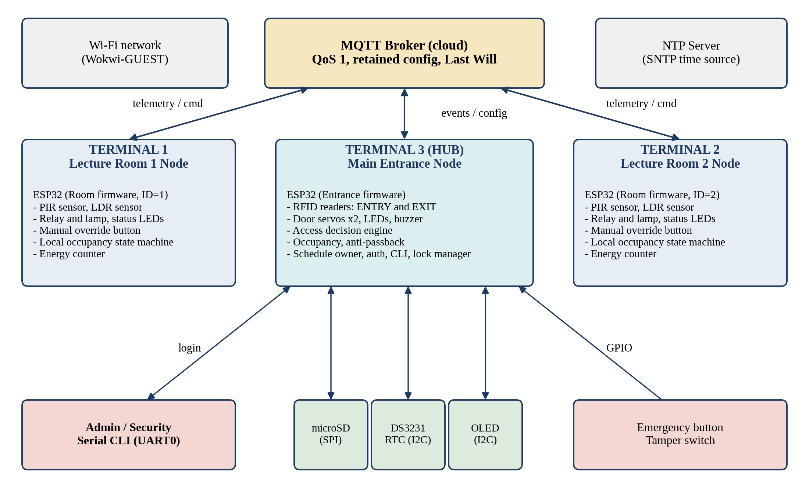
Figure 1: System architecture of the CoCIS smart control and monitoring system

7.2 Responsibilities of each terminal
Table 15: Node responsibilities
Node | Responsibilities | Owns (authoritative)
Terminal 3: Entrance (Hub) | ENTRY and EXIT RFID handling, access decision, door actuation, occupancy and anti-passback, SD logging, schedule enforcement, authentication, serial CLI, emergency handling, distributed lock and config coordination, OLED display. | User registry, occupancy table, access log, schedule and settings, audit log
Terminal 1: Lecture Room 1 | PIR and LDR sampling, lighting state machine, relay control, local override, energy counters, telemetry, heartbeat, offline buffering. | Its own sensor state and lamp state (reported, not shared for writing)
Terminal 2: Lecture Room 2 | Same firmware as Terminal 1 with ROOM_ID = 2. | Its own sensor state and lamp state

7.3 Key design decisions
Table 16: Design decisions and rationale
Decision | Rationale | Alternative considered
Central authority at the Hub (single writer) | Removes most race conditions by construction; simplifies consistency of occupancy and schedule. | Peer-to-peer replication (complex consensus, unnecessary for three nodes)
MQTT over Wi-Fi as the inter-node bus | Publish/subscribe fits event-driven design; supports QoS, retained messages and Last Will; works with Wokwi-GUEST. | ESP-NOW (not supported by the Wokwi simulator), raw TCP sockets (more code)
Room nodes decide lighting locally | Lights keep working during network failure; low latency. | Hub-driven lighting (single point of failure)
SD card only at the Hub | Central log and registry; cheaper; rooms keep short RAM ring buffers. | SD on every node (more hardware, more sync)
Hardware abstraction layer for every device | Lets the team swap the RFID source and re-use drivers; helps AI agents generate code. | Direct driver calls in application code
Fail-secure entry, fail-safe emergency | Protects equipment while guaranteeing a way out in an emergency. | Always-locked doors (unsafe)

7.4 Deployment topology on Wokwi
The brief requires one ESP32 per terminal, so the baseline deployment uses three Wokwi projects, one per terminal, communicating through a public MQTT broker reached over the Wokwi-GUEST Wi-Fi network. Each project holds the full circuit for its node. To avoid cross-talk with other student groups on a public broker, every topic starts with a unique group prefix (Section 11).
Table 17: Deployment options
Option | Description | When to use
A (baseline) | Three Wokwi projects, three ESP-IDF firmwares, MQTT between them. The lecturer opens the three links; run them side by side. | Default if the day-one spike (Section 17) shows MQTT works between two simulations.
B (fallback) | One Wokwi project containing the three terminals as separate task groups on one ESP32, linked by an in-memory message bus that mirrors the MQTT topic and payload design. | Only if multi-project MQTT or the broker is unreachable. Report must state the limitation honestly.

Verification required: at the time of writing the exact Wokwi capabilities (multiple boards in one project, network access, available RFID and SD parts) must be confirmed hands-on. Section 17 defines the spike tests that settle this on day one. The architecture is intentionally transport-neutral so that the decision does not change the application code.

7.5 Layered software architecture
Each node uses the same four-layer structure shown in Figure 2. Application modules depend only on services; services depend on drivers (HAL); drivers depend on ESP-IDF. No application code touches registers or GPIOs directly.
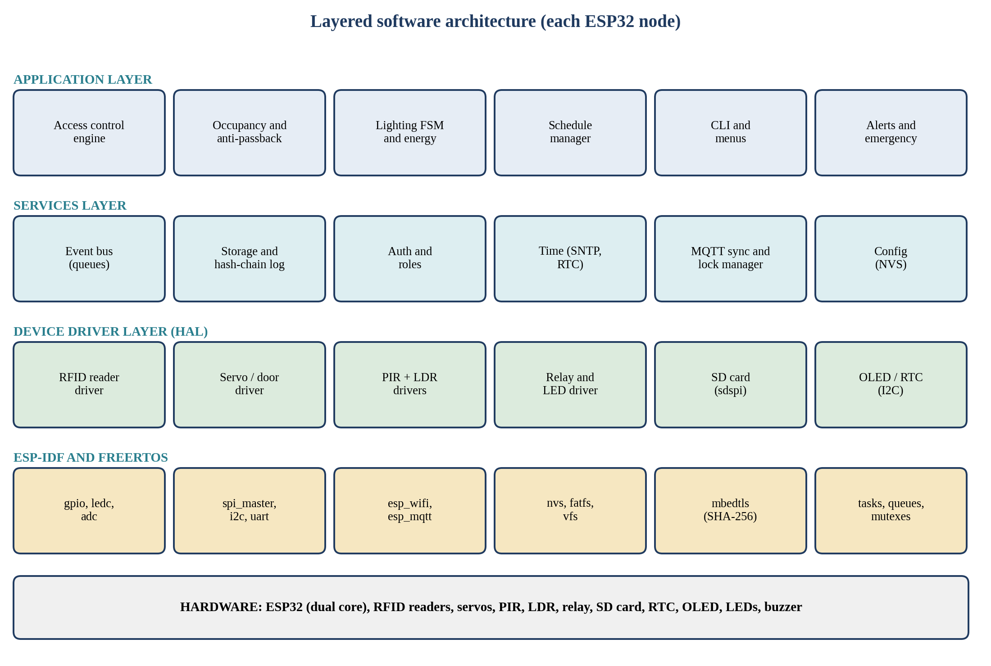
Figure 2: Layered software architecture used on every node

7.6 Operating modes
Table 18: System operating modes
Mode | Condition | Behaviour
NORMAL | Inside the access period, network up | Standard access control, occupancy, lighting, logging.
AFTER_HOURS | Outside the access period | ENTRY and EXIT scans denied; lights off unless override; motion triggers intrusion check; closing sweep list available.
EMERGENCY | Emergency button or CLI command | Both doors unlocked, lights on, roll-call, high-priority alert; schedule ignored.
DEGRADED | Network, broker or SD failure | Local decisions continue; events buffered; alert raised; retry with back-off.
MAINTENANCE | Admin sets maintenance flag | Doors locked normally, test commands enabled, access logged as TEST.

8. Hardware Design

8.1 Bill of components
Table 19: Components required (simulation parts in Wokwi)
Component | Qty | Node | Purpose | Wokwi part (verify)
ESP32 DevKit | 3 | All | Microcontroller, Wi-Fi | ESP32 DevKit V1
RFID reader (13.56 MHz) | 2 | Hub | ENTRY and EXIT identification | See Section 8.4
RFID tags/cards | 10 to 20 | Demo | User identities (UIDs) | Simulated UIDs
Servo motor SG90 | 2 | Hub | Door latch mechanisms (0 deg locked, 90 deg open) | Servo
microSD card module | 1 | Hub | Logs, registry, configuration | microSD card
RTC DS3231 | 1 | Hub | Battery-backed time fallback | DS3231 / DS1307 RTC
OLED SSD1306 128x64 | 1 (+2 optional) | Hub (rooms) | Local status display | SSD1306
PIR motion sensor HC-SR501 | 2 | Rooms | Room occupancy detection | PIR motion sensor
LDR light sensor module | 2 | Rooms | Daylight measurement | Photoresistor sensor
Relay module | 2 | Rooms | Switch the lamp circuit | Relay module
Lamp (LED as stand-in) | 2 | Rooms | Room lights | LED
Status LEDs (red, green, yellow, blue) | 4 (hub) + 6 (rooms) | All | Feedback and status | LED
Resistors 220 ohm | 10+ | All | LED current limiting | Resistor
Buzzer | 1 | Hub | Audible feedback and alarm | Buzzer
Push buttons | 4 | Hub (2), rooms (1 each) | Emergency, tamper, manual override | Pushbutton

8.2 Entrance Hub wiring and pin map
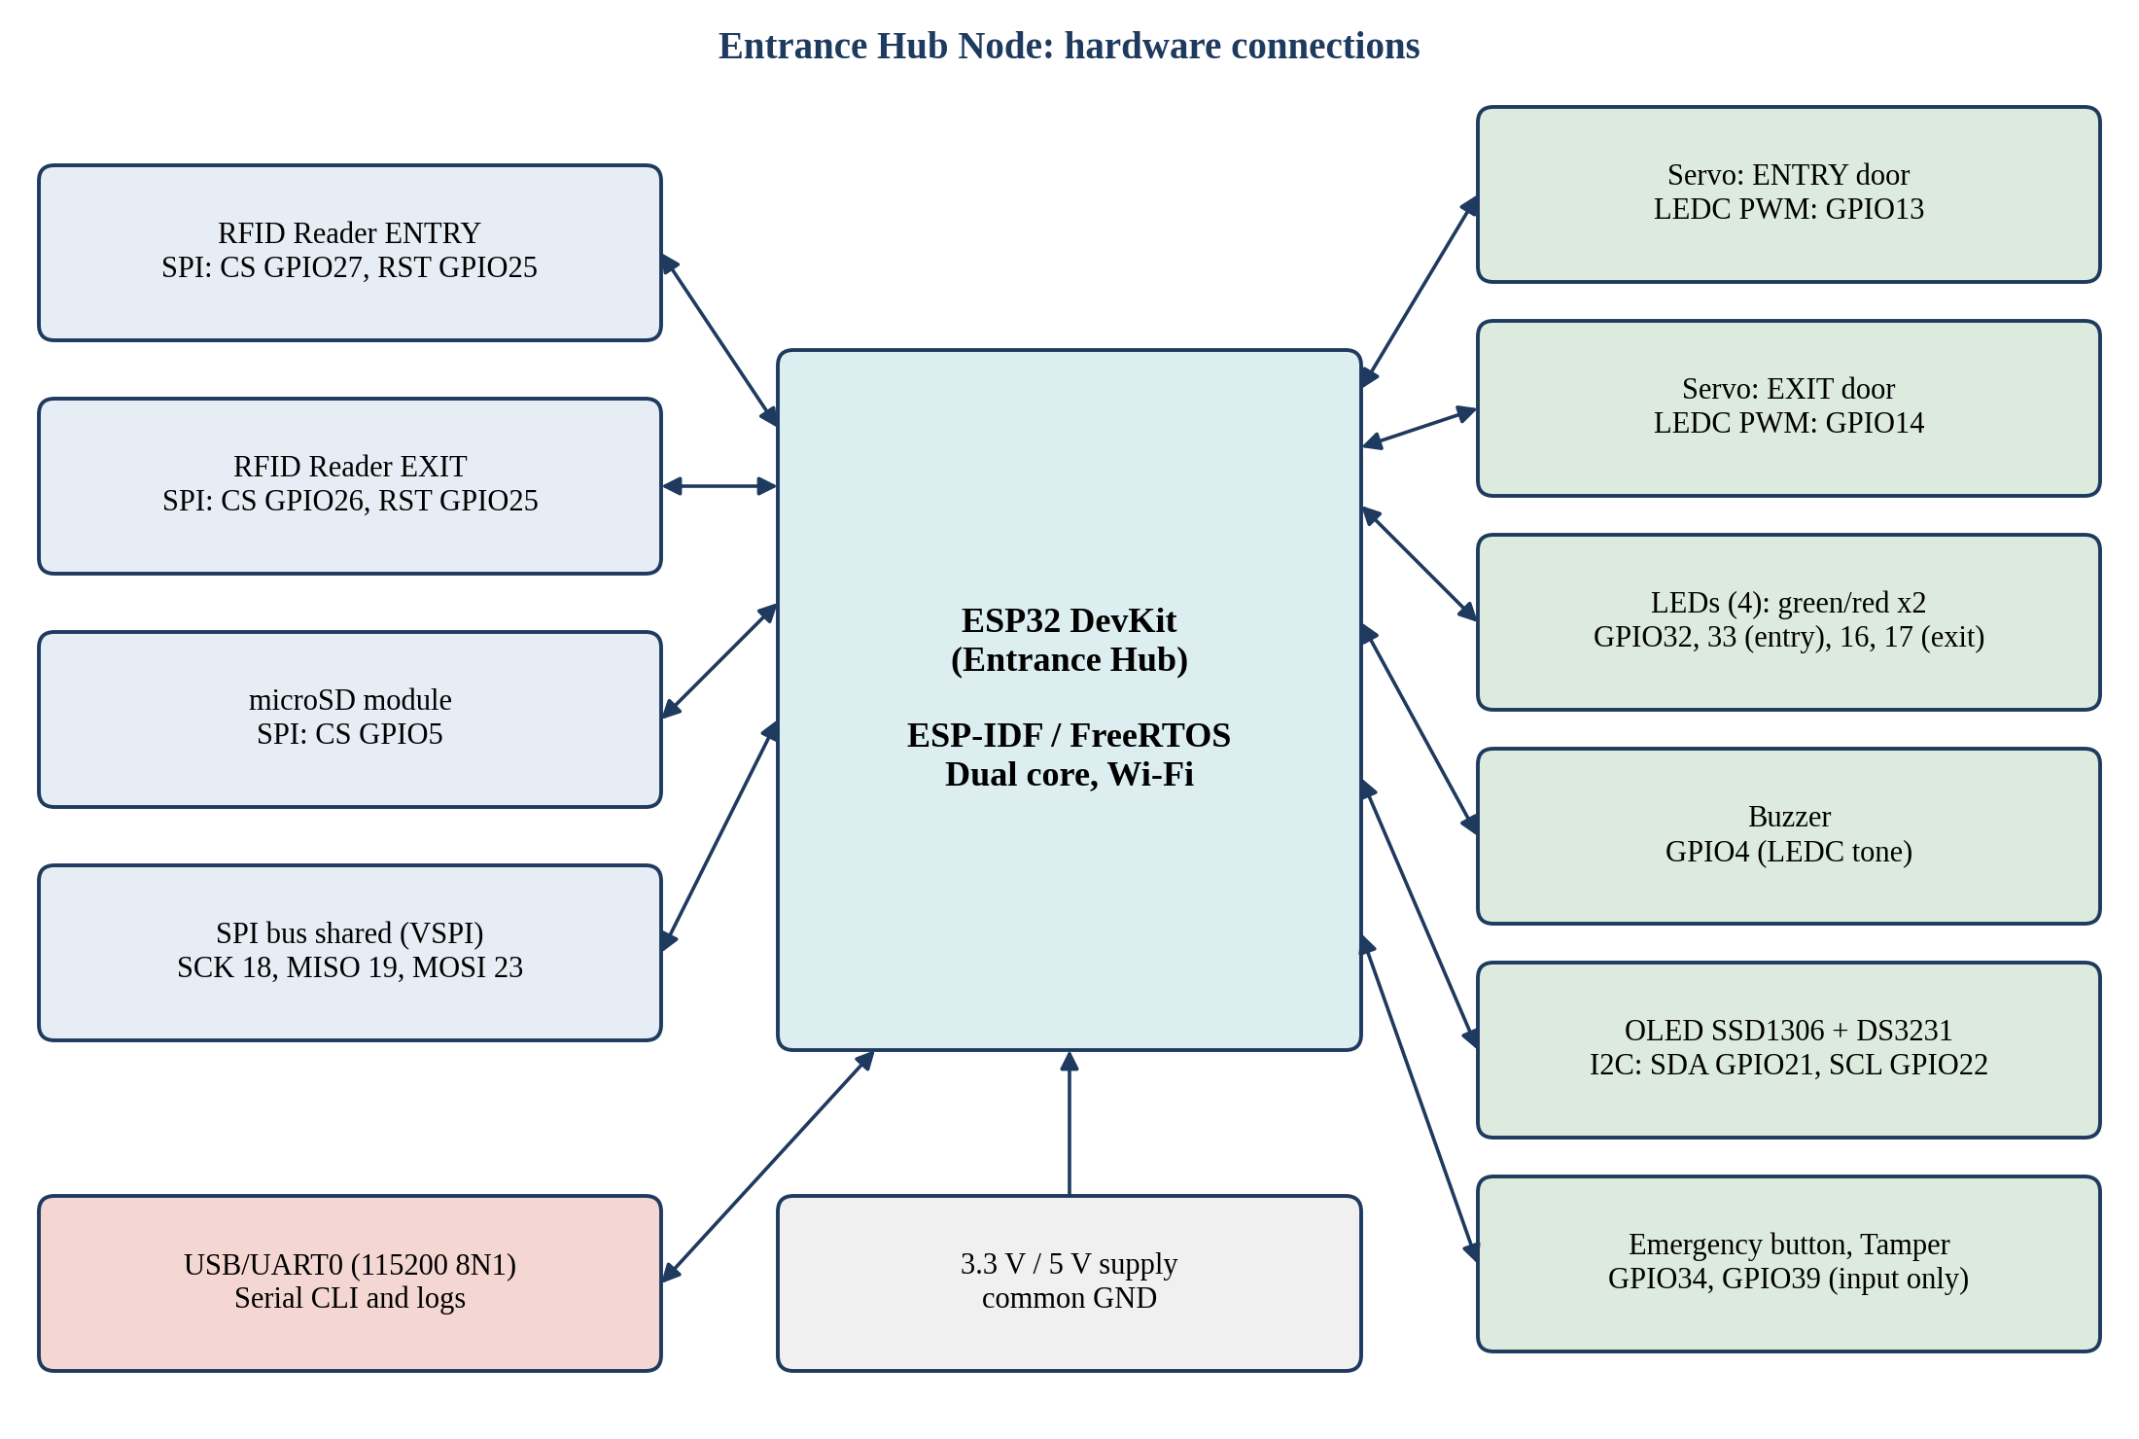
Figure 3: Entrance Hub hardware connections
Table 20: Hub GPIO assignment
Signal | GPIO | Type | Notes
SPI SCK / MISO / MOSI (VSPI) | 18 / 19 / 23 | SPI bus | Shared by SD card and both RFID readers; guarded by sd_mutex
SD card CS | 5 | Output | Idle high
RFID ENTRY CS | 27 | Output | Idle high
RFID EXIT CS | 26 | Output | Idle high
RFID RST (shared) | 25 | Output
I2C SDA / SCL | 21 / 22 | I2C | OLED (0x3C) and DS3231 (0x68)
Servo ENTRY door | 13 | LEDC PWM 50 Hz | 1 ms = locked, 2 ms = open (calibrate)
Servo EXIT door | 14 | LEDC PWM 50 Hz
LED ENTRY green / red | 32 / 33 | Output
LED EXIT green / red | 16 / 17 | Output
Buzzer | 4 | LEDC tone
Emergency button | 34 | Input (ISR, falling edge) | GPIO 34 to 39 are input only and have no internal pull-ups: use an external pull-up
Tamper switch | 39 | Input (ISR) | External pull-up
Passage sensor (optional, INN-12) | 35 | Input (ISR) | External pull-up
UART0 (CLI) | 1 / 3 | UART | 115200 8N1 through USB

8.3 Lecture room wiring and pin map
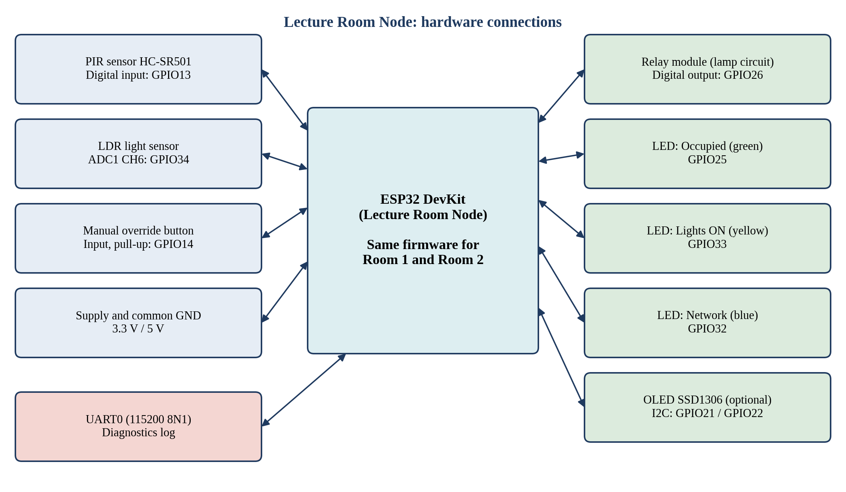
Figure 4: Lecture room node hardware connections
Table 21: Room node GPIO assignment (identical on Room 1 and Room 2)
Signal | GPIO | Type | Notes
PIR output | 13 | Input | HC-SR501 retrigger mode; 3.3 V logic
LDR analog out | 34 | ADC1 channel 6 | Use ADC1 only (ADC2 conflicts with Wi-Fi)
Manual override button | 14 | Input, pull-up | Active low, debounced
Relay IN (lamp) | 26 | Output | Active high in Wokwi; document polarity
LED Occupied (green) | 25 | Output
LED Lights ON (yellow) | 33 | Output
LED Network (blue) | 32 | Output | Blinks while connecting, steady when linked
I2C SDA / SCL (optional OLED) | 21 / 22 | I2C

GPIO cautions: avoid strapping pins (0, 2, 12, 15) for outputs that affect boot. GPIO 5 is a strapping pin but is acceptable as an idle-high chip select. GPIO 6 to 11 are connected to flash and must not be used.

8.4 Wokwi part availability and substitutions
Table 22: Simulation risks for specific parts
Part | Risk | Planned substitute
RFID reader | The simulator may not offer a ready RFID reader part. | Keep the HAL interface rfid_read_uid(reader_id). Provide two implementations selected in Kconfig: (1) hardware driver for MFRC522 over SPI for realism; (2) simulated reader fed by console commands (sim scan entry UID) or a Wokwi custom chip. Decide on day one.
Door mechanism | No door part exists. | Servo for latch plus LED or label in the report; angle shown in the log.
Lamp | No mains lamp. | LED driven through the relay contact circuit.
PIR sensor | Motion is simulated by clicking the part. | Use hold-time logic to filter bounce; include a scripted demo sequence.
SD card | Needs a formatted image in the project. | Use the Wokwi SD card part with an empty FAT image; create folders at boot if missing.

8.5 Feedback semantics
Table 23: LED, buzzer and OLED feedback table
Event | Green LED | Red LED | Buzzer | OLED
Access granted | On 2 s | Off | 1 short beep | Welcome, name, direction
Denied | Off | On 2 s | 2 long beeps | Denied and reason code
Outside hours | Off | Blink 3 times | 3 short beeps | Closed until HH:MM
Emergency | Both doors green | Off | Continuous slow pulse | EMERGENCY ROLL-CALL
Intrusion alert | Off | Fast blink | Fast beeps | INTRUSION room N
SD or network fault | Off | Slow blink | Single beep per minute | DEGRADED

9. Software Design

9.1 ESP-IDF project organisation
Each node is an ESP-IDF project. Shared code lives in components that are copied or symlinked into every project so that the same file implements the same behaviour on all nodes. The structure below is the agreed baseline.
Table 24: Repository and component layout
Path | Content
common/cocis_types | Shared enums, reason codes, event structs, message schema constants, error codes.
common/cocis_proto | JSON encode and decode, topic builders, event ID generation.
common/cocis_log_chain | SHA-256 chained log record builder and verifier.
common/cocis_time | SNTP, RTC fallback, schedule time helpers, EAT conversion.
entrance_node/main | app_main, task creation, board configuration.
entrance_node/components/hal_rfid, hal_door, hal_oled, hal_rtc, hal_sd | Device drivers for the Hub.
entrance_node/components/access_ctrl, occupancy, schedule, auth, cli, storage, net_sync, emergency | Application and service modules for the Hub.
room_node/main | app_main with ROOM_ID from Kconfig.
room_node/components/hal_pir, hal_ldr, hal_relay, hal_led | Device drivers for rooms.
room_node/components/light_fsm, energy, net_sync, diag | Application and service modules for rooms.
docs/ | This document, report drafts, diagrams, test logs, Wokwi links.

9.2 Hub task architecture
The Hub uses preemptive FreeRTOS multitasking on both cores. Time-critical RFID and door tasks run on core 1; Wi-Fi, MQTT and CLI tasks are pinned to core 0 together with the ESP-IDF network stack. Tasks communicate by queues and event groups; shared state is touched only inside short mutex-protected sections (Figure 5).
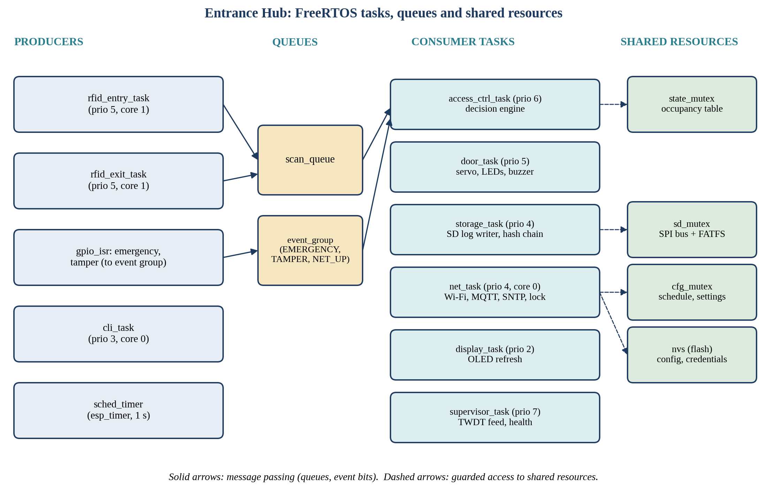
Figure 5: Entrance Hub tasks, queues and shared resources
Table 25: Hub task table
Task | Priority | Stack (bytes) | Responsibility
supervisor_task | 7 | 3072 | Feeds the task watchdog, monitors queue depths, heap, heartbeats; raises DEGRADED mode.
access_ctrl_task | 6 | 4096 | Consumes scan_queue, runs the decision algorithm, updates occupancy, posts door, log and network commands.
rfid_entry_task, rfid_exit_task | 5 | 3072 | Poll or interrupt-driven read of each reader, debounce, post scan events.
door_task | 5 | 2560 | Drives servos, LEDs and buzzer; enforces open time; fail-secure relock.
storage_task | 4 | 6144 | Sole SD writer; builds chained log records; flush policy; rotation; ring-buffer drain.
net_task | 4 | 6144 | Wi-Fi, MQTT client, SNTP, heartbeat, lock coordinator, config distribution.
cli_task | 3 | 6144 | Line editor, parser, session and role handling, command execution.
display_task | 2 | 3072 | Refreshes OLED every 500 ms from a snapshot of state.

Priorities follow the principle that safety and access decisions outrank logging and display. Stack sizes are initial values to be tuned with uxTaskGetStackHighWaterMark.

9.3 Room node task architecture
Table 26: Room task table
Task | Priority | Stack (bytes) | Responsibility
light_fsm_task | 5 | 3072 | Runs the lighting state machine every 100 ms from sensor events and timers; drives relay and LEDs.
sensor_task | 4 | 2560 | PIR edge handling with hold time; LDR sampling and averaging at 2 Hz.
net_task | 4 | 6144 | Wi-Fi, MQTT, config receive, telemetry, heartbeat, offline buffer.
energy_task | 3 | 2560 | Accumulates lamp-on seconds and estimated energy; persists every 5 min.
diag_task | 2 | 2560 | Prints diagnostics and feeds watchdog.

9.4 Access decision algorithm
Figure 6 specifies the order of checks executed by the access control task for every scan. The order matters: cheap and safety-critical checks come first, and all state changes happen in one short critical section after every rule has passed, so a half-applied decision can never be observed by another task.
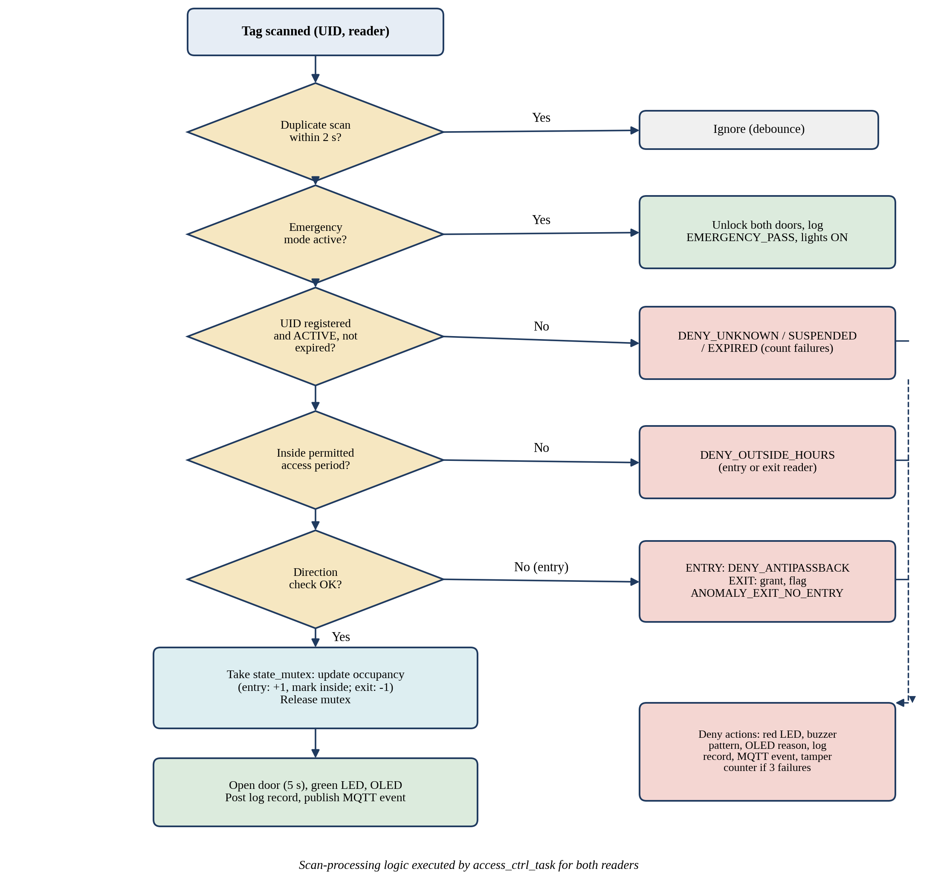
Figure 6: Scan processing and access decision flow

9.5 Occupancy and anti-passback model
- State per registered user: inside (boolean), entered_at (timestamp), last_scan (timestamp).
- ENTRY granted: inside = true, building count increments by one, entered_at set.
- EXIT granted: inside = false, building count decrements but never below zero.
- The occupancy table is protected by state_mutex and is snapshotted to NVS on every change and to SD every minute.
- On boot the Hub reloads the table from NVS, falls back to the SD snapshot, then reconciles with the last log lines.

9.6 Lighting state machine
Each room node implements the finite state machine in Figure 7. Transitions are driven by PIR events, the vacancy and warning timers, the LDR value with hysteresis, the override button and messages from the Hub (building occupancy and alerts).
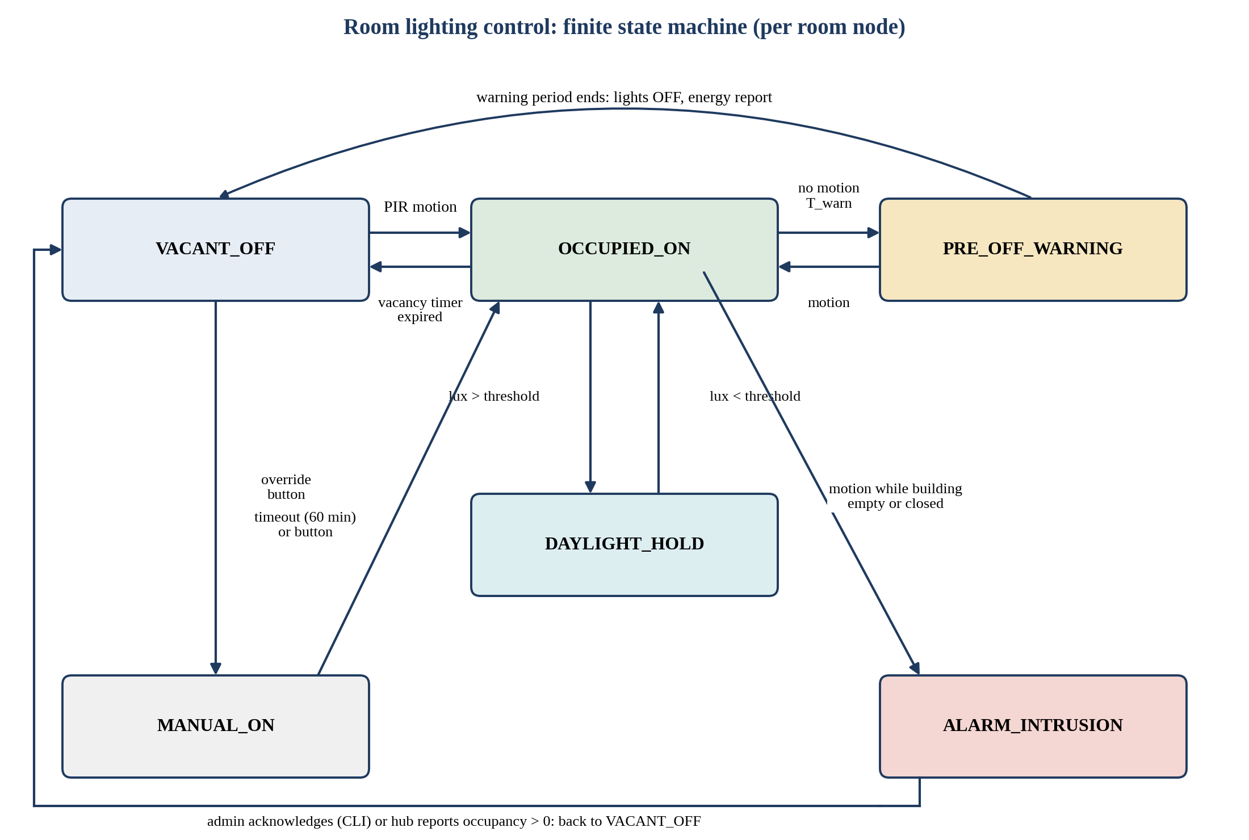
Figure 7: Lighting control state machine on a room node
Table 27: Lighting parameters and defaults
Parameter | Default | Demo value | Notes
Vacancy timeout (T_vac) | 300 s | 20 s | Time without motion before warning starts
Warning period (T_warn) | 30 s | 5 s | Lamp blinks at 1 Hz
PIR hold time | 2 s | 1 s | Ignore retriggers
Lux threshold on / off | 600 / 800 (ADC counts) | Same | Hysteresis band prevents flicker
Manual override duration | 60 min | 30 s | Button press extends
Lamp power (for energy estimate) | 72 W | 72 W | Four 18 W tubes, configurable
Tariff | UGX 780 per kWh (configurable) | Same | Illustrative value, set by management

9.7 Operational timing parameters
Table 28: Timing and limit defaults
Parameter | Default
Door open time | 5 s, then relock
Duplicate scan window | 2 s
Heartbeat interval / offline threshold | 5 s / 15 s
Distributed lock lease | 3 s (auto-expire)
CLI session idle timeout | 120 s
Login lockout | 3 failed attempts then 60 s
Log flush | After each record and fsync every 10 s
Occupancy SD snapshot | Every 60 s
Task watchdog timeout | 10 s

9.8 Reason and result codes
Table 29: Access result codes
Code | Meaning
GRANTED | Access allowed and door actuated
DENY_UNKNOWN | UID not in registry
DENY_SUSPENDED / DENY_EXPIRED | Registry status not ACTIVE or past expiry date
DENY_OUTSIDE_HOURS | Entry attempted outside the access period
DENY_EXIT_OUTSIDE_HOURS | Exit attempted outside the access period (while inside)
DENY_ANTIPASSBACK | Entry attempted while already recorded inside
ANOMALY_EXIT_NO_ENTRY | Exit granted with no recorded entry; flagged
EMERGENCY_PASS | Doors opened by emergency mode
ALERT_INTRUSION / ALERT_TAMPER / ALERT_BRUTE | Security alerts

9.9 Coding standards
- Language C (C99) with ESP-IDF conventions; one component per responsibility; public API in include/ headers.
- Every function that can fail returns esp_err_t; callers check with ESP_ERROR_CHECK only during init and handle errors explicitly at runtime.
- No blocking calls inside ISRs; use FromISR APIs and defer work to tasks. No malloc inside loops; allocate at init.
- All mutex takes use a timeout (pdMS_TO_TICKS) and the failure path is handled; follow the lock order cfg, state, sd.
- No magic numbers: configuration values live in Kconfig or a constants header. Log with ESP_LOGI, ESP_LOGW, ESP_LOGE and a per-module TAG.
- Each file begins with a comment block: purpose, author, requirement IDs covered.

10. Embedded Systems Concepts to Demonstrate
The assessment looks for a clear understanding of embedded systems principles. The table maps each concept to where it is used in this system, the ESP-IDF facility involved and the evidence a student can show in the video or presentation. Every team member should be able to explain at least the rows linked to their own work.
Table 30: Concept map
Concept | Application in this system | ESP-IDF facility | Evidence to show
GPIO, pull-ups and interrupts | Emergency, tamper, PIR, buttons | gpio_config, gpio_isr_handler_add | ISR posts to queue or event group
Debouncing | Buttons, duplicate RFID reads, PIR hold | esp_timer, tick comparison | Log shows one event per press
PWM | Servo position, buzzer tones | LEDC (ledc_timer, ledc_channel) | Servo angle in simulation
ADC and filtering | LDR daylight level | adc_oneshot, moving average | Lux values and hysteresis
SPI with multiple devices | SD card and two RFID readers on one bus | spi_bus_initialize, device CS | Bus guarded by sd_mutex
I2C | OLED and RTC on one bus | i2c_master | Two device addresses
UART | Serial CLI and diagnostics | uart driver, console | Interactive session
RTOS tasks, priorities, core affinity | Task set in Sections 9.2 and 9.3 | xTaskCreatePinnedToCore | Task list with priorities
Queues | scan_queue, log_queue, door commands | xQueueSend, xQueueReceive | Producer-consumer diagram
Mutexes and priority inheritance | Occupancy, config, SD card | xSemaphoreCreateMutex | Lock order rule and timeouts
Binary semaphores and notifications | ISR to task signalling | xTaskNotifyFromISR | Latency measurement
Event groups | EMERGENCY, TAMPER, NET_UP, SD_OK flags | xEventGroupSetBits | Multi-condition waits
Software timers | Vacancy timer, warning timer, door relock | esp_timer, xTimerCreate | Timer callbacks
Finite state machines | Lighting FSM, door FSM, session FSM | Table-driven C code | State diagram matches code
Non-volatile storage | Credentials, schedule, occupancy | nvs_flash, nvs_set_blob | Value survives reboot
File systems on SD | Daily CSV logs, registry | esp_vfs_fat_sdspi_mount, FATFS | Files in SD image
Wi-Fi station mode | Network access | esp_wifi, esp_netif, event loop | Connect and reconnect logs
MQTT (QoS, retained, Last Will) | Inter-node protocol | esp_mqtt_client | Topic trace
Time keeping | SNTP with DS3231 fallback, EAT conversion | esp_sntp, setenv TZ | Schedule uses local time
Watchdogs | Detect stuck tasks | esp_task_wdt | Forced hang is recovered
Cryptography | Password hashing, chained log | mbedtls SHA-256, PBKDF2 | Verify command output
Memory management | Heap budget, stack sizing, ring buffers | heap_caps, high-water marks | Diagnostics command
Concurrency hazards | Race conditions, deadlock, priority inversion | Lock ordering, timeouts | Section 13 scenarios
Fault tolerance and fail-safe design | Degraded mode, store and forward | Event groups, retry back-off | Pull network, system continues
Hardware abstraction | RFID, door, sensors behind HAL | Component interfaces | Swap simulated reader
Configuration management | Kconfig, partitions | menuconfig, partition table | ROOM_ID per node

11. Inter-Node Communication Design

11.1 Transport
Nodes communicate with MQTT version 3.1.1 using the ESP-IDF esp_mqtt client. A public broker (for example broker.hivemq.com or test.mosquitto.org) is reachable from the Wokwi-GUEST network. Public brokers are not private, so topics use a unique group prefix and payloads avoid personal data (UIDs are sent as short hashes, names never leave the Hub). The code reads the broker URI and prefix from Kconfig so it can be changed in one place.

11.2 Topic structure
Let {g} be the unique group identifier chosen by the team (for example cocis26-g7). All topics are of the form {g}/...
Table 31: MQTT topics
Topic | Publisher | Subscriber | QoS / retain | Purpose
{g}/entrance/event | Hub | Rooms, tools | 1 / no | Access event summary (granted, denied, anomaly)
{g}/entrance/occupancy | Hub | Rooms | 1 / retained | Building count and open/closed state
{g}/room/{n}/telemetry | Room n | Hub | 1 / no | Occupied flag, lamp state, lux, energy counters
{g}/room/{n}/event | Room n | Hub | 1 / no | Motion, state changes, alerts
{g}/room/{n}/cmd | Hub | Room n | 1 / no | Override, force off, test
{g}/config/schedule/prepare | Hub | Rooms | 1 / no | Phase 1 of schedule update
{g}/config/schedule/ack | Rooms | Hub | 1 / no | Acknowledgement of prepared version
{g}/config/schedule/commit | Hub | Rooms | 1 / retained | Phase 2: activate version; late joiners read it
{g}/lock/request, grant, release | Any | Hub (coordinator) | 1 / no | Distributed lock protocol (Section 13)
{g}/sys/emergency | Hub | All | 1 / retained | Emergency on or off
{g}/node/{id}/status | Each node | Hub, tools | 1 / retained | Heartbeat and Last Will (online or offline)

11.3 Message envelope
Every message is a compact JSON object with a common envelope so that handlers can validate and de-duplicate uniformly.
{
"v": 1, // protocol version
"id": "R1-0007-000142", // node, boot count, sequence (unique)
"ts": 1793088000, // UTC epoch seconds
"src": "R1", // H, R1 or R2
"type": "motion", // message type
"data": { "occupied": true, "lux": 412 }
}
Example payloads:
access event: {"type":"access","data":{"uidh":"a1b2c3","dir":"IN","res":"GRANTED"}}
telemetry: {"type":"tele","data":{"occ":true,"lamp":true,"lux":412,"wh":18.4}}
schedule prep: {"type":"sched_prep","data":{"ver":12,"base":11,"days":[...],"hol":[...]}}
ack: {"type":"sched_ack","data":{"ver":12,"ok":true}}
lock request: {"type":"lock_req","data":{"res":"cfg","lease_ms":3000}}

11.4 Reliability of delivery
- QoS 1 (at least once) is used for every functional topic. Duplicates are expected, so every handler is idempotent and discards an already processed id.
- Retained messages on occupancy, schedule commit, emergency and node status give a late-joining or reconnecting node the latest state immediately.
- Each node sets a Last Will on its status topic so the broker announces an offline node without waiting for the heartbeat timeout.
- Outgoing messages that cannot be sent are placed in a bounded ring buffer (64 entries) and replayed in order after reconnect.

11.5 Time distribution
All nodes obtain UTC from SNTP and convert to East Africa Time. The Hub additionally holds a DS3231 RTC and uses it if SNTP is unavailable. Timestamps in messages are UTC epoch seconds, so ordering does not depend on local time zone settings. When a node has no valid time its events are marked with uptime-relative timestamps and corrected later by the Hub.

12. Data Design

12.1 Storage layout on the SD card
Table 32: SD card directory structure
Path | Content | Written by
/sdcard/config/users.csv | User registry | storage_task (on admin command)
/sdcard/config/schedule.json | Access schedule and holidays | storage_task (on commit)
/sdcard/config/settings.json | Thresholds, tariff, timeouts | storage_task
/sdcard/logs/access/YYYYMMDD.csv | Access events with hash chain | storage_task
/sdcard/logs/audit/YYYYMMDD.csv | Logins, configuration changes, alerts | storage_task
/sdcard/logs/energy/YYYYMMDD.csv | Per-room lamp-on time and energy estimates | storage_task
/sdcard/state/occupancy.json | Occupancy snapshot | storage_task (every 60 s)
/sdcard/export/ | Reports generated by CLI export commands | storage_task

12.2 Record formats
Table 33: File schemas
File | Columns
users.csv | uid, name, role, status, expiry_date, created_at
access log | seq, ts_utc, ts_local, node, uid, name, direction, result, reason, prev_hash, hash
audit log | seq, ts_utc, actor, action, target, old_value, new_value, result, prev_hash, hash
energy log | ts_utc, room, lamp_on_seconds, baseline_seconds, est_wh_used, est_wh_saved
occupancy.json | version, ts_utc, count, inside[ {uid, since} ]

12.3 Schedule and settings model
{ "version": 12,
"modified_by": "admin", "modified_at": "2026-10-30T09:14:00+03:00",
"days": { "mon": ["07:00","21:00"], "tue": ["07:00","21:00"],
"wed": ["07:00","21:00"], "thu": ["07:00","21:00"],
"fri": ["07:00","21:00"], "sat": ["08:00","14:00"],
"sun": null },
"holidays": ["2026-12-25"] }

12.4 NVS namespaces
Table 34: NVS keys
Namespace | Keys | Purpose
auth | user_n_hash, user_n_salt, user_n_role, fail_n | Credentials and role (hash only)
sched | json_blob, version | Last committed schedule
occ | blob, version | Occupancy table
cfg | t_vac, t_warn, lux_on, lux_off, tariff, lamp_w | Tunable settings
sys | boot_count, seq_counter, last_hash | Event ID generation and log chain head

12.5 Hash-chain definition
For record i, hash_i = SHA-256( hash_(i-1) || canonical_text_of_record_i ). The first record of each day starts from the last hash of the previous day, stored in NVS (sys/last_hash) and written in the file header. The verify command recomputes the chain and prints OK or the line number of the first mismatch.

12.6 Retention and failure handling
- Daily files keep individual files small and make rotation simple. Older files are retained until the card is 80 percent full, then the oldest energy logs are deleted first; audit and access logs are never auto-deleted.
- If a write fails, the record stays in the RAM ring buffer, the SD_OK bit is cleared and the system enters DEGRADED mode until the card is writable again.
- File writes are append-only; each record is flushed with fflush and fsync on a timer to balance safety and wear.

13. Synchronisation and Reliability Design

13.1 Hazards to design against
Table 35: Concurrency hazards and countermeasures
Hazard | Example in this system | Countermeasure
Race condition on occupancy | ENTRY and EXIT readers process two scans at the same instant and both update the count. | Single access_ctrl_task consumes scan_queue serially; state_mutex around the table.
Interleaved writes to the SD card | Access log, audit log and energy log written from different tasks corrupt a file. | Single-writer storage_task fed by log_queue; sd_mutex covers the shared SPI bus with the RFID readers.
Inconsistent configuration | Room 1 applies the new schedule while Room 2 still uses the old one. | Two-phase versioned update with ACKs (Figure 8); retained commit.
Duplicate events | QoS 1 redelivers an entry event; the count is incremented twice. | Unique event id and processed-id cache; idempotent handlers.
Lost update | Two admin sessions edit the schedule from the same base version. | Update carries base version; Hub rejects stale base.
Deadlock | Task A holds cfg waiting for sd; task B holds sd waiting for cfg. | Fixed lock order cfg, then state, then sd; timeouts on all takes.
Priority inversion | Low priority CLI task holds a mutex needed by access_ctrl_task. | Mutexes (not binary semaphores) with priority inheritance; short critical sections.
ISR and task sharing | ISR increments a counter while a task reads it. | Use FromISR APIs, atomic types or portENTER_CRITICAL; copy then process.

13.2 Local synchronisation primitives
Table 36: Primitives used on the Hub
Primitive | Protects or signals | Holder rule
cfg_mutex | Schedule and settings structure | Held only while copying or replacing the structure
state_mutex | Occupancy table and counters | Held during the single update step of a decision
sd_mutex | SPI bus and FAT operations | Held by storage_task for a write and by RFID tasks for a read transaction
scan_queue (depth 8) | Scan events from two readers | Producers never block longer than 20 ms; overflow is logged
log_queue (depth 32) | Records to be written | Drops and alerts if full for more than 1 s
system_event_group | EMERGENCY, TAMPER, NET_UP, SD_OK, TIME_OK | Set from ISR or tasks; read with xEventGroupWaitBits

13.3 Distributed synchronisation
Because three separate microcontrollers cannot share a mutex, consistency is obtained by three complementary techniques.
- Single-writer authority. Only the Hub modifies the registry, occupancy, schedule and logs. Rooms propose changes through events or commands and never write shared records. This eliminates write-write conflicts.
- Versioned two-phase updates. A configuration change is prepared on all nodes, acknowledged, then committed (Figure 8). Nodes keep serving the old version until the commit arrives, so no two nodes ever enforce different versions for longer than one network round trip. Late or rebooting nodes read the retained commit.
- Leased distributed lock. For operations that need exclusive multi-node access (for example a global lights-off sweep at closing time or a log export), a node sends lock_req to the Hub coordinator. The Hub grants the lock to one requester at a time, each grant carrying a lease of 3 s and a fencing token that increases with every grant. A node that crashes while holding the lock loses it automatically when the lease expires, and stale holders are rejected by the token check.
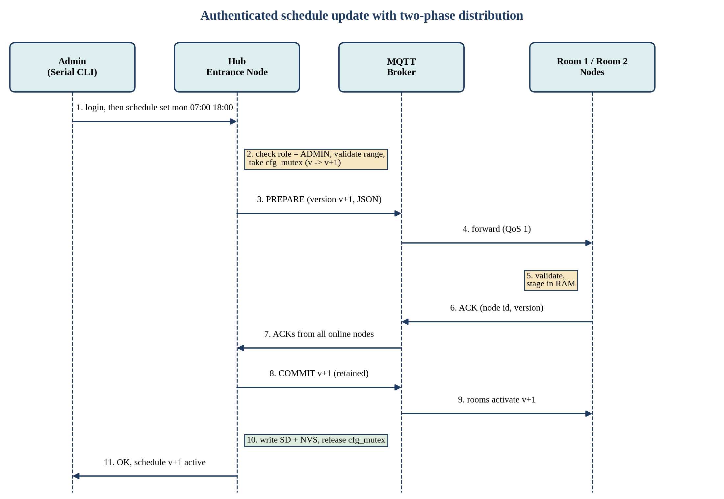
Figure 8: Authenticated schedule update with two-phase distribution

13.4 Failure modes and responses
Table 37: Failure analysis
Failure | Detection | System response
Wi-Fi or broker outage | MQTT disconnect event; heartbeat gaps | DEGRADED mode: local decisions, buffer events, retry with exponential back-off, blue LED slow blink.
Room node crash | Last Will or missing heartbeat for 15 s | Hub raises alert; room restarts under watchdog and resynchronises from retained messages.
Hub crash during scan | Task watchdog | Restart; occupancy reloaded from NVS; last log chain head restored; doors default to locked.
SD card removed or full | FAT error or free-space check | Ring buffer holds records, alert, resume on recovery.
Time not available | TIME_OK bit clear | Fail-secure: deny entry, allow emergency, show warning.
Sensor stuck (PIR always high) | No change for more than 2 hours | Diagnostics warning; lamp follows schedule limit.
Power loss | Brownout detector | State persisted on every change; doors lock on restart; mechanical release required for egress (documented).

14. Security Design

14.1 Authentication and roles
Table 38: Role permission matrix
Capability | VIEWER | SECURITY | ADMIN
View status, occupancy, rooms, lights | Yes | Yes | Yes
View access and audit logs | No | Yes | Yes
Roll-call, who is inside | No | Yes | Yes
Trigger or clear emergency mode | No | Yes | Yes
Suspend or reactivate a tag | No | Yes | Yes
Change access schedule and holidays | No | No | Yes
Add or remove users, change roles | No | No | Yes
Change thresholds, tariff, passwords | No | No | Yes
Verify and export logs | No | Yes | Yes

14.2 Credential and session handling
- Passwords are stored as PBKDF2-HMAC-SHA256 (at least 1000 iterations in simulation) with a 16-byte random salt per user. Plain text never touches NVS, SD or logs.
- The first boot creates a default ADMIN account with a one-time password that must be changed at first login.
- Three failed attempts lock the account for 60 s; each failure and lock is written to the audit log. Comparison uses a constant-time function.
- A session ends after 120 s idle or on logout. The prompt shows the current role, for example admin#.
- Optional INN-14: a physical admin action (card plus PIN on a keypad) is required for sensitive changes done at the door.

14.3 Threats and mitigations
Table 39: Threat analysis (STRIDE style)
Threat | Scenario | Mitigation
Spoofing | Cloned or shared tag | Anti-passback, suspension, alerts on repeated denials
Tampering | Editing a log file to hide an entry | Hash-chained logs and verify command; audit of config changes
Repudiation | Admin denies changing schedule | Audit log with actor, time, old and new value
Information disclosure | Reading MQTT on a public broker | Group prefix, UID hashing, no names or secrets in payloads; TLS option documented for real deployment
Denial of service | Flooding scans or MQTT | Duplicate window, queue limits, rate limiting
Elevation of privilege | Viewer runs admin command | Role checks in the command dispatcher and a unit test per command
Physical tampering | Opening the reader cabinet | Tamper switch raises ALERT_TAMPER

Security in the simulation is a proof of design. The report should state clearly which protections would be added in a real deployment (TLS to a private broker, secure boot, flash encryption, authenticated card protocols such as MIFARE DESFire).

15. Serial Interface and Management Menus

15.1 Interaction model
The CLI runs on UART0. A banner shows firmware version, time and mode. Commands are lower case words with arguments. Typing help lists the commands permitted for the current role; typing menu shows a numbered menu that maps to the same commands for users who prefer selection. Read-only commands work without login at VIEWER level; configuration commands require login.

15.2 Command reference
Table 40: Command set of the Hub CLI
Command | Role | Description
help, menu | All | List commands, show numbered menu
login <user>, logout, whoami | All | Authenticate (password prompt, no echo), end session, show role
status | VIEWER | Mode, time, schedule state, SD state, network state, uptime
occupancy | VIEWER | Building count and open or closed state
who | SECURITY | Names and UIDs of people inside, with entry time
rooms | VIEWER | Both rooms: occupied, lamp state, lux, vacancy timer
room <n> | VIEWER | Detailed status of one room including energy figures
lights | VIEWER | Lamp states and reasons (occupied, daylight hold, override)
log [n] | SECURITY | Last n access events (default 10)
log search <uid|name> | SECURITY | Filtered access events
log verify | SECURITY | Verify the hash chain; print first broken line
log export <date> | SECURITY | Create a report file in /sdcard/export
audit [n] | SECURITY | Last n audit entries
alerts | SECURITY | Active and recent alerts (intrusion, tamper, node offline)
nodes | VIEWER | Heartbeat status of the three nodes
schedule show | VIEWER | Current weekly schedule, holidays, version
schedule set <day> <open> <close> | ADMIN | Set a weekday window; example: schedule set mon 07:00 21:00
schedule off <day> | ADMIN | Close the building for a whole weekday
schedule holiday add|del <date> | ADMIN | Maintain holiday list
user list | SECURITY | Registered users and status
user add <uid> <name> <role> | ADMIN | Register a tag
user suspend|activate|del <uid> | SECURITY (suspend), ADMIN (others) | Change status or remove
user temp <uid> <name> <hours> | ADMIN | Create a visitor card with expiry
config set <key> <value> | ADMIN | Change t_vac, t_warn, lux thresholds, tariff, door time
energy [room] | VIEWER | Lamp-on time, estimated kWh, UGX saved
emergency on|off | SECURITY | Start or end emergency mode; prints roll-call
release <uid> | ADMIN | Authorise a person to leave after hours (audited)
diag | VIEWER | Heap, stack high-water marks, queue depths, task list
sim scan <entry|exit> <uid> | ADMIN | Simulation only: inject an RFID scan
passwd | Own account | Change password

15.3 Example session
cocis> login admin
Password: ********
OK. Role ADMIN. Session expires after 120 s idle.
admin# schedule set mon 07:00 21:00
Preparing schedule v13 ... Room1 ACK, Room2 ACK ... committed.
admin# occupancy
Building: OPEN until 21:00 | Inside now: 3 | Room1: occupied, lights ON | Room2: vacant, lights OFF
admin# who
1) Okello J. (UID 04A1...) since 08:12 2) Nakato S. (UID 0B7C...) since 08:40 3) ...

15.4 Additional output interfaces
- OLED at the Hub: time, mode, building count, last event, alert banner.
- Status LEDs and buzzer patterns as in Section 8.5.
- MQTT status topics, which allow any MQTT client to subscribe and view live telemetry (useful during the demonstration).
- Optional: a minimal HTTP status page served by the ESP-IDF HTTP server (stretch goal).

16. Access Schedule Specification

16.1 Data and evaluation rules
- The schedule maps each weekday to an open and close time, or to closed. A holiday date always means closed.
- A time t is inside the period when open <= t < close in East Africa Time. Midnight-crossing windows are not supported; configure two days instead.
- The Hub evaluates the rule for every scan using a copy of the schedule taken under cfg_mutex. Room nodes use their copy for intrusion and after-hours logic.
- If the schedule version is unknown or time is invalid, the system treats the building as closed (fail-secure) and raises an alert.
- A schedule change is committed only when all online nodes acknowledge. Offline nodes receive the retained commit on return.

16.2 Behaviour at and after closing time
- At close time the Hub switches to AFTER_HOURS, locks both doors against normal scans, and builds the list of people still inside (INN-10).
- The CLI and OLED display the list, security is alerted, and all lights in rooms with no motion are switched off.
- Exit scans outside the period are denied with DENY_EXIT_OUTSIDE_HOURS, as the brief requires (FR-SCH-03). An administrator can authorise a specific person to leave with the release command; the action is audited. Emergency mode always unlocks both doors for life safety.
Assumption A-1 (confirm with the lecturer): the brief says individuals must not be permitted to leave the building outside the authorised period while still inside. The design implements this literally for normal scans, and adds two audited safety exceptions (administrator release and emergency mode). The report should present this as a deliberate safety-versus-policy decision.

16.3 Edge cases to test
- Scan exactly at the open and close second.
- Schedule edited while a person is mid-scan.
- Change from open to closed while people are inside.
- Clock not yet synchronised at boot.
- Holiday on a normally open weekday.

17. Simulation Plan on Wokwi

17.1 Day-one spike tests
The following small experiments decide the deployment option and part substitutions before any large coding begins. Each should take under an hour and must be recorded in the project log.
Table 41: Spike tests
# | Question | Pass criterion | If it fails
S1 | Does an ESP-IDF project build and run in Wokwi? | Hello world and a FreeRTOS task print on the serial monitor | Use the Wokwi VS Code or CLI workflow with a local ESP-IDF build
S2 | Can two Wokwi projects exchange MQTT messages through the Wokwi-GUEST network? | Messages published by A are received by B | Switch to deployment Option B
S3 | Does SNTP return time in the simulation? | Correct UTC time printed | Use DS3231 RTC with manual set command
S4 | Does the SD card part mount with FATFS and allow append and read? | File written and read back | Use NVS-only storage plus RAM ring buffer and document the limitation
S5 | Which RFID source works? | A UID reaches the HAL from a part, custom chip or console | Console injection (sim scan command)
S6 | Do servo, PIR, LDR, relay, OLED, RTC parts behave as expected? | Each part driven from the HAL | Replace with LED indicators and note in the report

17.2 Wokwi project set-up
- Create three projects: cocis-entrance, cocis-room1, cocis-room2 (room firmware is identical; ROOM_ID differs through sdkconfig).
- Keep diagram.json (circuit) and wokwi.toml in the repository so the circuit is reproducible; commit the final share links into docs/links.md.
- Use the pin maps in Section 8 exactly; any change must be updated in this document first.
- Prepare a demo sequence file (list of scan commands and PIR clicks) so the demonstration is repeatable under time pressure.

17.3 Demonstration scenarios for the presentation
Table 42: Scripted demo
# | Scenario | Shows
D1 | Registered user scans ENTRY inside hours | Grant, door servo, OLED, log line, occupancy 1
D2 | Same tag scans ENTRY again | Anti-passback denial
D3 | Unknown tag scans ENTRY three times | Denials and brute-force alert
D4 | Admin changes schedule so the building is closed, then a user scans | Authenticated configuration, propagation to rooms, outside-hours denial
D5 | Person is inside when the building closes, tries to exit | Exit denial, roll-call list, administrator release
D6 | Motion in Room 1 | Lights on, status at the Hub, energy counter starts
D7 | No motion | Pre-off blink, lights off, energy saved
D8 | Bright LDR with motion | Daylight hold keeps lamp off
D9 | Motion in Room 2 while building empty | Intrusion alert
D10 | Press emergency button | Doors unlocked, lights on, roll-call
D11 | Disconnect Wi-Fi on a room node | Offline operation, buffering, resynchronisation on reconnect
D12 | Edit a log line then run log verify | Hash chain detects tampering

18. Testing and Validation

18.1 Strategy
Testing combines unit-level checks (pure logic such as the schedule evaluator, the hash chain and the lighting state machine, which can be run with scripted inputs), integration tests across nodes in the simulator, and a soak test. Every test case cites the requirement it verifies, and the results are pasted into the report as evidence.

18.2 Test cases
Table 43: Test case catalogue
ID | Test | Expected result | Verifies
TC-01 | Valid tag at ENTRY inside hours | Door opens 5 s, green LED, log and count updated | FR-ACC-02, 03, 05; FR-OCC-01
TC-02 | Unknown tag | Denied, red LED, DENY_UNKNOWN logged | FR-ACC-04
TC-03 | Suspended and expired tags | Denied with correct reason | FR-ACC-08
TC-04 | Duplicate scan within 2 s | Second read ignored | FR-ACC-06
TC-05 | Anti-passback | Second ENTRY denied; EXIT without entry flagged | FR-ACC-07
TC-06 | Three denied scans | Alert raised and logged | FR-ACC-09
TC-07 | Who is inside | List matches entries minus exits | FR-OCC-02
TC-08 | Reboot Hub with 3 inside | Same 3 users after restart | FR-OCC-03; NFR-04
TC-09 | Motion in room | Lamp on within 1 s; Hub shows occupied | FR-LGT-01, 03; NFR-02
TC-10 | No motion for T_vac | Pre-off blink then lamp off | FR-LGT-02, 04
TC-11 | Bright LDR with motion | Lamp stays off (daylight hold) | FR-LGT-05
TC-12 | Manual override | Lamp on for override time then normal | FR-LGT-06
TC-13 | Hub offline, motion in room | Lamp still switches | FR-LGT-08
TC-14 | Motion while building empty | Intrusion alert, lamp off | FR-LGT-09
TC-15 | Schedule set without login | Rejected with message | FR-SCH-04, FR-CLI-04
TC-16 | Schedule set as VIEWER or SECURITY | Rejected; audited | FR-SCH-04
TC-17 | Schedule set as ADMIN | Both rooms ACK, version increments, entry rules change | FR-SCH-01, 06; FR-SYN-04
TC-18 | Scan outside hours at ENTRY and EXIT | Both denied with correct reasons | FR-SCH-02, 03
TC-19 | Emergency button | Doors unlock, lights on, roll-call printed | FR-SCH-08; INN-02
TC-20 | Wrong password 3 times | Account locked for 60 s | NFR-05; INN-09
TC-21 | Wi-Fi drop on a room | Offline flag in 15 s; events replayed on return without duplicates | FR-DST-03, 04; FR-SYN-03
TC-22 | Remove SD card | DEGRADED mode, buffer, recovery on reinsert | FR-STO-04
TC-23 | Edit log line, run log verify | First broken line reported | FR-STO-05; INN-03
TC-24 | Concurrent scans at both readers plus CLI commands | No corruption, no negative count, no deadlock | FR-SYN-01, 07
TC-25 | Stale schedule update (old base version) | Rejected | FR-SYN-04
TC-26 | 30 minute soak with random scans and motion | No crash; heap and stack margins hold | NFR-03, 08

18.3 Acceptance criteria
- All Must requirements pass their test cases in the simulator.
- At least the Tier 1 innovations (INN-01 to INN-06, INN-08, INN-09) are demonstrated live.
- Each member can run their own feature in the demo and explain the code and the concepts used.
- The report, simulation links, videos, contribution statements and member details are submitted before the deadline.

19. Project Management

19.1 Suggested work breakdown for five members
The roles below spread the work so that every member owns a distinct, explainable part. Each member must also review at least one other member's code, since marks are lost when a student cannot explain a claimed contribution. If the team is smaller, merge roles 4 and 5 first.
Table 44: Roles and responsibilities
Role | Main ownership | Key deliverables | Concepts to master for Q&A
M1: Access and RFID lead | Hub hardware, RFID HAL, doors, access decision, occupancy, anti-passback, emergency | FR-ACC, FR-OCC, INN-01, INN-02, INN-12 | SPI, GPIO ISR, PWM, queues, FSM
M2: Storage and integrity lead | SD driver, log writer, CSV, hash chain, NVS persistence, energy logs | FR-STO, INN-03, INN-07 | FATFS, VFS, mbedtls, NVS, single-writer design
M3: Room and lighting lead | Room hardware, PIR, LDR, relay, lighting FSM, energy counters, intrusion detection on room side | FR-LGT, INN-04 (room), INN-05, INN-06 | ADC, timers, hysteresis, state machines
M4: Networking and synchronisation lead | Wi-Fi, MQTT, SNTP, protocol, distributed lock, versioned updates, offline buffer, heartbeat | FR-DST, FR-SYN, INN-08, INN-13 | MQTT QoS, Last Will, idempotency, locks, race conditions
M5: CLI, security, schedule and documentation lead | CLI, authentication, RBAC, schedule engine, tests, report assembly | FR-CLI, FR-SCH, INN-09, INN-10, test log, report | UART, parsing, crypto, RBAC, time zones

19.2 Timeline (27 October to 2 November 2026)
Table 45: Day-by-day plan
Date | Goals | Exit criterion
Tue 27 Oct | Kick-off; read this document; create repository and group MQTT prefix; run spike tests S1 to S6; assign roles | Deployment option and RFID source decided
Wed 28 Oct | HAL drivers and Wokwi circuits for all nodes; shared types; MQTT hello between nodes; storage skeleton | Every peripheral works from a test task
Thu 29 Oct | Access engine, occupancy, lighting FSM, schedule engine, event protocol, SD logging; first end-to-end demo D1 to D7 | Core Must requirements work together
Fri 30 Oct | CLI, authentication, schedule distribution, Tier 1 innovations, hash chain, emergency | TC-01 to TC-20 pass
Sat 31 Oct | Integration, fault tests, soak test, bug fixes, feature freeze at evening; report drafting by owners | TC-21 to TC-26 pass; code frozen
Sun 1 Nov | Record individual videos; finalise report with figures and test evidence; publish Wokwi links; rehearse Q&A | Report and videos ready
Mon 2 Nov | Final check, submit on Muele before the deadline, present to lecturer | Submission confirmed

19.3 Working agreements
- Version control: one Git repository, short-lived feature branches, pull requests reviewed by a second member, commit messages that cite requirement IDs.
- Definition of done for any feature: code merged, requirement ID in header comment, test case passed and recorded, demo step written, owner able to explain it without notes.
- Interface changes (topics, payloads, pins, structs) require an update to this document in the same pull request and notification to the team.
- Daily 15 minute stand-up: yesterday, today, blockers. Keep a shared risk and decision log.

20. Report, Video and Presentation Guide

20.1 Recommended report structure
Table 46: Report outline mapped to the brief
Chapter | Content | Reuse from this document
1. Introduction | Problem, objectives, scope | Sections 1 to 3
2. Requirements | Functional, non-functional, innovative features | Sections 4 to 6
3. System architecture | Overall design, node roles, communication, deployment on Wokwi | Section 7, 11
4. Hardware design | Components, pin maps, wiring figures | Section 8
5. Software design | Tasks, state machines, algorithms, data and storage | Sections 9, 12, 15, 16
6. Synchronisation and security | Mutexes, distributed protocol, authentication | Sections 13, 14
7. Implementation and operation | How to run, screenshots of CLI and logs, demo walkthrough | Section 17
8. Testing and results | Test table with evidence | Section 18
9. Innovation summary | What was added and why it matters | Section 6
10. Contributions and member details | Individual contributions, names and identification details | Section 19 and group table
11. Conclusion and future work | Limits, lessons, real deployment recommendations | Section 21
Appendices | Wokwi links, video links, code excerpts | Section 20.3

20.2 Individual video checklist
- Length 5 to 8 minutes, screen recording with voice, face optional.
- Start by stating name, student number, role and the requirement IDs you implemented.
- Show the code you wrote file by file, explaining data structures, tasks, synchronisation and error handling.
- Run the simulation and show your feature working, including one failure case.
- Name the embedded systems concepts used (use Section 10) and why you chose them over alternatives.
- Do not read from a script without understanding; you will be asked questions on the same material.

20.3 Submission checklist
Table 47: Final checklist
Item | Done
Report with all required sections, figures and test evidence
Wokwi link(s) open without login and run
One video link per group member, accessible to the lecturer
Individual contribution statement for every member
Names and identification details of all members
Submitted on Muele before 2 November 2026
Every member available for the presentation

20.4 Likely questions in the presentation
- Why a hub-and-spoke design, and what happens when the Hub fails?
- Show me where a race condition could occur and which primitive prevents it.
- What is priority inversion and how does your mutex configuration address it?
- Why is only one task allowed to write to the SD card?
- How does your system guarantee that all rooms use the same schedule version?
- How are passwords stored, and what would you change for a real deployment?
- Why use QoS 1 and what problem does that create?
- How did you choose task priorities and stack sizes?
- What happens to occupancy when power is lost during a scan?
- Explain your lighting state machine and how you avoid flicker.

21. Risks and Mitigations
Table 48: Risk register
ID | Risk | Likelihood | Impact | Mitigation
R1 | Wokwi lacks an RFID part | High | Medium | HAL with simulated reader (console or custom chip); decide on day one
R2 | Multi-project MQTT does not work in the simulator | Medium | High | Spike S2; fall back to Option B with the same message design
R3 | Six days is too short for full scope | High | High | Strict Must-first order; Tier 2 and 3 only after Tier 1 is stable; daily integration
R4 | SD card simulation limitations | Medium | Medium | Spike S4; NVS and ring buffer fallback documented
R5 | Public broker unreliable or shared with other groups | Medium | Medium | Unique topic prefix; retry logic; local fallback
R6 | Integration bugs from late merging | High | High | Shared types component, daily merges, protocol tests with recorded messages
R7 | A member cannot explain their code | Medium | High | Peer reviews, own-feature demos, rehearsal of Q&A
R8 | Race conditions appear only late | Medium | Medium | Design rules in Section 13; stress test TC-24; code review checklist
R9 | Simulator timing differs from real hardware | Low | Low | State assumption in the report; use timeouts and retries, not fixed delays

22. Guidelines for AI Coding Agents
This section is addressed to AI agents that read this document to generate, review or document code for the team. Following these rules keeps contributions consistent and safe to merge.
- Read order: Sections 1.4 (conventions), 4 (requirements), 8 (pins), 11 (protocol), 12 (data), then the section relevant to the assigned task.
- Cite requirement IDs in header comments, commit messages and test names. Do not invent new IDs; propose additions to the team.
- Never change GPIO assignments, topic names, JSON field names, reason codes, schedule or NVS keys without an accompanying update to this document and approval from the task owner.
- Use ESP-IDF (C) and FreeRTOS APIs only. Do not generate Arduino code. Target the ESP32 and ESP-IDF 5.x style APIs; check the version used by the Wokwi project before using newer driver APIs.
- Respect the architecture: hardware access only through HAL components; only storage_task writes the SD card; only the Hub modifies authoritative data; lock order cfg, state, sd; every mutex take has a timeout.
- Handle errors explicitly, log with ESP_LOG macros, and keep ISRs minimal.
- Do not hard-code secrets. Default credentials come from Kconfig and must be changed at first login.
- Produce testable units: keep pure logic (schedule evaluator, hash chain, state machine step function, JSON codec) free of hardware calls so it can be tested on the host.
- State assumptions and open items in comments marked TODO(ID) rather than guessing silently, especially for simulator part behaviour that is still unverified.
- Style of prose output: use plain ASCII hyphens, never long dashes, and keep explanations short and factual.

Appendix A: Glossary
Table 49: Terms and abbreviations
Term | Meaning
ADC | Analog to digital converter
Anti-passback | Rule that prevents a tag from entering twice without an exit between
CLI | Command line interface
EAT | East Africa Time, UTC+3
ESP-IDF | Espressif IoT Development Framework
FATFS | File allocation table file system library
FSM | Finite state machine
HAL | Hardware abstraction layer
Idempotent | Operation that has the same effect if applied more than once
LDR | Light dependent resistor
LEDC | ESP32 PWM peripheral
LWT | MQTT Last Will and Testament
MQTT | Message Queuing Telemetry Transport, publish and subscribe protocol
NVS | Non-volatile storage in flash
PBKDF2 | Password-based key derivation function
PIR | Passive infrared motion sensor
RBAC | Role-based access control
RFID | Radio frequency identification
SNTP | Simple network time protocol
TWDT | Task watchdog timer
UID | Unique identifier of an RFID tag

Appendix B: Requirement Traceability Matrix
Table 50: Requirement areas to design sections and tests
Brief section | Requirement IDs | Design sections | Test cases
2.1 Access control and occupancy | FR-ACC-01 to 09, FR-OCC-01 to 06 | 7, 8.2, 9.4, 9.5 | TC-01 to 08, 24
2.2 Automated lighting | FR-LGT-01 to 09 | 8.3, 9.3, 9.6 | TC-09 to 14
2.3 Distributed ESP32 control | FR-DST-01 to 05 | 7, 11 | TC-21
2.4 Data storage | FR-STO-01 to 06 | 12 | TC-08, 22, 23
2.5 Serial interface | FR-CLI-01 to 06 | 15 | TC-07, 15, 20
2.6 Configurable schedule | FR-SCH-01 to 08 | 16, 14 | TC-15 to 19, 25
2.7 Synchronisation and reliability | FR-SYN-01 to 07 | 13 | TC-21, 24, 25, 26
3 Innovation emphasis | INN-01 to 15 | 6 | TC-05, 14, 19, 20, 23

Appendix C: Default Configuration Values
door_open_ms = 5000
dup_scan_ms = 2000
t_vac_s = 300 (demo: 20)
t_warn_s = 30 (demo: 5)
override_min = 60 (demo: 0.5)
lux_on / lux_off = 600 / 800 (ADC counts, 12-bit, tune in simulation)
heartbeat_s = 5 offline_after_s = 15
lock_lease_ms = 3000
session_idle_s = 120 login_fail_max = 3 lockout_s = 60
lamp_w = 72 tariff_ugx_per_kwh = 780
tz = EAT-3
mqtt_prefix = <unique group id>

Appendix D: Open Questions for the Lecturer
- Is it acceptable to demonstrate three terminals as three linked Wokwi projects, or is a single project expected?
- Is the literal interpretation of the exit restriction (Assumption A-1) acceptable, with the audited release and emergency exceptions?
- Is a simulated RFID source (console or custom chip) acceptable if no RFID part is available?
- Is an external MQTT broker acceptable for inter-terminal communication in the simulation?
- May the room nodes share the Hub's SD card through the Hub, or must each terminal have its own memory card module?

