The CoCIS Smart Building System in Simple Terms
Makerere University, College of Computing and Information Sciences | Summary for the team
1. What is this project about?
Imagine a college building with a main entrance and two lecture rooms. We are building a pretend smart version of it. Three tiny computers (called ESP32 chips) act like the building's helpers. They check ID cards at the doors, remember who is inside, switch lamps on and off to save electricity, and write everything down safely. The whole thing runs on a computer screen (the Wokwi simulator), not in a real building.
2. The doors: who gets in?
The main entrance has two doors: one for going in (ENTRY) and one for going out (EXIT). Every person has an ID card (an RFID tag) and taps it on a small reader next to the door. The system asks three easy questions: Is this a real card? Is the building open right now? Is this person already inside? If all answers are good, the door opens for 5 seconds and a green light shines. If not, a red light and a beep tell the person to stay out, and the reason is written down.
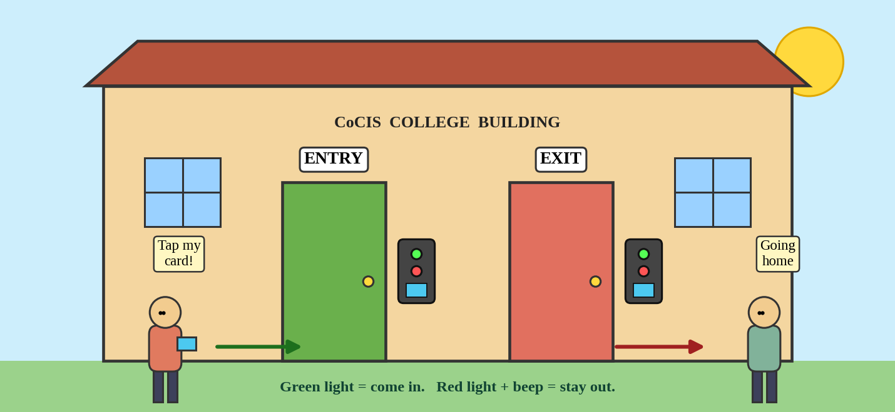
Figure 1: The main entrance with its ENTRY door, EXIT door and card readers.
3. Counting people and saving electricity
The system keeps a live list of who is in the building, like a teacher taking attendance. It stops card sharing: a person who is already inside cannot tap in again (called anti-passback). The list is saved in memory, so a power cut does not erase it.
Each lecture room has a motion eye (PIR sensor) and a light sensor (LDR). When someone is in the room, the lamp turns on. When nobody moves for a while (5 minutes normally), the lamp blinks as a warning and then turns off. If the room is already bright from the sun, the lamp stays off. If something moves while the building should be empty, the system sounds an intruder alert.
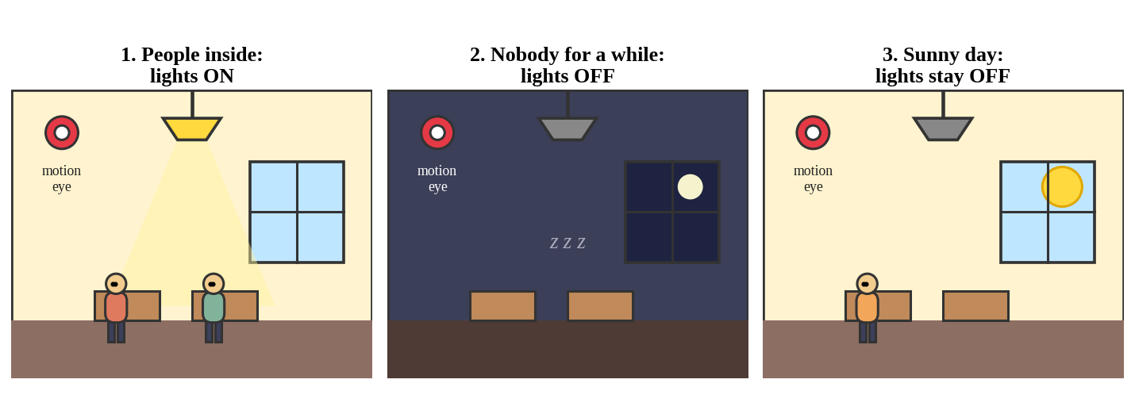
Figure 2: A lecture room with people (lamp on), empty (lamp off) and sunny (lamp stays off).
4. Records, controls and safety
- Safe records. Every event is saved on an SD card. Each line is linked to the one before it (a hash chain, like a mini blockchain), so anyone who edits a record is caught.
- Text console. An admin or security officer types simple commands on a laptop to see who is inside, read logs, or change opening hours. A password is needed for changes.
- Opening hours. The building only lets people in during the allowed times. Anyone still inside after closing time is listed and security is told.
- Emergency button. One big red button unlocks every door and turns on every light so people can leave quickly. A roll call then shows who is still inside.
5. How the pieces fit together (deployment)
There are three terminals, each on its own ESP32. The Entrance Hub is the brain: it checks cards, owns the list of people, the opening hours and the memory card. Lecture Room 1 and Lecture Room 2 are almost the same: each controls its own lamp even when the network is down. The three talk to each other over Wi-Fi using short messages (MQTT), so they always agree. In Wokwi, each terminal is its own project and the lecturer opens the three links side by side.
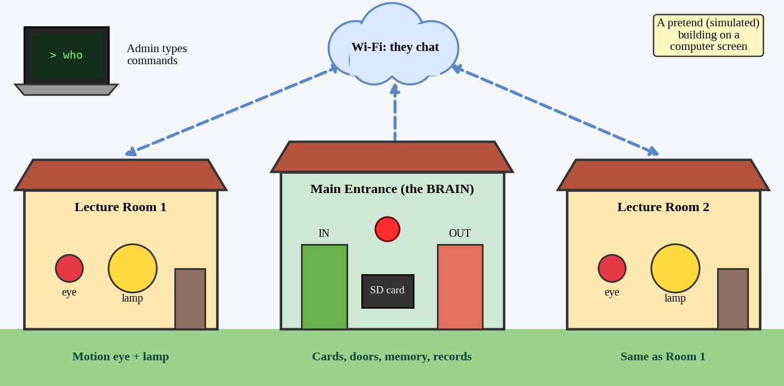
Figure 3: The three terminals chat over Wi-Fi. The admin laptop talks to the Entrance Hub.
6. What the team must deliver by 2 November 2026
Write the firmware in C with ESP-IDF, simulate it on Wokwi, write a report, record one video per member, and give a live demo. Every member must be able to explain their own part. The marks reward extra ideas most: anti-passback, emergency roll call, tamper-proof logs, daylight-aware lighting, working offline, and strong passwords.
7. A day in the life of the building
In the morning the doors unlock for cards and the lamps wait for people. A student taps in, the door opens, and the count goes from 0 to 1. She walks into Room 1, the motion eye sees her, and the lamp turns on. When she leaves for lunch and nobody moves for 5 minutes, the lamp blinks and goes off, saving money. In the evening the building closes: the doors stop accepting normal cards, security sees a list of anyone left inside, and a night-time movement in an empty room raises the alarm.
8. Who does what in the team
Five members share the work so everyone owns one clear part: (1) doors, cards and people counting; (2) SD card, safe records and saved memory; (3) rooms, sensors and lamps; (4) Wi-Fi, messages and keeping the three chips in step; (5) text console, passwords, opening hours, tests and the report. Everyone also checks one friend's code.
9. Big words in simple words
- RFID tag: a plastic card that whispers its secret number to the reader.
- PIR sensor: an eye that notices warm bodies moving.
- MQTT: a notice board where chips pin short messages for each other.
- Hash chain: a chain of locks; break one link and everyone can see.
- Simulation: a video-game version of the electronics that works on a laptop.
In one sentence: three small chips cooperate to open doors with ID cards, count who is inside, switch lamps by motion, and keep safe records, all controlled from a text console.

