WEEK 7 PROGRESS REPORT
Evaluation, Observability and Guardrails
Field | Detail
Group / Project Name | Group A Day (BSSE Day), University Student-Support Case Agent
Evaluation Result | Current final run: 49/49 pass; 0 safety violations; 39/39 traces complete. A valid pre-fix comparison is not available in the retained outputs.
Focus: Produce evidence that the system is reliable, grounded, inspectable and safe for its bounded use case.

1. Work Completed Against Weekly Objectives
- Evaluation set: 49 scripted scenarios across normal (8), edge (13), incorrect-information (4), adversarial (9), tool-failure (5) and unauthorized (10) cases. The runner measures task completion, groundedness, tool selection, instruction following, safety violations, latency and traceability against expected behaviours.
- Current final results: 49/49 scenarios pass; task completion, groundedness, tool selection and instruction following each pass 49/49; there are 0 safety violations. Local scripted-planner latency is p50 1.0 ms, p95 20.8 ms and max 26.8 ms against a 2,000 ms limit. These are local scripted-planner measurements, not live-model latency.
- Observability: the final output contains per-scenario trace JSON files and an events.jsonl stream. All 39 traces emitted by the agent runs pass the completeness check. The retained baseline output also reports 39/39, so the current files do not demonstrate a change from 0/39.
- Guardrail coverage includes input and output validation, tool allow-listing, authorization, iteration limits, approval controls and prompt-injection handling. The 49-scenario final run reports no safety violations; the individual scenario results are in evidence/week7_eval/final/RESULTS.md.
- Failure Catalogue: 14 entries are documented. The generated catalogue marks FC-12, FC-13 and FC-14 as passing re-tests. FC-01 through FC-11 are marked FAIL because the retained baseline and final outputs both show their cited scenarios passing (and both show 39/39 traces); these artifacts do not provide a valid before/after re-test for those entries. FC-14 separately confirms 8/8 Week 6 scenarios on polluted test data.
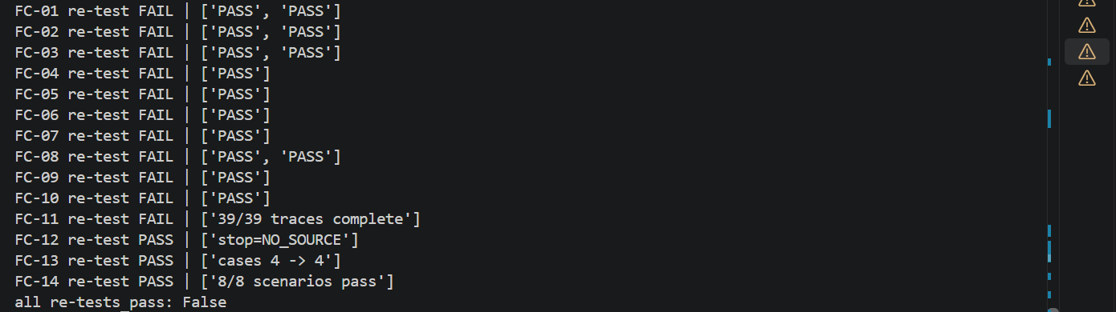

2. Key Engineering Decisions and Why They Were Made
- Comparison integrity. The retained baseline and final result files both report 49/49 pass and 0 safety violations. In tests/run_week7_eval.py, --label selects the output folder; it does not load the historical Week 6 implementation. The current files therefore cannot substantiate the earlier draft claim of 29/49 before fixes and 49/49 after, or 3 safety violations reduced to 0.
- Deterministic regression testing. The runner uses the scripted planner to make local results repeatable and avoid dependence on live model availability. This is useful for regression checks, but it does not measure live Gemini behaviour or replace an independent held-out evaluation.
- Evidence-led reporting. Scenario-level results, traces and failure-catalogue statuses are treated as the source of truth; a successful current run is not presented as proof that a historical defect was fixed unless a genuine pre-fix result is retained and compared.
- Safety design. Authorization, approval and bounded tool execution are enforced as explicit controls rather than relying only on prompt wording. Their current regression coverage is recorded in the scenario set and generated results.

3. Failures / Challenges and Current Response
- Evidence gap: the Failure Catalogue records authorization and internal-trace exposure among its historical findings. However, U05/U10 and the cited FC-02 scenarios pass in both retained evaluation outputs, so those outputs do not independently reproduce the defects or prove their fixes. Keep the findings as documented history, but rerun against a preserved pre-fix revision before claiming the retests are verified.
- The same evidence limitation applies to FC-03 through FC-11: their cited scenarios and traceability checks pass in both current output sets, making their failure-catalogue retest status FAIL. This denotes insufficient before/after evidence in the generated catalogue, not proof that the current code exhibits those defects.
- Limitations and response: the 49-case set is a fixed regression suite, not an independent held-out test. The baseline label does not represent Week 6 code, and FC-01 through FC-11 lack valid baseline-to-final retests in the generated catalogue. Latency is local and scripted; the live Gemini planner has not been demonstrated end to end. Preserve a pre-fix revision, regenerate baseline evidence from it, rerun final and the catalogue, then add held-out and live-model testing.

GitHub and ClickUp Evidence
Repository: github.com/OpiyoOscar01/group_A_ai_agentic_capstone_assignment. Week 7 inputs and runners:
ClickUp evidence: add the Week 7 board URL and screenshot before submission.
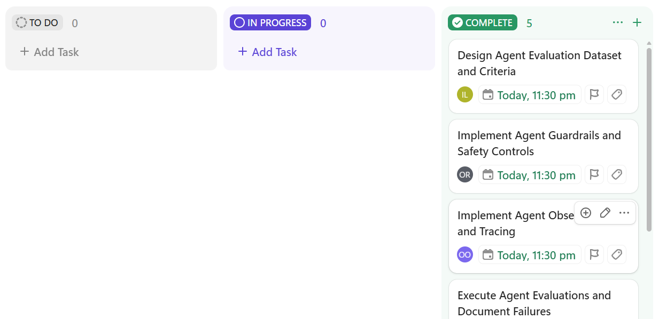

5. Individual Contribution Summary
Member | Task Owned This Week | Evidence
Isio Lily | Evaluation criteria and scenario design | tests/week7_eval_set.json; evaluation criteria and scenario outputs
Opiyo Oscar | Implement guardrail and validation fixes | src/agent.py, src/tools.py changes
Namatovu Christine maria | Run evaluation, Failure Catalogue and re-tests | tests/run_week7_eval.py; tests/retest_failures.py; evidence/week7_failures/CATALOGUE_EVIDENCE.md
Ogwal Richard | Observability and tracing | Trace fields and JSONL; Observability document
Babirye Sandra | Guardrail evidence; review; compile progress report | Guardrail document; this report

6. Plan for Next Week (Week 8, Final Integration and Presentation)
- Run the live Gemini planner end to end and retain its trace and evaluation output; check model-written text against the output validator.
- Re-run the Week 3 retrieval baseline after the DOC-12 change. Create held-out scenarios and rerun Week 7 baseline from a preserved Week 6 revision, final code, and catalogue re-tests so historical comparisons are reproducible.
- Prepare the final report, demonstration script and presentation (27th, 29th, 30th October), including results, limitations and human responsibility.
AI use declared: Claude (Anthropic) assisted with code, evaluation design and documents, recorded in the AI Engineering Log.

