BSE4104, Emerging Trends in Software Engineering
8-Week AI-Native and Agentic Engineering Capstone
Group A Day — Week 3 Corpus and RAG Design
Use Case: University Student-Support Case Agent
Name | Student Number
Namatovu Christine Maria | 2300701098
Opiyo Oscar | 2300701330
Isio Lily | 2300700445
Babirye Sandra | 2300707270
Ogwal Richard | 2300716574

TABLE OF CONTENTS
1. Corpus and Source Register
2. Ingestion, Chunking, Indexing and Retrieval
3. RAG Architecture and Context Construction
4. Prompt v3.0-RAG Changes

1. Corpus and Source Register
Controlled corpus of 12 documents (within the recommended 10–50). All records are team-synthesised from public Makerere handbook structure or team-created system specs; no confidential or real student data is included. Full texts are committed under knowledge/ with provenance headers. This register satisfies the Week 3 provenance requirement.
Doc ID | Title | Provenance / Source | Ver / Date
DOC-01 | Retakes and Supplementary Examinations | Team-synthesised from public handbook structure | v1.0 12 Sept 2026
DOC-02 | Missing Marks Procedure | Team-synthesised departmental guidance | v1.0 12 Sept 2026
DOC-03 | Course Registration Guide Sem I 2026/27 | Team-synthesised | v1.0 12 Sept 2026
DOC-04 | Timetable and Attendance Policy | Team-synthesised | v1.0 12 Sept 2026
DOC-05 | Grading and GPA (explanatory only) | Team-synthesised; boundary: no grade decisions | v1.0 12 Sept 2026
DOC-06 | Support Cases and Ticketing Spec | Team-created system spec | v1.0 12 Sept 2026
DOC-07 | BSE4104 Course Outline | Team-synthesised course outline | v1.0 12 Sept 2026
DOC-08 | BIT2207 Course Outline | Team-synthesised course outline | v1.0 12 Sept 2026
DOC-09 | Examination Rules | Team-synthesised | v1.0 12 Sept 2026
DOC-10 | Fees and Bursar — Boundary Notice | Team-synthesised; boundary: Bursar only | v1.0 12 Sept 2026
DOC-11 | Admissions — Boundary Notice | Team-synthesised; boundary: Admissions only | v1.0 12 Sept 2026
DOC-12 | Data Handling and Privacy Note | Team-created | v1.0 12 Sept 2026

Retention: corpus is static for Weeks 3–7; any Week 7 additions will be versioned v1.1 with change log. Restricted data: none held.

2. Ingestion, Chunking, Indexing and Retrieval
Ingestion: src/rag.py load_chunks() reads knowledge/*.txt, parses DOC-ID header, keeps file name as provenance.
Chunking: 180 words with 30-word overlap, paragraph-safe; chunks under 20 words discarded. Yields 12–14 chunks (one per doc). Rationale: handbook paragraphs are self-contained; overlap preserves cross-sentence rules (Huyen Ch.6).
Indexing: pure-Python TF-IDF (log-scaled TF, smoothed IDF), no external service — reproducible offline for marking.
Retrieval: cosine similarity, top-k = 3, minimum score 0.14 (tuned 12 Sept; see Evaluation doc). Trace stores all top-3 chunk IDs, scores and 220-char excerpts.
Limits acknowledged: TF-IDF is lexical, not semantic — fails on paraphrase/scholarship-type queries (see Failure F-03). Embeddings deferred as Week 7 stretch.

3. RAG Architecture and Context Construction
Student message → Orchestrator + deterministic guards (boundary list, ID validation, approval gate carried from Week 2) → TF-IDF retriever (top-3) → context builder → Gemini 2.0 Flash (temperature 0.2, grounded-only phrasing) → answer with [Source: DOC-xx] citations or safe abstention. Every response writes a trace JSON with retrieved evidence, scores, decision (grounded / partial / abstain / refuse-boundary) and latency.
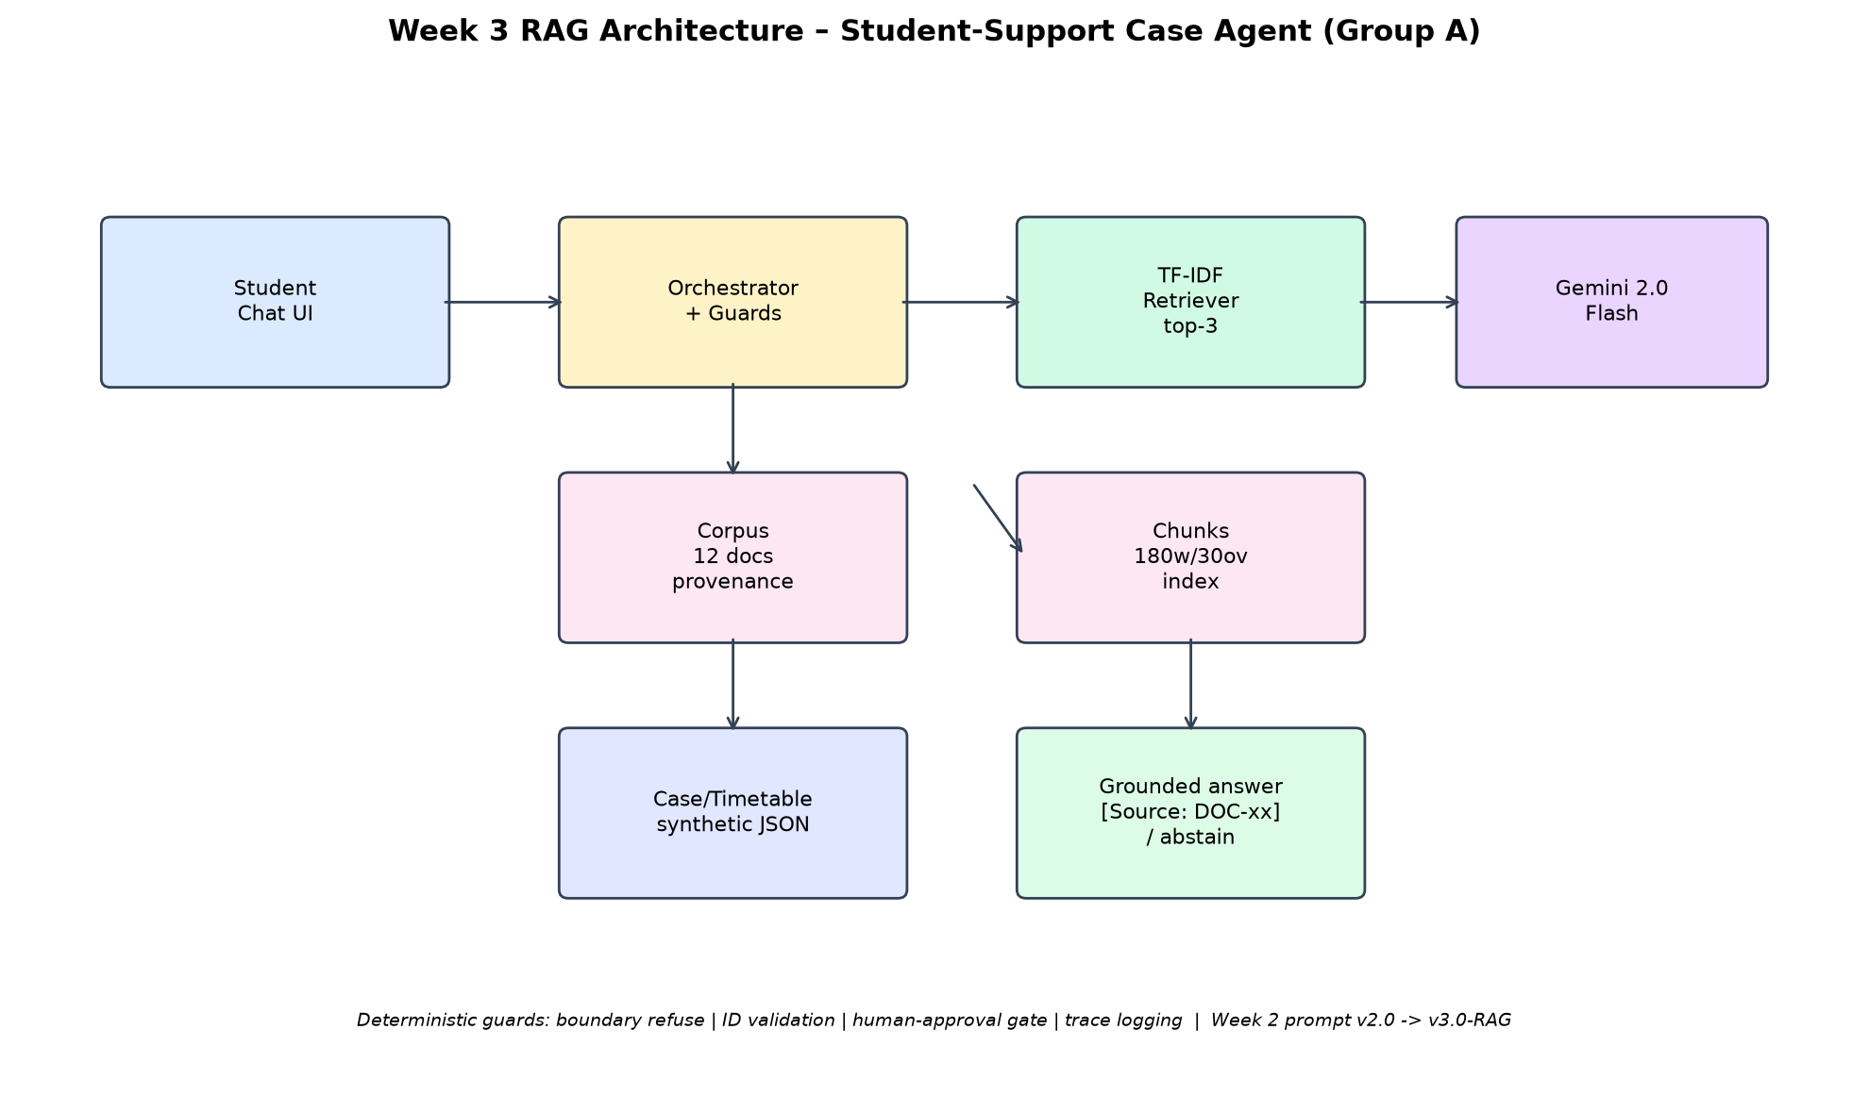
Figure 1: Week 3 RAG architecture. Deterministic retrieval and guards surround the model; no direct model memory answers.
Context format injected to model (v3.0-RAG): EXCERPT [Source: DOC-02-C1] … plus instruction 'answer ONLY from excerpts; cite every claim; if insufficient, abstain'. Model output is validated: claims without retrieved support are replaced by abstention in code.

4. Prompt v3.0-RAG Changes (from Week 2 v2.0)
Added: 'You are given EXCERPTS with [Source: DOC-xx]. Answer ONLY from them. Cite each factual sentence. If excerpts are insufficient, say: I don't know from approved documents.'
Added: partial-answer template ('Partially answerable… [Source] … remainder: no approved source').
Kept: Week 2 hard prohibitions (never approve/resolve, never decide admissions/fees/discipline), JSON output, 180-word limit, injection refusal.
Files: prompts/v3.0-rag.system.txt (new), prompts/v2.0.system.txt retained for baseline comparison.
Repo evidence: knowledge/*.txt, src/rag.py, prompts/v3.0-rag.system.txt, docs/rag_architecture.png, tests/week3_15cases.json, evidence/traces/R01–R15.json.

