GROUP A WEEK 1 PROGRESS REPORT
BSE4104, AI-Native and Agentic Engineering Capstone
Field | Detail
Group Name | Group A Day
Project Name | University Student-Support Case Agent
Week Ending | 4th September 2026

Work Completed Against Weekly Objectives
- Selected the University Student-Support Case Agent as the team's approved use case from the recommended list.
- Defined the single primary end-to-end workflow: ask a grounded policy question, check timetable or case status, or submit a new support case.
- Drafted the Project Charter covering problem, user, pain point, AI value, scope, assumptions and constraints.
- Wrote 12 testable user stories with acceptance criteria covering Q&A grounding, timetable lookup, case status, case creation, boundary handling, session memory, staff review, human approval, traceability, and data handling.
- Built the AI Boundary Matrix defining what the AI may do, what stays deterministic, and what requires human approval.
- Produced the initial architecture and context diagram showing the student, chat interface, orchestrator, foundation model, knowledge base, timetable data, case store, and human review boundary.
- Created the GitHub repository using the recommended structure and the ClickUp project with Week 1 tasks assigned to owners.

Key Engineering Decisions and Why They Were Made
- Chose the student-support case agent because it maps naturally to a bounded, traceable multi-step workflow (question, retrieval, optional case creation, human review) rather than being just a chatbot, satisfying the assignment's proposal rule.
- Decided the agent will never finalise a case status beyond "Pending". This keeps every academically consequential decision under human control, directly addressing the safety boundary specified for this use case.
- Scoped the corpus to public course and handbook documents and synthetic student or case data only, avoiding any need for confidential institutional data access in Week 1.
- Assigned the Requirements Lead role to the group leader so that charter ownership and weekly reporting sit with the same person for consistency.

Failures / Challenges and Current Response
- No technical build has started yet, which is expected at Week 1 since foundation model integration begins Week 2, so no implementation failures to report yet.

GitHub and ClickUp Setup Evidence

Repository
Repository link: https://github.com/OpiyoOscar01/group_A_ai_agentic_capstone_assignment.git
ClickUp Board
ClickUp board link: https://app.clickup.com/1200410000004185/v/o/s/1200410000006385
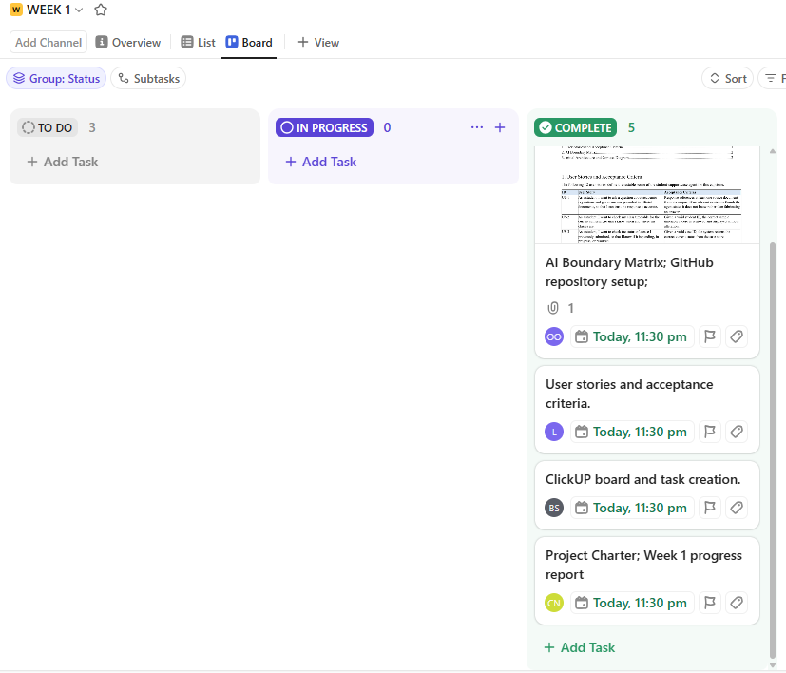

Individual Contribution Summary
Member | Task Owned This Week
Namatovu Christine Maria | Project Charter; Week 1 progress report
Ogwal Richard | Architecture and context diagram
Opiyo Oscar | AI Boundary Matrix; GitHub repository setup;
Isio Lily | User stories and acceptance criteria
Babirye Sandra | ClickUp board and task creation

Plan for Next Week (Week 2)
- Choose an accessible foundation model and document capability, cost, latency and privacy considerations.
- Integrate the model into the application and produce a working baseline interaction.
- Write Prompt Specification v1.0, covering role, task, context, constraints, output format, and failure behaviour.
- Create at least 10 test cases and record expected versus actual behaviour; version at least two prompt iterations.

