BSE4104, Emerging Trends in Software Engineering
8-Week AI-Native and Agentic Engineering Capstone
Group A Week 1 Requirements and Design Artifacts
Use Case: University Student-Support Case Agent
Name | Student Number
Namatovu Christine Maria | 2300701098
Opiyo Oscar | 2300701330
Isio Lily | 2300700445
Babirye Sandra | 2300707270
Ogwal Richard | 2300716574

TABLE OF CONTENTS
1. User Stories and Acceptance Criteria 1
2. AI Boundary Matrix 2
3. Initial Architecture and Context Diagram 3

User Stories and Acceptance Criteria
The following 12 user stories define the testable scope of the student-support case agent for this capstone.
ID | User Story | Acceptance Criteria
US-1 | As a student, I want to ask a question about academic regulations and get an answer grounded in official documents, so that I can trust the response is accurate. | Response references at least one source document from the corpus. If no relevant content is found, the agent states it does not know rather than fabricating an answer.
US-2 | As a student, I want to check my class timetable for the current semester, so that I know when and where my classes are. | Given a valid student ID, the correct sample timetable record is retrieved and displayed without alteration.
US-3 | As a student, I want to check the status of a case I previously submitted, so that I know if it is pending, in progress, or resolved. | Given a valid case ID, the system returns the correct current status from the case store.
US-4 | As a student, I want to submit a new support case, for example missing marks, a retake request, or a registration issue, through the chat interface, so that I do not have to visit the office in person. | The system collects name, student ID, category, and description before creating a ticket. The ticket receives a unique ID and status "Pending".
US-5 | As a student, I want to be told clearly when my request is outside what the agent can help with, for example admissions or grading decisions, so that I am redirected to the right human office. | For out-of-scope queries, the agent returns a boundary message naming the correct office and does not attempt to answer or act on the request.
US-6 | As a student, I want the agent to remember my active case within our conversation, so that I do not have to repeat my case ID every time. | Once a case ID is referenced in a session, later queries in that same session use the stored ID unless the student provides a different one.
US-7 | As support staff, I want every agent-created case to appear in a reviewable queue, so that I can act on it. | Every case created by the agent appears in a queue or log with timestamp, category, and submitted details, visible to staff.
US-8 | As a student, I want reassurance that no case will be auto-approved or auto-rejected, so that I trust a human reviews my request. | Any status change beyond "Pending" requires an explicit recorded human action. The agent alone cannot close or approve a case.
US-9 | As a project team member, I want every agent response logged with the evidence it used, so that we can inspect what informed an answer. | Each response has an associated trace record listing retrieved documents and tool calls used to produce it.
US-10 | As a student, I want to ask natural follow-up questions, so that I do not have to restart my query each time. | The agent correctly resolves references such as "that policy" or "my case" using the current session's context.
US-11 | As a student, I want to know my data is used only for handling my case, so that I feel safe using the system. | The system's data-handling note is available on request and no student data is sent to any service outside the approved application boundary.
US-12 | As a project team member, I want a record of which use case, data, and boundaries the team committed to in Week 1, so that later weeks stay consistent with the approved scope. | The Project Charter, user stories, and AI Boundary Matrix are committed to the repository and linked from the ClickUp board.

AI Boundary Matrix
This matrix defines what the AI component may do independently, what must remain deterministic, rule-based, non-generative software, and what requires explicit human approval before it takes effect.
AI May Do | Deterministic Software Controls | Requires Human Approval
Interpret a student's natural-language question | Validate student ID format and authenticate the session | Final confirmation before a new case is created and submitted
Retrieve and summarise relevant handbook or course content with source references | Generate the unique case or ticket ID and store the record | Any status change beyond "Pending" (for example Resolved or Rejected)
Suggest which case category best matches a student's description | Enforce which fields are mandatory before a case can be created | Escalation of a case flagged as disciplinary, admissions, or fee-related
Draft a case description for staff to review | Control routing rules, that is, which queue or office a case goes to | Any deletion or modification of an existing case record
Ask clarifying questions when a request is ambiguous | Log and store all traces, prompts, and retrieved evidence | Overriding or bypassing a boundary or out-of-scope response

Guiding rule: the agent may retrieve, reason, draft and suggest. It may never finalise, approve, reject, escalate, or delete a student case, and it must always be able to hand off to a human when a request falls outside this boundary.

Initial Architecture and Context Diagram
The diagram below shows the Week 1 context: how a student's request flows through the application layer to a deterministic controller, which coordinates the foundation model, the planned course knowledge base, sample timetable data, and the case and ticket store, with human staff retaining review and approval authority over all case outcomes.
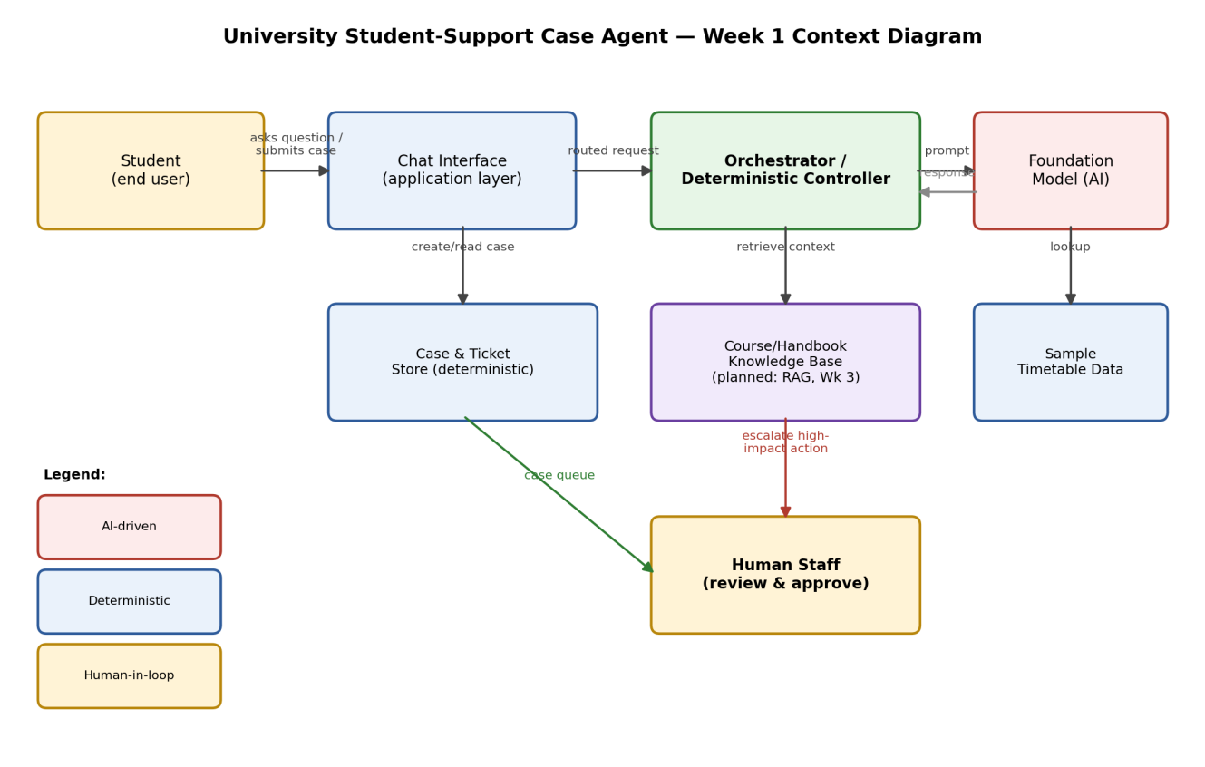

Note: The Course/Handbook Knowledge Base is shown as "planned" because full retrieval-augmented generation is a Week 3 deliverable. In Week 1 this box represents the intended data source, not yet an implemented pipeline.

