WEEK 2 PROGRESS REPORT

Foundation-Model Engineering and Prompting

Field | Detail
Group / Project Name | Group A Day (BSSE Day), University Student-Support Case Agent
Week Ending | 11th September 2026
Model Baseline | Gemini Flash (gemini-2.0-flash), Prompt v2.0, tag week2-baseline

Focus: Build the smallest useful model-backed capability and establish a tested baseline before adding RAG or agents.

Work Completed Against Weekly Objectives
- Selected Gemini 2.0 Flash and documented capability, cost, latency and privacy in a one-page Model Selection Note.
- Integrated the model into a working baseline (src/app.py) supporting both live-API and offline MOCK modes, with deterministic code enforcing student-ID/case-ID validation, timetable/case lookup from synthetic JSON, and a human-approval gate.
- Authored Prompt Specification v1.0 through v2.0, covering role, task, context, constraints, JSON output format and failure behaviour.
- Designed and executed 10 prompt test cases: MOCK run achieved 10/10 PASS; live Gemini sampling achieved 8/10 PASS with 2 PARTIAL results, with full traces saved to evidence/traces/.
- Pushed the repository with a week2-baseline tag and updated the ClickUp board with owners and deadlines.

Key Engineering Decisions and Why They Were Made
- Chose Gemini 2.0 Flash over GPT-4o-mini and Llama 3.1 (via Groq) for free-tier availability, a 1-million-token context window for future RAG work, and native JSON/function-calling support for future tool integration.
- Adopted "LLM suggests, deterministic software enforces": timetable and case records are read only from data/*.json and never accepted from model-generated text. This directly implements the Week 1 AI Boundary Matrix and resolved a hallucinated-timetable defect found in testing (T02).
- Required the model to explicitly say "I don't know from approved documents" rather than fabricate policy content, since no retrieval exists yet; the underlying fix (real document grounding) is deferred to Week 3 RAG work.
- Retained three prompt versions (v1.0, v1.1, v2.0) as a visible record of what problem each iteration fixed.

Failures / Challenges and Current Response
- Prompt v1.0 hallucinated retake regulations and implied case auto-approval (test failures T01, T05, T09). Resolved by adding an explicit honesty rule, a hard prohibition list with a redirect_office fallback, and a code-level guard restricting any case status beyond "Pending"; re-tested to PASS.
- Live-model formatting gaps remain in T09 (missing redirect_office field) and T10 (missing Data-Handling-Note citation); both are classified PARTIAL since refusal behaviour was correct but schema completeness needs tightening in v2.1 via strict JSON validation.
- No retrieval grounding exists yet, so groundedness is 0 percent by design at this stage; this is explicitly labelled in every policy answer and will be addressed by the Week 3 corpus.
- The team discovered that the repository already contains Week 3 RAG work (src/rag.py, a 15-case evaluation, a 12-document corpus) committed alongside Week 2 baseline work. This needs to be reconciled across the team so everyone is working from the same current state rather than duplicating or overwriting completed work.

GitHub and ClickUp Evidence

Repository
Repository: github.com/OpiyoOscar01/group_A_ai_agentic_capstone_assignment (tag: week2-baseline; paths: prompts/, src/app.py, tests/week2_10cases.json, evidence/traces/, .env.example, no secrets committed).
Reproduce in one command: pip install -r requirements.txt && python src/app.py --run-tests

ClickUp Board
ClickUp board: List | List | GROUP A AI AGENTIC CAPSTONE ASSIGNMENT WORKSPACE (List)
The ClickUp board was updated to track the Week 2 activities, including model selection, model integration, prompt specification, the 10-case evaluation, and the progress report. Each task was assigned an owner and deadline, with links to the relevant repository evidence.

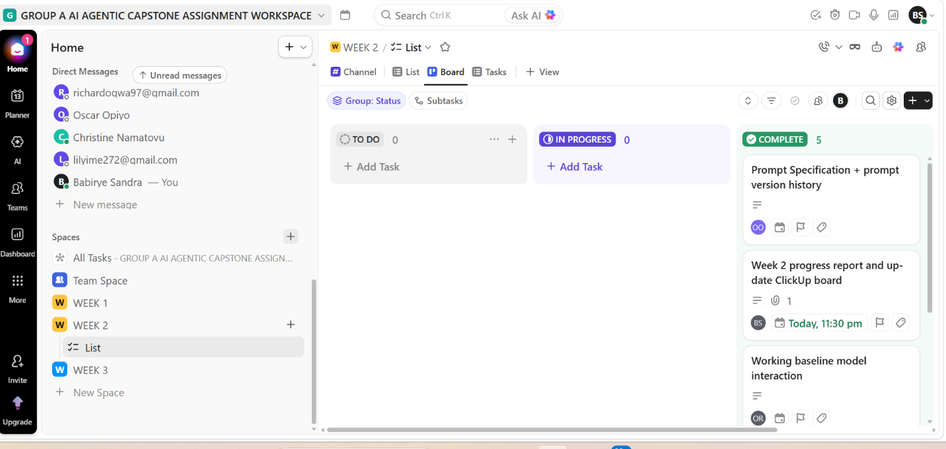
Figure 1: ClickUp Board Showing Week 2 Tasks, Owners and Deadlines

Individual Contribution Summary
Member | Task Owned This Week | Evidence
Namatovu Christine Maria | Prompt Specification v2.0 review; this Week 2 progress report | docs/weekly-reports/ in repo
Opiyo Oscar | Foundation-model integration and deterministic guards (src/app.py, .env.example) | src/ in repo
Isio Lily | Ten-case design, evaluation run, expected-vs-actual log | tests/, evidence/traces/ in repo
Babirye Sandra | Model Selection Note and ClickUp board/tasks | docs/requirements/ in repo
Ogwal Richard | Trace logging (evidence/traces/) and README/run instructions | README.md, evidence/traces/ in repo

Plan for Next Week (Week 3, Context Engineering and RAG)
- Confirm as a team what Week 3 work already exists in the repository (src/rag.py, corpus, 15-case evaluation) before assigning new Week 3 tasks, to avoid duplicated effort.
- Assemble or verify a controlled 10 to 50-document handbook corpus with a provenance Source Register.
- Implement or verify chunking, indexing, and top-k retrieval, injecting retrieved excerpts as model context with source citations.
- Author or verify 15 RAG evaluation questions spanning answerable, partially answerable, and deliberately unanswerable cases, documenting at least three retrieval/grounding failures and their fixes.

