WEEK 5 PROGRESS REPORT
Agent Architecture and Bounded Autonomy
Field | Detail
Group / Project Name | Group A Day (BSSE Day), University Student-Support Case Agent
Week Ending | 2nd October 2026
Group Leader | Namatovu Christine Maria (2300701098)
Agent Planner | Gemini planner (model-driven) and scripted rule-based planner (reproducible traces), behind one interface
Focus: Implement one goal-directed, multi-step workflow in which the system chooses among approved next actions and stops safely.

1. Work Completed Against Weekly Objectives
- Task defined: prepare and submit a support case. It needs a loop rather than a fixed script because each next action depends on the previous observation: the policy search, the existing-case lookup, the fields still missing, and the student's reply. The Agent Task Contract (goal, six approved actions, state, limits, stop conditions, guardrails) is complete.
- Loop designed: Sense, Plan, Validate, Act, Observe, Stop/Re-plan. The Agent Architecture Diagram shows the planner, controller, validation gate, approved actions, data stores and the three human control points.
- Workflow implemented by direct orchestration (no framework) in src/agent.py: controller, validation gate, session and run state, and two planners. The Week 4 lookup tool gained a read-only my_cases query (own cases only) for the duplicate check; the Week 4 tests still pass 10/10.
- Limits enforced in code: 8 iterations, 6 tool calls, 3 questions, 10 planner calls, 60 seconds, one retry on SERVICE_UNAVAILABLE. Every run ends with one of 11 named stop reasons and a hand-off message.
- 13 execution traces captured (3 required plus 10 contract tests); all 13 pass with python tests/run_week5_agent_traces.py. The three headline traces:
Trace | Scenario | Stop reason | Iterations / tool calls
W5-T01 | Happy path: missing marks, grounded draft (DOC-02), student says yes, case CASE-0005 created and confirmed by lookup | GOAL_MET | 6 / 4
W5-T02 | Failure and recovery: SERVICE_UNAVAILABLE on the existing-case lookup, one retry succeeds, run completes | GOAL_MET | 6 / 5
W5-T03 | Safe stop: student already has a Pending retake case for BIT2101; nothing created | DUPLICATE_FOUND | 2 / 2
W5-T04 to T13 cover a fee/grade request, an unmet prerequisite, a declined approval, a persistent outage, a misbehaving planner (8 prohibited proposals, all rejected), another student's case, an unsupported request, a prompt injection, the question limit, and an invalid proposal that is rejected and then recovered.
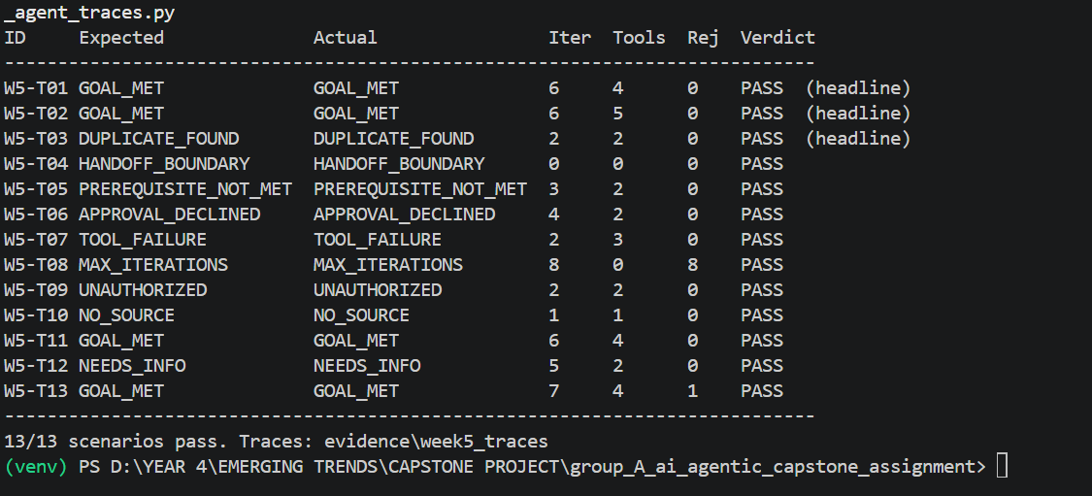

2. Key Engineering Decisions and Why They Were Made
- The planner proposes, the controller decides. Every proposal is checked against the allow-list, argument schema, limits, approval state and identity before it runs. A rejected proposal never executes but still costs an iteration, so a misbehaving model is stopped by the limit (W5-T08).
- Approval and identity are set only by code. student_id comes from the session; the approved flag is set only on an explicit "yes"; the create call must match the approved draft exactly. The draft text is composed by code from collected fields, so the draft shown is the case created.
- Defence in depth. In a test that disabled the validator's approval check, the Week 4 tool's own approval gate still refused the write and no case was created.
- Stops must be justified by state. For example GOAL_MET is accepted only after a case was created and confirmed by lookup; DUPLICATE_FOUND only if a duplicate exists. Boundary requests (fees, admissions, grading, discipline) are stopped before any planning.

3. Failures / Challenges and Current Response
- Retrieval near-miss (found by W5-T10): an unrelated parking-permit request retrieved DOC-02 at 0.168, just above the Week 3 threshold of 0.14. Response: a stricter 0.25 bar when the category has no policy document. The base threshold is unchanged and will be revisited in Week 7.
- Week 4 test T09 writes to the real data/cases.json on every run, which created the duplicate CASE-0003 and CASE-0004. The Week 5 runner uses a temporary copy of data/ per scenario, so the real file is untouched.
- Planner-call budget is tight: the normal path already uses 8 of the 10 planner calls (present_draft and finish count) but only 6 of 8 iterations. Proposed contract change: raise the limit to 12 or count only iterations.
- Live Gemini planner not yet run end to end. It is implemented behind the same validation gate, but the traces use the scripted planner. Response: run it with the API key and add one live trace in Week 6.

4. GitHub and ClickUp Evidence
Repository: github.com/OpiyoOscar01/group_A_ai_agentic_capstone_assignment. Key Week 5 files: docs/requirements/Week5/Week5_Agent_Task_Contract.docx, docs/architecture/week5_agent_architecture.png, src/agent.py, src/tools.py (my_cases), tests/run_week5_agent_traces.py, evidence/week5_traces/W5-T01 to T13 (.json and .md). Commit: [add commit hash after push]
ClickUp board: [add Week 5 board link and screenshot]

5. Individual Contribution Summary
Member | Task Owned This Week | Evidence
Namatovu Christine Maria | Agent Task Contract and goal (author) | Week5_Agent_Task_Contract.docx
Opiyo Oscar | Implement bounded agent workflow | src/agent.py; my_cases query in src/tools.py
Isio Lily | Execute and document agent workflow traces | tests/run_week5_agent_traces.py; W5-T01 to T13
Babirye Sandra | Review Week 5 work; compile progress report | This report; Week 5 evidence checklist
Ogwal Richard | Agent architecture and safety controls | week5_agent_architecture.png; validation gate, approval and limits design

6. Plan for Next Week (Week 6, Memory, State and Interoperability)
- Present the contract's state model as a diagram and demonstrate session and run state explicitly.
- Write the Memory Design and Data Handling Note for the one retained item, active_case_id: what is stored, why, who can access it, retention and deletion (DOC-12), and show it helps a legitimate task without controlling a decision.
- Write an MCP-style interface specification for the lookup and create capabilities (inputs, outputs, permissions, security boundary).
- Run the Gemini planner live and add one live trace; complete the Week 6 required reading.

