WEEK 4 PROGRESS REPORT
Tools and Function Calling
Field | Detail
Group / Project Name | Group A Day (BSSE Day), University Student-Support Case Agent
Week Ending | 25th September 2026
Group Leader | Namatovu Christine Maria (2300701098)
Model Baseline | Gemini 2.0 Flash – native function-calling / structured-output support
Focus: Define and implement a controlled tool-calling layer in which the model selects from predefined tools, while the orchestrator remains responsible for authorization, validation, failure handling and human approval.
1. Work Completed Against Weekly Objectives
- Defined a controlled Tool Catalogue of four tools: get_timetable, get_case_status, search_knowledge_base and create_support_case, classified as read operations (information retrieval) or a write operation (drafting a support case).
- Defined authorization requirements: session-bound student identity and case ownership restrict access to student-specific information.
- Built deterministic authorization and validation checks into the design, so the model cannot create new capabilities or bypass the application's control logic.
- Added a human-approval step to support-case creation; the simulated side effect cannot proceed without approval.
- Defined handling for invalid parameters, unauthorized requests, unavailable services, missing records and malformed tool responses.
- Executed all 10 planned failure/authorization tests (normal success, missing parameters, unauthorized access, unavailable service, out-of-scope category and the human-approval gate). Traces, including evidence before and after the identified fix, are retained in evidence/week4_traces/T01–T10.json.
2. Key Engineering Decisions and Why They Were Made
- Orchestrator authority: the model can select a tool and supply arguments, but only the orchestrator decides whether a call may execute.
- Deterministic authorization and validation: performed in application code before any tool result is returned to the model.
- Fixed tool catalogue: no unrestricted function generation, so each tool has its own authorization and validation rules.
- Human approval for write operations: create_support_case is treated differently from read operations, so the agent never causes a side effect just because the model selected the tool.
- Prohibited capabilities are not exposed as tools: following the Week 3 finding that wording or boundary detection alone can fail, a capability that is not a tool cannot be executed through the tool-calling interface.
3. Failures / Challenges and Current Response
Week 4 testing targeted failures in the tool-calling and authorization layer rather than only successful execution. The scenarios covered:
- Missing parameters: validation runs before execution, so incomplete requests do not trigger uncontrolled tool calls.
- Unauthorized access: a user cannot retrieve or modify another student's information; checks use the authenticated session and case ownership.
- Unavailable service: a tool outage is handled without being treated as a successful operation.
- Out-of-scope category: the tool layer does not attempt operations outside the capabilities deliberately exposed.
- Human-approval gate: a write operation cannot proceed automatically without the approval step.
All 10 execution traces are retained as evidence of actual behaviour before and after the identified fix, rather than relying on written description alone.
4. GitHub and ClickUp Evidence
Repository: github.com/OpiyoOscar01/group_A_ai_agentic_capstone_assignment. Key Week 4 evidence: tool catalogue and API definitions, tool implementation and orchestration integration, authorization/validation logic, human-approval workflow, tests/run_week4_tool_tests.py and evidence/week4_traces/T01–T10.json.
ClickUp board: Board | WEEK4 | GROUP A AI AGENTIC CAPSTONE ASSIGNMENT WORKSPACE (Board) The board tracked tool catalogue definition, implementation, authorization and human approval, testing and reporting, following the dependency sequence Isio Lily → Opiyo Oscar → Ogwal Richard → Namatovu Christine Maria → Babirye Sandra.
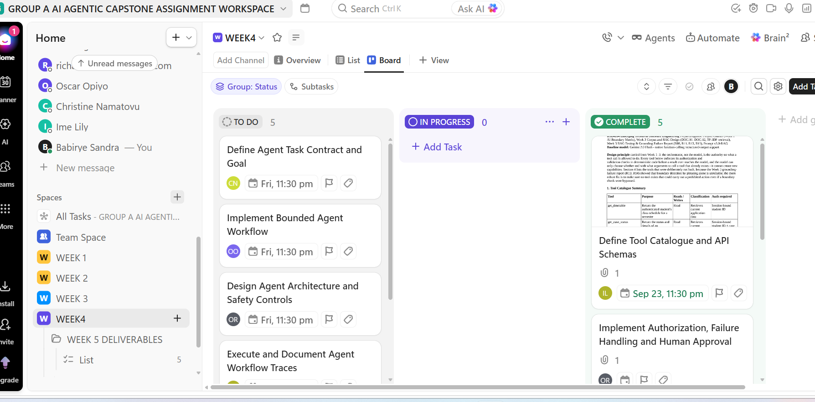
Figure 1: Showing the click up board for WEEK4 with all tasks completed
5. Individual Contribution Summary
Member | Task Owned This Week | Evidence
Isio Lily | Defined the Tool Catalogue and Tool/API schemas. | Tool Catalogue (purpose, operation type, authorization requirements)
Opiyo Oscar | Implemented the tools and integrated tool calling into the orchestration layer. | [To be completed after Oscar's implementation document is reviewed]
Ogwal Richard | Authorization, validation, failure handling, architecture and human approval. | Control design, failure-handling mechanisms and approval workflow
Namatovu Christine Maria | Executed the Week 4 tool failure and authorization tests. | run_week4_tool_tests.py, 10 traces (T01–T10) and Tool Testing Report
Babirye Sandra | Reviewed Week 4 work, coordinated evidence and compiled the progress report. | Week 4 Progress Report and evidence checklist
6. Plan for Next Week (Week 5, Agent Architecture and Bounded Autonomy)
- Select one task that genuinely benefits from multi-step decision making (e.g. resolving a student's support case using the approved Week 4 tools).
- Design the Sense/Context → Plan/Decide → Act/Tool → Observe → Stop/Re-plan loop and produce the Agent Architecture Diagram and Agent Task Contract (goal, tools, state, limits and stop conditions).
- Implement the bounded workflow with a maximum iteration count, approved tools, safe stop conditions and human hand-off, keeping approval on all write operations.
- Capture at least three execution traces, including one failure/recovery case, and complete the Week 5 required reading (Osmani Ch. 10, Huyen Ch. 6, Lanham Ch. 11).

