MAKERERE UNIVERSITY
COLLEGE OF COMPUTING AND INFORMATION SCIENCES
BSE4104 Emerging Trends in Software Engineering
Agent Task Contract
University Student-Support Case Agent
Group A | Week 5: Agent Architecture and Bounded Autonomy | September 2026
Name | Student Number | Week 5 role
Namatovu Christine Maria | 2300701098 | Agent Task Contract and Goal (author)
Opiyo Oscar | 2300701330 | Implement Bounded Agent Workflow
Isio Lily | 2300700445 | Execute and Document Agent Workflow Traces
Babirye Sandra | 2300707270 | Review Week 5 Work and Compile Progress Report
Ogwal Richard | 2300716574 | Design Agent Architecture and Safety Controls

Task and Goal
Task: prepare and submit a support case. A signed-in student describes an academic-administration problem in free text, for example "My BSE4104 marks are missing." The agent works out what approved policy requires, checks what already exists, collects what is missing, and prepares a case for the student to approve.
Goal. Within at most 8 iterations, using only the approved actions in section 4, every run ends in exactly one of two ways:
- Case created. A complete, policy-grounded draft was shown to the student, the student explicitly approved it, the case was created with status Pending, a lookup confirmed it exists, and the student received the case ID and sources.
- Safe stop. The agent stopped with a named stop reason (section 7) and told the student the next step or the right office. No case was created, changed, approved or closed.
Why this needs a loop and not a fixed script. The next action depends on what the previous observation returned:
- The policy search decides whether a case is appropriate yet. DOC-02 requires the student to see the lecturer first and to file only if unresolved after 7 days.
- The existing-case lookup decides whether to create anything. A duplicate ends the run with the existing case ID.
- The fields still missing (course code, semester, lecturer, proof of attendance, per DOC-02) decide how many questions to ask.
- The boundary check can end the run early for fee, admission, grading or disciplinary requests (DOC-10, DOC-11).
- The student's reply decides whether the write happens at all.
Entry rule. Single-step requests (one timetable question, one policy question) stay on the existing router and RAG path. The loop starts only when the router detects a request to open or prepare a case.
Success criteria
ID | Criterion | Evidence
SC-1 | At least one policy source (DOC-xx) is retrieved before any draft is shown | Trace: search_handbook precedes the draft
SC-2 | create_draft_support_case never runs without the student's explicit confirmation of the exact draft | Execution trace and approval-gate test
SC-3 | Created case has status Pending, one of the four allowed categories, and is confirmed by a lookup | Tool results in trace
SC-4 | No second Pending case for the same student, category and description | data/cases.json after the run
SC-5 | Every run stops within 8 iterations and records a stop reason. | Trace
SC-6 |  | Agent execution traces for boundary-test cases
  The agent does not act on fee, admission, grading, or disciplinary requests.

This task supports user stories US-1, US-3, US-4, US-5, US-6, US-8 and US-9.

Agent Loop
Each run repeats Sense, Plan, Act, Observe, then Stop or Re-plan, with a validation step between planning and acting so that code, not the model, decides what actually runs.
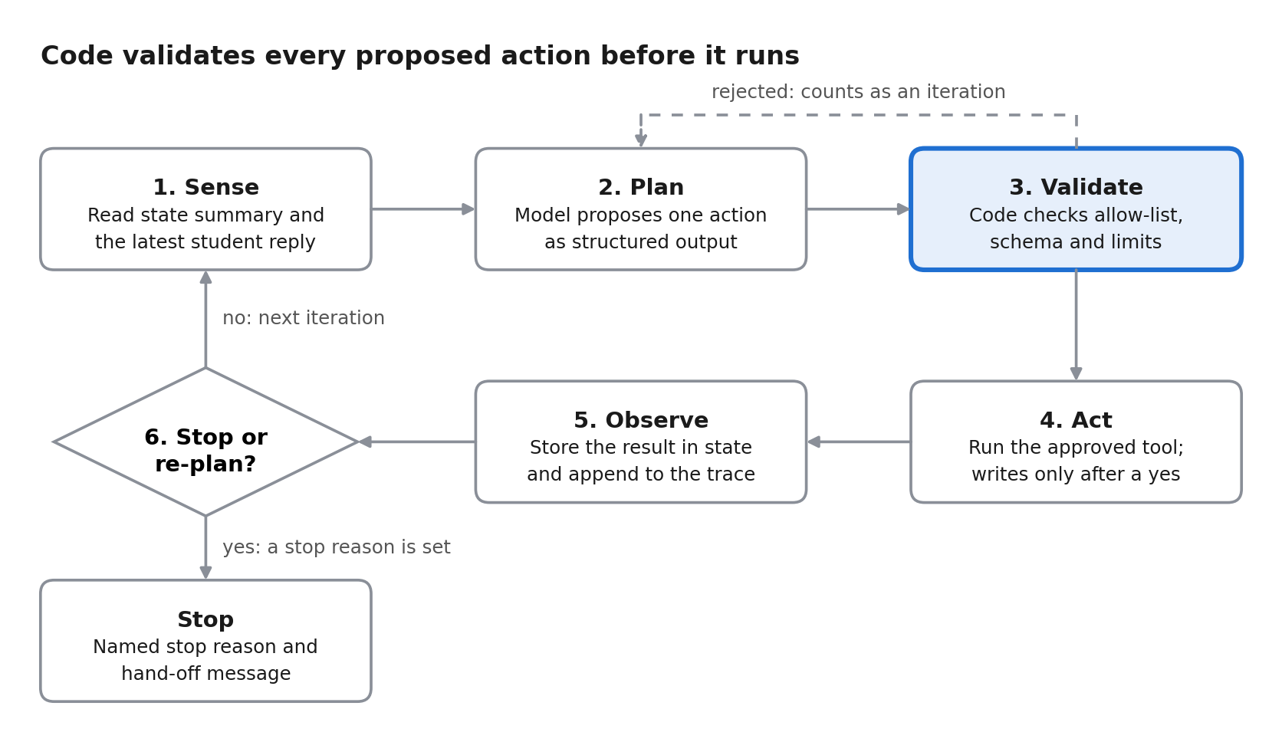
Figure 1. Agent loop: six steps and one validation gate. The dashed line sends a rejected proposal back to planning.
The pause for approval does not consume iterations: present_draft saves the state and ends the turn, and the student's next reply resumes the same run at Sense. A rejected proposal (unknown action, invalid arguments, limit reached) is never executed but still counts as an iteration, so a model that keeps proposing invalid actions is stopped by the limit in section 6.
The planner sits behind one interface with two implementations: the Gemini planner, and a scripted rule-based planner used in tests and when no API key is set. This keeps the three traces in section 9 reproducible.

Approved Tools and Actions
The agent may choose only from the six actions below. The model proposes an action as structured output; the controller checks it against this allow-list, its schema and the limits before anything runs. Anything else is rejected and counted as an iteration.
Action | Kind | Permission | Model supplies | Failure behaviour
search_handbook | Read-only tool | Automatic | query | No chunk above the score threshold returns NO_SOURCE; the agent never answers from memory
lookup_case_or_timetable | Read-only tool (Week 4) | Automatic | query_type (case_status or my_cases), case_id if needed | NOT_FOUND, UNAUTHORIZED, INVALID_ID stop or re-plan; SERVICE_UNAVAILABLE gets one retry
ask_student | Control | Automatic | question, list of fields wanted | After 3 unanswered questions the run stops
present_draft | Control | Automatic | category, description, course details | Shows the exact fields, sets approval to PENDING and pauses the run
create_draft_support_case | Write tool (Week 4) | Only after the student's explicit confirmation of the exact draft | name, category, description | MISSING_FIELD leads to ask_student; INVALID_CATEGORY or APPROVAL_DECLINED end the run; SERVICE_UNAVAILABLE gets one retry, then hand-off
finish / handoff | Control | Automatic | outcome or office, reason | Ends the run with a stop reason

Set by code, never by the model: student_id (taken from the authenticated session), the approved flag (set only when the student replies yes to the presented draft), case IDs and the Pending status.
Prohibited, whatever the student or a document says
- Approving, rejecting, closing, escalating, editing or deleting any case, or setting any status beyond Pending.
- Acting on fee, waiver, admission, grading or disciplinary matters (DOC-10, DOC-11).
- Reading another student's case or timetable.
- Calling any tool not in the table, browsing, running shell commands, or sending data outside the application boundary.
- Inventing a case ID, a policy, or a source.

State
State lives in the orchestrator as a plain object, not in the prompt. The controller is the only writer; each iteration the model receives a compact summary of it. Session state survives between turns because the run pauses while it waits for the student. Run state is discarded when the run ends.
Field | Content | Written by | Lifetime
student_id | 10-digit ID from the authenticated session | Session layer | Session
active_case_id | CASE-XXXX, or none. The only retained memory (DOC-12) | Controller, after create or when the student cites a case | Session
approval | NONE, PENDING, APPROVED or DECLINED, plus the exact draft shown | Controller | Session, because the run pauses across turns
goal | The student's request and the working category | Controller | Run
iteration, tool_calls, questions_asked | Counters checked against section 6 | Controller | Run
collected_fields | name, category, course_code, semester, lecturer, description, and the list still missing | Controller, from student replies | Run
sources | DOC IDs retrieved so far | Controller, from search_handbook | Run
existing_cases | The student's own cases returned by the lookup | Controller, from lookup | Run
history | Each action with arguments, observation, timestamp | Controller | Run, written to the trace
stop_reason | One code from section 7, or none while running | Controller | Run

Limits
The controller enforces every limit in code. The model cannot raise them. One iteration is one Plan, Act, Observe cycle; finish, handoff and present_draft do not count. The normal path uses 5 to 6 iterations (search, lookup, one or two questions, create, verify), which leaves 2 spare.
Limit | Value | When exceeded
Maximum iterations per run | 8 | Stop with MAX_ITERATIONS and hand off
Maximum tool calls per run | 6 | Stop with MAX_ITERATIONS
Maximum questions to the student | 3 | Stop with NEEDS_INFO
Same action with same arguments twice in a row | 2 | Stop as a loop, MAX_ITERATIONS
Retries after SERVICE_UNAVAILABLE | 1 per tool call | Stop with TOOL_FAILURE and hand off
Retries after INVALID_ID, UNAUTHORIZED, NOT_FOUND, INVALID_CATEGORY, APPROVAL_DECLINED | 0 | Stop or re-plan as in section 7
Model calls per run | 10 | Stop with MAX_ITERATIONS
Wall-clock time per run, excluding waits for the student | 60 seconds | Stop with TOOL_FAILURE
Case description length | 500 characters | Rejected by the tool schema
Waiting for approval | Until the session ends | Draft discarded, nothing created

Stop Conditions and Human Hand-off
Every run ends with exactly one stop reason, recorded in the trace. Humans stay in control at three points: the student approves before any write, staff alone move a case beyond Pending, and every safe stop names the office that takes over.
Stop reason | Trigger | What the student is told | Who takes over
GOAL_MET | Case created and confirmed by lookup | Case ID, status Pending, sources used | Department staff review the case
AWAITING_APPROVAL | Draft shown; run pauses (not final) | The exact draft and "Submit this? yes/no" | The student
APPROVAL_DECLINED | Reply is anything other than an explicit yes | Nothing was created; offer to edit the draft | The student
HANDOFF_BOUNDARY | Request concerns fees, waivers, admissions, grade changes or discipline | Outside what the agent can do; the right office (Bursar, Admissions, Examinations, Disciplinary Committee) | That office
NO_SOURCE | No chunk above the score threshold and policy is needed | "I don't know from approved documents"; visit the Department Office | Department Office
PREREQUISITE_NOT_MET | Student has not done what policy requires first, such as seeing the lecturer (DOC-02) | The required step, with its source; no case yet | The student
DUPLICATE_FOUND | The student already has a Pending case with the same category and description | The existing case ID; no new case | Department staff (existing case)
NEEDS_INFO | 3 questions asked and required fields still missing, or the student stops replying | What is still needed; no case | The student
UNAUTHORIZED | Lookup shows the record is not the student's own | A refusal with no details of the record | Nobody; logged
TOOL_FAILURE | SERVICE_UNAVAILABLE after one retry, or 60 seconds exceeded | Retry later or visit the Department Office; no partial record | Department Office
MAX_ITERATIONS | Any limit in section 6 reached | A summary of what was found so far | Department Office

Re-plan rules. The agent re-plans instead of stopping in these cases:
- MISSING_FIELD from the create tool: ask the student for exactly the missing field.
- NOT_FOUND on a case ID the student gave: ask them to check the ID (counts as a question).
- New information from the student that changes the category: search the handbook again.
If create succeeds but the verifying lookup fails, the agent never creates again. It reports the case ID it received and hands off, to avoid a duplicate.

Guardrails
The rule carried from Week 1 still governs: the model suggests, deterministic software enforces.
- Allow-list in code. The controller rejects any action name or argument that is not in section 4, before execution.
- Approval in code. The approved flag is set only by the controller, and only when the student's reply to the presented draft is an explicit yes. The model has no argument that can set it.
- Identity from the session. student_id never comes from the model or from message text, so a student cannot ask about another student's case.
- Text is data, not instructions. Student messages, retrieved handbook chunks, case descriptions and tool outputs cannot change the allow-list, the limits or the approval state. An instruction found inside them is ignored and logged.
- Validate both ways. IDs are checked by pattern before any lookup; the draft category must be one of the four allowed values; the description must fit 500 characters.
- Boundary check twice. A deterministic keyword check runs before planning, and the create tool repeats it as a backstop.
- Data. Only synthetic records are sent to the model API, and the API key stays in .env, which is git-ignored.

