WEEK 6 STATE MODEL
Session, Run and Persistent State (Group A)
Purpose. This note makes the workflow state explicit: what exists, who may write it, who reads it and how long it lives. State is held in plain objects, never in the prompt. The controller in src/agent.py is the only writer; the planner receives a compact summary of the run state each iteration and never sees memory. Only one item is persistent.
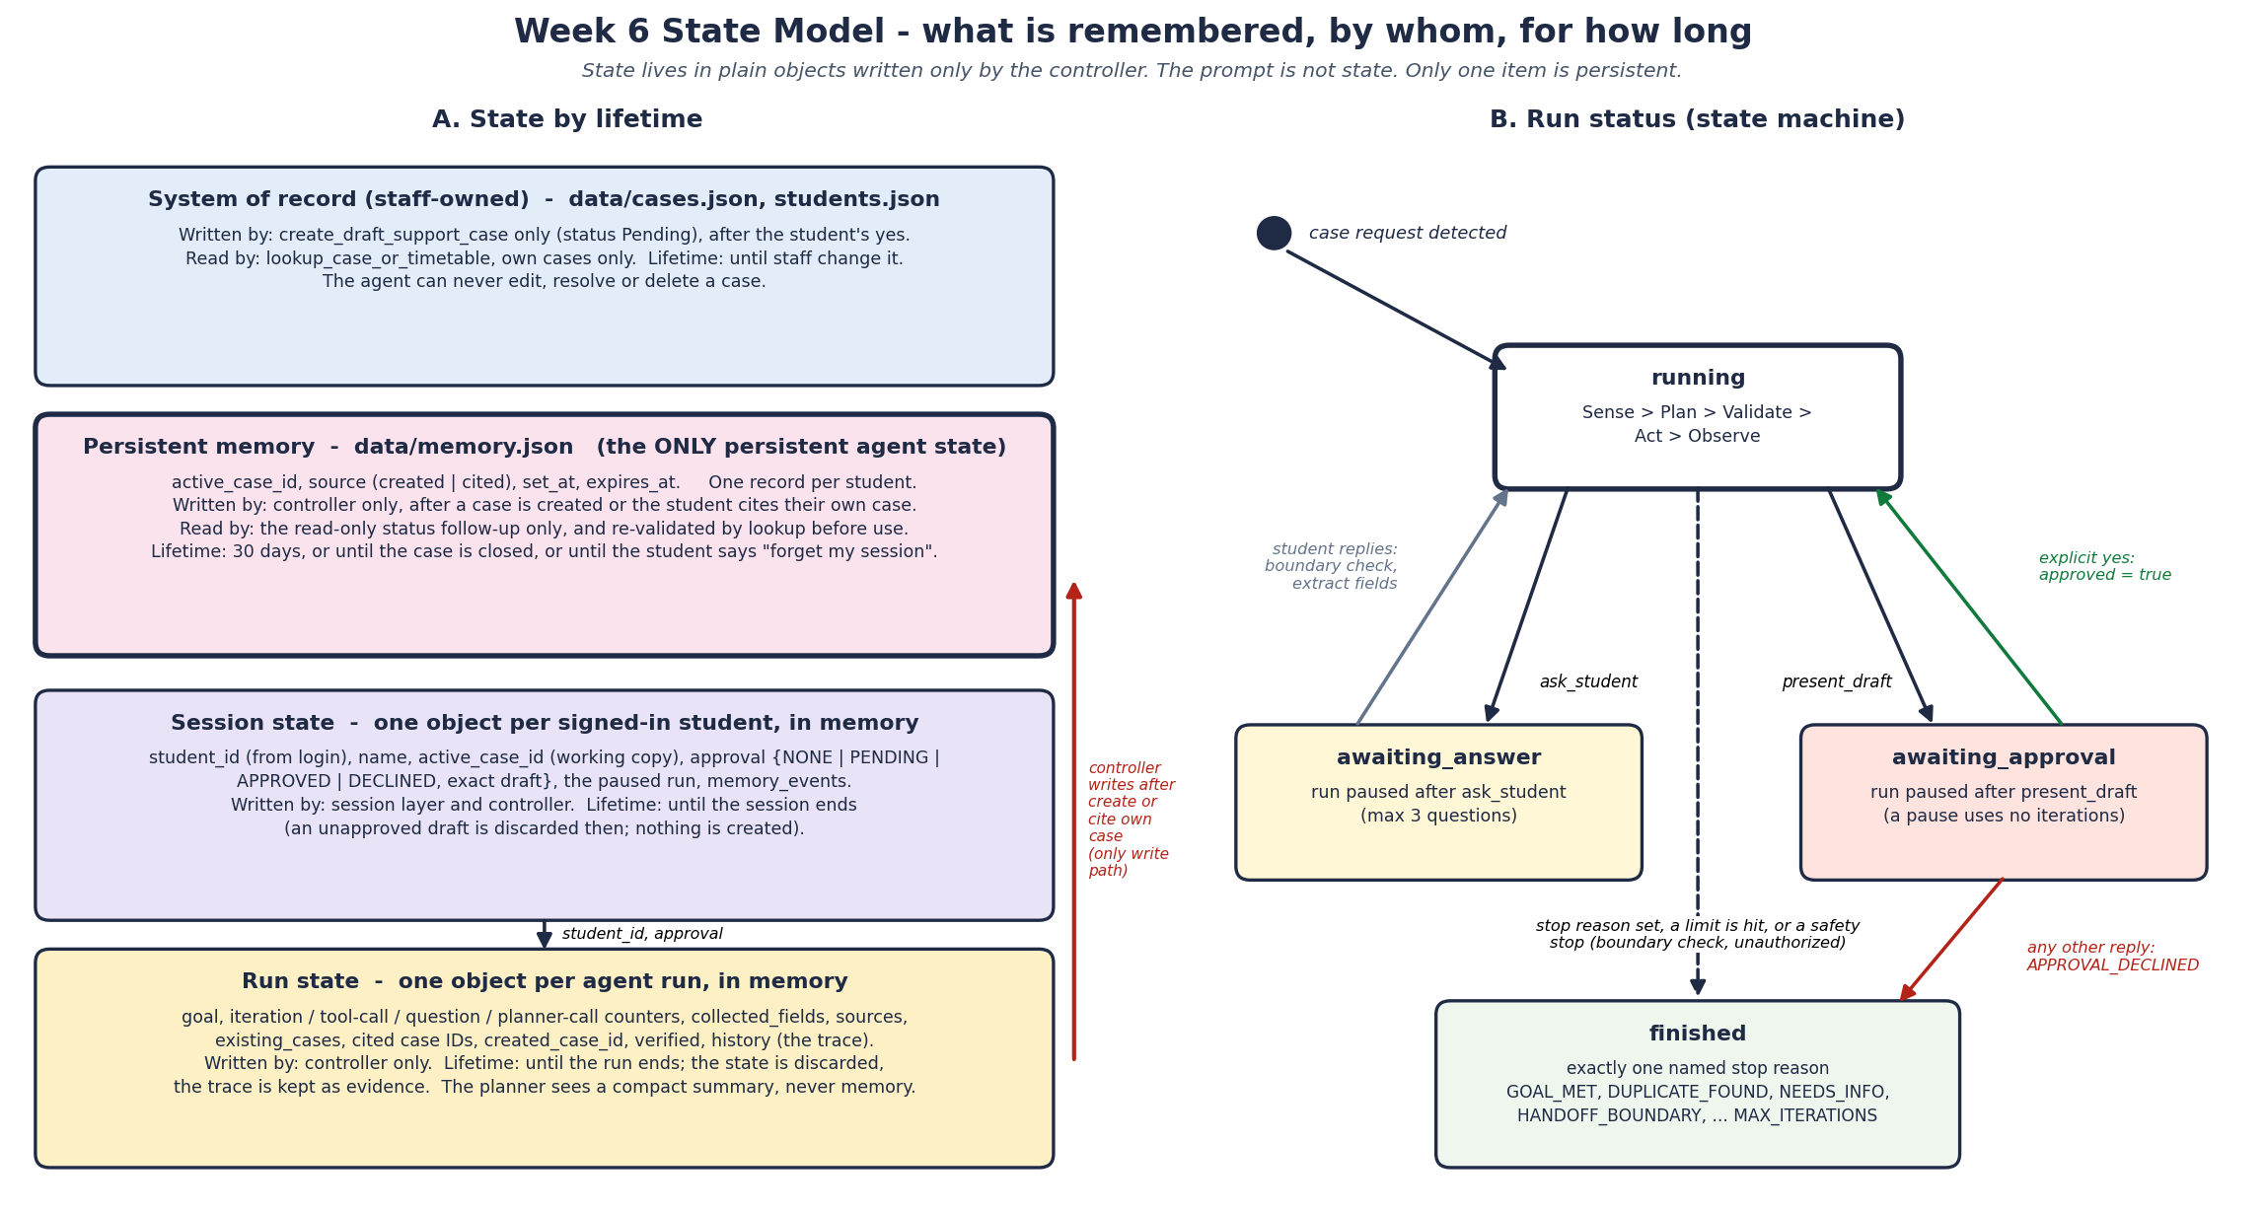

1. State inventory
Item | Tier | Contents | Written by | Lifetime
student_id, name | Session | 10-digit ID from login; name from the student profile | Session layer, never the model | Until the session ends
approval | Session (held by the run) | NONE, PENDING, APPROVED or DECLINED, plus the exact draft shown | Controller; APPROVED only on an explicit yes | Until the run or session ends; an unapproved draft is discarded
paused run | Session | The run object while it waits for an answer or an approval | Controller | Until the student replies or the session ends
active_case_id (working copy) | Session | CASE-XXXX or none | Controller, via one helper | Until the session ends; the durable copy is in memory
goal, category, counters | Run | Student's request, chosen category, iterations, tool calls, questions, planner calls | Controller | Until the run ends
collected_fields, sources | Run | Course code, semester, lecturer, proof of attendance, prerequisite facts; retrieved DOC IDs | Controller, from student replies and tool results | Until the run ends
existing_cases, cited IDs | Run | The student's own cases from a live lookup; case IDs the student mentioned | Controller, from tool results | Until the run ends; never persisted
created_case_id, verified | Run | ID of the case created and whether a lookup confirmed it | Controller | Until the run ends
history (events) | Run | Every plan, validation verdict, tool call, observation and stop reason | Controller | State discarded at run end; the trace is kept as evidence
active_case_id record | Persistent memory | active_case_id, source, set_at, expires_at; one record per student | Controller only | 30 days, case closed, or student deletion
cases, students | System of record | Case queue and student profiles (synthetic) | create_draft_support_case may only add a Pending case | Until staff change it

2. Run status transitions
From | Trigger | To | Decided by
start | Message passes the entry rule (opens or prepares a case) | running | Router (code)
running | Boundary keyword hit (fees, admissions, grading, discipline) | finished: HANDOFF_BOUNDARY | Controller, before any planning
running | ask_student accepted (maximum 3) | awaiting_answer | Validator accepts, controller pauses
awaiting_answer | Student replies | running | Controller extracts fields and re-runs the boundary check
running | present_draft accepted (all fields, policy found, no duplicate) | awaiting_approval | Validator accepts, controller pauses
awaiting_approval | Reply is an exact member of the explicit-yes set | running | Controller sets approved
awaiting_approval | Any other reply | finished: APPROVAL_DECLINED | Controller
running | Stop reason justified by state, a limit is hit, or a safety stop | finished | Controller

3. Design rules
- One writer. Only the controller changes state. The planner proposes actions; a proposal can change state only after validation.
- The prompt is not state. The planner receives a compact summary each iteration. It contains no memory, so memory cannot steer a decision (Week 6 scenario M2 checks this).
- Pauses are cheap and safe. A pause for an answer or an approval uses no iterations. Pending state lives in the session object, so a student can reply later in the same session.
- Discard by default. Run state is dropped when the run ends and an unapproved draft is dropped when the session ends. Nothing is created without a yes.
- Known limit. Session and run objects are in process memory. A server restart loses a paused run; the safe result is that the draft is discarded and nothing is created. Serialising sessions is future work.

