WEEK 6 PROGRESS REPORT
Memory, State and Interoperability
Field | Detail
Group / Project Name | Group A Day (BSSE Day), University Student-Support Case Agent
Focus: Make the workflow state explicit, retain only justified memory, and connect capabilities through clear interfaces.

1. Work Completed Against Weekly Objectives
- State model: session state, run state, persistent memory and the staff-owned case store are documented by lifetime, writer and reader, with a run-status state machine (running, awaiting_answer, awaiting_approval, finished).
- One justified memory: the student's active case ID, implemented in src/memory.py and wired into the controller. A returning student can ask "what is the status of my case?" and get a live answer in 1 turn instead of 2, including after a restart.
- Memory Design and Data Handling Note: what is stored (four fields, no free text), why this memory and not case history, preferences or prior results, who can access it, retention (30 days, case closed, or "forget my session") and deletion. Every read, write and delete is logged without content.
- Memory without control: memory is re-checked by the ownership-enforcing lookup before use, is never in the planner's summary, and never affects approval, duplicate or creation decisions. DOC-12 was amended to v1.1 so policy matches behaviour.
- MCP-style interface specification for the three capabilities (inputs, outputs, errors, permission scopes, security boundary, threat-to-control table) plus a machine-readable manifest checked against the code.
- Working demonstration: python tests/run_week6_memory_demo.py runs eight scenarios, 8 of 8 and 41 of 41 checks pass;
- 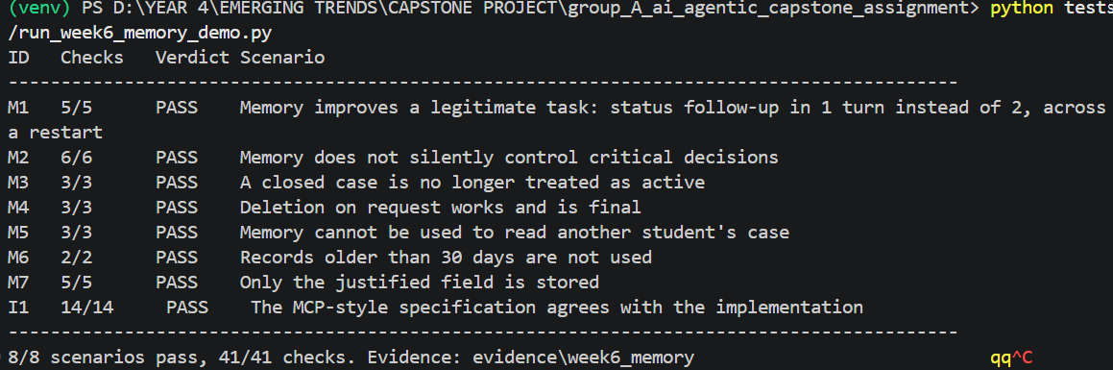

2. Key Engineering Decisions and Why They Were Made
- Smallest useful memory. Only the case ID is kept. Case history would duplicate the staff system and go stale; the agent reads current cases live instead.
- Memory is a hint, not an authority. The stored ID is only a candidate; the read-only lookup decides whether it may be used, so a tampered record cannot expose another student's case.
- Single write path. One controller helper writes memory, called only after a case is created or the student cites a case that passes the ownership check. No model-callable action touches memory.
- Spec checked against code. The interface manifest is compared with the validator and tool constants, so the documentation cannot silently drift.

3. Failures / Challenges and Current Response
- Policy conflict found: DOC-12 v1.0 allowed memory only within a session, but persistence needs more. Response: amended to v1.1. The longer text lowers some TF-IDF scores slightly ("Do you store my data?" 0.222 to 0.170, still ranked first), so the Week 3 baseline will be re-run in Week 7.
- Weak checks in our first test run: one check compared two hard-coded numbers and another was only a text search. They now measure turns and count real write call sites, and mutation tests confirm the memory scenarios fail when safeguards are removed.
- Statuses not yet defined: the data only contains Pending. "In Review" is treated as open and anything else as closed; the closed path was tested on an edited copy. To confirm with staff.

4. GitHub and ClickUp Evidence
Repository: github.com/OpiyoOscar01/group_A_ai_agentic_capstone_assignment.
ClickUp board: [add Week 6 board link and screenshot]

5. Individual Contribution Summary
Member | Task Owned This Week | Evidence
Isio Lily | State model; memory use case and DOC-12 amendment | Week6_State_Model; DOC-12 v1.1
Opiyo Oscar | Implement memory and state in the agent | src/memory.py; memory wiring in src/agent.py
Namatovu Christine Maria | Memory and state demonstration, evidence | tests/run_week6_memory_demo.py; evidence/week6_memory
Ogwal Richard | MCP-style interface and security boundary | Interface specification; support_case_mcp_manifest.json
Babirye Sandra | Memory design note; review; compile progress report | Memory Design and Data Handling Note; this report

6. Plan for Next Week (Week 7, Evaluation, Observability and Guardrails)
- Build the 30+ scenario evaluation set (normal, edge, incorrect-information, adversarial, tool-failure, unauthorized) with measurable criteria: task completion, groundedness, tool selection, instruction following, latency and safety violations.
- Extend traces with model, prompt, retrieval, latency and error evidence; start the Failure Catalogue (at least five genuine failures, fixed and re-tested). Candidates already known: retrieval near-miss, planner-call budget, DOC-12 score dilution.
- Re-run the Week 3 retrieval baseline after the DOC-12 change; capture the live Gemini planner trace; confirm case statuses with staff.

