Here is image A, a drawing of the number 1:

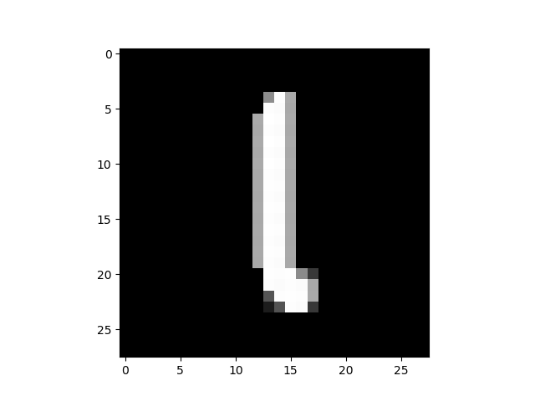

Here is image A after scaling it up to 34\*34 and trimming the excess:

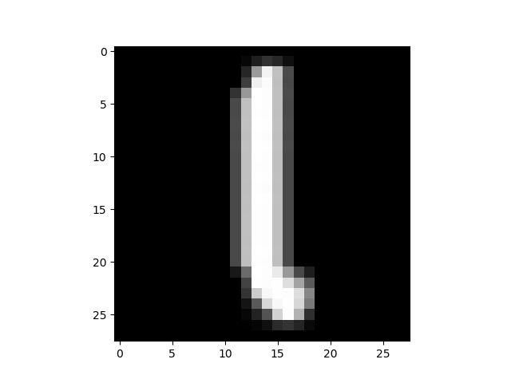

Here is image A after it was translated up 2 pixels:

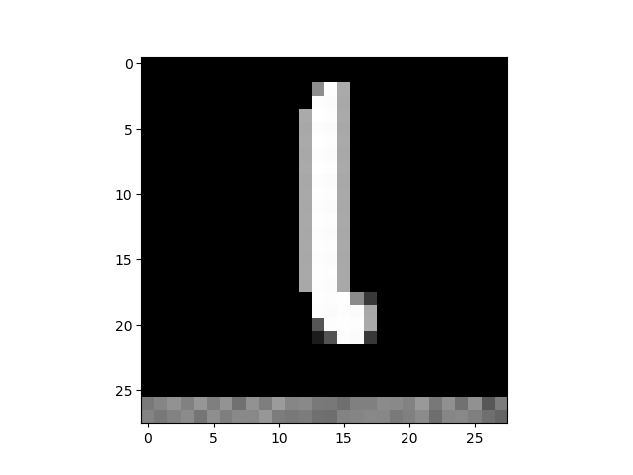

Here is image B, a drawing of the number 7:

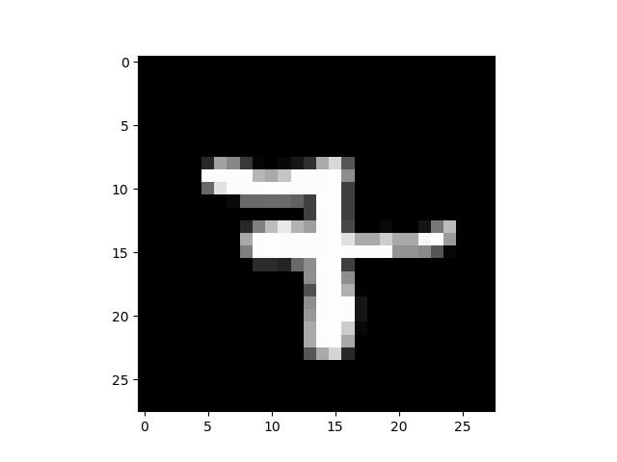

Here is image B after applying random noise to it:

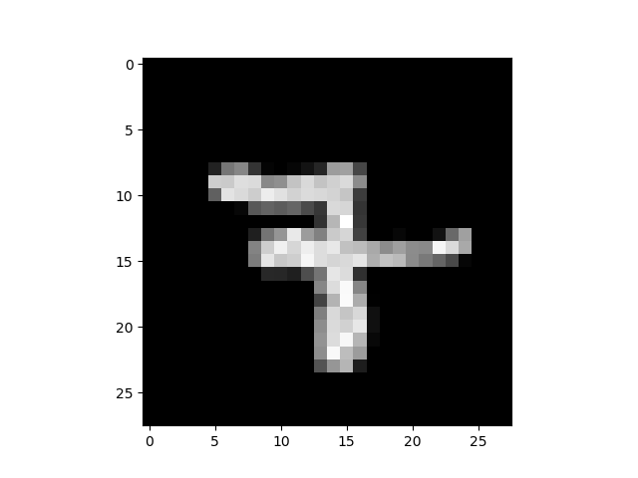

Here is image B after rotating it 25 degrees:

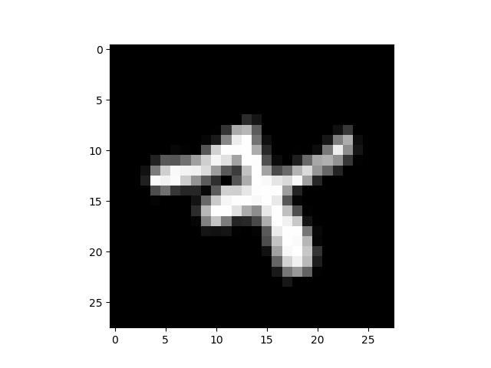

Below is a screenshot of the results. The addition of the training set improved the accuracy slightly.

