**QUERIES FOR Ivan’s Restaurant PIZZA SALE**

1. **Ivan’s Pizza Queries**
2. **Total Revenue**

SELECT ROUND(SUM(total_price),2) AS total_revenue

FROM dbo.pizza_sales



1. **Average Order value**

WITH avg_order_value AS (

SELECT ROUND(SUM(total_price) / COUNT(DISTINCT order_id), 2) AS average_order_value

FROM dbo.pizza_sales

)

SELECT * FROM avg_order_value;

// Can be simplier but I like to do this one



1. Total Pizzas Sold

SELECT SUM(quantity) AS total_pizza_sold

FROM dbo.pizza_sales



1. **Total Orders**

SELECT COUNT(DISTINCT order_id) AS total_pizza_sold

FROM dbo.pizza_sales



1. **Average Pizzas Per order**

SELECT CAST(CAST(SUM(quantity) AS DECIMAL(10,2))

/ CAST(COUNT(DISTINCT order_id) AS DECIMAL(10,2))

AS DECIMAL (10,2))

AS avg_pizzas_per_order

FROM DBO.pizza_sales



But if full is

SELECT CAST(SUM(quantity) AS DECIMAL(10,2))

/ CAST(COUNT(DISTINCT order_id) AS DECIMAL(10,2))

AS avg_pizzas_per_order

FROM DBO.pizza_sales



**CHARTS & their Queries**

1. **Daily Trend**

SELECT order_day, total_orders

FROM (

SELECT

DATENAME(WEEKDAY, order_date) AS order_day,

COUNT(DISTINCT order_id) AS total_orders,

CASE DATENAME(WEEKDAY, order_date)

WHEN 'Monday' THEN 1

WHEN 'Tuesday' THEN 2

WHEN 'Wednesday' THEN 3

WHEN 'Thursday' THEN 4

WHEN 'Friday' THEN 5

WHEN 'Saturday' THEN 6

WHEN 'Sunday' THEN 7

END AS weekday_number

FROM dbo.pizza_sales

GROUP BY DATENAME(WEEKDAY, order_date)

) AS temp

ORDER BY weekday_number;

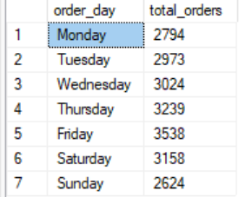

-- used a subquery to not show the weekday_number in the final output

-- Made a CASE WHEN expression so it can be used in the order by clause. The reason for this use is because the output of DATENAME is a weekday name and using order by will Order alphabetically

1. **HOURLY TREND**

WITH HourDay AS (

SELECT DATENAME(HOUR, order_time) AS time_of_hour, order_id

FROM dbo.pizza_sales

)

SELECT time_of_hour, COUNT(DISTINCT order_id) AS total_orders_hourly

FROM HourDay

GROUP BY time_of_hour

ORDER BY CAST(time_of_hour AS INT) DESC

--casted as INT because there is a problem when DESC it stays at the top.

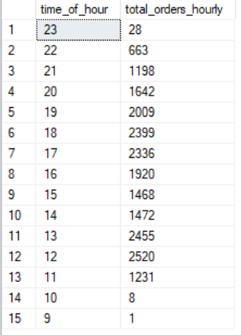

1. **.**