THE UNIVERSITY OF HUDDERSFIELD
School of Computing and Engineering

ASSIGNMENT SPECIFICATION

Module | Details
Module Code | CHS2406-2526
Module Title | Data-driven Artificial Intelligence
Course Title/s | BSc (Hons) Computer Science, BSc (Hons) Computer Science with Games Programming, BSc (Hons) Computer Science with Cyber Security, BSc (Hons) Computer Science with Artificial Intelligence, BSc (Hons) Software Engineering, BSc (Hons)  Computing, BSc (Hons) Applied Computing (Top-up)

Assessment | Weighting, Type and Contact Details
Title | COVID Correct Hand Washing Prediction
Weighting | 50%
Mode of working for assessment task | Individual  This assessment task is to be completed on an individual basis and there should be no collusion or collaboration whilst working  on and subsequently submitting this assignment.
Module Leader | Abirami Gunasekaran
Module Tutor/s | Abirami Gunasekaran

Submission | Submission and Feedback Details
Hand-out date | 30/09/2025
How to submit your  work. | Brightspace submission point
Submission date/s | 19/12/2025 by 12:00 noon – if you have any technical issues  submitting your work, please contact the Module Leader as soon as possible.
Expected amount of  independent time you should allocate to | 20 hours

1

Submission | Submission and Feedback Details
complete this
assessment
Submission type and  format | A Jupyter Notebook file in .ipynb format containing executed results and outputs.
Date by which your  grade and feedback will be returned | 30/01/2026  Note: This is a maximum of three working weeks after the submission deadline.

Additional Guidance  Information | Details
Your responsibility | It is your responsibility to read and understand the University regulations regarding conduct in assessment.  Please pay special attention to the assessment regulations (section 10) on Academic Misconduct.  In brief: ensure that you;  - DO NOT use the work of another student - this includes students from previous years and other institutions, as well as current students on the module.  - DO NOT make your work available or leave insecure, for other students to view or use.  - Any examples provided by the module tutor should be appropriately referenced, as should examples from external sources.  Further guidance can be found in the SCEN Academic Skills Resource and UoH Academic Integrity Resource module in Brightspace.  If you experience difficulties with this assessment or with time management, please speak to the module tutor/s, your Personal Academic Tutor, or the Students’ Progress Mentors Team (sce.progress.mentors@hud.ac.uk).

2

Additional Guidance  Information | Details
Guidance on using AI: | Level 1 – Not Permitted    The use of AI tools is not permitted in any part of this assessment except for limited writing support as permitted by the University Human and Computer Proof Reading policy.
Requesting a Late Submission | It is expected that you complete your assessments by the published deadlines. However, it is recognised that there can be unexpected circumstances which may affect you being able to do so. In such circumstances, you may submit a request for an extension. Extension applications must be submitted before the published assessment deadline has passed. All students can apply for self-certified extension via MyHud/MyStudies.  Self-certified illness extension of up to 5 working days:  - Evidence will not be required for this type of request  - One extension per assessment is allowed  - Extension request must be submitted before the original deadline.  If you are unable to meet the extended deadline, you must apply for extenuating circumstances (EC, see the next section), which requires supporting information. Non-submission will be recorded if neither extension nor EC is approved, and work is not submitted. Please note that some assessments (such as ICTs, Exams, Group Presentations, etc) do not allow extensions. Further information can be found here in Section-8 - University of Huddersfield.

3

Additional Guidance  Information | Details
Extenuating Circumstances (ECs) | An EC claim is appropriate in exceptional circumstances, when an extension is not sufficient due to the nature of the request.  You can access the EC Claim Form on the Registry website; where you can also find out more about the process.  You will need to submit independent, verifiable evidence for your claim to be considered.  Once your EC claim has been reviewed you will get an EC outcome email from Registry. If you are unsure what it means or what you need to do next, please speak to the iPoint - University of Huddersfield (in the Student Central, Barbara Hepworth Building and Daphne Steele Building). An approved EC will extend the submission date to the next assessment period (e.g July  resit period).
Late Submission (No ECs approved) | Late submission, up to 5 working days, of the assessment submission deadline, will result in your grade being capped to a maximum of a pass mark.  Submission after this period, without an approved extension, will result in a 0% grade for this assessment component.
Tutor Referral  available | YES
Resources | - Please note: you can access free Office365 software and you have 1 Tb of free storage space available on Microsoft’s OneDrive – Guidance on downloading Office 365.

4

Assignment 1: COVID Correct Hand Washing Prediction

Assignment Aims
The assignment is designed to test your skills in finding and preparing data, as well as training a deep convolutional neural network to recognise images. It's designed to give you the know- how to create solutions for image classification. By completing this coursework, you'll gain practical skills in handling data and teaching computers to understand images, preparing you for various image-related tasks.

Learning Outcomes:

  - Investigate and identify the most appropriate data-driven technique to solve a given problem.
  - Apply data-driven concepts and techniques using industry standard tools to implement intelligent systems for applications such as natural language processing and image recognition.
  - Data Proficiency: By the end of this coursework, students will have acquired the proficiency to gather and preprocess relevant high-quality data for a computer vision problem. They will demonstrate the ability to navigate the challenges associated with data collection, annotation, and augmentation, ensuring the readiness of datasets for training deep convolutional neural networks.
  - Model Training Competence: Upon completion of the coursework, students will demonstrate competence in training deep convolutional neural networks (CNNs) for image classification. They will showcase the skills necessary to design, implement, and fine-tune CNN architectures, enabling them to create effective solutions for recognising and classifying various stages of handwashing instructions for COVID-19.

Assessment Brief
During the COVID-19 pandemic, practicing good hygiene, especially for healthcare professionals and essential workers, was crucial for their safety. The World Health Organisation (WHO) provided guidelines on proper handwashing to prevent disease transmission. However, there was no way to ensure whether people were following these instructions. Even though we're past the pandemic, handwashing remains vital, particularly for healthcare professionals. The NHS-England has assigned you the task of creating an AI solution to automatically monitor the handwashing of healthcare professionals. Cameras are installed above each washbasin/sink in health facilities to record the handwashing process.

5

To make this AI solution effective, we need a computer vision model for image classification that recognises all eight stages of handwashing as outlined by WHO. If the person successfully follows all the handwashing instructions, both visually and confirmed by our AI model, a green light next to the tap will signal completion. Otherwise, a red light will indicate that the person needs to repeat the handwashing process.
Your assignment is to train a deep convolutional neural network capable of identifying the eight stages of the handwashing process as shown in the image below.
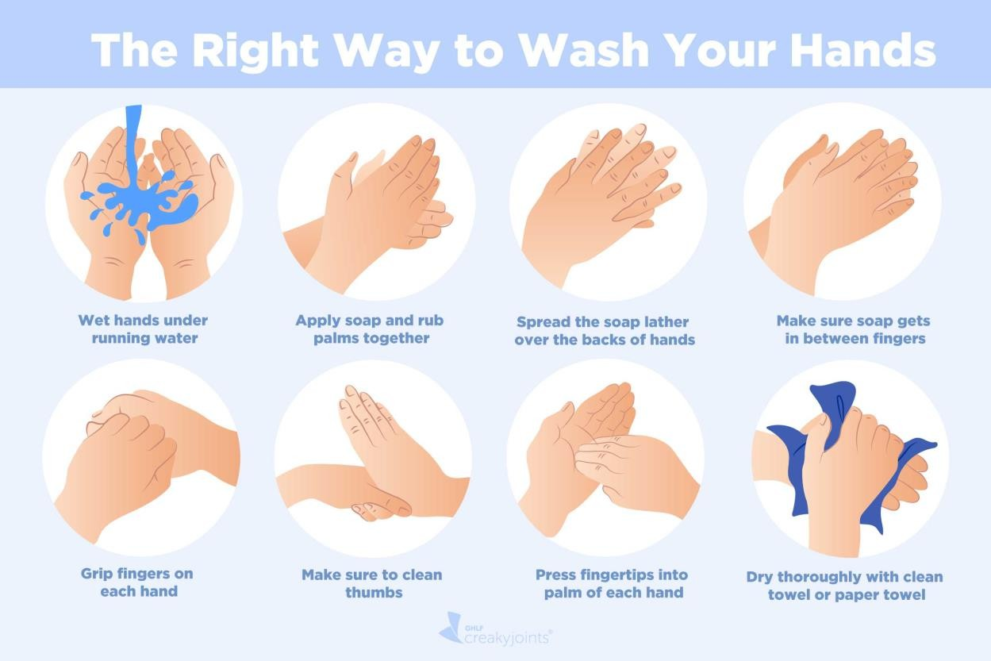

Your responsibilities include:

Data Acquisition:

- Capture images of your hands while following the WHO instructions.
- Take 10 pictures for each step from slightly different angles.
- Upload the pictures to a shared repository at Link: CHS2406_Coursework2_Data_Repository
  - Follow the link above to a shared OneDrive Folder (CHS2406_Coursework2_Data_Repository).
  - There are eight folders in the shared folder.
  - Upload your 10 images for each stage in the relevant folder.
  - The deadline for the data acquisition is 17-Nov-2025.

6

- The final dataset will comprise images contributed by you and your classmates.
- Your images must follow the following guidelines.
  - Capture 10 images for each stage.
  - Image size should be 150*150*3.
  - Try to capture only the hands and maybe some part of wash basin/sink and water tap. Having more objects in image will add noise to our dataset and will hinder the model training.
  - Rename the images with the following information.
    - Stage_X_yourStudentNumber.jpg
    - The accepted image extensions are JPG, PNG, and JPEG.

Labelling Errors:

- Scrutinise the final datasets for any labelling errors. Refer to Week 1, Lecture 2 to familiarise yourself with various labelling errors in computer vision applications.

Data Pre-Processing and data splitting:

- Follow the necessary pre-processing steps for your image dataset.
- Split the data into appropriate sizes of training, validation, and testing datasets.

Convolutional Neural Network:

- Either train a CNN from scratch or use a pre-trained model, selecting the best architecture, kernel size, window size, features, activation functions, and neurons.
- Utilise data augmentation to enhance model robustness and realism.

Model Evaluation:

- Employ various model evaluation techniques covered in class and practical sessions.
- Ensure your model avoids overfitting or underfitting by utilising learning curves.

Submission format:

Submit the Jupyter notebook as either an IPYNB file or PDF. Do not submit other formats or compressed files. Ensure notebook contains executed results, and that PDFs are complete with nothing cut off.

7

Marking Scheme
Data Acquisition: (10%)

Labelling Errors: (20%)

Data Pre-Processing and data splitting: (10%)

Model Implementation (Convolutional Neural Network) : (40%) Model Evaluation: (20%)

Grading Rubric
The rubric file has been attached to Brightspace for your reference.

