MACHINE LEARNING-BASED WATER QUALITY INDEX PREDICTION INCORPORATING FEATURE SELECTION TECHNIQUES: A CASE STUDY OF QUANG NINH PROVINCE, VIETNAM
A seminar report submitted to University of Huddersfield in partial fulfilment of degree of
BSc. Applied Computing
Toan Nguyen The
Student ID: U2560895

DEPARTMENT OF COMPUTER SCIENCE
SCHOOL OF COMPUTING AND ENGINEERING
April 2026

Acknowledgement
I would like to express my sincere gratitude to my supervisor, Dr. Muhammad Zahid Hussain, and my aunt and teacher, Associate Professor Nguyen Thi The Nguyen. Their invaluable guidance, expertise, and encouragement were instrumental throughout this project, and their insights substantially shaped the direction and quality of this work.
I extend my appreciation to the School of Computing and Engineering at the University of Huddersfield for providing the resources and academic environment that supported this research.
Finally, I must thank my family and friends for their unwavering support. I am profoundly grateful for their financial assistance and constant motivation, which gave me the strength to complete this journey.

ABSTRACT

Table of Contents
Acknowledgement 2
ABSTRACT 3
CHAPTER 1. INTRODUCTION 7
1.1 Background of The Study 7
1.2 Research Significance and Motivation 8
1.2.1 Research Gap 8
1.2.2 Research Significance 9
1.2.3 Motivation 9
1.3 Research Scope 9
1.4 Aim and Objectives 9
1.3.1 Aim 9
1.3.2 Objectives 9
1.5 Outline of The Thesis 10
CHAPTER 2. LITERATURE REVIEW 10
2.1 Introduction to WQI 10
2.1.1 Evolution and Conceptual Foundation of the WQI 10
2.1.2 Conventional WQI Construction Framework 10
2.1.2 Two Conventional Schools of Thought 10
2.2 Overview of Machine Learning Techniques for WQI 13
2.2.1 Traditional algorithms 13
2.3 Theoretical Framework 14
2.3.1 Machine Learning Models and Ensemble Algorithms 14
• Random Forest: An ensemble learning algorithm based on decision trees, developed by Ho (1995) and Breiman (2001), that builds multiple trees using bootstrap sampling and random feature selection. Predictions are aggregated through averaging (regression) or majority voting (classification) to enhance accuracy and reduce overfitting. In this study, it models water quality by capturing complex, non-linear relationships among multiple variables. While highly accurate and robust, it is less interpretable and computationally more demanding than single-tree models. 14
2.3.2 Evaluation metrics 16
CHAPTER 3. METHODOLOGY 18
3.1 Experimental Design Logic and Workflow 18
3.2 Study Area and Data Collection 19
3.3 Data Pre-processing 19
• K-Nearest Neighbors (KNN) Imputation for Missing Values: A distance-based K-Nearest Neighbors (KNN) algorithm was deployed to estimate and impute localized missing values (specifically for CrVI and E. coli) by exploiting the multidimensional similarity of adjacent data points. 21
3.4 Exploratory Data Analysis 21
3.5 Feature Engineering Approach 21
3.5 Classifier Training 23
CHAPTER 4. RESULTS 24
Xem đặt lại tên sub-section, vừa viết xong tranh thủ viết conclusion luôn, highlight tất cả nhưng phát hiện 24
4.1 Data Analysis 26
4.2 WQI based on Direct Measurement Inputs 33
4.2.1 Before removing unimportant features 33
4.2.2 After removing unimportant features 36
4.3 WQI based on Feature Engineered Inputs (WQI_SI) 38
4.3.1 Before removing unimportant features 38
4.3.2 After removing unimportant features 40
CHAPTER 5. DICUSSION 44
5.1 Overview of Principal Findings 44
5.2 Behavioural Analysis of Machine Learning Models 44
5.2.1 Nonlinear Structure of Raw Environmental Data 44
5.2.2 Sensitivity to Feature Reduction 45
5.2.3 Impact of Domain-Informed Feature Engineering 45
5.3 Comparison with Existing WQI Prediction Studies 45
5.4 Methodological Contributions 45
5.5 Practical Implications for Coastal Water Governance 45
5.6 Model Robustness and Generalisability 45
5.7 Limitations and Research Boundaries 45
5.8 Conceptual Synthesis of the Proposed Framework 45
5.1 Technical 45
5.2 Performance 46
CHAPTER 6. CONCLUSION 46
CHAPTER 7. FUTURE WORK 46
REFERENCE 46

Figure 1 Evolutionary trends in the deployment of AI, Machine Learning, and Deep Learning for water quality forecasting (Muñoz-Alegría et al., 2025) 8
Figure 2 Prevalent ML/DL algorithms for water quality forecasting, focusing on: (a) Model taxonomy; (b) Frequency of application (Muñoz-Alegría et al., 2025) 9
Figure 3 The experimental workflow. 11
Figure 4 Distribution of Temperature 23
Figure 5 Distribution of pH 24
Figure 6 Distribution of DO 25
Figure 7 Distribution of COD 26
Figure 8 Distribution of BOD₅ 27
Figure 9 Distribution of NO₃⁻ 28
Figure 10 Distribution of NO₂⁻ 29
Figure 11 Distribution of NH₄⁺ 30
Figure 12 Distribution of PO₄³⁻ 31
Figure 13 Distribution of Coliform 32
Figure 14 Distribution of E. coli 33
Figure 15 Distribution of Arsenic 34
Figure 16 Distribution of Mercury 35
Figure 17 Distribution of Lead 36
Figure 18 Distribution of Cadmium 37
Figure 19 Distribution of Cr(VI) 38
Figure 20 39
Figure 21 40
Figure 22 41
Figure 23 43
Figure 24 Permutation Feature Importance for WQI Prediction Using Raw Input Parameters (Pre-Feature Selection) 48
Figure 25 51
Figure 26 55
Figure 27 Performance comparison of Machine Learning and Traditional Calculation methods under Feature Reduction constraints. 55

Table 1Table 1 Descriptive statistics of water quality parameters and WQI in Quang Ninh Province (2019–2021) 12
Table 2 Individual Regression Model Performance on Raw Water Quality Inputs (Pre-Feature Selection) 45
Table 3 Performance comparison of different stacking model configurations with varying base learners. 46
Table 4 Model Performance Comparison (After Feature Selection) 48
Table 5 49
Table 6 50
Table 7 50
Table 8 52
Table 9 54

CHAPTER 1. INTRODUCTION

Background of The Study
Water quality management is essential for environmental protection and sustainable development, particularly in ecologically sensitive areas such as Quang Ninh Province and Ha Long Bay, a UNESCO World Heritage Site (UNESCO World Heritage Centre., n.d.; Van Hien et al., 2024). The region supports tourism, aquaculture and coastal ecosystems, but is increasingly affected by socioeconomic development and associated pollution pressures, leading to growing concerns over seawater quality (Dinh Duong, n.d.; Nguyen & Sevando, 2019; Van Hien et al., 2024).
The Water Quality Index (WQI) is widely used to evaluate water quality by integrating multiple parameters into a single, interpretable value, especially for assessing temporal water quality trends (Brown et al., 1970; Chidiac et al., 2023; Dasu, 2025; Noori et al., 2019; Ott, 1978; Van Hien et al., 2024). However, traditional WQI calculation requires extensive field sampling and laboratory analysis, making it costly, time‑consuming (Barathkumar & Devi, 2025; Jayaraman et al., 2024; Lap et al., 2023; Moeinzadeh et al., 2024; Uddin et al., 2021; Xu et al., 2024). Attempts to reduce monitoring costs by calculating WQI using fewer parameters have often resulted in reduced accuracy and reliability (Mogane et al., 2023; Rangeti et al., 2015; Uddin et al., 2021).
Recent advances in artificial intelligence (AI) and machine learning offer an alternative approach for water quality assessment (Dasu, 2025). AI‑based WQI prediction models can effectively capture complex relationships among water quality variables while using reduced sets of input parameters, improving prediction efficiency and reducing dependence on extensive sampling without significantly compromising accuracy (Lap et al., 2023). As a result, machine learning‑driven WQI prediction has emerged as a promising trend for improving water quality management in contexts where conventional monitoring is constrained by cost and logistics.

Research Significance and Motivation

1.2.1 Research Gap
Recent research on AI-based Water Quality Index (WQI) prediction has largely focused on comparing individual machine learning algorithms, with limited attention to advanced optimization techniques such as GridSearchCV and ensemble learning. Hybrid methods, including stacking models, have rarely been applied, restricting potential improvements in predictive performance. Furthermore, conventional feature selection methods often rely on permutation importance, which may underestimate the impact of low-importance features in specific cases, leading to reduced accuracy in certain scenarios. In addition, engineered features derived from WQI sub-indices have not been extensively utilized as model inputs, leaving further opportunities to enhance prediction quality.

1.2.2 Research Significance
Addressing these research gaps is of significant importance both academically and practically. By integrating advanced optimization techniques, ensemble learning, careful feature engineering, and the use of WQI sub-indices, the proposed research aims to develop AI-based models with improved prediction accuracy and robustness. Such models can reduce dependency on extensive field sampling, thereby saving time and resources, while providing reliable tools for effective water quality management in coastal regions such as Ha Long Bay.

1.2.3 Motivation
The motivation for this research stems from the growing environmental pressures on coastal water resources and the limitations of conventional monitoring approaches. Developing intelligent models capable of accurate and efficient WQI prediction can support sustainable water management, inform policy-making, and serve as a reference framework for similar ecologically sensitive regions.

Research Scope
This study focuses on water quality data from Quang Ninh Province. Due to the limited size of available datasets, machine learning methods are employed instead of deep learning approaches to develop predictive models that are accurate and efficient under data-constrained conditions. The models aim to predict the results of the Vietnamese Water Quality Index (WQI-VN) calculation, including one formulation that follows the Robert K. Horton-based WQI approach.

1.4 Aim and Objectives

1.3.1 Aim
To design a resource-efficient predictive model for the Water Quality Index (WQI) of Quang Ninh province that minimizes input requirements through feature importance analysis.

1.3.2 Objectives
• To Synthesize a dataset from records of different Quang Ninh locations
• Perform Exploratory Data Analysis
• Execute feature selection based on correlation between variables and Permutation Importance
• To optimize model performance through a data-driven AI approach
• To enhance predictive accuracy through a data-centric AI approach

1.5 Outline of The Thesis

CHAPTER 2. LITERATURE REVIEW

2.1 Introduction to WQI

2.1.1 Evolution and Conceptual Foundation of the WQI
The Water Quality Index (WQI) synthesizes physical, chemical, and biological water quality data into a single score, facilitating environmental communication and management (Štambuk-Giljanović, 1999, 2003; Sutadian et al., 2016). Horton (1965, as cite in Dasu, 2025; Talukdar et al., 2023) first proposed arithmetic aggregation of normalized parameters. Brown et al. (1970) refined this approach via the NSFWQI, incorporating expert-based weighting (Abbasi & Abbasi, 2012). The CCME model later emphasized regulatory compliance using scope, frequency, and amplitude of exceedances (CCME, 2017). Overall, WQI evolution reflects a shift from arithmetic reduction to governance-oriented assessment.

2.1.2 Conventional WQI Construction Framework
Conventional WQI models follow a systematic four-stage workflow: parameter selection, sub-index transformation, weighting, and aggregation (Abbasi & Abbasi, 2012). This framework allows heterogeneous water quality indicators to be converted into a single dimensionless score, supporting integrated assessment while maintaining comparability across studies.

2.1.2 Two Conventional Schools of Thought
The National Sanitation Foundation WQI (NSFWQI) exemplifies the weighted arithmetic expert-based approach, where weights are assigned based on expert judgment (Abbasi & Abbasi, 2012; Brown et al., 1970). Advantages of this method include simplicity and ease of interpretation for policymakers and the public. However, reliance on subjective weighting can introduce bias and limit reproducibility across regions or studies (Sutadian et al., 2016).
In contrast, the CCME WQI represents a regulatory-focused approach, calculating water quality based on scope, frequency, and amplitude of standard exceedances (CCME, 2017). This approach reduces subjectivity and aligns evaluation with legal standards, but it may be less intuitive and require more complex computations.
Both approaches implement the general four-stage workflow but differ in weighting strategy and evaluation focus. Expert-based indices prioritize interpretability, whereas compliance-based indices prioritize objectivity and adherence to standards. The choice of approach depends on the intended application, whether for rapid public reporting or enforcement of environmental regulations (Uddin et al., 2021).

2.1.3 Parameter Selection and Sensitivity Issues
Parameter selection fundamentally constrains WQI validity, as index scores reflect only the included variables. Conventional models typically incorporate dissolved oxygen, biochemical oxygen demand, pH, turbidity, suspended solids, and nutrients (Abbasi & Abbasi, 2012; Brown et al., 1970; Sutadian et al., 2016). However, parameter relevance varies by water-use objective: drinking water emphasizes microbial and toxic contaminants, irrigation prioritizes salinity indicators, and ecosystem assessments focus on oxygen balance and nutrient enrichment (Štambuk-Giljanović, 2003; Uddin et al., 2021).
WQI outcomes are sensitive to parameter inclusion and weighting, as aggregation amplifies the influence of dominant variables (Lumb et al., 2006; Sutadian et al., 2016). Moreover, omission of emerging pollutants such as trace metals or pharmaceuticals may produce overly optimistic classifications. Thus, parameter selection is not purely technical but a normative decision shaping environmental interpretation and policy relevance.

2.1.4 Water Quality Classification Systems Across Countries
Most WQI frameworks convert numerical scores, commonly within a 0–100 scale, into categorical classes to enhance interpretability. However, classification thresholds differ substantially across countries. For instance, while both NSFWQI and CCME WQI use similar numerical ranges, their category boundaries and regulatory bases vary (Brown et al., 1970; CCME, 2017).
These differences reflect divergent environmental standards, intended water uses, and policy priorities (Sutadian et al., 2016; Uddin et al., 2021). As a result, identical WQI scores may correspond to different quality categories across jurisdictions.
The absence of global standardization limits international comparability. Direct comparison of WQI values without methodological harmonization may therefore produce misleading cross-country assessments.

2.1.5 Limitations of Conventional WQI
Conventional WQI models face several structural limitations. First, subjective weighting, particularly in expert-based indices, introduces bias and reduces reproducibility (Abbasi & Abbasi, 2012; Sutadian et al., 2016). Second, aggregation of multidimensional data into a single score leads to information loss, potentially generating a masking effect in which critical parameter exceedances are diluted (Chidiac et al., 2023).
Moreover, most WQI frameworks lack uncertainty quantification, failing to account for measurement error and temporal variability. Finally, differences in parameter selection, weighting schemes, and classification thresholds create regional inconsistency, limiting cross-study and cross-country comparability (Uddin et al., 2021).
While WQI enhances communicability, these methodological constraints challenge its robustness and analytical transparency.

2.2 Overview of Machine Learning Techniques for WQI
According to Muñoz-Alegría et al. (2025), the main approach used to predict WQI can be grouped into three categories: traditional algorithms, ensemble models, deep learning techniques.

2.2.1 Traditional algorithms
Classical machine learning models, such as Artificial Neural Networks (ANN) (Kouadri et al., 2021; Maier & Dandy, 2000) and Decision Tree (Khoi et al., 2022; Lap et al., 2023), Support Vector Machines (Lap et al., 2023) have been widely applied in the prediction of WQI across various environmental contexts. While ML techniques successfully addressed non-linear environmental data (Talukdar et al., 2023; Yaseen et al., 2018), they encountered limitations in capturing the high-frequency temporal fluctuations (Talukdar et al., 2023).
2.2.2 Ensemble Models
Ensemble learning techniques, such as Random Forest (Lap et al., 2023), Gradient Boosting Machines (Sidek et al., 2024), and XGBoost (Yuan et al., 2025), have been widely adopted in WQI prediction due to their ability to capture complex non-linear relationships (Ahmad et al., 2025) and reduce overfitting in noisy environmental datasets (Dasu, 2025; Makumbura et al., 2024a). These methods aggregate multiple base learners to improve overall predictive accuracy and robustness compared to individual models (Ahmad et al., 2025).
2.2.3 Deep Learning Techniques
Deep learning models like Long Short-Term Memory (LSTM) (Baek et al., 2020; Barzegar et al., 2020) were introduced to problem-relevant parameters and represent highly intricate record distributions (Shen, 2018) and automated feature extraction (Liu et al., 2019). This paradigm shift reflects a movement toward hierarchical learning systems (Barzegar et al., 2020) that provide superior accuracy and robustness in predicting complex hydrological variables.
2.2.4 Emerging Trends: Hybridization, Optimization, and Interpretability
Current research in the field has transitioned toward more integrated and transparent frameworks:
- Hybridization: There is a significant trend toward hybrid architectures, such as the CNN-LSTM model (Barzegar et al., 2020). Hybird models can bring more accurate than single models (Chou et al., 2018) and exhibit greater flexibility and resilience when handling noisy datasets (Talukdar et al., 2023). However, they are inherently complex, computationally time-consuming (Talukdar et al., 2023).
- Optimization: Systematic hyperparameter optimization, particularly through techniques like Grid Search, is widely employed (Shekar & Dagnew, 2019) and achieve a higher level of predictive accuracy (Elgeldawi et al., 2021; Uddin et al., 2022; Villalobos-Arias et al., 2020).
- Interpretability: The integration of Explainable AI (XAI) techniques, specifically SHAP (SHapley Additive exPlanations) (Choudhary et al., 2025), is a critical emerging trend. These methods aim to decipher the "black-box" nature of ML models by quantifying the specific contribution of individual parameters to the final WQI score (Makumbura et al., 2024b).

2.3 Theoretical Framework

2.3.1 Machine Learning Models and Ensemble Algorithms

Random Forest: An ensemble learning algorithm based on decision trees, developed by Ho (1995) and Breiman (2001), that builds multiple trees using bootstrap sampling and random feature selection. Predictions are aggregated through averaging (regression) or majority voting (classification) to enhance accuracy and reduce overfitting. In this study, it models water quality by capturing complex, non-linear relationships among multiple variables. While highly accurate and robust, it is less interpretable and computationally more demanding than single-tree models.
- Gradient Boosting: A supervised ensemble algorithm that builds sequential decision trees, where each new tree corrects the residual errors of the previous ensemble using gradient-based optimization. This iterative boosting process enables the model to capture complex, non-linear relationships between predictors and the target variable. It offers high flexibility and predictive accuracy but requires careful hyperparameter tuning (e.g., learning rate, number of trees, tree depth). Despite strong performance, it is computationally intensive and sensitive to noise compared to methods like Random Forest.
- Multiple Linear Regression: A statistical method used to model the relationship between a continuous dependent variable and multiple independent variables. It assumes a linear relationship, expressed as $Y=β_{0}+β_{1}X_{1}+⋯+β_{n}X_{n}+ϵ$, where coefficients represent the magnitude and direction of each predictor’s effect. In water quality studies, it helps quantify how different parameters influence WQI. While interpretable and straightforward, it relies on linearity assumptions and may not capture complex non-linear interactions.
- K-Nearest Neighbors (KNN): A non-parametric, instance-based supervised algorithm used for classification and regression by identifying the k closest data points using a distance metric (e.g., Euclidean distance). Predictions are made through majority voting (classification) or averaging (regression) of the nearest neighbors. It is simple, flexible, and capable of modeling complex patterns without assuming a specific functional form. However, performance depends heavily on the choice of k, feature scaling, and can be computationally expensive for large datasets.
- Support Vector Regression (SVR): A supervised learning algorithm derived from Support Vector Machines, designed to predict continuous outcomes by fitting a function within a specified ε-margin of tolerance. It maximizes the margin while penalizing deviations beyond this threshold using a regularization parameter $C$, and employs kernel functions (e.g., linear, polynomial, RBF) to model non-linear relationships. SVR is robust to overfitting and effective in high-dimensional spaces. However, its performance depends heavily on careful tuning of hyperparameters and it can be computationally demanding for large datasets.
- Stacking (Stacked Ensemble): An advanced ensemble technique that combines multiple base models and a meta-learner to improve predictive performance. Base learners (e.g., tree-based models, SVR) are trained independently, and their predictions are used as inputs for a second-level model that learns how to optimally combine them. This approach enhances accuracy and generalization by leveraging complementary strengths of different algorithms. However, it requires careful model selection and tuning and can be computationally intensive.
- Bagging (Bootstrap Aggregating): An ensemble method that trains multiple base learners on bootstrapped samples from the original dataset to reduce variance and improve generalization. Predictions are aggregated—typically by averaging for regression—to produce the final output. It is effective for high-variance models like decision trees, mitigating overfitting without increasing bias. Bagging trains base learners independently, allowing parallel computation, though it offers limited gains for low-variance models and reduces interpretability.

2.3.2 Evaluation metrics
The accuracy of machine learning models can be assessed using metrics such as R-squared, Mean Squared Error (MSE), and Mean Absolute Error (MAE). Evaluating a model should not rely solely on a single metric; rather, it requires a combination of techniques and appropriate indicators tailored to the specific problem. A thorough understanding of these evaluation methods ensures that the model achieves optimal performance and can be effectively applied in practice.
- Mean Squared Error (MSE): MSE represents the average of the squared differences between predicted and actual values. A lower MSE indicates higher predictive accuracy of the model.
$$\text{MSE}=\frac{1}{n}\sum_{i=1}^{n}{(}y_{i}-{\hat{y}}_{i})^{2}$$
- Root Mean Squared Error (RMSE): RMSE is the square root of MSE. It quantifies the average prediction error while bringing the error back to the same units as the original data, facilitating more intuitive interpretation.
$$\text{RMSE}=\sqrt{\frac{1}{n}\sum_{i=1}^{n}{(}y_{i}-{\hat{y}}_{i})^{2}}$$
- R-squared (R²): R-squared measures the proportion of variance in the dependent variable that is explained by the model. Its value ranges from 0 to 1, with higher values indicating better explanatory power of the model regarding the data variability.
$$R^{2}=1-\frac{\sum_{i=1}^{n}{(}y_{i}-{\hat{y}}_{i})^{2}}{\sum_{i=1}^{n}{(}y_{i}-\overset{ˉ}{y})^{2}}$$
- Mean Absolute Error (MAE): MAE is the average of the absolute differences between predicted and actual values. It provides a straightforward measure of the average deviation of predictions from actual observations.
$$\text{MAE}=\frac{1}{n}\sum_{i=1}^{n}{∣}y_{i}-{\hat{y}}_{i}∣$$
Where:
- $n$is the total number of samples in the dataset.
- $y_{i}$denotes the observed value of the $i$-th sample.
- ${\hat{y}}_{i}$denotes the predicted value of the $i$-th sample.
Importance of Model Evaluation:
- Ensures the predictive accuracy of the model.
- Prevents overfitting or underfitting.
- Tests the model’s generalizability on unseen data.
- Enables performance comparison among different models to select the most suitable one.
- Ensures model stability and robustness.
- Guarantees the reliability of predictions for real-world applications.

CHAPTER 3. METHODOLOGY

3.1 Experimental Design Logic and Workflow
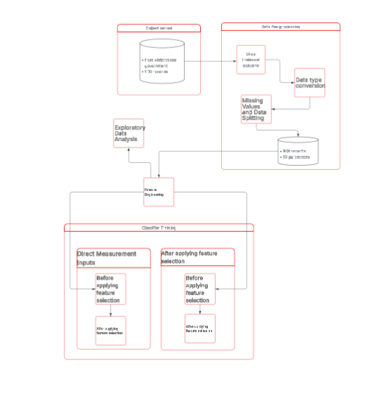

3.2 Study Area and Data Collection
Geographic coordinates?

3.3 Data Pre-processing

3.3.1 Data Type and Format Standardization
To ensure the dataset was compatible with machine learning algorithms, several numerical transformation steps were performed:
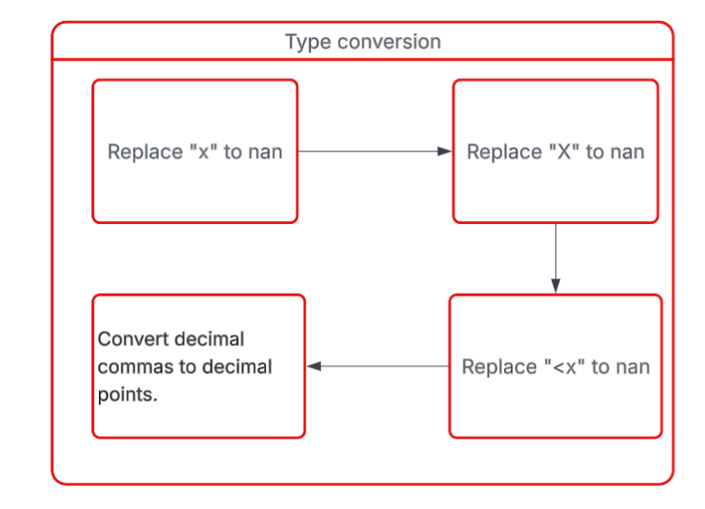
- Handling Missing Value Placeholders: Non-numeric characters such as "x" and "X," which were used in the raw records to denote missing measurements, were converted to NaN (Not a Number) to facilitate systematic imputation.
- Treatment of Censored Data: For parameters recorded as "< x" (indicating values below the analytical limit of detection), the prefix "<" was removed, and the limit value x was retained for the analysis.
- Numerical Localization: Decimal separators were standardized by converting commas to points to align with the standard floating-point format required by the Python processing environment.
- Numerical Data Conversion: Following the cleaning of non-numeric characters and format standardization, all water quality parameters were cast into appropriate numerical data types to enable mathematical operations.

3.3.2 Handling Missing Data and Dataset Partitioning
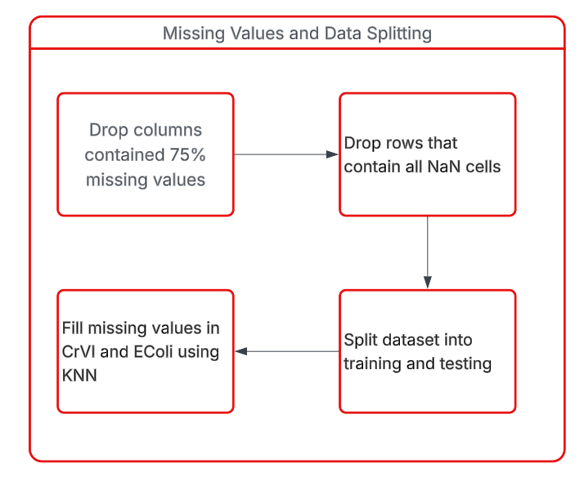
- Removal of High-Sparsity Features: Features exhibiting a missing data rate exceeding the 75% threshold were entirely eliminated to prevent the introduction of statistical noise and computational bias into the model's learning process.
- Elimination of Empty Records: Observations entirely devoid of measured values were purged from the dataset, as they offer no discriminative information and solely degrade computational efficiency.
- Train-Test Split Configuration: The dataset was strictly partitioned into training and testing subsets prior to imputation to preserve the integrity of model evaluation and completely mitigate the risk of data leakage.

K-Nearest Neighbors (KNN) Imputation for Missing Values: A distance-based K-Nearest Neighbors (KNN) algorithm was deployed to estimate and impute localized missing values (specifically for CrVI and E. coli) by exploiting the multidimensional similarity of adjacent data points.

3.4 Exploratory Data Analysis
- Boxplot: Boxplots were employed to visualize the statistical distribution and identify potential outliers for each of the monitored water quality parameters.
- Bar chart: Bar charts were utilized to depict the frequency distribution and overall data shape of the various physicochemical and microbiological measurements.
- Heatmap: A Pearson correlation matrix heatmap was generated to elucidate the underlying linear associations between raw physicochemical parameters, sub-indices, and the final aggregate Water Quality Index (VN_WQI).

3.5 Feature Engineering Approach
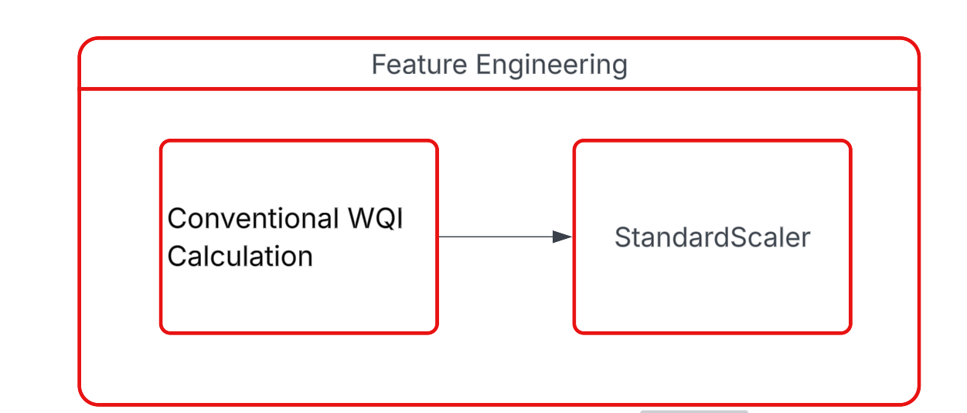
- Data Standardization: Data Standardization was employed to eliminate severe scale disparities among water quality parameters, ensuring that distance-based algorithms like LR, SVR and KNN are not disproportionately biased by features with large magnitudes.
- Derivation of WQI-based Features
In this study, the Vietnamese Water Quality Index (VN_WQI) was calculated strictly in accordance with the technical guidelines issued by the MONRE (2019). The VN_WQI framework categorizes water quality parameters into five thematic groups: (I) pH, (II) pesticides, (III) heavy metals, (IV) organic matter and nutrients, and (V) microbiological indicators.
For each thematic group g, a group-level index was derived by aggregating its corresponding standardized sub-indices (WQISI) using either the geometric mean or the arithmetic mean, depending on the specific requirements prescribed for each parameter group. Individual water quality parameters were first transformed into dimensionless sub-indices based on the official rating curves, and these sub-indices were subsequently integrated to quantify the overall surface water quality status.
In this study, the VN_WQI was calculated using 16 water quality variables, including temperature, pH, dissolved oxygen (DO), chemical oxygen demand (COD), biochemical oxygen demand (BOD₅), nitrate (NO₃⁻), nitrite (NO₂⁻), ammonium (NH₄⁺), phosphate (PO₄³⁻), total coliforms, Escherichia coli (E. coli), and the heavy metals arsenic (As), mercury (Hg), lead (Pb), cadmium (Cd), and hexavalent chromium (Cr⁶⁺). The final VN_WQI value was obtained by aggregating all available group indices in accordance with the formulation specified in the official guidelines. The VN_WQI is computed according to the following formulation:
$$WQI = \frac{{WQI}_{pH}}{100}×\frac{{\left(\prod_{a=1}^{5}{{WQI}_{III}}\right)}^{\frac{1}{5}}}{100}×{\left(\frac{1}{7}\sum_{b=1}^{7}{{WQI}_{IV}}×\frac{1}{2}\sum_{c=1}^{2}{{WQI}_{IV}}\right)}^{\frac{1}{2}}$$
The WQI provides an aggregated assessment of water quality, allowing classification into five categories: excellent (91–100), good (76–90), fair (51–75), poor (26–50), and very poor (0–25).

3.6 Classifier Training

3.6.1 Experimental Design Scenarios
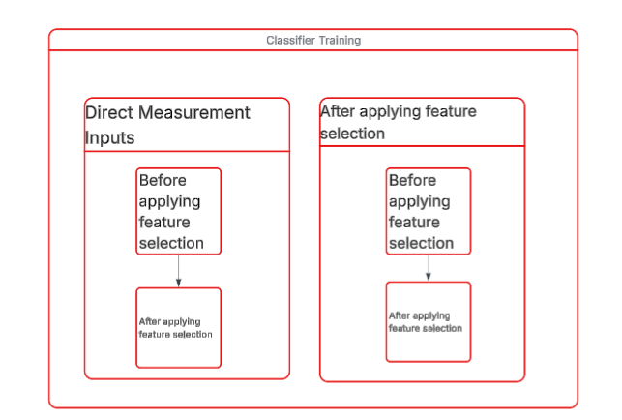
- Scenario 1: Comprehensive Direct Measurement Configuration
- Scenario 2: Parsimonious Direct Measurement Configuration
- Scenario 3: Comprehensive Domain-Informed Configuration
- Scenario 4: Parsimonious Domain-Informed Configuration

3.6.2 Standardized Training and Evaluation Pipeline
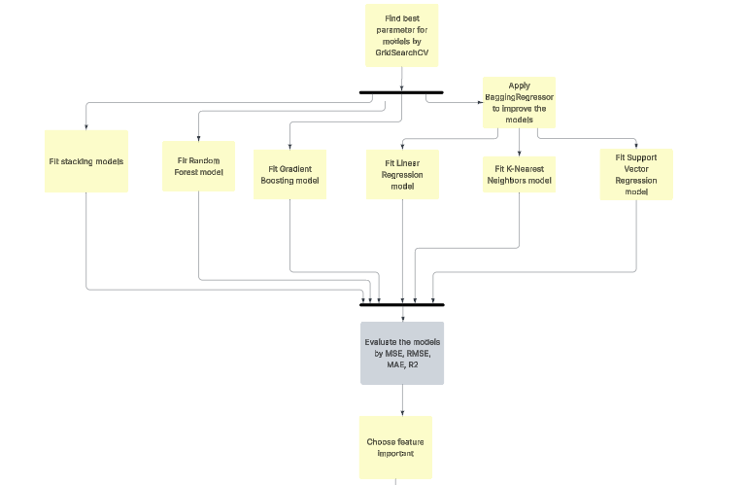

CHAPTER 4. RESULTS

4.1 Dataset Descriptive Statistics
Water quality data from Center for Natural Resources and Environment Monitoring of Quang Ninh Province, Vietnam, 1110 records were collected from 2019 to 2021 at 125 different location, including key sites near Ha Long Bay, a UNESCO World Natural Heritage site. The dataset includes monthly and bimonthly measurements of physical, chemical, microbiological, and heavy metal parameters to provide a comprehensive assessment of water quality in the province.
The monitored water quality variables comprised: Temperature (T, °C), pH, Dissolved Oxygen (DO, mg/L), Biochemical Oxygen Demand over 5 days (BOD₅, mg/L), Chemical Oxygen Demand (COD, mg/L), Nitrate (NO₃, mg/L), Nitrite (NO₂, mg/L), Ammonium (NH₄⁺, mg/L), Phosphate (PO₄³⁻, mg/L), Coliform (MPN/100 mL), E. coli, and trace heavy metals (As, Hg, Pb, Cd, CrVI, mg/L).
The descriptive statistics of the observed water quality parameters and WQI are summarized in Table 1. Parameters such as Coliform, COD, and BOD₅ exhibited considerable variability, reflecting differences in point and non-point sources of pollution, as well as seasonal hydro-climatic influences. In contrast, parameters such as pH and trace metals showed relatively stable values over the monitoring period.

Table 1 Descriptive statistics of water quality parameters and WQI in Quang Ninh Province (2019–2021)
Paramters | Unit | Minimum | Maximum | Mean | Median | Std. Deviation
Temperature | degrees Celsius | 7.400 | 39.4 | 24.222 | 23.6 | 4.843
pH |  | 4.590 | 8.64 | 6.685 | 6.64 | 0.444
DO | Mg/L | 1.080 | 9.7 | 6.703 | 6.72 | 0.997
COD | Mg/L | 1.500 | 306.4 | 15.604 | 11.3 | 23.158
BOD5 | Mg/L | 1.000 | 54.4 | 4.28 | 3.1 | 4.192
NO3 | Mg/L | 0.008 | 6.528 | 0.345 | 0.214 | 0.638
NO2 | Mg/L | 0.002 | 8.337 | 0.185 | 0.002 | 0.951
NH4 | Mg/L | 0.01 | 6.321 | 0.399 | 0.054 | 1.018
PO4 | Mg/L | 0.01 | 10.365 | 0.051 | 0.01 | 0.336
Coliform | MPN/100ml | 3 | 25000 | 766.685 | 150 | 1885.311
EColi |  | 3 | 400 | 14.118 | 3 | 35.718
As | Mg/L | 0 | 0.014 | 0.001 | 0 | 0.001
Hg | Mg/L | 0 | 0.006 | 0 | 0 | 0
Pb | Mg/L | 0 | 0.066 | 0.001 | 0.001 | 0.003
Cd | Mg/L | 0 | 0.011 | 0.001 | 0.001 | 0
CrVI | Mg/L | 0.001 | 0.03 | 0.001 | 0.001 | 0.003

4.1 Data Analysis
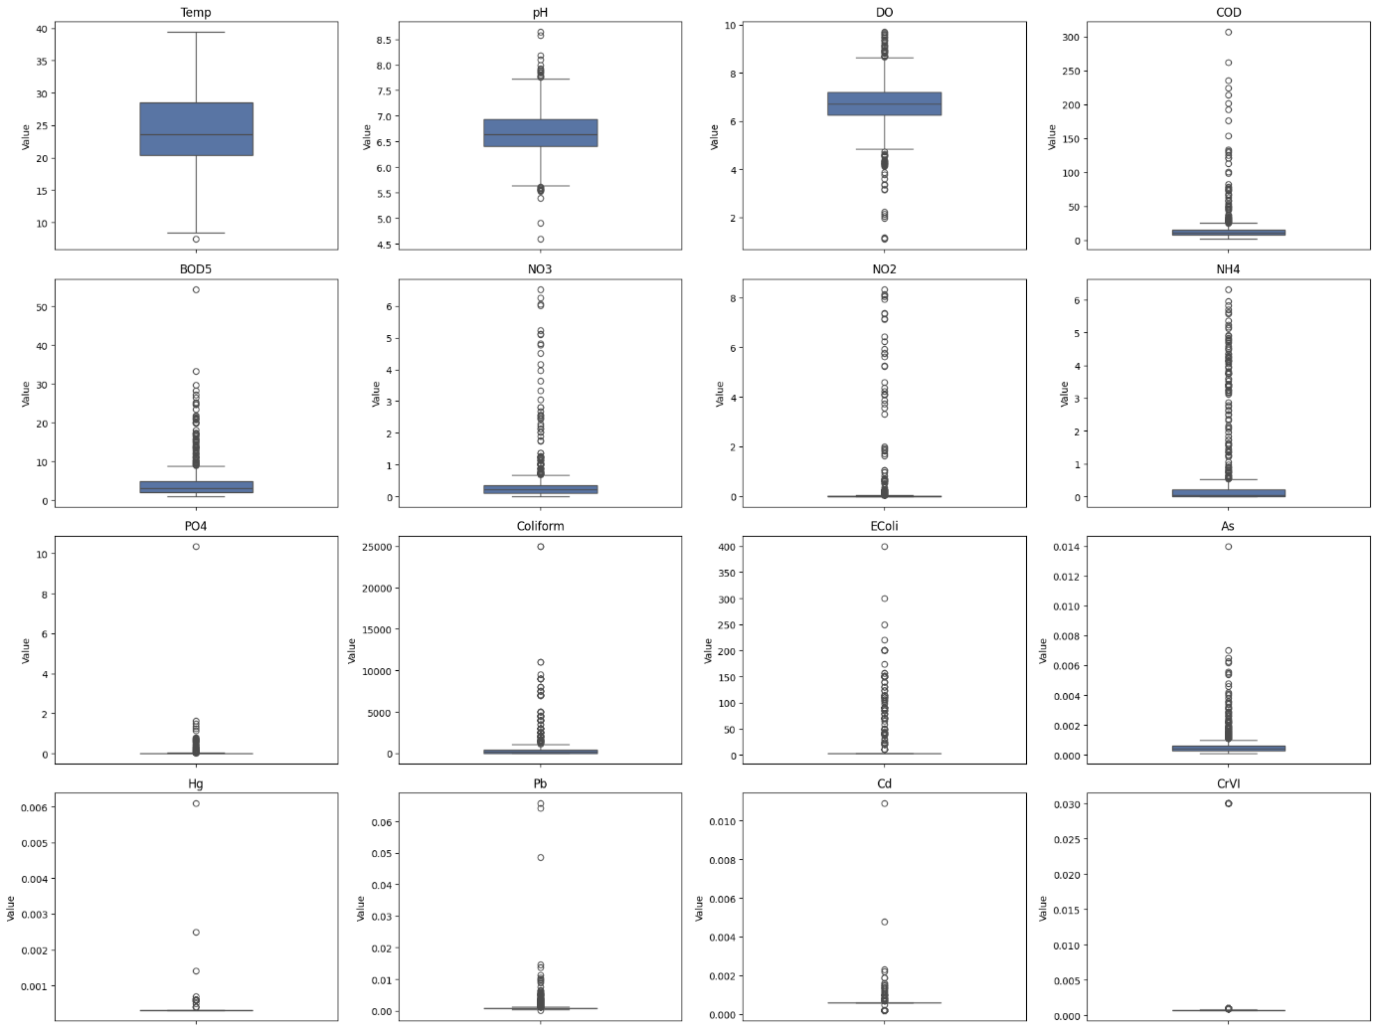

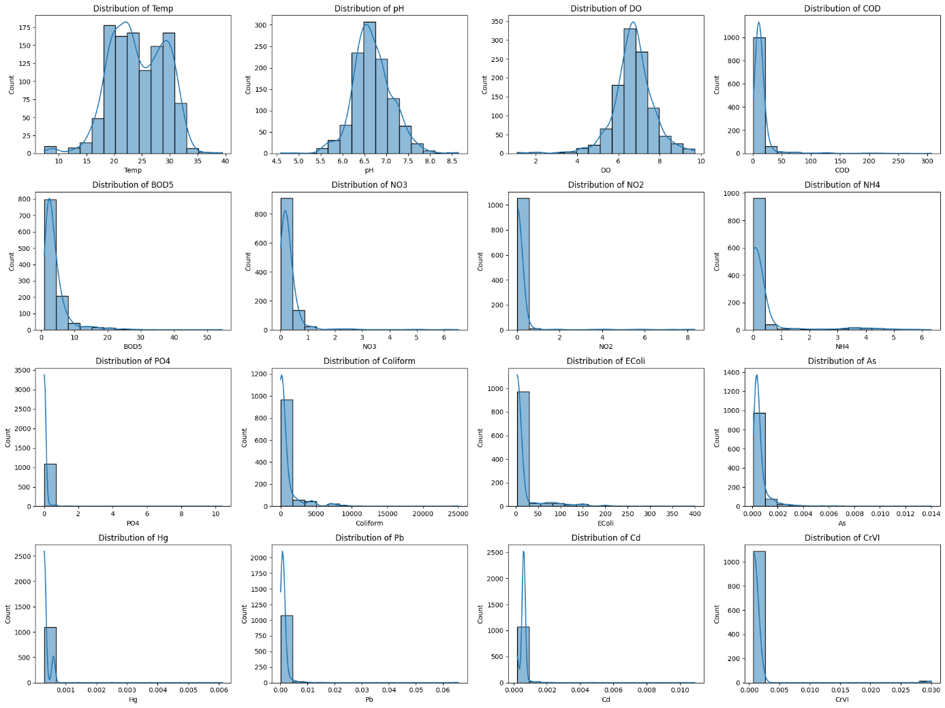


Figure 20
Observations on the Relationship between Temperature and DO:
- Overall Trend: The chart shows a wide dispersion of data points, indicating that there is no strong, simple linear correlation between the two variables. While DO levels vary significantly, there is a visible concentration of higher DO values in the moderate temperature range ($18$–$25$°C), with a slight tendency for the maximum DO values to decrease as temperature exceeds $30$°C, consistent with the physical principle that oxygen solubility typically drops as water warms.
- Distribution of Data Points: The majority of the samples are densely clustered within the temperature range of $20$°C to $30$°C, suggesting this is the most common thermal environment for the collected samples. Within this cluster, most DO values fluctuate between $6$ and $8$ mg/l.
- Variability and Anomalies: There is significant fluctuation in DO levels, with several outliers falling below $4$ mg/l across various temperatures. These low-oxygen instances—some even dropping near $1$ mg/l—indicate that in certain conditions (such as high organic loading or poor aeration), temperature is not the sole factor limiting DO, potentially creating "dead zones" harmful to aquatic life.

Figure 21
Observations on the Relationship between COD and BOD5:
- Overall Trend: The chart illustrates a positive correlation between COD and BOD5, meaning that as Chemical Oxygen Demand increases, Biochemical Oxygen Demand generally increases as well. This relationship is expected, as both parameters measure the amount of organic matter in the water, though COD represents the total chemically oxidizable matter while BOD5 focuses on the biodegradable fraction.
- Distribution of Data Points: The data points are highly concentrated in the low-range area, specifically where COD is under 50 mg/l and BOD5 is under 10 mg/l. Within this dense cluster, the relationship appears more linear, suggesting a consistent ratio between biodegradable and non-biodegradable substances in the majority of the water samples.
- Variability and Anomalies: As the values increase toward the right of the X-axis, the data points become much more scattered. There are several outliers with high COD (up to $300$ mg/l) and significantly higher BOD5 values (exceeding $50$ mg/l). The widening gap between points at higher concentrations suggests that in more polluted samples, the composition of organic waste varies significantly, which could indicate different sources of pollution or varying levels of wastewater treatment.

Figure 22
Observations on the Relationship between Coliform and E. coli:
- Overall Trend: The plot indicates a general upward trend where E. coli levels tend to increase alongside Total Coliform levels, though the relationship is less strictly linear compared to other parameters. Since E. coli is a subgroup of Total Coliforms, it is expected that E. coli counts remain lower than or equal to the total count.
- Distribution of Data Points: Most samples are clustered at the lower end of the scale, with Coliform counts below 5,000 MPN/100mL and E. coli below 150 MPN/100mL. The points are distributed in vertical "stripes" at certain intervals, which may reflect specific measurement thresholds or common levels found in the sampling environment.
- Variability and Anomalies: Significant variability is observed, with a prominent outlier reaching an E. coli level of 400 MPN/100mL at a Coliform level around 4,500 MPN/100mL. Additionally, there is an extreme outlier on the X-axis with a Coliform count of 25,000 MPN/100mL but a relatively low E. coli count (under 100 MPN/100mL), indicating a high presence of non-fecal coliform bacteria in that specific sample

Figure 23
To elucidate the underlying relationships between physicochemical parameters and the constructed Water Quality Indices (WQIs), a Pearson correlation matrix was generated (Figure 4.X). This heatmap visualizes the linear associations between raw water quality parameters, sub-indices, and the final aggregate index (VN_WQI).
A preliminary examination of the raw physicochemical data reveals significant positive correlations among indicators of organic pollution and microbial contamination, consistent with established theoretical expectations. Notably, a strong positive correlation ($r = 0.74$) was observed between Chemical Oxygen Demand (COD) and Biochemical Oxygen Demand (BOD5). This relationship is statistically significant and indicates that the oxidizable organic matter in the sampled water bodies is closely linked to the biodegradable fraction, suggesting a consistent source of organic effluent.
Similarly, the microbiological parameters demonstrated a moderate-to-strong positive association. Total Coliforms and E. coli exhibited a correlation coefficient of $r = 0.63$. Since E. coli is a taxonomical subset of the total coliform group, this covariance is expected; however, the imperfect correlation suggests the presence of other coliform bacteria (e.g., Enterobacter, Klebsiella) driven by environmental factors distinct from purely fecal contamination events.
While the organic and biological markers followed expected linear patterns, the relationships among nitrogenous compounds—Nitrate ($NO_3^-$), Nitrite ($NO_2^-$), and Ammonium ($NH_4^+$)—deviated from the theoretical equilibrium of the nitrogen cycle. In an idealized closed system, sequential nitrification and denitrification processes typically yield strong correlations between these intermediates.
However, the heatmap reveals a distinct decoupling of these variables. While $NO_2^-$ and $NH_4^+$ show a moderate positive correlation ($r \approx 0.64$), $NO_3^-$ displays negligible correlation with $NO_2^-$ ($r = 0.07$) and weak correlation with $NH_4^+$ ($r = 0.28$). This divergence suggests that the nitrogen dynamics in the study area are likely influenced by external, non-linear factors such as varying oxygenation levels, selective agricultural runoff, or distinct point-source pollution inputs that disrupt the standard nitrification kinetics.
Finally, an analysis of the derived indices confirms the structural validity of the aggregate VN_WQI. The final output variable exhibits robust positive correlations with its constituent sub-indices (e.g., WQI_Ecoli, WQI_BOD5, WQI_NH4), with coefficients generally exceeding $0.50$. This strong covariance confirms that the VN_WQI is highly sensitive to changes in its underlying components, effectively synthesizing the multi-dimensional variance of the dataset into a single, representative metric for water quality assessment.
Correlation Analysis of Water Quality Parameters
To investigate the linear relationships between physicochemical parameters and the target variable (VN_WQI), a Pearson correlation matrix was computed, as illustrated in Figure 39. The heatmap reveals distinct patterns of association that are critical for understanding the drivers of water quality in Quang Ninh province.
1. Determinants of Water Quality Index (VN_WQI) The analysis indicates that the Water Quality Index is most strongly influenced by biological and organic pollutants. Specifically, VN_WQI exhibits a significant negative correlation with Coliform (r = -0.64), E. coli (r = -0.64), and Ammonium (NH₄⁺) (r = -0.59). This strong inverse relationship confirms that fecal contamination and nutrient enrichment are the primary factors degrading water quality in the study area. Conversely, Dissolved Oxygen (DO) shows a moderate positive correlation (r = 0.43) with VN_WQI, reinforcing its role as a key indicator of ecosystem health.
2. Multicollinearity among Predictors A high degree of multicollinearity is observed between certain organic indicators, most notably between COD and BOD₅ (r = 0.74). This strong positive correlation is consistent with their chemical nature, as both measure the oxygen demand required for organic matter degradation. Similarly, Coliform and E. coli share a correlation of 0.63, reflecting their redundancy as microbiological indicators. These interdependencies suggest that while these features are individually important, their simultaneous inclusion in linear models (e.g., Linear Regression) may introduce redundancy, whereas non-linear ensemble models like Random Forest are expected to handle these interactions more effectively.
3. Heavy Metal Independence It is noteworthy that heavy metal parameters (As, Hg, Pb, Cd, CrVI) display negligible correlations with VN_WQI, with coefficients nearing zero (ranging from -0.04 to 0.04). This statistical independence aligns with the distribution analysis, which showed that heavy metal concentrations are predominantly low and stable across the monitoring network. Consequently, these parameters contribute minimally to the variance of the overall WQI compared to the fluctuations observed in organic and nutrient parameters.

4.2 WQI based on Direct Measurement Inputs

4.2.1 Before removing unimportant features
Table 2 Individual Regression Model Performance on Raw Water Quality Inputs (Pre-Feature Selection)
Model | MSE | RMSE | MAE | R²
Gradient Boosting | 4.04 | 2.01 | 0.91 | 0.97
Random Forest | 4.97 | 2.23 | 1.06 | 0.96
Support Vector Regression | 10.31 | 3.21 | 1.75 | 0.91
K-Nearest Neighbors | 14.34 | 3.79 | 2.15 | 0.88
Linear Regression | 27.06 | 5.20 | 3.51 | 0.77
The comparative analysis highlights a significant disparity in performance among the evaluated algorithms. Linear Regression exhibited the least efficacy, yielding the highest error metrics (MSE = 27.06, RMSE = 5.20) and the lowest coefficient of determination ($R^{2}$ = 0.77). Conversely, tree-based ensemble models (Gradient Boosting and Random Forest) demonstrated superior predictive capabilities compared to the geometric and distance-based approaches (SVR and KNN). Notably, Gradient Boosting emerged as the optimal model, achieving the most robust performance across all metrics ($R^{2}$ = 0.97, RMSE = 2.01).

Table 3 Performance comparison of different stacking model configurations with varying base learners.
Base Models | Num Models | MSE | RMSE | MAE | $$R^{2}$$
KNN + SVR + GB | 3 | 3.777 | 1.9434 | 0.8738 | 0.9678
SVR + GB | 2 | 3.7792 | 1.944 | 0.8746 | 0.9678
LR + SVR + GB | 3 | 3.8292 | 1.9568 | 0.869 | 0.9673
KNN + LR + SVR + GB | 4 | 3.8384 | 1.9592 | 0.8662 | 0.9673
RF + KNN + SVR + GB | 4 | 3.9324 | 1.983 | 0.8855 | 0.9665
As presented in Table 3, the ensemble combining KNN, SVR, and GB achieved the marginally best statistical performance, with the lowest MSE (3.777) and RMSE (1.9434). However, the dual-model configuration (SVR + GB) demonstrated virtually indistinguishable predictive power, yielding an MSE of 3.7792 and an identical
$R^{2}$of 0.9678. Given that the performance difference is negligible, the SVR + GB model is preferable; it offers a more efficient balance between accuracy and computational complexity by utilizing fewer base learners. Overall, the results indicate that increasing the complexity of the stacking ensemble beyond two models yields diminishing returns, with minimal performance variance observed across the tested configurations.



Figure 24 Permutation Feature Importance for WQI Prediction Using Raw Input Parameters (Pre-Feature Selection)
Guided by the permutation importance analysis, features with negligible predictive contribution—specifically ${NO}_{3}$ As, Cd, ${NH}_{4}$, and ${PO}_{4}$—were excluded from the final model to enhance parsimony. Furthermore, to mitigate multicollinearity, Coliform and COD were removed due to their strong correlations with E. coli and ${BOD}_{5}$, respectively. This selection strategy ensures that the variance associated with biological and organic load is preserved through proxy variables while reducing redundant feature space.

4.2.2 After removing unimportant features
Table 4 Model Performance Comparison (After Feature Selection)
Model | MSE | RMSE | MAE | R²
Gradient Boosting | 5.96 | 2.44 | 1.24 | 0.95
Random Forest | 6.98 | 2.64 | 1.31 | 0.94
Support Vector Regression | 11.64 | 3.41 | 1.92 | 0.9
K-Nearest Neighbors | 20.74 | 4.55 | 2.54 | 0.82
Linear Regression | 32.11 | 5.67 | 3.8 | 0.73
While the reduction of the feature space led to a universal decline in absolute performance metrics, the relative hierarchy of the models remained invariant. However, a distinct divergence in model sensitivity was observed: Gradient Boosting, Random Forest, and SVR demonstrated remarkable robustness with only marginal deviations in error rates. In contrast, K-Nearest Neighbors and Linear Regression exhibited significant performance deterioration, indicating a higher dependency on the excluded features to maintain predictive stability.
Table 5
Base Models | Num Models | MSE | RMSE | MAE | $$R^{2}$$
RF + LR + SVR + GB | 4 | 5.1082 | 2.2601 | 1.1314 | 0.9564
RF + SVR + GB | 3 | 5.1118 | 2.2609 | 1.1314 | 0.9564
LR + SVR + GB | 3 | 5.1195 | 2.2626 | 1.1383 | 0.9563
SVR + GB | 2 | 5.1225 | 2.2633 | 1.1384 | 0.9563
RF + KNN + SVR + GB | 4 | 5.1509 | 2.2696 | 1.1468 | 0.9561
A comparative analysis demonstrates that the performance disparity between the complex stacking ensembles and the standalone Gradient Boosting model is negligible. While the stacking models achieved a marginally higher coefficient of determination ($R^{2}≈$ 0.9564), the Gradient Boosting baseline demonstrated comparable predictive capability ($R^{2}$ = 0.95). Consequently, the deployment of stacking architectures introduces unwarranted redundancy; the minimal reduction in error metrics (MSE/RMSE) does not justify the substantial increase in computational overhead and training latency required by the ensemble approach.

4.3 WQI based on Feature Engineered Inputs (WQI_SI)

4.3.1 Before removing unimportant features
Table 6
Model | MSE | RMSE | MAE | R²
Gradient Boosting | 3.4292 | 1.8518 | 0.7538 | 0.9707
Random Forest | 3.5357 | 1.880 | 0.7122 | 0.9698
Support Vector Regression | 0.7263 | 0.8522 | 0.4017 | 0.9938
K-Nearest Neighbors | 2.8414 | 1.6857 | 0.7024 | 0.9758
Linear Regression | 0.75 | 0.8660 | 0.4503 | 0.9936
A comparative analysis reveals that geometric and distance-based models provide a substantial improvement in predictive accuracy over tree-based models. The transition from tree-based methods (Gradient Boosting, Random Forest) to distance-based methods (SVR, Linear Regression) results in a sharp decrease in Mean Squared Error (from ~3.5 to ~0.75). Consequently, SVR and Linear Regression emerge as the most robust models for this dataset, achieving near-perfect $R^{2}$ scores exceeding 0.99.
Table 7
Base Models | Num Models | MSE | RMSE | MAE | R2
LR + SVR | 2 | 0.3035 | 0.5509 | 0.3548 | 0.9974
KNN + LR + SVR | 3 | 0.3336 | 0.5776 | 0.3563 | 0.9972
RF + LR + SVR | 3 | 0.3437 | 0.5862 | 0.3575 | 0.9971
RF + KNN + LR + SVR | 4 | 0.3527 | 0.5939 | 0.3593 | 0.997
KNN + LR + SVR + GB | 4 | 0.4323 | 0.6575 | 0.3729 | 0.9963
The evaluation metrics indicate that the stacking ensemble models significantly outperformed the standalone Support Vector Regression (SVR) model. Specifically, the stacking configurations achieved considerably lower error rates (MSE, RMSE, MAE) and higher $R^{2}$ scores compared to the single SVR baseline. Among the best stacking models, the performance variances were negligible, suggesting a high degree of stability across the different ensemble combinations.

Figure 25
Based on the Permutation Importance analysis in Figure 41, we performed feature selection with the primary objective of minimizing the number of required water quality parameters, thereby reducing monitoring costs and operational complexity in real-world deployment.
While WQI_ph, WQI_EColi, and WQI_NO2_mg_L were identified as critical indicators, the analysis allowed us to streamline the input set by excluding variables that do not justify the cost of measurement:
Elimination of non-contributing parameters: Variables such as NO3, Cd, As, and NH4 showed negligible impact on the model's predictive accuracy (importance near 0). Consequently, these parameters can be safely omitted from the regular monitoring protocol without compromising prediction quality.
Reduction of redundant measurements: Although Coliform and BOD are relevant, their strong correlation with EColi and COD indicates that measuring the latter provides sufficient information. By relying on representative indicators, we eliminate the need for redundant laboratory tests.

4.3.2 After removing unimportant features
In this study, the performance of five distinct machine learning models—Support Vector Regression (SVR), Linear Regression, K-Nearest Neighbors (KNN), Gradient Boosting (GB), and Random Forest (RF)—was evaluated to determine the most effective approach for the predictive task. The models were assessed using four standard statistical metrics: Mean Squared Error (MSE), Root Mean Squared Error (RMSE), Mean Absolute Error (MAE), and the Coefficient of Determination (
$R^{2}$).
The comprehensive experimental results are presented in Table 8 below:
Table 8
Model | MSE | RMSE | MAE | $$R^{2}$$
Support Vector Regression | 4.6480 | 2.1559 | 0.9883 | 0.9604
Linear Regression | 4.8789 | 2.2088 | 1.0946 | 0.9584
KNN | 5.4195 | 2.3280 | 1.0145 | 0.9538
GB | 5.6622 | 2.3795 | 1.2021 | 0.9517
RF | 6.9596 | 2.6381 | 1.2312 | 0.9407
1. General Assessment
As observed from the results, all five models demonstrated strong predictive capabilities, with $R^{2}$scores consistently exceeding 0.94. This indicates that the selected features possess a strong correlation with the target variable and that the data preprocessing stage was effective.
2. Detailed Comparative Analysis
- Support Vector Regression (SVR): SVR emerged as the superior model, outperforming all other algorithms across every evaluation metric. It achieved the lowest error rates with an MSE of 4.6480, RMSE of 2.1559, and an MAE of 0.9883. Notably, an MAE value below 1.0 signifies a minimal absolute deviation between the predicted values and the actual observed data. Furthermore, SVR achieved the highest $R^{2}$ score of 0.9604, implying that the model can explain approximately 96.04% of the variance in the target variable.
- Linear Regression: The Linear Regression model demonstrated remarkable stability, ranking second in overall performance. With an RMSE of 2.2088 and an $R^{2}$ of 0.9584, it performed nearly as well as the SVR model. These results suggest that the relationship between the input variables and the output target in this dataset is predominantly linear.
- Tree-based Models and KNN:
  - KNN and Gradient Boosting (GB) yielded respectable results, with
$R^{2}$ values of 0.9538 and 0.9517, respectively.
  - Conversely, Random Forest (RF), despite typically being considered a robust ensemble method, exhibited the lowest performance in this specific experiment, recording an RMSE of 2.6381 and an $R^{2}$ of 0.9407. This suggests that the specific distribution of this dataset may not favor the bagging technique utilized by Random Forest as effectively as the vector-based or linear approaches.
Conclusion
Based on the quantitative analysis presented above, Support Vector Regression (SVR) is identified as the optimal model for this project. Due to its superior generalization capability and minimal prediction error, SVR has been selected as the primary model for the final deployment of the prediction system.

Table 9
Base Models | Num Models | MSE | RMSE | MAE | $$R^{2}$$
KNN + SVR + GB | 3 | 3.8321 | 1.9576 | 0.9826 | 0.9673
SVR + GB | 2 | 3.8588 | 1.9644 | 0.9889 | 0.9671
RF + KNN + SVR | 3 | 3.8841 | 1.9708 | 0.9791 | 0.9669
KNN + LR + SVR + GB | 4 | 3.9149 | 1.9786 | 0.9913 | 0.9666
RF + KNN + SVR + GB | 4 | 3.917 | 1.9791 | 0.993 | 0.9666


Figure 26


Figure 27 Performance comparison of Machine Learning and Traditional Calculation methods under Feature Reduction constraints.
The charts above contrast two approaches: predicting WQI via Machine Learning algorithms versus calculating the index using the traditional formula with a reduced parameter set. While the left plot demonstrates the accuracy of the ML predictions against actual values, the right plot assesses how robust the traditional formula is when input variables are removed. Specifically, the horizontal axes (X) serve as the ground truth or baseline values—actual WQI on the left and original manual calculation on the right. The vertical axes (Y) plot the experimental results: the model's predictions and the recalculated WQI with fewer parameters, respectively.
While the Machine Learning model adheres well to the ground truth, it displays noticeable variance (noise). Conversely, the traditional method using a reduced parameter set shows high consistency with minimal noise but induces a positive systematic bias, resulting in scores slightly elevated compared to the baseline calculation.

CHAPTER 5. DICUSSION

5.1 Overview of Principal Findings
5.1.1 Restatement of Research Problem
5.1.1 Key Findings
Tree-based models outperform linear models under raw inputs.
Engineered sub-index inputs dramatically improve linear/SVR performance.
Stacking provides marginal gain but limited cost-efficiency advantage.

5.2 Behavioural Analysis of Machine Learning Models

5.2.1 Nonlinear Structure of Raw Environmental Data
- Environmental data = nonlinear + interaction-heavy.
- Multicollinearity (COD–BOD5, Coliform–Ecoli) harms linear regression.
- Random Forest/GB handle:
  - nonlinearity
  - interaction
  - feature redundancy
→ Link to bias–variance tradeoff theory.

5.2.2 Sensitivity to Feature Reduction
• KNN & LR sensitive to dimensionality reduction.
• Ensemble models robust due to internal feature sampling.
• Discuss model sensitivity to variance and feature dependency.

5.2.3 Impact of Domain-Informed Feature Engineering

5.3 Comparison with Existing WQI Prediction Studies

5.4 Methodological Contributions

5.5 Practical Implications for Coastal Water Governance

5.6 Model Robustness and Generalisability

5.7 Limitations and Research Boundaries

5.8 Conceptual Synthesis of the Proposed Framework

5.1 Technical
Select feature importance by permutation importance might remove important knowledge (talk about choosing feature important tatical)
Nói lý do chọn csv
Hybird model: kết hợp giữa tính WQI_SI và stacking model
Các
About choosing machine learning instead of deep learning
About apply gridsearchCV, bagging techniques
- Compare them with other reseach (có những research cho thấy RF tốt nhưng có nghiên cứu lại chỉ ra SVR mới tốt)

5.2 Performance
Algorithms based tree performance better than others as they effectively handle noisy data
Xem xét so sánh giữa apply machine learning với k áp dụng machine learning
So sánh từng bước sau khi áp dụng các phương pháp, so sánh các thuật toán với nhau

CHAPTER 6. CONCLUSION
6.1 Summary of Research Purpose
6.2 Synthesis of Key Findings
6.3 Theoretical Contributions
6.4 Practical and Policy Implications
6.5 Study Limitations
6.6 Concluding Statement
6.7 Future Work

REFERENCE
Abbasi, T., & Abbasi, S. A. (2012). Water Quality Indices. Elsevier. http://ebookcentral.proquest.com/lib/hud/detail.action?docID=892231
Ahmad, T., Ali, L., Alshamsi, D., Aldahan, A., El-Askary, H., & Ahmed, A. (2025). AI-Powered Water Quality Index Prediction: Unveiling Machine Learning Precision in Hyper-Arid Regions. Earth Systems and Environment, 9(2), 677–694. https://doi.org/10.1007/s41748-024-00524-8
Baek, S.-S., Pyo, J., & Chun, J. A. (2020). Prediction of Water Level and Water Quality Using a CNN-LSTM Combined Deep Learning Approach. Water, 12(12). https://doi.org/10.3390/w12123399
Barathkumar, S., & Devi, A. C. (2025). Modeling and Prediction of Water Quality Using Artificial Intelligence Techniques for Enhanced Monitoring and Management. Water Environment Research, 97(7), e70143. https://doi.org/10.1002/wer.70143
Barzegar, R., Aalami, M., & Adamowski, J. (2020). Short-term water quality variable prediction using a hybrid CNN–LSTM deep learning model. Stochastic Environmental Research and Risk Assessment, 34, 1–19. https://doi.org/10.1007/s00477-020-01776-2
Breiman, L. (2001). Random Forests. Machine Learning, 45(1), 5–32. https://doi.org/10.1023/A:1010933404324
Brown, R. M., McClelland, N. I., Deininger, R. A., & Tozer, R. G. (1970). A water quality index—Do we dare? [Journal Article]. Water & Sewage Works. https://www.researchgate.net/profile/Paul-Hernandez-Romero/post/Brown_et_al_1970A_Water_Quality_Index_Do_We_Dare/attachment/5c74aa66cfe4a781a5834c0c/AS%3A730388808880129%401551149670060/download/A-Water-Quality-Index-Do-we-dare-BROWN-R-M-1970.pdf
CCME. (2017). Canadian Water Quality Guidelines for the Protection of Aquatic Life. User’s Manual. Canadian Council of Ministers of the Environment. USA.
Chidiac, S., El Najjar, P., Ouaini, N., El Rayess, Y., & El Azzi, D. (2023). A comprehensive review of water quality indices (WQIs): History, models, attempts and perspectives. Reviews in Environmental Science and Bio/Technology, 22(2), 349–395. https://doi.org/10.1007/s11157-023-09650-7
Chou, J.-S., Ho, C.-C., & Hoang, H.-S. (2018). Determining quality of water in reservoir using machine learning. Ecological Informatics, 44, 57–75. https://doi.org/10.1016/j.ecoinf.2018.01.005
Choudhary, R., Kumar, A., C., P., Naik, M. M., Choudhury, M., & Khan, N. A. (2025). Predicting water quality index using stacked ensemble regression and SHAP based explainable artificial intelligence. Scientific Reports, 15(1), 31139. https://doi.org/10.1038/s41598-025-09463-4
Dasu, D. (2025). Comparative Analysis of Machine Learning Algorithms for Water Quality Index Prediction. Communications on Applied Nonlinear Analysis, 32(9s), 692–701. https://doi.org/10.52783/cana.v32.3975
Dinh Duong, N. (n.d.). Land Use Changes and GIS-database Development for Strategic Environmental Assessment in Ha Long Bay, Quang Ninh Province, Vietnam.
Elgeldawi, E., Sayed, A., Galal, A. R., & Zaki, A. M. (2021). Hyperparameter Tuning for Machine Learning Algorithms Used for Arabic Sentiment Analysis. Informatics, 8(4). https://doi.org/10.3390/informatics8040079
Ho, T. K. (1995). Random decision forests. Proceedings of 3rd International Conference on Document Analysis and Recognition, 1, 278–282 vol.1. https://doi.org/10.1109/ICDAR.1995.598994
Jayaraman, P., Nagarajan, K. K., Partheeban, P., & Krishnamurthy, V. (2024). Critical review on water quality analysis using IoT and machine learning models. International Journal of Information Management Data Insights, 4(1), 100210. https://doi.org/10.1016/j.jjimei.2023.100210
Khoi, D. N., Quan, N. T., Linh, D. Q., Nhi, P. T. T., & Thuy, N. T. D. (2022). Using Machine Learning Models for Predicting the Water Quality Index in the La Buong River, Vietnam. Water, 14(10). https://doi.org/10.3390/w14101552
Kouadri, S., Elbeltagi, A., Islam, A. R. Md. T., & Kateb, S. (2021). Performance of machine learning methods in predicting water quality index based on irregular data set: Application on Illizi region (Algerian southeast). Applied Water Science, 11(12), 190. https://doi.org/10.1007/s13201-021-01528-9
Lap, B. Q., Phan, T.-T.-H., Nguyen, H. D., Quang, L. X., Hang, P. T., Phi, N. Q., Hoang, V. T., Linh, P. G., & Hang, B. T. T. (2023). Predicting Water Quality Index (WQI) by feature selection and machine learning: A case study of An Kim Hai irrigation system. Ecological Informatics, 74, 101991. https://doi.org/10.1016/j.ecoinf.2023.101991
Liu, P., Wang, J., Sangaiah, A. K., Xie, Y., & Yin, X. (2019). Analysis and Prediction of Water Quality Using LSTM Deep Neural Networks in IoT Environment. Sustainability, 11(7). https://doi.org/10.3390/su11072058
Lumb, A., Halliwell, D., & Sharma, T. (2006). Application of CCME Water Quality Index to Monitor Water Quality: A Case Study of the Mackenzie River Basin, Canada. Environmental Monitoring and Assessment, 113(1), 411–429. https://doi.org/10.1007/s10661-005-9092-6
Maier, H. R., & Dandy, G. C. (2000). Neural networks for the prediction and forecasting of water resources variables: A review of modelling issues and applications. Environmental Modelling & Software, 15(1), 101–124. https://doi.org/10.1016/S1364-8152(99)00007-9
Makumbura, R. K., Mampitiya, L., Rathnayake, N., Meddage, D. P. P., Henna, S., Dang, T. L., Hoshino, Y., & Rathnayake, U. (2024a). Advancing water quality assessment and prediction using machine learning models, coupled with explainable artificial intelligence (XAI) techniques like shapley additive explanations (SHAP) for interpreting the black-box nature. Results in Engineering, 23, 102831. https://doi.org/10.1016/j.rineng.2024.102831
Makumbura, R. K., Mampitiya, L., Rathnayake, N., Meddage, D. P. P., Henna, S., Dang, T. L., Hoshino, Y., & Rathnayake, U. (2024b). Advancing water quality assessment and prediction using machine learning models, coupled with explainable artificial intelligence (XAI) techniques like shapley additive explanations (SHAP) for interpreting the black-box nature. Results in Engineering, 23, 102831. https://doi.org/10.1016/j.rineng.2024.102831
Moeinzadeh, H., Yong, K.-T., & Withana, A. (2024). A critical analysis of parameter choices in water quality assessment. Water Research, 258, 121777. https://doi.org/10.1016/j.watres.2024.121777
Mogane, L. K., Masebe, T., Msagati, T. A. M., & Ncube, E. (2023). A comprehensive review of water quality indices for lotic and lentic ecosystems. Environmental Monitoring and Assessment, 195(8), 926. https://doi.org/10.1007/s10661-023-11512-2
MONRE. (2019). The Decision on the promulgation of technical guidelines for calculation and publication of the Vietnam water quality index (VN_WQI).
Muñoz-Alegría, J. A., Núñez, J., Oyarzún, R., Chávez, C. A., Arumí, J. L., & Rodríguez-López, L. (2025). A Bibliometric-Systematic Literature Review (B-SLR) of Machine Learning-Based Water Quality Prediction: Trends, Gaps, and Future Directions. Water, 17(20). https://doi.org/10.3390/w17202994
Nguyen, N., & Sevando, M. (2019). Assessing Coastal Water Quality throughan Overall Index. Polish Journal of Environmental Studies, 28(4), 2321–2330. https://doi.org/10.15244/pjoes/90836
Noori, R., Berndtsson, R., Hosseinzadeh, M., Adamowski, J. F., & Abyaneh, M. R. (2019). A critical review on the application of the National Sanitation Foundation Water Quality Index. Environmental Pollution, 244, 575–587. https://doi.org/10.1016/j.envpol.2018.10.076
Ott, W. R. (1978). Environmental indices: Theory and practice. https://www.osti.gov/biblio/6681348
Rangeti, I., Dzwairo, B., Barratt, G., & Otieno, F. (2015). Ecosystem-specific water quality indices. African Journal of Aquatic Science, 40(3), 227–234. https://doi.org/10.2989/16085914.2015.1054341
Shekar, B. H., & Dagnew, G. (2019). Grid Search-Based Hyperparameter Tuning and Classification of Microarray Cancer Data. 2019 Second International Conference on Advanced Computational and Communication Paradigms (ICACCP), 1–8. https://doi.org/10.1109/ICACCP.2019.8882943
Shen, C. (2018). A Transdisciplinary Review of Deep Learning Research and Its Relevance for Water Resources Scientists. Water Resources Research, 54(11), 8558–8593. https://doi.org/10.1029/2018WR022643
Sidek, L. M., Mohiyaden, H. A., Marufuzzaman, M., Noh, N. S. M., Heddam, S., Ehteram, M., Kisi, O., & Sammen, S. Sh. (2024). Developing an ensembled machine learning model for predicting water quality index in Johor River Basin. Environmental Sciences Europe, 36(1), 67. https://doi.org/10.1186/s12302-024-00897-7
Štambuk-Giljanović, N. (1999). Water quality evaluation by index in Dalmatia. Water Research, 33(16), 3423–3440. https://doi.org/10.1016/S0043-1354(99)00063-9
Štambuk-Giljanović, N. (2003). Comparison of Dalmatian Water Evaluation Indices. Water Environment Research, 75(5), 388–405. https://doi.org/10.2175/106143003X141196
Sutadian, A. D., Muttil, N., Yilmaz, A. G., & Perera, B. J. C. (2016). Development of river water quality indices—A review. Environmental Monitoring and Assessment, 188(1), 58. https://doi.org/10.1007/s10661-015-5050-0
Talukdar, S., Shahfahad, Ahmed, S., Naikoo, M. W., Rahman, A., Mallik, S., Ningthoujam, S., Bera, S., & Ramana, G. V. (2023). Predicting lake water quality index with sensitivity-uncertainty analysis using deep learning algorithms. Journal of Cleaner Production, 406, 136885. https://doi.org/10.1016/j.jclepro.2023.136885
Uddin, M. G., Nash, S., Mahammad Diganta, M. T., Rahman, A., & Olbert, A. I. (2022). Robust machine learning algorithms for predicting coastal water quality index. Journal of Environmental Management, 321, 115923. https://doi.org/10.1016/j.jenvman.2022.115923
Uddin, Md. G., Nash, S., & Olbert, A. I. (2021). A review of water quality index models and their use for assessing surface water quality. Ecological Indicators, 122, 107218. https://doi.org/10.1016/j.ecolind.2020.107218
UNESCO World Heritage Centre., U. W. H. (n.d.). Ha Long Bay—Cat Ba Archipelago. UNESCO World Heritage Centre. Retrieved 10 February 2026, from https://whc.unesco.org/en/list/672/
Van Hien, D., My, D. H., & Orbell, J. D. (2024). The impact of the COVID-19 pandemic on the seawater quality of Ha Long Bay, Vietnam. Marine Pollution Bulletin, 201, 116242. https://doi.org/10.1016/j.marpolbul.2024.116242
Vapnik, V. (2013). The Nature of Statistical Learning Theory. Springer Science & Business Media.
Villalobos-Arias, L., Quesada-López, C., Guevara-Coto, J., Martínez, A., & Jenkins, M. (2020). Evaluating hyper-parameter tuning using random search in support vector machines for software effort estimation. Proceedings of the 16th ACM International Conference on Predictive Models and Data Analytics in Software Engineering, PROMISE 2020, 31–40. https://doi.org/10.1145/3416508.3417121
Xu, J., Mo, Y., Zhu, S., Wu, J., Jin, G., Wang, Y.-G., Ji, Q., & Li, L. (2024). Assessing and predicting water quality index with key water parameters by machine learning models in coastal cities, China. Heliyon, 10(13). https://doi.org/10.1016/j.heliyon.2024.e33695
Yaseen, Z. M., Ramal, M. M., Diop, L., Jaafar, O., Demir, V., & Kisi, O. (2018). Hybrid Adaptive Neuro-Fuzzy Models for Water Quality Index Estimation. Water Resources Management, 32(7), 2227–2245. https://doi.org/10.1007/s11269-018-1915-7
Yuan, P., Li, H., Yi, X., Wang, J., Ning, C., Xu, X., & Nong, X. (2025). Optimizing water quality index using machine learning: A six-year comparative study in riverine and reservoir systems. Scientific Reports, 15(1), 33919. https://doi.org/10.1038/s41598-025-10187-8

