MACHINE LEARNING-BASED WQI PREDICTION INCORPORATING FEATURE SELECTION TECHNIQUES: A CASE STUDY OF QUANG NINH PROVINCE, VIETNAM
A seminar report submitted to University of Huddersfield in partial fulfilment of degree of
BSc. Applied Computing
Toan Nguyen The
Student ID: U2560895

DEPARTMENT OF COMPUTER SCIENCE
SCHOOL OF COMPUTING AND ENGINEERING
April 2026

Acknowledgement
I would like to express my sincere gratitude to my supervisor, Dr. Muhammad Zahid Hussain, and my aunt and teacher, Associate Professor Nguyen Thi The Nguyen. Their invaluable guidance, expertise, and encouragement were instrumental throughout this project, and their insights substantially shaped the direction and quality of this work.
I extend my appreciation to the School of Computing and Engineering at the University of Huddersfield for providing the resources and academic environment that supported this research.
Finally, I must thank my family and friends for their unwavering support. I am profoundly grateful for their financial assistance and constant motivation, which gave me the strength to complete this journey.

Abstract

Table of Contents
Abstract 2
Chapter 1. Introduction 9
1.1. Background of The Study 9
1.2. Research Significance and Motivation 9
1.2.1. Research Gap 9
1.2.2. Motivation 10
1.2.3. Research Significance 10
1.3. Research Scope 10
1.4. Aim and Objectives 11
1.4.1. Aim 11
1.4.2. Objectives 11
1.5. Outline of The Thesis 11
Chapter 2. Literature Review 12
2.1. Introduction to WQI 12
2.1.1. Evolution and Conceptual Foundation of the WQI 12
2.1.2. Two Conventional Schools of Thought 12
2.1.3. Parameter Selection and Sensitivity Issues 13
2.1.4. Water Quality Classification Systems Across Countries 13
2.1.5. Limitations of Conventional WQI 14
2.2. Overview of Machine Learning Techniques for WQI 14
2.2.1. Traditional algorithms 15
2.2.2. Ensemble Models 15
2.2.3. Deep Learning Techniques 15
2.2.4. Emerging Trends: Hybridization Optimization 15
2.3. Conclusion 16
Chapter 3. Methodology 17
3.1. Research Approach 17
3.1.1. Justification of Selected Development Approach 17
3.1.2. Experimental Desgin Logic 19
3.1.3. Evaluation Framework Selection 20
3.2. Study Area and Data Acquisition Strategy 21
3.2.1. Study Area Description 21
3.2.2. Data Quality Considerations 23
3.3. Data Preparation Strategy 25
3.3.1. Data Formatting and Type Standardization 25
3.3.2. Data Reduction and Filtering 27
3.3.3. Dataset Partitioning and Imputation 28
3.4. Feature Engineering Framework 28
3.4.1. Derivation of WQI-based Features 29
3.4.2. Data Standardization 29
3.5. Controlled Experimental Design and Modelling Framework 30
3.5.1. Experimental Design Scenarios 30
3.5.2. Standardized Training and Evaluation Pipeline 32
Chapter 4. Results 33
4.1. Dataset Characteristics and Exploratory Analysis 33
4.2. Baseline WQI Prediction Using Raw Inputs 37
4.2.1. Performance with Complete Raw Features 37
4.2.2. Performance with Selected Raw Features 40
4.3. WQI Prediction Using Engineered Features 42
4.3.1. Performance with Complete Engineered Features 43
4.3.2. Performance with Selected Engineered Features 45
4.4. Comparative Performance Analysis 48
Chapter 5. Discussion 49
5.1. Overview of Principal Findings 49
5.1.1. Key Findings 49
5.2. Technical Discussion 49
5.2.1. Behavioural Analysis of Machine Learning Models 50
5.2.2. Methodological Contributions 51
5.2.3. Practical Implications for Coastal Water Governance 51
5.2.4. Conceptual Synthesis of the Proposed Framework 51
5.3. Performance Discussion 51
5.3.1. Predictive Accuracy Across Algorithms 52
5.3.2. Influence of Feature Representation on Model Performance 52
5.3.3. Model Stability and Generalization 53
5.3.4. Sensitivity to Dataset Characteristics 53
5.3.5. Implications for Algorithm Selection in Environmental Modelling 54
5.3.6. Broader Implications for AI-based Environmental Monitoring 54
5.4. Comparison with Existing WQI Prediction Studies 55
5.4.1. Performance of Algorithms in Previous Studies 55
5.4.2. Methodological Approaches in the Literature 55
5.5. Limitations 55
5.5.1. Limitations of the Topic 55
5.5.2. Limitations of the Study 55
Chapter 6. Conclusion 56
6.1. Summary of Achievements 56
6.2. Key Findings and Contributions 56
6.3. Future Work and Recommendations 56
Chapter 7. Reference 58

Figure 2.1: Evolutionary trends in the deployment of AI, Machine Learning, and Deep Learning for water quality forecasting (Muñoz-Alegría et al., 2025) 15
Figure 3.1: High-Level Overview of the Workflow 20
Figure 3.2: Spatial distribution of the study area and water quality sampling stations in Quang Ninh Province, Vietnam. 23
Figure 3.3: Sequential Workflow for Data Formatting and Type Standardization 25
Figure 3.4: Sequential Workflow for Data Reduction and Filtering 26
Figure 3.5: Sequential Workflow for Dataset Partitioning and Imputation 27
Figure 3.6: Sequential Workflow for Data Exploration and Engineering 27
Figure 3.7: Standardized Machine Learning Training and Evaluation Pipeline. 31
Figure 4.1: Box Plots of the Attributes in the Dataset 33
Figure 4.2: Heatmap of Relationships Between Numeric Variables in the Dataset 34
Figure 4.3: Comparison of COD and BO$D5$ concentrations 35
Figure 4.4: Comparison of NH₄ and BO$D5$concentrations 35
Figure 4.5: Comparison of NH₄ and N$O2$ concentrations 36
Figure 4.6: Comparison of Coliform and E.Coli concentrations 37
Figure 4.7: Top 15 Models Performance Metrics for Individual and Stacking Ensembles Before Feature Selection with Raw Inputs 39
Figure 4.8: Permutation Feature Importance with 5-Fold CV for WQI Prediction Using Raw Input Parameters (Pre Feature Selection) 40
Figure 4.9: Top 15 Models Performance Metrics for Individual and Stacking Ensembles After Feature Selection with Raw Inputs 42
Figure 4.10: Top 15 Models Performance Metrics for Individual and Stacking Ensembles Before Feature Selection with WQI sub-indices Inputs 44
Figure 4.11: Permutation Feature Importance with 5-Fold CV for WQI Prediction Using Raw Input Parameters (Pre-Feature Selection) 45
Figure 4.12: Top 15 Models Performance Metrics for Individual and Stacking Ensembles After Feature Selection with WQI sub-indices Inputs 47
Figure 4.13: Performance comparison of Best-Perform Machine Learning Model and Traditional Calculation methods under Feature Reduction constraints. 48

Table 3.1: Description of the initial environmental variables prior to data preprocessing. 22
Table 4.1: Individual Regression Models Performance on Raw Water Quality Inputs (Pre Feature Selection) 37
Table 4.2: Performance Comparison of 5 Best-Perform Stacking Models Configurations Using Raw Input Features Before Feature Selection 38
Table 4.3: Individual Models Performance Comparison After Feature Selection with Raw Inputs 40
Table 4.4: Top 5 Stacking Models Performance Comparison After Feature Selection with Raw Inputs 41
Table 4.5: Individual Regression Models Performance on WQI sub-indices Inputs Before Feature Selection 43
Table 4.6: Top 5 Stacking Models Performance Comparison on WQI sub-indices Inputs Before Feature Selection 43
Table 4.7: Individual Regression Models Performance on WQI sub-indices Inputs After Feature Selection 45
Table 4.8: Top 5 Stacking Models Performance Comparison on WQI sub-indices Inputs After Feature Selection 46

List of Abbreviations
AI | Artificial Intelligence
WQI | Water Quality Index
RF | Random Forest
GB | Gradient Boosting
LR | Linear Regression
KNN | K-Nearest Neighbors
SVR | Support Vector Regression
XGBoost | Extreme Gradient Boosting
NSFWQI | National Sanitation Foundation WQI
CCME | Canadian Council of Ministers of the Environment
MONRE | Ministry of Natural Resources and Environment
pH | Potential of Hydrogen
DO | Dissolved Oxygen
Sal | Salinity
Turb | Turbidity
COD | Chemical Oxygen Demand
BOD5 | Biochemical Oxygen Demand
SO4 | Sulfate concentration
NO3 | Nitrate concentration
NO2 | Nitrite concentration
NH4 | Ammonium concentration
PO4 | Phosphate concentration
Cl | Chloride concentration in mg/L
OilFat | Total oil and fat content in mg/L
Coliform | Coliform bacteria count (MPN/100ml)
EColi | E. Coli bacteria count
As | Arsenic concentration in mg/L
Hg | Mercury concentration in mg/L
Pb | Lead concentration in mg/L
Cd | Cadmium concentration in mg/L
Cr | Chromium concentration
CrVI | Hexavalent Chromium concentration

Introduction

Background of The Study
Water quality management is essential for environmental protection and sustainable development, particularly in ecologically sensitive areas such as Quang Ninh Province and Ha Long Bay, a UNESCO World Heritage Site (UNESCO World Heritage Centre., n.d.). The region supports tourism, aquaculture and coastal ecosystems, but is increasingly affected by socioeconomic development and associated pollution pressures, leading to growing concerns over seawater quality (Dinh Duong, n.d.; Nguyen & Sevando, 2019; Van Hien et al., 2024).
The WQI is widely used to evaluate water quality by integrating multiple parameters into a single, interpretable value, especially for assessing temporal water quality trends (Chidiac et al., 2023; Dasu, 2025; Noori et al., 2019; Ott, 1978; Van Hien et al., 2024). However, traditional WQI calculation requires extensive field sampling and laboratory analysis, making it costly and time‑consuming (Barathkumar & Devi, 2025; Jayaraman et al., 2024; Moeinzadeh et al., 2024a; Uddin et al., 2021; Xu et al., 2024a). Attempts to reduce monitoring costs by calculating WQI using fewer parameters have often resulted in reduced accuracy and reliability (Mogane et al., 2023; Rangeti et al., 2015; Uddin et al., 2021).
Recent advances in AI and machine learning offer an alternative approach for water quality assessment (Dasu, 2025). AI‑based WQI prediction models can effectively capture complex relationships among water quality variables while using reduced sets of input parameters, improving prediction efficiency and reducing dependence on extensive sampling without significantly compromising accuracy (Lap et al., 2023). As a result, machine learning‑driven WQI prediction has emerged as a promising trend for improving water quality management in contexts where conventional monitoring is constrained by cost and logistics.

Research Significance and Motivation

Research Gap
Despite the growing interest in AI-based WQI prediction, several research gaps remain. Most studies have focused on comparing individual machine learning algorithms, with limited exploration of advanced optimization techniques such as GridSearchCV and ensemble methods. Hybrid approaches, including stacking models, have rarely been implemented, which restricts potential improvements in predictive performance. Moreover, conventional feature selection methods, often based on permutation importance, may underestimate the contribution of low-importance features in certain contexts, potentially reducing model accuracy. Finally, engineered features derived from WQI sub-indices have not been widely incorporated as model inputs, indicating untapped opportunities to enhance prediction quality.

Motivation
The motivation for this research stems from the growing environmental pressures on coastal water resources and the limitations of conventional monitoring approaches. Developing intelligent models capable of accurate and less time and costly WQI prediction can support sustainable water management, inform policy-making, and serve as a reference framework for similar ecologically sensitive regions.

Research Significance
Addressing these research gaps is of significant importance both academically and practically. By integrating advanced optimization techniques, ensemble learning, and carefully constructing WQI sub-indices as features, while performing feature selection using multiple approaches beyond simple feature importance plots, the proposed research aims to develop AI-based models with improved prediction accuracy and robustness. Such models can reduce the number of water quality parameters that need to be measured during field sampling, thereby saving time and resources, while providing reliable tools for effective water quality management in coastal regions such as Ha Long Bay.

Research Scope
The scope of this research is defined according to four primary dimensions: research focus, geographical coverage, time frame, WQI formulation.
• Research focus: The study focuses on the development of methodology.
• Geographical coverage: The geographical scope of the research is restricted to Quang Ninh Province, Vietnam with particular reference to Ha Long Bay.
• Time frame: The analysis is conducted using water quality monitoring data collected between 2021 and 2024.
• WQI formulation: The study adopts the Vietnamese Water Quality Index (VN-WQI), which published by Ministry of Natural Resources and Environment (MONRE).

Aim and Objectives

Aim
To design a new methodology for WQI prediction in the context of Quang Ninh province that less input requirements.

Objectives
• To synthesize a dataset from monitoring records across different locations in Quang Ninh
• To identify the optimal machine learning model for each scenario and the most effective scenario overall.
• To evaluate whether the final results are suitable for real-world application

Outline of The Thesis

Literature Review

Introduction to WQI

Evolution and Conceptual Foundation of the WQI
The WQI has evolved over time, with different regions developing distinct formulations. The WQI synthesizes physical, chemical, and biological water quality data into a single score, facilitating environmental communication and management (Štambuk-Giljanović, 1999, 2003; Sutadian et al., 2016). Horton (1965, as cite in Dasu, 2025; Talukdar et al., 2023) first proposed arithmetic aggregation of normalized parameters. Brown et al. (1970) refined this approach via the NSFWQI, incorporating expert-based weighting (Abbasi & Abbasi, 2012). The CCME model later emphasized regulatory compliance using scope, frequency, and amplitude of exceedances (CCME, 2017). Overall, WQI evolution reflects a shift from arithmetic reduction to governance-oriented assessment.
Conventional WQI models follow a systematic four-stage workflow: parameter selection, sub-index transformation, weighting, and aggregation (Abbasi & Abbasi, 2012). This framework allows heterogeneous water quality indicators to be converted into a single dimensionless score, supporting integrated assessment while maintaining comparability across studies.

Two Conventional Schools of Thought
Currently, two main approachs to WQI development are widely adopted worldwide. The NSFWQI exemplifies the weighted arithmetic expert-based approach, where weights are assigned based on expert judgment (Abbasi & Abbasi, 2012; Brown et al., 1970). Advantages of this method include simplicity and ease of interpretation for policymakers and the public. However, reliance on subjective weighting can introduce bias and limit reproducibility across regions or studies (Sutadian et al., 2016).
In contrast, the CCME WQI represents a regulatory-focused approach, calculating water quality based on scope, frequency, and amplitude of standard exceedances (CCME, 2017). This approach reduces subjectivity and aligns evaluation with legal standards, but it may be less intuitive and require more complex computations.
Both approaches implement the general four-stage workflow but differ in weighting strategy and evaluation focus. Expert-based indices prioritize interpretability, whereas compliance-based indices prioritize objectivity and adherence to standards. The choice of approach depends on the intended application, whether for rapid public reporting or enforcement of environmental regulations (Uddin et al., 2021).

Parameter Selection and Sensitivity Issues
Parameter selection fundamentally constrains WQI validity, as index scores reflect only the included variables. Conventional models typically incorporate dissolved oxygen, biochemical oxygen demand, pH, turbidity, suspended solids, and nutrients (Sutadian et al., 2016). However, parameter relevance varies by water-use objective: drinking water emphasizes microbial and toxic contaminants, irrigation prioritizes salinity indicators, and ecosystem assessments focus on oxygen balance and nutrient enrichment (Štambuk-Giljanović, 2003; Uddin et al., 2021).
WQI outcomes are sensitive to parameter inclusion and weighting, as aggregation amplifies the influence of dominant variables (Lumb et al., 2006; Sutadian et al., 2016). Moreover, omission of emerging pollutants such as trace metals or pharmaceuticals may produce overly optimistic classifications. Thus, parameter selection is not purely technical but a normative decision shaping environmental interpretation and policy relevance.

Limitations of Conventional WQI
Conventional WQI models face several structural limitations. Firstly, calculating WQI requires a large number of parameters, making data collection costly, time-consuming, and potentially hazardous. For example, a study by Moeinzadeh et al., (2024b) used 47 water parameters to computer the WQI index. This highlights the need to reduce the number of parameters while maintaining acceptable accuracy.
Secondly, aggregation of multidimensional data into a single score leads to information loss, potentially generating a masking effect in which critical parameter exceedances are diluted (Chidiac et al., 2023). This limitation may also apply to machine learning models, as they use water quality parameters as inputs, the WQI index as the output, and learn from WQI-based formulations.
Thirdly, differences in parameter selection, weighting schemes, and classification thresholds create regional inconsistency, limiting cross-study and cross-country comparability (Uddin et al., 2021). This arguments suggests the difficulty of using a reference study between countries due to differences in in formulas and environmental conditions.

Introduction of Machine Learning Techniques for WQI

Overview of Machine Learning Techniques in WQI Modeling
Overall, machine learning models have been studied for WQI prediction for a long time. As shown in Figure 2.1, this research area has grown significantly from 2005 to 2025. According to (Muñoz-Alegría et al., 2025), the main approach used to predict WQI can be grouped into three categories: traditional algorithms, ensemble models, deep learning techniques.

Figure 2.1: Evolutionary trends in the deployment of AI, Machine Learning, and Deep Learning for water quality forecasting (Muñoz-Alegría et al., 2025)

Traditional algorithms
Classical machine learning models, such as Decision Tree (Khoi et al., 2022; Lap et al., 2023), Support Vector Machines (SVR) (Lap et al., 2023) and K-Nearest Neighbors (KNN) (Krishnamoorthy & Lakshmanan, 2025) have been widely applied in the prediction of WQI across various environmental contexts. While ML techniques successfully addressed non-linear environmental data (Talukdar et al., 2023; Yaseen et al., 2018), they encountered limitations in capturing the high-frequency temporal fluctuations (Talukdar et al., 2023).

Ensemble Models
Ensemble learning techniques, such as Random Forest (RF) (Lap et al., 2023), Gradient Boosting (GB) (Sidek et al., 2024), and Extreme Gradient Boosting (XGBoost) (Yuan et al., 2025), have been widely adopted in WQI prediction due to their ability to capture complex non-linear relationships (Ahmad et al., 2025) and reduce overfitting in noisy environmental datasets (Dasu, 2025; Makumbura et al., 2024). These methods aggregate multiple base learners to improve overall predictive accuracy and robustness compared to individual models (Ahmad et al., 2025).

Deep Learning Techniques
Deep learning models like Long Short-Term Memory (LSTM) (Baek et al., 2020; Barzegar et al., 2020) were introduced to problem-relevant parameters and represent highly intricate record distributions (Shen, 2018) and automated feature extraction (Liu et al., 2019). This paradigm shift reflects a movement toward hierarchical learning systems (Barzegar et al., 2020) that provide superior accuracy and robustness in predicting complex hydrological variables.

Emerging Trends: Hybridization Optimization
Current research in the field has transitioned toward more integrated and transparent frameworks:
- Hybridization: There is a significant trend toward hybrid architectures, such as the CNN-LSTM model (Barzegar et al., 2020) and stacking model (Niazkar & Piraei, 2025). Hybird models can bring more accurate than single models (Chou et al., 2018) and exhibit greater flexibility and resilience when handling noisy datasets (Talukdar et al., 2023). However, they are inherently complex, computationally time-consuming (Talukdar et al., 2023).
- Optimization: Systematic hyperparameter optimization, particularly through techniques like GridSearchCV, is widely employed (Shekar & Dagnew, 2019) and achieve a higher level of predictive accuracy (Elgeldawi et al., 2021; Uddin et al., 2022a; Villalobos-Arias et al., 2020).

Conclusion
The WQI offers a simplified and intuitive perspective, enabling more effective assessment and management of water resources. Over the years, numerous studies have applied a variety of technologies to predict and analyze WQI.
However, numerous studies make limited use of standardized techniques such as GridSearchCV, and feature selection, often relying primarily on feature importance analysis.
Furthermore, variations in WQI formulations and regional characteristics limit the transferability of models and datasets across different contexts, highlighting the importance of reproducing models that have been successfully applied to new datasets. Nevertheless, their methodologies and logical frameworks can still serve as valuable references. This idea support the importance of creating an standard framework
This study focuses on proposing a new methodology, beginning with core machine learning algorithms and stacking models, which are a type of hybrid model, to identify which models should be further explored in future research. Although deep learning is also a promising field, the available data are insufficient to effectively train deep learning models.

Methodology

Research Approach

Method of Selected Development Approach
The foundational methodology of this research is built upon core machine learning algorithms and ensemble models, integrated with Feature Selection to reduce computational cost and minimize time-consuming model development. The use of feature selection is particularly important in this study, as it aims to identify the most informative predictors while improving model efficiency and interpretability.
Core machine learning algorithms were deliberately selected because they generally perform well on small datasets, which aligns with the characteristics of the dataset used in this study. Moreover, employing fundamental algorithms allows for a clearer understanding of which algorithmic family performs best under the given conditions, thereby providing direction for deeper investigation in future research.
GridSearchCV was applied to all candidate models to systematically optimize hyperparameters. Preprocessing steps were strictly fitted on the training dataset within each cross-validation fold to prevent data leakage. This approach ensured methodological rigor while leveraging the benefits of cross-validation, improving or at least maintaining predictive accuracy compared to models without hyperparameter tuning.
For machine learning models such as RF, GB, LR, KNN, SVR are selected in this study, as follows:
- RF was selected based on experimental evidence reported by Lap et al., (2023), which demonstrated that RF outperformed other algorithms within a comparable research context. This empirical support provides strong justification for its inclusion in the present study.
- GB was chosen because prior studies (Ahmed et al., 2019; Shams et al., 2024) indicate that this algorithm achieves superior performance in specific scenarios. Given its ability to capture complex nonlinear relationships, it is included to evaluate whether similar advantages can be observed in this dataset.
- LR was incorporated due to findings by Barathkumar & Devi, (2025), whose experiments showed that LR outperformed all competing models with superior evaluation metrics. Including LR also allows assessment of whether a simple parametric model can rival more complex machine learning approaches under the transformed feature structure applied in this study.
- KNN and SVR was selected despite evidence suggesting that it performs poorly in WQI prediction (Uddin et al., 2022b; Xu et al., 2024b). The intention is exploratory: to empirically evaluate its behavior on this specific dataset. Furthermore, this study applies Feature Transformation by converting raw input variables into WQI sub-indices scaled uniformly from 0 to 100, consistent with the final WQI index. This transformation may increase linearity and homogeneity in the feature space, potentially improving the suitability of distance-based algorithms such as KNN.
- Stacking and other ensemble models were incorporated because stacking approaches are not frequently applied in WQI prediction studies. Evaluating stacked models therefore contributes methodological novelty. Additionally, Choudhary et al., (2025) reported that stacked ensembles outperformed all individual regressors, demonstrating superior generalization and predictive performance. This empirical evidence supports the inclusion of stacking in the present framework to assess whether similar performance gains can be achieved.

Experimental Desgin Logic
The experimental design follows a structured and sequential logic to ensure methodological consistency and valid comparison (Figure 3.1). The process begins with data pre-processing, where raw records are formatted, standardized, filtered, and reduced to construct a coherent analytical dataset. Dataset partitioning and imputation are conducted in a controlled manner to prevent data leakage and preserve the integrity of model evaluation.
After pre-processing, the study proceeds to the Data Exploration and Engineering stage. Exploratory Data Analysis is not treated as a descriptive step but as a decision-support mechanism. It is applied to examine data distributions, detect anomalies, assess relationships among variables. The insights derived from EDA directly inform feature transformation strategies and feature selection decisions. Feature engineering is therefore implemented based on empirical evidence rather than arbitrary modification.
The processed dataset is then introduced into four experimental scenarios. All scenarios share an identical modeling pipeline to ensure fairness and comparability. The study strictly retains consistent data processing procedures, thereby eliminating procedural bias and enabling reliable comparisons.
The four scenarios systematically evaluate: (1) prediction using raw inputs before feature selection, (2) prediction using raw inputs after feature selection, (3) prediction using engineered features before feature selection, and (4) prediction using engineered features after feature selection. Performance is assessed before and after feature selection in both raw and engineered settings to isolate the contribution of transformation and selection mechanisms.
Overall, the experimental logic is comparative and controlled. The objective is not only to improve predictive accuracy but to rigorously determine the marginal effect of feature engineering and feature selection under a unified and consistent evaluation framework.
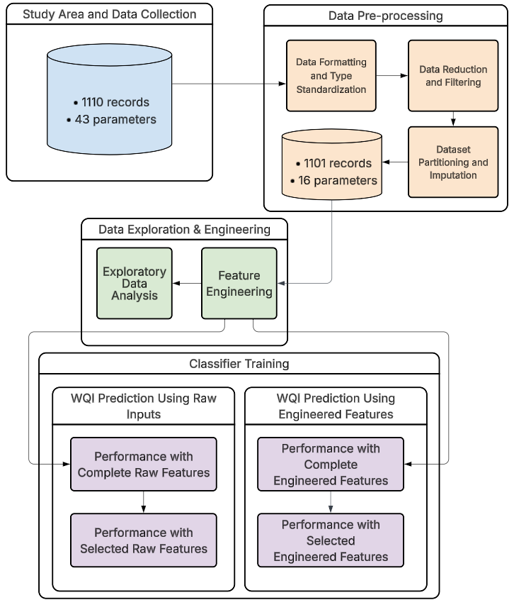
Figure 3.1: High-Level Overview of the Workflow

Evaluation Framework Selection
In this study, model performance is evaluated using four widely recognized regression metrics: Mean Absolute Error (MAE), Mean Squared Error (MSE), Root Mean Squared Error (RMSE), and the Coefficient of Determination (R²). The combination of these complementary metrics enables a rigorous, multi-dimensional assessment of predictive accuracy, error magnitude, and explanatory power. Specifically, MAE quantifies the average absolute difference between observed and predicted values, providing a straightforward measure of prediction error. However, MAE treats all errors equally and may underrepresent the impact of large deviations; RMSE addresses this limitation by penalizing larger errors more heavily, making it more sensitive to significant outliers. R² further complements these metrics by assessing the proportion of variance in the observed data explained by the model, offering a normalized measure of explanatory power. MSE serves as an intermediate step for computing RMSE, aggregating squared errors, while RMSE converts these values back into the original data units, facilitating intuitive interpretation.

Study Area and Data Acquisition Strategy

Study Area Description
The study was conducted in Quang Ninh Province, a coastal province located in the north-eastern region of Vietnam, bordering China to the north and the Gulf of Tonkin to the south. The province extends approximately between latitudes 20.8°–21.6°N and longitudes 106.4°–108.0°E, encompassing a complex landscape of mountainous uplands, river networks, estuarine systems, and extensive coastal waters. This geographic heterogeneity creates pronounced spatial gradients in hydrological and water quality conditions, making the area particularly suitable for computational environmental modelling.
A defining feature of the province is the presence of Ha Long Bay, a UNESCO World Heritage Site, and Bai Tu Long Bay, semi-enclosed marine systems characterized by dense limestone karst formations and intricate tidal circulation. These embayments receive freshwater inputs from multiple river systems and urban drainage networks before discharging into the Gulf of Tonkin. The semi-enclosed morphology reduces flushing efficiency in certain sub-regions, increasing the sensitivity of water quality to anthropogenic pressures and seasonal variability.
Hydrologically, Quang Ninh experiences a humid subtropical monsoon climate with two distinct seasons: a wet season (typically May–October) dominated by high rainfall and surface runoff, and a dry season (November–April) characterized by reduced freshwater inflow and stronger marine influence. This seasonal contrast significantly affects salinity gradients, suspended solids transport, nutrient dynamics, and dissolved oxygen concentrations. During the wet season, increased runoff enhances the transport of nutrients, organic matter, and particulate pollutants from inland areas. Conversely, during the dry season, reduced dilution capacity may intensify localized pollutant accumulation in estuarine and nearshore zones.
From a socio-economic perspective, Quang Ninh is one of Vietnam’s most industrialized coastal provinces. It is nationally significant for coal mining, thermal power generation, port operations, aquaculture, tourism, and rapidly expanding urban development. Industrial clusters, mining discharge, municipal wastewater, and maritime activities collectively exert pressure on receiving water bodies. In addition, cage aquaculture and coastal fisheries contribute nutrient loads that may exacerbate eutrophication processes in semi-enclosed bays. The coexistence of heavy industry and environmentally sensitive coastal ecosystems creates a complex pollution regime with both point and non-point sources.
Water quality concerns in the province include elevated concentrations of suspended solids, organic matter (COD and BOD₅), ammonium (NH₄), nitrate (NO₃), and localized salinity intrusion. Mining areas may also influence metal and sediment loads, while urbanized coastal wards contribute domestic wastewater inputs. Spatial heterogeneity is therefore expected across upstream freshwater sites, transitional estuarine zones, and fully marine sampling locations. Such variability provides a strong empirical basis for applying machine learning approaches to capture nonlinear interactions among physicochemical parameters and to improve WQI (WQI) estimation.
Overall, Quang Ninh represents a dynamically coupled river–estuary–coastal system under substantial anthropogenic pressure and marked seasonal forcing. Its environmental complexity, multi-source pollution inputs, and pronounced spatial–temporal variability make it an appropriate and scientifically meaningful case study for data-driven water quality modelling and WQI prediction.
Figure 3.2 presents the spatial distribution of the study area within Quang Ninh Province, Vietnam. The inset map indicates the geographical location of Quang Ninh within the national context. Within the main panel, provincial boundaries define the study area, while national roads and river networks are displayed to provide geographic reference. Red markers denote the sampling locations. Latitude and longitude coordinates are provided along the axes to assist readers in interpreting spatial position and scale.

Figure 3.2: Spatial distribution of the study area and water quality sampling stations in Quang Ninh Province, Vietnam.

Data Quality Considerations
The dataset utilized in this study was obtained from the provincial environmental monitoring program implemented by the Quang Ninh Environmental Monitoring Center, under the authority of Vietnamese government. The official monitoring network includes stations distributed along the southwest–northeast axis and islands of the province, encompassing:
- Surface waters affected by domestic activities and residential wastewater discharge
- Industrial estates and their associated drainage catchments
- Water bodies located in proximity to mining and mineral extraction sites
- Natural freshwater systems, including rivers, streams, and lakes
The monitoring network exhibits a well-distributed spatial design, effectively capturing the variability of both anthropogenic and natural water systems across the province. The dataset, collected from 2019 to 2021, offers a valuable temporal snapshot; however, the relatively short three-year period may constrain the ability to detect long-term trends or seasonal anomalies in water quality.
The dataset originates from a credible source and encompasses samples collected across diverse environments settings and over an extended temporal range.
Table 3.1: Descriptive statistics of water quality parameters and WQI in Quang Ninh Province.
Paramters | Unit | Minimum | Maximum | Mean | Median | Std. Deviation
Temperature | degrees Celsius | 7.400 | 39.4 | 24.222 | 23.6 | 4.843
pH |  | 4.590 | 8.64 | 6.685 | 6.64 | 0.444
DO | Mg/L | 1.080 | 9.7 | 6.703 | 6.72 | 0.997
COD | Mg/L | 1.500 | 306.4 | 15.604 | 11.3 | 23.158
BOD5 | Mg/L | 1.000 | 54.4 | 4.28 | 3.1 | 4.192
NO3 | Mg/L | 0.008 | 6.528 | 0.345 | 0.214 | 0.638
NO2 | Mg/L | 0.002 | 8.337 | 0.185 | 0.002 | 0.951
NH4 | Mg/L | 0.01 | 6.321 | 0.399 | 0.054 | 1.018
PO4 | Mg/L | 0.01 | 10.365 | 0.051 | 0.01 | 0.336
Coliform | MPN/100ml | 3 | 25000 | 766.685 | 150 | 1885.311
EColi |  | 3 | 400 | 14.118 | 3 | 35.718
As | Mg/L | 0 | 0.014 | 0.001 | 0 | 0.001
Hg | Mg/L | 0 | 0.006 | 0 | 0 | 0
Pb | Mg/L | 0 | 0.066 | 0.001 | 0.001 | 0.003
Cd | Mg/L | 0 | 0.011 | 0.001 | 0.001 | 0
CrVI | Mg/L | 0.001 | 0.03 | 0.001 | 0.001 | 0.003

Data Preparation Strategy

Data Formatting and Type Standardization
To ensure the dataset was compatible with machine learning algorithms, several preliminary formatting and numerical transformation steps were performed (Figure 3.3):

Figure 3.3: Sequential Workflow for Data Formatting and Type Standardization
- Standardization of Missing Data Indicators: Non-numeric characters such as "x" and "X," which were used in the raw records to denote missing measurements, were converted to NaN (Not a Number) to facilitate systematic imputation.
- Treatment of Censored Data: For parameters recorded as "< x" (indicating values below the analytical limit of detection), the prefix "<" was removed, and the limit value x was retained for the analysis.
- Numerical Localization: Decimal separators were standardized by converting commas to points to align with the standard floating-point format required by the Python processing environment.
- Numerical Data Conversion: Following the cleaning of non-numeric characters and format standardization, all water quality parameters were cast into appropriate numerical data types to enable mathematical operations.

Data Reduction and Filtering
Following standardization, a rigorous screening process was conducted to remove uninformative or highly deficient records and features (Figure 3.4):

Figure 3.4: Sequential Workflow for Data Reduction and Filtering
- Feature Screening: Irrelevant columns that did not contribute to the target objective were removed from the dataset to reduce dimensionality and focus the model on meaningful predictors. Specifically, the removed columns included: 'Location', 'ID', 'Month', 'Sal', 'Turb', 'TSS', 'SO4', 'MBAS', 'Cyan', 'Fluor', 'Cl', 'OilFat', 'Fe', 'Mn', 'Cu', 'Ni', 'Zn', 'Cr', 'Phenol', 'RadAlpha', and 'RadBeta'.
- Removal of High-Sparsity Features: Features exhibiting a missing data rate exceeding the 75% threshold were entirely eliminated to prevent the introduction of statistical noise and computational bias into the model's learning process. Specifically, the removed features included: 'Aldrin', 'BHC', 'Dieldrin', 'DDTs', 'Heptach', and 'TOC'.
- Elimination of Empty Records: Observations entirely devoid of measured values were purged from the dataset, as they offer no discriminative information and solely degrade computational efficiency.

Dataset Partitioning and Imputation
The final pre-processing stage prepared the refined data for predictive modeling (Figure 3.5):

Figure 3.5: Sequential Workflow for Dataset Partitioning and Imputation
- Cross-Validation Configuration: The dataset was evaluated using k-fold cross-validation, ensuring that training and validation subsets were properly separated in each fold. This approach preserves the integrity of model evaluation and effectively mitigates the risk of data leakage.
- KNN (KNN) Imputation for Missing Values: A distance-based KNN (KNN) algorithm was deployed to estimate and impute localized missing values (specifically for CrVI and E. coli) by exploiting the multidimensional similarity of adjacent data points.

Feature Engineering Framework
To optimize the dataset for predictive modeling, a systematic feature engineering framework was implemented, as illustrated below (Figure 3.6):

Figure 3.6: Sequential Workflow for Data Exploration and Engineering

Derivation of WQI-based Features
In this study, the Vietnamese WQI (VN_WQI) was calculated strictly in accordance with the technical guidelines issued by the MONRE (2019). The VN_WQI framework categorizes water quality parameters into five thematic groups: (I) pH, (II) pesticides, (III) heavy metals, (IV) organic matter and nutrients, and (V) microbiological indicators.
For each thematic group g, a group-level index was derived by aggregating its corresponding standardized sub-indices (WQISI) using either the geometric mean or the arithmetic mean, depending on the specific requirements prescribed for each parameter group. Individual water quality parameters were first transformed into dimensionless sub-indices based on the official rating curves, and these sub-indices were subsequently integrated to quantify the overall surface water quality status.
In this study, the VN_WQI was calculated using 16 water quality variables, including temperature, pH, dissolved oxygen (DO), chemical oxygen demand (COD), biochemical oxygen demand (BOD₅), nitrate (NO₃⁻), nitrite (NO₂⁻), ammonium (NH₄⁺), phosphate (PO₄³⁻), total coliforms, Escherichia coli (E. coli), and the heavy metals arsenic (As), mercury (Hg), lead (Pb), cadmium (Cd), and hexavalent chromium (Cr⁶⁺). The final VN_WQI value was obtained by aggregating all available group indices in accordance with the formulation specified in the official guidelines. The VN_WQI is computed according to the following formulation:
$$WQI = \frac{{WQI}_{pH}}{100}×\frac{{\left(\prod_{a=1}^{5}{{WQI}_{III}}\right)}^{\frac{1}{5}}}{100}×{\left(\frac{1}{7}\sum_{b=1}^{7}{{WQI}_{IV}}×\frac{1}{2}\sum_{c=1}^{2}{{WQI}_{IV}}\right)}^{\frac{1}{2}}$$
The WQI provides an aggregated assessment of water quality, allowing classification into five categories: excellent (91–100), good (76–90), fair (51–75), poor (26–50), and very poor (0–25).

Data Standardization
Data Standardization was employed to eliminate severe scale disparities among water quality parameters, ensuring that distance-based algorithms like LR, SVR and KNN are not disproportionately biased by features with large magnitudes.

Controlled Experimental Design and Modelling Framework

Experimental Design Scenarios
To systematically evaluate the influence of input dimensionality and domain knowledge on WQI prediction, as shown in Figure 3.1, this study defines four experimental scenarios using a $2×2$ factorial design based on:
(i) feature scope (comprehensive vs. parsimonious), and
(ii) feature construction strategy (direct measurement vs. domain-informed).
This design enables assessment of both main effects and interaction effects between data richness and expert knowledge integration.
Scenario 1: Performance with Complete Raw Features Configuration
This scenario uses the full set of directly measured water-quality variables available in the dataset (Temperature, pH, DO, BO$D_{5}$, COD, N$O_{2}$, $NH_{4}$, N$O_{3}$, P$O_{4}$, Coliform, EColi, As, Hg, Pb, Cd, CrVI).
- All features are included in their original measured form after standard preprocessing.
- This scenario aims to finds best-perform models so that create feature important plot based on best-perform models
Scenario 2: Performance with Selected Raw Features Configuration
This scenario retains only a minimal subset of directly measured variables, selected based on statistical relevance and operational feasibility.
- All features are included in their original measured form after standard preprocessing.
- It targets real-world contexts where sampling budgets are limited but reliable prediction remains essential.
Scenario 3: Performance with Complete Engineered Features Configuration
This scenario combines the full feature set with domain-informed engineered variables (${WQI}_{pH}$, ${WQI}_{DO}$, ${WQI}_{BOD_{5}}$, ${WQI}_{COD}$, ${WQI}_{NH_{4}}$, ${WQI}_{NO_{3}}$, ${WQI}_{PO_{4}}, {WQI}_{NO_{2}},$ ${WQI}_{PO_{4}}, {WQI}_{Coliform}, {WQI}_{EColi}, {WQI}_{As}$, ${WQI}_{Hg}, {WQI}_{Cd}, {WQI}_{CrVI}$).

- All WQI sub-indices are used as inputs.
- This scenario aims to finds best-perform models so that create feature important plot based on best-perform models.
Scenario 4: Performance with Selected Engineered Features Configuration
This scenario combines a reduced direct-measurement set with a compact set of high-value domain-informed features.
- The design reduces the number of WQI sub-indices used as inputs.
- It targets real-world contexts where sampling budgets are limited but reliable prediction remains essential.

Standardized Training and Evaluation Pipeline
Figure 3.8 illustrates the overall modeling and evaluation framework. Grid Search CV was systematically implemented across all candidate models to ensure uniform and unbiased hyperparameter optimization. This approach guarantees methodological consistency and eliminates preferential tuning effects among algorithms.
For inherently non-ensemble learners, a Bagging Regressor framework was integrated to reduce variance and improve stability under noisy environmental conditions. This design allows single estimators to benefit from bootstrap aggregation while preserving their intrinsic learning characteristics.
Additionally, multiple stacking architectures were constructed and empirically evaluated. These configurations varied in base-learner composition and meta-learner structure, enabling a comprehensive investigation of ensemble synergy and performance trade-offs.
Subsequently, all trained models were evaluated using four regression metrics (MSE, RMSE, MAE, and R²), enabling a structured comparison of predictive error magnitude and variance explanation under a consistent testing framework.

Figure 3.7: Standardized Machine Learning Training and Evaluation Pipeline.

Results

Dataset Characteristics and Exploratory Analysis
Water quality data from Center for Natural Resources and Environment Monitoring of Quang Ninh Province, Vietnam, 1110 records were collected from 2021 to 2024 at 125 different location, including key sites near Ha Long Bay, a UNESCO World Natural Heritage site. The dataset includes monthly and bimonthly measurements of physical, chemical, microbiological, and heavy metal parameters to provide a comprehensive assessment of water quality in the province.
The monitored water quality variables comprised: Temperature (T, °C), pH, Dissolved Oxygen (DO, mg/L), Biochemical Oxygen Demand over 5 days (BOD₅, mg/L), Chemical Oxygen Demand (COD, mg/L), Nitrate (NO₃, mg/L), Nitrite (NO₂, mg/L), Ammonium (NH₄⁺, mg/L), Phosphate (PO₄³⁻, mg/L), Coliform (MPN/100 mL), E. coli, and trace heavy metals (As, Hg, Pb, Cd, CrVI, mg/L).
As clearly depicted in Figure 4.1, the box plots illustrate the distribution of various dataset attributes, highlighting a striking prevalence of extreme values extending far beyond the upper whiskers across most parameters. Although there are many apparent outliers, they are not truly outliers caused by random noise. They reflect real phenomena from pollution sources such as mining industries, other industrial activities, and residential waste. These values are realistic and valid. This supports the idea that tree-based models are more suitable for this data, as they handle such extreme values effectively.

Figure 4.1: Box Plots of the Attributes in the Dataset

The heatmap in Figure 4.2 illustrates the correlations between attributes, where red cells indicate a direct proportional relationship and the blue cells indicate an inverse relationship. WQI sub-index attributes are highly impact to WQI scores. For example, the contributions of WQ$I_{BOD_{5}}$ and WQ$I_{{NH}_{4}} to WQI are 0.6 and 0.64, respectively.$Applying feature engineering to transform raw input parameters into WQI-specific features may enhance the accuracy and robustness of the evaluation. Some attributes are highly correlated with each other, such as COD with BOD, Coliform and Ecoli, N$H_{4}$ and N$O_{2}$. This information can help us decide which attributes to remove, as some features contain overlapping information.

Figure 4.2: Heatmap of Relationships Between Numeric Variables in the Dataset

The scatter plot below (Figure 4.3) illustrates the correlation between the two parameters, with the x-axis representing COD concentration (mg/L) and the y-axis representing BOD5 concentration (mg/L). Although the figure shows wide dispersion and errors at high concentrations, a general upward trend remains visible, and since this study does not focus on accuracy, it is still acceptable to consider removing one of them.

Figure 4.3: Comparison of COD and BO$D_{5}$ concentrations

The scatter plot (Figure 4.4) compares the concentrations of ammonium (NH₄) and 5-day Biochemical Oxygen Demand (BOD₅), measured in milligrams per litre (mg/L). The data displays no clear correlation; therefore, there is insufficient evidence to justify removing either variable from the analysis.

Figure 4.4: Comparison of NH₄ and BO$D_{5}$concentrations

The scatter plot (Figure 4.5) illustrates the relationship between the concentrations of NH₄ (ammonium) and N$O_{2}$ (nitrite) in the water samples, measured in mg/l. As the chart demonstrates, there is no discernible correlation between N$O_{2}$ and NH₄, as the data points exhibit a highly dispersed distribution without any clear linear or monotonic trend.

Figure 4.5: Comparison of NH₄ and N$O_{2}$ concentrations
The scatter plot illustrates the relationship between the concentrations of Coliform and E. coli in the water samples, measured in MPN/100mL. As the chart demonstrates, there is no strong linear correlation between the two variables; rather, the data exhibits dense clustering at lower concentration levels, alongside a highly dispersed distribution where the variance of E. coli noticeably increases at higher Coliform levels.

Figure 4.6: Comparison of Coliform and E.Coli concentrations

Baseline WQI Prediction Using Raw Inputs

Performance with Complete Raw Features
Table 4.1: Individual Regression Models Performance on Raw Water Quality Inputs (Pre Feature Selection)

Model | MSE | RMSE | MAE | R²
GB | 5.6108 | 2.3687 | 0.9521 | 0.9674
RF | 9.2733 | 3.0452 | 1.2057 | 0.9462
SVR | 19.8463 | 4.4549 | 2.1498 | 0.8849
KNN | 26.4492 | 5.1429 | 2.4002 | 0.8465
LR | 51.1147 | 7.1495 | 4.0137 | 0.7034
In the following table, the rows indicate the different machine learning models before selected features and with raw inputs, and the columns show their respective performance metrics: MSE, RMSE, MAE and R² . Tree-based models such as GB and RF achieved high performance across all evaluation metrics. Meanwhile, linear and instance-based models such as SVR, KNN LR perform comparatively poorly.
Table 4.2: Performance Comparison of 5 Best-Perform Stacking Models Configurations Using Raw Input Features Before Feature Selection
Base Models | Num Models | MSE | RMSE | MAE | R2
RF + LR + SVR + GB | 4 | 5.8966 | 2.4283 | 1.1589 | 0.9658
RF + KNN + LR + SVR + GB | 5 | 5.9031 | 2.4296 | 1.1693 | 0.9658
KNN + LR + SVR + GB | 4 | 6.0305 | 2.4557 | 1.1935 | 0.9650
RF + LR + GB | 3 | 6.0701 | 2.4638 | 1.0740 | 0.9648
RF + KNN + LR + GB | 4 | 6.0794 | 2.4656 | 1.0755 | 0.9647
The table present top 5 stacking models achieved highest scores before selected features and with raw inputs. As we can see, stacking models not perform better than GB but need more time to training
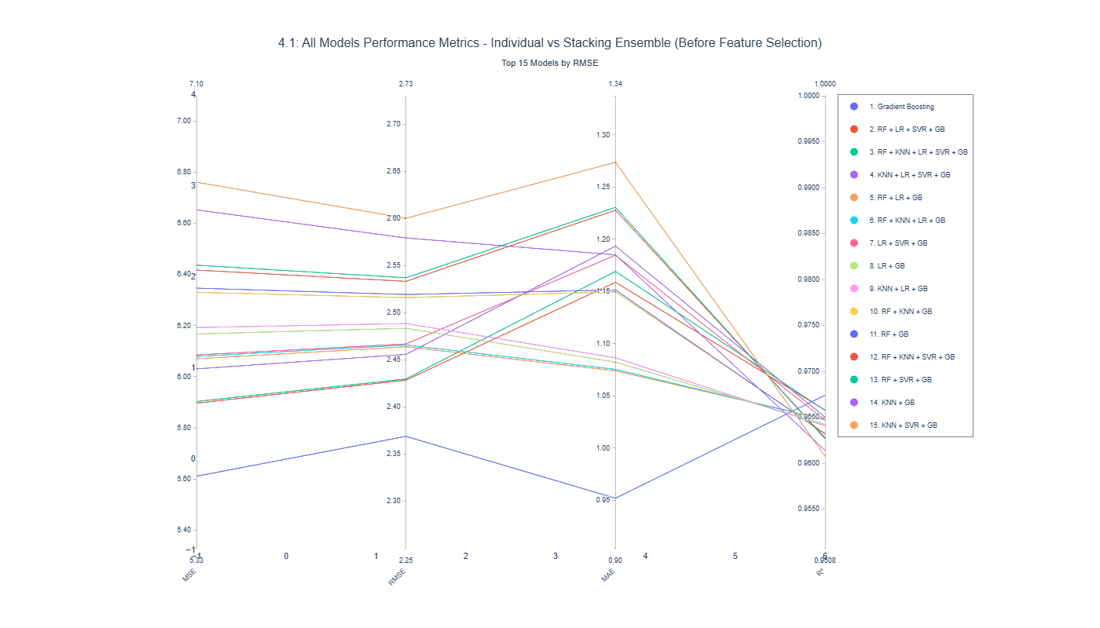
Figure 4.7: Top 15 Models Performance Metrics for Individual and Stacking Ensembles Before Feature Selection with Raw Inputs
The parallel Coordinates Plot compares the performance metrics of the top 15 predictive models before selected features and with raw inputs. Including both individual algorithms and stacking ensembles measured by MSE, RMSE, MAE and $R^{2}$.The figure show that GB is significantly better than others meanwhile, although stacking models take more time to training. They perform not much differently with traditional algorithms.

Figure 4.8: Permutation Feature Importance with 5-Fold CV for WQI Prediction Using Raw Input Parameters (Pre Feature Selection)
The feature importance plot shows the contribution of each parameter to the GB model, which is the best-performing model. Among all parameters, pH has the greatest impact on the model. This result may be explained by mining activities(find ciation), which can alter the pH level in water and consequently affect the overall WQI score. The most influential attributes are those that contain extreme values, the more extreme the values, the greater their impact on the model.

Performance with Selected Raw Features
I decided to remove BOD5, which is a parameter that takes a long time to measure, but can be replaced by COD. I also removed NO₃, Pb, Cd, As, and PO₄, as they do not have much impact on the models. Temperature was retained because it does not require much time or cost to measure.
Table 4.3: Individual Models Performance Comparison After Feature Selection with Raw Inputs
Model | MSE | RMSE | MAE | R²
GB | 6.1961 | 2.4892 | 1.1059 | 0.9641
RF | 8.8684 | 2.9780 | 1.2338 | 0.9485
SVR | 14.3827 | 3.7925 | 1.9064 | 0.9166
KNN | 22.9904 | 4.7948 | 2.3475 | 0.8666
LR | 50.7014 | 7.1205 | 4.0457 | 0.7058
In the table, the performance of different machine learning models is reported in terms of MSE, RMSE, MAE, and R², based on raw inputs after feature selection. The order of importance remains unchanged following feature selection. The MAE of all models is still acceptable when compared with the range of scores. In addition, the MSE of non-tree-based models is substantially high, indicating that they may perform poorly in certain specific situations.
Table 4.4: Top 5 Stacking Models Performance Comparison After Feature Selection with Raw Inputs
Base Models | Num Models | MSE | RMSE | MAE | R²
RF + LR + SVR + GB | 4 | 6.4640 | 2.5424 | 1.2968 | 0.9625
RF + KNN + LR + SVR + GB | 5 | 6.5651 | 2.5622 | 1.3259 | 0.9619
RF + SVR + GB | 3 | 6.5732 | 2.5638 | 1.2979 | 0.9619
KNN + LR + SVR + GB | 4 | 6.6064 | 2.5703 | 1.3357 | 0.9617
LR + SVR + GB | 3 | 6.6196 | 2.5729 | 1.3146 | 0.9616
The table shows the top five stacking models that achieved the highest performance after feature selection using the input data. The results are consistent with those obtained before feature selection and remain lower than the best-performing single model, GB. Moreover, there is no significant difference among the top stacking models, indicating that feature selection affects all models proportionally without altering their relative rankings.
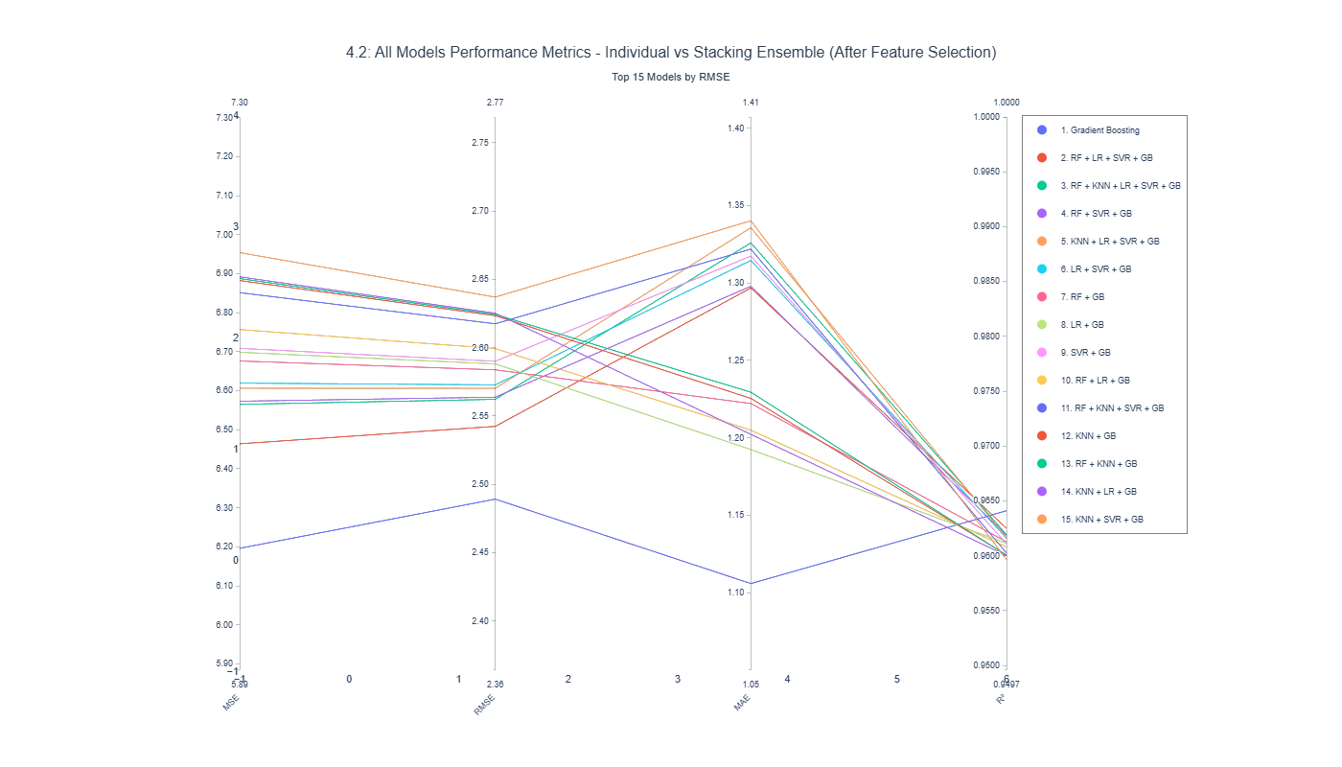
Figure 4.9: Top 15 Models Performance Metrics for Individual and Stacking Ensembles After Feature Selection with Raw Inputs
The Parallel Coordinates Plot presents the performance metrics of the top 15 predictive models using raw inputs before feature selection, including both individual algorithms and stacking ensembles, evaluated in terms of MSE, RMSE, MAE, and R². The figure indicates that GB outperforms the other models significantly. Although stacking ensembles require longer training times, their performance is generally comparable to that of traditional algorithms. In addition, these results are consistent with those obtained before applying feature selection.

WQI Prediction Using Engineered Features
Because the high correlation with Final WQI which showed by heatmap. I try to convert all raw inputs into WQI sub-index which are WQI-pH, WQI-DO, WQI-BOD5, WQI-NO3, WQI-NO2, WQI-NH4, WQI-PO4, WQI-Coliform, WQI-EColi, WQI-As, WQI-Hg, WQI-Pb, WQI-Cd, WQI-CrVI.

Performance with Complete Engineered Features
Table 4.5: Individual Regression Models Performance on WQI sub-indices Inputs Before Feature Selection
Model | MSE | RMSE | MAE | R²
LR | 1.0597 | 1.0294 | 0.4499 | 0.9939
SVR | 2.4172 | 1.5547 | 0.4098 | 0.9860
GB | 3.6600 | 1.9131 | 0.7504 | 0.9788
KNN | 5.3084 | 2.3040 | 0.8305 | 0.9692
RF | 7.5059 | 2.7397 | 0.9403 | 0.9565
In the table below, each row represents a machine learning model trained with the selected features and after transforming the raw parameters into WQI sub-indices, while the columns display their respective performance metrics, including MSE, RMSE, MAE, and R². The new inputs are scaled to the same range as the outputs, which implies a linear correlation between inputs and outputs. Linear-based models (LR and SVR) achieve significantly higher performance compared to instance-based and tree-based models such as GB, KNN, and RF.
Table 4.6: Top 5 Stacking Models Performance Comparison on WQI sub-indices Inputs Before Feature Selection
Base Models | Num Models | MSE | RMSE | MAE | R²
KNN + LR + GB | 3 | 0.9471 | 0.9732 | 0.4651 | 0.9945
KNN + LR | 2 | 0.9519 | 0.9756 | 0.4601 | 0.9945
LR + GB | 2 | 0.9787 | 0.9893 | 0.4536 | 0.9943
RF + KNN + LR | 3 | 0.9886 | 0.9943 | 0.4762 | 0.9943
LR + SVR | 2 | 1.0190 | 1.0095 | 0.4757 | 0.9941
The table shows the top five stacking models that achieved the best performance across different evaluation metrics using the selected features and after transforming the raw parameters into WQI sub-indices. The figure shows that all top stacking models perform similarly and slightly outperform the best-performing traditional model, LR. This result also highlights the benefits of stacking models when using WQI sub-indices as inputs, whereas applying stacking was unnecessary in the previous scenario.
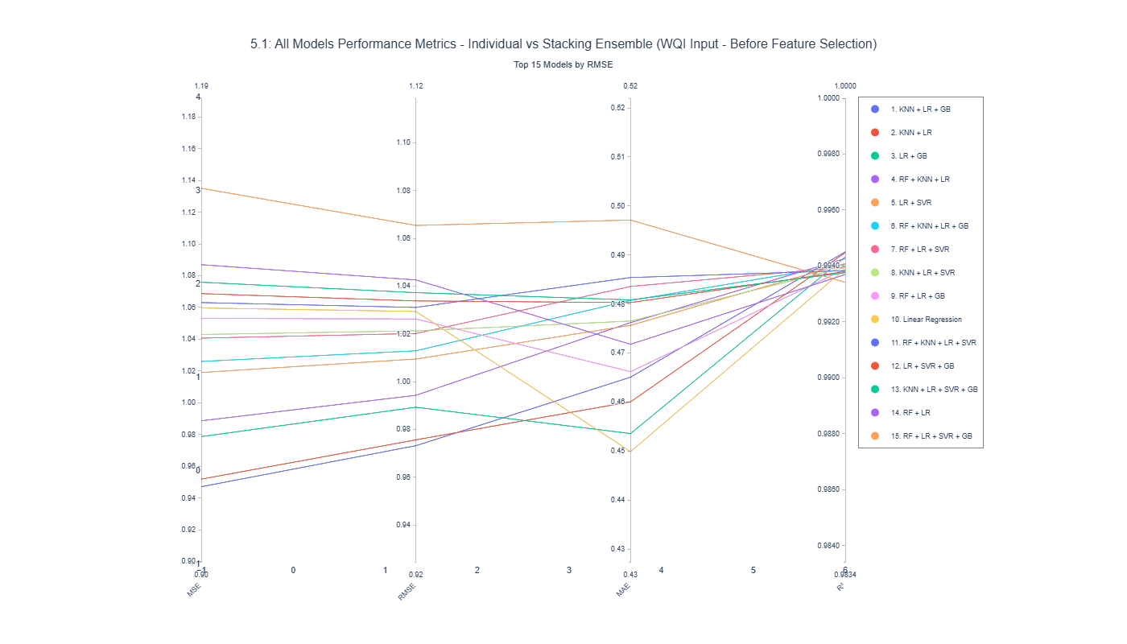
Figure 4.10: Top 15 Models Performance Metrics for Individual and Stacking Ensembles Before Feature Selection with WQI sub-indices Inputs
Figure 4.4 illustrates the comparative performance of the top 15 predictive models, including individual algorithms and stacking ensemble combinations, evaluated across multiple metrics (MSE, RMSE, MAE, and R²) using the WQI input dataset before feature selection. The range of the evaluation metrics shows that there are no sharp differences between the models. This suggests that the choice of model is not critically important in this scenario.

Figure 4.11: Permutation Feature Importance with 5-Fold CV for WQI Prediction Using Raw Input Parameters (Pre-Feature Selection)
The feature importance plot illustrates the contribution of each parameter to the stacking model combining KNN, LR, and GB, which achieved the best performance. Among all parameters, WQI-pH has the greatest impact on the model. The order of the parameters does not change significantly compared with the feature importance chart before applying engineered features.

Performance with Selected Engineered Features
In this study, I decided to remove WQI-BOD5, which is a parameter that takes a long time to measure, but can be replaced by WQI-COD, same reason with when I select features for the raw input scenario. I also removed WQI-NO₃, WQI-Cd and WQI-As, as they do not have much impact on the models.
Table 4.7: Individual Regression Models Performance on WQI sub-indices Inputs After Feature Selection
Model | MSE | RMSE | MAE | R²
LR | 1.5584 | 1.2484 | 0.7055 | 0.9910
SVR | 2.2601 | 1.5034 | 0.6357 | 0.9869
GB | 3.6180 | 1.9021 | 0.8969 | 0.9790
KNN | 5.1389 | 2.2669 | 0.9935 | 0.9702
RF | 7.7947 | 2.7919 | 1.0960 | 0.9548
The table show the performance of different traditional algorithms after selecting features. As shown in the table, evaluated scores are slightly change compared to them before using selecting features.
Table 4.8: Top 5 Stacking Models Performance Comparison on WQI sub-indices Inputs After Feature Selection
Base Models | Num Models | MSE | RMSE | MAE | R²
KNN + LR + GB | 3 | 1.3086 | 1.1439 | 0.6737 | 0.9924
KNN + LR | 2 | 1.3477 | 1.1609 | 0.6753 | 0.9922
RF + KNN + LR + GB | 4 | 1.3512 | 1.1624 | 0.6800 | 0.9922
LR + GB | 2 | 1.3793 | 1.1744 | 0.6924 | 0.9920
RF + KNN + LR | 3 | 1.3972 | 1.1820 | 0.6862 | 0.9919
The table displays the results of various ways of combining stacking models. It shows that the best-performing stacking model, which combines KNN, LR, and GB, performs slightly better than LR, the best-performing single model. However, there are no significant differences between the evaluation scores of the stacking models.
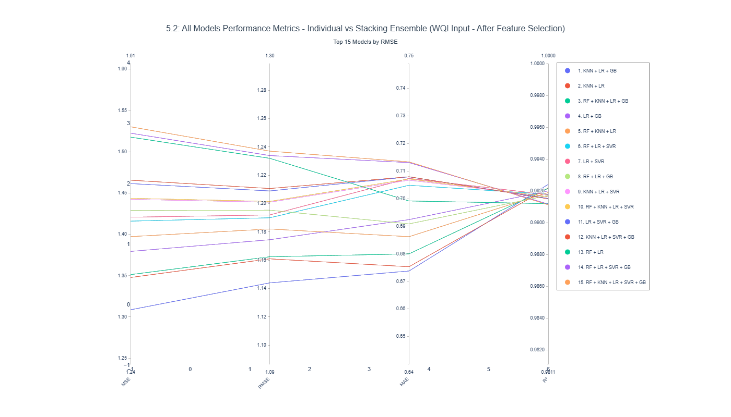
Figure 4.12: Top 15 Models Performance Metrics for Individual and Stacking Ensembles After Feature Selection with WQI sub-indices Inputs
This chart compares the performance of the top 15 models, including both individual models and stacking ensembles, across several evaluation metrics such as MSE, RMSE, MAE, and R² after feature selection. The mean of the evaluated scores for the models is not significantly worse than before applying feature selection.

Comparative Performance Analysis

Figure 4.13: Performance comparison of Best-Perform Machine Learning Model and Traditional Calculation methods under Feature Reduction constraints.
The scatter plots illustrate the relationship between WQI values calculated using the traditional WQI formula and those predicted by machine learning models when the number of attributes is reduced, compared with the actual WQI scores computed using the full set of features. As shown in the charts, applying the WQI formula results in wider scatters around the red reference line (y = x), where points closer to the line indicate higher accuracy. In contrast, the machine learning approach demonstrates more stable predictions when fewer attributes are used. However, in some cases, several points still deviate noticeably from the reference line.

Discussion

Overview of Principal Findings

Key Findings
Applying transformations from raw inputs to WQI sub-indices improves predictive accuracy because the models no longer need to learn the highly complex relationships between the original input variables and the output.
The experimental results indicate that tree-based models perform well when using raw inputs, as they are capable of effectively handling extreme values and capturing non-linear relationships. However, when WQI sub-indices are used as inputs, linear-based algorithms demonstrate higher predictive performance.
Furthermore, stacking models do not significantly improve prediction performance. In the raw input scenario, their performance is not better than that of the best-performing single models. In the WQI sub-index scenario, stacking models achieve only a slight improvement over the best-performing individual algorithms.
Another important challenge when predicting WQI using a reduced feature set is the difficulty in capturing special or extreme cases, as removing attributes may lead to a loss of critical information. Recent studies have paid limited attention to this issue. This study demonstrates that combining heatmaps with scatter plots can help identify whether certain attributes implicitly contain information represented by other variables. This approach provides researchers with an additional perspective when deciding which features should be retained or removed, thereby reducing excessive reliance on feature importance plots.

Technical Discussion
This section interprets the experimental findings from a methodological and theoretical perspective while comparing them with patterns reported in previous WQI prediction studies. Prior research has produced inconsistent conclusions regarding the most suitable algorithms for WQI modelling: some studies report superior performance of tree-based models such as Random Forest, whereas others identify Support Vector Regression or linear approaches as more effective depending on dataset characteristics. The results of this study confirm that algorithm performance is strongly influenced by data structure and feature representation rather than the inherent superiority of any single model.

Behavioural Analysis of Machine Learning Models

Nonlinear Structure of Raw Environmental Data
Environmental datasets are typically characterized by nonlinear relationships and strong interactions among variables. In the raw-input scenario, tree-based algorithms such as Random Forest and Gradient Boosting achieved strong predictive performance because they can naturally capture nonlinear patterns and interactions without strict distributional assumptions. In contrast, linear regression models are sensitive to multicollinearity among parameters such as COD, BOD5, and microbial indicators, which reduces their predictive stability.
From a theoretical perspective, ensemble tree models reduce variance through aggregation while maintaining relatively low bias. This property allows them to handle complex environmental datasets more effectively than simple parametric models when raw measurements are used.

Sensitivity to Feature Reduction
Dimensionality reduction affects algorithms differently. Distance-based and linear models, such as KNN and LR, are generally more sensitive to the removal of predictors because their predictive structure relies heavily on the geometry of the feature space. Removing variables can therefore alter distance relationships or weaken linear associations.
In contrast, ensemble models are more robust to feature reduction due to internal mechanisms such as random feature sampling and hierarchical splitting. These mechanisms allow tree-based models to adapt to reduced feature spaces while maintaining predictive performance.

Impact of Domain-Informed Feature Engineering
Transforming raw variables into WQI sub-indices significantly alters the modelling environment. Because the sub-indices are scaled within the same range as the final WQI score, the relationship between inputs and output becomes more structured and partially linearized. As a result, algorithms with simpler functional forms, including linear regression, can achieve competitive performance under this representation.
This finding highlights the importance of domain-informed feature engineering. Rather than relying solely on algorithmic complexity, incorporating domain knowledge into feature construction can simplify the learning task and improve model interpretability.

Methodological Contributions
The study recommends using a combination of heatmaps and scatter plots for feature selection, rather than relying solely on feature importance plots. Heatmaps can help identify strong relationships between features, while scatter plots provide visual insights that support arguments and reveal details about these relationships.
Furthermore, cross-validation is a standard technique in machine learning, its application in WQI prediction studies has been limited. In this study, we integrate k-fold cross-validation into our model evaluation workflow to ensure unbiased performance assessment.
In addition, the study recommends using GridSearchCV for model evaluation, as it often improves performance through systematic hyperparameter tuning.
Moreover, the study introduces engineered features, demonstrating that using WQI sub-indices as inputs can enhance model accuracy.
Finally, This research compares the results of the best-performing model with the WQI formula, which has been rarely evaluated in previous studies.

Practical Implications for Coastal Water Governance
As the Vietnamese government has already provided guidance on when the WQI formula should be updated and how to ensure that techniques using fewer features are still acceptable, this study focuses on recommending when AI models can be applied versus when the traditional formula should be used to calculate WQI. Since the dataset still requires regular updates, WQI should be calculated using the full set of attributes each quarter to monitor environmental changes. However, AI models can be used on a monthly basis to predict WQI, offering an efficient supplement to the traditional approach.

Conceptual Synthesis of the Proposed Framework

Performance Discussion
The experimental results reveal several important insights regarding the predictive behaviour of machine learning models for Water Quality Index (WQI) estimation. Rather than merely identifying the model with the highest numerical accuracy, the findings highlight how predictive performance is shaped by the interaction between algorithmic structure, feature representation, and the statistical characteristics of environmental datasets.

Predictive Accuracy Across Algorithms
Among the evaluated models, ensemble tree-based algorithms consistently demonstrated strong predictive capability. This outcome aligns with the theoretical advantages of ensemble learning, where multiple weak learners are aggregated to improve generalization performance. In environmental datasets, which are typically characterized by nonlinear interactions and heterogeneous distributions, tree-based ensembles can partition the feature space adaptively without requiring strict assumptions about variable distributions.
The superior performance of these models can be explained through the bias–variance decomposition framework. Environmental monitoring datasets often contain noise due to measurement uncertainty, seasonal variation, and localized environmental fluctuations. Ensemble methods reduce variance by averaging predictions from multiple decision trees while maintaining relatively low bias, allowing them to capture complex patterns without overfitting excessively.
In contrast, simpler parametric models such as Linear Regression tend to perform adequately only when the relationship between predictors and WQI approximates linearity. While such models provide high interpretability, their predictive power is limited when the underlying environmental processes involve nonlinear biochemical interactions among parameters such as dissolved oxygen, nutrient concentration, and microbial indicators.

Influence of Feature Representation on Model Performance
A critical observation from this study is that model performance varies significantly depending on how environmental variables are represented. When raw water quality parameters are used as predictors, the learning task becomes inherently complex because the mapping between individual parameters and the aggregated WQI score is nonlinear and influenced by threshold-based transformations in the official WQI formula.
However, when variables are transformed into WQI sub-indices through domain-informed feature engineering, the prediction task becomes structurally simpler. The sub-indices already encode the nonlinear scaling used in the official WQI calculation, effectively embedding expert knowledge into the dataset. As a result, the relationship between predictors and the final WQI value becomes more regular and easier for algorithms to approximate.
This phenomenon illustrates an important principle in machine learning for environmental science: feature engineering guided by domain knowledge can substantially reduce the complexity of the modelling problem. In some cases, well-designed features can compensate for the limitations of simpler algorithms, enabling them to achieve competitive predictive performance.

Model Stability and Generalization
Beyond raw predictive accuracy, model stability across validation folds provides additional insight into generalization capability. Environmental datasets are often relatively small compared with typical machine learning benchmarks, and they may exhibit strong temporal or spatial correlations. Under such conditions, models that perform well on a single train–test split may not generalize reliably.
The use of k-fold cross-validation in this study therefore plays an important role in evaluating model robustness. Models with stable performance across folds demonstrate stronger generalization potential, suggesting that their learned patterns reflect genuine environmental relationships rather than artefacts of specific data partitions.
Tree-based ensemble models generally exhibited more stable behaviour under cross-validation. This stability arises from their inherent randomness mechanisms, such as bootstrap sampling and random feature selection, which reduce the likelihood that a model becomes overly dependent on a particular subset of the data.

Sensitivity to Dataset Characteristics
Another important factor influencing model performance is the statistical structure of the dataset itself. Water quality datasets often exhibit characteristics such as multicollinearity, skewed distributions, and outliers resulting from episodic pollution events or measurement errors.
Algorithms respond differently to these characteristics. Linear models are particularly sensitive to multicollinearity among predictors, which can inflate coefficient variance and reduce predictive reliability. Distance-based algorithms such as KNN are sensitive to scaling and distributional differences between features, which may distort similarity relationships in the feature space.
Tree-based algorithms are comparatively robust to these issues because their decision boundaries are based on hierarchical splits rather than distance metrics or linear coefficients. This structural robustness partially explains why ensemble tree models frequently perform well in environmental prediction tasks.

Implications for Algorithm Selection in Environmental Modelling
The findings of this study suggest that algorithm selection for WQI prediction should not be based solely on benchmark accuracy but should consider the broader interaction between data characteristics, feature engineering, and model interpretability.
From a practical perspective, ensemble models offer strong predictive accuracy and robustness for raw environmental datasets. However, simpler models may remain valuable when domain-informed features are available or when interpretability is prioritized for policy communication and environmental governance.
This perspective highlights an important methodological insight: effective environmental machine learning systems should integrate domain knowledge with algorithmic modelling rather than relying exclusively on model complexity. By aligning feature design, data preprocessing, and model selection with the underlying environmental processes, researchers can develop predictive systems that are both accurate and scientifically meaningful.

Broader Implications for AI-based Environmental Monitoring
More broadly, the performance patterns observed in this study reflect a general trend in environmental data science. Environmental monitoring datasets are typically small, noisy, and highly contextual, meaning that predictive modelling requires careful integration of statistical techniques and domain expertise.
The results therefore support the emerging paradigm of hybrid environmental intelligence, where machine learning models are not used as purely data-driven black boxes but are instead combined with established environmental indices and scientific knowledge. Such an approach enhances both predictive performance and practical applicability in environmental management systems.

Comparison with Existing WQI Prediction Studies

Performance of Algorithms in Previous Studies

Methodological Approaches in the Literature
Project doesn’t experience deep learning models, not apply advanced machine learning techicals
Other study not using

Limitations

Limitations of the Topic
This topic aims to develop a surrogate model for the WQI formula using fewer parameters. However, this approach does not guarantee the stability of AI applications due to potential data leakage, as outputs are calculated directly from the inputs. Models may need to be retrained if the dataset becomes outdated. Moreover, AI cannot fully replace the traditional WQI formula, since human intervention may still be required to update datasets, retrain models, or handle special cases that AI cannot predict accurately. Nevertheless, machine learning models can still serve as substitutes for the WQI formula in typical scenarios, while the WQI formula itself may also need to be redesigned for special cases.

Limitations of the Study
This study does not evaluate the potential cost savings from applying AI or the optimization of the trade-off between reduced costs and accuracy. In addition, the experiments were not designed to handle rare or exceptional cases that are absent from the dataset. For example, sudden illegal industrial discharges that sharply increase the concentration of Cd. Furthermore, this study does not address the social acceptance of AI-based WQI prediction, as people may be more critical of AI errors than human errors.

Conclusion

Summary of Achievements
This project collects records to construct a dataset, provides an overview of the field, and conducts comparative analysis among different machine learning models. The study evaluates core traditional algorithms, including Random Forest (RF), Gradient Boosting (GB), K-Nearest Neighbors (KNN), Logistic Regression (LR), and Support Vector Regression (SVR), as well as hybrid approaches such as stacking models across different scenarios.
Moreover, the study employs several methods that are rarely applied in this field, including GridSearchCV and cross-validation. It also introduces a novel feature selection methodology and proposes a reusable framework that can be applied in future research.

Key Findings and Contributions
A range of technologies has been applied, but differences in WQI formulations and regional characteristics limit model and dataset transferability. Successful models should be reproduced on new datasets, while their methodologies remain valuable references. Standardized techniques like GridSearchCV, cross-validation, and feature selection are underutilized, with many studies relying mainly on feature importance analysis.
Transforming raw inputs into WQI sub-indices improves predictive accuracy by reducing the complexity of relationships that models must learn. Tree-based models perform best with raw inputs due to their ability to capture non-linear patterns and handle extreme values, whereas linear models achieve higher performance when using WQI sub-indices. Stacking models provide limited benefits, offering little to no improvement over the best single models in both scenarios. Additionally, feature reduction poses challenges in capturing extreme cases, as important information may be lost; however, combining heatmaps with scatter plots offers a more robust approach to identifying implicit relationships between variables and supports more informed feature selection decisions beyond conventional feature importance methods.

Future Work and Recommendations
It is recommended that future studies collect larger datasets and explore the use of deep learning models, comparing their performance with the machine learning models presented in this study. Additionally, future work could employ SHAP analysis to interpret the “black-box” behavior of both machine learning and deep learning models in this domain. Furthermore, research could investigate the integration of IoT technologies, enabling sensors to automatically collect data, thereby reducing the time, cost, and potential hazards associated with manual data collection. The application of additional evaluation metrics, such as FA2 and NSE, could also be considered to provide a more comprehensive assessment of model performance. Moreover, this study suggests that future research carefully consider the costs associated with feature selection, evaluating the trade-offs between the costs and benefits of the selected features. Finally, future studies are encouraged to reference previous research when dealing with similar cases, such as datasets with the same attributes, similar environments, and, especially, the same WQI formula.

Reference
Abbasi, T., & Abbasi, S. A. (2012). Water Quality Indices. Elsevier. http://ebookcentral.proquest.com/lib/hud/detail.action?docID=892231
Ahmad, T., Ali, L., Alshamsi, D., Aldahan, A., El-Askary, H., & Ahmed, A. (2025). AI-Powered Water Quality Index Prediction: Unveiling Machine Learning Precision in Hyper-Arid Regions. Earth Systems and Environment, 9(2), 677–694. https://doi.org/10.1007/s41748-024-00524-8
Ahmed, U., Mumtaz, R., Anwar, H., Shah, A. A., Irfan, R., & García-Nieto, J. (2019). Efficient Water Quality Prediction Using Supervised Machine Learning. Water, 11(11), 2210. https://doi.org/10.3390/w11112210
Baek, S.-S., Pyo, J., & Chun, J. A. (2020). Prediction of Water Level and Water Quality Using a CNN-LSTM Combined Deep Learning Approach. Water, 12(12). https://doi.org/10.3390/w12123399
Barathkumar, S., & Devi, A. C. (2025). Modeling and Prediction of Water Quality Using Artificial Intelligence Techniques for Enhanced Monitoring and Management. https://doi.org/10.1002/wer.70143
Barzegar, R., Aalami, M., & Adamowski, J. (2020). Short-term water quality variable prediction using a hybrid CNN–LSTM deep learning model. Stochastic Environmental Research and Risk Assessment, 34, 1–19. https://doi.org/10.1007/s00477-020-01776-2
Brown, R. M., McClelland, N. I., Deininger, R. A., & Tozer, R. G. (1970). A water quality index—Do we dare? [Journal Article]. Water & Sewage Works. https://www.researchgate.net/profile/Paul-Hernandez-Romero/post/Brown_et_al_1970A_Water_Quality_Index_Do_We_Dare/attachment/5c74aa66cfe4a781a5834c0c/AS%3A730388808880129%401551149670060/download/A-Water-Quality-Index-Do-we-dare-BROWN-R-M-1970.pdf
CCME. (2017). Canadian Water Quality Guidelines for the Protection of Aquatic Life. User’s Manual. Canadian Council of Ministers of the Environment. USA.
Chidiac, S., El Najjar, P., Ouaini, N., El Rayess, Y., & El Azzi, D. (2023). A comprehensive review of water quality indices (WQIs): History, models, attempts and perspectives. Reviews in Environmental Science and Bio/Technology, 22(2), 349–395. https://doi.org/10.1007/s11157-023-09650-7
Chou, J.-S., Ho, C.-C., & Hoang, H.-S. (2018). Determining quality of water in reservoir using machine learning. Ecological Informatics, 44, 57–75. https://doi.org/10.1016/j.ecoinf.2018.01.005
Choudhary, R., Kumar, A., C., P., Naik, M. M., Choudhury, M., & Khan, N. A. (2025). Predicting water quality index using stacked ensemble regression and SHAP based explainable artificial intelligence. Scientific Reports, 15(1), 31139. https://doi.org/10.1038/s41598-025-09463-4
Dasu, D. (2025). Comparative Analysis of Machine Learning Algorithms for Water Quality Index Prediction. Communications on Applied Nonlinear Analysis, 32(9s), 692–701. https://doi.org/10.52783/cana.v32.3975
Dinh Duong, N. (n.d.). Land Use Changes and GIS-database Development for Strategic Environmental Assessment in Ha Long Bay, Quang Ninh Province, Vietnam.
Elgeldawi, E., Sayed, A., Galal, A. R., & Zaki, A. M. (2021). Hyperparameter Tuning for Machine Learning Algorithms Used for Arabic Sentiment Analysis. Informatics, 8(4). https://doi.org/10.3390/informatics8040079
Jayaraman, P., Nagarajan, K. K., Partheeban, P., & Krishnamurthy, V. (2024). Critical review on water quality analysis using IoT and machine learning models. International Journal of Information Management Data Insights, 4(1), 100210. https://doi.org/10.1016/j.jjimei.2023.100210
Khoi, D. N., Quan, N. T., Linh, D. Q., Nhi, P. T. T., & Thuy, N. T. D. (2022). Using Machine Learning Models for Predicting the Water Quality Index in the La Buong River, Vietnam. Water, 14(10). https://doi.org/10.3390/w14101552
Krishnamoorthy, L., & Lakshmanan, V. R. (2025). Groundwater quality assessment using machine learning models: A comprehensive study on the industrial corridor of a semi-arid region. Environmental Science and Pollution Research, 32(49), 28319–28342. https://doi.org/10.1007/s11356-024-34119-7
Lap, B. Q., Phan, T.-T.-H., Nguyen, H. D., Quang, L. X., Hang, P. T., Phi, N. Q., Hoang, V. T., Linh, P. G., & Hang, B. T. T. (2023). Predicting Water Quality Index (WQI) by feature selection and machine learning: A case study of An Kim Hai irrigation system. Ecological Informatics, 74, 101991. https://doi.org/10.1016/j.ecoinf.2023.101991
Liu, P., Wang, J., Sangaiah, A. K., Xie, Y., & Yin, X. (2019). Analysis and Prediction of Water Quality Using LSTM Deep Neural Networks in IoT Environment. Sustainability, 11(7). https://doi.org/10.3390/su11072058
Lumb, A., Halliwell, D., & Sharma, T. (2006). Application of CCME Water Quality Index to Monitor Water Quality: A Case Study of the Mackenzie River Basin, Canada. Environmental Monitoring and Assessment, 113(1), 411–429. https://doi.org/10.1007/s10661-005-9092-6
Makumbura, R. K., Mampitiya, L., Rathnayake, N., Meddage, D. P. P., Henna, S., Dang, T. L., Hoshino, Y., & Rathnayake, U. (2024). Advancing water quality assessment and prediction using machine learning models, coupled with explainable artificial intelligence (XAI) techniques like shapley additive explanations (SHAP) for interpreting the black-box nature. Results in Engineering, 23, 102831. https://doi.org/10.1016/j.rineng.2024.102831
Moeinzadeh, H., Yong, K.-T., & Withana, A. (2024a). A critical analysis of parameter choices in water quality assessment. Water Research, 258, 121777. https://doi.org/10.1016/j.watres.2024.121777
Moeinzadeh, H., Yong, K.-T., & Withana, A. (2024b). A critical analysis of parameter choices in water quality assessment. Water Research, 258, 121777. https://doi.org/10.1016/j.watres.2024.121777
Mogane, L. K., Masebe, T., Msagati, T. A. M., & Ncube, E. (2023). A comprehensive review of water quality indices for lotic and lentic ecosystems. Environmental Monitoring and Assessment, 195(8), 926. https://doi.org/10.1007/s10661-023-11512-2
MONRE. (2019). The Decision on the promulgation of technical guidelines for calculation and publication of the Vietnam water quality index (VN_WQI).
Muñoz-Alegría, J. A., Núñez, J., Oyarzún, R., Chávez, C. A., Arumí, J. L., & Rodríguez-López, L. (2025). A Bibliometric-Systematic Literature Review (B-SLR) of Machine Learning-Based Water Quality Prediction: Trends, Gaps, and Future Directions. Water, 17(20). https://doi.org/10.3390/w17202994
Nguyen, N., & Sevando, M. (2019). Assessing Coastal Water Quality throughan Overall Index. Polish Journal of Environmental Studies, 28(4), 2321–2330. https://doi.org/10.15244/pjoes/90836
Niazkar, M., & Piraei, R. (2025). Enhancing estimation of water quality index using stacking machine learning techniques: The case of Southern Bug River. Science of The Total Environment, 1003, 180744. https://doi.org/10.1016/j.scitotenv.2025.180744
Noori, R., Berndtsson, R., Hosseinzadeh, M., Adamowski, J. F., & Abyaneh, M. R. (2019). A critical review on the application of the National Sanitation Foundation Water Quality Index. Environmental Pollution, 244, 575–587. https://doi.org/10.1016/j.envpol.2018.10.076
Ott, W. R. (1978). Environmental indices: Theory and practice. https://www.osti.gov/biblio/6681348
Rangeti, I., Dzwairo, B., Barratt, G., & Otieno, F. (2015). Ecosystem-specific water quality indices. African Journal of Aquatic Science, 40(3), 227–234. https://doi.org/10.2989/16085914.2015.1054341
Shams, M. Y., Elshewey, A. M., El-kenawy, E.-S. M., Ibrahim, A., Talaat, F. M., & Tarek, Z. (2024). Water quality prediction using machine learning models based on grid search method. Multimedia Tools and Applications, 83(12), 35307–35334. https://doi.org/10.1007/s11042-023-16737-4
Shekar, B. H., & Dagnew, G. (2019). Grid Search-Based Hyperparameter Tuning and Classification of Microarray Cancer Data. 2019 Second International Conference on Advanced Computational and Communication Paradigms (ICACCP), 1–8. https://doi.org/10.1109/ICACCP.2019.8882943
Shen, C. (2018). A Transdisciplinary Review of Deep Learning Research and Its Relevance for Water Resources Scientists. Water Resources Research, 54(11), 8558–8593. https://doi.org/10.1029/2018WR022643
Sidek, L. M., Mohiyaden, H. A., Marufuzzaman, M., Noh, N. S. M., Heddam, S., Ehteram, M., Kisi, O., & Sammen, S. Sh. (2024). Developing an ensembled machine learning model for predicting water quality index in Johor River Basin. Environmental Sciences Europe, 36(1), 67. https://doi.org/10.1186/s12302-024-00897-7
Štambuk-Giljanović, N. (1999). Water quality evaluation by index in Dalmatia. Water Research, 33(16), 3423–3440. https://doi.org/10.1016/S0043-1354(99)00063-9
Štambuk-Giljanović, N. (2003). Comparison of Dalmatian Water Evaluation Indices. Water Environment Research, 75(5), 388–405. https://doi.org/10.2175/106143003X141196
Sutadian, A. D., Muttil, N., Yilmaz, A. G., & Perera, B. J. C. (2016). Development of river water quality indices—A review. Environmental Monitoring and Assessment, 188(1), 58. https://doi.org/10.1007/s10661-015-5050-0
Talukdar, S., Shahfahad, Ahmed, S., Naikoo, M. W., Rahman, A., Mallik, S., Ningthoujam, S., Bera, S., & Ramana, G. V. (2023). Predicting lake water quality index with sensitivity-uncertainty analysis using deep learning algorithms. Journal of Cleaner Production, 406, 136885. https://doi.org/10.1016/j.jclepro.2023.136885
Uddin, M. G., Nash, S., Mahammad Diganta, M. T., Rahman, A., & Olbert, A. I. (2022a). Robust machine learning algorithms for predicting coastal water quality index. Journal of Environmental Management, 321, 115923. https://doi.org/10.1016/j.jenvman.2022.115923
Uddin, M. G., Nash, S., Mahammad Diganta, M. T., Rahman, A., & Olbert, A. I. (2022b). Robust machine learning algorithms for predicting coastal water quality index. Journal of Environmental Management, 321, 115923. https://doi.org/10.1016/j.jenvman.2022.115923
Uddin, Md. G., Nash, S., & Olbert, A. I. (2021). A review of water quality index models and their use for assessing surface water quality. Ecological Indicators, 122, 107218. https://doi.org/10.1016/j.ecolind.2020.107218
UNESCO World Heritage Centre., U. W. H. (n.d.). Ha Long Bay—Cat Ba Archipelago. UNESCO World Heritage Centre. Retrieved 10 February 2026, from https://whc.unesco.org/en/list/672/
Van Hien, D., My, D. H., & Orbell, J. D. (2024). The impact of the COVID-19 pandemic on the seawater quality of Ha Long Bay, Vietnam. Marine Pollution Bulletin, 201, 116242. https://doi.org/10.1016/j.marpolbul.2024.116242
Villalobos-Arias, L., Quesada-López, C., Guevara-Coto, J., Martínez, A., & Jenkins, M. (2020). Evaluating hyper-parameter tuning using random search in support vector machines for software effort estimation. Proceedings of the 16th ACM International Conference on Predictive Models and Data Analytics in Software Engineering, PROMISE 2020, 31–40. https://doi.org/10.1145/3416508.3417121
Xu, J., Mo, Y., Zhu, S., Wu, J., Jin, G., Wang, Y.-G., Ji, Q., & Li, L. (2024a). Assessing and predicting water quality index with key water parameters by machine learning models in coastal cities, China. Heliyon, 10(13). https://doi.org/10.1016/j.heliyon.2024.e33695
Xu, J., Mo, Y., Zhu, S., Wu, J., Jin, G., Wang, Y.-G., Ji, Q., & Li, L. (2024b). Assessing and predicting water quality index with key water parameters by machine learning models in coastal cities, China. Heliyon, 10(13), e33695. https://doi.org/10.1016/j.heliyon.2024.e33695
Yaseen, Z. M., Ramal, M. M., Diop, L., Jaafar, O., Demir, V., & Kisi, O. (2018). Hybrid Adaptive Neuro-Fuzzy Models for Water Quality Index Estimation. Water Resources Management, 32(7), 2227–2245. https://doi.org/10.1007/s11269-018-1915-7
Yuan, P., Li, H., Yi, X., Wang, J., Ning, C., Xu, X., & Nong, X. (2025). Optimizing water quality index using machine learning: A six-year comparative study in riverine and reservoir systems. Scientific Reports, 15(1), 33919. https://doi.org/10.1038/s41598-025-10187-8

