MACHINE LEARNING-BASED WQI PREDICTION INCORPORATING FEATURE SELECTION TECHNIQUES: A CASE STUDY OF QUANG NINH PROVINCE, VIETNAM
A seminar report submitted to University of Huddersfield in partial fulfilment of degree of
BSc. Applied Computing
Toan Nguyen The
Student ID: U2560895

DEPARTMENT OF COMPUTER SCIENCE
SCHOOL OF COMPUTING AND ENGINEERING
April 2026

Acknowledgement
I would like to express my sincere gratitude to my supervisor, Dr. Muhammad Zahid Hussain, and my aunt and teacher, Associate Professor Nguyen Thi The Nguyen. Their invaluable guidance, expertise, and encouragement were instrumental throughout this project, and their insights substantially shaped the direction and quality of this work.
I extend my appreciation to the School of Computing and Engineering at the University of Huddersfield for providing the resources and academic environment that supported this research.
Finally, I must thank my family and friends for their unwavering support. I am profoundly grateful for their financial assistance and constant motivation, which gave me the strength to complete this journey.

Abstract

Table of Contents
Acknowledgement 2
Abstract 3
Chapter 1. Introduction 9
1.1 Background of The Study 9
1.2 Research Significance and Motivation 9
1.2.1 Research Gap 9
1.2.2 Motivation 10
1.2.3 Research Significance 10
1.3 Research Scope 10
1.4 Aim and Objectives 10
1.4.1 Aim 10
1.4.2 Objectives 11
1.5 Outline of The Thesis 11
Chapter 2. Literature Review 12
2.1 Introduction to WQI 12
2.1.1 Evolution and Conceptual Foundation of the WQI 12
2.1.2 Conventional WQI Construction Framework 12
2.1.2 Two Conventional Schools of Thought 12
2.1.3 Parameter Selection and Sensitivity Issues 13
2.1.4 Water Quality Classification Systems Across Countries 13
2.1.5 Limitations of Conventional WQI 14
2.2 Overview of Machine Learning Techniques for WQI 14
2.2.1 Traditional algorithms 14
2.2.2 Ensemble Models 14
2.2.3 Deep Learning Techniques 15
2.2.4 Emerging Trends: Hybridization, Optimization, and Interpretability 15
Chapter 3. Methodology 16
3.1 Research Approach 16
3.1.1 Justification of Selected Development Approach 16
3.1.2 Experimental Desgin Logic 18
3.1.3 Evaluation Framework Selection 19
3.2 Study Area and Data Acquisition Strategy 20
3.2.1 Study Area Description 20
3.2.2 Data Quality Considerations 21
3.3 Data Preparation Strategy 22
3.3.1 Data Formatting and Type Standardization 22
3.3.2 Data Reduction and Filtering 23
3.3.3 Dataset Partitioning and Imputation 24
3.4 Feature Engineering Framework 25
3.4.1 Derivation of WQI-based Features 25
3.4.2 Data Standardization 26
3.5 Controlled Experimental Design and Modelling Framework 26
3.6.1 Experimental Design Scenarios 26
3.6.2 Standardized Training and Evaluation Pipeline 29
Chapter 4. Results 30
4.1 Dataset Characteristics and Exploratory Analysis 30
4.1 Exploratory Analysis of the Dataset 32
4.2 Baseline WQI Prediction Using Raw Inputs 39
4.2.1 Performance Before Feature Selection 39
4.2.2 Performance After Feature Selection 42
4.3 WQI Prediction Using Engineered Features 44
4.3.1 Performance Before Feature Selection 44
4.3.2 Performance After Feature Selection 47
Chapter 5. Discussion 52
5.1 Overview of Principal Findings 52
5.2 Behavioural Analysis of Machine Learning Models 52
5.2.1 Nonlinear Structure of Raw Environmental Data 52
5.2.2 Sensitivity to Feature Reduction 52
5.2.3 Impact of Domain-Informed Feature Engineering 53
5.3 Comparison with Existing WQI Prediction Studies 53
5.4 Methodological Contributions 53
5.5 Practical Implications for Coastal Water Governance 53
5.6 Model Robustness and Generalisability 53
5.7 Limitations and Research Boundaries 53
5.8 Conceptual Synthesis of the Proposed Framework 53
5.1 Technical 53
5.2 Performance 53
Chapter 6. Conclusion 54
6.1 Summary of Research Purpose 54
6.2 Synthesis of Key Findings 54
6.3 Theoretical Contributions 54
6.4 Practical and Policy Implications 54
6.5 Study Limitations 54
6.6 Concluding Statement 54
6.7 Future Work 54
Reference 55

Figure 1 Evolutionary trends in the deployment of AI, Machine Learning, and Deep Learning for water quality forecasting (Muñoz-Alegría et al., 2025) 8
Figure 2 Prevalent ML/DL algorithms for water quality forecasting, focusing on: (a) Model taxonomy; (b) Frequency of application (Muñoz-Alegría et al., 2025) 9
Figure 3 The experimental workflow. 11
Figure 4 Distribution of Temperature 23
Figure 5 Distribution of pH 24
Figure 6 Distribution of DO 25
Figure 7 Distribution of COD 26
Figure 8 Distribution of BOD₅ 27
Figure 9 Distribution of NO₃⁻ 28
Figure 10 Distribution of NO₂⁻ 29
Figure 11 Distribution of NH₄⁺ 30
Figure 12 Distribution of PO₄³⁻ 31
Figure 13 Distribution of Coliform 32
Figure 14 Distribution of E. coli 33
Figure 15 Distribution of Arsenic 34
Figure 16 Distribution of Mercury 35
Figure 17 Distribution of Lead 36
Figure 18 Distribution of Cadmium 37
Figure 19 Distribution of Cr(VI) 38
Figure 20 39
Figure 21 40
Figure 22 41
Figure 23 43
Figure 24 Permutation Feature Importance for WQI Prediction Using Raw Input Parameters (Pre-Feature Selection) 48
Figure 25 51
Figure 26 55
Figure 27 Performance comparison of Machine Learning and Traditional Calculation methods under Feature Reduction constraints. 55

Table 1Table 1 Descriptive statistics of water quality parameters and WQI in Quang Ninh Province (2019–2021) 12
Table 2 Individual Regression Model Performance on Raw Water Quality Inputs (Pre-Feature Selection) 45
Table 3 Performance comparison of different stacking model configurations with varying base learners. 46
Table 4 Model Performance Comparison (After Feature Selection) 48
Table 5 49
Table 6 50
Table 7 50
Table 8 52
Table 9 54

List of Abbreviations
AI | Artificial Intelligence
WQI | Water Quality Index
RF | Random Forest
GB | Gradient Boosting
LR | Linear Regression
KNN | K-nearest neighbors
SVR | Support Vector Regression
XGBoost | Extreme Gradient Boosting
NSFWQI | National Sanitation Foundation WQI
CCME | Canadian Council of Ministers of the Environment

Chapter 1. Introduction

1.1 Background of The Study
Water quality management is essential for environmental protection and sustainable development, particularly in ecologically sensitive areas such as Quang Ninh Province and Ha Long Bay, a UNESCO World Heritage Site (UNESCO World Heritage Centre., n.d.). The region supports tourism, aquaculture and coastal ecosystems, but is increasingly affected by socioeconomic development and associated pollution pressures, leading to growing concerns over seawater quality (Dinh Duong, n.d.; Nguyen & Sevando, 2019; Van Hien et al., 2024).
The WQI is widely used to evaluate water quality by integrating multiple parameters into a single, interpretable value, especially for assessing temporal water quality trends (Chidiac et al., 2023; Dasu, 2025; Noori et al., 2019; Ott, 1978; Van Hien et al., 2024). However, traditional WQI calculation requires extensive field sampling and laboratory analysis, making it costly, time‑consuming (Barathkumar & Devi, 2025; Jayaraman et al., 2024; Moeinzadeh et al., 2024; Uddin et al., 2021; Xu et al., 2024). Attempts to reduce monitoring costs by calculating WQI using fewer parameters have often resulted in reduced accuracy and reliability (Mogane et al., 2023; Rangeti et al., 2015; Uddin et al., 2021).
Recent advances in AI and machine learning offer an alternative approach for water quality assessment (Dasu, 2025). AI‑based WQI prediction models can effectively capture complex relationships among water quality variables while using reduced sets of input parameters, improving prediction efficiency and reducing dependence on extensive sampling without significantly compromising accuracy (Lap et al., 2023). As a result, machine learning‑driven WQI prediction has emerged as a promising trend for improving water quality management in contexts where conventional monitoring is constrained by cost and logistics.

1.2 Research Significance and Motivation

1.2.1 Research Gap
Recent research on AI-based WQI prediction has largely focused on comparing individual machine learning algorithms, with limited attention to advanced optimization techniques such as GridSearchCV and ensemble learning. Hybrid methods, including stacking models, have rarely been applied, restricting potential improvements in predictive performance. Furthermore, conventional feature selection methods often rely on permutation importance, which may underestimate the impact of low-importance features in specific cases, leading to reduced accuracy in certain scenarios. In addition, engineered features derived from WQI sub-indices have not been extensively utilized as model inputs, leaving further opportunities to enhance prediction quality.

1.2.2 Motivation
The motivation for this research stems from the growing environmental pressures on coastal water resources and the limitations of conventional monitoring approaches. Developing intelligent models capable of accurate and efficient WQI prediction can support sustainable water management, inform policy-making, and serve as a reference framework for similar ecologically sensitive regions.

1.2.3 Research Significance
Addressing these research gaps is of significant importance both academically and practically. By integrating advanced optimization techniques, ensemble learning, careful feature engineering, and the use of WQI sub-indices, the proposed research aims to develop AI-based models with improved prediction accuracy and robustness. Such models can reduce dependency on extensive field sampling, thereby saving time and resources, while providing reliable tools for effective water quality management in coastal regions such as Ha Long Bay.

1.3 Research Scope
This study focuses on water quality data from Quang Ninh Province. Due to the limited size of available datasets, machine learning methods are employed instead of deep learning approaches to develop predictive models that are accurate and efficient under data-constrained conditions. The models aim to predict the results of the Vietnamese WQI calculation, including one formulation that follows the Robert K. Horton-based WQI approach.

1.4 Aim and Objectives

1.4.1 Aim
To design a resource-efficient predictive model for the WQI of Quang Ninh province that minimizes input requirements through feature importance analysis.

1.4.2 Objectives
• To Synthesize a dataset from records of different Quang Ninh locations
• Perform Exploratory Data Analysis
• Execute feature selection based on correlation between variables and Permutation Importance
• To optimize model performance through a data-driven AI approach
• To enhance predictive accuracy through a data-centric AI approach

1.5 Outline of The Thesis

Chapter 2. Literature Review

2.1 Introduction to WQI

2.1.1 Evolution and Conceptual Foundation of the WQI
The WQI synthesizes physical, chemical, and biological water quality data into a single score, facilitating environmental communication and management (Štambuk-Giljanović, 1999, 2003; Sutadian et al., 2016). Horton (1965, as cite in Dasu, 2025; Talukdar et al., 2023) first proposed arithmetic aggregation of normalized parameters. Brown et al. (1970) refined this approach via the NSFWQI, incorporating expert-based weighting (Abbasi & Abbasi, 2012). The CCME model later emphasized regulatory compliance using scope, frequency, and amplitude of exceedances (CCME, 2017). Overall, WQI evolution reflects a shift from arithmetic reduction to governance-oriented assessment.

2.1.2 Conventional WQI Construction Framework
Conventional WQI models follow a systematic four-stage workflow: parameter selection, sub-index transformation, weighting, and aggregation (Abbasi & Abbasi, 2012). This framework allows heterogeneous water quality indicators to be converted into a single dimensionless score, supporting integrated assessment while maintaining comparability across studies.

2.1.2 Two Conventional Schools of Thought
The NSFWQI exemplifies the weighted arithmetic expert-based approach, where weights are assigned based on expert judgment (Abbasi & Abbasi, 2012; Brown et al., 1970). Advantages of this method include simplicity and ease of interpretation for policymakers and the public. However, reliance on subjective weighting can introduce bias and limit reproducibility across regions or studies (Sutadian et al., 2016).
In contrast, the CCME WQI represents a regulatory-focused approach, calculating water quality based on scope, frequency, and amplitude of standard exceedances (CCME, 2017). This approach reduces subjectivity and aligns evaluation with legal standards, but it may be less intuitive and require more complex computations.
Both approaches implement the general four-stage workflow but differ in weighting strategy and evaluation focus. Expert-based indices prioritize interpretability, whereas compliance-based indices prioritize objectivity and adherence to standards. The choice of approach depends on the intended application, whether for rapid public reporting or enforcement of environmental regulations (Uddin et al., 2021).

2.1.3 Parameter Selection and Sensitivity Issues
Parameter selection fundamentally constrains WQI validity, as index scores reflect only the included variables. Conventional models typically incorporate dissolved oxygen, biochemical oxygen demand, pH, turbidity, suspended solids, and nutrients (Sutadian et al., 2016). However, parameter relevance varies by water-use objective: drinking water emphasizes microbial and toxic contaminants, irrigation prioritizes salinity indicators, and ecosystem assessments focus on oxygen balance and nutrient enrichment (Štambuk-Giljanović, 2003; Uddin et al., 2021).
WQI outcomes are sensitive to parameter inclusion and weighting, as aggregation amplifies the influence of dominant variables (Lumb et al., 2006; Sutadian et al., 2016). Moreover, omission of emerging pollutants such as trace metals or pharmaceuticals may produce overly optimistic classifications. Thus, parameter selection is not purely technical but a normative decision shaping environmental interpretation and policy relevance.

2.1.4 Water Quality Classification Systems Across Countries
Most WQI frameworks convert numerical scores, commonly within a 0–100 scale, into categorical classes to enhance interpretability. However, classification thresholds differ substantially across countries. For instance, while both NSFWQI and CCME WQI use similar numerical ranges, their category boundaries and regulatory bases vary (Brown et al., 1970; CCME, 2017).
These differences reflect divergent environmental standards, intended water uses, and policy priorities (Sutadian et al., 2016; Uddin et al., 2021). As a result, identical WQI scores may correspond to different quality categories across jurisdictions.
The absence of global standardization limits international comparability. Direct comparison of WQI values without methodological harmonization may therefore produce misleading cross-country assessments.

2.1.5 Limitations of Conventional WQI
Conventional WQI models face several structural limitations. First, subjective weighting, particularly in expert-based indices, introduces bias and reduces reproducibility (Sutadian et al., 2016). Second, aggregation of multidimensional data into a single score leads to information loss, potentially generating a masking effect in which critical parameter exceedances are diluted (Chidiac et al., 2023).
Moreover, most WQI frameworks lack uncertainty quantification, failing to account for measurement error and temporal variability. Finally, differences in parameter selection, weighting schemes, and classification thresholds create regional inconsistency, limiting cross-study and cross-country comparability (Uddin et al., 2021).
While WQI enhances communicability, these methodological constraints challenge its robustness and analytical transparency.

2.2 Overview of Machine Learning Techniques for WQI
According to (Muñoz-Alegría et al., 2025), the main approach used to predict WQI can be grouped into three categories: traditional algorithms, ensemble models, deep learning techniques.

2.2.1 Traditional algorithms
Classical machine learning models, such as Artificial Neural Networks (ANN) (Kouadri et al., 2021; Maier & Dandy, 2000) and Decision Tree (Khoi et al., 2022; Lap et al., 2023), Support Vector Machines (Lap et al., 2023) have been widely applied in the prediction of WQI across various environmental contexts. While ML techniques successfully addressed non-linear environmental data (Talukdar et al., 2023; Yaseen et al., 2018), they encountered limitations in capturing the high-frequency temporal fluctuations (Talukdar et al., 2023).

2.2.2 Ensemble Models
Ensemble learning techniques, such as RF (Lap et al., 2023), GB (Sidek et al., 2024), and XGBoost (Yuan et al., 2025), have been widely adopted in WQI prediction due to their ability to capture complex non-linear relationships (Ahmad et al., 2025) and reduce overfitting in noisy environmental datasets (Dasu, 2025; Makumbura et al., 2024a). These methods aggregate multiple base learners to improve overall predictive accuracy and robustness compared to individual models (Ahmad et al., 2025).

2.2.3 Deep Learning Techniques
Deep learning models like Long Short-Term Memory (LSTM) (Baek et al., 2020; Barzegar et al., 2020) were introduced to problem-relevant parameters and represent highly intricate record distributions (Shen, 2018) and automated feature extraction (Liu et al., 2019). This paradigm shift reflects a movement toward hierarchical learning systems (Barzegar et al., 2020) that provide superior accuracy and robustness in predicting complex hydrological variables.

2.2.4 Emerging Trends: Hybridization, Optimization, and Interpretability
Current research in the field has transitioned toward more integrated and transparent frameworks:
- Hybridization: There is a significant trend toward hybrid architectures, such as the CNN-LSTM model (Barzegar et al., 2020). Hybird models can bring more accurate than single models (Chou et al., 2018) and exhibit greater flexibility and resilience when handling noisy datasets (Talukdar et al., 2023). However, they are inherently complex, computationally time-consuming (Talukdar et al., 2023).
- Optimization: Systematic hyperparameter optimization, particularly through techniques like Grid Search, is widely employed (Shekar & Dagnew, 2019) and achieve a higher level of predictive accuracy (Elgeldawi et al., 2021; Uddin et al., 2022; Villalobos-Arias et al., 2020).
- Interpretability: The integration of Explainable AI (XAI) techniques, specifically SHAP (SHapley Additive exPlanations) (Choudhary et al., 2025), is a critical emerging trend. These methods aim to decipher the "black-box" nature of ML models by quantifying the specific contribution of individual parameters to the final WQI score (Makumbura et al., 2024b).

Chapter 3. Methodology

3.1 Research Approach

3.1.1 Justification of Selected Development Approach
The foundational methodology of this research is built upon core machine learning algorithms and ensemble models, integrated with Feature Selection to reduce computational cost and minimize time-consuming model development. The use of feature selection is particularly important in this study, as it aims to identify the most informative predictors while improving model efficiency and interpretability.
Core machine learning algorithms were deliberately selected because they generally perform well on small datasets, which aligns with the characteristics of the dataset used in this study. Moreover, employing fundamental algorithms allows for a clearer understanding of which algorithmic family performs best under the given conditions, thereby providing direction for deeper investigation in future research.
Grid Search was conducted using a single train–test split. The decision to adopt this approach was based on empirical observation that applying Grid Search improved or at least maintained predictive accuracy compared to models without hyperparameter tuning.
Grid Search with cross-validation was not implemented because preprocessing steps were fitted on the training dataset prior to tuning. Under this configuration, applying cross-validation could introduce data leakage, as information from validation folds might indirectly influence preprocessing parameters. Therefore, to preserve methodological rigor and prevent leakage, hyperparameter tuning was confined to a single train–test framework.
RF was selected based on experimental evidence reported by Lap et al., (2023), which demonstrated that RF outperformed other algorithms within a comparable research context. This empirical support provides strong justification for its inclusion in the present study.
GB was chosen because prior studies (Ahmed et al., 2019; Shams et al., 2024) indicate that this algorithm achieves superior performance in specific scenarios. Given its ability to capture complex nonlinear relationships, it is included to evaluate whether similar advantages can be observed in this dataset.
LR was incorporated due to findings by Barathkumar & Devi, (2025), whose experiments showed that LR outperformed all competing models with superior evaluation metrics. Including LR also allows assessment of whether a simple parametric model can rival more complex machine learning approaches under the transformed feature structure applied in this study.
KNN and SVR was selected despite evidence suggesting that it performs poorly in WQI prediction. The intention is exploratory: to empirically evaluate its behavior on this specific dataset. Furthermore, this study applies Feature Transformation by converting raw input variables into WQI sub-indices scaled uniformly from 0 to 100, consistent with the final WQI index. This transformation may increase linearity and homogeneity in the feature space, potentially improving the suitability of distance-based algorithms such as KNN.
Stacking and other ensemble models were incorporated because stacking approaches are not frequently applied in WQI prediction studies. Evaluating stacked models therefore contributes methodological novelty.
Additionally, Choudhary et al., (2025) reported that stacked ensembles outperformed all individual regressors, demonstrating superior generalization and predictive performance. This empirical evidence supports the inclusion of stacking in the present framework to assess whether similar performance gains can be achieved.

3.1.2 Experimental Desgin Logic

The experimental design follows a structured and sequential logic to ensure methodological consistency and valid comparison. The process begins with data pre-processing, where raw records are formatted, standardized, filtered, and reduced to construct a coherent analytical dataset. Dataset partitioning and imputation are conducted in a controlled manner to prevent data leakage and preserve the integrity of model evaluation.
After pre-processing, the study proceeds to the Data Exploration and Engineering stage. Exploratory Data Analysis (EDA) is not treated as a descriptive step but as a decision-support mechanism. It is applied to examine data distributions, detect anomalies, assess relationships among variables. The insights derived from EDA directly inform feature transformation strategies and feature selection decisions. Feature engineering is therefore implemented based on empirical evidence rather than arbitrary modification.
The processed dataset is then introduced into four experimental scenarios. All scenarios share an identical modeling pipeline to ensure fairness and comparability. The study strictly retains consistent data processing procedures, thereby eliminating procedural bias and enabling reliable comparisons.
The four scenarios systematically evaluate: (1) prediction using raw inputs before feature selection, (2) prediction using raw inputs after feature selection, (3) prediction using engineered features before feature selection, and (4) prediction using engineered features after feature selection. Performance is assessed before and after feature selection in both raw and engineered settings to isolate the contribution of transformation and selection mechanisms.
Overall, the experimental logic is comparative and controlled. The objective is not only to improve predictive accuracy but to rigorously determine the marginal effect of feature engineering and feature selection under a unified and consistent evaluation framework.

3.1.3 Evaluation Framework Selection
In this study, model performance is evaluated using four widely recognized regression metrics: Mean Absolute Error (MAE), Mean Squared Error (MSE), Root Mean Squared Error (RMSE), and the Coefficient of Determination (R²). The combination of these complementary metrics enables a rigorous, multi-dimensional assessment of predictive accuracy, error magnitude, and explanatory power. Specifically, MAE quantifies the average absolute difference between observed and predicted values, providing a straightforward measure of prediction error. However, MAE treats all errors equally and may underrepresent the impact of large deviations; RMSE addresses this limitation by penalizing larger errors more heavily, making it more sensitive to significant outliers. R² further complements these metrics by assessing the proportion of variance in the observed data explained by the model, offering a normalized measure of explanatory power. MSE serves as an intermediate step for computing RMSE, aggregating squared errors, while RMSE converts these values back into the original data units, facilitating intuitive interpretation.

3.2 Study Area and Data Acquisition Strategy
Figure X presents the spatial distribution of the study area within Quang Ninh Province, Vietnam. The inset map indicates the geographical location of Quang Ninh within the national context. Within the main panel, provincial boundaries define the study area, while national roads and river networks are displayed to provide geographic reference. Red markers denote the sampling locations. Latitude and longitude coordinates are provided along the axes to assist readers in interpreting spatial position and scale.


3.2.1 Study Area Description
The study was conducted in Quang Ninh Province, a coastal province located in the north-eastern region of Vietnam, bordering China to the north and the Gulf of Tonkin to the south. The province extends approximately between latitudes 20.8°–21.6°N and longitudes 106.4°–108.0°E, encompassing a complex landscape of mountainous uplands, river networks, estuarine systems, and extensive coastal waters. This geographic heterogeneity creates pronounced spatial gradients in hydrological and water quality conditions, making the area particularly suitable for computational environmental modelling.
A defining feature of the province is the presence of Ha Long Bay and Bai Tu Long Bay, semi-enclosed marine systems characterized by dense limestone karst formations and intricate tidal circulation. These embayments receive freshwater inputs from multiple river systems and urban drainage networks before discharging into the Gulf of Tonkin. The semi-enclosed morphology reduces flushing efficiency in certain sub-regions, increasing the sensitivity of water quality to anthropogenic pressures and seasonal variability.
Hydrologically, Quang Ninh experiences a humid subtropical monsoon climate with two distinct seasons: a wet season (typically May–October) dominated by high rainfall and surface runoff, and a dry season (November–April) characterized by reduced freshwater inflow and stronger marine influence. This seasonal contrast significantly affects salinity gradients, suspended solids transport, nutrient dynamics, and dissolved oxygen concentrations. During the wet season, increased runoff enhances the transport of nutrients, organic matter, and particulate pollutants from inland areas. Conversely, during the dry season, reduced dilution capacity may intensify localized pollutant accumulation in estuarine and nearshore zones.
From a socio-economic perspective, Quang Ninh is one of Vietnam’s most industrialized coastal provinces. It is nationally significant for coal mining, thermal power generation, port operations, aquaculture, tourism, and rapidly expanding urban development. Industrial clusters, mining discharge, municipal wastewater, and maritime activities collectively exert pressure on receiving water bodies. In addition, cage aquaculture and coastal fisheries contribute nutrient loads that may exacerbate eutrophication processes in semi-enclosed bays. The coexistence of heavy industry and environmentally sensitive coastal ecosystems creates a complex pollution regime with both point and non-point sources.
Water quality concerns in the province include elevated concentrations of suspended solids, organic matter (COD and BOD₅), ammonium (NH₄⁺), nitrate (NO₃⁻), and localized salinity intrusion. Mining areas may also influence metal and sediment loads, while urbanized coastal wards contribute domestic wastewater inputs. Spatial heterogeneity is therefore expected across upstream freshwater sites, transitional estuarine zones, and fully marine sampling locations. Such variability provides a strong empirical basis for applying machine learning approaches to capture nonlinear interactions among physicochemical parameters and to improve WQI (WQI) estimation.
Overall, Quang Ninh represents a dynamically coupled river–estuary–coastal system under substantial anthropogenic pressure and marked seasonal forcing. Its environmental complexity, multi-source pollution inputs, and pronounced spatial–temporal variability make it an appropriate and scientifically meaningful case study for data-driven water quality modelling and WQI prediction.

3.2.2 Data Quality Considerations
The dataset utilized in this study was obtained from the provincial environmental monitoring program implemented by the Quang Ninh Environmental Monitoring Center, under the authority of Vietnamese government. The official monitoring network includes stations distributed along the southwest–northeast axis and islands of the province, encompassing:
- Surface waters affected by domestic activities and residential wastewater discharge
- Industrial estates and their associated drainage catchments
- Water bodies located in proximity to mining and mineral extraction sites
- Natural freshwater systems, including rivers, streams, and lakes
The monitoring network exhibits a well-distributed spatial design, effectively capturing the variability of both anthropogenic and natural water systems across the province. The dataset, collected from 2019 to 2021, offers a valuable temporal snapshot; however, the relatively short three-year period may constrain the ability to detect long-term trends or seasonal anomalies in water quality.
The dataset originates from a credible source and encompasses samples collected across diverse environments settings and over an extended temporal range.

3.3 Data Preparation Strategy

3.3.1 Data Formatting and Type Standardization
To ensure the dataset was compatible with machine learning algorithms, several preliminary formatting and numerical transformation steps were performed:

- Standardization of Missing Data Indicators: Non-numeric characters such as "x" and "X," which were used in the raw records to denote missing measurements, were converted to NaN (Not a Number) to facilitate systematic imputation.
- Treatment of Censored Data: For parameters recorded as "< x" (indicating values below the analytical limit of detection), the prefix "<" was removed, and the limit value x was retained for the analysis.
- Numerical Localization: Decimal separators were standardized by converting commas to points to align with the standard floating-point format required by the Python processing environment.
- Numerical Data Conversion: Following the cleaning of non-numeric characters and format standardization, all water quality parameters were cast into appropriate numerical data types to enable mathematical operations.

3.3.2 Data Reduction and Filtering
Following standardization, a rigorous screening process was conducted to remove uninformative or highly deficient records and features:

- Feature Screening: Irrelevant columns that did not contribute to the target objective were removed from the dataset to reduce dimensionality and focus the model on meaningful predictors.
- Removal of High-Sparsity Features: Features exhibiting a missing data rate exceeding the 75% threshold were entirely eliminated to prevent the introduction of statistical noise and computational bias into the model's learning process.
- Elimination of Empty Records: Observations entirely devoid of measured values were purged from the dataset, as they offer no discriminative information and solely degrade computational efficiency.

3.3.3 Dataset Partitioning and Imputation
The final pre-processing stage prepared the refined data for predictive modeling:
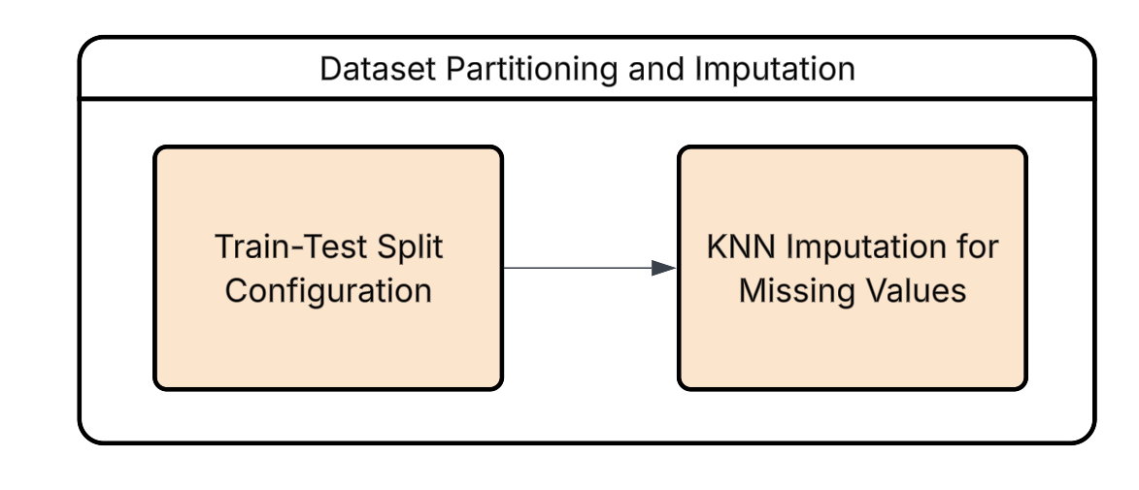
- Train-Test Split Configuration: The dataset was strictly partitioned into training and testing subsets prior to imputation to preserve the integrity of model evaluation and completely mitigate the risk of data leakage.
- KNN (KNN) Imputation for Missing Values: A distance-based KNN (KNN) algorithm was deployed to estimate and impute localized missing values (specifically for CrVI and E. coli) by exploiting the multidimensional similarity of adjacent data points.

3.4 Feature Engineering Framework
To optimize the dataset for predictive modeling, a systematic feature engineering framework was implemented, as illustrated below:


3.4.1 Derivation of WQI-based Features
In this study, the Vietnamese WQI (VN_WQI) was calculated strictly in accordance with the technical guidelines issued by the MONRE (2019). The VN_WQI framework categorizes water quality parameters into five thematic groups: (I) pH, (II) pesticides, (III) heavy metals, (IV) organic matter and nutrients, and (V) microbiological indicators.
For each thematic group g, a group-level index was derived by aggregating its corresponding standardized sub-indices (WQISI) using either the geometric mean or the arithmetic mean, depending on the specific requirements prescribed for each parameter group. Individual water quality parameters were first transformed into dimensionless sub-indices based on the official rating curves, and these sub-indices were subsequently integrated to quantify the overall surface water quality status.
In this study, the VN_WQI was calculated using 16 water quality variables, including temperature, pH, dissolved oxygen (DO), chemical oxygen demand (COD), biochemical oxygen demand (BOD₅), nitrate (NO₃⁻), nitrite (NO₂⁻), ammonium (NH₄⁺), phosphate (PO₄³⁻), total coliforms, Escherichia coli (E. coli), and the heavy metals arsenic (As), mercury (Hg), lead (Pb), cadmium (Cd), and hexavalent chromium (Cr⁶⁺). The final VN_WQI value was obtained by aggregating all available group indices in accordance with the formulation specified in the official guidelines. The VN_WQI is computed according to the following formulation:
$$WQI = \frac{{WQI}_{pH}}{100}×\frac{{\left(\prod_{a=1}^{5}{{WQI}_{III}}\right)}^{\frac{1}{5}}}{100}×{\left(\frac{1}{7}\sum_{b=1}^{7}{{WQI}_{IV}}×\frac{1}{2}\sum_{c=1}^{2}{{WQI}_{IV}}\right)}^{\frac{1}{2}}$$
The WQI provides an aggregated assessment of water quality, allowing classification into five categories: excellent (91–100), good (76–90), fair (51–75), poor (26–50), and very poor (0–25).

3.4.2 Data Standardization
Data Standardization was employed to eliminate severe scale disparities among water quality parameters, ensuring that distance-based algorithms like LR, SVR and KNN are not disproportionately biased by features with large magnitudes.

3.5 Controlled Experimental Design and Modelling Framework

3.6.1 Experimental Design Scenarios
To systematically evaluate how input dimensionality and domain knowledge affect WQI prediction, this study defines four experimental scenarios using a (2 \times 2) factorial design:
(i) feature scope (Comprehensive vs. Parsimonious), and
(ii) feature construction strategy (Direct Measurement vs. Domain-Informed).
This design enables an explicit assessment of both main effects and interaction effects between data richness and expert knowledge integration.


Scenario 1: Comprehensive Direct Measurement Configuration
This scenario uses the full set of directly measured water-quality variables available in the dataset (Temperature, pH, DO, BO$D_{5}$, COD, N$O_{2}$, $NH_{4}$, N$O_{3}$, P$O_{4}$, Coliform, EColi, As, Hg, Pb, Cd, CrVI).
- All features are included in their original measured form after standard preprocessing.
- No domain-engineered variables are introduced.
- This serves as a “data-rich, knowledge-light” baseline to test the model’s ability to learn directly from raw monitoring signals.
Scenario 2: Parsimonious Direct Measurement Configuration
This scenario retains only a minimal subset of directly measured variables, selected based on statistical relevance and operational feasibility.
- The objective is to reduce monitoring burden, improve deployment practicality, and mitigate redundancy/multicollinearity.
- As in Scenario 1, no domain-derived features are added.
- This setup quantifies the accuracy-cost trade-off when moving from a full to a reduced direct-measurement feature set.
Scenario 3: Comprehensive Domain-Informed Configuration
This scenario combines the full feature set with domain-informed engineered variables (${WQI}_{pH}$, ${WQI}_{DO}$, ${WQI}_{BOD_{5}}$, ${WQI}_{COD}$, ${WQI}_{NH_{4}}$, ${WQI}_{NO_{3}}$, ${WQI}_{PO_{4}}, {WQI}_{NO_{2}},$ ${WQI}_{PO_{4}}, {WQI}_{Coliform}, {WQI}_{EColi}, {WQI}_{As}$, ${WQI}_{Hg}, {WQI}_{Cd}, {WQI}_{CrVI}$).

- In addition to raw measurements, derived features are constructed to reflect known water-quality processes (e.g., meaningful ratios, pollutant-load proxies, seasonal/hydrological indicators, and ecologically plausible interactions).
- The aim is to integrate empirical data with process-aware knowledge to improve generalization and robustness under heterogeneous conditions.
- This is a “data-rich, knowledge-rich” setting and is expected to provide the strongest and most stable predictive performance.
Scenario 4: Parsimonious Domain-Informed Configuration
This scenario combines a reduced direct-measurement set with a compact set of high-value domain-informed features.
- The design principle is “minimum inputs, maximum information density.”
- It targets real-world contexts where sampling budgets are limited but reliable prediction remains essential.
- If performance is close to Scenario 3, this configuration offers a strong candidate for practical large-scale deployment.

3.6.2 Standardized Training and Evaluation Pipeline

Grid search was systematically implemented across all candidate models to ensure uniform and unbiased hyperparameter optimisation. This approach guarantees methodological consistency and eliminates preferential tuning effects among algorithms.
For inherently non-ensemble learners, a Bagging Regressor framework was integrated to reduce variance and improve stability under noisy environmental conditions. This design allows single estimators to benefit from bootstrap aggregation while preserving their intrinsic learning characteristics.
Additionally, multiple stacking architectures were constructed and empirically evaluated. These configurations varied in base-learner composition and meta-learner structure, enabling a comprehensive investigation of ensemble synergy and performance trade-offs.
Subsequently, all trained models were evaluated using four regression metrics (MSE, RMSE, MAE, and R²), enabling a structured comparison of predictive error magnitude and variance explanation under a consistent testing framework.

Chapter 4. Results

4.1 Dataset Characteristics and Exploratory Analysis
Water quality data from Center for Natural Resources and Environment Monitoring of Quang Ninh Province, Vietnam, 1110 records were collected from 2019 to 2021 at 125 different location, including key sites near Ha Long Bay, a UNESCO World Natural Heritage site. The dataset includes monthly and bimonthly measurements of physical, chemical, microbiological, and heavy metal parameters to provide a comprehensive assessment of water quality in the province.
The monitored water quality variables comprised: Temperature (T, °C), pH, Dissolved Oxygen (DO, mg/L), Biochemical Oxygen Demand over 5 days (BOD₅, mg/L), Chemical Oxygen Demand (COD, mg/L), Nitrate (NO₃, mg/L), Nitrite (NO₂, mg/L), Ammonium (NH₄⁺, mg/L), Phosphate (PO₄³⁻, mg/L), Coliform (MPN/100 mL), E. coli, and trace heavy metals (As, Hg, Pb, Cd, CrVI, mg/L).
The descriptive statistics of the observed water quality parameters and WQI are summarized in Table 1. Parameters such as Coliform, COD, and BOD₅ exhibited considerable variability, reflecting differences in point and non-point sources of pollution, as well as seasonal hydro-climatic influences. In contrast, parameters such as pH and trace metals showed relatively stable values over the monitoring period.

Table 1 Descriptive statistics of water quality parameters and WQI in Quang Ninh Province (2019–2021)
Paramters | Unit | Minimum | Maximum | Mean | Median | Std. Deviation
Temperature | degrees Celsius | 7.400 | 39.4 | 24.222 | 23.6 | 4.843
pH |  | 4.590 | 8.64 | 6.685 | 6.64 | 0.444
DO | Mg/L | 1.080 | 9.7 | 6.703 | 6.72 | 0.997
COD | Mg/L | 1.500 | 306.4 | 15.604 | 11.3 | 23.158
BOD5 | Mg/L | 1.000 | 54.4 | 4.28 | 3.1 | 4.192
NO3 | Mg/L | 0.008 | 6.528 | 0.345 | 0.214 | 0.638
NO2 | Mg/L | 0.002 | 8.337 | 0.185 | 0.002 | 0.951
NH4 | Mg/L | 0.01 | 6.321 | 0.399 | 0.054 | 1.018
PO4 | Mg/L | 0.01 | 10.365 | 0.051 | 0.01 | 0.336
Coliform | MPN/100ml | 3 | 25000 | 766.685 | 150 | 1885.311
EColi |  | 3 | 400 | 14.118 | 3 | 35.718
As | Mg/L | 0 | 0.014 | 0.001 | 0 | 0.001
Hg | Mg/L | 0 | 0.006 | 0 | 0 | 0
Pb | Mg/L | 0 | 0.066 | 0.001 | 0.001 | 0.003
Cd | Mg/L | 0 | 0.011 | 0.001 | 0.001 | 0
CrVI | Mg/L | 0.001 | 0.03 | 0.001 | 0.001 | 0.003

4.1 Exploratory Analysis of the Dataset
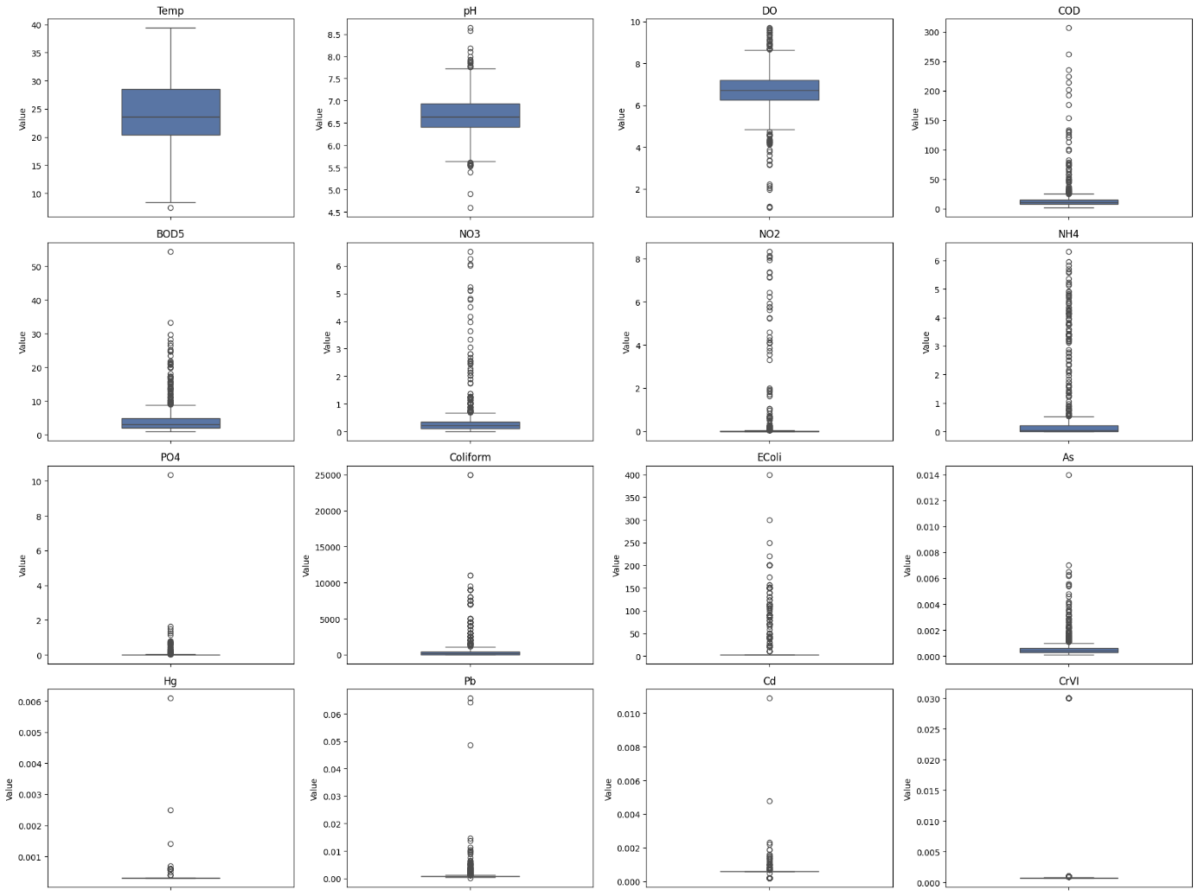

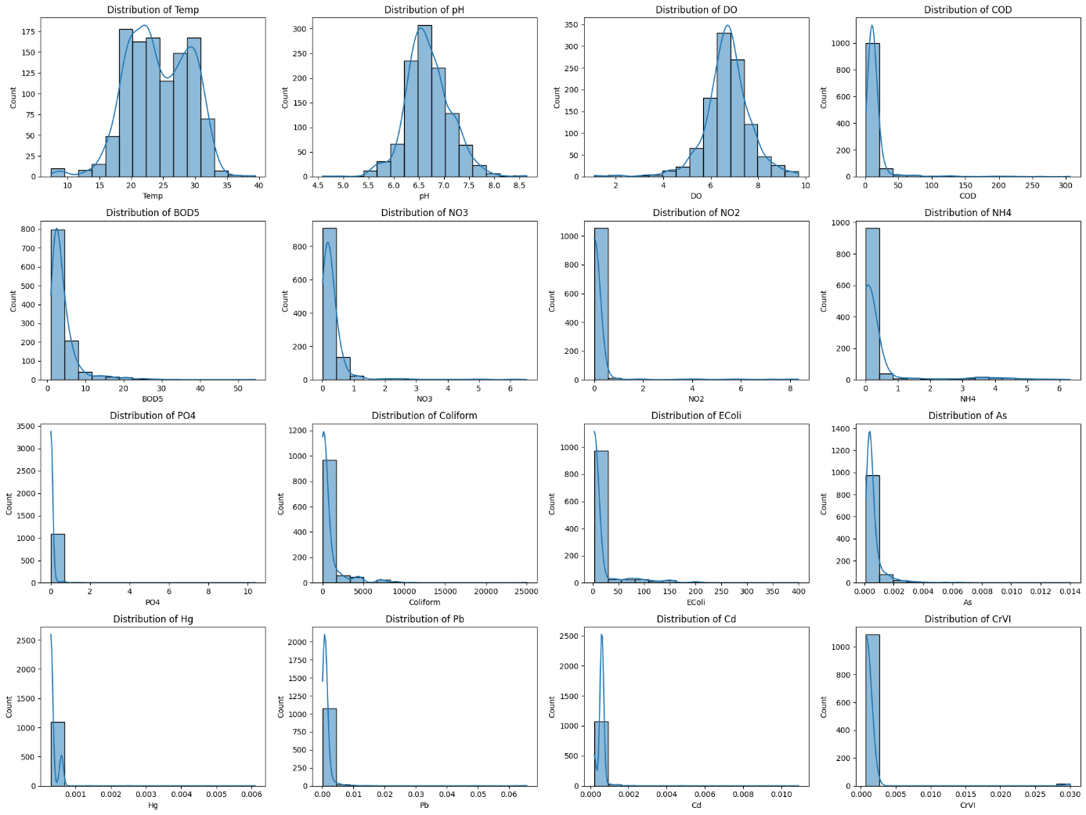


Figure 20
Observations on the Relationship between Temperature and DO:
- Overall Trend: The chart shows a wide dispersion of data points, indicating that there is no strong, simple linear correlation between the two variables. While DO levels vary significantly, there is a visible concentration of higher DO values in the moderate temperature range ($18$–$25$°C), with a slight tendency for the maximum DO values to decrease as temperature exceeds $30$°C, consistent with the physical principle that oxygen solubility typically drops as water warms.
- Distribution of Data Points: The majority of the samples are densely clustered within the temperature range of $20$°C to $30$°C, suggesting this is the most common thermal environment for the collected samples. Within this cluster, most DO values fluctuate between $6$ and $8$ mg/l.
- Variability and Anomalies: There is significant fluctuation in DO levels, with several outliers falling below $4$ mg/l across various temperatures. These low-oxygen instances—some even dropping near $1$ mg/l—indicate that in certain conditions (such as high organic loading or poor aeration), temperature is not the sole factor limiting DO, potentially creating "dead zones" harmful to aquatic life.

Figure 21
Observations on the Relationship between COD and BOD5:
- Overall Trend: The chart illustrates a positive correlation between COD and BOD5, meaning that as Chemical Oxygen Demand increases, Biochemical Oxygen Demand generally increases as well. This relationship is expected, as both parameters measure the amount of organic matter in the water, though COD represents the total chemically oxidizable matter while BOD5 focuses on the biodegradable fraction.
- Distribution of Data Points: The data points are highly concentrated in the low-range area, specifically where COD is under 50 mg/l and BOD5 is under 10 mg/l. Within this dense cluster, the relationship appears more linear, suggesting a consistent ratio between biodegradable and non-biodegradable substances in the majority of the water samples.
- Variability and Anomalies: As the values increase toward the right of the X-axis, the data points become much more scattered. There are several outliers with high COD (up to $300$ mg/l) and significantly higher BOD5 values (exceeding $50$ mg/l). The widening gap between points at higher concentrations suggests that in more polluted samples, the composition of organic waste varies significantly, which could indicate different sources of pollution or varying levels of wastewater treatment.

Figure 22
Observations on the Relationship between Coliform and E. coli:
- Overall Trend: The plot indicates a general upward trend where E. coli levels tend to increase alongside Total Coliform levels, though the relationship is less strictly linear compared to other parameters. Since E. coli is a subgroup of Total Coliforms, it is expected that E. coli counts remain lower than or equal to the total count.
- Distribution of Data Points: Most samples are clustered at the lower end of the scale, with Coliform counts below 5,000 MPN/100mL and E. coli below 150 MPN/100mL. The points are distributed in vertical "stripes" at certain intervals, which may reflect specific measurement thresholds or common levels found in the sampling environment.
- Variability and Anomalies: Significant variability is observed, with a prominent outlier reaching an E. coli level of 400 MPN/100mL at a Coliform level around 4,500 MPN/100mL. Additionally, there is an extreme outlier on the X-axis with a Coliform count of 25,000 MPN/100mL but a relatively low E. coli count (under 100 MPN/100mL), indicating a high presence of non-fecal coliform bacteria in that specific sample

Figure 23
To elucidate the underlying relationships between physicochemical parameters and the constructed Water Quality Indices (WQIs), a Pearson correlation matrix was generated (Figure 4.X). This heatmap visualizes the linear associations between raw water quality parameters, sub-indices, and the final aggregate index (VN_WQI).
A preliminary examination of the raw physicochemical data reveals significant positive correlations among indicators of organic pollution and microbial contamination, consistent with established theoretical expectations. Notably, a strong positive correlation ($r = 0.74$) was observed between Chemical Oxygen Demand (COD) and Biochemical Oxygen Demand (BOD5). This relationship is statistically significant and indicates that the oxidizable organic matter in the sampled water bodies is closely linked to the biodegradable fraction, suggesting a consistent source of organic effluent.
Similarly, the microbiological parameters demonstrated a moderate-to-strong positive association. Total Coliforms and E. coli exhibited a correlation coefficient of $r = 0.63$. Since E. coli is a taxonomical subset of the total coliform group, this covariance is expected; however, the imperfect correlation suggests the presence of other coliform bacteria (e.g., Enterobacter, Klebsiella) driven by environmental factors distinct from purely fecal contamination events.
While the organic and biological markers followed expected linear patterns, the relationships among nitrogenous compounds—Nitrate ($NO_3^-$), Nitrite ($NO_2^-$), and Ammonium ($NH_4^+$)—deviated from the theoretical equilibrium of the nitrogen cycle. In an idealized closed system, sequential nitrification and denitrification processes typically yield strong correlations between these intermediates.
However, the heatmap reveals a distinct decoupling of these variables. While $NO_2^-$ and $NH_4^+$ show a moderate positive correlation ($r \approx 0.64$), $NO_3^-$ displays negligible correlation with $NO_2^-$ ($r = 0.07$) and weak correlation with $NH_4^+$ ($r = 0.28$). This divergence suggests that the nitrogen dynamics in the study area are likely influenced by external, non-linear factors such as varying oxygenation levels, selective agricultural runoff, or distinct point-source pollution inputs that disrupt the standard nitrification kinetics.
Finally, an analysis of the derived indices confirms the structural validity of the aggregate VN_WQI. The final output variable exhibits robust positive correlations with its constituent sub-indices (e.g., WQI_Ecoli, WQI_BOD5, WQI_NH4), with coefficients generally exceeding $0.50$. This strong covariance confirms that the VN_WQI is highly sensitive to changes in its underlying components, effectively synthesizing the multi-dimensional variance of the dataset into a single, representative metric for water quality assessment.
Correlation Analysis of Water Quality Parameters
To investigate the linear relationships between physicochemical parameters and the target variable (VN_WQI), a Pearson correlation matrix was computed, as illustrated in Figure 39. The heatmap reveals distinct patterns of association that are critical for understanding the drivers of water quality in Quang Ninh province.
1. Determinants of WQI (VN_WQI) The analysis indicates that the WQI is most strongly influenced by biological and organic pollutants. Specifically, VN_WQI exhibits a significant negative correlation with Coliform (r = -0.64), E. coli (r = -0.64), and Ammonium (NH₄⁺) (r = -0.59). This strong inverse relationship confirms that fecal contamination and nutrient enrichment are the primary factors degrading water quality in the study area. Conversely, Dissolved Oxygen (DO) shows a moderate positive correlation (r = 0.43) with VN_WQI, reinforcing its role as a key indicator of ecosystem health.
2. Multicollinearity among Predictors A high degree of multicollinearity is observed between certain organic indicators, most notably between COD and BOD₅ (r = 0.74). This strong positive correlation is consistent with their chemical nature, as both measure the oxygen demand required for organic matter degradation. Similarly, Coliform and E. coli share a correlation of 0.63, reflecting their redundancy as microbiological indicators. These interdependencies suggest that while these features are individually important, their simultaneous inclusion in linear models (e.g., LR) may introduce redundancy, whereas non-linear ensemble models like RF are expected to handle these interactions more effectively.
3. Heavy Metal Independence It is noteworthy that heavy metal parameters (As, Hg, Pb, Cd, CrVI) display negligible correlations with VN_WQI, with coefficients nearing zero (ranging from -0.04 to 0.04). This statistical independence aligns with the distribution analysis, which showed that heavy metal concentrations are predominantly low and stable across the monitoring network. Consequently, these parameters contribute minimally to the variance of the overall WQI compared to the fluctuations observed in organic and nutrient parameters.

4.2 Baseline WQI Prediction Using Raw Inputs

4.2.1 Performance Before Feature Selection
Table 2 Individual Regression Model Performance on Raw Water Quality Inputs (Pre-Feature Selection)
Model | MSE | RMSE | MAE | R²
GB | 4.4109 | 2.1002 | 0.9411 | 0.9721
RF | 7.2490 | 2.6924 | 1.1643 | 0.9542
SVR | 12.9041 | 3.5922 | 1.8688 | 0.9184
KNN | 17.3276 | 4.1626 | 2.1910 | 0.8905
LR | 31.6483 | 5.6257 | 3.8525 | 0.7999
The comparative analysis highlights a significant disparity in performance among the evaluated algorithms. LR exhibited the least efficacy, yielding the highest error metrics (MSE = 27.06, RMSE = 5.20) and the lowest coefficient of determination ($R^{2}$ = 0.77). Conversely, tree-based ensemble models (GB and RF) demonstrated superior predictive capabilities compared to the geometric and distance-based approaches (SVR and KNN). Notably, GB emerged as the optimal model, achieving the most robust performance across all metrics ($R^{2}$ = 0.97, RMSE = 2.01).

Table 3 Performance comparison of different stacking model configurations with varying base learners.
Base Models | Num Models | MSE | RMSE | MAE | $$R^{2}$$
RF + KNN + SVR + GB | 4 | 4.036 | 2.009 | 0.9575 | 0.9745
RF + SVR + GB | 3 | 4.0388 | 2.0097 | 0.9584 | 0.9745
SVR + GB | 2 | 4.1123 | 2.0279 | 0.9333 | 0.974
KNN + SVR + GB | 3 | 4.1231 | 2.0305 | 0.9398 | 0.9739
RF + LR + SVR + GB | 4 | 4.1245 | 2.0309 | 0.9782 | 0.9739
As presented in Table 3, the ensemble combining KNN, SVR, and GB achieved the marginally best statistical performance, with the lowest MSE (3.777) and RMSE (1.9434). However, the dual-model configuration (SVR + GB) demonstrated virtually indistinguishable predictive power, yielding an MSE of 3.7792 and an identical
$R^{2}$of 0.9678. Given that the performance difference is negligible, the SVR + GB model is preferable; it offers a more efficient balance between accuracy and computational complexity by utilizing fewer base learners. Overall, the results indicate that increasing the complexity of the stacking ensemble beyond two models yields diminishing returns, with minimal performance variance observed across the tested configurations.
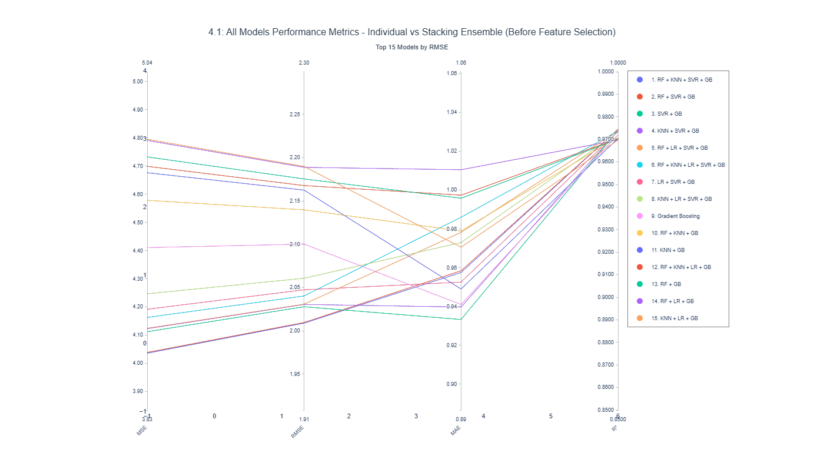

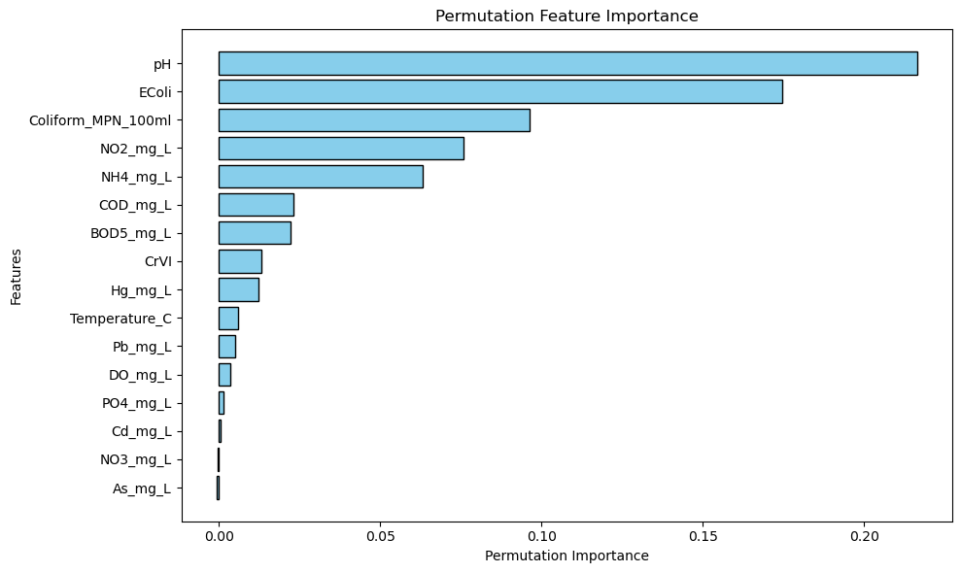
Figure 24 Permutation Feature Importance for WQI Prediction Using Raw Input Parameters (Pre-Feature Selection)
Guided by the permutation importance analysis, features with negligible predictive contribution—specifically ${NO}_{3}$ As, Cd, ${NH}_{4}$, and ${PO}_{4}$—were excluded from the final model to enhance parsimony. Furthermore, to mitigate multicollinearity, Coliform and COD were removed due to their strong correlations with E. coli and ${BOD}_{5}$, respectively. This selection strategy ensures that the variance associated with biological and organic load is preserved through proxy variables while reducing redundant feature space.

4.2.2 Performance After Feature Selection
Table 4 Model Performance Comparison (After Feature Selection)
Model | MSE | RMSE | MAE | R²
GB | 8.4868 | 2.9132 | 1.3952 | 0.9464
RF | 8.8807 | 2.9801 | 1.3245 | 0.9439
SVR | 13.6519 | 3.6948 | 2.0444 | 0.9137
KNN | 25.2235 | 5.0223 | 2.5673 | 0.8406
LR | 39.3430 | 6.2724 | 3.9545 | 0.7513
While the reduction of the feature space led to a universal decline in absolute performance metrics, the relative hierarchy of the models remained invariant. However, a distinct divergence in model sensitivity was observed: GB, RF, and SVR demonstrated remarkable robustness with only marginal deviations in error rates. In contrast, KNN and LR exhibited significant performance deterioration, indicating a higher dependency on the excluded features to maintain predictive stability.
Table 5
Base Models | Num Models | MSE | RMSE | MAE | $$R^{2}$$
KNN + SVR + GB | 3 | 6.9953 | 2.6449 | 1.2519 | 0.9558
RF + KNN + SVR + GB | 4 | 6.9968 | 2.6451 | 1.259 | 0.9558
SVR + GB | 2 | 7.0085 | 2.6474 | 1.2539 | 0.9557
RF + SVR + GB | 3 | 7.0119 | 2.648 | 1.2594 | 0.9557
LR + SVR + GB | 3 | 7.0496 | 2.6551 | 1.2574 | 0.9554

A comparative analysis demonstrates that the performance disparity between the complex stacking ensembles and the standalone GB model is negligible. While the stacking models achieved a marginally higher coefficient of determination ($R^{2}≈$ 0.9564), the GB baseline demonstrated comparable predictive capability ($R^{2}$ = 0.95). Consequently, the deployment of stacking architectures introduces unwarranted redundancy; the minimal reduction in error metrics (MSE/RMSE) does not justify the substantial increase in computational overhead and training latency required by the ensemble approach.
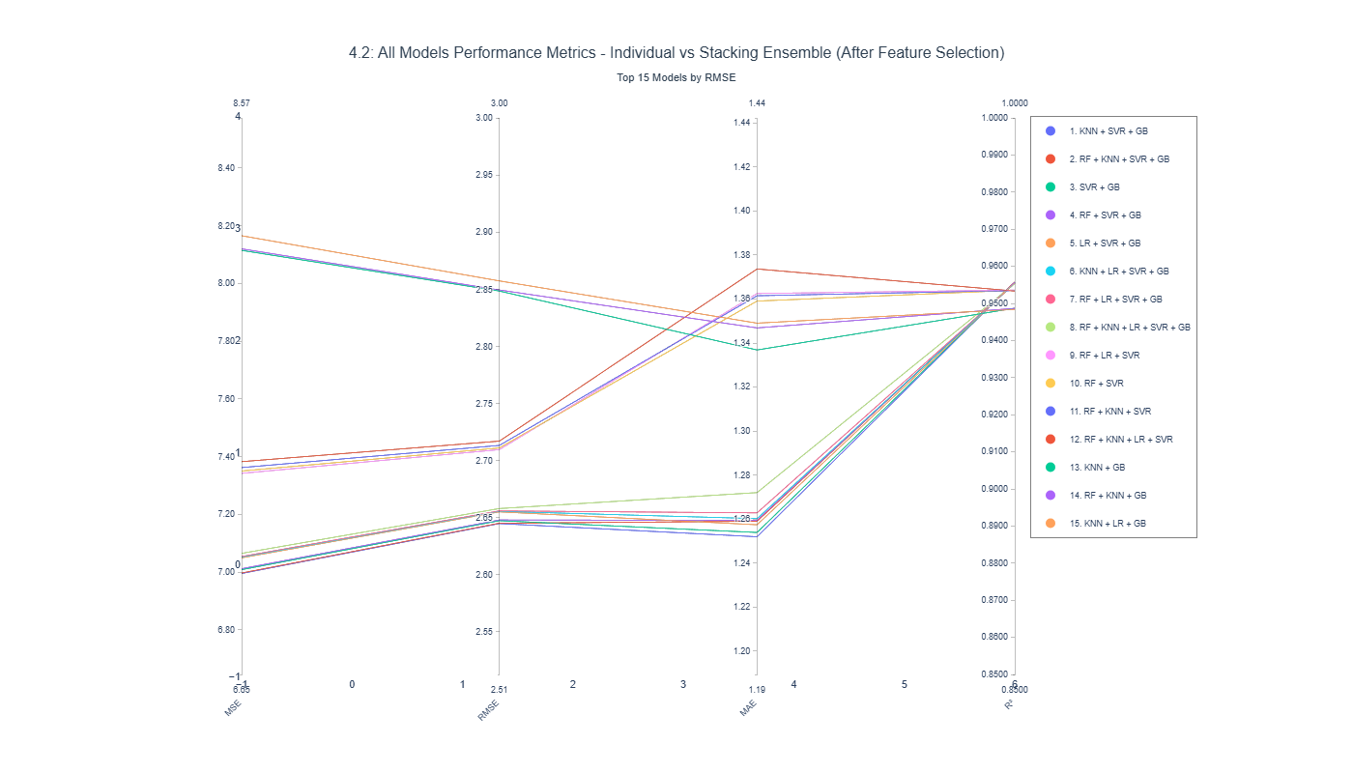
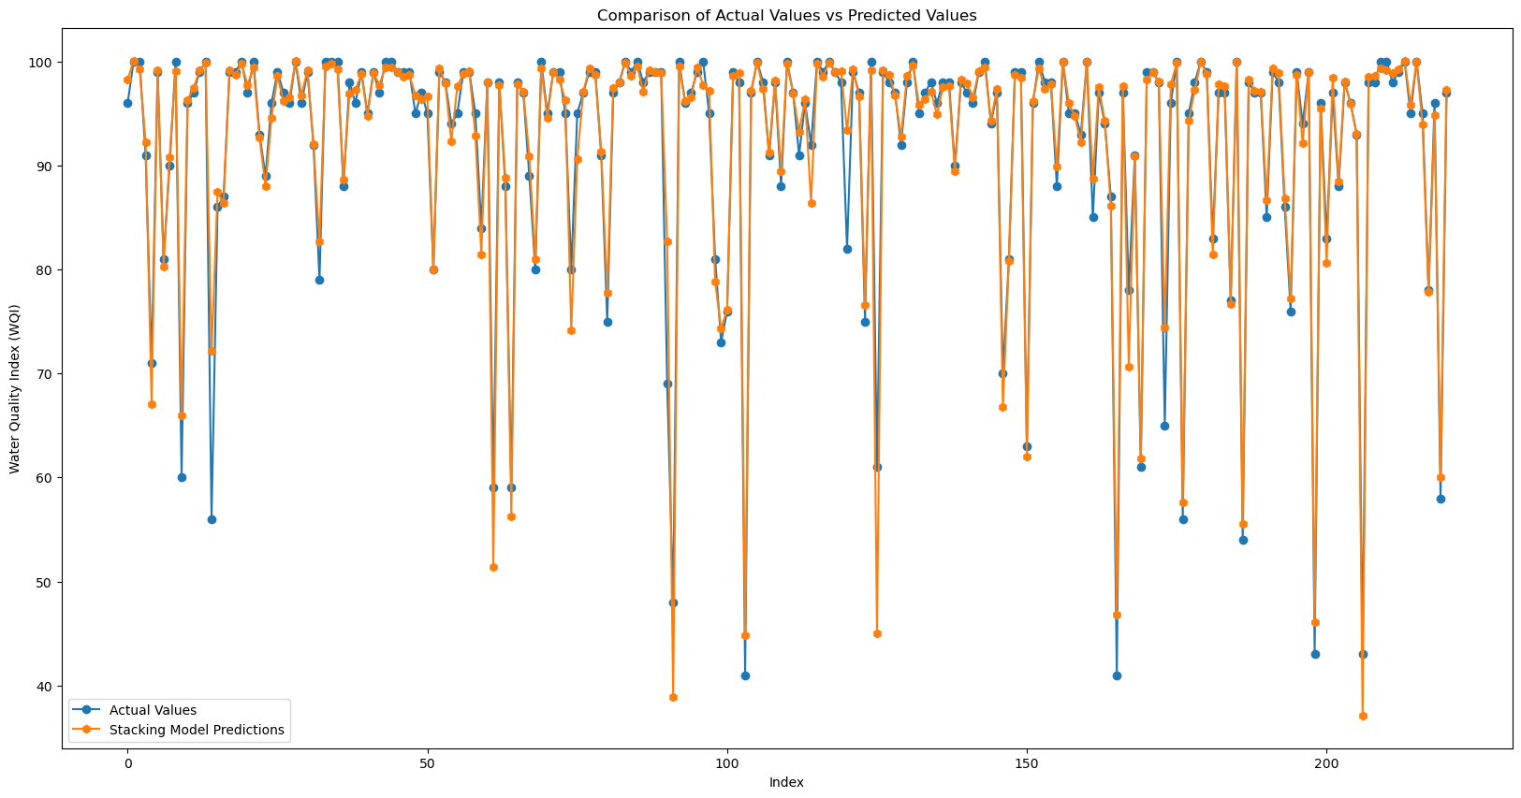

4.3 WQI Prediction Using Engineered Features

4.3.1 Performance Before Feature Selection
Table 6
Model | MSE | RMSE | MAE | R²
LR | 0.8171 | 0.9040 | 0.4086 | 0.9948
SVR | 1.0039 | 1.0019 | 0.39 | 0.9937
KNN | 2.9249 | 1.7102 | 0.7015 | 0.9815
GB | 4.5411 | 2.131 | 0.7542 | 0.9713
RF | 5.2488 | 2.2910 | 0.8576 | 0.9668
A comparative analysis reveals that geometric and distance-based models provide a substantial improvement in predictive accuracy over tree-based models. The transition from tree-based methods (GB, RF) to distance-based methods (SVR, LR) results in a sharp decrease in Mean Squared Error (from ~3.5 to ~0.75). Consequently, SVR and LR emerge as the most robust models for this dataset, achieving near-perfect $R^{2}$ scores exceeding 0.99.
Table 7
Base Models | Num Models | MSE | RMSE | MAE | R2
LR + SVR | 2 | 0.2745 | 0.5239 | 0.3139 | 0.9983
KNN + LR + SVR | 3 | 0.3103 | 0.5571 | 0.3307 | 0.998
RF +KNN + LR + SVR | 4 | 0.353 | 0.5942 | 0.3382 | 0.9978
RF + LR + SVR | 3 | 0.3611 | 0.6009 | 0.3363 | 0.9977
RF + KNN + LR + SVR + GB | 5 | 0.4738 | 0.6883 | 0.3471 | 0.997

The evaluation metrics indicate that the stacking ensemble models significantly outperformed the standalone SVR (SVR) model. Specifically, the stacking configurations achieved considerably lower error rates (MSE, RMSE, MAE) and higher $R^{2}$ scores compared to the single SVR baseline. Among the best stacking models, the performance variances were negligible, suggesting a high degree of stability across the different ensemble combinations.
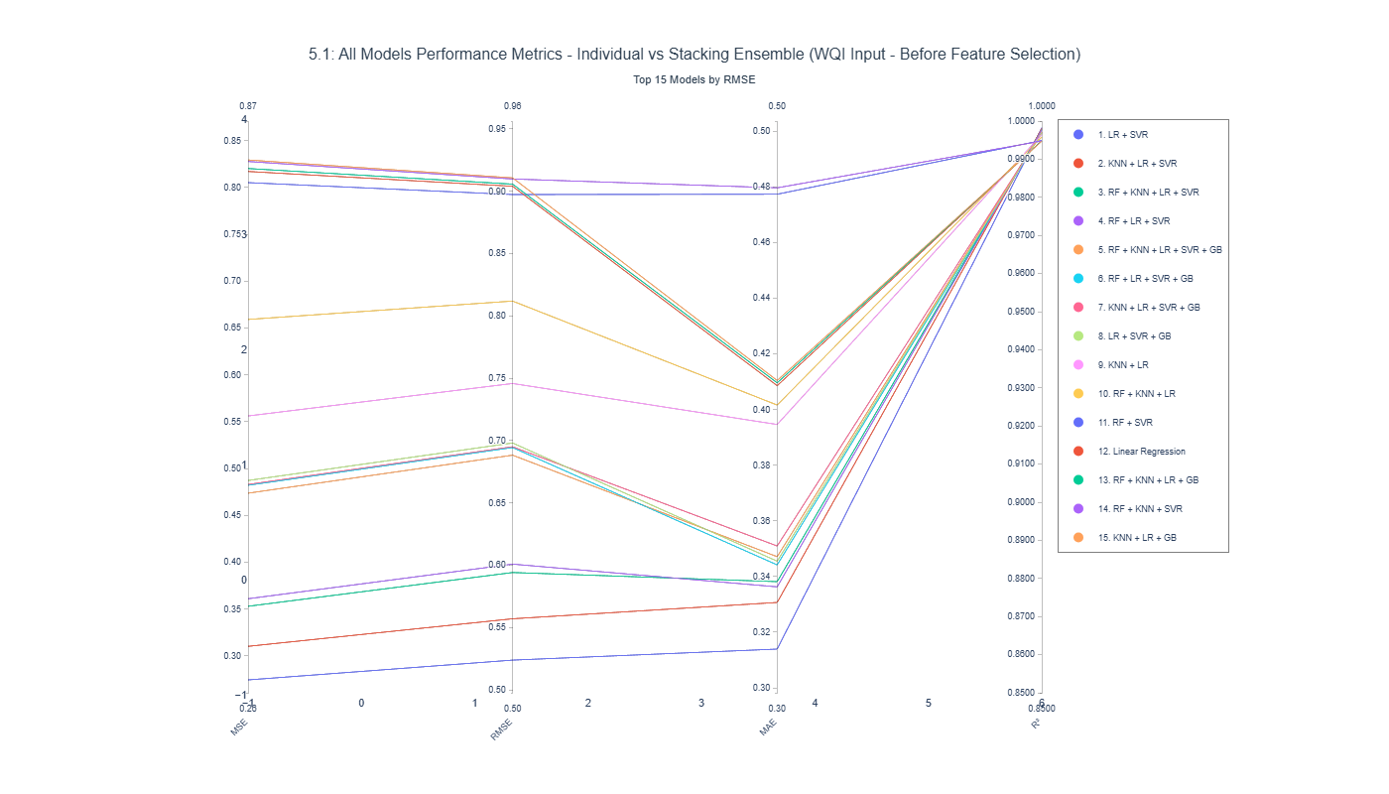
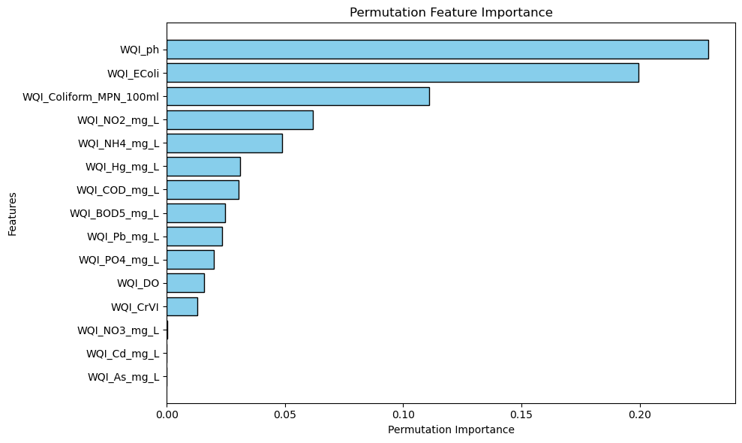
Figure 25
Based on the Permutation Importance analysis in Figure 41, we performed feature selection with the primary objective of minimizing the number of required water quality parameters, thereby reducing monitoring costs and operational complexity in real-world deployment.
While WQI_ph, WQI_EColi, and WQI_NO2_mg_L were identified as critical indicators, the analysis allowed us to streamline the input set by excluding variables that do not justify the cost of measurement:
Elimination of non-contributing parameters: Variables such as NO3, Cd, As, and NH4 showed negligible impact on the model's predictive accuracy (importance near 0). Consequently, these parameters can be safely omitted from the regular monitoring protocol without compromising prediction quality.
Reduction of redundant measurements: Although Coliform and BOD are relevant, their strong correlation with EColi and COD indicates that measuring the latter provides sufficient information. By relying on representative indicators, we eliminate the need for redundant laboratory tests.

4.3.2 Performance After Feature Selection
In this study, the performance of five distinct machine learning models—SVR (SVR), LR, KNN (KNN), GB (GB), and RF (RF)—was evaluated to determine the most effective approach for the predictive task. The models were assessed using four standard statistical metrics: Mean Squared Error (MSE), Root Mean Squared Error (RMSE), Mean Absolute Error (MAE), and the Coefficient of Determination (
$R^{2}$).
The comprehensive experimental results are presented in Table 8 below:
Table 8
Model | MSE | RMSE | MAE | $$R^{2}$$
LR | 5.6371 | 2.3743 | 1.0712 | 0.9644
SVR | 5.8017 | 2.4087 | 1.0106 | 0.9633
KNN | 7.6768 | 2.7707 | 1.1317 | 0.9515
RF | 8.5284 | 2.9203 | 1.2989 | 0.9461
GB | 8.6213 | 2.9362 | 1.3546 | 0.9455
1. General Assessment
As observed from the results, all five models demonstrated strong predictive capabilities, with $R^{2}$scores consistently exceeding 0.94. This indicates that the selected features possess a strong correlation with the target variable and that the data preprocessing stage was effective.
2. Detailed Comparative Analysis
- SVR (SVR): SVR emerged as the superior model, outperforming all other algorithms across every evaluation metric. It achieved the lowest error rates with an MSE of 4.6480, RMSE of 2.1559, and an MAE of 0.9883. Notably, an MAE value below 1.0 signifies a minimal absolute deviation between the predicted values and the actual observed data. Furthermore, SVR achieved the highest $R^{2}$ score of 0.9604, implying that the model can explain approximately 96.04% of the variance in the target variable.
- LR: The LR model demonstrated remarkable stability, ranking second in overall performance. With an RMSE of 2.2088 and an $R^{2}$ of 0.9584, it performed nearly as well as the SVR model. These results suggest that the relationship between the input variables and the output target in this dataset is predominantly linear.
- Tree-based Models and KNN:
  - KNN and GB (GB) yielded respectable results, with
$R^{2}$ values of 0.9538 and 0.9517, respectively.
  - Conversely, RF (RF), despite typically being considered a robust ensemble method, exhibited the lowest performance in this specific experiment, recording an RMSE of 2.6381 and an $R^{2}$ of 0.9407. This suggests that the specific distribution of this dataset may not favor the bagging technique utilized by RF as effectively as the vector-based or linear approaches.
Conclusion
Based on the quantitative analysis presented above, SVR (SVR) is identified as the optimal model for this project. Due to its superior generalization capability and minimal prediction error, SVR has been selected as the primary model for the final deployment of the prediction system.

Table 9
Base Models | Num Models | MSE | RMSE | MAE | $$R^{2}$$
KNN + LR + SVR | 3 | 4.411 | 2.1002 | 0.9325 | 0.9721
KNN + LR | 2 | 4.4594 | 2.1117 | 0.9532 | 0.9718
RF + KNN + LR + SVR | 4 | 4.4884 | 2.1186 | 0.977 | 0.9716
RF + KNN + SVR | 3 | 4.557 | 2.1347 | 0.9923 | 0.9712
RF + KNN + LR + SVR + GB | 5 | 4.62 | 2.1494 | 1.0119 | 0.9708

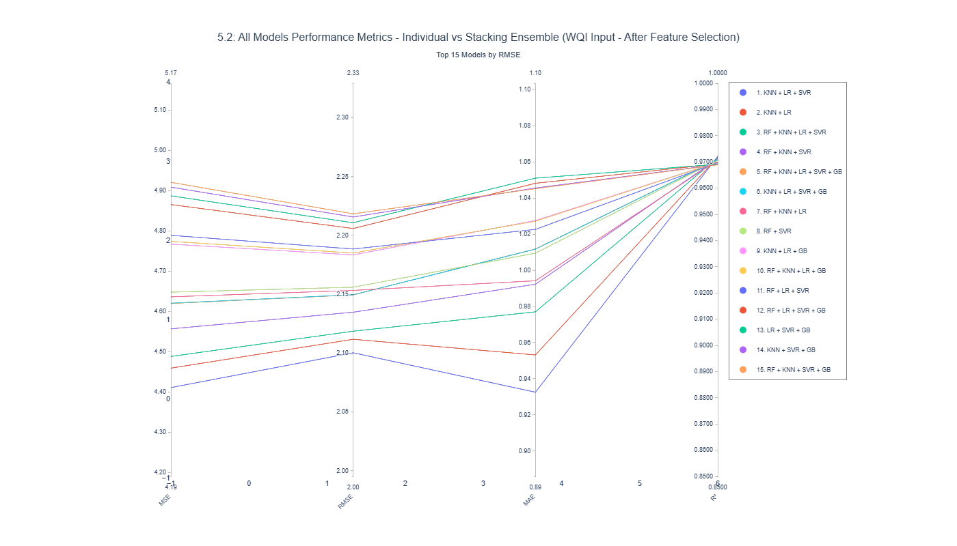
Figure 26
4.4 Comparative Performance Analysis

Figure 27 Performance comparison of Machine Learning and Traditional Calculation methods under Feature Reduction constraints.
The charts above contrast two approaches: predicting WQI via Machine Learning algorithms versus calculating the index using the traditional formula with a reduced parameter set. While the left plot demonstrates the accuracy of the ML predictions against actual values, the right plot assesses how robust the traditional formula is when input variables are removed. Specifically, the horizontal axes (X) serve as the ground truth or baseline values—actual WQI on the left and original manual calculation on the right. The vertical axes (Y) plot the experimental results: the model's predictions and the recalculated WQI with fewer parameters, respectively.
While the Machine Learning model adheres well to the ground truth, it displays noticeable variance (noise). Conversely, the traditional method using a reduced parameter set shows high consistency with minimal noise but induces a positive systematic bias, resulting in scores slightly elevated compared to the baseline calculation.
4.6 Key Empirical Findings
Using bullet academic

Chapter 5. Discussion

5.1 Overview of Principal Findings

5.1.1 Restatement of Research Problem

5.1.1 Key Findings
Tree-based models outperform linear models under raw inputs.
Engineered sub-index inputs dramatically improve linear/SVR performance.
Stacking provides marginal gain but limited cost-efficiency advantage.

5.2 Technical Discussion
Select feature importance by permutation importance might remove important knowledge (talk about choosing feature important tatical)
Nói lý do chọn csv
Hybird model: kết hợp giữa tính WQI_SI và stacking model
Các
About choosing machine learning instead of deep learning
About apply gridsearchCV, bagging techniques
- Compare them with other reseach (có những research cho thấy RF tốt nhưng có nghiên cứu lại chỉ ra SVR mới tốt)
Discuss về cách chọn độ đo

5.2.1 Behavioural Analysis of Machine Learning Models

Nonlinear Structure of Raw Environmental Data
- Environmental data = nonlinear + interaction-heavy.
- Multicollinearity (COD–BOD5, Coliform–Ecoli) harms LR.
- RF/GB handle:
  - nonlinearity
  - interaction
  - feature redundancy
→ Link to bias–variance tradeoff theory.

Sensitivity to Feature Reduction
- KNN & LR sensitive to dimensionality reduction.
- Ensemble models robust due to internal feature sampling.
- Discuss model sensitivity to variance and feature dependency.

Impact of Domain-Informed Feature Engineering

5.2.3 Methodological Contributions

5.2.4 Practical Implications for Coastal Water Governance
- Policy Implications
- Monitoring and Management Recommendations

5.2.5 Conceptual Synthesis of the Proposed Framework

5.3 Performance Discussion
Algorithms based tree performance better than others as they effectively handle noisy data
Xem xét so sánh giữa apply machine learning với k áp dụng machine learning
So sánh từng bước sau khi áp dụng các phương pháp, so sánh các thuật toán với nhau

5.4 Comparison with Existing WQI Prediction Studies
- Literature Comparison: Algorithm Performance
- Literature Comparison: Methodological Approaches

5.5 Comparison with Existing WQI Prediction Studies

5.6 Limitations and Research Boundaries

5.6.1 Model Robustness and Generalisability
- Robustness to Data Variation
- Generalisability Across Regions

Chapter 6. Conclusion

6.1 Summary of Research Purpose

6.2 Synthesis of Key Findings

6.3 Theoretical Contributions (don’r put too much)

6.4 Practical and Policy Implications

6.5 Study Limitations

6.6 Concluding Statement

6.7 Future Work
Summary research

Reference
Abbasi, T., & Abbasi, S. A. (2012). Water Quality Indices. Elsevier. http://ebookcentral.proquest.com/lib/hud/detail.action?docID=892231
Ahmad, T., Ali, L., Alshamsi, D., Aldahan, A., El-Askary, H., & Ahmed, A. (2025). AI-Powered WQI Prediction: Unveiling Machine Learning Precision in Hyper-Arid Regions. Earth Systems and Environment, 9(2), 677–694. https://doi.org/10.1007/s41748-024-00524-8
Ahmed, U., Mumtaz, R., Anwar, H., Shah, A. A., Irfan, R., & García-Nieto, J. (2019). Efficient Water Quality Prediction Using Supervised Machine Learning. Water, 11(11), 2210. https://doi.org/10.3390/w11112210
Baek, S.-S., Pyo, J., & Chun, J. A. (2020). Prediction of Water Level and Water Quality Using a CNN-LSTM Combined Deep Learning Approach. Water, 12(12). https://doi.org/10.3390/w12123399
Barathkumar, S., & Devi, A. C. (2025). Modeling and Prediction of Water Quality Using AI Techniques for Enhanced Monitoring and Management. https://doi.org/10.1002/wer.70143
Barzegar, R., Aalami, M., & Adamowski, J. (2020). Short-term water quality variable prediction using a hybrid CNN–LSTM deep learning model. Stochastic Environmental Research and Risk Assessment, 34, 1–19. https://doi.org/10.1007/s00477-020-01776-2
Brown, R. M., McClelland, N. I., Deininger, R. A., & Tozer, R. G. (1970). A WQI—Do we dare? [Journal Article]. Water & Sewage Works. https://www.researchgate.net/profile/Paul-Hernandez-Romero/post/Brown_et_al_1970A_Water_Quality_Index_Do_We_Dare/attachment/5c74aa66cfe4a781a5834c0c/AS%3A730388808880129%401551149670060/download/A-Water-Quality-Index-Do-we-dare-BROWN-R-M-1970.pdf
CCME. (2017). Canadian Water Quality Guidelines for the Protection of Aquatic Life. User’s Manual. Canadian Council of Ministers of the Environment. USA.
Chidiac, S., El Najjar, P., Ouaini, N., El Rayess, Y., & El Azzi, D. (2023). A comprehensive review of water quality indices (WQIs): History, models, attempts and perspectives. Reviews in Environmental Science and Bio/Technology, 22(2), 349–395. https://doi.org/10.1007/s11157-023-09650-7
Chou, J.-S., Ho, C.-C., & Hoang, H.-S. (2018). Determining quality of water in reservoir using machine learning. Ecological Informatics, 44, 57–75. https://doi.org/10.1016/j.ecoinf.2018.01.005
Choudhary, R., Kumar, A., C., P., Naik, M. M., Choudhury, M., & Khan, N. A. (2025). Predicting WQI using stacked ensemble regression and SHAP based explainable AI. Scientific Reports, 15(1), 31139. https://doi.org/10.1038/s41598-025-09463-4
Dasu, D. (2025). Comparative Analysis of Machine Learning Algorithms for WQI Prediction. Communications on Applied Nonlinear Analysis, 32(9s), 692–701. https://doi.org/10.52783/cana.v32.3975
Dinh Duong, N. (n.d.). Land Use Changes and GIS-database Development for Strategic Environmental Assessment in Ha Long Bay, Quang Ninh Province, Vietnam.
Elgeldawi, E., Sayed, A., Galal, A. R., & Zaki, A. M. (2021). Hyperparameter Tuning for Machine Learning Algorithms Used for Arabic Sentiment Analysis. Informatics, 8(4). https://doi.org/10.3390/informatics8040079
Jayaraman, P., Nagarajan, K. K., Partheeban, P., & Krishnamurthy, V. (2024). Critical review on water quality analysis using IoT and machine learning models. International Journal of Information Management Data Insights, 4(1), 100210. https://doi.org/10.1016/j.jjimei.2023.100210
Khoi, D. N., Quan, N. T., Linh, D. Q., Nhi, P. T. T., & Thuy, N. T. D. (2022). Using Machine Learning Models for Predicting the WQI in the La Buong River, Vietnam. Water, 14(10). https://doi.org/10.3390/w14101552
Kouadri, S., Elbeltagi, A., Islam, A. R. Md. T., & Kateb, S. (2021). Performance of machine learning methods in predicting WQI based on irregular data set: Application on Illizi region (Algerian southeast). Applied Water Science, 11(12), 190. https://doi.org/10.1007/s13201-021-01528-9
Lap, B. Q., Phan, T.-T.-H., Nguyen, H. D., Quang, L. X., Hang, P. T., Phi, N. Q., Hoang, V. T., Linh, P. G., & Hang, B. T. T. (2023). Predicting WQI (WQI) by feature selection and machine learning: A case study of An Kim Hai irrigation system. Ecological Informatics, 74, 101991. https://doi.org/10.1016/j.ecoinf.2023.101991
Liu, P., Wang, J., Sangaiah, A. K., Xie, Y., & Yin, X. (2019). Analysis and Prediction of Water Quality Using LSTM Deep Neural Networks in IoT Environment. Sustainability, 11(7). https://doi.org/10.3390/su11072058
Lumb, A., Halliwell, D., & Sharma, T. (2006). Application of CCME WQI to Monitor Water Quality: A Case Study of the Mackenzie River Basin, Canada. Environmental Monitoring and Assessment, 113(1), 411–429. https://doi.org/10.1007/s10661-005-9092-6
Maier, H. R., & Dandy, G. C. (2000). Neural networks for the prediction and forecasting of water resources variables: A review of modelling issues and applications. Environmental Modelling & Software, 15(1), 101–124. https://doi.org/10.1016/S1364-8152(99)00007-9
Makumbura, R. K., Mampitiya, L., Rathnayake, N., Meddage, D. P. P., Henna, S., Dang, T. L., Hoshino, Y., & Rathnayake, U. (2024a). Advancing water quality assessment and prediction using machine learning models, coupled with explainable AI (XAI) techniques like shapley additive explanations (SHAP) for interpreting the black-box nature. Results in Engineering, 23, 102831. https://doi.org/10.1016/j.rineng.2024.102831
Makumbura, R. K., Mampitiya, L., Rathnayake, N., Meddage, D. P. P., Henna, S., Dang, T. L., Hoshino, Y., & Rathnayake, U. (2024b). Advancing water quality assessment and prediction using machine learning models, coupled with explainable AI (XAI) techniques like shapley additive explanations (SHAP) for interpreting the black-box nature. Results in Engineering, 23, 102831. https://doi.org/10.1016/j.rineng.2024.102831
Moeinzadeh, H., Yong, K.-T., & Withana, A. (2024). A critical analysis of parameter choices in water quality assessment. Water Research, 258, 121777. https://doi.org/10.1016/j.watres.2024.121777
Mogane, L. K., Masebe, T., Msagati, T. A. M., & Ncube, E. (2023). A comprehensive review of water quality indices for lotic and lentic ecosystems. Environmental Monitoring and Assessment, 195(8), 926. https://doi.org/10.1007/s10661-023-11512-2
MONRE. (2019). The Decision on the promulgation of technical guidelines for calculation and publication of the Vietnam WQI (VN_WQI).
Muñoz-Alegría, J. A., Núñez, J., Oyarzún, R., Chávez, C. A., Arumí, J. L., & Rodríguez-López, L. (2025). A Bibliometric-Systematic Literature Review (B-SLR) of Machine Learning-Based Water Quality Prediction: Trends, Gaps, and Future Directions. Water, 17(20). https://doi.org/10.3390/w17202994
Nguyen, N., & Sevando, M. (2019). Assessing Coastal Water Quality throughan Overall Index. Polish Journal of Environmental Studies, 28(4), 2321–2330. https://doi.org/10.15244/pjoes/90836
Noori, R., Berndtsson, R., Hosseinzadeh, M., Adamowski, J. F., & Abyaneh, M. R. (2019). A critical review on the application of the NSFWQI. Environmental Pollution, 244, 575–587. https://doi.org/10.1016/j.envpol.2018.10.076
Ott, W. R. (1978). Environmental indices: Theory and practice. https://www.osti.gov/biblio/6681348
Rangeti, I., Dzwairo, B., Barratt, G., & Otieno, F. (2015). Ecosystem-specific water quality indices. African Journal of Aquatic Science, 40(3), 227–234. https://doi.org/10.2989/16085914.2015.1054341
Shams, M. Y., Elshewey, A. M., El-kenawy, E.-S. M., Ibrahim, A., Talaat, F. M., & Tarek, Z. (2024). Water quality prediction using machine learning models based on grid search method. Multimedia Tools and Applications, 83(12), 35307–35334. https://doi.org/10.1007/s11042-023-16737-4
Shekar, B. H., & Dagnew, G. (2019). Grid Search-Based Hyperparameter Tuning and Classification of Microarray Cancer Data. 2019 Second International Conference on Advanced Computational and Communication Paradigms (ICACCP), 1–8. https://doi.org/10.1109/ICACCP.2019.8882943
Shen, C. (2018). A Transdisciplinary Review of Deep Learning Research and Its Relevance for Water Resources Scientists. Water Resources Research, 54(11), 8558–8593. https://doi.org/10.1029/2018WR022643
Sidek, L. M., Mohiyaden, H. A., Marufuzzaman, M., Noh, N. S. M., Heddam, S., Ehteram, M., Kisi, O., & Sammen, S. Sh. (2024). Developing an ensembled machine learning model for predicting WQI in Johor River Basin. Environmental Sciences Europe, 36(1), 67. https://doi.org/10.1186/s12302-024-00897-7
Štambuk-Giljanović, N. (1999). Water quality evaluation by index in Dalmatia. Water Research, 33(16), 3423–3440. https://doi.org/10.1016/S0043-1354(99)00063-9
Štambuk-Giljanović, N. (2003). Comparison of Dalmatian Water Evaluation Indices. Water Environment Research, 75(5), 388–405. https://doi.org/10.2175/106143003X141196
Sutadian, A. D., Muttil, N., Yilmaz, A. G., & Perera, B. J. C. (2016). Development of river water quality indices—A review. Environmental Monitoring and Assessment, 188(1), 58. https://doi.org/10.1007/s10661-015-5050-0
Talukdar, S., Shahfahad, Ahmed, S., Naikoo, M. W., Rahman, A., Mallik, S., Ningthoujam, S., Bera, S., & Ramana, G. V. (2023). Predicting lake WQI with sensitivity-uncertainty analysis using deep learning algorithms. Journal of Cleaner Production, 406, 136885. https://doi.org/10.1016/j.jclepro.2023.136885
Uddin, M. G., Nash, S., Mahammad Diganta, M. T., Rahman, A., & Olbert, A. I. (2022). Robust machine learning algorithms for predicting coastal WQI. Journal of Environmental Management, 321, 115923. https://doi.org/10.1016/j.jenvman.2022.115923
Uddin, Md. G., Nash, S., & Olbert, A. I. (2021). A review of WQI models and their use for assessing surface water quality. Ecological Indicators, 122, 107218. https://doi.org/10.1016/j.ecolind.2020.107218
UNESCO World Heritage Centre., U. W. H. (n.d.). Ha Long Bay—Cat Ba Archipelago. UNESCO World Heritage Centre. Retrieved 10 February 2026, from https://whc.unesco.org/en/list/672/
Van Hien, D., My, D. H., & Orbell, J. D. (2024). The impact of the COVID-19 pandemic on the seawater quality of Ha Long Bay, Vietnam. Marine Pollution Bulletin, 201, 116242. https://doi.org/10.1016/j.marpolbul.2024.116242
Villalobos-Arias, L., Quesada-López, C., Guevara-Coto, J., Martínez, A., & Jenkins, M. (2020). Evaluating hyper-parameter tuning using random search in support vector machines for software effort estimation. Proceedings of the 16th ACM International Conference on Predictive Models and Data Analytics in Software Engineering, PROMISE 2020, 31–40. https://doi.org/10.1145/3416508.3417121
Xu, J., Mo, Y., Zhu, S., Wu, J., Jin, G., Wang, Y.-G., Ji, Q., & Li, L. (2024). Assessing and predicting WQI with key water parameters by machine learning models in coastal cities, China. Heliyon, 10(13). https://doi.org/10.1016/j.heliyon.2024.e33695
Yaseen, Z. M., Ramal, M. M., Diop, L., Jaafar, O., Demir, V., & Kisi, O. (2018). Hybrid Adaptive Neuro-Fuzzy Models for WQI Estimation. Water Resources Management, 32(7), 2227–2245. https://doi.org/10.1007/s11269-018-1915-7
Yuan, P., Li, H., Yi, X., Wang, J., Ning, C., Xu, X., & Nong, X. (2025). Optimizing WQI using machine learning: A six-year comparative study in riverine and reservoir systems. Scientific Reports, 15(1), 33919. https://doi.org/10.1038/s41598-025-10187-8

