Abstract

Introduction

Product description
Effective water management has become an increasingly critical and urgent issue due to its significant impacts on environmental sustainability, public health, and socio-economic development. In Vietnam, Quang Ninh Province represents a particularly important case, as it encompasses Ha Long Bay, a UNESCO-recognized World Natural Heritage site that is highly sensitive to water quality degradation. Conventional approaches to calculating the Water Quality Index (WQI) rely on extensive field sampling and numerous physicochemical parameters, making the process time-consuming, costly, and potentially hazardous for monitoring personnel. To address these limitations, this project aims to develop a machine learning-based system capable of predicting WQI using a reduced set of key water quality parameters obtained from official monitoring data. By applying and evaluating multiple machine learning algorithms, including an ensemble stacking model, the system seeks to enhance predictive accuracy while minimizing data collection requirements. Furthermore, a systematic feature selection strategy is integrated to identify the most influential parameters, thereby reducing operational costs and improving the efficiency and safety of water quality management in Quang Ninh Province. This approach represents a step towards more efficient, reliable, and data-driven water quality assessment without the need for extensive field operations.

AIM
To design a resource-efficient predictive model for the Water Quality Index (WQI) of Quang Ninh province that minimizes input requirements through feature importance analysis.

OBJECTIVES
• To Synthesize a dataset from records of different Quang Ninh locations
• Perform Exploratory Data Analysis
• Execute feature selection based on correlation between variables and Permutation Importance
• To optimize model performance through a data-driven AI approach
• To enhance predictive accuracy through a data-centric AI approach

Literacy Review

Methodology

3.1 Study Area
Geographic coordinates?

3.2 Workflow
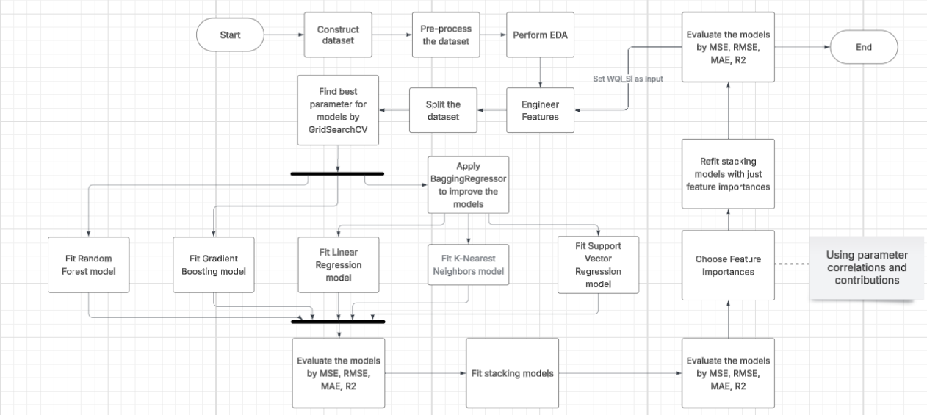

3.3 Data Collection and Processing
Water quality data from Center for Natural Resources and Environment Monitoring of Quang Ninh Province, Vietnam, 1110 records were collected from 2019 to 2021 at 125 different location, including key sites near Ha Long Bay, a UNESCO World Natural Heritage site. The dataset includes monthly and bimonthly measurements of physical, chemical, microbiological, and heavy metal parameters to provide a comprehensive assessment of water quality in the province.
The monitored water quality variables comprised: Temperature (T, °C), pH, Dissolved Oxygen (DO, mg/L), Biochemical Oxygen Demand over 5 days (BOD₅, mg/L), Chemical Oxygen Demand (COD, mg/L), Nitrate (NO₃, mg/L), Nitrite (NO₂, mg/L), Ammonium (NH₄⁺, mg/L), Phosphate (PO₄³⁻, mg/L), Coliform (MPN/100 mL), E. coli, and trace heavy metals (As, Hg, Pb, Cd, CrVI, mg/L).
The descriptive statistics of the observed water quality parameters and WQI are summarized in Table 1. Parameters such as Coliform, COD, and BOD₅ exhibited considerable variability, reflecting differences in point and non-point sources of pollution, as well as seasonal hydro-climatic influences. In contrast, parameters such as pH and trace metals showed relatively stable values over the monitoring period.
The Water Quality Index (WQI) was calculated for each monitoring station using standard guidelines issued by the Ministry of Natural Resources and Environment (MONRE) of Vietnam. The WQI provides an aggregated assessment of water quality, allowing classification into five categories: excellent (91–100), good (76–90), fair (51–75), poor (26–50), and very poor (0–25).
Paramters | Unit | Minimum | Maximum | Mean | Median | Std. Deviation
Temperature | degrees Celsius | 7.400 | 39.4 | 24.222 | 23.6 | 4.843
pH |  | 4.590 | 8.64 | 6.685 | 6.64 | 0.444
DO | Mg/L | 1.080 | 9.7 | 6.703 | 6.72 | 0.997
COD | Mg/L | 1.500 | 306.4 | 15.604 | 11.3 | 23.158
BOD5 | Mg/L | 1.000 | 54.4 | 4.28 | 3.1 | 4.192
NO3 | Mg/L | 0.008 | 6.528 | 0.345 | 0.214 | 0.638
NO2 | Mg/L | 0.002 | 8.337 | 0.185 | 0.002 | 0.951
NH4 | Mg/L | 0.01 | 6.321 | 0.399 | 0.054 | 1.018
PO4 | Mg/L | 0.01 | 10.365 | 0.051 | 0.01 | 0.336
Coliform | MPN/100ml | 3 | 25000 | 766.685 | 150 | 1885.311
EColi |  | 3 | 400 | 14.118 | 3 | 35.718
As | Mg/L | 0 | 0.014 | 0.001 | 0 | 0.001
Hg | Mg/L | 0 | 0.006 | 0 | 0 | 0
Pb | Mg/L | 0 | 0.066 | 0.001 | 0.001 | 0.003
Cd | Mg/L | 0 | 0.011 | 0.001 | 0.001 | 0
CrVI | Mg/L | 0.001 | 0.03 | 0.001 | 0.001 | 0.003
Table 1: Descriptive statistics of water quality parameters and WQI in Quang Ninh Province (2019–2021)
Data pre-processing was performed to ensure quality, consistency, and reliability. Variables were standardized with clear, descriptive names, and irrelevant or redundant columns were removed to reduce dimensionality and computational overhead. Missing values, including placeholders (e.g., “x”, “KCM”), were converted to NaN; columns with excessive missing data were excluded, while remaining gaps were imputed using K-Nearest Neighbors (KNN) to preserve multivariate relationships. Numeric consistency was ensured by converting comma-based decimals and symbolic measurements (e.g., “<x”) into numeric (float) formats. Finally, inconsistencies and extreme values were assessed using domain knowledge; genuine extremes reflecting natural variability were retained, whereas errors were corrected to maintain data integrity and robust model performance.

3.4 Calculation of Water Quality Index (WQI)
In this study, the Vietnamese Water Quality Index (VN_WQI) was calculated strictly in accordance with the technical guidelines issued by the Vietnam Environment Administration (Decision No. 1460/QĐ-TCMT, 2019). The VN_WQI framework categorizes water quality parameters into five thematic groups: (I) pH, (II) pesticides, (III) heavy metals, (IV) organic matter and nutrients, and (V) microbiological indicators.
For each thematic group g, a group-level index was derived by aggregating its corresponding standardized sub-indices (WQISI) using either the geometric mean or the arithmetic mean, depending on the specific requirements prescribed for each parameter group. Individual water quality parameters were first transformed into dimensionless sub-indices based on the official rating curves, and these sub-indices were subsequently integrated to quantify the overall surface water quality status.
In this study, the VN_WQI was calculated using 16 water quality variables, including temperature, pH, dissolved oxygen (DO), chemical oxygen demand (COD), biochemical oxygen demand (BOD₅), nitrate (NO₃⁻), nitrite (NO₂⁻), ammonium (NH₄⁺), phosphate (PO₄³⁻), total coliforms, Escherichia coli (E. coli), and the heavy metals arsenic (As), mercury (Hg), lead (Pb), cadmium (Cd), and hexavalent chromium (Cr⁶⁺). The final VN_WQI value was obtained by aggregating all available group indices in accordance with the formulation specified in the official guidelines. The VN_WQI is computed according to the following formulation:
$$WQI = \frac{{WQI}_{pH}}{100}×\frac{{\left(\prod_{a=1}^{5}{{WQI}_{III}}\right)}^{\frac{1}{5}}}{100}×{\left(\frac{1}{7}\sum_{b=1}^{7}{{WQI}_{IV}}×\frac{1}{2}\sum_{c=1}^{2}{{WQI}_{IV}}\right)}^{\frac{1}{2}}$$

3.4 Exploratory Data Analysis

3.5 Feature Engineering
StandardScaler
RobustScaler

3.6 Data Splitting
Data splitting is a fundamental step in the development of predictive models, as it ensures that the model's performance is evaluated on unseen data, thus providing a reliable estimate of its generalization capability. The primary objective of data splitting is to prevent overfitting and to assess the predictive accuracy of the model under conditions that mimic real-world application.

3.6.1 Hold-out Method
The hold-out method is the most straightforward approach to data partitioning. In this technique, the dataset is divided into two or three mutually exclusive subsets: a training set, a validation set (optional), and a test set. Typically, a common split ratio is 70:30 or 80:20 for training and testing, respectively. The training set is used to fit the model, the validation set is employed for hyperparameter tuning, and the test set provides an unbiased evaluation of model performance. Despite its simplicity, the hold-out method can lead to high variance in performance estimation, especially when the dataset is small, as the evaluation heavily depends on which data points are assigned to each subset.

3.6.2 K-Fold Cross-Validation
K-fold cross-validation (CV) is a more robust and widely used technique that mitigates the variance issues of the hold-out method. In K-fold CV, the dataset is partitioned into K equally sized folds. The model is trained K times, each time using K–1 folds as the training set and the remaining fold as the validation set. The performance metrics are then averaged across all K iterations to obtain a comprehensive estimate of model accuracy. This approach not only maximizes the utilization of available data for both training and evaluation but also reduces the risk of biased performance estimates due to random data splits. Common choices for K are 5 or 10, balancing computational cost and estimation reliability.

3.4 Machine Learning Models

3.4.1 Random Forest
Random Forest is an ensemble learning algorithm built upon the foundation of decision trees. It operates by constructing a large number of individual decision trees during the training phase, each using a randomly selected subset of the data (bagging) and a randomly chosen subset of features for node splitting. This stochastic process ensures diversity among the trees, which, when aggregated through majority voting (for classification) or averaging (for regression), enhances predictive performance and reduces the risk of overfitting.
In this study, Random Forest is employed to model and predict water quality based on multiple independent variables, enabling the algorithm to capture complex, non-linear interactions that may not be adequately represented by a single decision tree. Its notable advantages include high predictive accuracy, robustness against overfitting, and the capacity to handle large datasets with numerous and potentially correlated features. However, it also has limitations, such as reduced interpretability of individual predictors and higher computational demands. Due to its flexibility and reliability, Random Forest is widely applied in various domains, including regression tasks and classification problems, making it a popular choice in contemporary machine learning research.

3.4.2 Gradient Boosting
Gradient Boosting is a supervised machine learning algorithm widely employed for regression and classification tasks. The algorithm operates on the principle of boosting, whereby a sequence of weak learners—typically shallow decision trees—is built iteratively. Each successive tree is trained to correct the residual errors of the combined ensemble of preceding trees by optimizing a specified loss function, often using gradient-based methods to determine the most effective direction for minimizing errors. This sequential approach allows Gradient Boosting to capture complex, non-linear relationships between predictors and the target variable.
Gradient Boosting is highly flexible, capable of handling both linear and non-linear patterns in data, and supports a variety of loss functions, such as mean squared error for regression or log-loss for classification. However, achieving optimal performance requires careful tuning of hyperparameters, including the learning rate, number of trees (n_estimators), and tree depth (max_depth). While Gradient Boosting often yields high predictive accuracy, it is sensitive to noisy data and generally demands greater computational resources compared to algorithms such as Random Forest. Its adaptability and precision make it widely applied in domains such as finance, healthcare, and data science.

3.4.3 Linear Regression
Multiple Linear Regression is a statistical method used to model the relationship between a continuous dependent variable and one or more independent variables, which may be either continuous or categorical. In data analysis and predictive modeling, multiple linear regression plays a pivotal role in understanding and forecasting the relationships between a dependent variable—such as the Water Quality Index (WQI)—and several independent variables (water quality indicators).
A multiple linear regression model provides critical insights into the extent to which each independent variable influences the dependent variable, as well as the overall integrity and predictive capability of the model. Formally, a multiple linear regression model represents a linear relationship between a dependent variable $Y$and multiple independent variables $X_{1},X_{2},…,X_{n}$. The model can be expressed mathematically as:
$$Y=β_{0}+β_{1}X_{1}+β_{2}X_{2}+⋯+β_{n}X_{n}+ϵ$$
where:
- $Y$denotes the dependent variable (also referred to as the response or predicted variable).
- $X_{1},X_{2},…,X_{n}$denote the independent variables (also called explanatory or predictor variables).
- $β_{1},β_{2},…,β_{n}$are the regression coefficients, representing the magnitude and direction of each independent variable’s effect on the dependent variable.
- $ϵ$is the random error term capturing unexplained variation.

3.4.4 K-Nearest Neighbors
K-Nearest Neighbors (KNN) is a non-parametric, instance-based supervised learning algorithm commonly used for both regression and classification tasks. KNN operates on a simple yet powerful principle: to predict the output for a given query point, it identifies the k closest data points (neighbors) in the training set based on a chosen distance metric, such as Euclidean or Manhattan distance. For classification, the algorithm assigns the class most frequently represented among the neighbors, while for regression, it computes the predicted value as the average of the neighbors’ target values.
One of the main strengths of KNN is its simplicity and capacity to capture complex patterns without assuming a specific functional form for the relationship between predictors and the target variable. It is also naturally adaptive to multi-class problems and can easily incorporate different distance metrics to reflect domain-specific similarity. However, KNN has notable limitations: it can be sensitive to irrelevant or highly correlated features, the choice of k significantly affects performance, and computational costs increase with large datasets since all distances must be computed at prediction time. Despite these challenges, KNN remains widely used in domains such as pattern recognition, environmental modeling, and healthcare, due to its intuitive approach and effectiveness in situations where the underlying data distribution is unknown.

3.4.5 Support Vector Regression
Support Vector Regression (SVR) is a supervised learning algorithm derived from the principles of Support Vector Machines (SVM), designed for regression tasks. SVR aims to find a function that approximates the relationship between input variables and a continuous target variable while maintaining a predefined tolerance $ε$around the predicted values. Specifically, the algorithm constructs a hyperplane in a high-dimensional feature space that maximizes the margin of tolerance for deviations within $ε$, while penalizing predictions that fall outside this margin using a regularization parameter $C$. Kernel functions, such as linear, polynomial, or radial basis function (RBF), allow SVR to capture both linear and highly non-linear relationships between predictors and the target variable.
The key advantages of SVR include its ability to handle high-dimensional data, robustness to overfitting through regularization, and flexibility in modeling complex non-linear patterns. However, SVR is sensitive to the choice of hyperparameters—particularly $C$, $ε$, and the kernel parameters—and can be computationally intensive for large datasets. Despite these challenges, SVR has been successfully applied in numerous fields, including environmental modeling, finance, and engineering, due to its precise predictive performance and theoretical grounding in statistical learning theory.

3.4.6 Stacking Model
Stacking (Stacked Ensemble) Model is an advanced ensemble learning technique that combines multiple base learners to improve predictive performance. Unlike bagging or boosting, which aggregate predictions directly, stacking operates in a two-level framework: the first level consists of several diverse base models—such as decision trees, Random Forest, Gradient Boosting, or Support Vector Regression—that are independently trained on the original dataset. The second-level model, often called the meta-learner, is trained on the predictions of the base models to learn how to optimally combine them, thereby reducing individual model biases and leveraging complementary strengths.
Stacking is particularly effective for capturing complex patterns in data, as it integrates the predictive power of heterogeneous models. Its advantages include improved accuracy and generalization compared to single models or simple ensembles. However, it requires careful selection and tuning of both base models and the meta-learner, and it can be computationally demanding. In this study, stacking is employed to enhance water quality index prediction by aggregating multiple machine learning algorithms, enabling robust and accurate modeling of non-linear relationships among water quality indicators.

3.4.7 Bagging ensemble method
Bagging (Bootstrap Aggregating) is an ensemble learning technique primarily aimed at reducing model variance and improving generalization performance. The method trains multiple base learners on bootstrapped samples generated via random sampling with replacement from the original dataset, thereby introducing diversity among individual models. For regression tasks, the final prediction is obtained by averaging the outputs of all base learners.
Bagging is particularly effective when applied to high-variance algorithms, such as decision tree–based models, as it mitigates overfitting without increasing model bias. Unlike boosting methods, base learners in bagging are trained independently, making the approach computationally efficient and well suited for parallel implementation. However, performance improvements are limited for low-variance models, and the interpretability of the ensemble is reduced compared to single-model approaches.

3.5 Evaluation metrics
The accuracy of machine learning models can be assessed using metrics such as R-squared, Mean Squared Error (MSE), and Mean Absolute Error (MAE). Evaluating a model should not rely solely on a single metric; rather, it requires a combination of techniques and appropriate indicators tailored to the specific problem. A thorough understanding of these evaluation methods ensures that the model achieves optimal performance and can be effectively applied in practice.
- Mean Squared Error (MSE): MSE represents the average of the squared differences between predicted and actual values. A lower MSE indicates higher predictive accuracy of the model.
$$\text{MSE}=\frac{1}{n}\sum_{i=1}^{n}{(}y_{i}-{\hat{y}}_{i})^{2}$$
- Root Mean Squared Error (RMSE): RMSE is the square root of MSE. It quantifies the average prediction error while bringing the error back to the same units as the original data, facilitating more intuitive interpretation.
$$\text{RMSE}=\sqrt{\frac{1}{n}\sum_{i=1}^{n}{(}y_{i}-{\hat{y}}_{i})^{2}}$$
- R-squared (R²): R-squared measures the proportion of variance in the dependent variable that is explained by the model. Its value ranges from 0 to 1, with higher values indicating better explanatory power of the model regarding the data variability.
$$R^{2}=1-\frac{\sum_{i=1}^{n}{(}y_{i}-{\hat{y}}_{i})^{2}}{\sum_{i=1}^{n}{(}y_{i}-\overset{ˉ}{y})^{2}}$$
- Mean Absolute Error (MAE): MAE is the average of the absolute differences between predicted and actual values. It provides a straightforward measure of the average deviation of predictions from actual observations.
$$\text{MAE}=\frac{1}{n}\sum_{i=1}^{n}{∣}y_{i}-{\hat{y}}_{i}∣$$
Where:
- $n$is the total number of samples in the dataset.
- $y_{i}$denotes the observed value of the $i$-th sample.
- ${\hat{y}}_{i}$denotes the predicted value of the $i$-th sample.
Importance of Model Evaluation:
- Ensures the predictive accuracy of the model.
- Prevents overfitting or underfitting.
- Tests the model’s generalizability on unseen data.
- Enables performance comparison among different models to select the most suitable one.
- Ensures model stability and robustness.
- Guarantees the reliability of predictions for real-world applications.

Results

4.1 Data Analysis
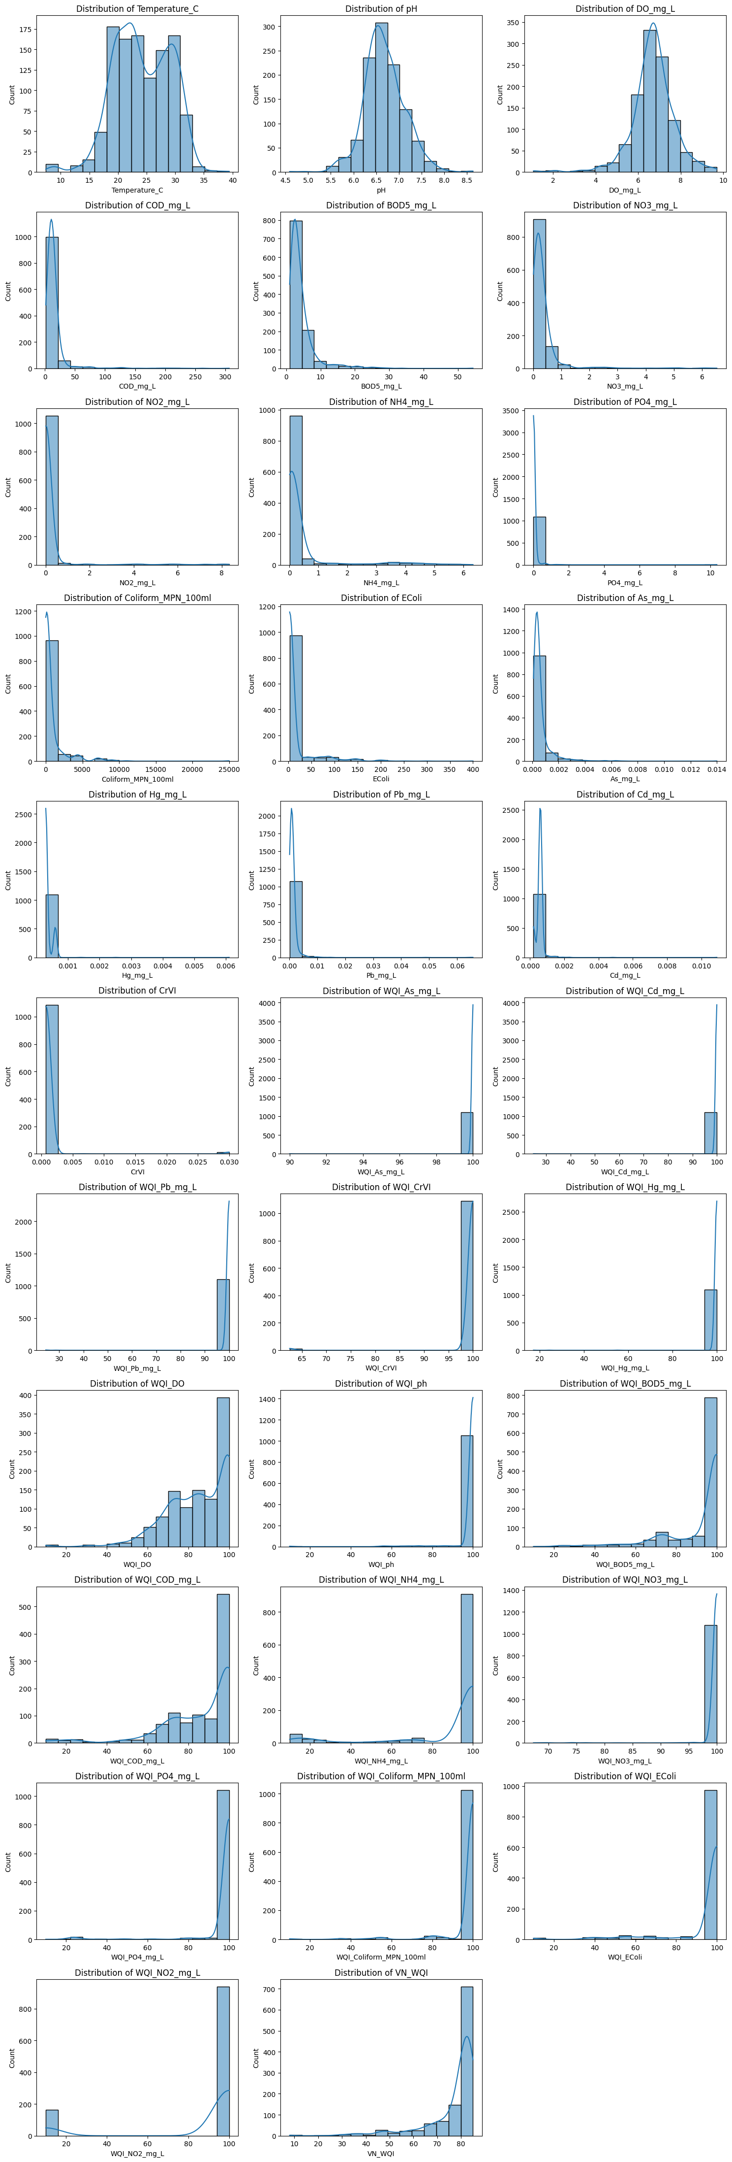




4.2 Direct Measurement Inputs
Before removing unimportant features
Model | MSE | RMSE | MAE | R²
Random Forest | 4.97 | 2.23 | 1.06 | 0.96
Gradient Boosting | 4.04 | 2.01 | 0.91 | 0.97
Linear Regression | 27.06 | 5.20 | 3.51 | 0.77
K-Nearest Neighbors | 14.34 | 3.79 | 2.15 | 0.88
Support Vector Regression | 10.31 | 3.21 | 1.75 | 0.91

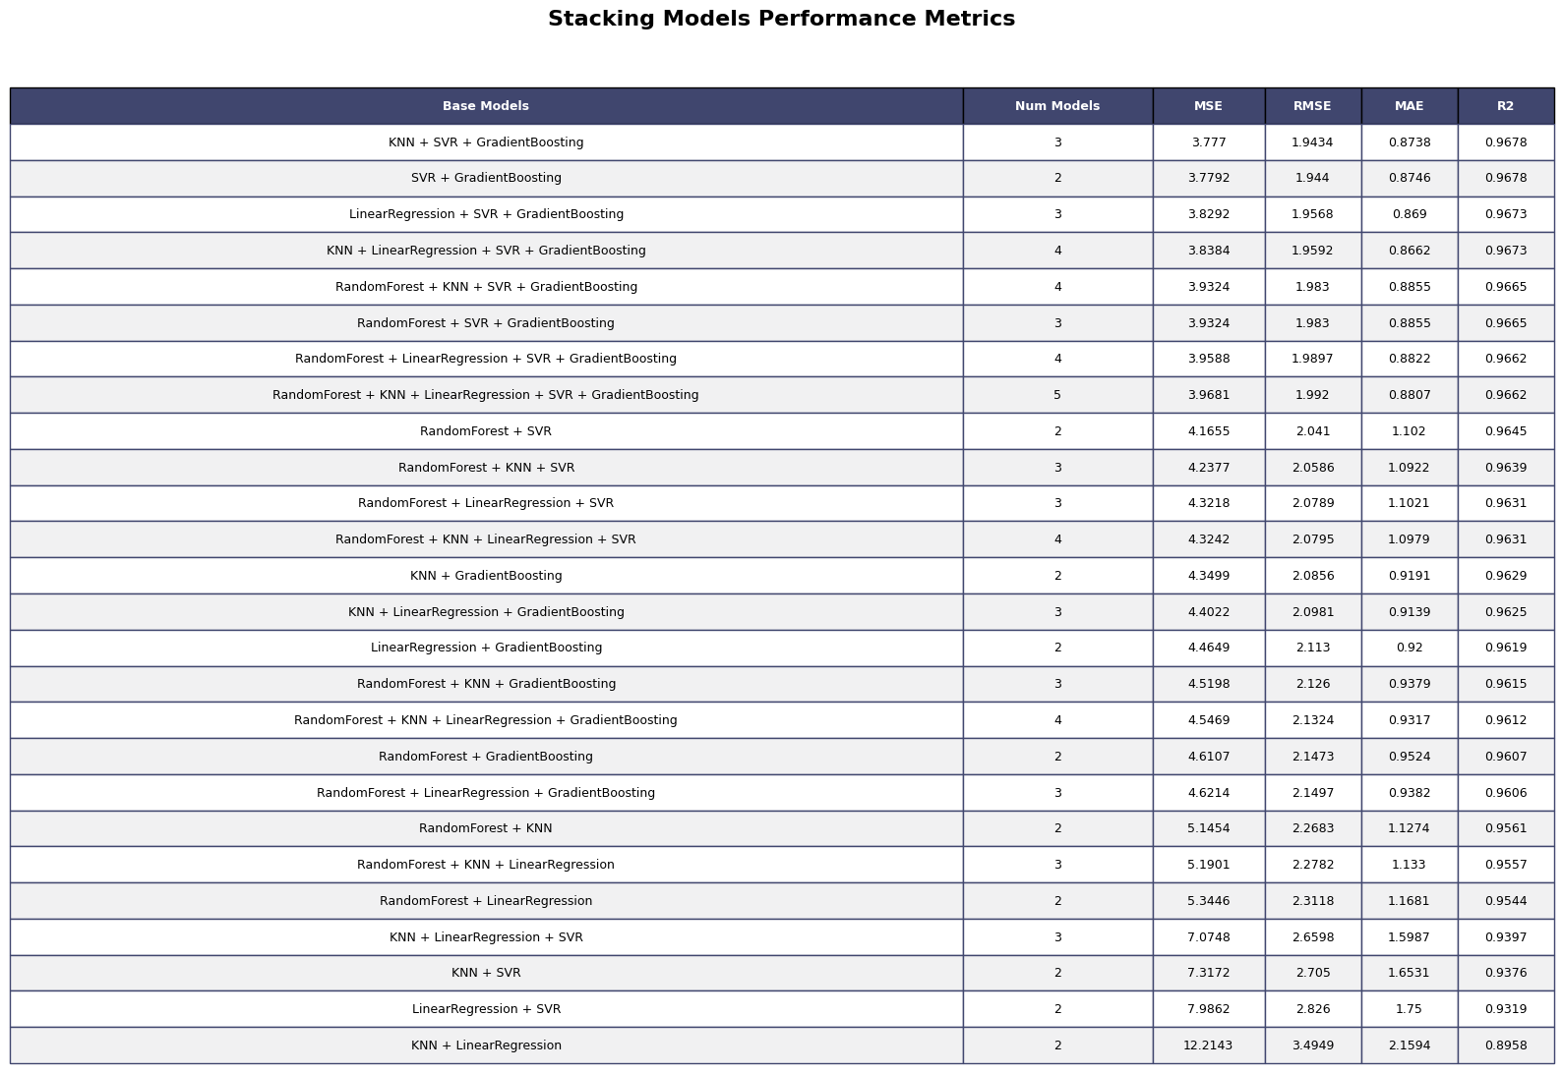


After removing unimportant features
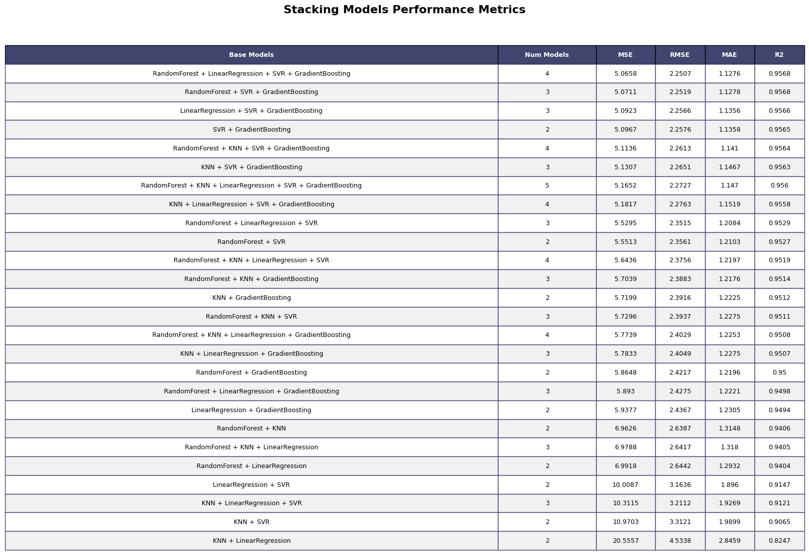

4.3 Feature Engineered Inputs (WQI_SI)
Before removing unimportant features
Random Forest | 3.54 | 1.88 | 0.71 | 0.97
Gradient Boosting | 3.43 | 1.85 | 0.75 | 0.97
Linear Regression | 0.75 | 0.87 | 0.45 | 0.99
K-Nearest Neighbors | 2.84 | 1.69 | 0.70 | 0.98
Support Vector Regression | 0.73 | 0.85 | 0.40 | 0.99

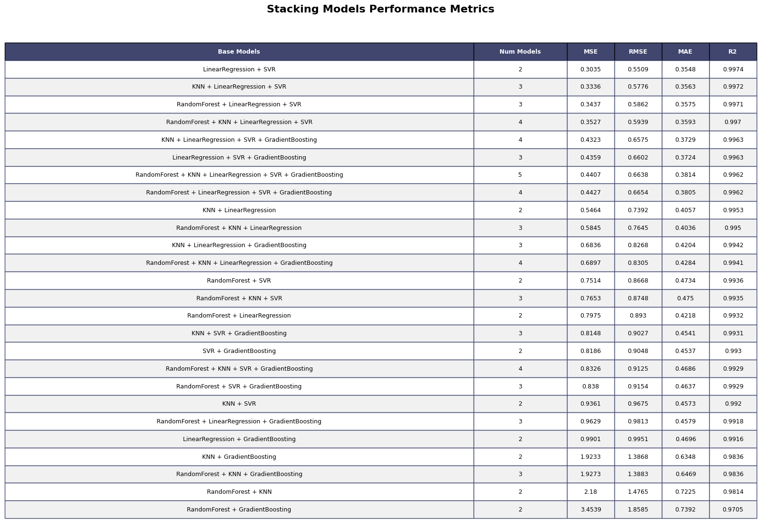

After removing unimportant features
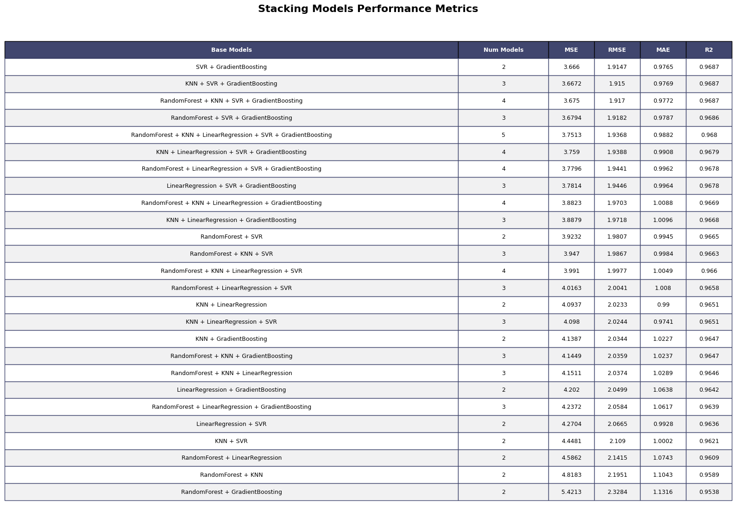

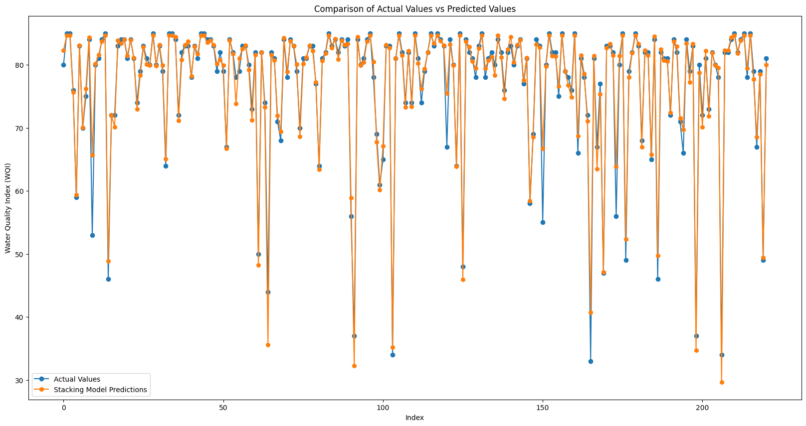

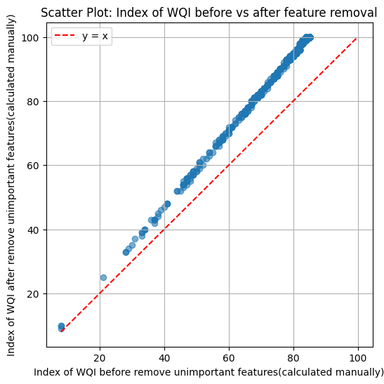

Discussion

Technical:
Select feature importance by permutation importance might remove important knowledge

Performance:
Algorithms based tree performance better than others as they effectively handle noisy data

Conclusion

Future work

Reference:

