ABSTRACT

Table of Contents
ABSTRACT 1
CHAPTER 1. INTRODUCTION 1
Product description 1
AIM 1
OBJECTIVES 1
CHAPTER 2. LITERACY REVIEW 1
CHAPTER 3. METHODOLOGY 1
3.1 Study Area 1
3.2 Workflow 1
3.3 Data Collection and Processing 1
3.4 Calculation of Water Quality Index (WQI) 1
3.5 Exploratory Data Analysis 1
3.6 Feature Engineering 1
3.7 Data Splitting 1
3.7.1 Hold-out Method 1
3.7.2 K-Fold Cross-Validation 1
3.8 Machine Learning Models 1
3.8.1 Random Forest 1
3.8.2 Gradient Boosting 1
3.8.3 Linear Regression 1
3.8.4 K-Nearest Neighbors 1
3.8.5 Support Vector Regression 1
3.8.6 Stacking Model 1
3.9 Evaluation metrics 1
CHAPTER 4. RESULT 1
4.1 Data Analysis 1
CHAPTER 5. DICUSSION 1
5.1 Technical 1
5.2 Performance 1
CHAPTER 6. CONCLUSION 1
CHAPTER 7. FUTURE WORK 1
REFERENCE 1

Figure 1 1
Figure 2 1
Figure 3 1
Figure 4 1
Figure 5 1
Figure 6 1
Figure 7 1
Figure 8 1
Figure 9 1
Figure 10 1
Figure 11 1
Figure 12 1
Figure 13 1
Figure 14 1
Figure 15 1
Figure 16 1
Figure 17 1
Figure 18 1
Figure 19 1
Figure 20 1
Figure 21 1
Figure 22 1
Figure 23 1
Figure 24 1
Figure 25 1
Figure 26 1
Figure 27 1
Figure 28 1
Figure 29 1
Figure 30 1
Figure 31 1
Figure 32 1
Figure 33 1
Figure 34 1
Figure 35 1
Figure 36 1
Figure 37 1
Figure 38 1
Figure 39 1
Figure 40 1
Figure 41 1
Figure 42 1
Figure 43 1

Table 1 1
Table 2 1
Table 3 1
Table 4 1
Table 5 1
Table 6 1
Table 7 1
Table 8 1
Table 9 1

CHAPTER 1. INTRODUCTION

1.1 Product description
Effective water management has become an increasingly critical and urgent issue due to its significant impacts on environmental sustainability, public health, and socio-economic development. In Vietnam, Quang Ninh Province represents a particularly important case, as it encompasses Ha Long Bay, a UNESCO-recognized World Natural Heritage site that is highly sensitive to water quality degradation. Conventional approaches to calculating the Water Quality Index (WQI) rely on extensive field sampling and numerous physicochemical parameters, making the process time-consuming, costly, and potentially hazardous for monitoring personnel. To address these limitations, this project aims to develop a machine learning-based system capable of predicting WQI using a reduced set of key water quality parameters obtained from official monitoring data. By applying and evaluating multiple machine learning algorithms, including an ensemble stacking model, the system seeks to enhance predictive accuracy while minimizing data collection requirements. Furthermore, a systematic feature selection strategy is integrated to identify the most influential parameters, thereby reducing operational costs and improving the efficiency and safety of water quality management in Quang Ninh Province. This approach represents a step towards more efficient, reliable, and data-driven water quality assessment without the need for extensive field operations.

1.2 AIM
To design a resource-efficient predictive model for the Water Quality Index (WQI) of Quang Ninh province that minimizes input requirements through feature importance analysis.

1.3 OBJECTIVES
• To Synthesize a dataset from records of different Quang Ninh locations
• Perform Exploratory Data Analysis
• Execute feature selection based on correlation between variables and Permutation Importance
• To optimize model performance through a data-driven AI approach
• To enhance predictive accuracy through a data-centric AI approach

CHAPTER 2. LITERACY REVIEW

2.1 Background of WQI
The Water Quality Index (WQI) serves as a critical mathematical instrument designed to transform multivariate physical, chemical, and biological datasets into a single dimensionless score, thereby facilitating effective environmental communication to policymakers and the public (Štambuk-Giljanović, 1999, 2003; Sutadian et al., 2015). Originating from Horton’s (1965) foundational arithmetic approach and subsequently refined by Brown et al.’s (1970) consensus-based National Sanitation Foundation Water Quality Index (NSFWQI), the WQI has evolved through various regional adaptations and statistical frameworks, such as the flexible Canadian Council of Ministers of the Environment model (CCME, 2001) . Despite methodological heterogeneity, the construction of these indices universally adheres to a four-stage process comprising parameter selection, sub-index transformation, weighting, and aggregation (Abbasi & Abbasi, 2012), underscoring their enduring utility in integrated water resources management (Uddin et al., 2021).

2.2 Background of Machine Learning-based WQI
Current literature classifies Machine Learning (ML) methodologies for WQI prediction into four primary domains, ranging from baseline statistical models to advanced deep learning architectures.

Figure 1 Evolutionary trends in the deployment of AI, Machine Learning, and Deep Learning for water quality forecasting (Muñoz-Alegría et al., 2025)

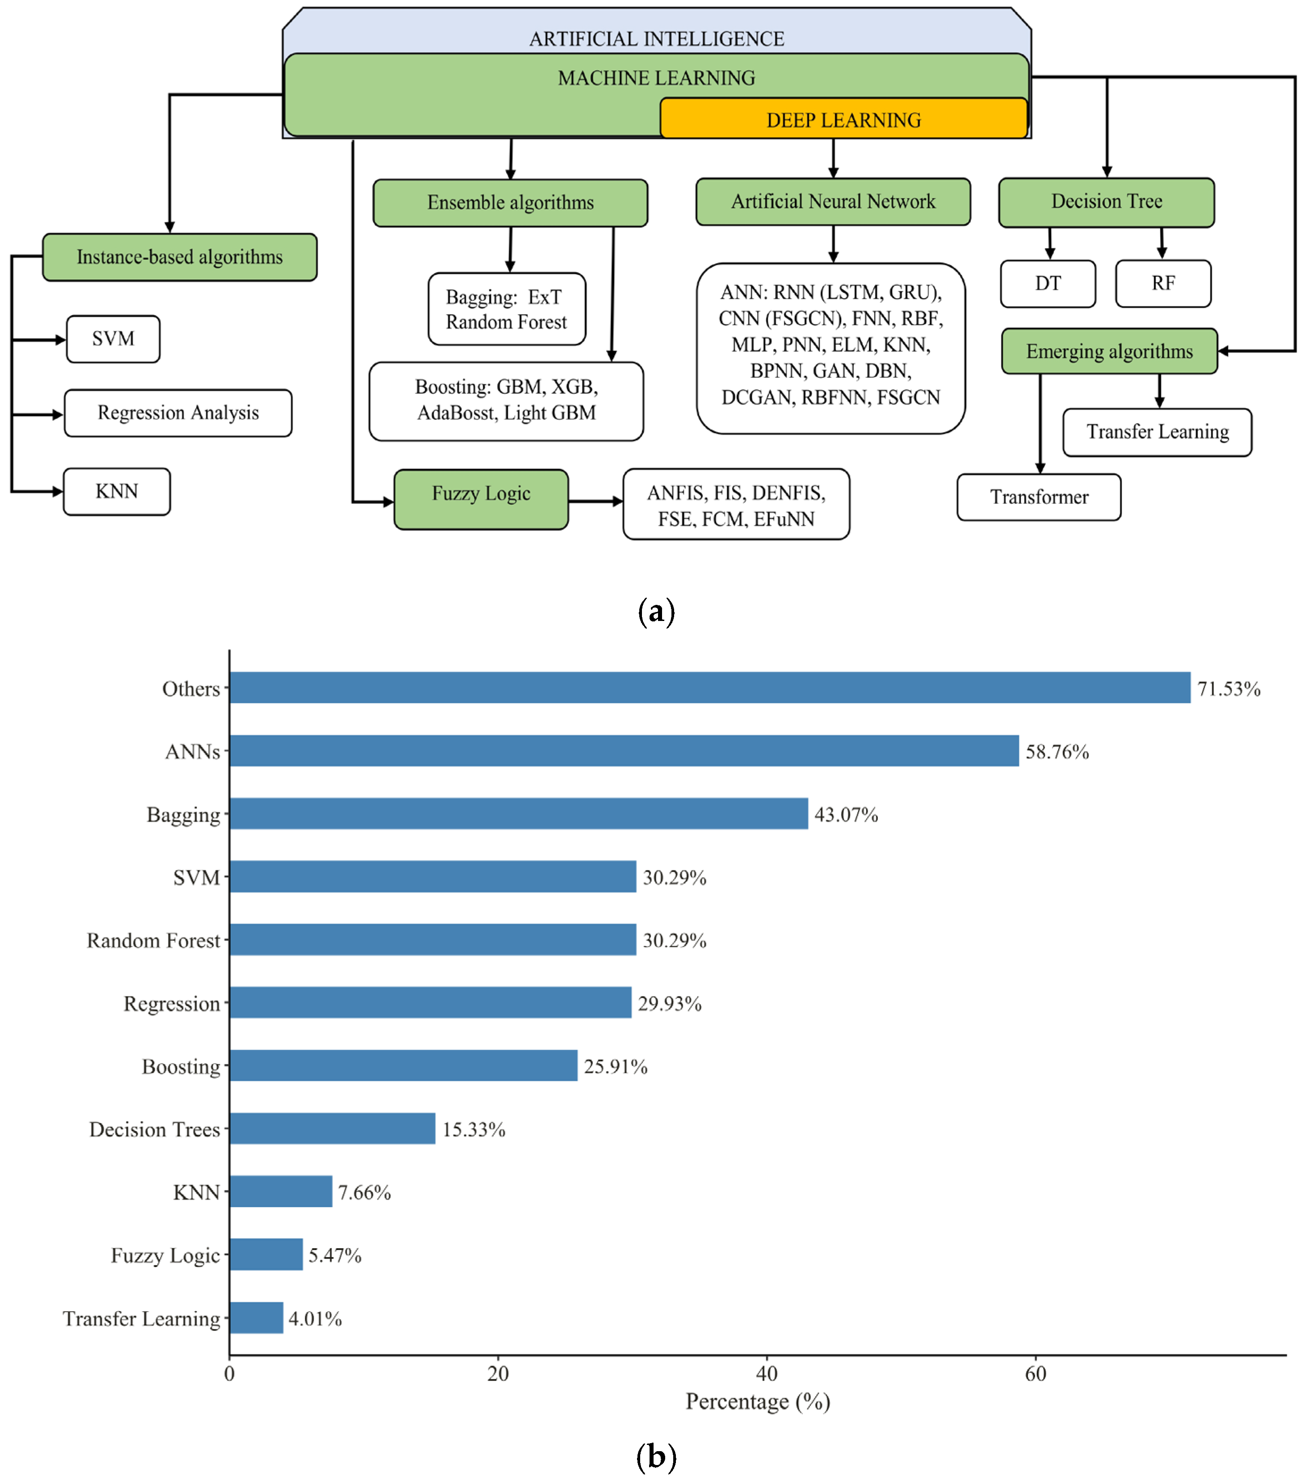
Figure 2 Prevalent ML/DL algorithms for water quality forecasting, focusing on: (a) Model taxonomy; (b) Frequency of application (Muñoz-Alegría et al., 2025)
Figure 2 delineates the taxonomy and application frequency of ML/DL algorithms in water quality forecasting (Muñoz-Alegría et al., 2025). While the classification (a) spans from instance-based to deep learning architectures, the usage data (b) reveals a preference for models capable of handling non-linear complexity, specifically Artificial Neural Networks (58.76%) and Bagging ensembles (43.07%). However, the prominence of the 'Others' category (71.53%) indicates substantial methodological fragmentation, suggesting widespread experimentation with niche algorithms beyond established frameworks.

1. Baseline and Statistical Models
- K-Nearest Neighbors (KNN): Modaresi et al., (2018) demonstrated that the non-parametric KNN algorithm yields effective prediction accuracy in hydrological time-series, particularly in nonlinear conditions where it successfully models complex data patterns without predetermined parametric relations.
2. Neuro-Fuzzy Systems
- Adaptive Neuro-Fuzzy Inference System (ANFIS): Yaseen et al. (2018) demonstrated that hybrid ANFIS models effectively handle the non-linearity, non-stationarity and uncertainty of water quality data. Their study concluded that ANFIS-SC is the superior approach, outperforming other methods in prediction accuracy while significantly minimizing computational time.
3. Advanced Ensemble Learning
4. Deep Learning and Hybrid Architectures

CHAPTER 3. METHODOLOGY

3.1 Study Area
Geographic coordinates?

3.2 Workflow
The experimental framework adopted in this study is systematically illustrated in Figure 3.1. The proposed pipeline encompasses five distinct phases designed to ensure data integrity and model robustness.
Initially, the Data Acquisition phase involves the collection of raw water quality monitoring data. Given the inherent noise and inconsistencies often present in environmental datasets, the subsequent Data Pre-processing stage is critical. This phase focuses on data curation, utilizing imputation techniques for missing values and applying RobustScaler to mitigate the influence of outliers, thereby normalizing the feature space.
Following pre-processing, a Feature Selection mechanism is employed to identify the most significant physicochemical parameters. This step is pivotal for reducing dimensionality and enhancing computational efficiency without compromising predictive accuracy.
The core of the methodology lies in the Predictive Modeling phase, where individual base learners (e.g., Random Forest, XGBoost) are trained and subsequently integrated via an Ensemble Stacking Strategy. This hierarchical approach aims to leverage the strengths of multiple algorithms to generalize better on unseen data.
Finally, the Model Evaluation phase rigorously assesses the system's performance using standard metrics such as RMSE and MAE, ensuring the reliability of the WQI predictions before deployment.
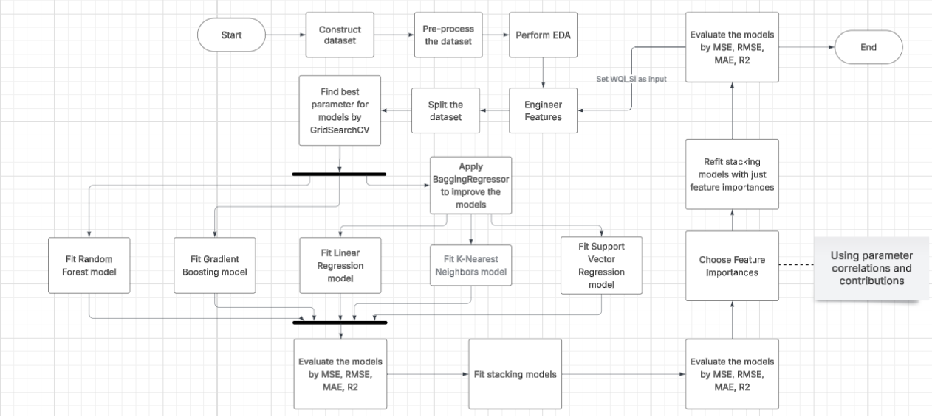
Figure 3 The experimental workflow.

3.3 Data Collection and Processing
Water quality data from Center for Natural Resources and Environment Monitoring of Quang Ninh Province, Vietnam, 1110 records were collected from 2019 to 2021 at 125 different location, including key sites near Ha Long Bay, a UNESCO World Natural Heritage site. The dataset includes monthly and bimonthly measurements of physical, chemical, microbiological, and heavy metal parameters to provide a comprehensive assessment of water quality in the province.
The monitored water quality variables comprised: Temperature (T, °C), pH, Dissolved Oxygen (DO, mg/L), Biochemical Oxygen Demand over 5 days (BOD₅, mg/L), Chemical Oxygen Demand (COD, mg/L), Nitrate (NO₃, mg/L), Nitrite (NO₂, mg/L), Ammonium (NH₄⁺, mg/L), Phosphate (PO₄³⁻, mg/L), Coliform (MPN/100 mL), E. coli, and trace heavy metals (As, Hg, Pb, Cd, CrVI, mg/L).
The descriptive statistics of the observed water quality parameters and WQI are summarized in Table 1. Parameters such as Coliform, COD, and BOD₅ exhibited considerable variability, reflecting differences in point and non-point sources of pollution, as well as seasonal hydro-climatic influences. In contrast, parameters such as pH and trace metals showed relatively stable values over the monitoring period.
Table 1
Paramters | Unit | Minimum | Maximum | Mean | Median | Std. Deviation
Temperature | degrees Celsius | 7.400 | 39.4 | 24.222 | 23.6 | 4.843
pH |  | 4.590 | 8.64 | 6.685 | 6.64 | 0.444
DO | Mg/L | 1.080 | 9.7 | 6.703 | 6.72 | 0.997
COD | Mg/L | 1.500 | 306.4 | 15.604 | 11.3 | 23.158
BOD5 | Mg/L | 1.000 | 54.4 | 4.28 | 3.1 | 4.192
NO3 | Mg/L | 0.008 | 6.528 | 0.345 | 0.214 | 0.638
NO2 | Mg/L | 0.002 | 8.337 | 0.185 | 0.002 | 0.951
NH4 | Mg/L | 0.01 | 6.321 | 0.399 | 0.054 | 1.018
PO4 | Mg/L | 0.01 | 10.365 | 0.051 | 0.01 | 0.336
Coliform | MPN/100ml | 3 | 25000 | 766.685 | 150 | 1885.311
EColi |  | 3 | 400 | 14.118 | 3 | 35.718
As | Mg/L | 0 | 0.014 | 0.001 | 0 | 0.001
Hg | Mg/L | 0 | 0.006 | 0 | 0 | 0
Pb | Mg/L | 0 | 0.066 | 0.001 | 0.001 | 0.003
Cd | Mg/L | 0 | 0.011 | 0.001 | 0.001 | 0
CrVI | Mg/L | 0.001 | 0.03 | 0.001 | 0.001 | 0.003
Table 1: Descriptive statistics of water quality parameters and WQI in Quang Ninh Province (2019–2021)
Data pre-processing was performed to ensure quality, consistency, and reliability. Variables were standardized with clear, descriptive names, and irrelevant or redundant columns were removed to reduce dimensionality and computational overhead. Missing values, including placeholders (e.g., “x”, “KCM”), were converted to NaN; columns with excessive missing data were excluded, while remaining gaps were imputed using K-Nearest Neighbors (KNN) to preserve multivariate relationships. Numeric consistency was ensured by converting comma-based decimals and symbolic measurements (e.g., “<x”) into numeric (float) formats. Finally, inconsistencies and extreme values were assessed using domain knowledge; genuine extremes reflecting natural variability were retained, whereas errors were corrected to maintain data integrity and robust model performance.

3.4 Calculation of Water Quality Index (WQI)
In this study, the Vietnamese Water Quality Index (VN_WQI) was calculated strictly in accordance with the technical guidelines issued by the MONRE (2019). The VN_WQI framework categorizes water quality parameters into five thematic groups: (I) pH, (II) pesticides, (III) heavy metals, (IV) organic matter and nutrients, and (V) microbiological indicators.
For each thematic group g, a group-level index was derived by aggregating its corresponding standardized sub-indices (WQISI) using either the geometric mean or the arithmetic mean, depending on the specific requirements prescribed for each parameter group. Individual water quality parameters were first transformed into dimensionless sub-indices based on the official rating curves, and these sub-indices were subsequently integrated to quantify the overall surface water quality status.
In this study, the VN_WQI was calculated using 16 water quality variables, including temperature, pH, dissolved oxygen (DO), chemical oxygen demand (COD), biochemical oxygen demand (BOD₅), nitrate (NO₃⁻), nitrite (NO₂⁻), ammonium (NH₄⁺), phosphate (PO₄³⁻), total coliforms, Escherichia coli (E. coli), and the heavy metals arsenic (As), mercury (Hg), lead (Pb), cadmium (Cd), and hexavalent chromium (Cr⁶⁺). The final VN_WQI value was obtained by aggregating all available group indices in accordance with the formulation specified in the official guidelines. The VN_WQI is computed according to the following formulation:
$$WQI = \frac{{WQI}_{pH}}{100}×\frac{{\left(\prod_{a=1}^{5}{{WQI}_{III}}\right)}^{\frac{1}{5}}}{100}×{\left(\frac{1}{7}\sum_{b=1}^{7}{{WQI}_{IV}}×\frac{1}{2}\sum_{c=1}^{2}{{WQI}_{IV}}\right)}^{\frac{1}{2}}$$
The WQI provides an aggregated assessment of water quality, allowing classification into five categories: excellent (91–100), good (76–90), fair (51–75), poor (26–50), and very poor (0–25).

3.6 Feature Engineering
StandardScaler
RobustScaler

3.7 Data Splitting
Data splitting is a fundamental step in the development of predictive models, as it ensures that the model's performance is evaluated on unseen data, thus providing a reliable estimate of its generalization capability. The primary objective of data splitting is to prevent overfitting and to assess the predictive accuracy of the model under conditions that mimic real-world application.

3.7.1 Hold-out Method
The hold-out method is the most straightforward approach to data partitioning. In this technique, the dataset is divided into two or three mutually exclusive subsets: a training set, a validation set (optional), and a test set. Typically, a common split ratio is 70:30 or 80:20 for training and testing, respectively. The training set is used to fit the model, the validation set is employed for hyperparameter tuning, and the test set provides an unbiased evaluation of model performance. Despite its simplicity, the hold-out method can lead to high variance in performance estimation, especially when the dataset is small, as the evaluation heavily depends on which data points are assigned to each subset.

3.7.2 K-Fold Cross-Validation
K-fold cross-validation (CV) is a more robust and widely used technique that mitigates the variance issues of the hold-out method. In K-fold CV, the dataset is partitioned into K equally sized folds. The model is trained K times, each time using K–1 folds as the training set and the remaining fold as the validation set. The performance metrics are then averaged across all K iterations to obtain a comprehensive estimate of model accuracy. This approach not only maximizes the utilization of available data for both training and evaluation but also reduces the risk of biased performance estimates due to random data splits. Common choices for K are 5 or 10, balancing computational cost and estimation reliability.

3.8 Machine Learning Models

3.8.1 Random Forest
Random Forest is an ensemble learning method constructed upon the framework of decision trees, originally proposed by Ho (1995) and significantly refined by Breiman (2001)The algorithm operates by generating a forest of uncorrelated decision trees during the training phase. This process employs two levels of randomization: bootstrap aggregating (bagging), where each tree is trained on a random subset of the data, and feature sampling, where a random subset of predictors is selected for node splitting. By aggregating the outputs of these diverse trees through majority voting for classification or averaging for regression, Random Forest enhances predictive accuracy and robustly mitigates the risk of overfitting (Breiman, 2001; Ho, 1995).
In this study, Random Forest is employed to model and predict water quality based on multiple independent variables, enabling the algorithm to capture complex, non-linear interactions that may not be adequately represented by a single decision tree. Its notable advantages include high predictive accuracy, robustness against overfitting, and the capacity to handle large datasets with numerous and potentially correlated features. However, it also has limitations, such as reduced interpretability of individual predictors and higher computational demands. Due to its flexibility and reliability, Random Forest is widely applied in various domains, including regression tasks and classification problems, making it a popular choice in contemporary machine learning research.

3.8.2 Gradient Boosting
Gradient Boosting is a supervised machine learning algorithm widely employed for regression and classification tasks. The algorithm operates on the principle of boosting, whereby a sequence of weak learners—typically shallow decision trees—is built iteratively. Each successive tree is trained to correct the residual errors of the combined ensemble of preceding trees by optimizing a specified loss function, often using gradient-based methods to determine the most effective direction for minimizing errors. This sequential approach allows Gradient Boosting to capture complex, non-linear relationships between predictors and the target variable.
Gradient Boosting is highly flexible, capable of handling both linear and non-linear patterns in data, and supports a variety of loss functions, such as mean squared error for regression or log-loss for classification. However, achieving optimal performance requires careful tuning of hyperparameters, including the learning rate, number of trees (n_estimators), and tree depth (max_depth). While Gradient Boosting often yields high predictive accuracy, it is sensitive to noisy data and generally demands greater computational resources compared to algorithms such as Random Forest. Its adaptability and precision make it widely applied in domains such as finance, healthcare, and data science.

3.8.3 Linear Regression
Multiple Linear Regression is a statistical method used to model the relationship between a continuous dependent variable and one or more independent variables, which may be either continuous or categorical. In data analysis and predictive modeling, multiple linear regression plays a pivotal role in understanding and forecasting the relationships between a dependent variable—such as the Water Quality Index (WQI)—and several independent variables (water quality indicators).
A multiple linear regression model provides critical insights into the extent to which each independent variable influences the dependent variable, as well as the overall integrity and predictive capability of the model. Formally, a multiple linear regression model represents a linear relationship between a dependent variable $Y$and multiple independent variables $X_{1},X_{2},…,X_{n}$. The model can be expressed mathematically as:
$$Y=β_{0}+β_{1}X_{1}+β_{2}X_{2}+⋯+β_{n}X_{n}+ϵ$$
where:
- $Y$denotes the dependent variable (also referred to as the response or predicted variable).
- $X_{1},X_{2},…,X_{n}$denote the independent variables (also called explanatory or predictor variables).
- $β_{1},β_{2},…,β_{n}$are the regression coefficients, representing the magnitude and direction of each independent variable’s effect on the dependent variable.
- $ϵ$is the random error term capturing unexplained variation.

3.8.4 K-Nearest Neighbors
K-Nearest Neighbors (KNN) is a non-parametric, instance-based supervised learning algorithm commonly used for both regression and classification tasks. KNN operates on a simple yet powerful principle: to predict the output for a given query point, it identifies the k closest data points (neighbors) in the training set based on a chosen distance metric, such as Euclidean or Manhattan distance. For classification, the algorithm assigns the class most frequently represented among the neighbors, while for regression, it computes the predicted value as the average of the neighbors’ target values.
One of the main strengths of KNN is its simplicity and capacity to capture complex patterns without assuming a specific functional form for the relationship between predictors and the target variable. It is also naturally adaptive to multi-class problems and can easily incorporate different distance metrics to reflect domain-specific similarity. However, KNN has notable limitations: it can be sensitive to irrelevant or highly correlated features, the choice of k significantly affects performance, and computational costs increase with large datasets since all distances must be computed at prediction time. Despite these challenges, KNN remains widely used in domains such as pattern recognition, environmental modeling, and healthcare, due to its intuitive approach and effectiveness in situations where the underlying data distribution is unknown.

3.8.5 Support Vector Regression
Support Vector Regression (SVR), introduced by Vapnik (2013), is a supervised learning algorithm derived from the principles of Support Vector Machines (SVM), designed for regression tasks. SVR aims to find a function that approximates the relationship between input variables and a continuous target variable while maintaining a predefined tolerance $ε$around the predicted values. Specifically, the algorithm constructs a hyperplane in a high-dimensional feature space that maximizes the margin of tolerance for deviations within $ε$, while penalizing predictions that fall outside this margin using a regularization parameter $C$. Kernel functions, such as linear, polynomial, or radial basis function (RBF), allow SVR to capture both linear and highly non-linear relationships between predictors and the target variable.
The key advantages of SVR include its ability to handle high-dimensional data, robustness to overfitting through regularization, and flexibility in modeling complex non-linear patterns. However, SVR is sensitive to the choice of hyperparameters—particularly $C$, $ε$, and the kernel parameters—and can be computationally intensive for large datasets. Despite these challenges, SVR has been successfully applied in numerous fields, including environmental modeling, finance, and engineering, due to its precise predictive performance and theoretical grounding in statistical learning theory.

3.8.6 Stacking Model
Stacking (Stacked Ensemble) Model is an advanced ensemble learning technique that combines multiple base learners to improve predictive performance. Unlike bagging or boosting, which aggregate predictions directly, stacking operates in a two-level framework: the first level consists of several diverse base models—such as decision trees, Random Forest, Gradient Boosting, or Support Vector Regression—that are independently trained on the original dataset. The second-level model, often called the meta-learner, is trained on the predictions of the base models to learn how to optimally combine them, thereby reducing individual model biases and leveraging complementary strengths.
Stacking is particularly effective for capturing complex patterns in data, as it integrates the predictive power of heterogeneous models. Its advantages include improved accuracy and generalization compared to single models or simple ensembles. However, it requires careful selection and tuning of both base models and the meta-learner, and it can be computationally demanding. In this study, stacking is employed to enhance water quality index prediction by aggregating multiple machine learning algorithms, enabling robust and accurate modeling of non-linear relationships among water quality indicators.

3.4.7 Bagging ensemble method
Bagging (Bootstrap Aggregating) is an ensemble learning technique primarily aimed at reducing model variance and improving generalization performance. The method trains multiple base learners on bootstrapped samples generated via random sampling with replacement from the original dataset, thereby introducing diversity among individual models. For regression tasks, the final prediction is obtained by averaging the outputs of all base learners.
Bagging is particularly effective when applied to high-variance algorithms, such as decision tree–based models, as it mitigates overfitting without increasing model bias. Unlike boosting methods, base learners in bagging are trained independently, making the approach computationally efficient and well suited for parallel implementation. However, performance improvements are limited for low-variance models, and the interpretability of the ensemble is reduced compared to single-model approaches.

3.9 Evaluation metrics
The accuracy of machine learning models can be assessed using metrics such as R-squared, Mean Squared Error (MSE), and Mean Absolute Error (MAE). Evaluating a model should not rely solely on a single metric; rather, it requires a combination of techniques and appropriate indicators tailored to the specific problem. A thorough understanding of these evaluation methods ensures that the model achieves optimal performance and can be effectively applied in practice.
- Mean Squared Error (MSE): MSE represents the average of the squared differences between predicted and actual values. A lower MSE indicates higher predictive accuracy of the model.
$$\text{MSE}=\frac{1}{n}\sum_{i=1}^{n}{(}y_{i}-{\hat{y}}_{i})^{2}$$
- Root Mean Squared Error (RMSE): RMSE is the square root of MSE. It quantifies the average prediction error while bringing the error back to the same units as the original data, facilitating more intuitive interpretation.
$$\text{RMSE}=\sqrt{\frac{1}{n}\sum_{i=1}^{n}{(}y_{i}-{\hat{y}}_{i})^{2}}$$
- R-squared (R²): R-squared measures the proportion of variance in the dependent variable that is explained by the model. Its value ranges from 0 to 1, with higher values indicating better explanatory power of the model regarding the data variability.
$$R^{2}=1-\frac{\sum_{i=1}^{n}{(}y_{i}-{\hat{y}}_{i})^{2}}{\sum_{i=1}^{n}{(}y_{i}-\overset{ˉ}{y})^{2}}$$
- Mean Absolute Error (MAE): MAE is the average of the absolute differences between predicted and actual values. It provides a straightforward measure of the average deviation of predictions from actual observations.
$$\text{MAE}=\frac{1}{n}\sum_{i=1}^{n}{∣}y_{i}-{\hat{y}}_{i}∣$$
Where:
- $n$is the total number of samples in the dataset.
- $y_{i}$denotes the observed value of the $i$-th sample.
- ${\hat{y}}_{i}$denotes the predicted value of the $i$-th sample.
Importance of Model Evaluation:
- Ensures the predictive accuracy of the model.
- Prevents overfitting or underfitting.
- Tests the model’s generalizability on unseen data.
- Enables performance comparison among different models to select the most suitable one.
- Ensures model stability and robustness.
- Guarantees the reliability of predictions for real-world applications.

CHAPTER 4. RESULT

4.1 Data Analysis


Figure 4 Distribution of Temperature
Chart Components:
- X-axis: Temperature values in degrees Celsius (°C)
- Y-axis: Frequency count of observations

Analysis:
- The dataset exhibits an empirical spread from $7°C$ to $39°C$ with the interquartile mass concentrated between $18°C$ and $31°C$, reflecting a transition from cool ambient conditions to high-heat thresholds.
- The profile displays a non-normal, bimodal distribution with distinct local maxima at $22°C$ and $30°C$, suggesting the data is derived from two heterogeneous environmental states or distinct temporal cycles.
- Isolated observations below $10°C$ indicate potential sensor noise or localized measurement errors, while the KDE tail near $40°C$ exhibits a smoothing artifact that overestimates probability where no empirical data exists.


Figure 5 Distribution of pH
Chart Components:
- X-axis: pH values (dimensionless)
- Y-axis: Frequency count of observations

Analysis:
The pH distribution exhibits a relatively narrow and near-normal distribution centered around 6.2-7, indicating predominantly neutral to slightly acidic water conditions suitable for aquatic ecosystems. The distribution shows a clear peak around pH 6.7, suggesting most water bodies maintain near-neutral conditions. The concentration of values within this range reflects relatively stable chemical conditions across the study area. A few observations at the lower end (pH < 6) and upper end (pH > 8) may indicate localized variations due to industrial discharge, agricultural runoff, or natural geological influences. Overall, the distribution suggests good buffering capacity in the water bodies.


Figure 6 Distribution of DO
Chart Components:
- X-axis: DO concentration in mg/L
- Y-axis: Frequency count of observations

Analysis:
The DO distribution shows moderate variability with a concentration of values between 4-8 mg/L. The distribution appears slightly right-skewed with a peak around 6.2-7.3 mg/L, indicating generally adequate oxygen levels to support aquatic life in most samples. However, the presence of lower values (< 4 mg/L) suggests potential oxygen depletion in some locations, possibly due to organic pollution, high biological oxygen demand, or eutrophication. The wider spread compared to pH and temperature indicates greater spatial and temporal variability in oxygen availability, which may be influenced by factors such as water flow rates, temperature variations, photosynthetic activity, and organic matter decomposition.


Figure 7 Distribution of COD
Chart Components:
- X-axis: COD concentration in mg/L
- Y-axis: Frequency count of observations

Analysis:
The COD distribution shows a strongly right-skewed pattern with most observations concentrated at lower values (< 20 mg/L), indicating acceptable baseline organic content in the majority of samples. However, the long tail extending toward higher values (> 60 mg/L) reveals the presence of significant organic pollution at specific locations or time periods. This bimodal-like pattern suggests two distinct water quality regimes: one representing relatively clean water bodies and another affected by organic contamination from industrial discharge, sewage, or agricultural runoff. The extreme values warrant further investigation to identify pollution sources and implement appropriate remediation measures.


Figure 8 Distribution of BOD₅
Chart Components:
- X-axis: BOD₅ concentration in mg/L
- Y-axis: Frequency count of observations

Analysis:
The BOD₅ distribution exhibits a strong right-skew with most values clustered below 10 mg/L, indicating low levels of biodegradable organic matter in most samples. The peak near 2-4 mg/L suggests that baseline BOD₅ levels are generally within acceptable ranges for surface water quality. However, several outliers extending to 30+ mg/L indicate episodic or localized organic pollution events, likely from domestic wastewater, agricultural activities, or industrial sources. The presence of these elevated values suggests potential stress on aquatic ecosystems due to increased oxygen consumption during organic matter decomposition, which could lead to oxygen depletion if not properly managed.


Figure 9 Distribution of NO₃⁻
Chart Components:
- X-axis: NO₃⁻ concentration in mg/L
- Y-axis: Frequency count of observations

Analysis:
The nitrate distribution shows a right-skewed pattern with most observations concentrated near zero and a long tail extending to higher values. The majority of samples exhibit low nitrate concentrations (<1 mg/L), suggesting limited nutrient loading under typical conditions. However, the presence of outliers reaching 6.5 mg/L indicates occasional nutrient enrichment events, likely associated with agricultural runoff from fertilizer application, livestock operations, or inadequately treated wastewater. These elevated concentrations pose a risk of eutrophication, particularly in sensitive water bodies such as lakes and coastal areas. The overall pattern suggests that while baseline nitrate levels are generally acceptable, targeted management interventions may be needed in specific locations or during high-input periods.


Figure 10 Distribution of NO₂⁻
Chart Components:
- X-axis: NO₂⁻ concentration in mg/L
- Y-axis: Frequency count of observations

Analysis:
The nitrite distribution is extremely right-skewed, with the vast majority of values clustered very close to zero (< 0.05 mg/L), indicating minimal nitrite presence in most water samples. This pattern reflects efficient nitrogen cycling processes and stable nitrification-denitrification dynamics in most locations. The extremely narrow concentration range around zero suggests that nitrite, an intermediate product in nitrogen transformation, does not accumulate under normal conditions. However, a few distinct outliers at higher concentrations (> 0.3 mg/L) may indicate incomplete nitrification processes, possibly due to oxygen limitation, pH imbalances, or inhibition of nitrifying bacteria. Although infrequent, these elevated nitrite levels warrant attention due to potential toxicity to aquatic organisms.


Figure 11 Distribution of NH₄⁺
Chart Components:
- X-axis: NH₄⁺ concentration in mg/L
- Y-axis: Frequency count of observations

Analysis:
The ammonium distribution displays a strong right-skew with most values concentrated below 2 mg/L, indicating minimal ammonia pollution in the majority of samples. The peak near 0.5-1.0 mg/L suggests that baseline ammonium levels are generally low and stable across most monitoring locations. However, the presence of numerous outliers extending to 10+ mg/L indicates episodic ammonia inputs from sources such as untreated wastewater discharge, livestock operations, aquaculture activities, or organic matter decomposition. These elevated concentrations are concerning because ammonia is toxic to aquatic life, particularly in its unionized form (NH₃), which increases with pH and temperature. The distribution pattern suggests that while general water quality is acceptable, localized pollution hotspots require targeted intervention.


Figure 12 Distribution of PO₄³⁻
Chart Components:
- X-axis: PO₄³⁻ concentration in mg/L
- Y-axis: Frequency count of observations

Analysis:
The coliform distribution is extremely right-skewed. It exhibits a highly concentrated peak near zero, with a long tail extending to exceptionally high values (> 20,000 MPN/100 mL). Most samples show relatively low coliform counts (< 5,000 MPN/100 mL), indicating that baseline microbiological conditions generally remain within typical background levels. Nevertheless, numerous high outliers reveal severe fecal contamination events at specific locations or during particular time periods. These events are likely associated with untreated sewage discharge, surface runoff containing animal waste, or inadequate sanitation infrastructure. The broad range of values reflects substantial spatial and temporal variability in microbiological water quality. Certain areas experience chronic or acute contamination, which poses significant public health risks. The observed pattern highlights the need for targeted microbiological monitoring and remediation strategies, particularly near population centers and recreational water use areas.


Figure 13 Distribution of Coliform
Chart Components:
- X-axis: Coliform count in MPN/100mL
- Y-axis: Frequency count of observations

Analysis:
The coliform distribution is extremely right-skewed, with a highly concentrated peak near zero and a long tail extending to exceptionally high values (> 20,000 MPN/100 mL). Most samples exhibit relatively low coliform counts (< 5,000 MPN/100 mL), suggesting that baseline microbiological conditions generally remain within typical background levels. Nevertheless, numerous high outliers indicate severe fecal contamination events at specific locations or during particular time periods, likely arising from untreated sewage discharge, surface runoff containing animal waste, or inadequate sanitation infrastructure. The broad range of values reflects substantial spatial and temporal variability in microbiological water quality, with certain areas experiencing chronic or acute contamination that poses significant public health risks. This pattern highlights the need for targeted microbiological monitoring and remediation strategies, particularly in proximity to population centers and recreational water use areas.


Figure 14 Distribution of E. coli
Chart Components:
- X-axis: E. coli count in MPN/100mL
- Y-axis: Frequency count of observations

Analysis:
The E. coli distribution mirrors the pattern observed for total coliforms. It exhibits an extreme right skew, with the majority of values concentrated near zero or at low levels (< 100 MPN/100 mL). This indicates that most samples are largely free from recent fecal contamination. Baseline conditions generally remain within typical background levels. Nevertheless, several measurements exceeding 500 MPN/100 mL reveal episodic or localized fecal pollution events. These events are likely associated with the same sources influencing total coliform counts, including sewage discharge, agricultural runoff, or wildlife waste. As E. coli is a more specific indicator of fecal contamination than total coliforms, elevated values are of particular concern for public health. The observed distribution highlights the need for regular microbiological monitoring, source tracking, and implementation of water quality management measures. Such actions are essential to safeguard human health and maintain ecosystem integrity.


Figure 15 Distribution of Arsenic
Chart Components:
- X-axis: Arsenic concentration in mg/L
- Y-axis: Frequency count of observations

Analysis:
The arsenic distribution is highly right-skewed, with most values clustered near zero (< 0.01 mg/L). This indicates minimal arsenic contamination in the majority of water samples. The observed pattern reflects low baseline arsenic levels, which may result from limited geological sources or effective natural attenuation processes. The narrow interquartile range suggests that arsenic concentrations are relatively stable across most monitoring locations. Nevertheless, several distinct measurements at higher concentrations (0.02–0.05 mg/L) indicate occasional exceedances. These may be associated with natural geological formations rich in arsenic-bearing minerals or anthropogenic sources, such as mining activities, industrial processes, or agricultural chemicals. Although typical arsenic levels are reassuringly low, these elevated values warrant careful attention due to arsenic's high toxicity and carcinogenic potential, even at relatively low chronic exposure levels.
.
Figure 16 Distribution of Mercury
Chart Components:
- X-axis: Mercury concentration in mg/L
- Y-axis: Frequency count of observations

Analysis:
The mercury distribution exhibits an extreme right-skew. The overwhelming majority of values are tightly clustered at or near zero (< 0.001 mg/L), indicating generally low background mercury levels across the study area. The extremely narrow central distribution suggests minimal mercury presence under typical environmental conditions. This is favorable given mercury's high toxicity. Nevertheless, several pronounced outliers at significantly higher concentrations (> 0.005 mg/L) reveal sporadic mercury contamination events. These outliers may be associated with localized pollution sources, including industrial facilities, artisanal gold mining, fossil fuel combustion, or accidental spills. Despite the low median concentration, these extreme values are environmentally critical. Mercury bioaccumulates in aquatic food chains and can cause severe neurological damage even at very low concentrations. The presence of any detectable mercury levels highlights the need for continued vigilant monitoring and source identification.

Figure 17 Distribution of Lead
Chart Components:
- X-axis: Lead concentration in mg/L
- Y-axis: Frequency count of observations

Analysis:
The lead distribution shows a wider spread compared to mercury and arsenic, with a right-skewed pattern but less extreme concentration at zero. Most observations fall below 0.03 mg/L, suggesting generally low but detectable lead levels in many samples. The distribution indicates that lead is present at measurable concentrations more frequently than mercury or arsenic, possibly due to more diverse and widespread sources. Numerous outliers extending to 0.08+ mg/L reveal considerable variability in lead contamination across sampling locations and time periods. The frequent occurrence of elevated values suggests that lead pollution is not isolated but influenced by multiple anthropogenic sources such as industrial effluents, leaded gasoline residues, battery manufacturing, mining activities, or deteriorating lead-based infrastructure. This distribution pattern highlights lead as a critical parameter requiring close monitoring and source control measures.

Figure 18 Distribution of Cadmium
Chart Components:
- X-axis: Cadmium concentration in mg/L
- Y-axis: Frequency count of observations

Analysis:
The cadmium distribution closely resembles the mercury pattern, with most values tightly concentrated near zero (< 0.005 mg/L), indicating minimal cadmium presence in the majority of water samples. The extremely narrow central distribution reflects low baseline cadmium levels across most monitoring locations. However, several pronounced outliers at significantly higher concentrations (> 0.01 mg/L) indicate occasional contamination spikes. These outliers may reflect localized pollution from industrial sources such as electroplating, battery manufacturing, pigment production, or metal smelting operations. Given cadmium's high toxicity, carcinogenicity, and tendency to bioaccumulate in kidneys and other organs, even these infrequent spikes are of significant environmental and public health concern. The distribution emphasizes the need for targeted source identification and control measures at locations showing elevated cadmium levels.

Figure 19 Distribution of Cr(VI)
Chart Components:
- X-axis: Cr(VI) concentration in mg/L
- Y-axis: Frequency count of observations

Analysis:
The hexavalent chromium distribution exhibits a strong right-skew similar to other heavy metals, with most values clustered near zero (< 0.01 mg/L), indicating generally low background Cr(VI) levels. The narrow concentration range for the majority of samples suggests limited chromium contamination under typical conditions. However, several distinct outliers at markedly higher concentrations (> 0.03 mg/L) indicate sporadic but significant chromium contamination events. These outliers may be linked to specific industrial activities such as electroplating, leather tanning, textile dyeing, or stainless steel manufacturing. The presence of hexavalent chromium is particularly concerning because Cr(VI) is highly toxic, mobile in aquatic environments, and classified as a human carcinogen. Unlike trivalent chromium (Cr(III)), which is relatively benign, Cr(VI) poses severe health and environmental risks even at low concentrations, warranting careful monitoring and targeted management at affected locations.
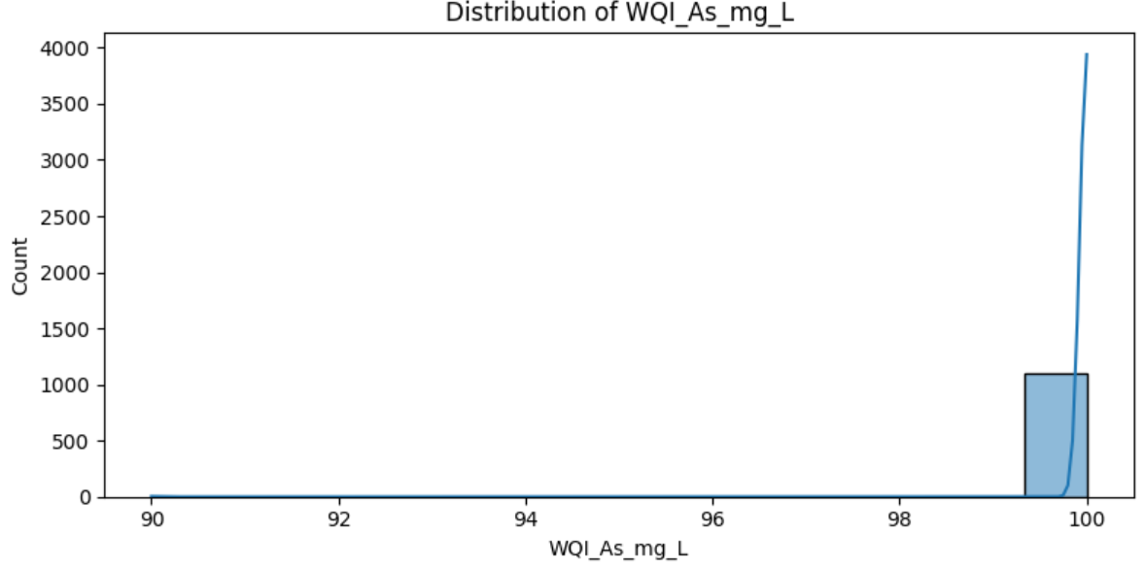
Figure 20 Distribution of As

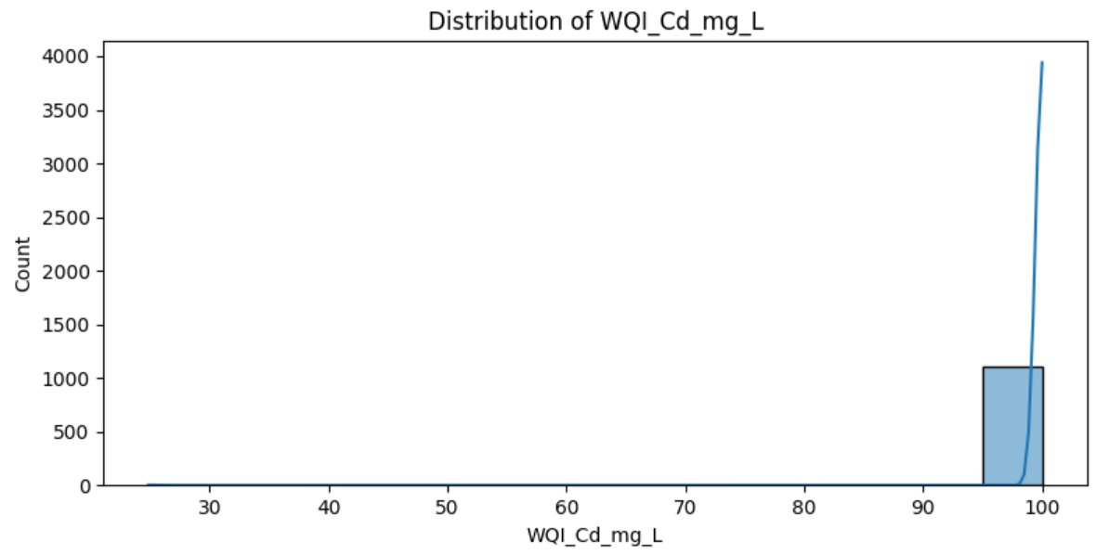
Figure 21 Distribution of WQI sub-index score for Cadmium
Chart Components:
- X-axis: WQI sub-index score for Cadmium (0-100 scale)
- Y-axis: Frequency count of observations
Analysis:
The distribution of the Cadmium Water Quality Index (WQI_Cd) exhibits an extreme negative (left) skew, with the overwhelming majority of observations clustered at the maximum score of 100. This pattern indicates that Cadmium concentrations in nearly all water samples are extremely low or non-detectable, resulting in a perfect sub-index score which corresponds to "excellent" water quality regarding this specific heavy metal. The dominance of the peak at the upper limit suggests that Cadmium pollution is negligible across the study area and does not currently pose a threat to the ecosystem. While there may be minute instances of lower scores (as suggested by the faint tail extending to the left), they are statistically insignificant compared to the primary cluster at 100, reflecting stable and safe conditions regarding Cadmium contamination.

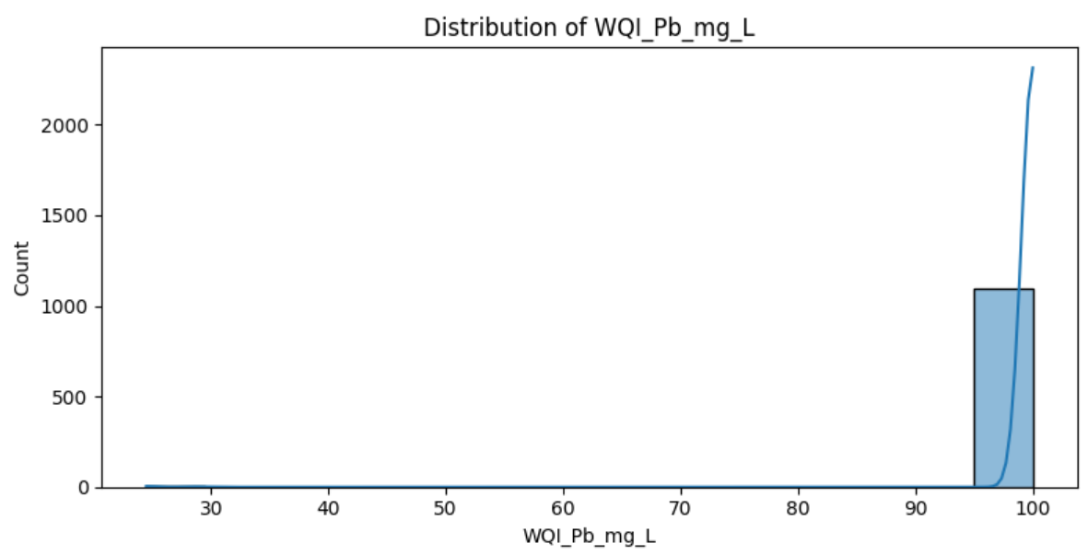
Figure 22 Distribution of WQI sub-index score for Lead
Chart Components:
- X-axis: WQI sub-index score for Lead (0-100 scale)
- Y-axis: Frequency count of observations
Analysis:
The distribution of the Lead Water Quality Index (WQI_Pb) displays an extreme negative (left) skew, with the vast majority of observations concentrated in the highest score range (95-100). This clustering at the maximum value indicates that lead concentrations in the sampled water bodies are consistently very low, resulting in "excellent" water quality scores for this parameter. The histogram shows virtually no observations in the lower or moderate score ranges, suggesting that lead contamination is not a significant issue in the study area. This pattern reflects either the absence of significant anthropogenic lead sources (such as industrial discharge or mining runoff) or highly effective control measures. Consequently, lead does not appear to be a limiting factor for the overall water quality index in this dataset.
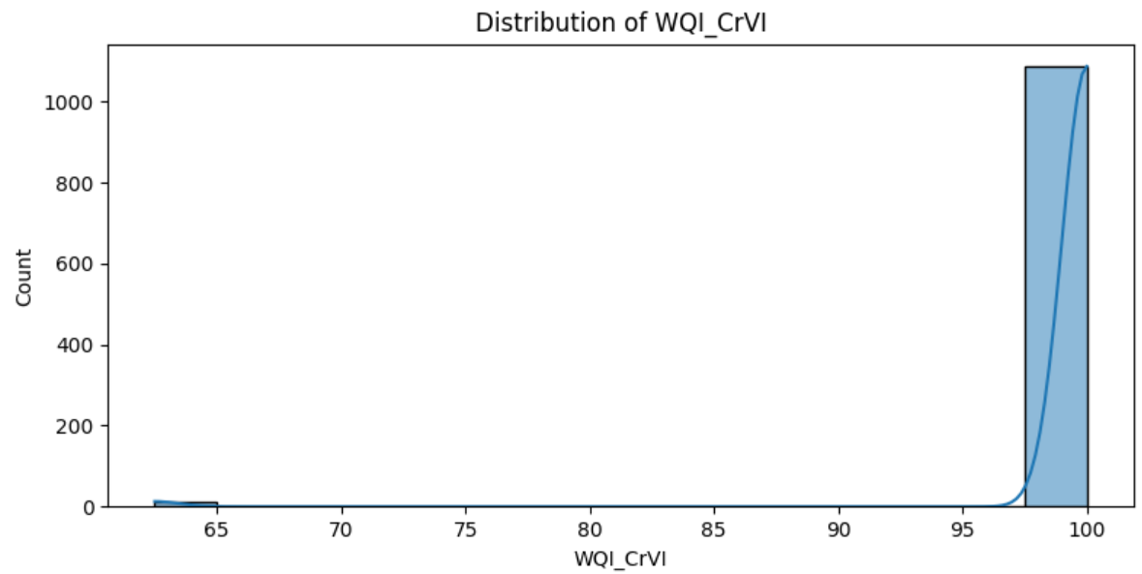
Figure 23 Distribution of WQI sub-index score for Hexavalent Chromium
Chart Components:
- X-axis: WQI sub-index score for Hexavalent Chromium (0-100 scale)
- Y-axis: Frequency count of observations
Analysis:
The distribution of the Hexavalent Chromium Water Quality Index (WQI_CrVI) shows a strong negative skew similar to other heavy metals, with a dominant peak at the maximum score of 100. This indicates that for the majority of monitoring locations, Cr(VI) levels are negligible, resulting in "excellent" water quality ratings. However, unlike the Lead distribution, there is a small but visible cluster of observations around the 60-65 score range. This distinct grouping suggests the existence of localized "hotspots" or specific pollution events where Hexavalent Chromium concentrations were high enough to degrade the water quality rating to "medium" or "fair." While these instances are few compared to the clean samples, they point to specific industrial discharges or contamination sources that require targeted investigation.
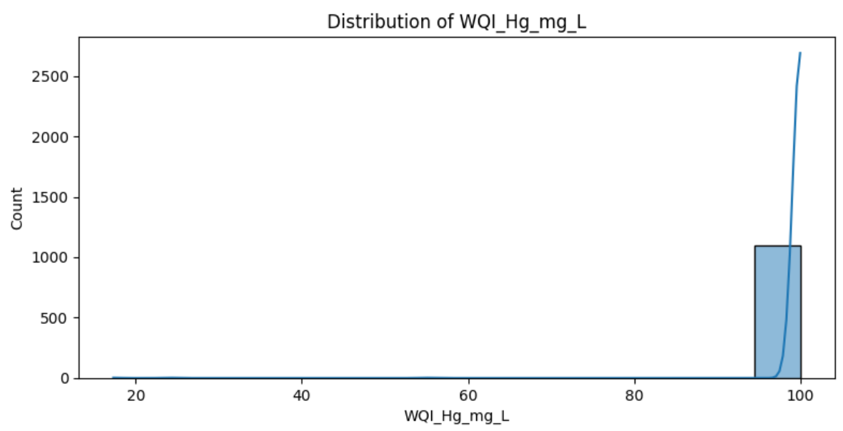
Figure 24 Distribution of WQI sub-index score for Mercury
Chart Components:
- X-axis: WQI sub-index score for Mercury (0-100 scale)
- Y-axis: Frequency count of observations
Analysis: The distribution for the Mercury Water Quality Index (WQI_Hg) exhibits an extreme negative skew, with the overwhelming majority of data points tightly clustered at the maximum score of 100. This indicates that Mercury concentrations are extremely low or non-detectable in nearly all samples, corresponding to "excellent" water quality for this specific toxic metal. While the baseline remains very high, there is a very thin tail extending toward lower scores (as low as 20), indicating rare, episodic contamination events or specific locations with significant mercury presence. Given the high toxicity of mercury, even these infrequent lower scores are critical for environmental management, though they do not represent the general condition of the water bodies studied.
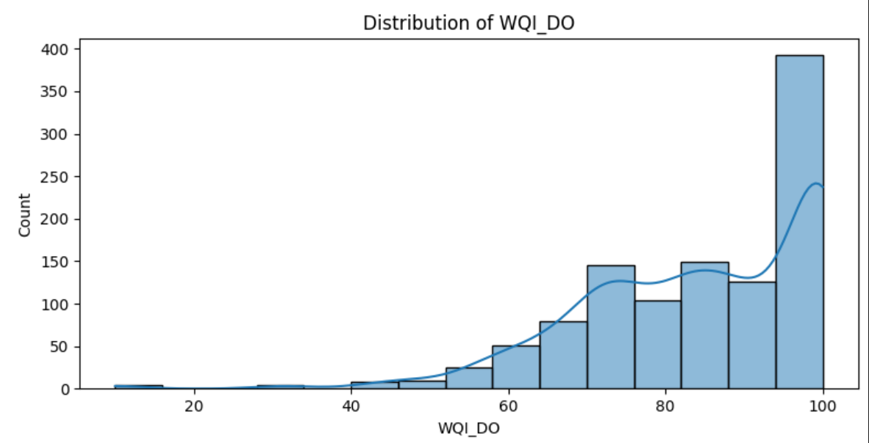
Figure 25 Distribution of WQI sub-index score for WQI_DO score
Chart Components:
- X-axis: WQI_DO score (0-100 scale)
- Y-axis: Frequency count of observations
Analysis:
The WQI_DO distribution exhibits a pronounced left-skewed pattern, with the overwhelming majority of observations concentrated at the high end of the scale (90-100). This indicates that for the Dissolved Oxygen parameter, most water bodies are in excellent condition, meeting or exceeding water quality standards. The distinct peak in the 90-100 range suggests that oxygen levels are consistently high enough to support healthy aquatic ecosystems in most locations. There is a gradual decline in frequency as scores drop below 90, with a notable "shoulder" around the 60-80 range representing fair to good quality. The scarcity of values at the lower end (< 50) implies that severe oxygen deficiency is rare, making DO a strong positive contributor to the overall water quality index in the study area.
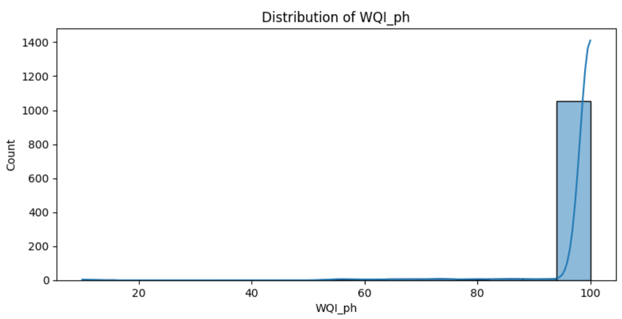
Figure 26 Distribution of WQI sub-index score for WQI_ph score
Chart Components:
- X-axis: WQI_ph score (0-100 scale)
- Y-axis: Frequency count of observations
Analysis:
The WQI_ph distribution displays an extreme left-skewed pattern, with the vast majority of observations heavily concentrated at the maximum end of the scale (95-100). The towering bar at the far right and the steeply rising density curve indicate that pH levels at almost all monitoring stations achieve an "excellent" quality rating. There is a near-total absence of low or moderate values across the spectrum, reflecting that pH is the most stable parameter among the monitored indicators and consistently remains within the ideal range for aquatic environments. Consequently, pH serves as a highly positive factor that consistently bolsters the overall Water Quality Index (VN_WQI) scores across the study area.
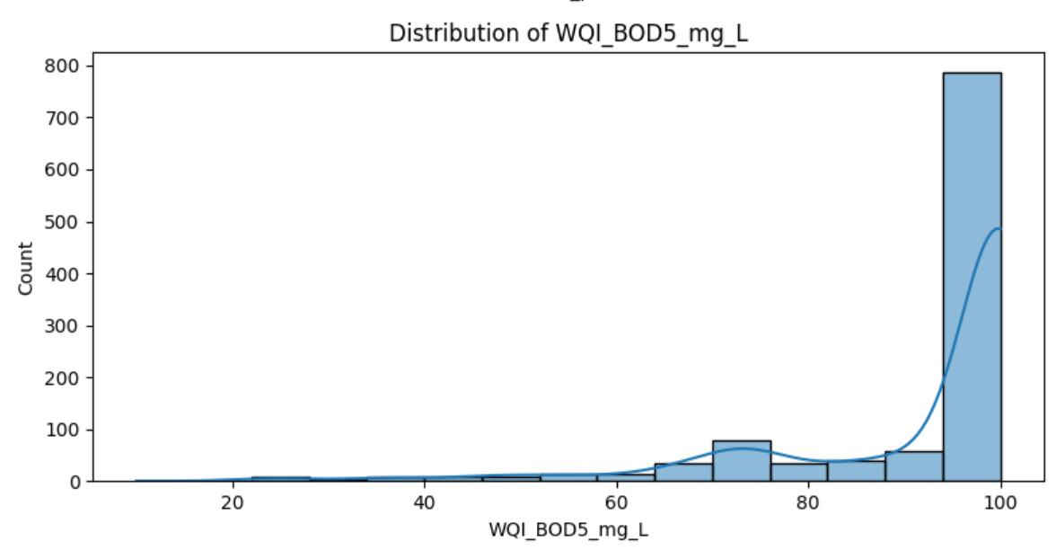
Figure 27 Distribution of WQI sub-index score for WQI_BOD5_mg_L score
Chart Components:
- X-axis: WQI_BOD5_mg_L score (0-100 scale)
- Y-axis: Frequency count of observations
Analysis:
The WQI_BOD5 distribution is strongly left-skewed, characterized by a dominant peak in the highest score range (90-100). This indicates that the vast majority of water samples have low Biochemical Oxygen Demand (BOD5) concentrations, resulting in "excellent" water quality scores for this parameter. While the primary concentration is at the top of the scale, there is a visible, smaller distribution of values between 60 and 90, suggesting that some locations experience moderate organic loads, falling into the "fair" to "good" categories. The scarcity of scores below 60 implies that severe organic pollution (high BOD5) is relatively rare in the monitored areas. Overall, this parameter contributes positively to the general water quality index, though slightly less uniformly than pH.
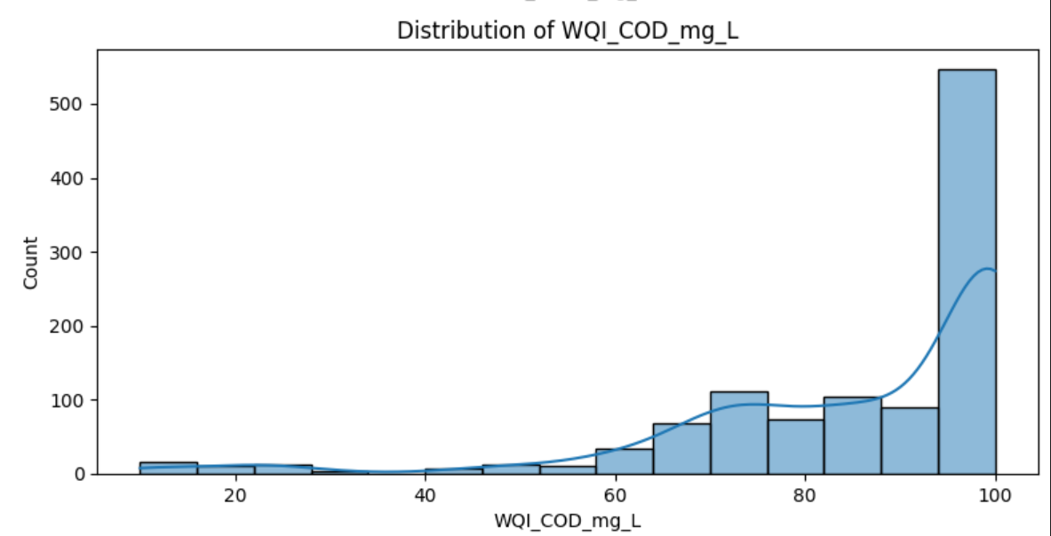
Figure 28 Distribution of WQI sub-index score for WQI_COD_mg_L score
Chart Components:
- X-axis: WQI_COD_mg_L score (0-100 scale)
- Y-axis: Frequency count of observations
Analysis:
The WQI_COD distribution exhibits a significant left-skew, with a dominant peak in the 95-100 score range. This indicates that the majority of monitoring samples possess low Chemical Oxygen Demand, reflecting "excellent" water quality in terms of total organic and inorganic oxidizable content. Below this primary peak, a secondary distribution of values is visible between 60 and 90, representing water bodies with "fair" to "good" quality that may be receiving moderate industrial or domestic runoff. While there are scattered observations at the lower end of the scale (< 40), they are infrequent, suggesting that severe chemical oxygen depletion is localized rather than a widespread regional issue. Overall, the COD parameter suggests generally healthy water conditions across most of the study area, contributing positively to the integrated water quality assessment.
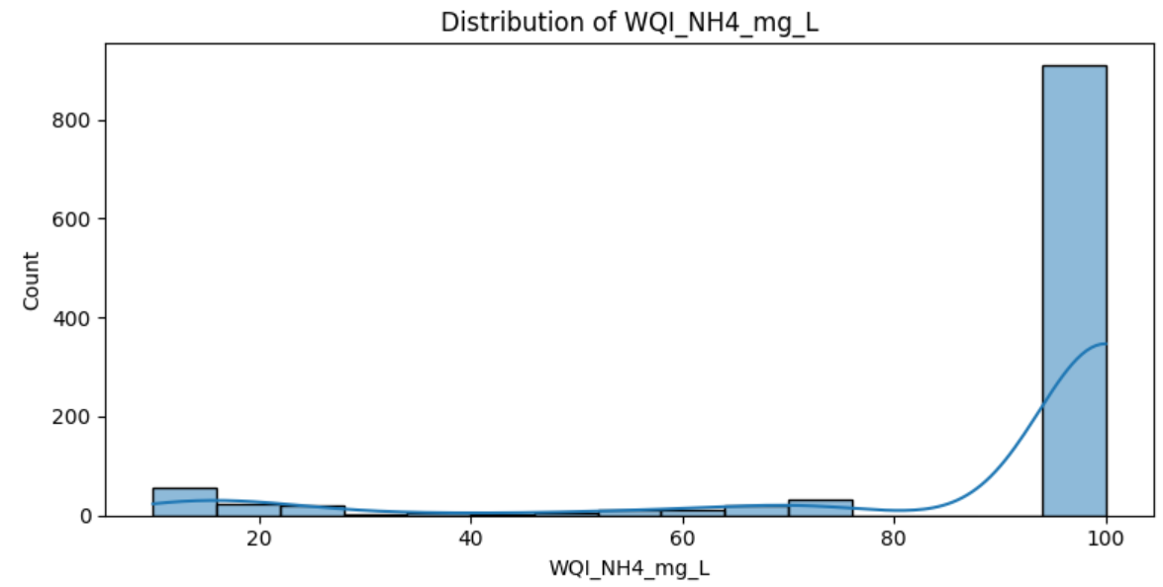
Figure 29 Distribution of WQI sub-index score for WQI_NH4_mg_L score
Chart Components:
- X-axis: WQI_NH4_mg_L score (0-100 scale)
- Y-axis: Frequency count of observations
Analysis:
The WQI_NH4 distribution displays a highly polarized, left-skewed pattern with a massive concentration of values in the 95-100 range. This indicates that for the vast majority of observations, ammonium levels are exceptionally low, falling within the "excellent" water quality category. However, unlike some other parameters, there is a small but distinct cluster of observations at the very low end of the scale (below 20), representing "very poor" quality. This suggests that while most of the study area remains free of significant ammonium pollution, there are specific hotspots—likely near untreated sewage outfalls or intensive livestock areas—where ammonium levels are high enough to severely degrade water quality. The relative absence of values in the middle of the scale suggests that water bodies tend to be either very clean or significantly impacted regarding this nutrient.
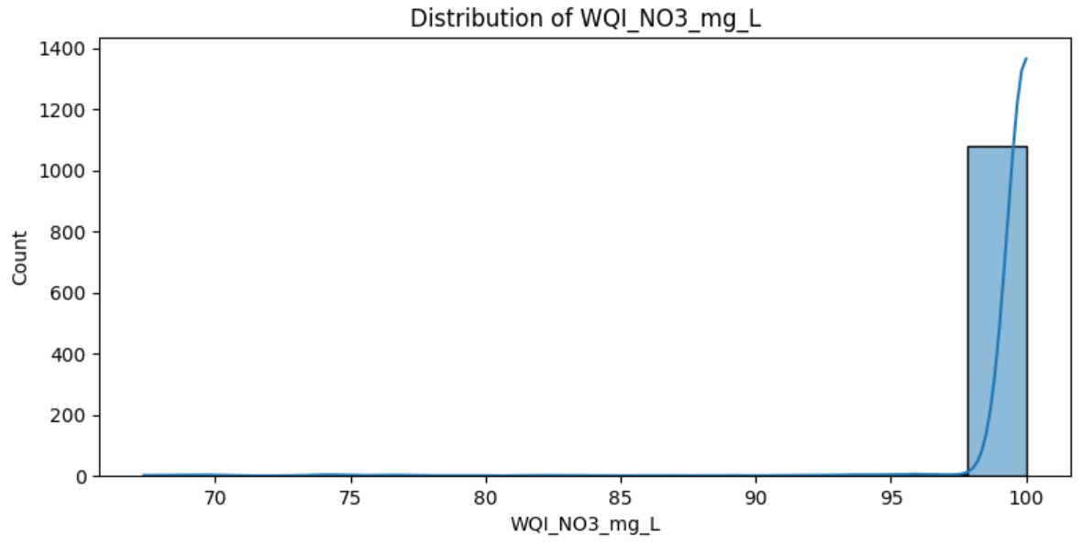
Figure 30 Distribution of WQI sub-index score for WQI_NO3_mg_L score
Chart Components:
- X-axis: WQI_NO3_mg_L score (approx. 65-100 scale)
- Y-axis: Frequency count of observations
Analysis:
The WQI_NO3 distribution demonstrates an extreme left-skewed pattern, with an overwhelming concentration of values tightly clustered at the maximum score of 100. This indicates that nitrate levels across nearly all monitoring samples are exceptionally low, consistently achieving an "excellent" water quality rating for this specific parameter. The chart shows almost no variation, with a singular, massive peak exceeding a count of 1,000 observations at the top of the scale. While there are negligible occurrences of scores trailing down toward 70, they represent a very small fraction of the total data. This pattern suggests that nitrate enrichment is not a significant environmental concern in the study area and that the water bodies currently maintain high buffering against nitrogen-based nutrient pollution.
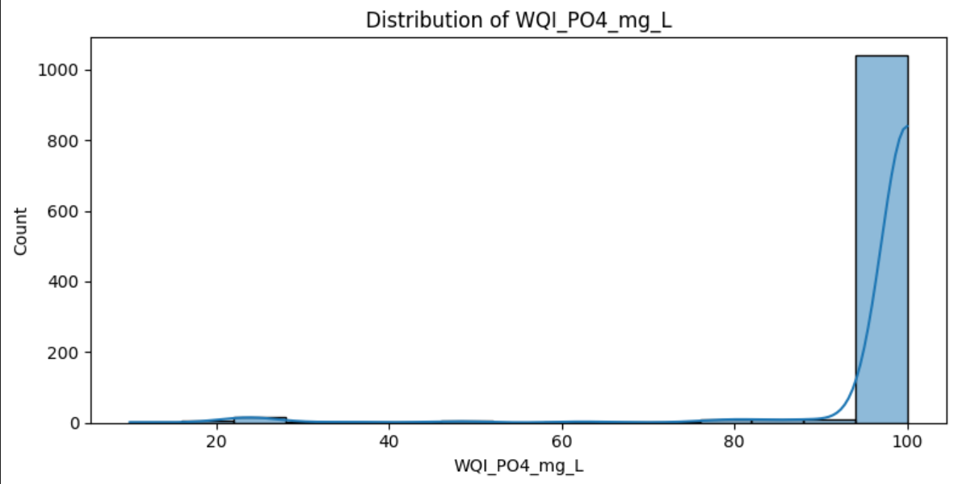
Figure 31 Distribution of WQI sub-index score for WQI_PO4_mg_L score
Chart Components:
- X-axis: WQI_PO4_mg_L score (0-100 scale)
- Y-axis: Frequency count of observations
Analysis:
The WQI_PO4 distribution displays an extreme left-skewed pattern, with a massive concentration of observations exceeding a count of 1,000 in the 95-100 score range. This indicates that phosphate levels at the vast majority of monitoring sites are minimal, consistently achieving an "excellent" water quality rating. While the central distribution is overwhelmingly positive, the chart reveals a very small number of scattered observations at the lower end of the scale, including a minor cluster around the 20-30 range. These low scores represent "poor" quality and suggest localized phosphate enrichment, likely due to specific instances of agricultural runoff or domestic detergent discharge. However, given the dominance of the maximum score, phosphate remains a negligible concern for the overall water quality in most of the studied areas.
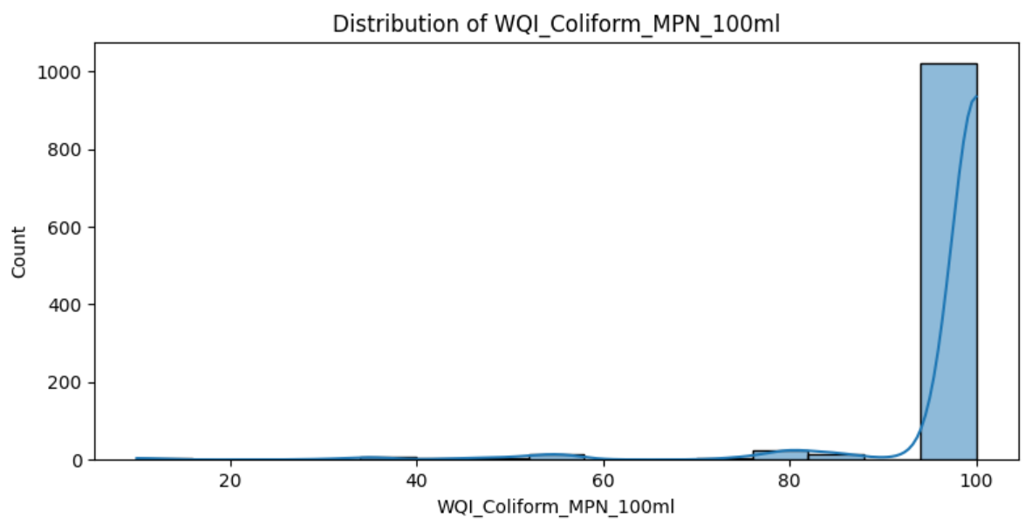
Figure 32 Distribution of WQI sub-index score for WQI_Coliform score
Chart Components:
- X-axis: WQI_Coliform score (0-100 scale)
- Y-axis: Frequency count of observations
Analysis:
The WQI_Coliform distribution exhibits an extreme left-skewed pattern, with a dominant peak exceeding 1,000 observations concentrated in the 95-100 range. This indicates that the vast majority of water samples meet the highest standards for microbiological safety, resulting in an "excellent" quality rating for this parameter. Despite this general trend of high quality, the distribution features a very thin "long tail" extending toward the lower end of the scale, including minor fluctuations around the 40-60 and 80 ranges. These outliers represent specific instances or locations where coliform bacteria levels are elevated, potentially due to localized runoff or proximity to waste discharge. However, the overwhelming frequency of maximum scores suggests that microbiological contamination is well-controlled across most of the study area.
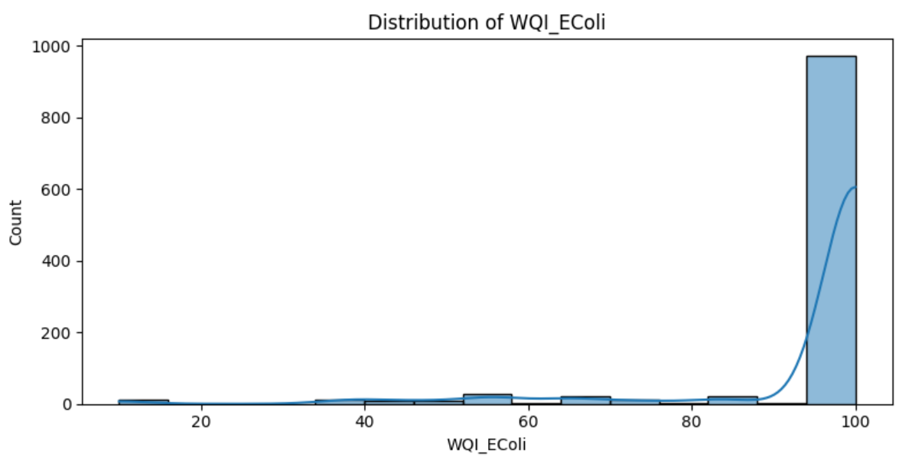
Figure 33 Distribution of WQI sub-index score for WQI_EColi score
Chart Components:
- X-axis: WQI_EColi score (0-100 scale)
- Y-axis: Frequency count of observations
Analysis:
The WQI_EColi distribution exhibits an extreme left-skewed pattern, with a dominant peak approaching 1,000 observations concentrated in the 95-100 range. This indicates that the vast majority of water samples possess very low levels of E. coli, resulting in an "excellent" water quality rating for this specific fecal indicator. Similar to the total coliform distribution, there is a sparse "long tail" of observations scattered across the lower end of the scale (10-90), representing sporadic or localized fecal contamination events. These outliers suggest that while most areas maintain high microbiological standards, certain locations experience intermittent pollution from sources such as sewage discharge or agricultural runoff. Overall, the high frequency of maximum scores demonstrates that E. coli levels are well within safe limits for most of the study area.
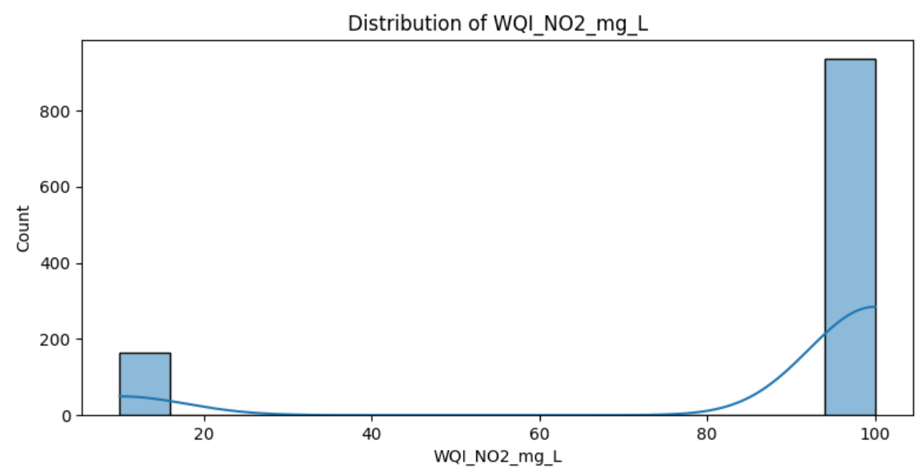
Figure 34 Distribution of WQI sub-index score for WQI_NO2_mg_L score
Chart Components:
- X-axis: WQI_NO2_mg_L score (0-100 scale)
- Y-axis: Frequency count of observations
Analysis:
The WQI_NO2 distribution exhibits a highly polarized, bimodal pattern with a dominant peak near the maximum score and a smaller, secondary cluster at the minimum end of the scale. The vast majority of observations (over 900 counts) are concentrated in the 95-100 range, indicating that nitrite levels are typically very low and reach an "excellent" water quality rating in most samples. However, there is a distinct secondary peak of nearly 200 observations occurring below a score of 20. This suggests that while baseline nitrite conditions are excellent, a significant subset of the data represents "very poor" water quality, likely indicating localized areas where nitrification processes are disrupted or where significant nitrogenous waste is being introduced. The near-absence of values in the 20-90 range highlights a sharp divide between clean water bodies and those severely impacted by nitrite.
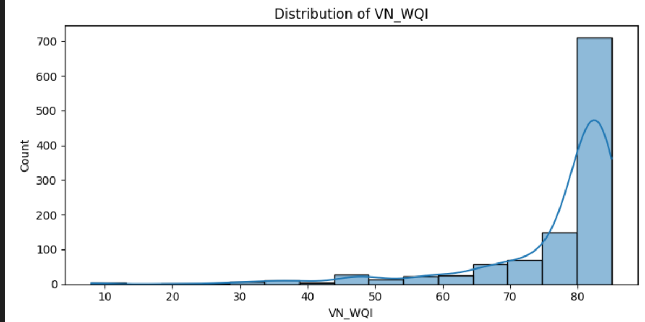
Figure 35 Distribution of VN_WQI score
Chart Components:
- X-axis: VN_WQI score (approx. 10-85 scale)
- Y-axis: Frequency count of observations
Analysis:
The overall VN_WQI distribution is heavily left-skewed, with a dominant peak of over 700 observations concentrated in the 80-85 score range. This indicates that, when aggregating all individual parameters, the majority of the water samples in the study area are classified as having "good" to "very good" quality according to the Vietnamese index. While the bulk of the data is concentrated at the high end, there is a visible trailing distribution extending down to scores as low as 10. This tail represents a minority of samples with "poor" or "very poor" integrated water quality, likely reflecting specific locations or time periods where multiple pollutants (such as nitrite or ammonium) coincided. Despite these localized areas of concern, the general environmental trend for the region remains strongly positive.

Figure 36
Observations on the Relationship between Temperature and DO:
- Overall Trend: The chart shows a wide dispersion of data points, indicating that there is no strong, simple linear correlation between the two variables. While DO levels vary significantly, there is a visible concentration of higher DO values in the moderate temperature range ($18$–$25$°C), with a slight tendency for the maximum DO values to decrease as temperature exceeds $30$°C, consistent with the physical principle that oxygen solubility typically drops as water warms.
- Distribution of Data Points: The majority of the samples are densely clustered within the temperature range of $20$°C to $30$°C, suggesting this is the most common thermal environment for the collected samples. Within this cluster, most DO values fluctuate between $6$ and $8$ mg/l.
- Variability and Anomalies: There is significant fluctuation in DO levels, with several outliers falling below $4$ mg/l across various temperatures. These low-oxygen instances—some even dropping near $1$ mg/l—indicate that in certain conditions (such as high organic loading or poor aeration), temperature is not the sole factor limiting DO, potentially creating "dead zones" harmful to aquatic life.

Figure 37
Observations on the Relationship between COD and BOD5:
- Overall Trend: The chart illustrates a positive correlation between COD and BOD5, meaning that as Chemical Oxygen Demand increases, Biochemical Oxygen Demand generally increases as well. This relationship is expected, as both parameters measure the amount of organic matter in the water, though COD represents the total chemically oxidizable matter while BOD5 focuses on the biodegradable fraction.
- Distribution of Data Points: The data points are highly concentrated in the low-range area, specifically where COD is under 50 mg/l and BOD5 is under 10 mg/l. Within this dense cluster, the relationship appears more linear, suggesting a consistent ratio between biodegradable and non-biodegradable substances in the majority of the water samples.
- Variability and Anomalies: As the values increase toward the right of the X-axis, the data points become much more scattered. There are several outliers with high COD (up to $300$ mg/l) and significantly higher BOD5 values (exceeding $50$ mg/l). The widening gap between points at higher concentrations suggests that in more polluted samples, the composition of organic waste varies significantly, which could indicate different sources of pollution or varying levels of wastewater treatment.

Figure 38
Observations on the Relationship between Coliform and E. coli:
- Overall Trend: The plot indicates a general upward trend where E. coli levels tend to increase alongside Total Coliform levels, though the relationship is less strictly linear compared to other parameters. Since E. coli is a subgroup of Total Coliforms, it is expected that E. coli counts remain lower than or equal to the total count.
- Distribution of Data Points: Most samples are clustered at the lower end of the scale, with Coliform counts below 5,000 MPN/100mL and E. coli below 150 MPN/100mL. The points are distributed in vertical "stripes" at certain intervals, which may reflect specific measurement thresholds or common levels found in the sampling environment.
- Variability and Anomalies: Significant variability is observed, with a prominent outlier reaching an E. coli level of 400 MPN/100mL at a Coliform level around 4,500 MPN/100mL. Additionally, there is an extreme outlier on the X-axis with a Coliform count of 25,000 MPN/100mL but a relatively low E. coli count (under 100 MPN/100mL), indicating a high presence of non-fecal coliform bacteria in that specific sample

Figure 39
4.2 Direct Measurement Inputs
Before removing unimportant features
Table 2
Model | MSE | RMSE | MAE | R²
Random Forest | 4.97 | 2.23 | 1.06 | 0.96
Gradient Boosting | 4.04 | 2.01 | 0.91 | 0.97
Linear Regression | 27.06 | 5.20 | 3.51 | 0.77
K-Nearest Neighbors | 14.34 | 3.79 | 2.15 | 0.88
Support Vector Regression | 10.31 | 3.21 | 1.75 | 0.91

Table 3
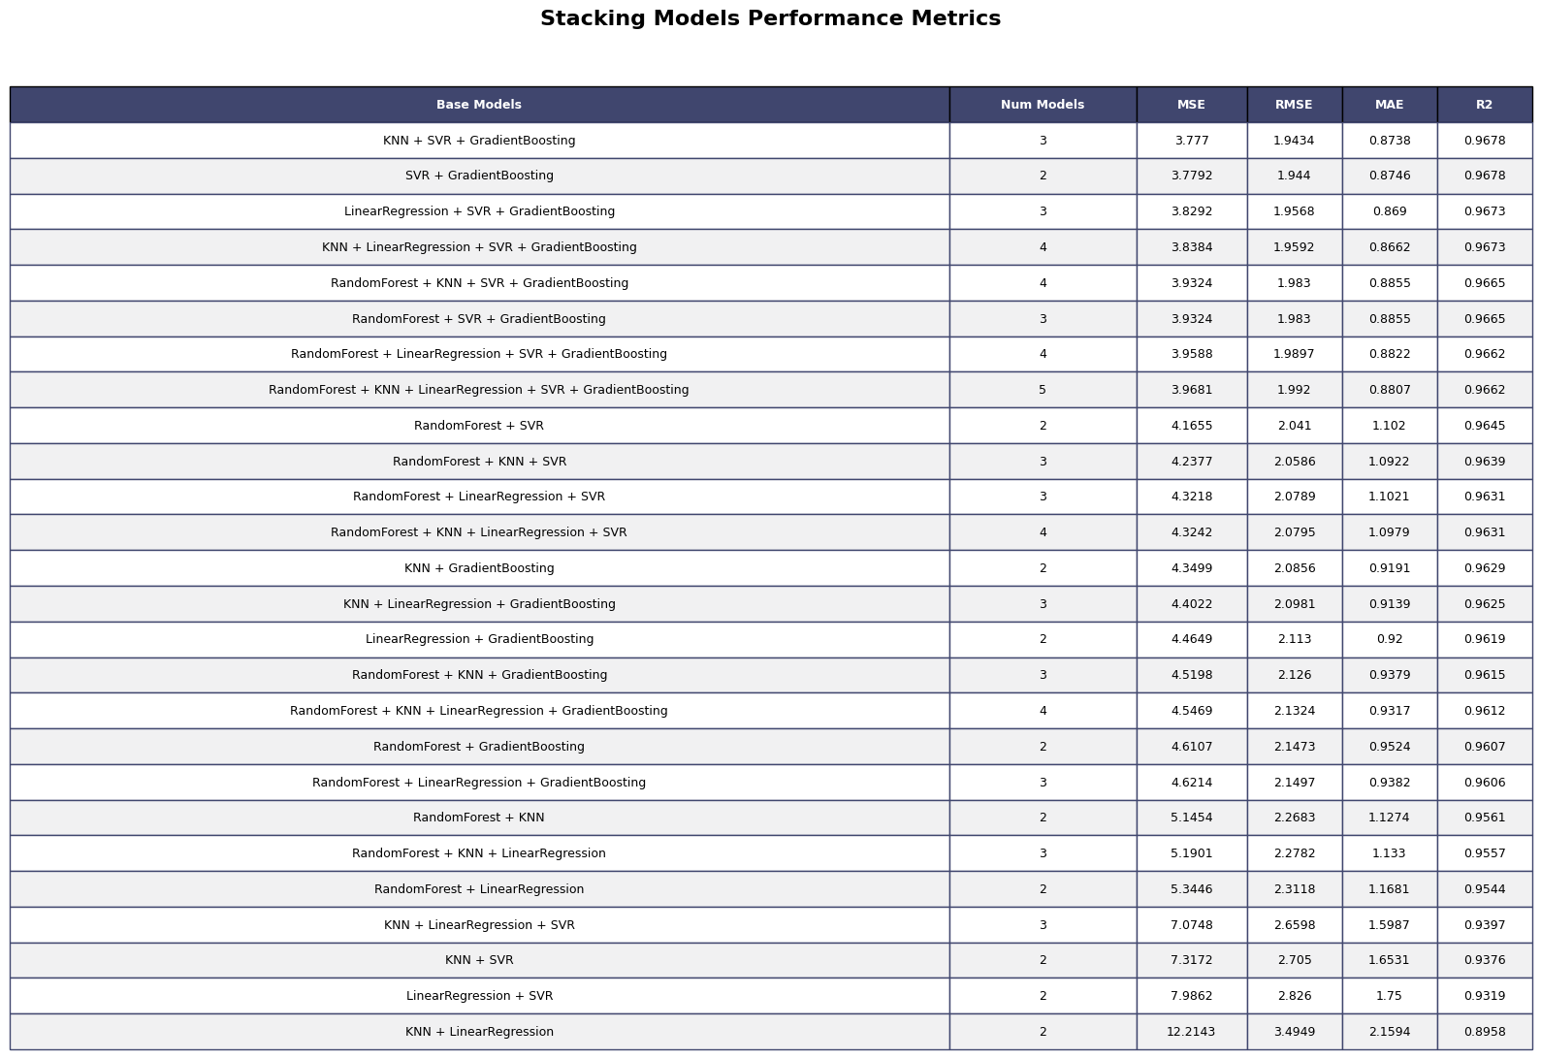


Figure 40
After removing unimportant features
Table 4
Model | MSE | RMSE | MAE | R²
Random Forest | 6.98 | 2.64 | 1.31 | 0.94
Gradient Boosting | 5.96 | 2.44 | 1.24 | 0.95
Linear Regression | 32.11 | 5.67 | 3.8 | 0.73
K-Nearest Neighbors | 20.74 | 4.55 | 2.54 | 0.82
Support Vector Regression | 11.64 | 3.41 | 1.92 | 0.9

Table 5
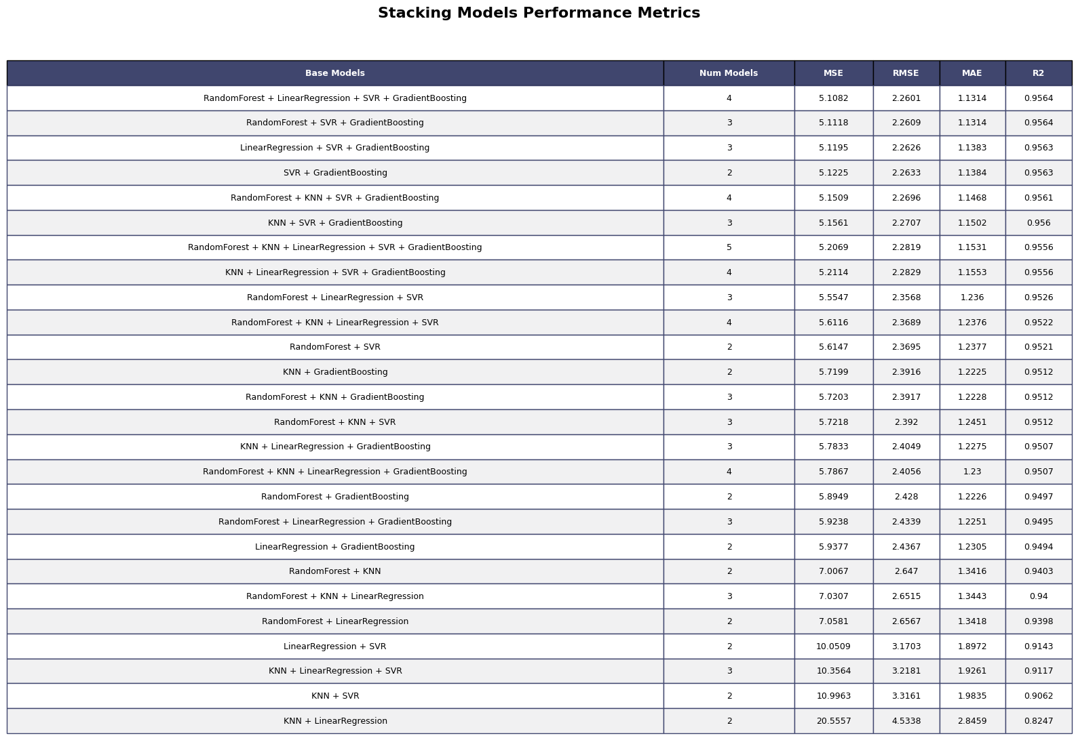

4.3 Feature Engineered Inputs (WQI_SI)
Before removing unimportant features
Table 6
Random Forest | 3.54 | 1.88 | 0.71 | 0.97
Gradient Boosting | 3.43 | 1.85 | 0.75 | 0.97
Linear Regression | 0.75 | 0.87 | 0.45 | 0.99
K-Nearest Neighbors | 2.84 | 1.69 | 0.70 | 0.98
Support Vector Regression | 0.73 | 0.85 | 0.40 | 0.99

Table 7
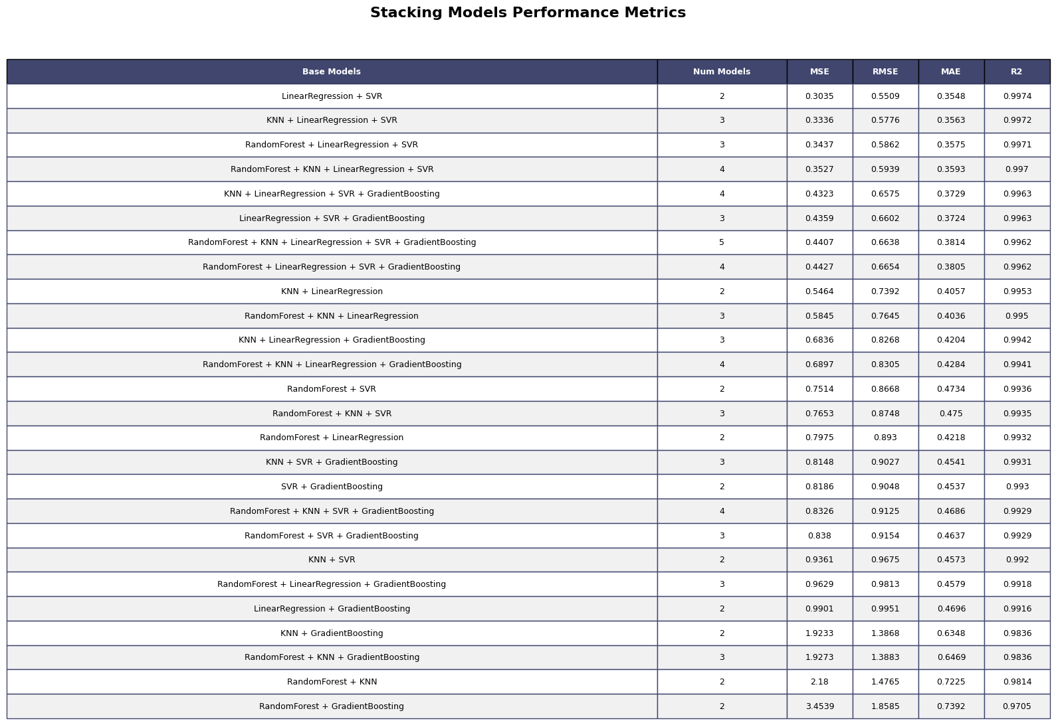

Figure 41
After removing unimportant features
Table 8
Random Forest | 6.96 | 2.64 | 1.23 | 0.94
Gradient Boosting | 5.66 | 2.38 | 1.2 | 0.95
Linear Regression | 4.88 | 2.21 | 1.09 | 0.96
K-Nearest Neighbors | 5.42 | 2.33 | 1.01 | 0.95
Support Vector Regression | 4.65 | 2.15 | 0.99 | 0.96

Table 9
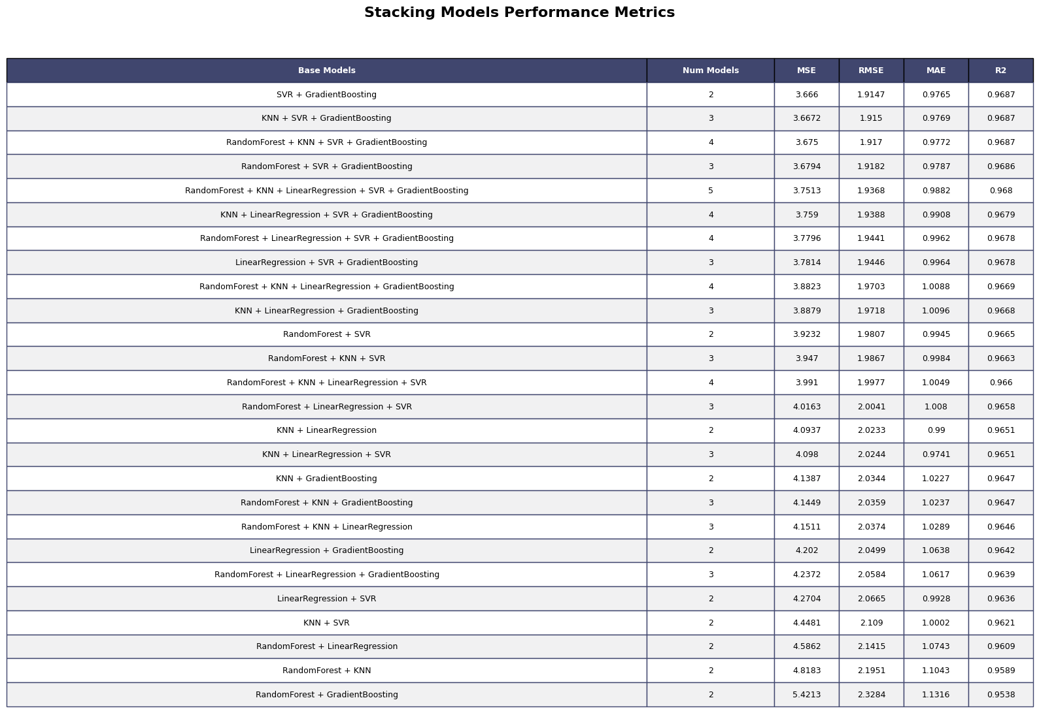

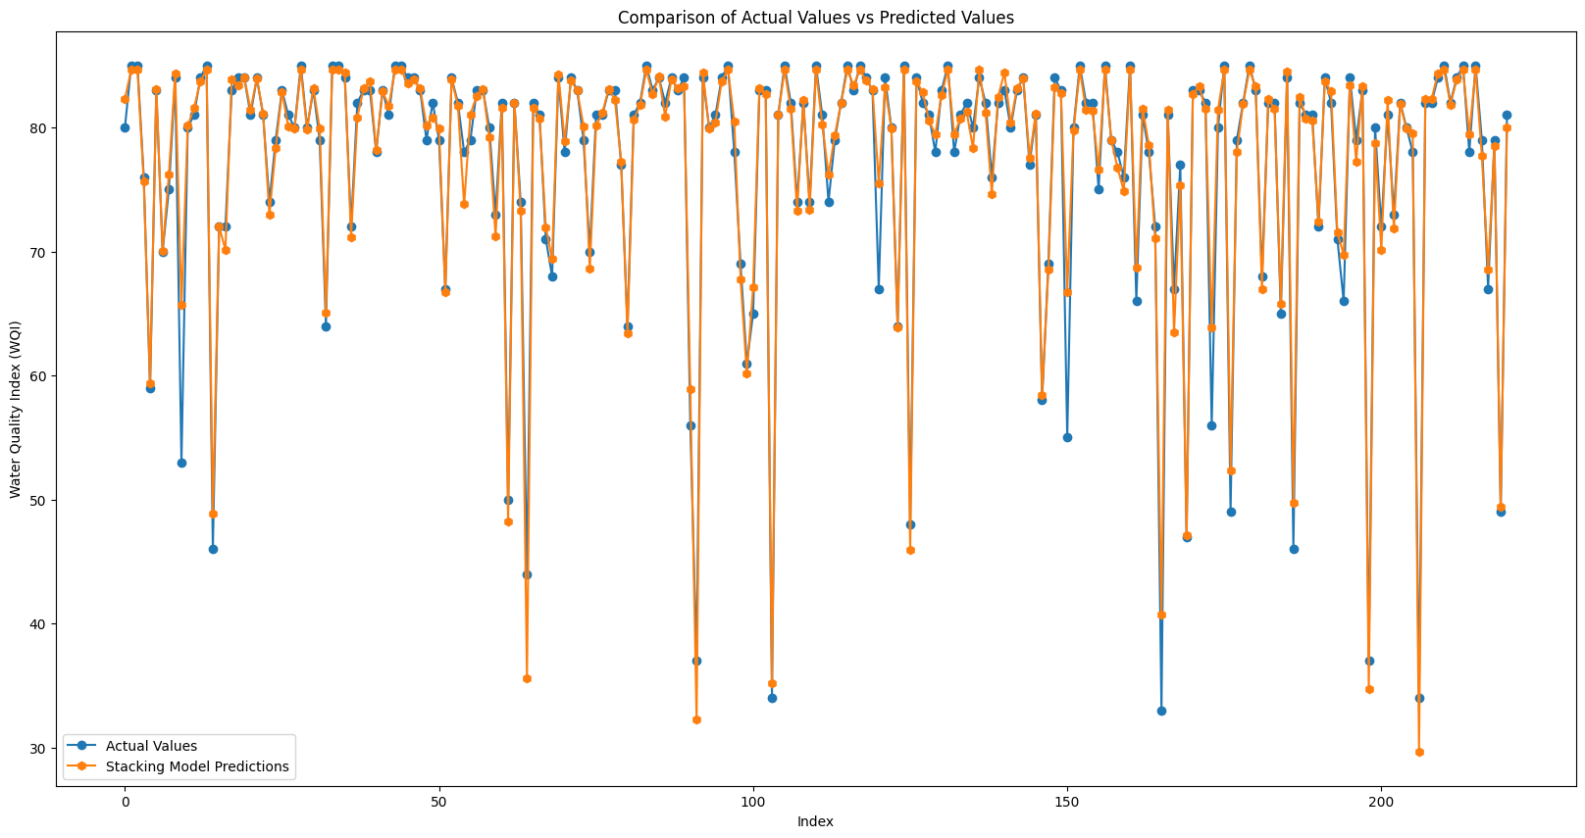
Figure 42
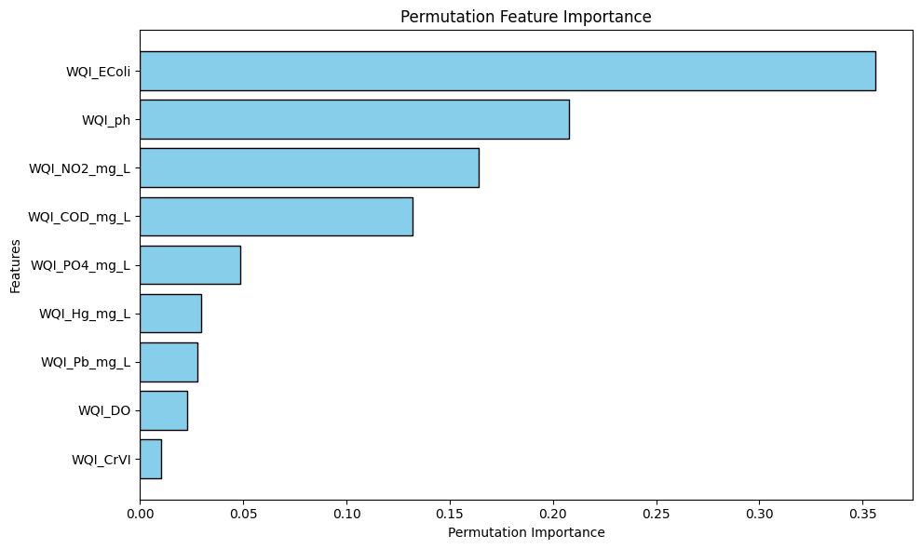
Figure 43

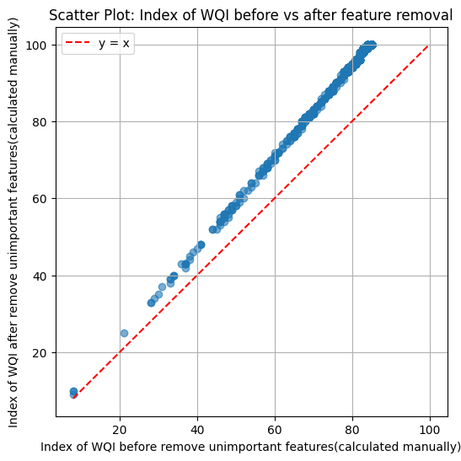
Figure 44

CHAPTER 5. DICUSSION

5.1 Technical
Select feature importance by permutation importance might remove important knowledge

5.2 Performance
Algorithms based tree performance better than others as they effectively handle noisy data

CHAPTER 6. CONCLUSION

CHAPTER 7. FUTURE WORK

REFERENCE
Abbasi, T., & Abbasi, S. A. (2012). Water Quality Indices. Elsevier. http://ebookcentral.proquest.com/lib/hud/detail.action?docID=892231
Breiman, L. (2001). Random Forests. Machine Learning, 45(1), 5–32. https://doi.org/10.1023/A:1010933404324
Ho, T. K. (1995). Random decision forests. Proceedings of 3rd International Conference on Document Analysis and Recognition, 1, 278–282 vol.1. https://doi.org/10.1109/ICDAR.1995.598994
Modaresi, F., Araghinejad, S., & Ebrahimi, K. (2018). A Comparative Assessment of Artificial Neural Network, Generalized Regression Neural Network, Least-Square Support Vector Regression, and K-Nearest Neighbor Regression for Monthly Streamflow Forecasting in Linear and Nonlinear Conditions. Water Resources Management, 32(1), 243–258. https://doi.org/10.1007/s11269-017-1807-2
MONRE. (2019). The Decision on the promulgation of technical guidelines for calculation and publication of the Vietnam water quality index (VN_WQI).
Muñoz-Alegría, J. A., Núñez, J., Oyarzún, R., Chávez, C. A., Arumí, J. L., & Rodríguez-López, L. (2025). A Bibliometric-Systematic Literature Review (B-SLR) of Machine Learning-Based Water Quality Prediction: Trends, Gaps, and Future Directions. Water, 17(20). https://doi.org/10.3390/w17202994
Štambuk-Giljanović, N. (1999). Water quality evaluation by index in Dalmatia. Water Research, 33(16), 3423–3440. https://doi.org/10.1016/S0043-1354(99)00063-9
Štambuk-Giljanović, N. (2003). Comparison of Dalmatian Water Evaluation Indices. Water Environment Research, 75(5), 388–405. https://doi.org/10.2175/106143003X141196
Sutadian, A. D., Muttil, N., Yilmaz, A. G., & Perera, B. J. C. (2015). Development of river water quality indices—A review. Environmental Monitoring and Assessment, 188(1), 58. https://doi.org/10.1007/s10661-015-5050-0
Vapnik, V. (2013). The Nature of Statistical Learning Theory. Springer Science & Business Media.
Yaseen, Z. M., Ramal, M. M., Diop, L., Jaafar, O., Demir, V., & Kisi, O. (2018). Hybrid Adaptive Neuro-Fuzzy Models for Water Quality Index Estimation. Water Resources Management, 32(7), 2227–2245. https://doi.org/10.1007/s11269-018-1915-7

