A Reduced-Input Machine Learning Framework for Predicting Water Quality Index Using WQI Sub-Indices as Engineered Features
A seminar report submitted to University of Huddersfield in partial fulfilment of degree of
BSc. Applied Computing
Toan Nguyen The
Student ID: U2560895

DEPARTMENT OF COMPUTER SCIENCE
SCHOOL OF COMPUTING AND ENGINEERING
April 2026

Abstract
Machine learning has been extensively explored to decrease the number of parameters required for Water Quality Index management, with the aim of lowering monitoring cost and time. This study addresses several key gaps, including the absence of a standardized evaluation framework, limited use of WQI sub-indices as engineered features, and the lack of direct comparisons between machine learning models and reduced-parameter WQI formulations. The dataset comprised 1,101 records collected from 125 monitoring locations between 2021 and 2024 and included 16 water quality features. A total of five single models (Random Forest, Gradient Boosting, Linear Regression, K-Nearest Neighbors, and Support Vector Regression) were evaluated individually. These models were also used as base learners to construct 26 stacking models, representing all possible combinations. All models were evaluated using GridSearchCV with five-fold cross-validation. Four experimental scenarios were designed to compare raw inputs and WQI sub-indices as engineered features, before and after feature selection, reducing the input space from 16 to six parameters. Correlation analysis and permutation importance were applied to eliminate redundant and low-impact variables. For raw inputs, Gradient Boosting achieved the best performance (MSE = 8.53, $R^{2}$ = 0.95), while stacking models showed no meaningful improvement. In contrast, using WQI sub-indices substantially improved model performance, after feature selection, Support Vector Regression achieved the best result (MSE = 5.59, $R^{2}$ = 0.97). The best AI model outperformed the reduced-parameter WQI formula. Overall, the proposed framework enhances predictive efficiency, reduces monitoring burden, and provides a scalable reference for WQI prediction.

Table of Contents
Chapter 1. Introduction 11
1.1. Background of The Study 11
1.2. Research Scope 12
1.3. Aim 12
1.4. Objectives 12
Chapter 2. Literature Review 13
2.1. Introduction to WQI 13
2.1.1. Evolution and Conceptual Foundation of the WQI 13
2.1.2. Two Conventional Schools of Thought 13
2.1.3. Parameter Selection and Sensitivity Issues 14
2.1.4. Limitations of Conventional WQI 14
2.2. Machine Learning Techniques for WQI 15
2.2.1. Overview of Machine Learning Techniques in WQI Modelling 15
2.2.2. Traditional algorithms 15
2.2.3. Ensemble Models 16
2.2.4. Deep Learning Techniques 16
2.2.5. Emerging Trends: Hybridization and Optimization 16
2.3. Feature Selection in Water Quality Modelling 16
2.3.1. Filter Methods 17
2.3.2. Wrapper Methods 17
2.3.3. Embedded Methods 18
2.4. Professional, Legal, Social and Ethical Issues 19
2.4.1. Professional Issues 19
2.4.2. Legal Issues 19
2.4.3. Ethical Issues 20
2.4.4. Social Issues 20
2.5. Key Findings 20
Chapter 3. Methodology 22
3.1. Study Area and Data Acquisition Strategy 22
3.1.1. Study Area Description 22
3.1.2. Data Quality Considerations 23
3.2. Research Approach 24
3.2.1. Method of Selected Development Approach 24
3.2.2. Theoretical Review 25
3.2.3. Evaluation Framework Selection 29
3.2.4. Experimental Design Logic 30
3.3. Data Preparation Strategy 31
3.3.1. Data Formatting and Type Standardization 31
3.3.2. Data Reduction and Filtering 32
3.3.3. Dataset Partitioning and Imputation 33
3.4. Feature Engineering Framework 34
3.4.1. Derivation of WQI-based Features 34
3.4.2. Data Standardization 35
3.5. Controlled Experimental Design and Modelling Framework 36
3.5.1. Experimental Design Scenarios 36
3.5.2. Standardized Training and Evaluation Pipeline 37
Chapter 4. Results 39
4.1. Exploratory Data Analysis 39
4.2. Baseline WQI Prediction Using Raw Inputs 44
4.2.1. Performance with Complete Raw Features 44
4.2.2. Performance with Selected Raw Features 46
4.3. WQI Prediction Using Engineered Features 48
4.3.1. Performance with Complete Engineered Features 48
4.3.2. Performance with Selected Engineered Features 50
4.4. Comparative Performance Analysis 53
Chapter 5. Technical Discussion 54
5.1. Outliers and Environmental Data Characteristics 54
5.2. Behavioural Analysis of Machine Learning Models 54
5.2.1. Stacking Versus Single Model 54
5.2.2. Nonlinear Structure of Raw Environmental Data 55
5.2.3. Impacting of WQI sub-indices based transformation technique 56
5.3. Effect of Feature Selection on Reduced-input Model 57
5.3.1. Impact of Reduced Features in Quang Ninh Data 57
5.3.2. Impact of Feature Selection Using Correlation Analysis 57
5.3.3. Impact of Selecting Features Using Permutation Importance 58
5.4. Practical Implications for Surface Water Quality Governance 58
5.5. Methodological Contributions 58
5.5.1. Recommended Approaches 58
5.5.2. Framework Contributions 59
5.6. Limitations 60
5.6.1. Limitations of the Topic 60
5.6.2. Limitations of the Study 60
Chapter 6. Performance Discussion 61
6.1. Key Learning and Implications 61
6.1.1. Achievement of Goals 61
6.1.2. Breakthrough Contributions 62
6.2. Skills and Competencies Developed 62
6.3. Critical Self-Reflection 63
Chapter 7. Conclusion 64
7.1. Summary of Achievements 64
7.2. Future Work and Recommendations 65
Bibliography 66
Apdendix 76

List of Figures
Figure 2.1: Evolutionary trends in the deployment of AI, Deep Learning, and Machine Learning for water quality forecasting (Muñoz-Alegría et al., 2025) 15
Figure 3.1: Spatial distribution of the study area and water quality sampling stations in Quang Ninh Province, Vietnam. 23
Figure 3.2: A visualization of GridSearchCV using 5-fold cross-validation (Scikit-learn developers, n.d.) 26
Figure 3.3: The architecture of Random Forest for regression tasks (Phulsawat et al., 2024) 26
Figure 3.4: A general flow diagram of the gradient boosting framework (Zhang et al., 2023) 27
Figure 3.5: Visual representation of the KNN algorithm (Qaddoura & Younes, 2023) 27
Figure 3.6: The visualization of LR in one dimension (L. Liu, 2025) 28
Figure 3.7: The process of SVR in one dimension (Kleynhans et al., 2017) 28
Figure 3.8: The operational process of the stacking model 29
Figure 3.9: High-Level Overview of the Workflow 31
Figure 3.10: Sequential Workflow for Data Formatting and Type Standardization 32
Figure 3.11: Sequential Workflow for Data Reduction and Filtering 33
Figure 3.12: Sequential Workflow for Dataset Partitioning and Imputation 33
Figure 3.13: Sequential Workflow for Data Exploration and Engineering 34
Figure 3.14: Visualization of WQI Formula 35
Figure 3.15: Standardized Machine Learning Training and Evaluation Pipeline. 38
Figure 4.1: Box Plots of the Attributes in the Dataset 40
Figure 4.2: Heatmap of Relationships Between Numeric Variables in the Dataset 41
Figure 4.3: Comparison of COD and BO$D5$ concentrations 42
Figure 4.4: Comparison of NH₄ and BO$D5$concentrations 42
Figure 4.5: Comparison of NH₄ and N$O2$ concentrations 43
Figure 4.6: Comparison of Coliform and E.coli concentrations 43
Figure 4.7: Permutation Feature Importance with 5-Fold CV for WQI Prediction Using Raw Input Parameters (Pre Feature Selection) 46
Figure 4.8: Top 15 Models Performance Metrics for Individual and Stacking Ensembles After Feature Selection with Raw Inputs 48
Figure 4.9: Permutation Feature Importance with 5-Fold CV for WQI Prediction Using Raw Input Parameters (Pre-Feature Selection) 50
Figure 4.10: Top 15 Models Performance Metrics for Individual and Stacking Ensembles After Feature Selection with WQI sub-indices Inputs 52
Figure 4.11: Performance comparison of Best-Perform Machine Learning Model and Traditional Calculation methods under Feature Reduction constraints. 53
Figure 5.1: Proposed Machine Learning Framework for WQI Prediction 60

List of Tables
Table 3.1: Descriptive statistics of water quality parameters and WQI in Quang Ninh Province 24
Table 4.1: Individual Regression Models Performance on Raw Water Quality Inputs (Pre Feature Selection) 44
Table 4.2: Performance Comparison of 5 Best-Perform Stacking Models Configurations Using Raw Input Features Before Feature Selection 45
Table 4.3: Individual Models Performance Comparison After Feature Selection with Raw Inputs 47
Table 4.4: Top 5 Stacking Models Performance Comparison After Feature Selection with Raw Inputs 47
Table 4.5: Individual Regression Models Performance on WQI sub-indices Inputs Before Feature Selection 49
Table 4.6: Top 5 Stacking Models Performance Comparison on WQI sub-indices Inputs Before Feature Selection 49
Table 4.7: Individual Regression Models Performance on WQI sub-indices Inputs After Feature Selection 51
Table 4.8: Top 5 Stacking Models Performance Comparison on WQI sub-indices Inputs After Feature Selection 52

List of Abbreviations
AI | Artificial Intelligence
WQI | Water Quality Index
VN_WQI | Vietnamese Water Quality Index
PLSE | Professional, Legal, Social and Ethical
RF | Random Forest
GB | Gradient Boosting
LR | Linear Regression
KNN | K-Nearest Neighbors
SVR | Support Vector Regression
XGBoost | Extreme Gradient Boosting
NSFWQI | National Sanitation Foundation WQI
CCME | Canadian Council of Ministers of the Environment
MONRE | Ministry of Natural Resources and Environment
pH | Potential of Hydrogen
DO | Dissolved Oxygen
Sal | Salinity
Turb | Turbidity
COD | Chemical Oxygen Demand
BO$D_{5}$ | Biochemical Oxygen Demand
S$O_{4}$ | Sulfate concentration
N$O_{3}$ | Nitrate concentration
N$O_{2}$ | Nitrite concentration
N$H_{4}$ | Ammonium concentration
P$O_{4}$ | Phosphate concentration
Cl | Chloride concentration in mg/L
OilFat | Total oil and fat content in mg/L
Coliform | Coliform bacteria count (MPN/100ml)
E. coli | Escherichia coli bacterial count
As | Arsenic concentration in mg/L
Hg | Mercury concentration in mg/L
Pb | Lead concentration in mg/L
Cd | Cadmium concentration in mg/L
CrVI | Hexavalent Chromium concentration
MSE | Mean Squared Error
RMSE | Root Mean Squared Error
MAE | Mean Absolute Error
$$R^{2}$$ | Coefficient of Determination

Introduction

Background of The Study
Water quality management is essential for environmental protection and sustainable development, particularly in ecologically sensitive areas such as Ha Long Bay in Quang Ninh Province, a UNESCO World Heritage Site. The region supports tourism, aquaculture and coastal ecosystems, but is increasingly affected by socioeconomic development and associated pollution pressures, leading to growing concerns over water quality (N. Nguyen & Sevando, 2019; Van Hien et al., 2024).
The WQI is commonly applied to more easily evaluate water quality by integrating multiple parameters into an interpretable score, particularly for analysing temporal water quality trends (Chidiac et al., 2023; Dasu, 2025; Noori et al., 2019; Ott, 1978; Van Hien et al., 2024). However, traditional WQI estimation requires substantial field data collection and laboratory analysis, resulting in high cost and long processing time (Barathkumar & Devi, 2025; Jayaraman et al., 2024; Uddin et al., 2021). Attempts to reduce monitoring costs by calculating WQI using fewer parameters have often resulted in reduced accuracy and reliability (Mogane et al., 2023; Rangeti et al., 2015; Uddin et al., 2021).
Nevertheless, recent advances in machine learning have introduced a new approach to water quality evaluation (Dasu, 2025). AI‑based WQI prediction models can effectively capture complex interactions among water quality variables while using reduced sets of input parameters, improving prediction efficiency and reducing dependence on the number of samples collected without significantly compromising accuracy (Lap et al., 2023). Consequently, machine learning‑driven WQI prediction has emerged as a promising trend for improving water quality management in contexts where conventional monitoring is constrained by cost and logistics.
However, although many studies have applied a wide range of techniques for model development and optimization, a standardized framework for systematically selecting and evaluating these methods is still lacking, leading to inconsistencies in model comparison and potentially suboptimal performance. In addition, previous studies have rarely considered WQI sub-indices as input variables, despite their potential to enhance predictive performance through domain-informed feature representation.

Research Scope
The scope of this study is defined according to four primary dimensions: research focus, geographical coverage, time frame, WQI formulation.
- Research focus: This research focuses on developing and evaluating a machine learning framework for reduced-input prediction of the Vietnamese Water Quality Index (VN_WQI).
- Geographical coverage: The geographical scope of the research is restricted to Quang Ninh Province, Vietnam home to Ha Long Bay, a UNESCO World Heritage Site.
- Time frame: The analysis is conducted using water quality records collected between 2021 and 2024.
- WQI formulation: The study adopts the VN_WQI, which published by Ministry of Natural Resources and Environment (MONRE).

Aim
This study aims to develop a reduced-input yet reliable machine learning framework for predicting the VN_WQI, balancing predictive accuracy and resource cost.

Objectives
- To identify the best-performing machine learning model for WQI prediction in Quang Ninh province.
- To compare the effects of raw features, and WQI sub-index as input features, in predictive modelling.
- To evaluate the best-performing model while saving time and cost with minimal loss in accuracy, and its assess their predictive performance relative to reduced-parameter WQI formulas.
- To investigate the effectiveness of different feature selection methods.

Introduction to WQI

Evolution and Conceptual Foundation of the WQI
The WQI has evolved over time, with different regions developing distinct formulations. The WQI synthesizes biological, physical and chemical water quality data into a single value, facilitating environmental management (Štambuk-Giljanović, 1999, 2003; Sutadian et al., 2016). Horton (1965, as cite in Dasu, 2025; Talukdar et al., 2023) first proposed arithmetic aggregation of normalized parameters. (Brown et al., 1970) enhanced this approach via the National Sanitation Foundation WQI (NSFWQI), incorporating expert-based weighting (Abbasi & Abbasi, 2012). The Canadian Council of Ministers of the Environment (CCME) model later emphasized regulatory compliance using amplitude, frequency, and scope of exceedances (CCME, 2017). Overall, WQI evolution reflects a shift from arithmetic reduction to governance-oriented assessment.
Conventional WQI models follow a systematic four-stage workflow: parameter selection, sub-index transformation, weighting, and aggregation (Abbasi & Abbasi, 2012). This framework allows heterogeneous water quality indicators to be converted into a single dimensionless score, supporting integrated assessment while maintaining comparability across studies.

Two Conventional Schools of Thought
Currently, two main approaches to WQI development are widely adopted worldwide. The NSFWQI exemplifies the weighted arithmetic expert-based approach, where weights are assigned based on expert judgment (Abbasi & Abbasi, 2012; Brown et al., 1970). Advantages of this method include simplicity and ease of interpretation for policymakers and the public. However, reliance on subjective weighting can introduce bias and limit reproducibility across regions or studies (Sutadian et al., 2016).
In contrast, the CCME WQI represents a regulatory-focused approach, calculating water quality based on scope, frequency, and amplitude of standard exceedances (CCME, 2017). This approach reduces subjectivity and aligns evaluation with legal standards, but it may be less intuitive and require more complex computations.
Both approaches implement the general four-stage workflow but differ in weighting strategy and evaluation focus. Expert-based indices prioritize interpretability, whereas compliance-based indices prioritize objectivity and adherence to standards. The choice of approach depends on the intended use, either for rapid public reporting or enforcement of environmental regulations (Uddin et al., 2021).

Parameter Selection and Sensitivity Issues
Parameter selection fundamentally constrains WQI validity, as index scores reflect only the included variables. Conventional models typically incorporate Biochemical Oxygen Demand (BO$D_{5}$), pH (Potential of Hydrogen), Turbidity (Turb), Dissolved Oxygen (DO), suspended solids, and nutrients (Sutadian et al., 2016). However, parameter relevance varies by water-use objective: drinking water emphasizes microbial and toxic contaminants, irrigation prioritizes Salinity (Sal) indicators, and ecosystem assessments focus on oxygen balance and nutrient enrichment (Štambuk-Giljanović, 2003; Uddin et al., 2021).
WQI outcomes are sensitive to parameter inclusion and weighting, as aggregation amplifies the influence of dominant variables (Lumb et al., 2006; Sutadian et al., 2016). Moreover, omission of emerging pollutants such as trace metals or pharmaceuticals may produce overly optimistic classifications. Thus, parameter selection is not purely technical but a normative decision shaping environmental interpretation and policy relevance.

Limitations of Conventional WQI
WQIs remain widely used because they condense multiple measurements into a single, interpretable indicator for assessment and communication (Uddin et al., 2021). However, conventional WQI models face several structural limitations. Firstly, conventional WQI computation is still labour-intensive because it depends on repeated measurement of numerous physicochemical and, in some applications, microbiological variables, which increases analytical cost and slows routine monitoring (D. P. Nguyen et al., 2023; Uddin et al., 2021). For example, calculating WQI issued in this study requires 16 parameters. This highlights the need to reduce the number of parameters while maintaining acceptable accuracy.
Secondly, aggregation of multidimensional data into a single score leads to information loss, potentially generating a masking effect in which critical parameter exceedances are diluted (Chidiac et al., 2023). This limitation may also apply to machine learning models, as they use water quality parameters as inputs, the WQI index as the output, and learn from WQI-based formulations.
Thirdly, differences in weighting schemes, parameter selection, and classification thresholds create regional inconsistency, limiting cross-study and cross-country comparability (Uddin et al., 2021). This arguments suggests the difficulty of using a reference study between countries due to differences in in formulas and environmental conditions.

Machine Learning Techniques for WQI

Overview of Machine Learning Techniques in WQI Modelling
Recent research has increasingly focused on how to preserve assessment reliability while reducing the number of monitored variables and simplifying the estimation process (D. P. Nguyen et al., 2023; Walczak & Walczak, 2025). Machine learning has become a major response to this challenge because it can model nonlinear relations among water-quality variables more flexibly than conventional empirical approaches (Najah Ahmed et al., 2019). As shown in Figure 2.1, the field has expanded rapidly in recent years and identified ensemble models as the dominant family, with boosting and bagging accounting for 25.91% and 43.07% of the literature, respectively (Muñoz-Alegría et al., 2025). The same review reported a shift toward hybrid and explainable architectures, transfer learning, and transformer-based approaches for time-series prediction. The main approach used to predict WQI can be grouped into three categories: traditional algorithms, ensemble techniques, deep learning models.

Figure 2.1: Evolutionary trends in the deployment of AI, Deep Learning, and Machine Learning for water quality forecasting (Muñoz-Alegría et al., 2025)

Traditional algorithms
Classical machine learning techniques, such as Decision Tree (Khoi et al., 2022; Lap et al., 2023), Linear Regression (LR) (Barathkumar & Devi, 2025), Support Vector Regression (SVR) (Lap et al., 2023) and K-Nearest Neighbors (KNN) (Krishnamoorthy & Lakshmanan, 2025) have been widely applied in the prediction of WQI across various environmental contexts. While ML techniques successfully addressed non-linear environmental data (Talukdar et al., 2023; Yaseen et al., 2018), they encountered limitations in capturing the high-frequency temporal fluctuations (Talukdar et al., 2023).

Ensemble Models
Ensemble learning techniques, such as Random Forest (RF) (Lap et al., 2023), Extreme Gradient Boosting (XGBoost) (Yuan et al., 2025), Gradient Boosting (GB) (Sidek et al., 2024), have been widely adopted in WQI prediction because of their capacity to capture complex non-linear relationships (Ahmad et al., 2025) and reduce overfitting in noisy environmental datasets (Dasu, 2025; Makumbura et al., 2024). These methods aggregate numerous base learners to enhance overall predictive robustness and accuracy compared to individual models (Ahmad et al., 2025).

Deep Learning Techniques
Architectures based on deep learning such as Long Short-Term Memory (LSTM) (Baek et al., 2020; Barzegar et al., 2020) were introduced to problem-relevant parameters and represent highly intricate record distributions (Shen, 2018) and automated feature extraction (P. Liu et al., 2019). This paradigm shift reflects a movement toward hierarchical learning systems (Barzegar et al., 2020) that provide superior accuracy and robustness in predicting complex hydrological variables.

Emerging Trends: Hybridization and Optimization
Current research in the field has transitioned toward more integrated and transparent frameworks:
- Hybridization: There is a significant trend toward hybrid architectures, such as the CNN-LSTM model (Barzegar et al., 2020) and stacking model (Niazkar & Piraei, 2025). Hybrid models can bring more accurate than single models (Chou et al., 2018) and exhibit greater flexibility and resilience when handling noisy datasets (Talukdar et al., 2023). However, they are inherently complex, computationally time-consuming (Talukdar et al., 2023).
- Optimization: Systematic hyperparameter optimization, particularly through techniques like GridSearchCV, is widely employed (Shekar & Dagnew, 2019) and achieve a higher level of predictive accuracy (Elgeldawi et al., 2021; Villalobos-Arias et al., 2020; Uddin et al., 2022).

Feature Selection in Water Quality Modelling
According to Guyon & Elisseeff (2003) Feature Selection can be described as a preprocessing procedure aiming to identify the most relevant subset of variables from a raw dataset to eliminate redundant or irrelevant information. Current methodologies are categorized into three primary frameworks based on their interaction with the induction algorithm: Wrapper, Embedded, and Filter methods (Guyon & Elisseeff, 2003).

Filter Methods
Filter methods evaluate the importance of features based on the intrinsic statistical characteristics of the dataset, such as distance measure, independently of any machine learning model (Guyon & Elisseeff, 2003).
These methods typically include:
- Pearson Correlation coefficient: measures the linear dependency of a feature $X$ and the target $Y$.
$$r=\frac{cov(X,Y)}{σ_{X}σ_{Y}}$$
- ANOVA: evaluates whether there are statistically significant differences between group means across classes.
$$F=\frac{\text{between-group variance}}{\text{within-group variance}}$$
- Chi-square: assesses the dependency between categorical variables by comparing observed and expected frequencies.
$$χ^{2}=∑\frac{\left(O − E)^{2}\right.}{E}$$
- Linear Discriminant Analysis: measures class separability by maximizing the ratio of inter-class to intra-class variance.
$$J(w)=\frac{w^{T}S_{B}w}{w^{T}S_{W}w}$$
Overall, filter methods provide model-independent and a fast way to evaluate feature relevance using statistical properties of the dataset. People can find more information about filter methods in Bommert et al. (2020).

Wrapper Methods
Wrapper methods in feature selection are techniques that evaluate and select feature subsets by training and validating a predictive model, treating the learning technique as a “black box” and optimizing based on its predictive performance (Kohavi & John, 1997).
These methods typically include:
- Forward Selection: initiates with a null feature set and incrementally adds the feature that most improves model accuracy at each step.
- Backward Elimination: initiates with all features and recursively drops the weakest feature based on model performance degradation.
- Best-First Search: explores the feature subset space using heuristic search strategies to identify high-performing combinations of features.
- Recursive Feature Elimination (RFE): repeatedly fits a model and filters out the least important features based on model-derived importance scores.
Overall, wrapper methods generally achieve higher predictive performance by explicitly modelling feature interactions, but they are computationally expensive and may suffer from overfitting, especially in high-dimensional datasets. Further information on wrapper-based feature selection can be found in Kohavi & John (1997).

Embedded Methods
Embedded feature selection techniques are methods in which feature selection is intrinsically incorporated into the model training process, allowing the learning algorithm to simultaneously optimize predictive performance and identify the most relevant features in a unified framework (Guyon & Elisseeff, 2003).
These methods typically include:
- LASSO (Least Absolute Shrinkage and Selection Operator): conducts feature selection by using L1 regularization to linear models, shrinking some coefficients exactly to zero and thereby dropping irrelevant features.
$$\sum_{i=1}^{N}{{\left(y_{i} − {\sum_{j}^{ }{x_{ij}}β}_{j}\right)}^{2}}+λ\sum_{j=1}^{p}{∣β_{j}∣}$$
- Elastic Net regularization: extends LASSO by combining L1 and L2 penalties to handle correlated features more effectively.
$$\underset{β}{min⁡}\left(\sum_{i=1}^{n}{(}y_{i}-\sum_{j}^{ }{x_{ij}}β_{j})^{2}+λ_{1}\sum_{j=1}^{p}{∣}β_{j}∣+λ_{2}\sum_{j=1}^{p}{β_{j}^{2}}\right)$$
- Decision Trees: perform implicit feature selection by choosing splits that maximize impurity reduction at each node.
$$\text{Information Gain}=H(S)-\sum_{i}{\frac{n_{j}}{n_{t}}}\sum_{c}{\left(-\frac{n_{jc}}{n_{j}}\right)}\log_{2}\left(\frac{n_{jc}}{n_{j}}\right)$$
- Permutation Importance: evaluates feature relevance post-training by randomly shuffling value of a single feature and measuring the resulting decrease in predictive performance, offering a flexible, model-agnostic approach.
Overall, embedded methods provide a optimal balance between computational efficiency and predictive accuracy by integrating feature selection directly into the model optimization process.

Professional, Legal, Social and Ethical Issues
Any mistakes in water resource management may result in serious consequences, given that water is essential for human survival, ecosystems, and serves as a critical foundation for socio-economic development.

Professional Issues
There is a significant concern within scientific research regarding data fabrication and research misconduct. Z. Chen et al. (2024) highlight that AI technologies can potentially be used to fabricate data in support of desired outcomes. A well-known example is the Woo-Suk Hwang fraud case, widely regarded as one of the most significant cases of scientific misconduct in history, in which research records and experimental results were falsified (van der Heyden et al., 2009). Such misconduct can have far-reaching consequences, as fabricated findings may distort subsequent analyses, mislead future studies that rely on these results through citation and reuse, and ultimately undermine the reliability of the wider scientific literature.

Legal Issues
There is limited research on responsibility for AI errors. Lowe et al., (2022) stated that in certain cases where AI systems produce incorrect predictions, it is difficult to identify the liable party and determine compensation for damages due to gaps in legal frameworks across many regions. Consequently, there is a need to establish a robust legal framework prior to the deployment of AI-based WQI prediction systems.
Besides, the application of WQI prediction in real-world contexts requires governmental approval. For instance, Lowe et al. (2022) contend that machine learning models are highly dependent on local conditions, making it difficult to meet standard requirement imposed by governments. As a result, this poses a key obstacle to real-world deployment, as such systems may not fully comply with regulatory expectations.

Ethical Issues
As discussed in Limitations of Conventional WQI of Literature Review, the standard WQI formula, which is the most accurate technique, is still not reliable in all cases because of masking effect. One ethical issue is that, to save time and cost, the study has to remove features, potentially decreasing model accuracy, while the most accurate techniques may fail to provide fully reliable results under special conditions. As a result, this raises fundamental ethical concerns regarding whether AI systems should be granted decision-making authority in high-stakes environmental contexts, where even minor errors may lead to severe and far-reaching consequences, thereby challenging issues of accountability, responsibility, and human oversight.
Despite this, recently studies have shown that machine learning can maintain high accuracy while reducing number of features (Campos et al., 2026; K. Chen et al., 2020). For example, there are several machine learning models in the studies of Shams et al. (2024) and Barathkumar & Devi (2025) achieved MAE values close to zero. These arguments reinforce the promising capability of machine learning to achieve both efficiency and reliability in most cases, thereby supporting the case for feature reduction as a viable strategy for balancing computational efficiency and predictive performance.

Social Issues
As discussed above regarding infrastructural limitations, WQI prediction may contribute to regional inequality. A study by Barathkumar & Devi (2025) argued that data collected by sensors in hardware-constrained regions may contain significant noise, which reduces the accuracy of WQI prediction. As a result, this may exacerbate social instability and increase rural-to-urban migration.
Additionally, machine learning models may lead to a lack of transparency. Study by Campos et al. (2026) suggests that this lack of transparency may reduce stakeholder trust and make real-world testing more difficult. This study will discuss the behaviour of machine learning models in the Discussion section to ensure transparency.

Key Findings
The WQI offers a simplified and intuitive perspective, enabling more effective assessment and management of water resources.
WQI prediction has been a trending topic for more than 20 years, and numerous studies have applied a variety of technologies to predict and analyse WQI in different areas.
However, although a broad variety of techniques has been applied for model development and optimization, there remains a paucity of a standardized framework for the systematic selection and evaluation of these methods, resulting in inconsistencies in model comparison and potentially suboptimal performance. Moreover, previous studies have seldom incorporated WQI sub-indices as input features, despite their potential to improve predictive performance through domain-informed feature representation.
Furthermore, variations in WQI formulations and regional characteristics limit the transferability of models and datasets across different contexts, highlighting the importance of reproducing models that have been successfully applied to new datasets. Nevertheless, their methodologies and logical frameworks can still serve as valuable references. This idea support the importance of creating an standard framework.
This study focuses on proposing a new methodology, beginning with core machine learning algorithms and stacking models, which are a type of hybrid model, to identify which models should be further explored in future research. Although deep learning is also a promising field, the available data are insufficient in developing countries such as Vietnam to effectively train deep learning models.

Methodology

Study Area and Data Acquisition Strategy

Study Area Description
The study was conducted in Quang Ninh, a north-eastern coastal province of Vietnam with diverse terrain including mountains, rivers and estuaries, providing ideal conditions for environmental modelling.
Ha Long Bay and Bai Tu Long Bay are semi-enclosed systems with limited water circulation, sensitive to human activities and seasonal changes. The humid subtropical climate brings high runoff in the wet season and reduced freshwater in the dry season, affecting salinity, suspended solids, nutrients, and DO.
Quang Ninh is highly industrialized, with coal mining, power generation, ports, aquaculture, and tourism, creating non-both point and point pollution. Water quality is affected by suspended solids, BO$D_{5}$, COD, ammonium concentration (N$H_{4}$), nitrate concentration (N$O_{3}$), and localized salinity, with spatial variation across freshwater, estuarine, and marine areas.
The combination of multi-source pollution and its UNESCO World Heritage status makes Quang Ninh a critically important case for research.
Figure 3.1 presents the spatial distribution of the study area within Quang Ninh Province, Vietnam. The inset map indicates the geographical location of Quang Ninh within the national context. Within the main panel, provincial boundaries define the study area, while national roads and river networks are displayed to provide geographic reference. Red markers denote the sampling locations. Longitude and latitude and coordinates are provided along the axes to assist readers in interpreting spatial position and scale.

Figure 3.1: Spatial distribution of the study area and water quality sampling stations in Quang Ninh Province, Vietnam.

Data Quality Considerations
Water quality data from Center for Natural Resources and Environment Monitoring of Quang Ninh Province, Vietnam, 1,101 records were collected from 2021 to 2024 at 125 different location, including key sites near Ha Long Bay, a UNESCO World Natural Heritage site. The dataset includes monthly and bimonthly measurements of chemical, physical, microbiological, and heavy metal parameters to provide an extensive assessment of water quality in the province (Table 3.1).
Table 3.1: Descriptive statistics of water quality parameters and WQI in Quang Ninh Province
Parameters | Unit | Minimum | Maximum | Mean | Median | Std. Deviation
Temperature | degrees Celsius | 7.4 | 39.4 | 24.2 | 23.6 | 4.8
pH |  | 4.59 | 8.64 | 6.69 | 6.64 | 0.44
DO | mg/l | 1.08 | 9.7 | 6.7 | 6.72 | 1
COD | mg/l | 1.5 | 306.4 | 15.6 | 11.3 | 23.16
BO$D_{5}$ | mg/l | 1 | 54.4 | 4.3 | 3.1 | 4.2
N$O_{3}$ | mg/l | 0.008 | 6.528 | 0.345 | 0.214 | 0.638
N$O_{2}$ | mg/l | 0.002 | 8.337 | 0.185 | 0.002 | 0.951
N$H_{4}$ | mg/l | 0.01 | 6.32 | 0.4 | 0.05 | 1.02
P$O_{4}$ | mg/l | 0.01 | 10.37 | 0.05 | 0.01 | 0.34
Coliform | MPN/100ml | 3 | 25000 | 767 | 150 | 1885
EColi |  | 3 | 400 | 14 | 3 | 35
As | mg/l | 0 | 0.014 | 0.001 | 0 | 0.001
Hg | mg/l | 0 | 0.006 | 0 | 0 | 0
Pb | mg/l | 0 | 0.066 | 0.001 | 0.001 | 0.003
Cd | mg/l | 0 | 0.011 | 0.001 | 0.001 | 0
CrVI | mg/l | 0.001 | 0.03 | 0.001 | 0.001 | 0.003

Research Approach

Method of Selected Development Approach
The foundational methodology of this research is built upon core machine learning algorithms and ensemble models, integrated with feature selection to reduce computational cost and minimize time-consuming model development. The use of feature selection is particularly important in this study, as it aims to identify the most informative predictors while improving model efficiency and interpretability.
Core machine learning algorithms were deliberately selected because they generally perform well on small datasets, which aligns with the features of the dataset used in this study. Moreover, employing fundamental algorithms allows for a clearer understanding of which algorithmic family performs best under the given conditions, thereby providing direction for deeper investigation in future research.
GridSearchCV was applied to all candidate models to systematically optimize hyperparameters. Preprocessing steps were strictly fitted on the training subset in each cross-validation fold to avoid data leakage. This approach ensured methodological rigor while leveraging the benefits of cross-validation, improving or at least maintaining predictive accuracy compared to models without hyperparameter tuning.
For machine learning models such as RF, GB, LR, KNN, SVR are selected in this study, as follows:
- RF was selected based on experimental evidence reported by Lap et al., (2023), which demonstrated that RF outperformed other algorithms within a comparable research context. This empirical support provides strong justification for its inclusion in the present study.
- GB was chosen because prior studies (Ahmed et al., 2019; Shams et al., 2024) indicate that this algorithm achieves superior performance in specific scenarios. Given its ability to capture complex nonlinear relationships, it is included to evaluate whether similar advantages can be observed in this dataset.
- LR was incorporated due to findings by Barathkumar & Devi, (2025), whose experiments showed that LR outperformed all competing models with superior evaluation metrics. Including LR also allows assessment of whether a simple parametric model can rival more complex machine learning approaches under the transformed feature structure applied in this study.
- KNN and SVR was selected despite evidence suggesting that it performs poorly in WQI prediction (Uddin et al., 2022; Xu et al., 2024). The intention is exploratory: to empirically evaluate its behaviour on this specific dataset. Furthermore, this study applies Feature Transformation by converting raw input variables into WQI sub-indices scaled uniformly from 0 to 100, consistent with the final WQI index. This transformation may increase linearity and homogeneity in the feature space, potentially improving the suitability of distance-based algorithms such as KNN.
- Stacking and other ensemble models were incorporated because stacking approaches are not frequently applied in WQI prediction studies. Evaluating stacked models therefore contributes methodological novelty. Additionally, Choudhary et al., (2025) reported that stacked ensembles outperformed all individual regressors, demonstrating superior generalization and predictive performance. This empirical evidence supports the inclusion of stacking in the present framework to assess whether similar performance gains can be achieved.

Theoretical Review
GridSearchCV was introduced as part of the scikit-learn machine learning library, which was developed by Pedregosa et al. (2011) to provide a unified and efficient framework for implementing machine learning algorithms in Python. The core characteristic of GridSearchCV is that it conducts a search over a pre-specified hyperparameter grid while using cross-validation to identify the optimal parameter combination that maximizes model performance and generalization ability. A schematic illustration of the GridSearchCV workflow, including the hyperparameter grid exploration and cross-validation process, will be presented in Figure 4.2 for clearer conceptual understanding.
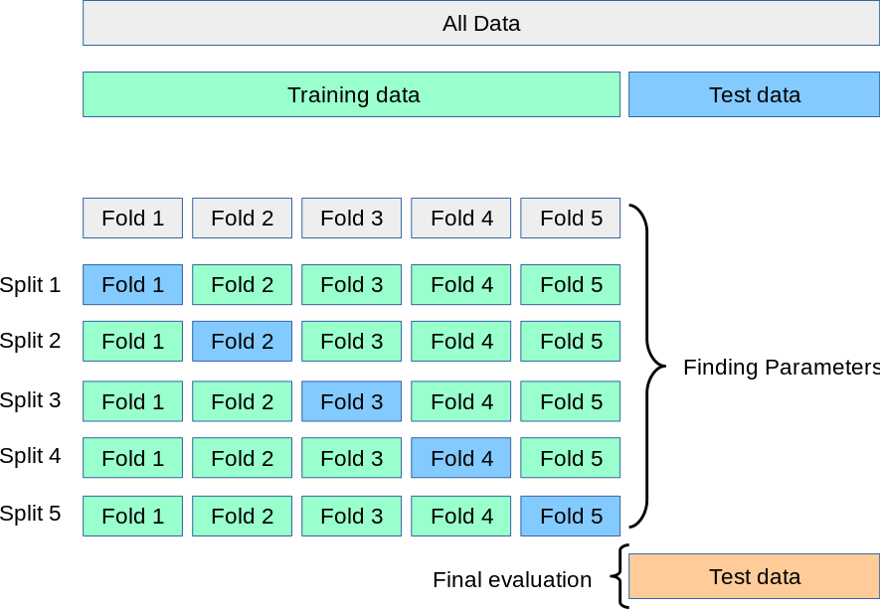
Figure 3.2: A visualization of GridSearchCV using 5-fold cross-validation (Scikit-learn developers, n.d.)
RF can be applied for both regression and classification problems, it is a tree-based ensemble method proposed by Breiman (2001) improve upon the Decision Tree algorithm. A visual representation of the model architecture is shown in the Figure 4.3.
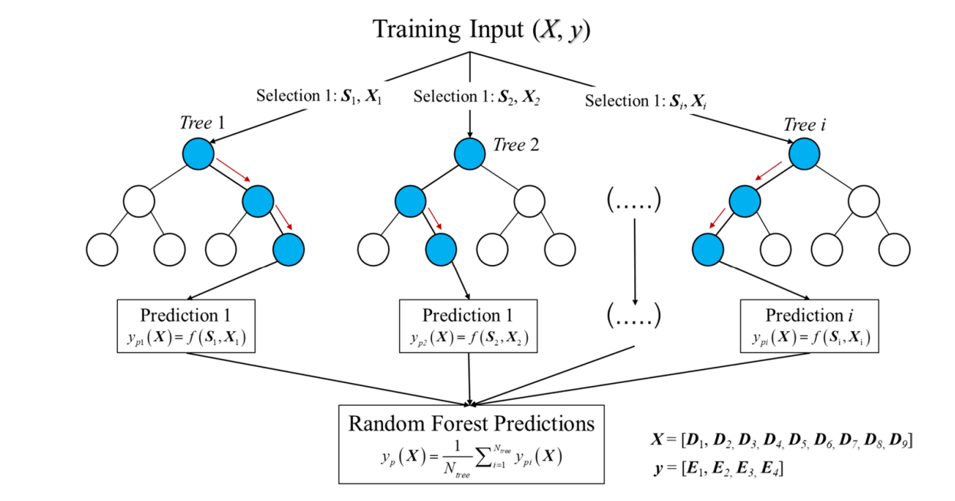
Figure 3.3: The architecture of Random Forest for regression tasks (Phulsawat et al., 2024)
GB is another tree-based ensemble model introduced by Friedman (2001). It constructs the model in a stage-wise manner by sequentially adding weak learners to minimize the overall prediction error. The Figure 4.4 illustrates the step-by-step workflow of the GB process.
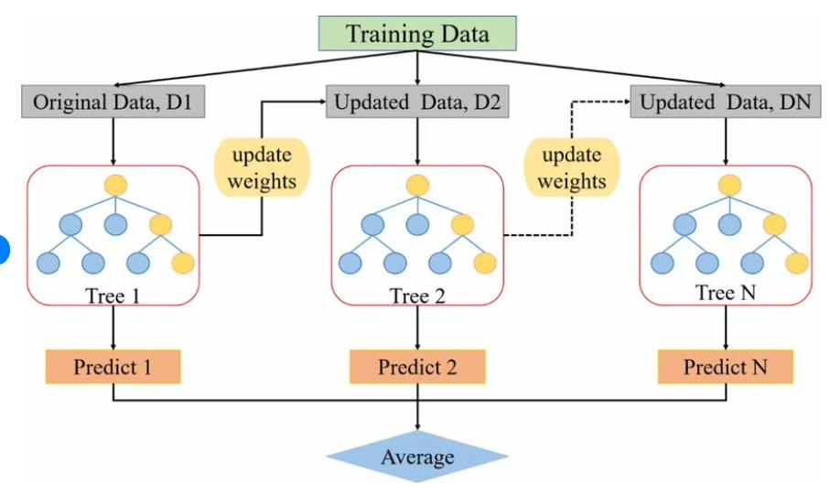
Figure 3.4: A general flow diagram of the gradient boosting framework (Zhang et al., 2023)
The KNN algorithm was formally introduced by Cover & Hart (1967). KNN is a supervised learning method that predicts the value of a new data point based on the average of its KNN in the input space, without an explicit training phase. A visual illustration of the KNN process is presented in Figure 4.5 to demonstrate how nearest neighbours are selected and how predictions are made.
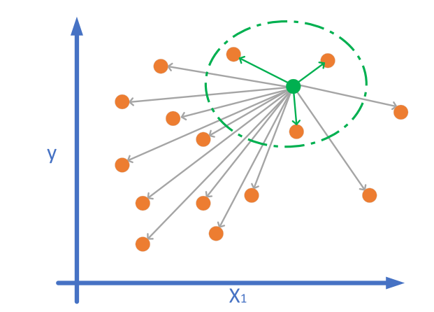
Figure 3.5: Visual representation of the KNN algorithm (Qaddoura & Younes, 2023)
According to Stanton (2001), LR model was mathematically formalized by Karl Pearson. LR is a supervised learning method that describes how a dependent variable is related to one or more independent variables by fitting a linear function to the observed data, typically by minimizing the sum of squared errors. An illustration of LR can be seen in Figure 4.6.
$$Y=β_{0}+β_{1}X_{1}+β_{2}X_{2}+⋯+β_{n}X_{n}+ε$$
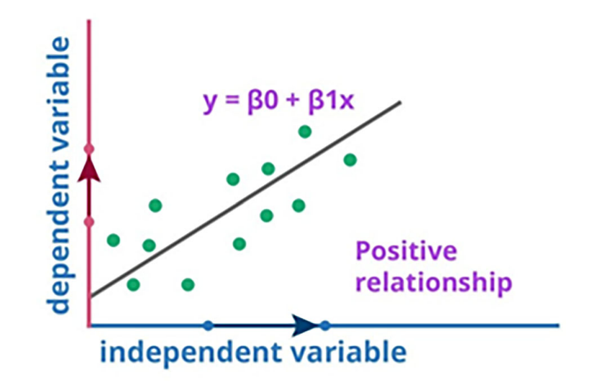
Figure 3.6: The visualization of LR in one dimension (L. Liu, 2025)
SVR was developed as an extension of Support Vector Machines by Cortes & Vapnik, (1995). SVR is a supervised learning method that aims to find a function which approximates the target values within a predefined ε-insensitive tube while maintaining model complexity control through margin maximization and regularization. A visual illustration of the SVR model, including the ε-insensitive tube and support vectors, is presented in Figure 4.7 to clarify how the regression function is constructed and constrained.
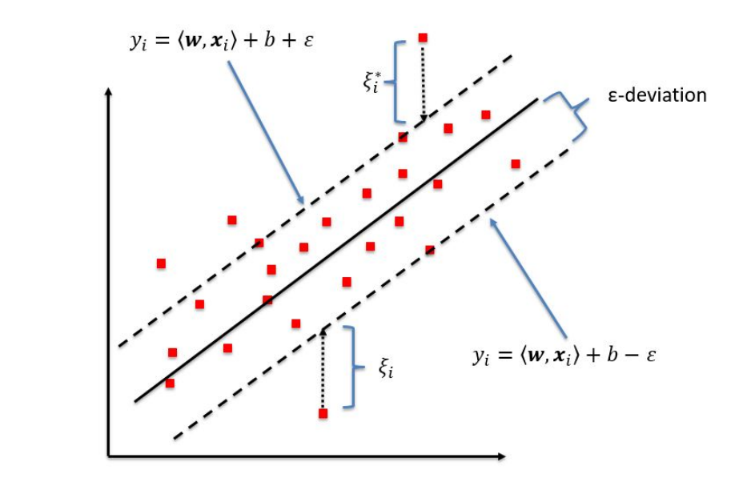
Figure 3.7: The process of SVR in one dimension (Kleynhans et al., 2017)
Stacked Generalization (Stacking) was originally introduced by (Wolpert, 1992) as an ensemble learning framework designed to combine multiple base learners through a meta-regression to improve predictive performance. The key characteristic of stacking lies in its ability to leverage heterogeneous models and learn how to optimally integrate their outputs, thereby reducing generalisation error compared to individual predictors. A detailed visual representation of the stacking architecture and its learning process is provided in Figure 4.8 for further illustration.
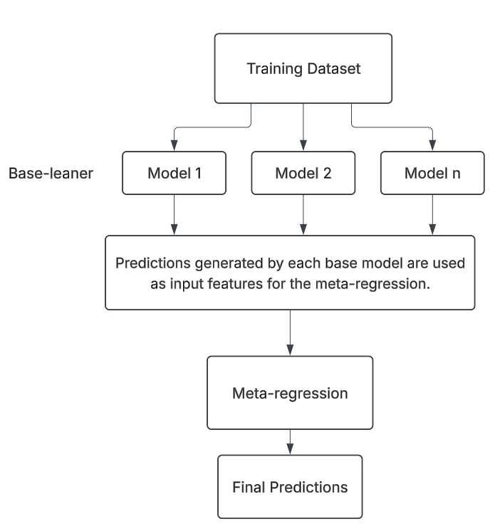
Figure 3.8: The operational process of the stacking model

Evaluation Framework Selection
In this study, model performances are evaluated using four widely recognized regression metrics: Mean Absolute Error (MAE), Root Mean Squared Error (RMSE), the Coefficient of Determination ($R^{2}$) and Mean Squared Error (MSE). The combination of these complementary metrics enables a rigorous, multi-dimensional assessment of predictive accuracy, error magnitude, and explanatory power.
Specifically, MAE quantifies the mean absolute difference between observed and predicted values, providing an intuitive measure of prediction error.
$$MAE=\frac{1}{n}\sum_{i=1}^{n}{∣y_{i}-{\hat{y}}_{i}∣}$$
However, MAE treats all errors equally and may underrepresent the impact of large deviations. In contrast, RMSE addresses this limitation by penalizing larger errors more heavily, enhancing its sensitivity to significant outliers.
$$RMSE=\sqrt{\frac{1}{n}\sum_{i=1}^{n}{(}y_{i}-{\hat{y}}_{i})^{2}}$$
$R^{2}$ further complements these metrics by quantifying the extent to which the model explains variance in the observed data, providing a normalized measure of explanatory strength.
$$R^{2}=1-\frac{\sum_{i=1}^{n}{(}y_{i}-{\hat{y}}_{i})^{2}}{\sum_{i=1}^{n}{(}y_{i}-\overset{ˉ}{y})^{2}}$$
MSE serves as an intermediate step for computing RMSE, aggregating squared errors, while RMSE converts these values back into the original data units, facilitating intuitive interpretation.
$$MSE=\frac{1}{n}\sum_{i=1}^{n}{(}y_{i}-{\hat{y}}_{i})^{2}$$

Experimental Design Logic
The experimental design follows a structured and sequential logic to ensure methodological consistency and valid comparison (Figure 4.9). The process initiates with data pre-processing, where raw records are formatted, standardized, filtered, and reduced to construct a coherent analytical dataset. Dataset partitioning and imputation are conducted in a controlled manner to prevent data leakage and preserve the integrity of model evaluation.
After pre-processing, the study proceeds to the Data Exploration and Engineering stage. Exploratory Data Analysis is not treated as a descriptive step but as a decision-support mechanism. It is applied to examine data distributions, detect anomalies, assess relationships among variables. The insights derived from Exploratory Data Analysis directly inform feature transformation strategies and feature selection decisions. Feature engineering is therefore implemented based on empirical evidence rather than arbitrary modification.
The processed dataset is then introduced into four experimental scenarios. All scenarios share an identical modelling pipeline to ensure fairness and comparability. The study strictly retains consistent data processing procedures, thereby eliminating procedural bias and enabling reliable comparisons.
The four scenarios systematically evaluate: (1) prediction using raw inputs before feature selection, (2) prediction using raw inputs after feature selection, (3) prediction using engineered features before feature selection, and (4) prediction using engineered features after feature selection. Performance is assessed before and after feature selection in both raw and engineered settings to isolate the contribution of transformation and selection mechanisms.
In the end, the best-performing model will be compared with the traditional WQI formula using evaluation metrics.
Overall, the experimental logic is comparative and controlled. The objective is not only to improve predictive accuracy but to rigorously determine the marginal effect of feature engineering and feature selection under a unified and consistent evaluation framework.
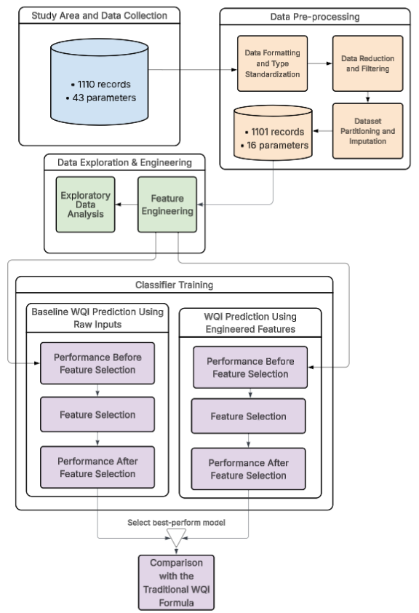
Figure 3.9: High-Level Overview of the Workflow

Data Preparation Strategy

Data Formatting and Type Standardization
To ensure the dataset was aligned with machine learning models, several preliminary formatting and numerical transformation steps were performed (Figure 4.10):

Figure 3.10: Sequential Workflow for Data Formatting and Type Standardization
- Standardization of Missing Data Indicators: Non-numeric characters such as "x" and "X," which were used in the raw records to denote missing measurements, were converted to NaN (Not a Number) to facilitate systematic imputation.
- Treatment of Censored Data: For parameters recorded as "< x" (indicating values below the analytical limit of detection), the prefix "<" was removed, and the limit value x was retained for the analysis.
- Numerical Localization: Decimal separators were standardized by converting commas to points to align with the standard floating-point format required by the Python processing environment.
- Numerical Data Conversion: Following the cleaning of non-numeric characters and format standardization, all water quality parameters were cast into appropriate numerical data types to enable mathematical operations.

Data Reduction and Filtering
Following standardization, a rigorous screening process was conducted to remove uninformative or highly deficient records and features (Figure 4.11):

Figure 3.11: Sequential Workflow for Data Reduction and Filtering
- Feature Screening: Irrelevant columns that did not contribute to the target objective were removed from the dataset to reduce dimensionality and focus the model on meaningful predictors. Specifically, the removed columns included: 'Location', 'ID', 'Month', 'Sal', 'Turb', 'TSS', 'SO4', 'MBAS', 'Cyan', 'Fluor', 'Cl', 'OilFat', 'Fe', 'Mn', 'Cu', 'Ni', 'Zn', 'Cr', 'Phenol', 'RadAlpha', and 'RadBeta'.
- Removal of High-Sparsity Features: Features exhibiting a missing data rate exceeding the 75% threshold were entirely eliminated to prevent the introduction of statistical noise and computational bias into the model's learning process. Specifically, the removed features included: 'Aldrin', 'BHC', 'Dieldrin', 'DDTs', 'Heptach', and 'TOC'.
- Elimination of Empty Records: Observations entirely devoid of measured values were purged from the dataset, as they offer no discriminative information and solely degrade computational efficiency.

Dataset Partitioning and Imputation
The final pre-processing stage prepared the refined data for predictive modelling (Figure 4.12):

Figure 3.12: Sequential Workflow for Dataset Partitioning and Imputation
- Cross-Validation Configuration: The dataset was evaluated using k-fold cross-validation, ensuring that training and validation subsets were properly separated in each fold. This approach preserves the integrity of model evaluation and effectively mitigates the risk of data leakage.
- KNN Imputation for Missing Values: A distance-based KNN algorithm was deployed to estimate and impute localized missing values (specifically for CrVI and E. coli) by exploiting the multidimensional similarity of adjacent data points.

Feature Engineering Framework
To optimize the dataset for predictive modelling, a systematic feature engineering framework was implemented, as illustrated below (Figure 4.13):

Figure 3.13: Sequential Workflow for Data Exploration and Engineering

Derivation of WQI-based Features
In this study, the VN_WQI was calculated strictly in accordance with the technical guidelines issued by the MONRE (2019). The VN_WQI framework categorizes water quality parameters into five thematic groups: (I) pH, (II) pesticides, (III) heavy metals, (IV) organic matter and nutrients, and (V) microbiological indicators.
For each thematic group, a group-level index was derived by aggregating its corresponding standardized sub-indices using either the geometric mean or the arithmetic mean, depending on the specific requirements prescribed for each parameter group. Individual water quality parameters were first transformed into dimensionless sub-indices based on the official rating curves, and these sub-indices were subsequently integrated to quantify the overall surface water quality status.
In this study, the VN_WQI was calculated using 16 water quality variables, including temperature, pH, DO, COD, BO$D_{5}$, N$O_{3}$, N$O_{2}$, N$H_{4}$, P$O_{4}$, total coliforms, E. coli), and the heavy metals arsenic (As), mercury (Hg), lead (Pb), cadmium (Cd), and hexavalent chromium (CrVI). The final VN_WQI value was obtained by aggregating all available group indices in accordance with the formulation specified in the official guidelines. The VN_WQI is computed according to the following formulation:
$$WQI = \frac{{WQI}_{pH}}{100}×\frac{{\left(\prod_{a=1}^{5}{{WQI}_{III}}\right)}^{\frac{1}{5}}}{100}×{\left(\frac{1}{7}\sum_{b=1}^{7}{{WQI}_{IV}}×\frac{1}{2}\sum_{c=1}^{2}{{WQI}_{IV}}\right)}^{\frac{1}{2}}$$
The WQI provides an aggregated assessment of water quality, allowing classification into five categories: excellent (91–100), good (76–90), fair (51–75), poor (26–50), and very poor (0–25). Figure 4.14 below shows the step-by-step process for calculating the WQI.
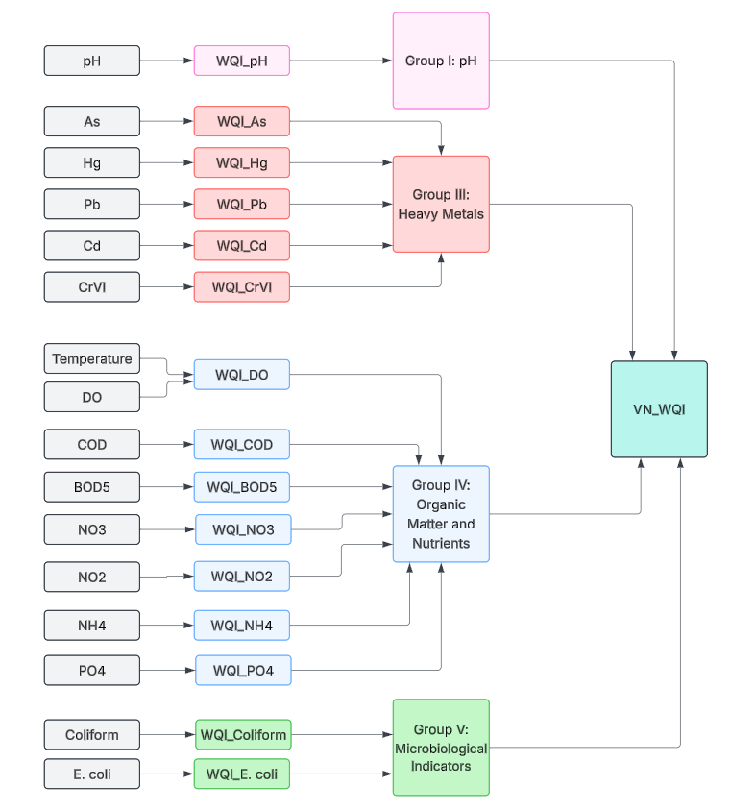
Figure 3.14: Visualization of WQI Formula

Data Standardization
Data Standardization was employed to eliminate severe scale disparities among water quality parameters, ensuring that distance-based algorithms like LR, SVR and KNN are not disproportionately biased by features with large magnitudes.
$$x^{'}=\frac{x-μ}{σ}$$

Controlled Experimental Design and Modelling Framework

Experimental Design Scenarios
To systematically evaluate the influence of input dimensionality and domain knowledge on WQI prediction, as shown in Figure 4.9, this study defines four experimental scenarios using a $2×2$ factorial design based on:
- feature scope (comprehensive vs. parsimonious)
- feature construction strategy (direct measurement vs. domain-informed).
This design enables assessment of both main effects and interaction effects between data richness and expert knowledge integration.
Scenario 1: Complete Raw Features Configuration
This scenario uses the full set of directly measured water-quality variables available in the dataset (Temperature, pH, DO, BO$D_{5}$, COD, N$O_{2}$, $NH_{4}$, N$O_{3}$, P$O_{4}$, Coliform, E. coli, As, Hg, Pb, Cd, CrVI).
- All features are included in their original measured form after standard preprocessing.
- This scenario aims to finds best-perform models so that create feature important plot based on best-perform models
Scenario 2: Selected Raw Features Configuration
This scenario retains only a minimal subset of directly measured variables, selected based on statistical relevance and operational feasibility.
- All features are included in their original measured form after standard preprocessing.
- It targets real-world contexts where sampling budgets are limited but reliable prediction remains essential.
Scenario 3: Complete Engineered Features Configuration
This scenario combines the full feature set with domain-informed engineered variables (${WQI}_{pH}$, ${WQI}_{DO}$, ${WQI}_{BOD_{5}}$, ${WQI}_{COD}$, ${WQI}_{NH_{4}}$, ${WQI}_{NO_{3}}$, ${WQI}_{PO_{4}}, {WQI}_{NO_{2}},$ ${WQI}_{Pb}, {WQI}_{Coliform}, {WQI}_{E. coli}, {WQI}_{As}$, ${WQI}_{Hg}, {WQI}_{Cd}, {WQI}_{CrVI}$).
- All WQI sub-indices are used as inputs.
- This scenario aims to finds best-perform models so that create feature important plot based on best-perform models.
Scenario 4: Selected Engineered Features Configuration
This scenario combines a reduced direct-measurement set with a compact set of high-value domain-informed features.
- The design reduces the number of WQI sub-indices used as inputs.
- It targets real-world contexts where sampling budgets are limited but reliable prediction remains essential.

Standardized Training and Evaluation Pipeline
Figure 4.15 illustrates the overall modelling and evaluation framework. GridSearchCV was systematically implemented across all candidate models to ensure uniform and unbiased hyperparameter optimization. This approach guarantees methodological consistency and eliminates preferential tuning effects among algorithms.
For inherently non-ensemble learners, a Bagging Regressor framework was integrated to reduce variance and improve stability under noisy environmental conditions. This design allows single estimators to benefit from bootstrap aggregation while preserving their intrinsic learning characteristics.
Additionally, multiple stacking architectures were constructed using all 26 possible combinations of RF, GB, LR, SVR, and KNN as base learners, with LR fixed as the meta-learner, enabling a comprehensive evaluation of ensemble synergy and performance trade-offs.
Subsequently, all trained models were evaluated using four regression metrics (MSE, RMSE, MAE, and $R^{2}$), enabling a structured comparison of predictive error magnitude and variance explanation under a consistent testing framework.

Figure 3.15: Standardized Machine Learning Training and Evaluation Pipeline.

Results

Exploratory Data Analysis
The provided set of boxplots (Figure 4.1) illustrates the statistical distribution and variance of sixteen distinct water quality parameters, including physical properties, organic pollutants, and heavy metals.
Overall, the charts reveal a stark contrast in data dispersion among the indicators. Most environmental contaminants, notably heavy metals and organic compounds, display tight median values near the baseline but suffer from severe upper extremes, whereas foundational metrics such as temperature and pH show a much more balanced and typical spread of data.
For instance, while temperature and pH exhibit relatively constrained distributions with median values around 21–28°C and 6.4–6.9 respectively, several contaminants show pronounced right-skewness, as evidenced by COD reaching extreme values above 250–300 mg/L despite a median below 20 mg/L, NH₄ exceeding 6 mg/L from a baseline near 0.2 mg/L, and Coliform counts surging to over 25,000 MPN/100 mL while remaining tightly clustered near zero for most observations.

Figure 4.1: Box Plots of the Attributes in the Dataset
The heatmap in Figure 4.2 illustrates the correlations between attributes, where red cells indicate a direct proportional relationship and the blue cells indicate an inverse relationship. Some attributes are highly correlated with each other, such as COD with BOD (0.74), Coliform and E. coli (0.63), N$H_{4}$ and N$O_{2}$.( 0.64). This information can help us decide which attributes to remove, as some features contain overlapping information.
An important observation is that WQI sub-index attributes are highly impact to WQI scores. For example, the contributions of WQ$I_{BOD_{5}}$ and WQ$I_{{NH}_{4}}$to WQI are 0.6 and 0.64,respectively. Applying feature engineering to transform raw input parameters into WQI-specific features may improve the robustness and accuracy of the evaluation.

Figure 4.2: Heatmap of Relationships Between Numeric Variables in the Dataset
The scatter plot below (Figure 4.3) illustrates the correlation between COD and BO$D_{5}$. Although the figure shows wide dispersion and errors at high concentrations, a general upward trend remains visible, and since this study does not focus on accuracy, it is still acceptable to consider removing one of them.

Figure 4.3: Comparison of COD and BO$D_{5}$ concentrations
The scatter plot (Figure 4.4) compares the concentrations of ammonium NH₄ and BOD₅. The data displays no clear correlation. Therefore, there is insufficient evidence to justify removing either variable from the analysis.

Figure 4.4: Comparison of NH₄ and BO$D_{5}$concentrations
Figure 4.5 illustrates the relationship between the concentrations of NH₄ and N$O_{2}$ in the water samples. As the chart demonstrates, there is no discernible correlation between N$O_{2}$ and NH₄, as the data points exhibit a highly dispersed distribution without any clear linear or monotonic trend.

Figure 4.5: Comparison of NH₄ and N$O_{2}$ concentrations
The scatter plot (Figure 4.6) illustrates the relationship between the concentrations of Coliform and E. coli. As the chart demonstrates, there is no strong linear correlation between the two variables. Rather, the data exhibits dense clustering at lower concentration levels, alongside a highly dispersed distribution where the variance of E. coli noticeably increases at higher Coliform levels.

Figure 4.6: Comparison of Coliform and E.coli concentrations

Baseline WQI Prediction Using Raw Inputs

Performance with Complete Raw Features
In the following Table 4.1, the rows indicate the different machine learning models before selected features and with raw inputs, and the columns show their respective performance metrics: MSE, RMSE, MAE and $R^{2}$. Tree-based models such as GB and RF achieved high performance across all evaluation metrics, with GB attaining the best results (MSE of 5.61, RMSE of 2.37, MAE of 0.95, and an $R^{2}$ of 0.97), followed by RF (MSE of 9.27, RMSE of 3.06, MAE of 1.21, and an $R^{2}$ of 0.95). Meanwhile, linear and instance-based models such as SVR, KNN, and LR performed comparatively poorly, with substantially higher errors and lower $R^{2}$ values, particularly LR (MSE of 51.11, RMSE of 7.15, MAE of 4.014, and an $R^{2}$ of 0.7).
Table 4.1: Individual Regression Models Performance on Raw Water Quality Inputs (Pre Feature Selection)
Model | MSE | RMSE | MAE | $$R^{2}$$
GB | 5.61 | 2.37 | 0.95 | 0.97
RF | 9.27 | 3.05 | 1.21 | 0.95
SVR | 19.85 | 4.45 | 2.15 | 0.88
KNN | 26.45 | 5.14 | 2.4 | 0.85
LR | 51.11 | 7.15 | 4.01 | 0.7

The Table 4.2 presents the top 5 stacking models that achieved the highest scores using raw inputs before feature selection. A table containing all stacking model configurations is provided in the Appendix. The best-performing stacking models, including RF + LR + SVR + GB and RF + KNN + LR + SVR + GB, both achieved an MSE of 5.9. Compared with GB, which achieved an MSE of 5.61, the stacking models did not outperform GB and required more training time.

Table 4.2: Performance Comparison of 5 Best-Perform Stacking Models Configurations Using Raw Input Features Before Feature Selection
Base Models | Num Models | MSE | RMSE | MAE | $$R^{2}$$
RF + LR + SVR + GB | 4 | 5.9 | 2.43 | 1.16 | 0.97
RF + KNN + LR + SVR + GB | 5 | 5.9 | 2.43 | 1.17 | 0.97
KNN + LR + SVR + GB | 4 | 6.03 | 2.46 | 1.19 | 0.97
RF + LR + GB | 3 | 6.07 | 2.46 | 1.07 | 0.97
RF + KNN + LR + GB | 4 | 6.08 | 2.47 | 1.08 | 0.97
The bar chart (Figure 4.7) illustrates permutation feature importance for a GB model using five-fold cross-validation. Overall, pH is by far the most influential variable, while most other parameters contribute only marginally to the model’s predictive performance.
In detail, pH shows a substantially higher importance score than any other feature, indicating that changes in pH strongly affect the model’s predictions. The second most important variable is E. coli, though its contribution is considerably smaller than that of pH. N$O_{2}$ and N$H_{4}$ follow, with moderate importance values, suggesting they still play a meaningful role. Coliform also contributes to the model but at a lower level.
By contrast, variables such as BO$D_{5}$, COD, CrVI, and DO have minimal influence. The remaining parameters, including heavy metals and nutrients, show near-zero importance, implying limited predictive value. Overall, the results suggest that features with extreme or highly variable values tend to exert greater influence on the model. This pattern highlights the dominant role of pH and a small group of water quality indicators.

Figure 4.7: Permutation Feature Importance with 5-Fold CV for WQI Prediction Using Raw Input Parameters (Pre Feature Selection)

Performance with Selected Raw Features
BOD₅, which is a parameter that takes a long time to measure but can be replaced by COD, was removed. CrVI, DO, Hg, Temperature, Pb, ${PO}_{4}$, As, ${NO}_{3}$, and Cd were also removed as they were found to have little impact on the models.
The Table 4.3 presents the performance of machine learning models based on MSE, RMSE, MAE, and $R^{2}$ using raw inputs after feature selection. GB and RF achieved the best performance, with GB attaining an MSE of 8.53, an RMSE of 2.92, an MAE of 1.57, and an $R^{2}$ of 0.95, and RF attaining an MSE of 10.66, an RMSE of 3.26, an MAE of 1.73, and an $R^{2}$ of 0.94. Other models, including SVR, which showed an MSE of 13.92 and an MAE of 2.08, KNN, with an MSE of 16.41 and an MAE of 2.2, and LR, presenting an MSE of 56.21 and an MAE of 4.42, exhibited poorer performance, indicating lower predictive accuracy under certain conditions.

Table 4.3: Individual Models Performance Comparison After Feature Selection with Raw Inputs
Model | MSE | RMSE | MAE | $$R^{2}$$
GB | 8.53 | 2.92 | 1.57 | 0.95
RF | 10.66 | 3.26 | 1.72 | 0.94
SVR | 13.92 | 3.73 | 2.08 | 0.92
KNN | 16.41 | 4.05 | 2.2 | 0.9
LR | 56.21 | 7.5 | 4.42 | 0.67

The results in Table 4.4 indicate that stacking models do not surpass the performance of the best single model, GB. The top stacking configuration (RF, LR, SVR, and GB) achieves an MSE of 8.56, which is slightly higher than that of GB at 8.53. Similar marginal differences are observed across RMSE, MAE, and $R^{2}$. Furthermore, performance variation among stacking models is minimal, with MSE values ranging from 8.56 to 8.76. These findings are consistent with those obtained prior to feature selection, suggesting that feature selection influences all models proportionally without altering their relative rankings.

Table 4.4: Top 5 Stacking Models Performance Comparison After Feature Selection with Raw Inputs
Base Models | Num Models | MSE | RMSE | MAE | $$R^{2}$$
RF + LR + SVR + GB | 4 | 8.56 | 2.92 | 1.64 | 0.95
LR + SVR + GB | 3 | 8.6 | 2.93 | 1.63 | 0.95
RF + LR + GB | 3 | 8.67 | 2.94 | 1.61 | 0.95
LR + GB | 2 | 8.72 | 2.95 | 1.61 | 0.95
KNN + LR + SVR + GB | 4 | 8.76 | 2.96 | 1.65 | 0.95

The parallel coordinates plot (Figure 4.8) illustrates the comparative performance of the top 15 predictive models based on four evaluation metrics: MSE, RMSE, MAE, and $R^{2}$, using raw input data prior to feature selection. Overall, GB demonstrates superior performance across all error-related metrics, achieving the lowest values for MSE, RMSE, and MAE, alongside one of the highest $R^{2}$ scores.
In contrast, the stacking ensemble models, despite their increased computational complexity and longer training times, do not exhibit substantial performance gains. Their results remain closely aligned with those of traditional machine learning algorithms, with only marginal variations observed among different stacking configurations.

Figure 4.8: Top 15 Models Performance Metrics for Individual and Stacking Ensembles After Feature Selection with Raw Inputs

WQI Prediction Using Engineered Features
Because the high correlation with Final WQI which showed by heatmap. I try to convert all raw inputs into WQI sub-index which are WQ$I_{pH}$, WQ$I_{DO}$, WQ$I_{BOD_{5}}$, WQ$I_{NO_{3}}$, WQ$I_{NO_{2}}$, WQ$I_{NH_{4}}$, WQ$I_{PO_{4}}$, WQ$I_{Coliform}$, WQ$I_{E. coli}$, WQ$I_{As}$, WQ$I_{Hg}$, WQ$I_{Pb}$, WQ$I_{Cd}$, WQ$I_{CrVI}$.

Performance with Complete Engineered Features
In the table below (Table 4.5), each row represents a machine learning model trained with the selected features and after transforming the raw parameters into WQI sub-indices, while the columns display their respective performance metrics, including MSE, RMSE, MAE, and $R^{2}$. The new inputs are scaled to the same range as the outputs, implying a linear correlation between inputs and outputs. Linear-based models perform best: LR achieved the lowest MSE of 1.06 and RMSE of 1.03 with $R^{2}$ of 0.99, and SVR had the lowest MAE of 0.41 with $R^{2}$ of 0.99. Tree-based and instance-based models performed worse, for example GB with MSE of 3.66, KNN with MSE of 5.31, and RF with MSE of 7.51.
Table 4.5: Individual Regression Models Performance on WQI sub-indices Inputs Before Feature Selection
Model | MSE | RMSE | MAE | $$R^{2}$$
LR | 1.06 | 1.03 | 0.45 | 0.99
SVR | 2.42 | 1.55 | 0.41 | 0.99
GB | 3.66 | 1.91 | 0.75 | 0.98
KNN | 5.31 | 2.3 | 0.83 | 0.97
RF | 7.51 | 2.74 | 0.94 | 0.96
The Table 4.6 presents the top five stacking models evaluated using WQI sub-indices before feature selection. All top stacking models achieved very similar results, but did not provide any substantial improvement over the best-performing traditional model, LR. Specifically, the combination of KNN + LR + GB attained the lowest MSE of 0.95, RMSE of 0.97, MAE of 0.47. The KNN + LR stack also achieved comparable performance with MSE 0.95, RMSE 0.98, MAE 0.46. Other stacks, such as LR + GB and RF + KNN + LR, maintained MSE values under 0.99, while the LR + SVR combination showed slightly higher MSE of 1.02 and RMSE 1.01. However, LR achieved a lower MAE than most stacking models, indicating that the improvement is not consistent across all evaluation metrics. These results suggest that stacking with WQI sub-indices provides only marginal gains and does not significantly enhance predictive accuracy compared to traditional models, limiting its practical benefit in this scenario.
Table 4.6: Top 5 Stacking Models Performance Comparison on WQI sub-indices Inputs Before Feature Selection
Base Models | Num Models | MSE | RMSE | MAE | $$R^{2}$$
KNN + LR + GB | 3 | 0.95 | 0.97 | 0.47 | 0.99
KNN + LR | 2 | 0.95 | 0.98 | 0.46 | 0.99
LR + GB | 2 | 0.98 | 0.99 | 0.45 | 0.99
RF + KNN + LR | 3 | 0.99 | 0.99 | 0.48 | 0.99
LR + SVR | 2 | 1.02 | 1.01 | 0.48 | 0.99
The bar chart (Figure 4.9) illustrates permutation feature importance for a stacking model combining KNN, LR, and GB, using five-fold cross-validation. Overall, WQ$I_{pH}$ is the most influential variable, while most other parameters contribute only marginally to the model’s predictive performance.
In detail, WQ$I_{pH}$ shows a substantially higher importance score than any other feature, indicating that variations in pH strongly affect the model’s predictions. The second most important variable is WQ$I_{E. coli}$, although its contribution is considerably smaller than that of WQ$I_{pH}$. WQ$I_{Coliform}$, WQ$I_{NO_{2}}$, and WQ$I_{NH_{4}}$ follow, with moderate importance values, suggesting they still play a meaningful role in determining water quality.
By contrast, parameters such as WQ$I_{Cd}$, WQ$I_{As}$, and WQ$I_{NO_{3}}$ have minimal influence. The remaining features, including other chemical components, show near-zero importance, implying limited predictive value. Overall, the results indicate that pH and microbial indicators dominate the model’s predictive capability, while most chemical parameters exert relatively minor effects.

Figure 4.9: Permutation Feature Importance with 5-Fold CV for WQI Prediction Using Raw Input Parameters (Pre-Feature Selection)

Performance with Selected Engineered Features
In this study, WQ$I_{BOD_{5}}$ was excluded due to its long measurement time and its replaceability by WQ$I_{COD}$, consistent with the rationale applied in the raw input feature selection scenario. Furthermore, WQ$I_{DO}$, WQ$I_{CrVI}$, WQ$I_{PO_{4}}$, WQ$I_{Hg}$, WQ$I_{Pb}$, WQ$I_{NO_{3}}$, WQ$I_{As}$, and WQ$I_{Cd}$ were also removed because they exhibited minimal impact on model performance.
The Table 4.7 shows the performance of different traditional regression algorithms after feature selection. Overall, the evaluation metrics changed only slightly compared to the models trained with all features. Among the models, SVR achieved the best performance, with an MSE of 5.59, RMSE of 2.37, MAE of 1.32, and $R^{2}$ of 0.97. LR also performed well, recording an MSE of 5.87, RMSE of 2.42, MAE of 1.42, and $R^{2}$ of 0.97. GB showed moderate performance with an MSE of 7.28, RMSE of 2.7, MAE of 1.58, and $R^{2}$ of 0.96, while RF and KNN achieved lower performance, with RF having an MSE of 8.84, RMSE of 2.97, MAE of 1.67, $R^{2}$ of 0.95, and KNN showing an MSE of 9.14, RMSE of 3.02, MAE of 1.7, and $R^{2}$ of 0.95.
Table 4.7: Individual Regression Models Performance on WQI sub-indices Inputs After Feature Selection
Model | MSE | RMSE | MAE | $$R^{2}$$
SVR | 5.59 | 2.37 | 1.32 | 0.97
LR | 5.87 | 2.42 | 1.42 | 0.97
GB | 7.28 | 2.7 | 1.58 | 0.96
RF | 8.84 | 2.97 | 1.67 | 0.95
KNN | 9.14 | 3.02 | 1.7 | 0.95
The Table 4.8 presents the performance of the top five stacking models in predicting WQI sub-indices after feature selection. Overall, the evaluation metrics of all stacking models are very similar, showing only minor differences. The model combining LR, SVR, and GB achieves the lowest mean squared error of 5.34 and the highest $R^{2}$ of 0.97, indicating the most accurate predictions. The model using LR and SVR follows closely with an MSE of 5.37 and an $R^{2}$ of 0.97. Models that include KNN or RF do not provide substantial improvement, with MSE values ranging from 5.39 to 5.41 and $R^{2}$ of approximately 0.97. RMSE and MAE show a similar trend, reflecting negligible differences. The best stacking model (LR + SVR + GB) slightly outperforms the best single model (SVR) in terms of MSE (5.34 and 5.59), although SVR achieves a lower MAE (1.32 and 1.37), indicating a marginal trade-off in error characteristics. These results suggest that adding more base models beyond the most effective three offers minimal gains in predictive performance. These results suggest that adding more base models beyond the most effective three offers minimal gains in predictive performance.

Table 4.8: Top 5 Stacking Models Performance Comparison on WQI sub-indices Inputs After Feature Selection
Base Models | Num Models | MSE | RMSE | MAE | $$R^{2}$$
LR + SVR + GB | 3 | 5.34 | 2.31 | 1.37 | 0.97
LR + SVR | 2 | 5.37 | 2.32 | 1.37 | 0.97
KNN + LR + SVR + GB | 4 | 5.39 | 2.32 | 1.37 | 0.97
RF + LR + SVR + GB | 4 | 5.4 | 2.32 | 1.36 | 0.97
RF + LR + SVR | 3 | 5.41 | 2.33 | 1.37 | 0.97
The parallel coordinates plot (Figure 4.10) illustrates the performance of the top 15 models, including individual regressors and stacking ensembles, after feature selection. Across the models, MSE ranges narrowly from approximately 5.59 to 8.55, RMSE from 2.37 to 2.92, MAE from 1.32 to 1.98, and $R^{2}$ from 0.97 to 0.99. The best-performing stacking ensemble, combining LR, SVR, and GB, achieves an MSE of 5.59, RMSE of 2.37, MAE of 1.32, and $R^{2}$ of 0.97, indicating marginal improvements over single models. Overall, the performance variation between individual and ensemble models is minimal, confirming that feature selection maintains predictive accuracy without significant loss.


Figure 4.10: Top 15 Models Performance Metrics for Individual and Stacking Ensembles After Feature Selection with WQI sub-indices Inputs

Comparative Performance Analysis
The scatter plots (Figure 4.11) illustrate the relationship between WQI values calculated using the traditional WQI formula and those predicted by machine learning models when the number of attributes is reduced, compared with the actual WQI scores computed using the full set of features. As shown in the charts, applying the WQI formula results in wider scatters around the red reference line (y = x), where points closer to the line indicate higher accuracy. In contrast, the machine learning approach demonstrates more stable predictions when fewer attributes are used.
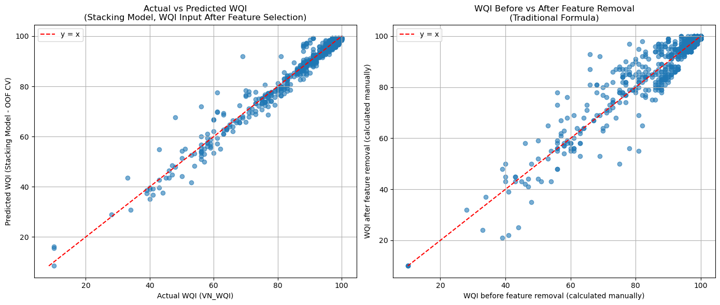
Figure 4.11: Performance comparison of Best-Perform Machine Learning Model and Traditional Calculation methods under Feature Reduction constraints.

Technical Discussion

Outliers and Environmental Data Characteristics
As can be seen from the analysis, outliers from Quang Ninh dataset might be extreme values. Study of Thien (2017) shows that the mining industry in Quang Ninh causes water pollution, with concentrations of metals and pH levels exceeding acceptable limits. Another study by Marquez et al. (2018) also illustrates that open-pit coal mining significantly contributes to water pollution in Quang Ninh province. These findings support the notion that the outliers in the Quang Ninh dataset reflect real phenomena, and should not be removed or treated as erroneous records. Therefore, researchers should consider this factor when preprocessing the dataset.
Environmental datasets often contain numerous outliers, not just extreme values. Wai et al., (2022) reported that environmental datasets frequently contain a large number of outliers, which can result from sensor malfunctions, miscalibrations, or other contributing factors. As a result, people should consider models that handle outliers and uncertain data well when studying this field.

Behavioural Analysis of Machine Learning Models

Stacking Versus Single Model
These results indicate that in each scenario, a single model (GB or SVR) generally demonstrated superior performance or performed roughly on par with the best stacking model.
- In the first scenario, Table 4.1 and Table 4.2 show that the stacking model (RF, LR, SVR, GB) achieved an MAE of 1.16, whereas the standalone GB model had a lower MAE of 0.95. GB also showed slightly better results across other evaluation metrics compared to the stacking model.
- In the second scenario, Table 4.3 and Table 4.4 show a similar trend: the single GB model reached an MAE of 1.57, outperforming the ensemble MAE of 1.64 and also achieving slightly better results on other metrics.
- In the third scenario, Table 4.5 and Table 4.6 indicate that the stacking model (KNN, LR, GB) produced an MAE of 0.47, slightly higher than that of the single LR model (MAE: 0.45), although the stacking model performed slightly better on other evaluation metrics. Overall, this suggests that the stacking approach did not offer a clear improvement over LR.
- In the final scenario, Table 4.7 and Table 4.8 show that the single SVR model (MAE: 1.32) slightly outperformed the stacking ensemble (LR, SVR, GB; MAE: 1.37) in terms of mean absolute error, while other metrics, including MSE, RMSE, and $R^{2}$, were slightly better for the stacking model.
Another study reported similar findings, indicating that the stacking model did not outperform the single model. The study by Barathkumar & Devi (2025) found that the stacking model achieved an RMSE of 13.81, whereas the best-performing single model, KNN, obtained an RMSE of 0.17, with its $R^{2}$ being nearly equal to that of the stacking model. In addition, the models selected for combination in that study included RF, LR, DT, and SVR, which are similar to those used in the present research. This evidence suggests that stacking models constructed from traditional machine learning algorithms may not necessarily improve predictive accuracy.
However, the performance of a stacking model largely depends on the selection of base learners and the meta-learner. Result of study by Talukdar et al. (2023) showed that a stacking model incorporating both machine learning and deep learning techniques outperformed other models. This finding indicates that stacking approaches may be more suitable for projects with sufficiently large datasets, where deep learning methods can be effectively applied.
Overall, the findings indicate that single models (GB or SVR) generally performed better than or comparably to the best stacking models across all scenarios. Combining models with less effective algorithms did not provide meaningful improvement and may have introduced additional noise. However, the effectiveness of stacking approaches depends heavily on the selection of base learners, meta-learner, and dataset characteristics. Previous studies suggest that stacking frameworks incorporating both machine learning and deep learning models may achieve better performance, particularly when large datasets are available.

Nonlinear Structure of Raw Environmental Data
Tree-based models can handle extreme values, whereas distance-based and linear models cannot. As shown in Table 4.1 and Table 4.3, GB and RF consistently outperform other models. Furthermore, Haggerty et al., (2023) founds that RF performs effectively even in the presence of large outliers. This perspective highlights that tree-based models should be preferred when applied to environmental datasets which contain numerous extreme values.
Tree-based algorithms are comparatively robust to these issues because their decision boundaries are based on hierarchical splits rather than distance metrics or linear coefficients. This structural robustness partially explains why ensemble tree models frequently perform well in environmental prediction tasks.
This study focuses on comparing the present study with previous studies conducted in different study areas in Vietnam, as varying environmental conditions lead to differences in WQI formulas and characteristics.
Tree-based models generally perform better than other models when using raw features. A study by Khoi et al., (2022) suggested that XGBoost, a tree-based ensemble model, was the best-performing model after being compared with eleven machine learning models, including ANN-based algorithms. Another study by Lap et al., (2023) indicated that RF, a tree-based model, achieved the best performance compared to four other models using raw inputs. Moreover, the present study also found that GB is the best-performing model among five core models under raw input scenarios. Similarly, D. P. Nguyen et al., (2023) reported consistent findings, showing that GB was the best-performing model after comparison with three other models. Evidence from different locations therefore suggests that tree-based models may be the most suitable for WQI prediction in Vietnamese regions using the WQI-VN formula and raw inputs.
However, several research gaps can be identified in previous studies. The study by D. P. Nguyen et al., (2023) did not apply GridSearchCV for hyperparameter tuning. Therefore, the strength of their findings may be limited, as model performance could change after proper optimization, potentially altering model rankings. In addition, Lap et al., (2023) did not use cross-validation, which may reduce the robustness and generalizability of their results. Furthermore, their feature selection strategy was based on importance scores derived from specific tree-based models such as RF and Decision Tree, which were then applied across different machine learning algorithms. This approach may introduce bias, as feature importance is model-dependent and not necessarily transferable across algorithms. As a result, the overall strength of the argument supporting the superiority of tree-based models remains limited.

Impacting of WQI sub-indices based transformation technique
Using WQI sub-indices as input features can enhance model accuracy. As shown in Table 4.3 and Table 4.7, the SVR model using WQI sub-indices as inputs achieves an MAE of 1.32 and an MSE of 5.59, whereas the GB model using raw inputs records higher errors, with an MAE of 1.57 and an MSE of 8.53. Therefore, the application of WQI sub-indices enables models to outperform those trained on raw input features.
Transforming raw variables into WQI sub-indices significantly alters the modelling environment. Because the sub-indices are scaled within the same range as the final WQI score, the data do not exhibit outliers or extreme values, the relationship between inputs and output becomes more structured and partially linearized. As a result, algorithms with simpler functional forms, including LR, can achieve competitive performance under this representation.
This finding highlights the importance of domain-informed feature engineering. Rather than relying solely on algorithmic complexity, incorporating domain knowledge into feature construction can simplify the learning task and improve model interpretability.
This phenomenon illustrates an important principle in machine learning for environmental science: feature engineering guided by domain knowledge can substantially reduce the complexity of the modelling problem. In some cases, well-designed features can compensate for the limitations of simpler algorithms, enabling them to achieve competitive predictive performance.

Effect of Feature Selection on Reduced-input Model

Impact of Reduced Features in Quang Ninh Data
Feature selection methods help reduce the number of features while maintaining accuracy. In this study, feature selection based on the heatmap (Figure 4.2) and scatter plots (Figure 4.3, Figure 4.4, Figure 4.5, Figure 4.6) removed one parameter in both types of inputs, while the feature importance plots (Figure 4.8, Figure 4.11) helped eliminate nine more parameters. Although ten parameters were removed, the prediction accuracy remained acceptable, with the MAE of the best-performing models below two. This indicates that some features are redundant, and certain important features contain most of the predictive information, providing a basis for practical applications aimed at reducing monitoring burdens.

Impact of Feature Selection Using Correlation Analysis
This study shows that using correlation analysis help to decrease one parameters because of detecting the redundant. This technique provides for people selecting feature method that not depends on performance of model.
Correlation analysis has both advantages and limitations. One key advantage is that it does not rely on training predictive models, which saves time by avoiding the need for multiple model trainings. However, this method cannot guarantee the precise removal of unimportant features due to the masking effect and the presence of non-linear relationships. Moreover, as noted by (Moeinzadeh et al., 2024) heavy metals often contain numerous missing values, which introduces additional uncertainty in correlation analysis with other parameters. Therefore, correlation analysis should ideally be combined with other feature selection methods to improve reliability.

Impact of Selecting Features Using Permutation Importance
Permutation importance is a technique that helps identify the core features that most impact a model. This is because permutation importance ranks features based on their effect on model performance. As a result, it is a reliable method for assisting in feature reduction.
However, permutation importance also has certain limitations. It requires training the model twice, and during the retraining process, the best-performing model may differ from the original one. As shown in Table 4.5 and Table 4.7, the best-performing model before feature selection is LR, whereas after feature selection it is SVR. Nevertheless, the performance difference between LR and SVR after feature selection in Table 4.7 is minimal, with LR achieving 1.42 and SVR 1.32. Furthermore, in the raw input scenario presented in Table 4.1 and Table 4.3, GB remains the best-performing model both before and after feature selection. These observations suggest that changes in the ranking of models after applying feature selection are unlikely to pose significant issues.
This study highlights the effectiveness of permutation importance for identifying core features. In the research, permutation importance plot contributes to reduce nine parameters while keeping the accuracy of best-perform models. Thus, it is the one of the main feature selection methods that might be used individually without combining with other methods (Lokman et al., 2025) but still decrease countless features while still keeping the accuracy of the model.

Practical Implications for Surface Water Quality Governance
As the Vietnamese government has already provided a guidance on when the WQI formula should be updated and how to ensure that techniques using fewer features are still acceptable, more details are available at MONRE (2019). This study focuses on recommending when AI models can be applied versus when the traditional formula should be used to calculate WQI. Since the dataset still requires regular updates, WQI should be calculated using the full set of attributes each quarter to monitor environmental changes. However, AI models can be used on a monthly basis to predict WQI, offering an efficient supplement to the traditional approach.

Methodological Contributions

Recommended Approaches
When using raw environmental data, tree-based models such as GB and RF are recommended due to their robustness to nonlinearity and extreme values. Their structure allows stable performance where linear and distance-based models typically fail.
In contrast, transforming variables into WQI sub-indices simplifies the data structure by reducing outliers and introducing partial linearity. Under this representation, simpler models such as LR and SVR become highly effective. This highlights the value of domain-informed feature engineering.
Stacking models are not recommended as a default strategy. When a single model clearly dominates, combining it with weaker models often introduces noise and reduces overall performance rather than improving it.
Finally, feature selection should integrate multiple methods. Correlation analysis helps remove redundancy efficiently, while permutation importance identifies key predictive features. Combining these with visual tools ensures effective dimensionality reduction without losing critical information.

Framework Contributions
This study proposes a machine learning framework for WQI prediction that can be applied across diverse environmental contexts, particularly for Vietnamese datasets. The Figure 5.1 illustrates a comprehensive and flexible machine learning framework developed for WQI prediction, starting from raw data processing to final performance assessment.
On the left-hand side, the main workflow begins with a dataset that undergoes data pre-processing. This is followed by exploratory data analysis to better understand the data characteristics. The raw input is then converted into WQI sub-indices, forming a structured input for modelling. Subsequently, relevant features are selected to improve model efficiency. A baseline model is then trained using these prepared inputs. After that, the workflow proceeds to a comparison stage with the traditional WQI formula, allowing for benchmarking. Finally, the model is retrained in an optimized manner, indicating refinement based on prior results.
The right-hand side represents the model training and evaluation pipeline, which operationalizes the baseline training and optimized retraining steps. Initially, GridSearchCV is applied for parameter tuning. Multiple models, including RF, GB, KNN, SVR and LR are trained in parallel. In addition, a Bagging Regressor is integrated as an ensemble method to enhance predictive performance. The outputs from all models are then aggregated and evaluated using performance metrics such as MSE, RMSE, MAE, and $R^{2}$, providing a comprehensive assessment of model effectiveness.

Figure 5.1: Proposed Machine Learning Framework for WQI Prediction

Limitations

Limitations of the Topic
This topic aims to develop a surrogate model for the WQI formula using fewer parameters. However, this approach does not guarantee the stability of AI applications due to the strong dependency between inputs and outputs, as outputs are calculated directly from the inputs. Models may need to be retrained if the dataset becomes outdated.
In addition, as reported by Lowe et al., (2022), the parameters of environmental datasets are highly dependent on local environmental conditions and geographic contexts, thereby constraining the generalizability of established models to new locations.
Moreover, AI cannot fully replace the traditional WQI formula, as human intervention may still be required to update datasets or to handle special cases that AI models cannot accurately predict using the WQI formula. Nevertheless, machine learning models can still serve as substitutes for the WQI formula in typical scenarios, while the WQI formula itself may also need to be redesigned for special cases.

Limitations of the Study
This study has not evaluated the potential cost savings from applying AI or the optimization of the trade-off between reduced costs and accuracy. In addition, the experiments were not designed to handle rare or exceptional cases that are absent from the dataset. For example, sudden illegal industrial discharges that sharply increase the concentration of Cd.

Conclusion

Summary of Achievements
Water quality management and the WQI are essential for environmental protection and sustainable development, yet conventional WQI computation remains time-consuming and costly because it relies on extensive sampling and laboratory analysis. Although machine learning has been applied to reduce this burden, this study evaluated and proposed a reduced-input framework for VN_WQI prediction.
This study suggests that the raw dataset often contains extreme values that represent real environmental conditions rather than erroneous outliers. Therefore, these values should not be removed during preprocessing. However, for other environmental datasets, researchers should still carefully consider the presence of outliers before deciding on appropriate handling strategies.
In the Quang Ninh study area, the results show that GB is the best-performing model when using raw input features, whereas SVR and LR performs best when using WQI sub-indices as inputs. This indicates that tree-based models are more suitable for raw data, while kernel-based and linear-based models tend to perform better when the input features are transformed into WQI sub-indices.
The study also demonstrates that using WQI sub-indices can improve prediction accuracy compared to raw inputs. This finding highlights the importance of feature engineering, as well-designed features can compensate for the limitations of simpler algorithms and enable them to achieve competitive performance.
Regarding feature selection, one parameter was removed through correlation analysis, and nine additional parameters were eliminated using permutation importance, while maintaining acceptable prediction accuracy. With only six core features, the SVR model still achieved the best performance for the Quang Ninh dataset under the reduced-input setting while maintaining accuracy. These results suggest that permutation importance is an effective method for identifying key features and reducing model complexity without significantly compromising accuracy. However, combining it with other methods, such as correlation analysis, can further improve the reliability of feature selection.
Furthermore, this study contributes a machine learning framework for WQI prediction that can be applied to other regions and environmental datasets.

Future Work and Recommendations
It is recommended that future research prioritize the collection of larger and more diverse datasets to enhance model robustness, particularly in capturing extreme or rare environmental events that were not represented in the present study, such as sudden illegal industrial discharges leading to sharp increases in contaminant concentrations (e.g., Cd). Expanding dataset coverage would improve the generalizability of predictive models to such exceptional scenarios.
Future studies should also incorporate explicit economic evaluations of AI-based approaches by conducting quantitative analyses of the trade-offs between predictive accuracy and the costs associated with data collection, feature selection, and model complexity. Addressing this limitation would support more informed and practical decision-making in environmental monitoring systems.
In addition, further research is encouraged to investigate the application of deep learning techniques and to systematically compare their performance with the machine learning models employed in this study, particularly when larger datasets become available. The integration of model interpretability methods, such as SHAP analysis, is also recommended to provide deeper insights into the “black-box” behaviour of both machine learning and deep learning models.

Bibliography
Abbasi, T., & Abbasi, S. A. (2012). Water Quality Indices. Elsevier. http://ebookcentral.proquest.com/lib/hud/detail.action?docID=892231
Ahmad, T., Ali, L., Alshamsi, D., Aldahan, A., El-Askary, H., & Ahmed, A. (2025). AI-Powered Water Quality Index Prediction: Unveiling Machine Learning Precision in Hyper-Arid Regions. Earth Systems and Environment, 9(2), 677–694. https://doi.org/10.1007/s41748-024-00524-8
Ahmed, U., Mumtaz, R., Anwar, H., Shah, A. A., Irfan, R., & García-Nieto, J. (2019). Efficient Water Quality Prediction Using Supervised Machine Learning. Water, 11(11), 2210. https://doi.org/10.3390/w11112210
Baek, S.-S., Pyo, J., & Chun, J. A. (2020). Prediction of Water Level and Water Quality Using a CNN-LSTM Combined Deep Learning Approach. Water, 12(12). https://doi.org/10.3390/w12123399
Barathkumar, S., & Devi, A. C. (2025). Modeling and Prediction of Water Quality Using Artificial Intelligence Techniques for Enhanced Monitoring and Management. https://doi.org/10.1002/wer.70143
Barzegar, R., Aalami, M., & Adamowski, J. (2020). Short-term water quality variable prediction using a hybrid CNN–LSTM deep learning model. Stochastic Environmental Research and Risk Assessment, 34, 1–19. https://doi.org/10.1007/s00477-020-01776-2
Bommert, A., Sun, X., Bischl, B., Rahnenführer, J., & Lang, M. (2020). Benchmark for filter methods for feature selection in high-dimensional classification data. Computational Statistics & Data Analysis, 143, 106839. https://doi.org/10.1016/j.csda.2019.106839
Breiman, L. (2001). Random Forests. Machine Learning, 45(1), 5–32. https://doi.org/10.1023/A:1010933404324
Brown, R. N., McClelland, N. I., Deininger, R. A., & Tozer, R. G. (1970). A water quality index-do we dare? Water and Sewage Works, 117(10). https://www.researchgate.net/profile/Paul-Hernandez-Romero/post/Brown_et_al_1970A_Water_Quality_Index_Do_We_Dare/attachment/5c74aa66cfe4a781a5834c0c/AS%3A730388808880129%401551149670060/download/A-Water-Quality-Index-Do-we-dare-BROWN-R-M-1970.pdf
Campos, D., Galvão, V., de Rezende, M. L., Braga, A., Bodini, M., Aires, U. R. V., Yonaba, R., & Goliatt, L. (2026). Automated machine learning achieves accurate water quality prediction with reduced parameter requirements. Scientific Reports, 16(1), 4431. https://doi.org/10.1038/s41598-025-34448-8
CCME. (2017). Canadian Water Quality Guidelines for the Protection of Aquatic Life. User’s Manual. Canadian Council of Ministers of the Environment. USA.
Chen, K., Chen, H., Zhou, C., Huang, Y., Qi, X., Shen, R., Liu, F., Zuo, M., Zou, X., Wang, J., Zhang, Y., Chen, D., Chen, X., Deng, Y., & Ren, H. (2020). Comparative analysis of surface water quality prediction performance and identification of key water parameters using different machine learning models based on big data. Water Research, 171, 115454. https://doi.org/10.1016/j.watres.2019.115454
Chen, Z., Chen, C., Yang, G., He, X., Chi, X., Zeng, Z., & Chen, X. (2024). Research integrity in the era of artificial intelligence: Challenges and responses. Medicine, 103(27), e38811. https://doi.org/10.1097/MD.0000000000038811
Chidiac, S., El Najjar, P., Ouaini, N., El Rayess, Y., & El Azzi, D. (2023). A comprehensive review of water quality indices (WQIs): History, models, attempts and perspectives. Reviews in Environmental Science and Bio/Technology, 22(2), 349–395. https://doi.org/10.1007/s11157-023-09650-7
Chou, J.-S., Ho, C.-C., & Hoang, H.-S. (2018). Determining quality of water in reservoir using machine learning. Ecological Informatics, 44, 57–75. https://doi.org/10.1016/j.ecoinf.2018.01.005
Choudhary, R., Kumar, A., C., P., Naik, M. M., Choudhury, M., & Khan, N. A. (2025). Predicting water quality index using stacked ensemble regression and SHAP based explainable artificial intelligence. Scientific Reports, 15(1), 31139. https://doi.org/10.1038/s41598-025-09463-4
Cortes, C., & Vapnik, V. (1995). Support-vector networks. Machine Learning, 20(3), 273–297. https://doi.org/10.1007/BF00994018
Cover, T., & Hart, P. (1967). Nearest neighbor pattern classification. IEEE Transactions on Information Theory, 13(1), 21–27. https://doi.org/10.1109/TIT.1967.1053964
Dasu, D. (2025). Comparative Analysis of Machine Learning Algorithms for Water Quality Index Prediction. Communications on Applied Nonlinear Analysis, 32(9s), 692–701. https://doi.org/10.52783/cana.v32.3975
Elgeldawi, E., Sayed, A., Galal, A. R., & Zaki, A. M. (2021). Hyperparameter Tuning for Machine Learning Algorithms Used for Arabic Sentiment Analysis. Informatics, 8(4). https://doi.org/10.3390/informatics8040079
Friedman, J. H. (2001). Greedy function approximation: A gradient boosting machine. The Annals of Statistics, 29(5), 1189–1232. https://doi.org/10.1214/aos/1013203451
Guyon, I., & Elisseeff, A. (2003). An Introduction to Variable and Feature Selection. Journal of Machine Learning Research, 3(7/8), 1157–1182. (11939737).
Haggerty, R., Sun, J., Yu, H., & Li, Y. (2023). Application of machine learning in groundwater quality modeling—A comprehensive review. Water Research, 233, 119745. https://doi.org/10.1016/j.watres.2023.119745
Jayaraman, P., Nagarajan, K. K., Partheeban, P., & Krishnamurthy, V. (2024). Critical review on water quality analysis using IoT and machine learning models. International Journal of Information Management Data Insights, 4(1), 100210. https://doi.org/10.1016/j.jjimei.2023.100210
Khoi, D. N., Quan, N. T., Linh, D. Q., Nhi, P. T. T., & Thuy, N. T. D. (2022). Using Machine Learning Models for Predicting the Water Quality Index in the La Buong River, Vietnam. Water, 14(10). https://doi.org/10.3390/w14101552
Kleynhans, T., Montanaro, M., Gerace, A., & Kanan, C. (2017). Predicting Top-of-Atmosphere Thermal Radiance Using MERRA-2 Atmospheric Data with Deep Learning. Remote Sensing, 9(11), 1133. https://doi.org/10.3390/rs9111133
Kohavi, R., & John, G. H. (1997). Wrappers for feature subset selection. Artificial Intelligence, Relevance, 97(1), 273–324. https://doi.org/10.1016/S0004-3702(97)00043-X
Krishnamoorthy, L., & Lakshmanan, V. R. (2025). Groundwater quality assessment using machine learning models: A comprehensive study on the industrial corridor of a semi-arid region. Environmental Science and Pollution Research, 32(49), 28319–28342. https://doi.org/10.1007/s11356-024-34119-7
Lap, B. Q., Phan, T.-T.-H., Nguyen, H. D., Quang, L. X., Hang, P. T., Phi, N. Q., Hoang, V. T., Linh, P. G., & Hang, B. T. T. (2023). Predicting Water Quality Index (WQI) by feature selection and machine learning: A case study of An Kim Hai irrigation system. Ecological Informatics, 74, 101991. https://doi.org/10.1016/j.ecoinf.2023.101991
Liu, L. (2025). Analysing the impact of sensory processing differences on color and texture preferences in individuals with autism spectrum disorder. Humanities and Social Sciences Communications, 12(1), 1408. https://doi.org/10.1057/s41599-025-05753-4
Liu, P., Wang, J., Sangaiah, A. K., Xie, Y., & Yin, X. (2019). Analysis and Prediction of Water Quality Using LSTM Deep Neural Networks in IoT Environment. Sustainability, 11(7). https://doi.org/10.3390/su11072058
Lokman, A., Wan Ismail, W. Z., & Ab Aziz, N. A. (2025). Enhancing water quality index prediction accuracy in Mranti lake and rivers in Malaysia using regression forest model. Applied Water Science, 16(2), 34. https://doi.org/10.1007/s13201-025-02705-w
Lowe, M., Qin, R., & Mao, X. (2022). A Review on Machine Learning, Artificial Intelligence, and Smart Technology in Water Treatment and Monitoring. Water, 14(9), 1384. https://doi.org/10.3390/w14091384
Lumb, A., Halliwell, D., & Sharma, T. (2006). Application of CCME Water Quality Index to Monitor Water Quality: A Case Study of the Mackenzie River Basin, Canada. Environmental Monitoring and Assessment, 113(1), 411–429. https://doi.org/10.1007/s10661-005-9092-6
Makumbura, R. K., Mampitiya, L., Rathnayake, N., Meddage, D. P. P., Henna, S., Dang, T. L., Hoshino, Y., & Rathnayake, U. (2024). Advancing water quality assessment and prediction using machine learning models, coupled with explainable artificial intelligence (XAI) techniques like shapley additive explanations (SHAP) for interpreting the black-box nature. Results in Engineering, 23, 102831. https://doi.org/10.1016/j.rineng.2024.102831
Marquez, J. E., Pourret, O., Faucon, M.-P., Weber, S., Hoàng, T. B. H., & Martinez, R. E. (2018). Effect of Cadmium, Copper and Lead on the Growth of Rice in the Coal Mining Region of Quang Ninh, Cam-Pha (Vietnam). Sustainability, 10(6), 1758. https://doi.org/10.3390/su10061758
Masood, A., Niazkar, M., Zakwan, M., & Piraei, R. (2023). A Machine Learning-Based Framework for Water Quality Index Estimation in the Southern Bug River. Water, 15(20), 3543. https://doi.org/10.3390/w15203543
Modaresi, F., Araghinejad, S., & Ebrahimi, K. (2018). A Comparative Assessment of Artificial Neural Network, Generalized Regression Neural Network, Least-Square Support Vector Regression, and K-Nearest Neighbor Regression for Monthly Streamflow Forecasting in Linear and Nonlinear Conditions. Water Resources Management, 32(1), 243–258. https://doi.org/10.1007/s11269-017-1807-2
Moeinzadeh, H., Yong, K.-T., & Withana, A. (2024). A critical analysis of parameter choices in water quality assessment. Water Research, 258, 121777. https://doi.org/10.1016/j.watres.2024.121777
Mogane, L. K., Masebe, T., Msagati, T. A. M., & Ncube, E. (2023). A comprehensive review of water quality indices for lotic and lentic ecosystems. Environmental Monitoring and Assessment, 195(8), 926. https://doi.org/10.1007/s10661-023-11512-2
MONRE. (2019). The Decision on the promulgation of technical guidelines for calculation and publication of the Vietnam water quality index (VN_WQI).
Muñoz-Alegría, J. A., Núñez, J., Oyarzún, R., Chávez, C. A., Arumí, J. L., & Rodríguez-López, L. (2025). A Bibliometric-Systematic Literature Review (B-SLR) of Machine Learning-Based Water Quality Prediction: Trends, Gaps, and Future Directions. Water, 17(20). https://doi.org/10.3390/w17202994
Najah Ahmed, A., Binti Othman, F., Abdulmohsin Afan, H., Khaleel Ibrahim, R., Ming Fai, C., Shabbir Hossain, M., Ehteram, M., & Elshafie, A. (2019). Machine learning methods for better water quality prediction. Journal of Hydrology, 578, 124084. https://doi.org/10.1016/j.jhydrol.2019.124084
Nguyen, D. P., Ha, H. D., Trinh, N. T., & Nguyen, M. T. (2023). Application of artificial intelligence for forecasting surface quality index of irrigation systems in the Red River Delta, Vietnam. Environmental Systems Research, 12(1), 24. https://doi.org/10.1186/s40068-023-00307-6
Nguyen, N., & Sevando, M. (2019). Assessing Coastal Water Quality throughan Overall Index. Polish Journal of Environmental Studies, 28(4), 2321–2330. https://doi.org/10.15244/pjoes/90836
Niazkar, M., & Piraei, R. (2025). Enhancing estimation of water quality index using stacking machine learning techniques: The case of Southern Bug River. Science of The Total Environment, 1003, 180744. https://doi.org/10.1016/j.scitotenv.2025.180744
Noori, R., Berndtsson, R., Hosseinzadeh, M., Adamowski, J. F., & Abyaneh, M. R. (2019). A critical review on the application of the National Sanitation Foundation Water Quality Index. Environmental Pollution, 244, 575–587. https://doi.org/10.1016/j.envpol.2018.10.076
Ott, W. R. (1978). Environmental indices: Theory and practice. https://www.osti.gov/biblio/6681348
Pedregosa, F., Varoquaux, G., Gramfort, A., Michel, V., Thirion, B., Grisel, O., Blondel, M., Prettenhofer, P., Weiss, R., Dubourg, V., Vanderplas, J., Passos, A., Cournapeau, D., Brucher, M., Perrot, M., & Duchesnay, É. (2011). Scikit-learn: Machine Learning in Python. Journal of Machine Learning Research, 12(85), 2825–2830.
Phulsawat, B., Senjuntichai, A., & Senjuntichai, T. (2024). Prediction of Multi-layered Pavement Moduli Based on Falling Weight Deflectometer Test Using Soft Computing Approaches. Transportation Infrastructure Geotechnology, 11(4), 2348–2381. https://doi.org/10.1007/s40515-024-00370-1
Qaddoura, R., & Younes, M. B. (2023). Temporal prediction of traffic characteristics on real road scenarios in Amman. Journal of Ambient Intelligence and Humanized Computing, 14(7), 9751–9766. https://doi.org/10.1007/s12652-022-03708-0
Rangeti, I., Dzwairo, B., Barratt, G., & Otieno, F. (2015). Ecosystem-specific water quality indices. African Journal of Aquatic Science, 40(3), 227–234. https://doi.org/10.2989/16085914.2015.1054341
Scikit-learn developers. (n.d.). Cross-validation: Evaluating estimator performance. Scikit-Learn. Retrieved 27 April 2026, from https://scikit-learn/stable/modules/cross_validation.html
Shams, M. Y., Elshewey, A. M., El-kenawy, E.-S. M., Ibrahim, A., Talaat, F. M., & Tarek, Z. (2024). Water quality prediction using machine learning models based on grid search method. Multimedia Tools and Applications, 83(12), 35307–35334. https://doi.org/10.1007/s11042-023-16737-4
Shekar, B. H., & Dagnew, G. (2019). Grid Search-Based Hyperparameter Tuning and Classification of Microarray Cancer Data. 2019 Second International Conference on Advanced Computational and Communication Paradigms (ICACCP), 1–8. https://doi.org/10.1109/ICACCP.2019.8882943
Shen, C. (2018). A Transdisciplinary Review of Deep Learning Research and Its Relevance for Water Resources Scientists. Water Resources Research, 54(11), 8558–8593. https://doi.org/10.1029/2018WR022643
Sidek, L. M., Mohiyaden, H. A., Marufuzzaman, M., Noh, N. S. M., Heddam, S., Ehteram, M., Kisi, O., & Sammen, S. Sh. (2024). Developing an ensembled machine learning model for predicting water quality index in Johor River Basin. Environmental Sciences Europe, 36(1), 67. https://doi.org/10.1186/s12302-024-00897-7
Štambuk-Giljanović, N. (1999). Water quality evaluation by index in Dalmatia. Water Research, 33(16), 3423–3440. https://doi.org/10.1016/S0043-1354(99)00063-9
Štambuk-Giljanović, N. (2003). Comparison of Dalmatian Water Evaluation Indices. Water Environment Research, 75(5), 388–405. https://doi.org/10.2175/106143003X141196
Stanton, J. M. (2001). Galton, Pearson, and the Peas: A Brief History of Linear Regression for Statistics Instructors. Journal of Statistics Education, 9(3). https://doi.org/10.1080/10691898.2001.11910537
Sutadian, A. D., Muttil, N., Yilmaz, A. G., & Perera, B. J. C. (2016). Development of river water quality indices—A review. Environmental Monitoring and Assessment, 188(1), 58. https://doi.org/10.1007/s10661-015-5050-0
Talukdar, S., Shahfahad, Ahmed, S., Naikoo, M. W., Rahman, A., Mallik, S., Ningthoujam, S., Bera, S., & Ramana, G. V. (2023). Predicting lake water quality index with sensitivity-uncertainty analysis using deep learning algorithms. Journal of Cleaner Production, 406, 136885. https://doi.org/10.1016/j.jclepro.2023.136885
Thien, C. T. (2017). Tran Thien Cuong Study on Soil and Water Environment in Coal Mining Area at Lo Tri Coal Mine, Quang Ninh Province. VNU Journal of Science: Earth and Environmental Sciences, 33(1S). https://doi.org/10.25073/2588-1094/vnuees.4178
Uddin, M. G., Nash, S., Mahammad Diganta, M. T., Rahman, A., & Olbert, A. I. (2022). Robust machine learning algorithms for predicting coastal water quality index. Journal of Environmental Management, 321, 115923. https://doi.org/10.1016/j.jenvman.2022.115923
Uddin, Md. G., Nash, S., & Olbert, A. I. (2021). A review of water quality index models and their use for assessing surface water quality. Ecological Indicators, 122, 107218. https://doi.org/10.1016/j.ecolind.2020.107218
van der Heyden, M. A. G., van de Ven, T., & Opthof, T. (2009). Fraud and misconduct in science: The stem cell seduction. Netherlands Heart Journal, 17(1), 25–29. https://doi.org/10.1007/BF03086211
Van Hien, D., My, D. H., & Orbell, J. D. (2024). The impact of the COVID-19 pandemic on the seawater quality of Ha Long Bay, Vietnam. Marine Pollution Bulletin, 201, 116242. https://doi.org/10.1016/j.marpolbul.2024.116242
Villalobos-Arias, L., Quesada-López, C., Guevara-Coto, J., Martínez, A., & Jenkins, M. (2020). Evaluating hyper-parameter tuning using random search in support vector machines for software effort estimation. Proceedings of the 16th ACM International Conference on Predictive Models and Data Analytics in Software Engineering, PROMISE 2020, 31–40. https://doi.org/10.1145/3416508.3417121
Wai, K. P., Chia, M. Y., Koo, C. H., Huang, Y. F., & Chong, W. C. (2022). Applications of deep learning in water quality management: A state-of-the-art review. Journal of Hydrology, 613, 128332. https://doi.org/10.1016/j.jhydrol.2022.128332
Walczak, N., & Walczak, Z. (2025). Assessing the feasibility of using Machine learning algorithms to determine reservoir water quality based on a reduced set of predictors. Ecological Indicators, 175, 113556. https://doi.org/10.1016/j.ecolind.2025.113556
Wolpert, D. H. (1992). Stacked generalization. Neural Networks, 5(2), 241–259. https://doi.org/10.1016/S0893-6080(05)80023-1
Xu, J., Mo, Y., Zhu, S., Wu, J., Jin, G., Wang, Y.-G., Ji, Q., & Li, L. (2024). Assessing and predicting water quality index with key water parameters by machine learning models in coastal cities, China. Heliyon, 10(13), e33695. https://doi.org/10.1016/j.heliyon.2024.e33695
Yaseen, Z. M., Ramal, M. M., Diop, L., Jaafar, O., Demir, V., & Kisi, O. (2018). Hybrid Adaptive Neuro-Fuzzy Models for Water Quality Index Estimation. Water Resources Management, 32(7), 2227–2245. https://doi.org/10.1007/s11269-018-1915-7
Yuan, P., Li, H., Yi, X., Wang, J., Ning, C., Xu, X., & Nong, X. (2025). Optimizing water quality index using machine learning: A six-year comparative study in riverine and reservoir systems. Scientific Reports, 15(1), 33919. https://doi.org/10.1038/s41598-025-10187-8
Zhang, Y., Song, Z., Lin, Y., Shi, Q., Hao, Y., Fu, Y., Wu, J., & Zhang, Z. (2023). Predicting mechanical properties of CO2 hydrates: Machine learning insights from molecular dynamics simulations. Journal of Physics: Condensed Matter, 36(1), 015101. https://doi.org/10.1088/1361-648X/acfa55

Apdendix
Appendix A: Extended Results
Table A.1: Performance Comparison of Stacking Models Configurations Using Raw Input Features Before Feature Selection
Ordinal number | Base Models | Num Models | MSE | RMSE | MAE | $$R^{2}$$
1 | RF + LR + SVR + GB | 4 | 5.90 | 2.43 | 1.16 | 0.97
2 | RF + KNN + LR + SVR + GB | 5 | 5.90 | 2.43 | 1.17 | 0.97
3 | KNN + LR + SVR + GB | 4 | 6.03 | 2.46 | 1.19 | 0.97
4 | RF + LR + GB | 3 | 6.07 | 2.46 | 1.07 | 0.96
5 | RF + KNN + LR + GB | 4 | 6.08 | 2.47 | 1.08 | 0.96
6 | LR + SVR + GB | 3 | 6.09 | 2.47 | 1.18 | 0.96
7 | LR + GB | 2 | 6.17 | 2.48 | 1.08 | 0.96
8 | KNN + LR + GB | 3 | 6.19 | 2.49 | 1.09 | 0.96
9 | RF + KNN + GB | 3 | 6.33 | 2.52 | 1.15 | 0.96
10 | RF + GB | 2 | 6.35 | 2.52 | 1.15 | 0.96
11 | RF + KNN + SVR + GB | 4 | 6.42 | 2.53 | 1.23 | 0.96
12 | RF + SVR + GB | 3 | 6.44 | 2.54 | 1.23 | 0.96
13 | KNN + GB | 2 | 6.65 | 2.58 | 1.19 | 0.96
14 | KNN + SVR + GB | 3 | 6.76 | 2.60 | 1.27 | 0.96
15 | SVR + GB | 2 | 6.80 | 2.61 | 1.28 | 0.96
16 | RF + KNN + LR + SVR | 4 | 8.82 | 2.97 | 1.55 | 0.95
17 | RF + LR + SVR | 3 | 8.88 | 2.98 | 1.55 | 0.95
18 | RF + LR | 2 | 9.59 | 3.10 | 1.40 | 0.94
19 | RF + KNN + LR | 3 | 9.69 | 3.11 | 1.41 | 0.94
20 | RF + SVR | 2 | 10.72 | 3.27 | 1.76 | 0.94
21 | RF + KNN + SVR | 3 | 10.80 | 3.29 | 1.73 | 0.94
22 | RF + KNN | 2 | 11.15 | 3.34 | 1.62 | 0.94
23 | KNN + LR + SVR | 3 | 15.67 | 3.96 | 2.12 | 0.91
24 | LR + SVR | 2 | 16.44 | 4.05 | 2.21 | 0.90
25 | KNN + SVR | 2 | 18.83 | 4.34 | 2.34 | 0.89
26 | KNN + LR | 2 | 24.16 | 4.92 | 2.64 | 0.86

Table A.2: Performance Comparison of Stacking Models Configurations Using Raw Input Features After Feature Selection
Ordinal number | Base Models | Num Models | MSE | RMSE | MAE | $$R^{2}$$
1 | RF + LR + SVR + GB | 4 | 8.56 | 2.92 | 1.64 | 0.95
2 | LR + SVR + GB | 3 | 8.60 | 2.93 | 1.63 | 0.95
3 | RF + LR + GB | 3 | 8.67 | 2.94 | 1.61 | 0.95
4 | LR + GB | 2 | 8.72 | 2.95 | 1.61 | 0.95
5 | KNN + LR + SVR + GB | 4 | 8.76 | 2.96 | 1.65 | 0.95
6 | RF + SVR + GB | 3 | 8.82 | 2.97 | 1.68 | 0.95
7 | SVR + GB | 2 | 8.85 | 2.97 | 1.67 | 0.95
8 | RF + KNN + LR + SVR + GB | 5 | 8.85 | 2.98 | 1.67 | 0.95
9 | KNN + SVR + GB | 3 | 8.88 | 2.98 | 1.68 | 0.95
10 | RF + GB | 2 | 8.88 | 2.98 | 1.66 | 0.95
11 | RF + KNN + SVR + GB | 4 | 9.05 | 3.01 | 1.70 | 0.95
12 | KNN + LR + GB | 3 | 9.55 | 3.09 | 1.69 | 0.94
13 | KNN + GB | 2 | 9.58 | 3.10 | 1.72 | 0.94
14 | RF + KNN + LR + GB | 4 | 9.65 | 3.11 | 1.71 | 0.94
15 | RF + KNN + GB | 3 | 9.73 | 3.12 | 1.74 | 0.94
16 | RF + LR + SVR | 3 | 10.44 | 3.23 | 1.82 | 0.94
17 | RF + KNN + LR + SVR | 4 | 10.61 | 3.26 | 1.83 | 0.94
18 | RF + KNN + SVR | 3 | 11.08 | 3.33 | 1.92 | 0.94
19 | RF + SVR | 2 | 11.16 | 3.34 | 1.94 | 0.94
20 | RF + LR | 2 | 11.27 | 3.36 | 1.83 | 0.93
21 | RF + KNN + LR | 3 | 12.62 | 3.55 | 1.94 | 0.93
22 | RF + KNN | 2 | 13.09 | 3.62 | 2.08 | 0.92
23 | LR + SVR | 2 | 13.98 | 3.74 | 2.22 | 0.92
24 | KNN + LR + SVR | 3 | 14.30 | 3.78 | 2.20 | 0.92
25 | KNN + SVR | 2 | 15.41 | 3.93 | 2.28 | 0.91
26 | KNN + LR | 2 | 20.77 | 4.56 | 2.59 | 0.88

Table A.3: Stacking Models Performance Comparison on WQI sub-indices Inputs Before Feature Selection
Ordinal number | Base Models | Num Models | MSE | RMSE | MAE | $$R^{2}$$
1 | KNN + LR + GB | 3 | 0.95 | 0.97 | 0.47 | 0.99
2 | KNN + LR | 2 | 0.95 | 0.98 | 0.46 | 0.99
3 | LR + GB | 2 | 0.98 | 0.99 | 0.45 | 0.99
4 | RF + KNN + LR | 3 | 0.99 | 0.99 | 0.48 | 0.99
5 | LR + SVR | 2 | 1.02 | 1.01 | 0.48 | 0.99
6 | RF + KNN + LR + GB | 4 | 1.03 | 1.01 | 0.48 | 0.99
7 | RF + LR + SVR | 3 | 1.04 | 1.02 | 0.48 | 0.99
8 | KNN + LR + SVR | 3 | 1.04 | 1.02 | 0.48 | 0.99
9 | RF + LR + GB | 3 | 1.05 | 1.03 | 0.47 | 0.99
10 | RF + KNN + LR + SVR | 4 | 1.06 | 1.03 | 0.49 | 0.99
11 | LR + SVR + GB | 3 | 1.07 | 1.03 | 0.48 | 0.99
12 | KNN + LR + SVR + GB | 4 | 1.08 | 1.04 | 0.48 | 0.99
13 | RF + LR | 2 | 1.09 | 1.04 | 0.47 | 0.99
14 | RF + LR + SVR + GB | 4 | 1.14 | 1.07 | 0.50 | 0.99
15 | RF + KNN + LR + SVR + GB | 5 | 1.14 | 1.07 | 0.50 | 0.99
16 | KNN + SVR + GB | 3 | 3.12 | 1.77 | 0.85 | 0.98
17 | RF + KNN + SVR + GB | 4 | 3.18 | 1.78 | 0.86 | 0.98
18 | SVR + GB | 2 | 3.20 | 1.79 | 0.89 | 0.98
19 | RF + SVR + GB | 3 | 3.23 | 1.80 | 0.89 | 0.98
20 | KNN + GB | 2 | 3.77 | 1.94 | 0.91 | 0.98
21 | KNN + SVR | 2 | 3.87 | 1.97 | 0.96 | 0.98
22 | RF + KNN + GB | 3 | 3.87 | 1.97 | 0.93 | 0.98
23 | RF + GB | 2 | 4.20 | 2.05 | 0.91 | 0.98
24 | RF + KNN + SVR | 3 | 4.86 | 2.21 | 1.13 | 0.97
25 | RF + SVR | 2 | 5.06 | 2.25 | 1.16 | 0.97
26 | RF + KNN | 2 | 7.17 | 2.68 | 1.34 | 0.96

Table A.4: Stacking Models Performance Comparison on WQI sub-indices Inputs After Feature Selection
Ordinal number | Base Models | Num Models | MSE | RMSE | MAE | $$R^{2}$$
1 | LR + SVR + GB | 3 | 5.34 | 2.31 | 1.37 | 0.97
2 | LR + SVR | 2 | 5.37 | 2.32 | 1.37 | 0.97
3 | KNN + LR + SVR + GB | 4 | 5.39 | 2.32 | 1.37 | 0.97
4 | RF + LR + SVR + GB | 4 | 5.40 | 2.32 | 1.36 | 0.97
5 | RF + LR + SVR | 3 | 5.41 | 2.33 | 1.37 | 0.97
6 | KNN + LR + GB | 3 | 5.42 | 2.33 | 1.40 | 0.97
7 | KNN + LR + SVR | 3 | 5.43 | 2.33 | 1.37 | 0.97
8 | RF + KNN + LR + GB | 4 | 5.44 | 2.33 | 1.40 | 0.97
9 | RF + KNN + LR + SVR | 4 | 5.45 | 2.33 | 1.38 | 0.97
10 | RF + KNN + LR + SVR + GB | 5 | 5.45 | 2.33 | 1.37 | 0.97
11 | RF + KNN + LR | 3 | 5.50 | 2.35 | 1.42 | 0.97
12 | RF + LR + GB | 3 | 5.54 | 2.35 | 1.41 | 0.97
13 | SVR + GB | 2 | 5.55 | 2.35 | 1.39 | 0.97
14 | KNN + LR | 2 | 5.57 | 2.36 | 1.41 | 0.97
15 | RF + SVR | 2 | 5.58 | 2.36 | 1.39 | 0.97
16 | LR + GB | 2 | 5.60 | 2.37 | 1.41 | 0.97
17 | RF + LR | 2 | 5.62 | 2.37 | 1.43 | 0.97
18 | RF + SVR + GB | 3 | 5.62 | 2.37 | 1.38 | 0.97
19 | KNN + SVR | 2 | 5.65 | 2.38 | 1.40 | 0.97
20 | KNN + SVR + GB | 3 | 5.69 | 2.39 | 1.41 | 0.97
21 | RF + KNN + SVR | 3 | 5.71 | 2.39 | 1.41 | 0.97
22 | RF + KNN + SVR + GB | 4 | 5.77 | 2.40 | 1.40 | 0.97
23 | KNN + GB | 2 | 6.89 | 2.63 | 1.57 | 0.96
24 | RF + KNN + GB | 3 | 6.96 | 2.64 | 1.57 | 0.96
25 | RF + GB | 2 | 7.55 | 2.75 | 1.65 | 0.96
26 | RF + KNN | 2 | 8.06 | 2.84 | 1.71 | 0.95

Appendix B: Ethical Review Form
University of Huddersfield
School of ComputinG and Engineering

Project EthicAL REVIEW FORM

Applicable for all research, masters and undergraduate projects

Project Title: | A Reduced-Input Machine Learning Framework for Predicting Water Quality Index Using WQI Sub-Indices as Engineered Features
Student: | _{Nguyen The Toan}
Course/Programme: | Applied Computing (Top-up) BSc(Hons)
Department: | _{Department of Computer Science}
Supervisor: | _{Dr. Muhammad Hussain}
Project Start Date: | _{20/10/2025}

ETHICAL REVIEW CHECKLIST

 | Yes | No
- Are there problems with any participant’s right to remain anonymous? |  | x
- Could a conflict of interest arise between a collaborating partner or funding source and the potential outcomes of the research, e.g. due to the need for confidentiality? |  | x
- Will financial inducements be offered? |  | x
- Will deception of participants be necessary during the research? |  | x
- Does the research involve experimentation on any of the following?
(i) animals? |  | x
(ii) animal tissues? |  | x
(iii) human tissues (including blood, fluid, skin, cell lines)? |  | x
- Does the research involve participants who may be particularly vulnerable, e.g. children or adults with severe learning disabilities? |  | x
- Could the research induce psychological stress or anxiety for the participants beyond that encountered in normal life? |  | x
- Is it likely that the research will put any of the following at risk:
(i) living creatures? |  | x
(ii) stakeholders (disregarding health and safety, which is covered by Q9)? |  | x
(iii) the environment? |  | x
(iv) the economy? |  | x
- Having completed a health and safety risk assessment form and taken all reasonable practicable steps to minimise risk from the hazards identified, are the residual risks acceptable (Please attach a risk assessment form – available at the end of this document) |  | x

STATEMENT OF ETHICAL ISSUES AND ACTIONS

If the answer to any of the questions above is yes, or there are any other ethical issues that arise that are not covered by the checklist, then please give a summary of the ethical issues and the action that will be taken to address these in the box below. If you believe there to be no ethical issues, please enter “NONE”.
NONE

STATEMENT BY THE STUDENT

I believe that the information I have given in this form on ethical issues is correct.

Signature: | Nguyen The Toan | Date: | 28/04/2026

AFFIRMATION BY THE SUPERVISOR

I have read this Ethical Review Checklist and I can confirm that, to the best of my understanding, the information presented by the student is correct and appropriate to allow an informed judgement on whether further ethical approval is required.

Signature: | Zahid. | Date: | 30/04/26

SUPERVISOR RECOMMENDATION ON THE PROJECT’S ETHICAL STATUS

Having satisfied myself of the accuracy of the project ethical statement, I believe that the appropriate action is:

The project proceeds in its present form
The project proposal needs further assessment by an Ethical Review Panel. The Supervisor will pass the form to the Ethical Review Panel Leader for consideration.

RETENTION OF THIS FORM

- The Supervisor must retain a copy of this form until the project report/dissertation is produced.
- The student must include a copy of the form as an appendix in the report/dissertation.

