DIABETES RISK & READMISSION

Publication Pipeline
Progress Report
  - Calibrated multi-model prediction, feature-availability routing, SHAP explainability, and publication-readiness status

Report field | Value
Status | Development record — work completed to date
Reporting date | 20 August 2026
Primary models | Random Forest, XGBoost, LightGBM, CatBoost
Reference baseline | Logistic Regression (small-cohort benchmarks)
Evidence included | PIDD and Sylhet pilots; BRFSS and Hospital130 smoke holdouts
Intended use | Conference/journal manuscript development

Evidence-status statement The pipeline implementation is complete through calibrated evaluation, SHAP, PIDD availability routing, patient-result generation, and large-cohort holdout engineering. The numerical results in this report are development-pilot or smoke-run findings, not the locked final paper estimates.
Prepared from immutable pipeline artifacts, saved predictions, confidence intervals, model bundles, and checkpoint reports.

Executive Summary
A publication-oriented machine-learning pipeline has been implemented for probability-first diabetes screening and a separate diabetes-related hospital readmission task. The system compares four tree ensembles, keeps Logistic Regression as a reference baseline on the smaller cohorts, selects calibration and operating thresholds without using evaluation labels, quantifies uncertainty, explains predictions with SHAP, and safely abstains when the available patient features do not match an evaluated panel.
Central result The strongest current finding is not that one algorithm universally wins. The four tree models are often statistically indistinguishable. The more defensible contribution is a leakage-controlled, calibrated, availability-aware and explainable system that measures how reliability changes when features are unavailable.

Current results at a glance
Study | Evidence level | Numerical leader | AUROC | AP | Brier | Interpretation
PIDD | Development pilot | CatBoost* | 0.8394 | 0.7097 | 0.1540 | Models statistically tied; XGB has highest AP
Sylhet | Grouped pilot | CatBoost* | 0.9722 | 0.9841 | 0.0642 | High performance; small symptom cohort
BRFSS | Smoke holdout | CatBoost† | 0.8308 | 0.4199 | 0.0936 | Engineering verification only
Hospital130 | Smoke holdout | XGBoost† | 0.6589 | 0.2065 | 0.0973 | Separate readmission endpoint

* Numerical probability-quality leader in held-out predictions; no Holm-significant superiority. † Development-selected champion; smoke results cannot be cited as final evidence.

What has been completed
- Audited four datasets, defined endpoint-specific cohorts, and generated deterministic split manifests.
- Implemented Random Forest, XGBoost, LightGBM and CatBoost adapters, with Logistic Regression as a reference comparator for PIDD and Sylhet.
- Implemented nested cross-validation for small cohorts and development-locked holdouts for BRFSS and Hospital130.
- Implemented probability calibration, three threshold policies, bootstrap confidence intervals, paired multiplicity-adjusted comparisons, decision curves, and diagnostic metrics.
- Implemented held-out SHAP, grouped original-feature explanations, stability checks, local contributors, and additivity verification.
- Implemented six PIDD feature-availability panels, development-only model routing, explicit abstention, and a detailed patient-result formatter.
- Implemented a 91-feature endpoint and feature ontology preventing invalid cross-dataset pooling.
- Verified the reorganized pipeline with 31 automated tests and 5 model-adapter subtests.

1. Introduction and Scope

1.1 Motivation
Many diabetes-prediction studies report a single accuracy value from one train/test split. That is insufficient for a clinically oriented probability system. A useful system must distinguish discrimination from calibration, prevent data leakage, state how a decision threshold was chosen, quantify uncertainty, explain the factors behind an estimate, and recognize when a patient’s available information falls outside the evaluated conditions.
This project addresses those requirements through one reproducible research pipeline. Its design goal is a conference- or journal-level methodological study rather than a one-model leaderboard. The pipeline is intentionally probability-first: the main output is a calibrated event probability with provenance and explanation, while binary decisions are secondary views produced under explicitly defined operating policies.

1.2 Project scope
- Diabetes screening endpoints: PIDD, Sylhet and BRFSS. These datasets are related but not interchangeable and their probabilities are never averaged across cohorts.
- Hospital readmission endpoint: Hospital130 predicts readmission within 30 days among encounters involving patients with diabetes. It is not a diabetes-detection model.
- Candidate algorithms: Random Forest, XGBoost, LightGBM and CatBoost. Logistic Regression is retained as a non-tree reference baseline in small-cohort benchmarking.
- Outputs: calibrated probability, operating-threshold interpretation, model/panel provenance, SHAP factors, cohort context, uncertainty summaries, and safe abstention.

1.3 Research contribution being tested
The intended contribution is an availability-aware calibrated prediction framework. It tests whether different feature panels require different algorithms, quantifies the loss of performance caused by unavailable measurements, and restricts inference to feature combinations that were evaluated. Current PIDD evidence shows that panel availability matters more than algorithm switching; this negative routing result is scientifically valuable and helps refine the paper’s central claim.

1.4 Current maturity
Layer | Status | Current evidence
Data and split contracts | Complete | Four audited cohorts; deterministic manifests
Four-model training | Complete | Nested-CV and locked-holdout runners
Calibration and thresholds | Complete | Cross-fitted selection; small-sample safeguard
Metrics and uncertainty | Complete | Bootstrap CIs, paired tests, DCA, diagnostic metrics
SHAP explainability | Complete | Held-out explanations for all four datasets
Availability routing | PIDD complete | BRFSS-scale routing remains
Patient result layer | Prototype complete | PIDD research ensemble and abstention
Final paper experiments | Not run | Configuration remains locked=false

2. Datasets, Endpoints and Cohorts
Each dataset has its own endpoint, population, missingness pattern and split strategy. The pipeline therefore selects the endpoint before it selects a dataset, feature panel or model.
Dataset | Endpoint | Retained n | Features | Prevalence | Evaluation protection
PIDD | Diabetes-positive label | 768 | 8 | 34.90% | Nested stratified CV
Sylhet | Early-stage diabetes label | 520 | 16 | 61.54% | Grouped by identical profiles
BRFSS 2015 | Self-reported diagnosed diabetes | 429,360 | 21 | 13.34% | Stratified locked holdout
Hospital130 | Readmission within 30 days | 99,343 | 46 | 11.39% | Patient-grouped holdout

2.1 PIDD
The Pima Indians Diabetes Database contains 768 records and eight numeric predictors: pregnancies, glucose, blood pressure, skin thickness, insulin, BMI, diabetes pedigree function and age. Physiologically impossible zero values in glucose, blood pressure, skin thickness, insulin and BMI are converted to missing markers. Imputation and missingness indicators are fitted inside the training fold only. Missingness is concentrated in insulin (374 records) and skin thickness (227), motivating the availability experiments.

2.2 Sylhet early-stage diabetes
Sylhet contains 520 symptom-questionnaire records and 16 predictors. It has no missing predictors but only 251 unique feature profiles; 269 rows duplicate another feature profile and the largest profile appears 16 times. Identical profiles are grouped in every outer and inner split to prevent the same predictor vector from appearing in training and validation.

2.3 BRFSS 2015
The primary BRFSS cohort retains 429,360 target-valid records and 21 survey-derived risk factors. The positive class is reported diagnosed diabetes; pregnancy-only diabetes, prediabetes/borderline diabetes, unknown, refused and missing target responses are excluded. Predictor missingness is retained for fold-specific handling instead of complete-case deletion. This makes the current endpoint more defensible than the legacy combined diabetes/prediabetes complete-case cohort.

2.4 Diabetes 130-US Hospitals
Hospital130 begins with 101,766 encounters. A total of 2,423 death/hospice discharges are excluded because ordinary post-discharge readmission is not an applicable outcome, leaving 99,343 encounters from 69,990 patient groups. Admission type, discharge disposition and admission source are treated as categorical identifiers. All encounters from a patient remain on one side of each split.
Endpoint boundary Hospital130 probabilities refer only to 30-day readmission. They must never be described as diabetes-risk probabilities or pooled with PIDD, Sylhet or BRFSS.

2.5 Master feature ontology
A validated 91-row dictionary covers all configured inputs: 8 PIDD, 16 Sylhet, 21 BRFSS and 46 Hospital130 features. It records canonical concept, measurement scale, direct/binned/proxy relationship and harmonization policy. For example, PIDD insulin is a serum measurement while Hospital130 insulin is a medication-status category; they are explicitly non-comparable.

3. End-to-End Pipeline
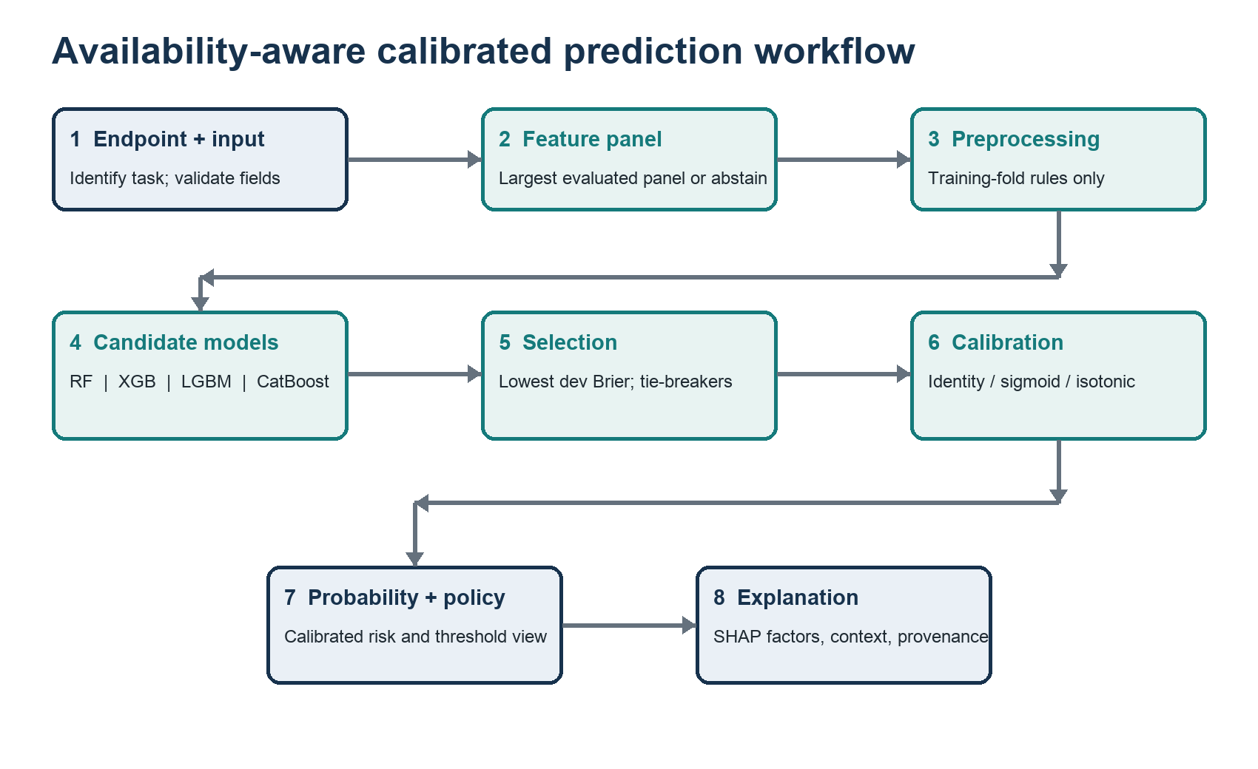
Figure 1. Endpoint-first, availability-aware prediction and reporting workflow.

3.1 Processing sequence
- Validate raw rows, endpoint labels, feature types, missingness and identity/grouping columns.
- Apply the immutable split contract: nested stratified folds for PIDD, grouped folds for Sylhet, stratified holdout for BRFSS, and patient-grouped holdout for Hospital130.
- Fit imputation, missingness indicators, scaling and categorical encoding only on the current training data.
- Tune candidate algorithms inside development folds using average precision as the optimization metric.
- Generate development out-of-fold probabilities and select a calibration method using Brier score, with log loss as the tie-breaker.
- Select operating thresholds using development predictions only.
- Evaluate once on the untouched outer fold or locked test partition.
- Produce metrics, bootstrap intervals, paired comparisons, decision curves, reloadable bundles and deterministic hashes.
- Generate held-out SHAP explanations and, where applicable, a detailed patient research report.

3.2 Models
Model | Role | Reason included
Random Forest | Bagged-tree candidate | Strong nonlinear baseline; low tuning sensitivity
XGBoost | Gradient-boosted candidate | Regularized boosted trees; strong tabular benchmark
LightGBM | Gradient-boosted candidate | Efficient leaf-wise boosting for larger cohorts
CatBoost | Gradient-boosted candidate | Robust boosting; useful for mixed/categorical settings
Logistic Regression | Reference baseline | Tests whether ensemble complexity adds meaningful value

3.3 How the model is chosen
Model choice is based only on development evidence; test or outer-validation labels are never used to pick the model. The exact decision depends on the experiment:
- Small-cohort benchmark: all models are evaluated with nested cross-validation. Numerical rankings are reported, but a universal champion is not claimed when paired differences are not significant.
- Feature-panel router: within each outer fold and panel, select the model with the lowest development Brier score; break ties using log loss and then average precision.
- BRFSS/Hospital holdout: select the development champion by Brier score, then log loss and average precision, lock all choices, and only then access the test partition once.
Why Brier score leads selection The intended output is a probability, so probability accuracy is prioritized over threshold-specific accuracy. Average precision remains the tuning objective because of class imbalance, while Brier score and log loss determine calibration/model selection.

3.4 Probability calibration
Identity (no recalibration), sigmoid/Platt scaling and isotonic regression are compared through cross-fitted development predictions. The candidate with the best development Brier score is selected, with log loss as the tie-breaker. Isotonic calibration is ineligible below 1,000 calibration samples because the Sylhet pilot showed severe small-sample overfit and extreme probabilities. Calibration is always learned without outer/test labels.

3.5 Operating policies
Policy | Selection source | Meaning
Fixed 0.5 | Predefined | Conventional reference; can be inappropriate at low prevalence
Youden | Development predictions | Balances sensitivity and specificity by maximizing their sum minus one
Sensitivity constrained | Development predictions | Targets at least 80% development sensitivity; outer/test sensitivity may differ

3.6 Metrics and statistical analysis
Metric family | Reported measures | Purpose
Discrimination | AUROC, average precision | Ranking and performance under imbalance
Probability quality | Brier, scaled Brier, log loss | Accuracy and sharpness of probability estimates
Calibration | Intercept, slope, O:E ratio, ECE | Agreement between predicted and observed risk
Operating point | Sensitivity, specificity, PPV, NPV, F1, MCC, likelihood ratios, DOR | Consequences of a selected threshold
Clinical utility | Decision-curve net benefit | Comparison with treat-all and treat-none strategies
Uncertainty | 95% bootstrap CIs; paired comparisons with Holm correction | Precision and controlled multiple testing

4. Results
How to read this section PIDD and Sylhet are complete development pilots with 5 outer folds, 5 inner folds, 5 tuning trials per model/fold and 200 bootstrap resamples. BRFSS and Hospital130 are 10,000-development/10,000-test smoke studies with 2 trials and 50 bootstraps. None is the final locked paper run.

4.1 PIDD probability performance
The PIDD pilot produced one held-out prediction per patient for each model. CatBoost had the best AUROC, Brier score and log loss, while XGBoost had the best average precision. All five models were close and no paired comparison survived Holm adjustment.
Model | AUROC (95% CI) | Average precision (95% CI) | Brier (95% CI) | Log loss (95% CI)
CatBoost | 0.8394 [0.8113–0.8626] | 0.7097 [0.6586–0.7622] | 0.1540 [0.1425–0.1671] | 0.4688 [0.4402–0.5021]
XGBoost | 0.8376 [0.8089–0.8667] | 0.7158 [0.6638–0.7698] | 0.1547 [0.1413–0.1680] | 0.4692 [0.4335–0.5036]
Random Forest | 0.8360 [0.8099–0.8660] | 0.6989 [0.6583–0.7495] | 0.1557 [0.1422–0.1672] | 0.4735 [0.4396–0.5076]
LightGBM | 0.8353 [0.8079–0.8625] | 0.7074 [0.6510–0.7605] | 0.1553 [0.1423–0.1682] | 0.4718 [0.4396–0.5058]
Logistic Regression | 0.8352 [0.8084–0.8626] | 0.7093 [0.6626–0.7667] | 0.1563 [0.1427–0.1682] | 0.4775 [0.4428–0.5074]

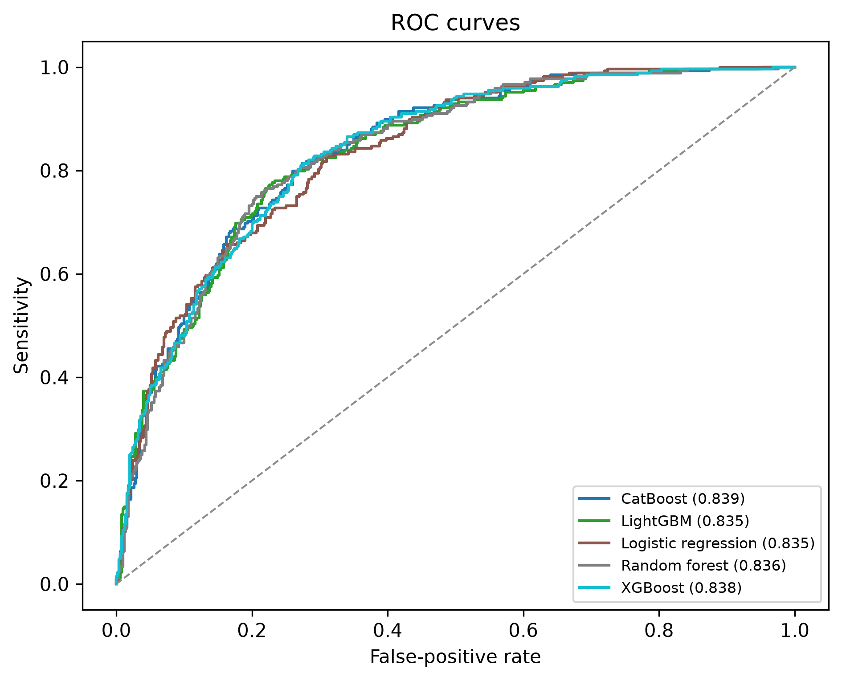
Figure 2. PIDD pooled held-out ROC curves across five outer folds.

PIDD sensitivity-constrained policy
At the fixed 0.5 threshold, sensitivity was only 0.575–0.619 while specificity was 0.850–0.876. The development-selected 80%-sensitivity policy lowered the mean threshold to approximately 0.29–0.34 and provided the following held-out behavior:
Model | Mean threshold [range] | Sensitivity (95% CI) | Specificity (95% CI) | PPV | NPV | F1
XGBoost | 0.317 [0.290–0.369] | 0.813 [0.769–0.855] | 0.710 [0.670–0.746] | 0.601 | 0.877 | 0.691
CatBoost | 0.318 [0.304–0.344] | 0.817 [0.772–0.858] | 0.700 [0.660–0.748] | 0.594 | 0.877 | 0.688
LightGBM | 0.315 [0.295–0.347] | 0.806 [0.754–0.851] | 0.710 [0.668–0.746] | 0.598 | 0.872 | 0.687
Random Forest | 0.336 [0.312–0.381] | 0.806 [0.765–0.855] | 0.708 [0.666–0.750] | 0.597 | 0.872 | 0.686
Logistic Regression | 0.295 [0.273–0.339] | 0.802 [0.765–0.847] | 0.686 [0.652–0.726] | 0.578 | 0.866 | 0.672

PIDD calibration behavior
Across five folds, identity versus sigmoid selection varied by model: Logistic Regression 2/3, Random Forest 1/4, XGBoost 3/2, LightGBM 2/3 and CatBoost 3/2. This supports selecting calibration per development fold rather than forcing one method. Isotonic was correctly ineligible because the calibration sample was below 1,000.

4.2 PIDD feature-availability routing
Six predeclared panels tested how predictions behave when measurements are unavailable. Each fold selected a model from inner masked predictions only. The largest result is that removal of insulin and skin thickness caused almost no degradation, while the absence of glucose caused a substantial decline.
Available panel | Features | AUROC (95% CI) | AP (95% CI) | Brier (95% CI) | Log loss
Full | 8 | 0.8394 [0.8088–0.8675] | 0.7068 [0.6522–0.7663] | 0.1540 [0.1406–0.1678] | 0.4686
No insulin/skinfold | 6 | 0.8389 [0.8135–0.8649] | 0.7144 [0.6615–0.7698] | 0.1539 [0.1418–0.1652] | 0.4682
Routine clinic | 5 | 0.8346 [0.7984–0.8639] | 0.6980 [0.6465–0.7612] | 0.1563 [0.1423–0.1711] | 0.4755
Core metabolic | 4 | 0.8357 [0.8053–0.8633] | 0.7209 [0.6706–0.7640] | 0.1550 [0.1420–0.1687] | 0.4705
Glucose + age | 2 | 0.8048 [0.7743–0.8384] | 0.6847 [0.6301–0.7410] | 0.1676 [0.1545–0.1808] | 0.5054
Non-laboratory | 4 | 0.7393 [0.7037–0.7746] | 0.5750 [0.5294–0.6305] | 0.1913 [0.1803–0.2027] | 0.5626

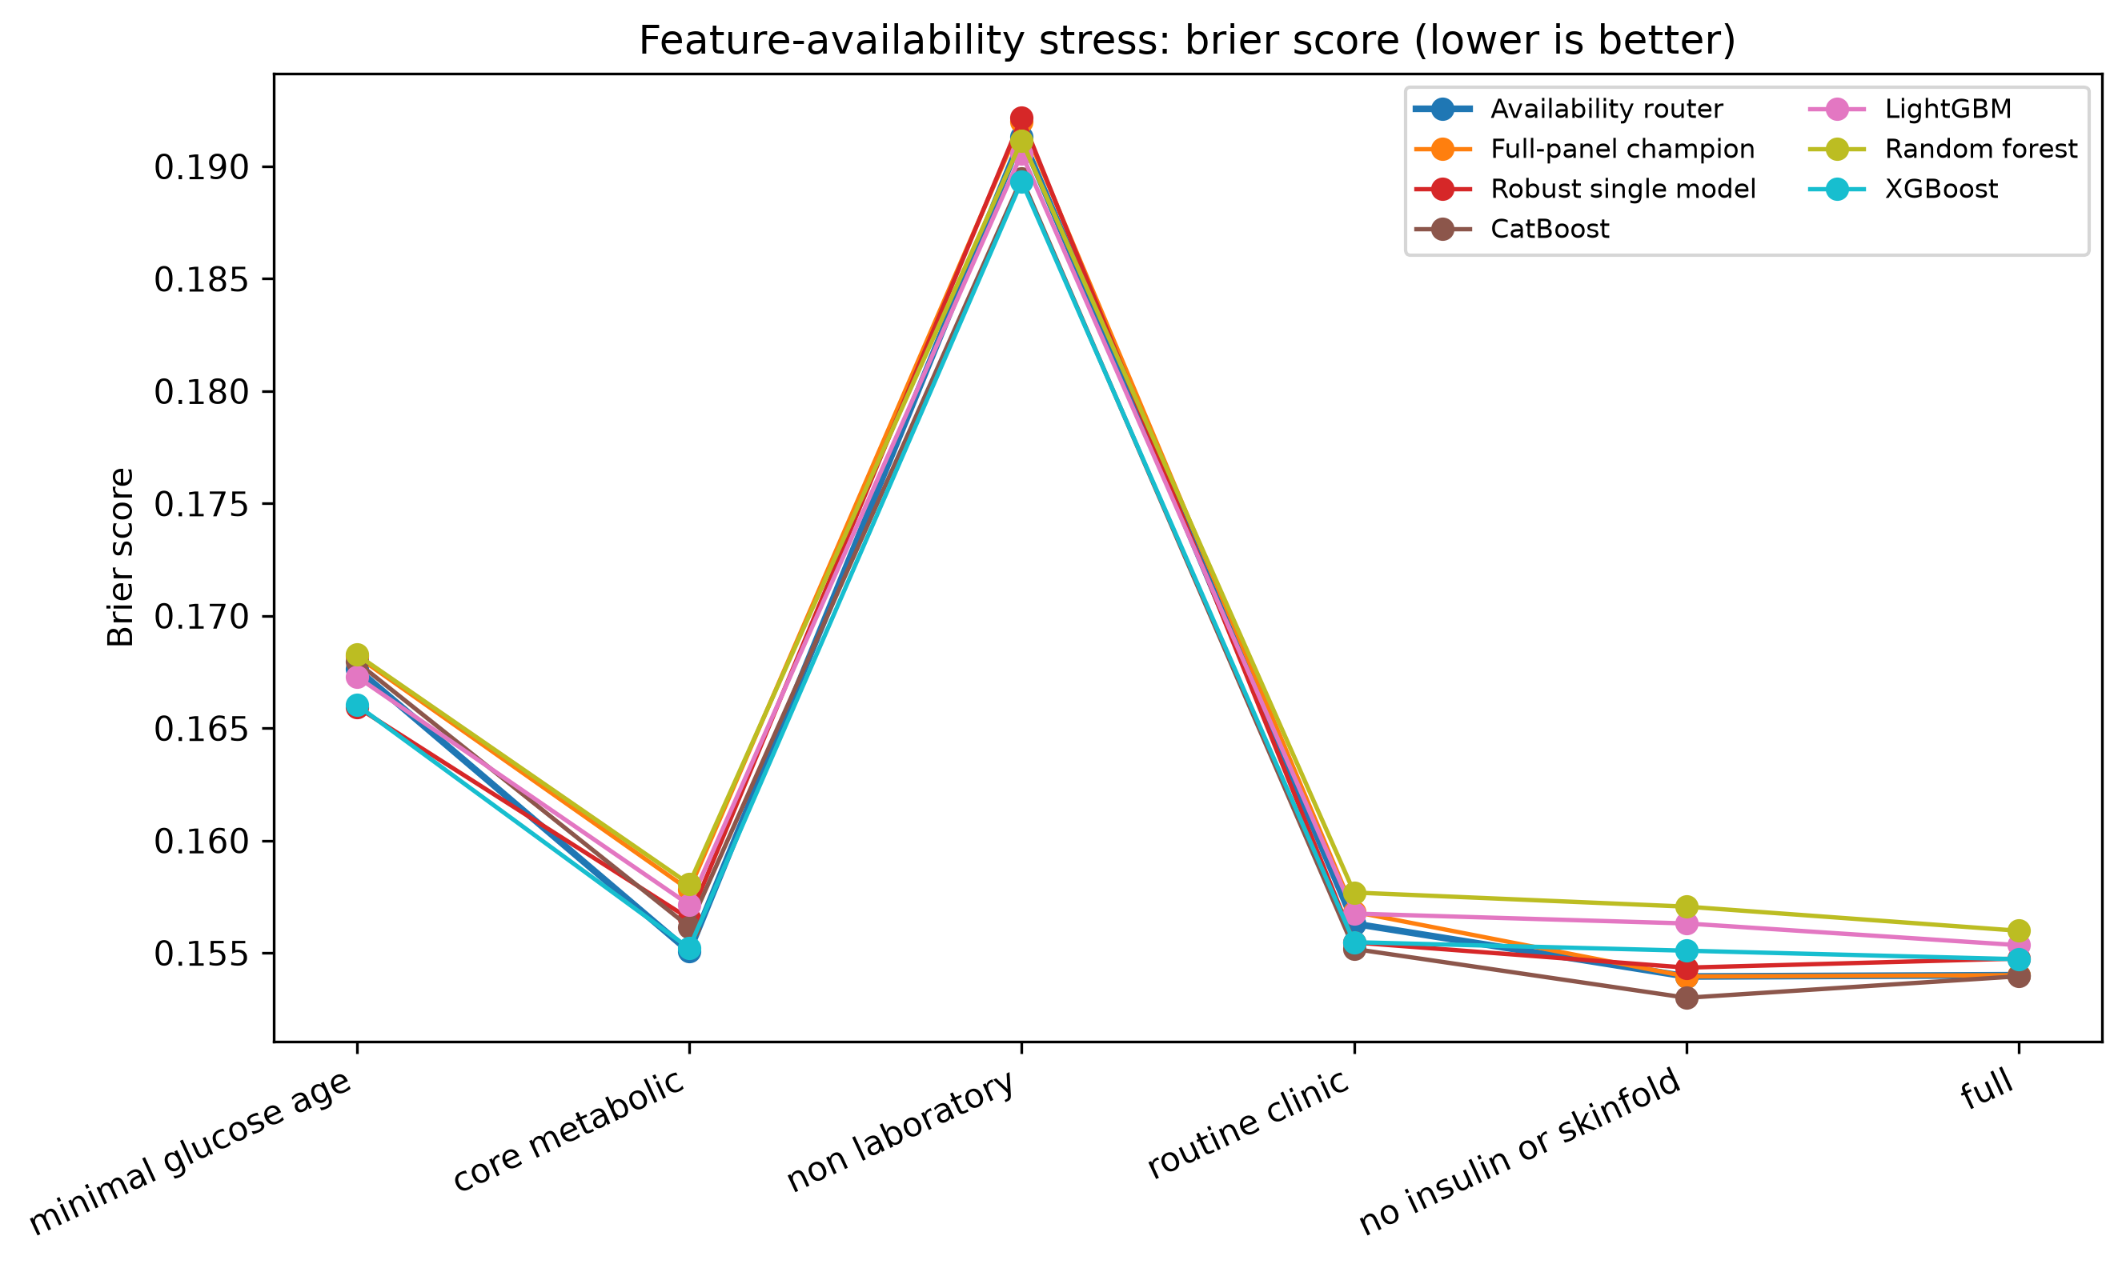
Figure 3. PIDD probability error across feature-availability scenarios and model-selection systems.

Does switching algorithms help?
Only marginally and inconsistently. Compared with the full-panel champion, mean fold-average Brier reductions were 0.00274 for the core panel, 0.00056 for glucose–age, 0.00053 for routine clinic and 0.00068 for the non-laboratory panel. No router-versus-baseline comparison was significant after Holm correction. Model selections also varied across folds: the core panel selected every model at least once, and the non-laboratory panel selected XGBoost in three folds plus two other models in the remaining folds.
Routing conclusion Keep dynamic routing as a tested component and ablation result. The current publishable claim is that feature availability changes reliability and the system can restrict itself to evaluated panels—not that switching among the four algorithms is already proven superior.
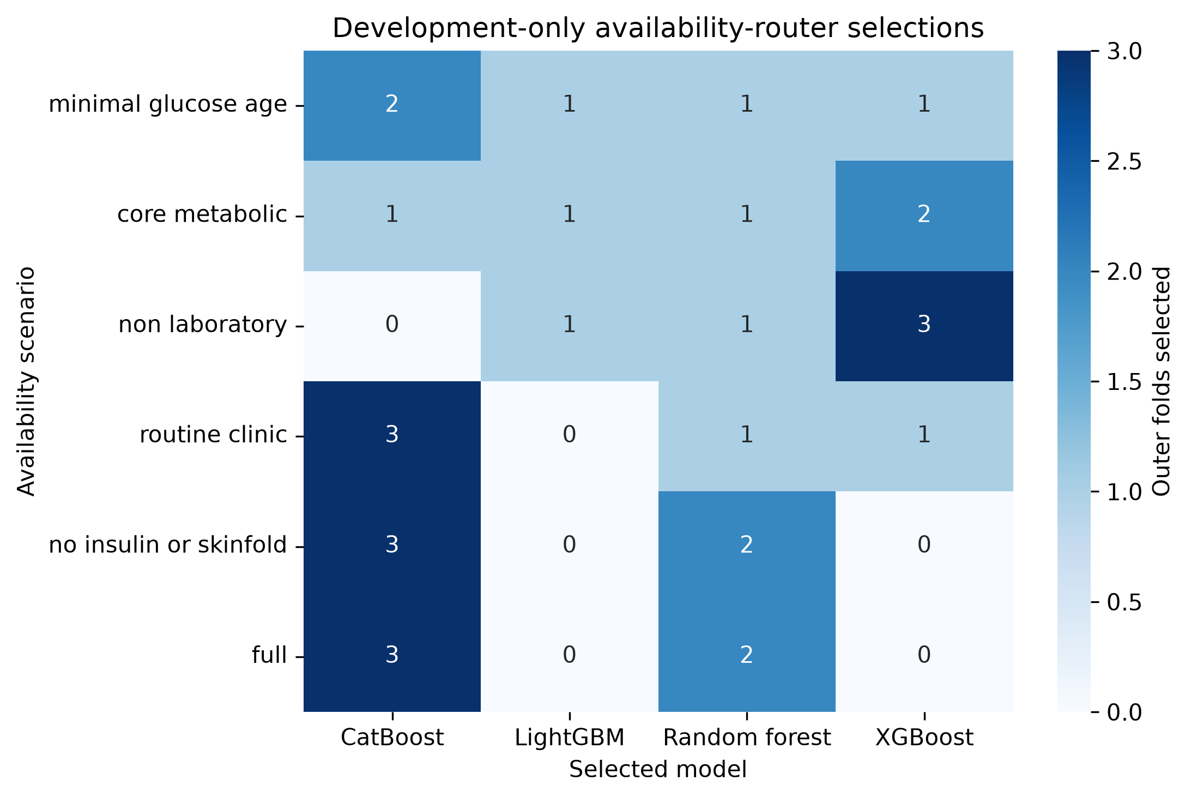
Figure 4. Development-only model selections by PIDD feature panel and outer fold.

Inference and abstention
At inference, the router first identifies the largest evaluated panel fully supported by the observed features. It reproduces that panel’s masking, applies the fold-selected model and scenario calibrator, and reports calibrated probability plus provenance. If no panel is supported, a required value is invalid, or an in-use value is outside the reference range, the system abstains instead of fabricating a probability.

4.3 Detailed patient probability report
Because the PIDD pilot did not identify a stable algorithm, the patient formatter uses all five independently developed outer-fold routers as a research ensemble. It reports the mean calibrated probability, minimum/maximum/standard deviation across folds, the count above the research threshold, selected-model counts, calibrator counts, normalized SHAP factors and observational cohort context. The fold range is model-development variability, not a statistical confidence interval.
Synthetic example field | Result
Available panel | No insulin or skinfold (6 predictors)
Mean calibrated probability | 0.6605
Model-fold range | 0.5954–0.7838
Model-fold standard deviation | 0.0660
Folds at/above 0.5 | 5 of 5
Selected models | CatBoost 3 folds; Random Forest 2 folds
Leading SHAP factors | Glucose, age, BMI, pregnancies, diabetes pedigree
Explanation agreement | Direction agreed across all five folds for the five leading factors

Safety note The example is synthetic and demonstrates the formatter only. The output is explicitly labelled research validation, not diagnosis or treatment advice.

4.4 PIDD SHAP findings
SHAP explanations were generated only for held-out patients using each fold’s saved preprocessing and fitted model. Because Random Forest is explained on probability scale while boosted trees are explained on margin scales, absolute SHAP magnitudes are not compared between model families. Valid comparisons are within-model feature ranking, direction and stability.
Model | Top five held-out features
CatBoost | Glucose; BMI; age; diabetes pedigree; pregnancies
LightGBM | Glucose; BMI; age; diabetes pedigree; pregnancies
Random Forest | Glucose; BMI; age; diabetes pedigree; pregnancies
XGBoost | Glucose; BMI; age; diabetes pedigree; insulin
Logistic Regression | Glucose; BMI; pregnancies; diabetes pedigree; missing-insulin indicator

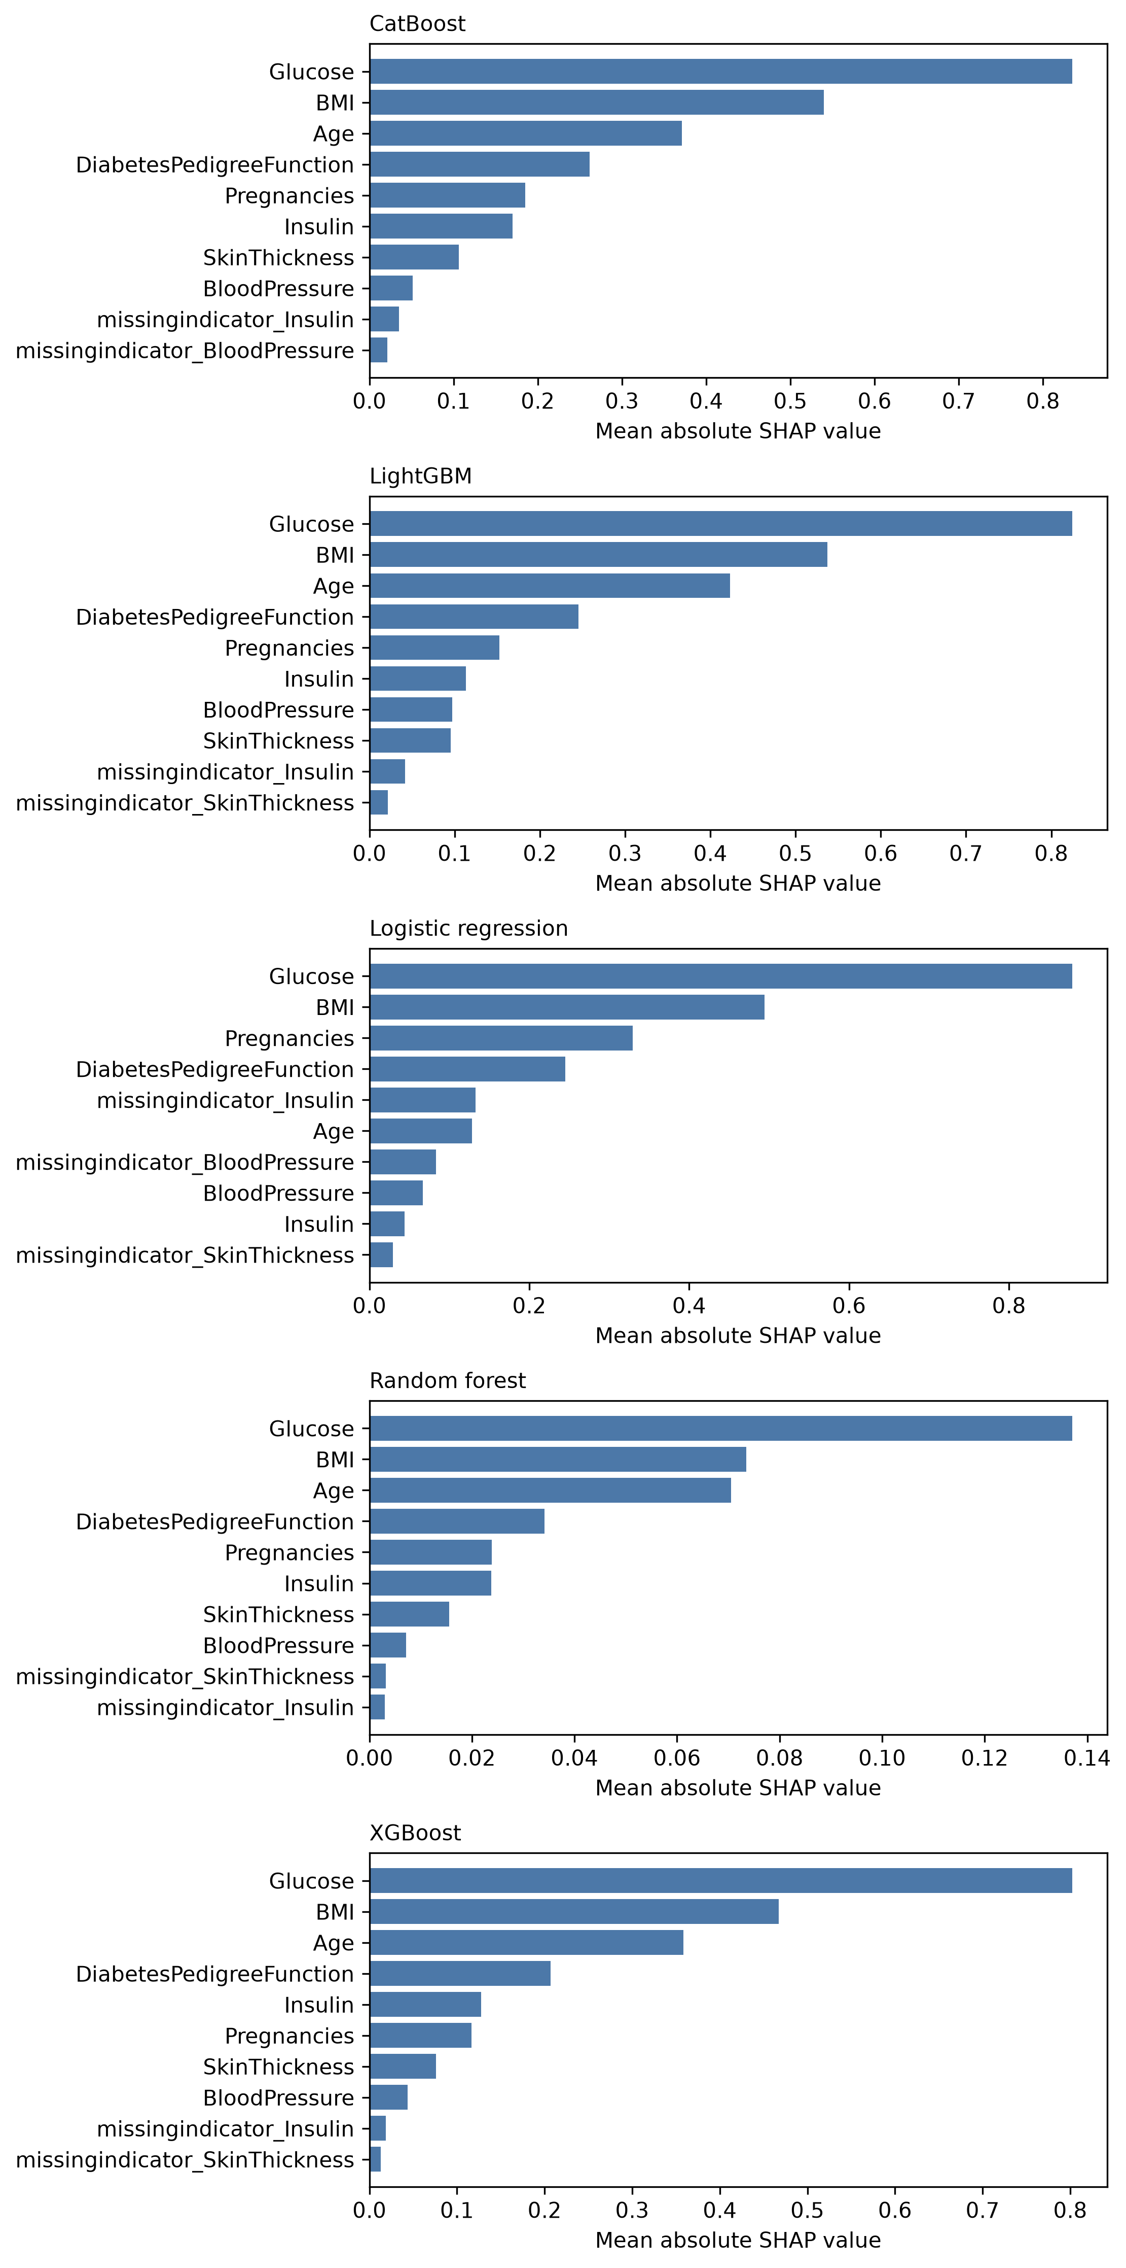
Figure 5. Global held-out PIDD SHAP importance. Magnitudes should be interpreted within model family.
Glucose ranked first and BMI second in every model. Higher glucose and BMI were positively associated with model output; age was also positive in the four tree models. Tree-model rank stability was high: mean fold-pair Spearman ranged from 0.9588 to 0.9787. All 25 model/fold explanation sets passed additivity; maximum reconstruction error was approximately 3.1×10⁻⁶.
Non-causal interpretation SHAP identifies factors contributing to the model estimate. It does not show that a factor caused diabetes. Exploratory age transition values are relative to model baselines in this cohort and are not clinical cutoffs.

4.5 Sylhet grouped-pilot results
All identical questionnaire profiles were isolated by group. CatBoost was numerically strongest across all probability metrics, but no paired five-fold comparison remained significant after Holm correction. The high scores require caution because this is a small symptom-rich cohort with predictors close to manifest disease symptoms.
Model | AUROC (95% CI) | Average precision (95% CI) | Brier (95% CI) | Log loss (95% CI)
CatBoost | 0.9722 [0.9577–0.9820] | 0.9841 [0.9764–0.9899] | 0.0642 [0.0489–0.0803] | 0.2093 [0.1662–0.2567]
LightGBM | 0.9649 [0.9515–0.9784] | 0.9801 [0.9730–0.9872] | 0.0701 [0.0570–0.0836] | 0.2373 [0.1954–0.2811]
Random Forest | 0.9586 [0.9436–0.9728] | 0.9749 [0.9668–0.9828] | 0.0759 [0.0623–0.0896] | 0.2518 [0.2074–0.2972]
XGBoost | 0.9535 [0.9362–0.9712] | 0.9709 [0.9606–0.9817] | 0.0800 [0.0630–0.0958] | 0.2665 [0.2162–0.3093]
Logistic Regression | 0.9478 [0.9287–0.9644] | 0.9704 [0.9591–0.9785] | 0.0871 [0.0718–0.1033] | 0.3026 [0.2434–0.3692]

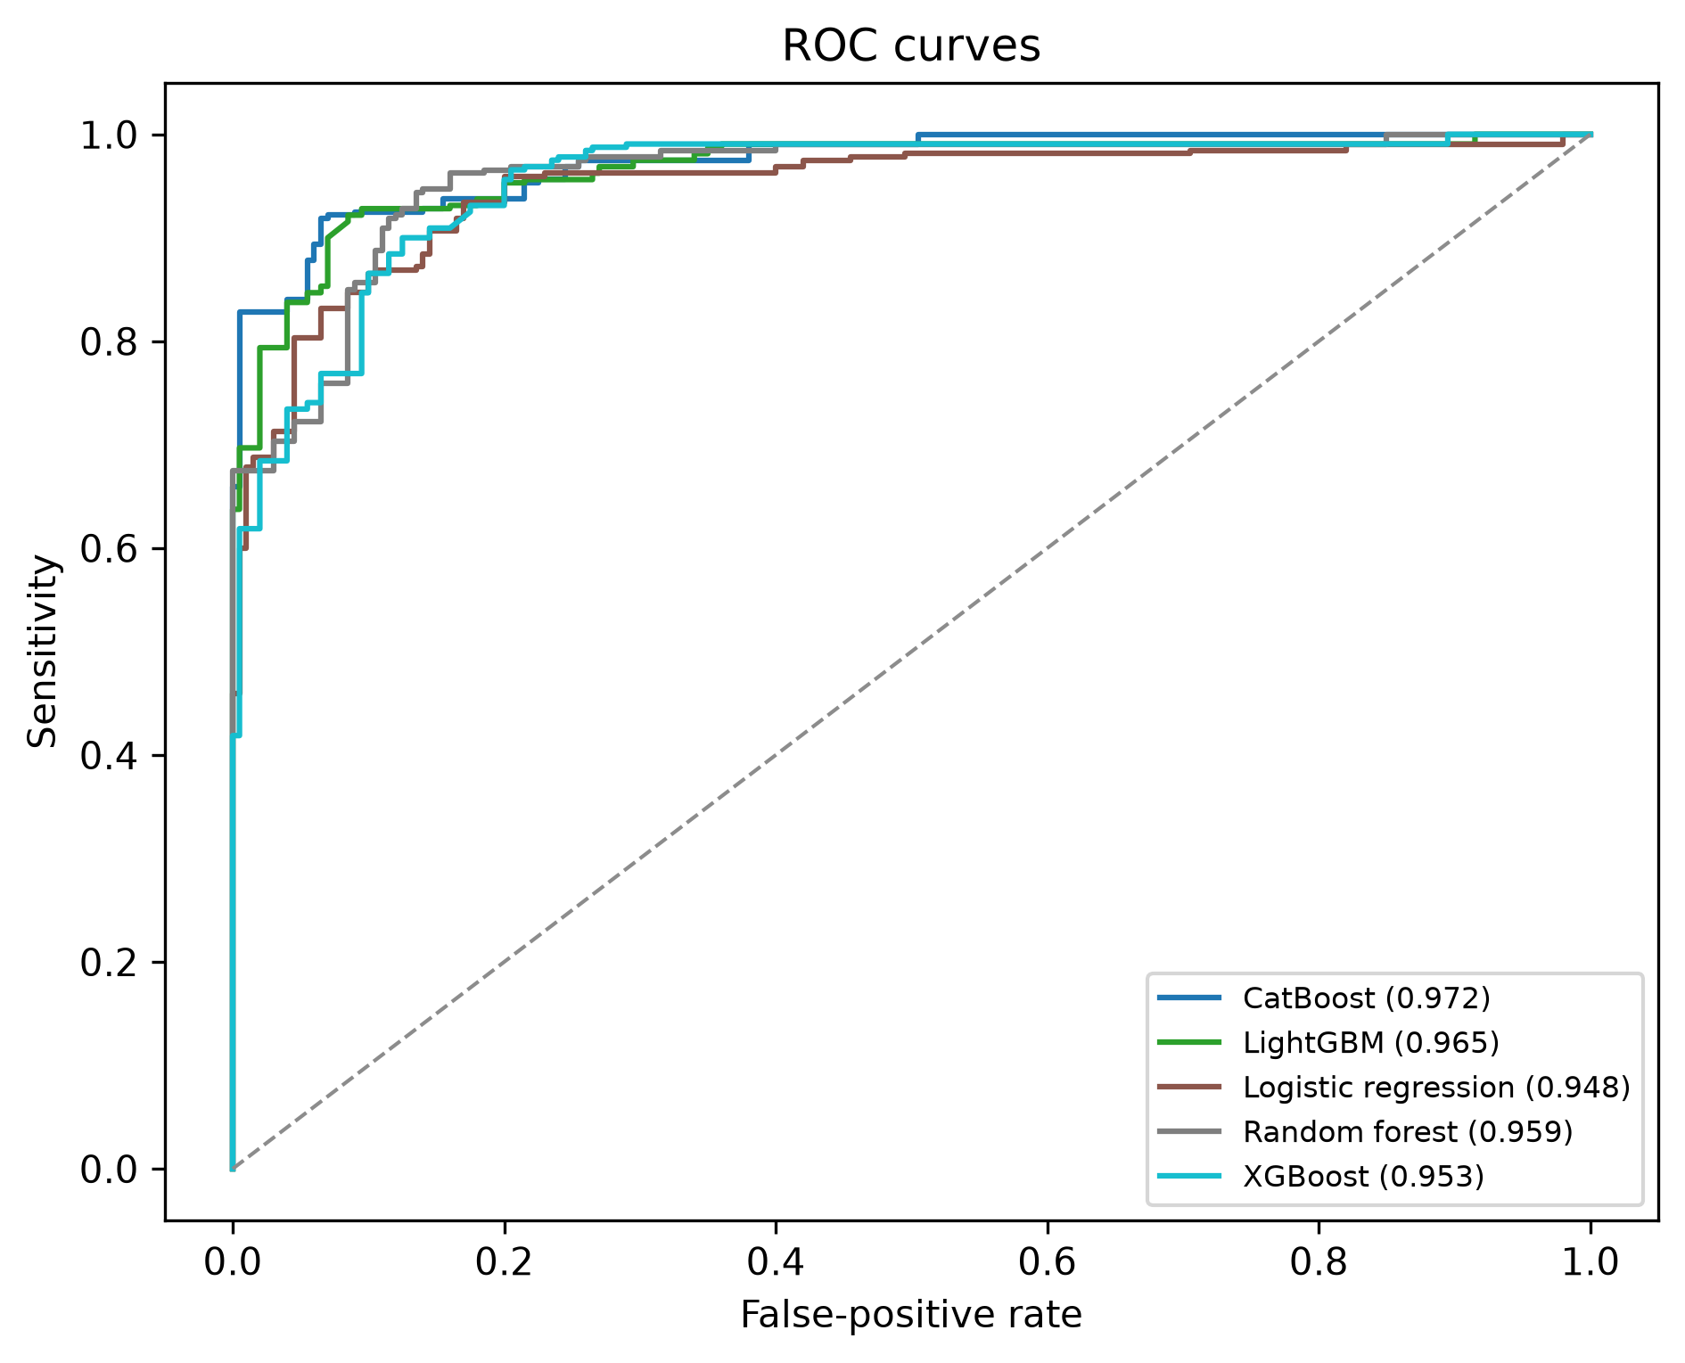
Figure 6. Sylhet grouped held-out ROC curves.

Sylhet calibration lesson
An exploratory run allowed isotonic calibration on approximately 416 training rows and produced extreme probabilities: XGBoost log loss 0.5070 and LightGBM log loss 0.3426. After declaring isotonic ineligible below 1,000 calibration samples, log loss improved to 0.2665 and 0.2373. This failure analysis directly strengthened the final calibration contract.

Sylhet SHAP
Polyuria ranked first for CatBoost, LightGBM, Random Forest and XGBoost; polydipsia ranked first for Logistic Regression and second for the other four; gender ranked third in all five. Itching, irritability, partial paresis, sudden weight loss, alopecia and age filled the remaining top positions. Random Forest had mean full-rank Spearman 0.9303 and top-five Jaccard 1.0; other models were less stable in the lower ranks.
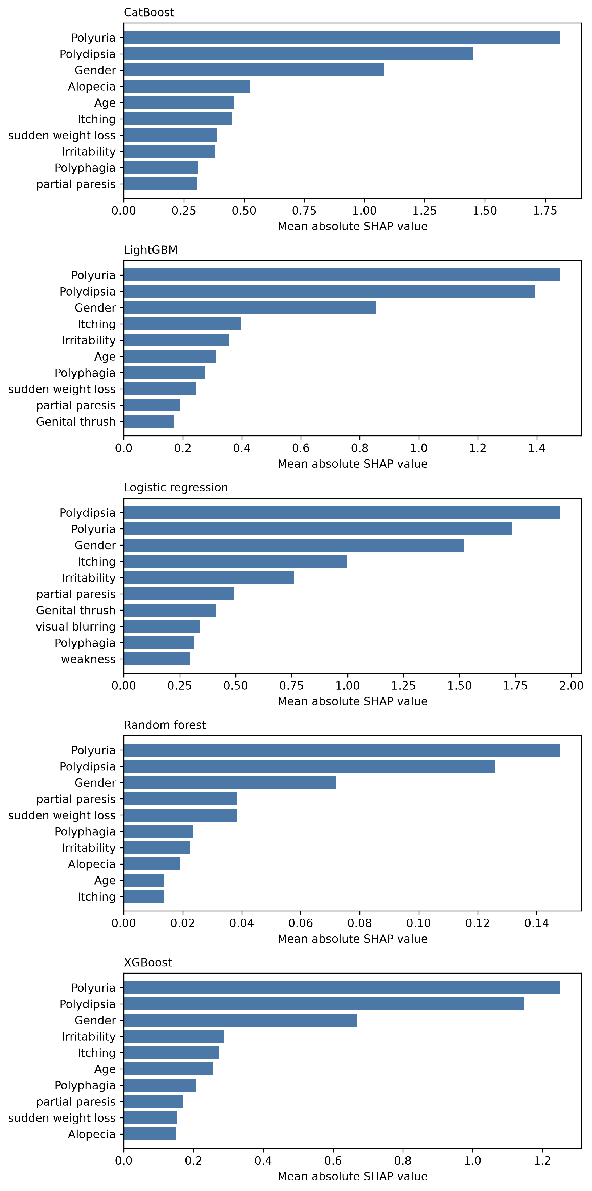
Figure 7. Global held-out Sylhet SHAP importance across the five benchmark models.

4.6 BRFSS smoke holdout
The holdout engine selected CatBoost from development probabilities. XGBoost was marginally better on held-out AUROC and average precision, illustrating why test results must not be used to retroactively change the champion. No pairwise difference was Holm-significant.
Model | AUROC | Average precision | Brier | Log loss
XGBoost | 0.8318 | 0.4221 | 0.0935 | 0.3044
CatBoost (dev champion) | 0.8308 | 0.4199 | 0.0936 | 0.3039
Random Forest | 0.8257 | 0.4148 | 0.0940 | 0.3073
LightGBM | 0.8135 | 0.3936 | 0.0963 | 0.3142

At development-selected sensitivity thresholds, sampled-test sensitivity ranged from 0.761 to 0.798 and specificity from 0.678 to 0.732. Leading original-feature SHAP variables were general health, age, BMI, high blood pressure and high cholesterol.
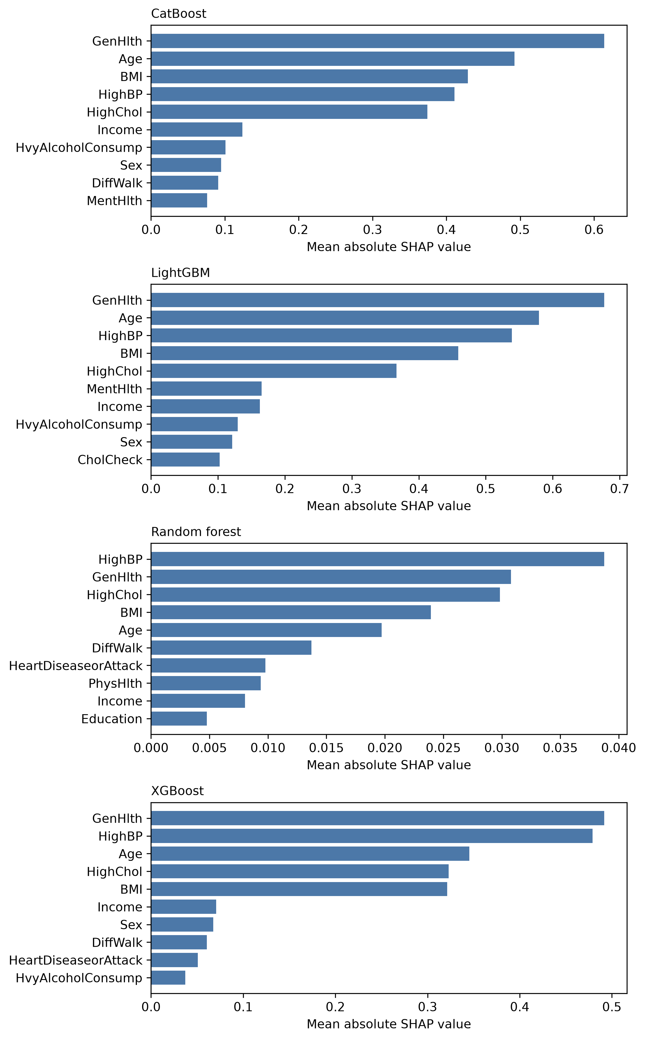
Figure 8. BRFSS held-out original-feature SHAP importance (500 sampled test rows per model).
Evidence restriction This study used 10,000 development and 10,000 test rows, two tuning trials and 50 bootstrap resamples. It verifies the large-cohort code path and is not a publication estimate.

4.7 Hospital130 smoke holdout
XGBoost was selected from development data and narrowly led the sampled test metrics. Performance was substantially lower than screening performance because the endpoint—30-day readmission—is a different and more difficult prediction task.
Model | AUROC | Average precision | Brier | Log loss
XGBoost (dev champion) | 0.6589 | 0.2065 | 0.0973 | 0.3382
Random Forest | 0.6584 | 0.2040 | 0.0973 | 0.3383
CatBoost | 0.6516 | 0.2003 | 0.0976 | 0.3396
LightGBM | 0.6334 | 0.1874 | 0.0984 | 0.3430

At threshold 0.5, sensitivity was approximately zero because calibrated probabilities reflected an 11.4% event prevalence. Development-selected Youden thresholds yielded sensitivity 0.566–0.671 and specificity 0.559–0.634. The 80%-sensitivity policy yielded sensitivity 0.809–0.860 but specificity only 0.273–0.378. This demonstrates why probability quality and operating policy must be presented separately.
Held-out SHAP consistently highlighted previous inpatient utilization, with discharge disposition, number of diagnoses, payer/specialty and other utilization/care variables also prominent. Categorical one-hot components were aggregated back to the 46 original source variables for the primary interpretation.
Evidence restriction This is a corrected engineering smoke run, not a final readmission study. Patient-cluster bootstrap is implemented for the final analysis.
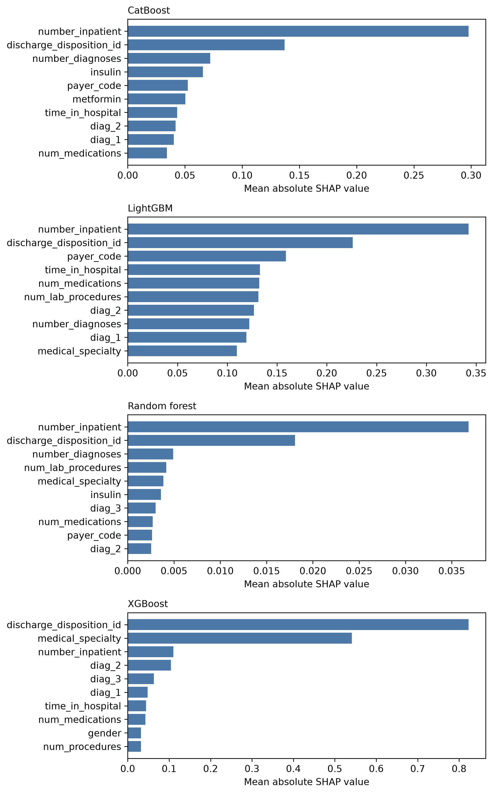
Figure 9. Hospital130 held-out original-feature SHAP importance (200 sampled test encounters per model).

5. SHAP Explainability Design

5.1 Explanation contract
- Reported SHAP values come only from outer-validation patients or held-out test rows.
- Background/reference data come only from the corresponding development partition.
- Every explanation must reconstruct the base-model output within an absolute error of 10⁻⁴.
- Transformed categorical components are grouped back to their original source variable for Hospital130 interpretation.
- SHAP scales differ across model families; magnitudes are normalized within fold before patient-level aggregation.
- Local wording uses “raised” or “lowered the model estimate,” never causal language.

5.2 Global and local outputs
Output | Purpose
Global importance | Ranks features by mean absolute SHAP within model
Beeswarm plots | Shows direction and distribution of contributions
Dependence bins | Explores how feature values relate to contributions
Fold stability | Spearman rank and top-k Jaccard consistency
Local contributors | Top factors for each held-out patient/encounter
Additivity checks | Verifies numerical reconstruction of base-model output

5.3 Summary of dominant factors
Dataset | Leading factors | Interpretive caution
PIDD | Glucose, BMI, age, pedigree, pregnancies | Population-specific; missing insulin can itself influence the model
Sylhet | Polyuria, polydipsia, gender, symptom variables | Symptoms may be close to manifest disease
BRFSS | General health, age, BMI, high BP, high cholesterol | Self-reported cross-sectional outcome
Hospital130 | Previous inpatient use, discharge disposition, diagnoses, care/utilization variables | Readmission endpoint; categorical context matters

5.4 What SHAP does not establish
SHAP explains the fitted model, not biological causation, treatment effect or future transportability. A positive contribution means that a feature increased a model’s output relative to its baseline under the fitted representation. It does not imply that changing the feature will change the outcome. Cohort-relative age transitions and prevalence bands are descriptive context only.

6. Leakage Prevention, Reproducibility and Safety

6.1 Leakage controls
- All imputers, missing indicators, scaling and encoders are fitted within training data only.
- PIDD outer labels do not participate in tuning, calibration or threshold selection.
- Identical Sylhet profiles cannot cross an evaluation fold.
- Hospital encounters from the same patient cannot cross development/test or development folds.
- BRFSS and Hospital test partitions remain inaccessible to non-smoke runs until the final configuration is explicitly locked.
- Holdout champion selection is frozen before test prediction; test superiority cannot change the chosen model.

6.2 Statistical safeguards
- Stratified bootstrap confidence intervals for PIDD, Sylhet and BRFSS; patient-cluster bootstrap for Hospital130.
- Paired model comparisons with Holm family-wise multiplicity correction.
- Calibration selection through cross-fitted probabilities rather than resubstitution predictions.
- Isotonic minimum of 1,000 calibration samples after an observed small-sample failure.
- Decision-curve analysis and multiple operating policies rather than one arbitrary cutoff.

6.3 Artifact provenance
Each study stores predictions, fold metrics, calibration choices, thresholds, confidence intervals, decision curves, plots, best parameters, model bundles, split/dataset/source hashes and reload checks. Saved bundles reproduce calibrated probabilities to floating-point precision. The active automated suite currently passes 31 tests plus 5 model-adapter subtests.

6.4 Patient-output safety
- Unsupported panels, invalid/non-finite values and out-of-reference-range values trigger abstention by default.
- Unknown fields are ignored and reported rather than silently incorporated.
- Patient inputs and results are not persisted unless output is explicitly requested.
- Probability, threshold status, fold spread and cohort context are labelled separately.
- The research report never presents the output as diagnosis or personalized medical advice.

7. Interpretation and Publication Value

7.1 What the results currently support
- A calibrated probability pipeline can be executed reproducibly across small clinical, symptom survey, population survey and hospital encounter datasets.
- The four tree ensembles often perform similarly; Logistic Regression is also competitive on PIDD, so complexity alone is not the contribution.
- Feature availability is consequential. PIDD tolerates loss of insulin and skin thickness, but loses substantial reliability when glucose is unavailable.
- Development-only routing can safely select among evaluated panels and abstain, although current PIDD evidence does not show significant benefit from switching algorithms.
- Thresholds should follow the intended operating policy. A universal 0.5 cutoff is especially misleading for low-prevalence Hospital130 readmission.
- Held-out SHAP can be generated with verified additivity and with model-scale limitations made explicit.

7.2 Proposed novelty position
Recommended paper framing An availability-aware, calibrated and explainable tabular prediction framework that quantifies feature-panel degradation, selects only from development-validated models, reports probability and operating-policy behavior separately, and abstains outside evaluated conditions.
The paper should avoid framing the contribution as “four algorithms were compared and the highest AUROC won.” That claim is weak and not supported by the current statistical comparisons. The stronger contribution integrates data-availability stress testing, calibration, decision policy, uncertainty, explainability, endpoint-aware feature semantics and safe inference behavior.

7.3 Honest negative result
On PIDD, dynamic per-panel algorithm switching did not significantly outperform fixed-model baselines. This should be reported, not hidden. It motivates the BRFSS-scale routing experiment, where the larger sample can determine whether routing instability is primarily a small-data effect. Even if BRFSS also shows little switching benefit, the framework remains valuable as a principled panel-selection and abstention system.

8. Limitations
No locked final estimates. PIDD and Sylhet use reduced tuning/bootstrap budgets; BRFSS and Hospital130 are smoke runs. Final configuration is intentionally locked=false.
No external or prospective validation. All current evaluations are internal to their source cohorts. Transportability and calibration drift remain unknown.
Small, population-specific cohorts. PIDD and Sylhet have limited sample size. Sylhet has many duplicate symptom profiles and unusually high apparent performance.
Routing evidence is currently PIDD-only. Availability-aware model routing has not yet been tested on BRFSS at scale.
Unstable champion selection. Differences among the four tree models are small and usually not statistically significant; fold-level router selections vary.
Probability estimates are cohort-dependent. A calibrated probability is valid only relative to the endpoint, cohort, prevalence, sampling process and evaluation conditions.
SHAP is not causal. Feature contributions explain model output, not mechanisms or intervention effects.
Subgroup performance is pending. Fairness/subgroup analyses by relevant demographic and clinical strata have not yet been implemented.
Patient formatter is a research prototype. The five-fold range is not a confidence interval, and the system has not undergone clinical usability or safety validation.
Endpoint heterogeneity. PIDD, Sylhet and BRFSS screening labels differ; Hospital130 is a distinct readmission task. Cross-dataset probabilities cannot be pooled.

8.1 Clinical and ethical boundary
The pipeline is not a medical device and is not ready for diagnosis, treatment selection or autonomous screening. Before clinical use it would require external and prospective validation, local recalibration, subgroup safety analysis, workflow evaluation, governance, monitoring and appropriate regulatory/ethical review.

9. Work Required for Conference/Journal Submission
Priority | Required work | Why it matters
1 | Implement BRFSS feature-availability routing | Tests routing stability and effect size at scale
2 | Add subgroup/fairness analyses | Required for credible health-ML reporting
3 | Freeze endpoints, panels, metrics and statistical plan | Prevents post-test analytical flexibility
4 | Lock final configuration and source hashes | Creates an auditable one-time final experiment
5 | Run final profiles: 75 trials and 2,000 bootstraps | Produces publication-grade estimates and intervals
6 | Run prespecified sensitivity analyses | Tests cohort definitions, missingness and policy robustness
7 | Refit deployment-research bundles on all development data | Creates a clearly separated post-evaluation prototype
8 | Write manuscript using frozen tables/figures | Aligns claims with actual evidence level

9.1 Final experimental profile already defined
Setting | Final value
Random seed | 42
Hyperparameter trials | 75 per model/evaluation unit
Bootstrap resamples | 2,000
Calibration candidates | Identity, sigmoid, isotonic (isotonic minimum n=1,000)
Thresholds | Fixed 0.5, development Youden, development 80%-sensitivity
Sample limits | None
Current lock state | false — final test access remains disabled

9.2 Suggested manuscript result hierarchy
Primary result. Calibrated probability performance and uncertainty for the prespecified endpoint/model-selection system.
Secondary result A. Feature-panel degradation and router-versus-fixed-model comparisons.
Secondary result B. Operating-policy performance and decision-curve net benefit.
Interpretability. Held-out SHAP rankings, directions and stability.
Safety/applicability. Abstention, out-of-range handling and endpoint ontology.
Sensitivity analyses. Alternative cohort definitions and subgroup analyses.

10. Conclusion
The project has progressed from a conventional single-model classifier to a complete publication-oriented research system. Four tree ensembles can be tuned and evaluated under leakage-controlled designs; probabilities are calibrated through development-only evidence; thresholds are tied to explicit operating policies; uncertainty and paired comparisons are generated; held-out SHAP explains both global and local behavior; feature availability is evaluated through predeclared panels; and the patient layer can return a detailed probability report or safely abstain.
The most important current scientific conclusion is that model choice alone is not decisive. On PIDD and Sylhet, numerical leaders exist but the algorithms are not statistically separated after multiplicity correction. PIDD routing further shows that availability of informative measurements—especially glucose—has a larger effect than dynamic switching among Random Forest, XGBoost, LightGBM and CatBoost. This supports a paper centered on calibrated, availability-aware, explainable and safety-conscious prediction rather than on a simple algorithm leaderboard.
Overall status The engineering and pilot-evidence foundation is strong enough to begin manuscript drafting. Publication claims must remain provisional until BRFSS routing, subgroup analyses, protocol freeze and the one-time locked final experiments are completed.

Appendix A. Canonical Study Artifacts
Dataset | Canonical study identifier | Status
PIDD | pidd_development_pilot_27b9bc88b493 | Development pilot + SHAP + routing
Sylhet | sylhet_development_pilot_ed7c05460503 | Grouped development pilot + SHAP
BRFSS | brfss_smoke_holdout_1f1344dceb63 | Holdout smoke + held-out SHAP
Hospital130 | hospital130_smoke_holdout_6640beff7a08 | Corrected grouped holdout smoke + SHAP

Appendix B. Key Generated Outputs
- Raw and calibrated held-out probabilities.
- Fold and pooled metrics across multiple threshold policies.
- Bootstrap confidence intervals and paired Holm-adjusted comparisons.
- Calibration candidate scores and selected calibration method.
- Development-selected thresholds and decision-curve data.
- ROC, precision–recall, calibration, probability-distribution and decision-curve figures.
- Reloadable preprocessing/model/calibration/threshold bundles.
- Held-out SHAP values, global importance, dependence summaries, local factors and reconstruction checks.
- Availability-router bundles, model-selection evidence, stress predictions and abstention behavior.
- Dataset, split, source and artifact checksums.

Appendix C. Data and Method References
BRFSS 2015 codebook: CDC documentation
Sylhet dataset: UCI Early Stage Diabetes Risk Prediction
Hospital dataset: UCI Diabetes 130-US Hospitals
Calibration safeguard: Niculescu-Mizil and Caruana (2005), Predicting Good Probabilities with Supervised Learning
Implementation guidance: scikit-learn probability calibration documentation

