DEVELOPMENT CONFERENCE PACKAGE
Availability-Aware Diabetes Screening Under Incomplete Predictor Panels
A multi-environment development study
NOT FINAL EVIDENCE | NOT AUTHORIZED FOR SUBMISSION
Evidence cutoff: 30 August 2026

Abstract
Background: Diabetes-screening models are commonly evaluated with a fixed, complete predictor set, although real users may provide only a clinically meaningful subset. Models trained on public cohorts also represent different endpoints and populations, making naïve cross-dataset fusion unsafe.
Objective: To evaluate how calibrated diabetes-status prediction changes across prespecified feature-availability panels and whether an availability-aware router preserves performance relative to strong fixed-model baselines while abstaining outside evaluated routes.
Methods: PIDD, the Sylhet early-stage symptom cohort, and BRFSS 2015 are treated as separate diabetes-status environments; Hospital130 is a distinct 30-day-readmission analysis. Logistic Regression, Random Forest, XGBoost, LightGBM, and CatBoost are compared using leakage-controlled nested cross-validation or a development holdout appropriate to each dataset. Model selection occurs inside development data. Evaluation includes AUROC, average precision, Brier score, log loss, calibration, threshold metrics, decision-curve net benefit, paired uncertainty, reduced-panel degradation, selective prediction, subgroups, missingness stress, and held-out SHAP explanations. The router chooses only among models evaluated for a supported within-dataset panel and otherwise abstains.
Development results: In the completed full-budget PIDD development study (768 participants; 5 repeats x 5 outer folds), participant-aggregated calibrated AUROC ranged from 0.838 to 0.844 and Brier score from 0.152 to 0.156 across the five model families. CatBoost had the lowest participant-level Brier score (0.152), but model differences were small. For the full panel, the availability router achieved participant-level AUROC 0.843 and Brier score 0.152; the robust fixed-model baseline achieved AUROC 0.843 and Brier score 0.152. No reduced-panel comparison survived metric-wise Holm correction in the matched contrast family. At 70% coverage, probability-certainty selection reduced full-panel router Brier score from 0.152 to 0.110 but retained only 55.6% of positive events, demonstrating a clinically important coverage trade-off. With 75% simulated feature dropout, supported-panel coverage fell to approximately 4.8%-6.6%, while Brier score rose to approximately 0.208-0.211 for Random Forest and XGBoost. In the grouped Sylhet development study (520 participants; 5 x 5 outer folds), CatBoost achieved participant-level AUROC 0.970, average precision 0.984, Brier score 0.061, and calibration slope 1.01. The full-panel router achieved AUROC 0.965 and Brier 0.068 versus 0.960 and 0.077 for the robust fixed baseline, without a corrected significance claim. Across 32 Sylhet panel-specific-training contrasts, no comparison survived Holm correction (minimum adjusted p=0.064). The full BRFSS development study used 343,488 development and 85,872 development-test respondents. XGBoost, CatBoost, and LightGBM had nearly identical calibrated AUROC (0.843) and Brier score (0.0915); none of their pairwise differences was Holm-significant. The development-selected LightGBM champion was retained even though XGBoost had the numerically lowest test Brier score. Survey weighting changed prevalence from 13.3% to 10.9% and increased XGBoost AUROC from 0.843 to 0.871, showing that sample-conditional and population-weighted estimands are not interchangeable. In the separate Hospital130 development study, 99,343 retained encounters from 69,990 patients yielded a 19,868-encounter patient-grouped test partition. LightGBM was selected on development data and achieved calibrated AUROC 0.679, average precision 0.229, Brier 0.0958, and calibration slope 1.02.
Conclusion: The development evidence supports a reliability and applicability paper, not a universal-model or algorithm-superiority claim. Availability-aware routing is technically feasible and traceable, but its incremental predictive gain over a robust fixed model is small. Missingness and selective acceptance can materially change both probability accuracy and which positive cases remain covered; these effects must be reported alongside headline discrimination.
Keywords: diabetes screening; missing predictors; model routing; calibration; selective prediction; abstention; explainable machine learning

1. Introduction
Public diabetes datasets are often used for model leaderboards in which a fixed feature vector is assumed to be available for every person. That assumption is fragile in practical screening: laboratory measurements may be absent, questionnaire fields may be skipped, and different environments may collect non-overlapping predictors. A system that always returns a probability can therefore appear convenient while silently extrapolating beyond its evaluated input patterns.
Missing-predictor handling is not a new problem. Pattern submodels, deployment-time imputation, and flexible feature acquisition have established that prediction can be adapted to incomplete inputs. Likewise, calibration, SHAP explanations, fairness reporting, and multi-model comparison are already well represented in diabetes modelling. The unresolved applied question is narrower: how much calibrated performance is retained under clinically interpretable feature panels, whether routing between evaluated models improves on a robust fixed-model baseline, and when the system should abstain.
This study evaluates that question across three separately analysed diabetes-status environments, with Hospital130 retained as a separate secondary readmission analysis. Its contributions are: (1) endpoint-safe feature and routing contracts; (2) matched evaluation of full and reduced panels on the same held-out participants; (3) calibration, paired uncertainty, clinical utility, selective prediction, subgroup coverage, and missingness stress beyond headline accuracy; and (4) reloadable prediction bundles with explicit provenance and fail-closed abstention. It does not claim future diabetes onset, age of onset, causal risk factors, cross-cohort probability fusion, or clinical deployment readiness.

2. Materials and methods

2.1 Prediction environments and endpoints
PIDD uses the configured binary diabetes-positive label in a high-risk Pima population. Sylhet uses the early-stage diabetes-positive label from a symptom-questionnaire cohort. BRFSS 2015 uses the configured self-reported diagnosed-diabetes status. These are parallel environments, not exchangeable samples of one universal population. Hospital130 predicts 30-day readmission and is retained only as a separate secondary engineering analysis.
For mixed namespaced input, the software validates features against each dataset contract, identifies eligible routers, and either invokes one explicitly selected compatible expert or abstains. It never averages probabilities across endpoints or cohorts.

2.2 Feature panels and preprocessing
Panels are prespecified in dataset configuration. PIDD includes the full eight-feature panel and reduced panels representing core metabolic, glucose-plus-age, non-laboratory, routine-clinic, and no-insulin-or-skinfold availability. Dataset-specific preprocessing is fitted inside each training partition. PIDD physiologically implausible zeros are treated according to the configured missingness contract; indicator-on and indicator-off variants are evaluated in a separate retraining ablation.
The pipeline rejects unknown features, invalid values, unsupported panels, and ambiguous multi-environment requests. The returned percentage is the calibrated estimated probability of the configured recorded label in the selected environment. It is not a diagnosis or a forecast of age at diabetes onset.

2.3 Models and validation
Candidate models are Logistic Regression, Random Forest, XGBoost, LightGBM, and CatBoost. PIDD uses repeated stratified nested cross-validation with five repeats, five outer folds, five inner folds, and 30 tuning trials per model-fold. Sylhet uses grouped splitting so identical feature profiles do not cross partitions. Large holdout datasets use outcome-blind split manifests and dataset-appropriate participant or patient grouping. Hyperparameter optimization targets average precision.
Calibration candidates are identity, sigmoid, and isotonic calibration, selected without access to outer evaluation outcomes. Isotonic calibration is disabled below the configured minimum calibration sample size. Threshold reports include 0.5, development Youden, and sensitivity-constrained policies; probability metrics remain primary.

2.4 Availability routing
For each supported panel and outer training partition, candidate model families are ranked using inner-development Brier score, with log loss and average precision as tie-breakers. The selected bundle stores the dataset, endpoint, panel, preprocessing contract, calibration method, threshold policy, training split identity, software provenance, and supported applicability range.
The primary routing comparison is against a prespecified robust fixed model evaluated on the identical participants and panel. A full-panel champion-family baseline is also evaluated after masking unavailable inputs. Model-family switching is considered superior only if the paired Brier improvement is at least 0.005, its 95% interval excludes zero, and its Holm-adjusted two-sided p-value is below 0.05. Otherwise switching is reported as negative or inconclusive.

2.5 Outcomes and statistical analysis
Brier score is the primary probability metric. AUROC and average precision are primary discrimination metrics. Supporting estimates include log loss, calibration intercept and slope, observed-to-expected ratio, expected calibration error, sensitivity, specificity, PPV, NPV, F1, MCC, likelihood ratios, and decision-curve net benefit.
Repeated held-out predictions are averaged per unique participant before primary inference. Sylhet uncertainty resamples complete identical-profile clusters. Panel and model comparisons are paired on the same participants. Percentile bootstrap confidence intervals and metric-wise Holm correction are used for comparison families. Reduced-panel degradation is oriented so positive values always mean worse performance.
Selective prediction ranks cases using the outcome-blind score 2 x |probability - 0.5| at 100%, 95%, 90%, 80%, and 70% target coverage. We report actual coverage, retained positive-event coverage, accepted prevalence, probability performance, and supported subgroup coverage. This score is an evaluated baseline, not an assumed optimal deferral policy.

2.6 Explainability, stress tests, and reproducibility
SHAP values are computed only for held-out observations and are grouped back to original clinical features before primary reporting. Encoded-column explanations remain diagnostic. Missingness stress applies shared MCAR-like and structured block masks to Random Forest and XGBoost at 0%, 25%, 50%, and 75% severity over five replicates. Deliberately invalid global-preprocessing and naïve-split runs are isolated as leakage demonstrations and prohibited from efficacy tables.
Every run records raw-data, configuration, split-manifest, and source-tree hashes. Saved models, calibrators, predictions, tuning records, thresholds, uncertainty tables, routing bundles, and explanations are linked by experiment identifier. Final profiles fail closed until a signed protocol and authorization record exist.

3. Development results

3.1 PIDD full-panel model performance
The full-budget PIDD development run contained 25 outer evaluations for each of five models and complete participant aggregation for all 768 individuals. Table 1 reports calibrated probabilities with the fixed 0.5 descriptive threshold. Differences were modest: the participant-level absolute Brier range was 0.0039 and the AUROC range was 0.0067.
Table 1. PIDD calibrated participant-level development performance after averaging each participant across five repeats
Model | AUROC | Average precision | Brier | Log loss | Calibration slope | ECE
CatBoost | 0.844 | 0.709 | 0.152 | 0.462 | 1.050 | 0.038
Random Forest | 0.840 | 0.710 | 0.154 | 0.468 | 1.046 | 0.032
LightGBM | 0.839 | 0.713 | 0.154 | 0.468 | 1.033 | 0.038
Logistic Regression | 0.838 | 0.712 | 0.156 | 0.475 | 1.036 | 0.043
XGBoost | 0.838 | 0.706 | 0.154 | 0.469 | 1.041 | 0.026

These results do not support a claim that a complex model clearly dominates the interpretable baseline.
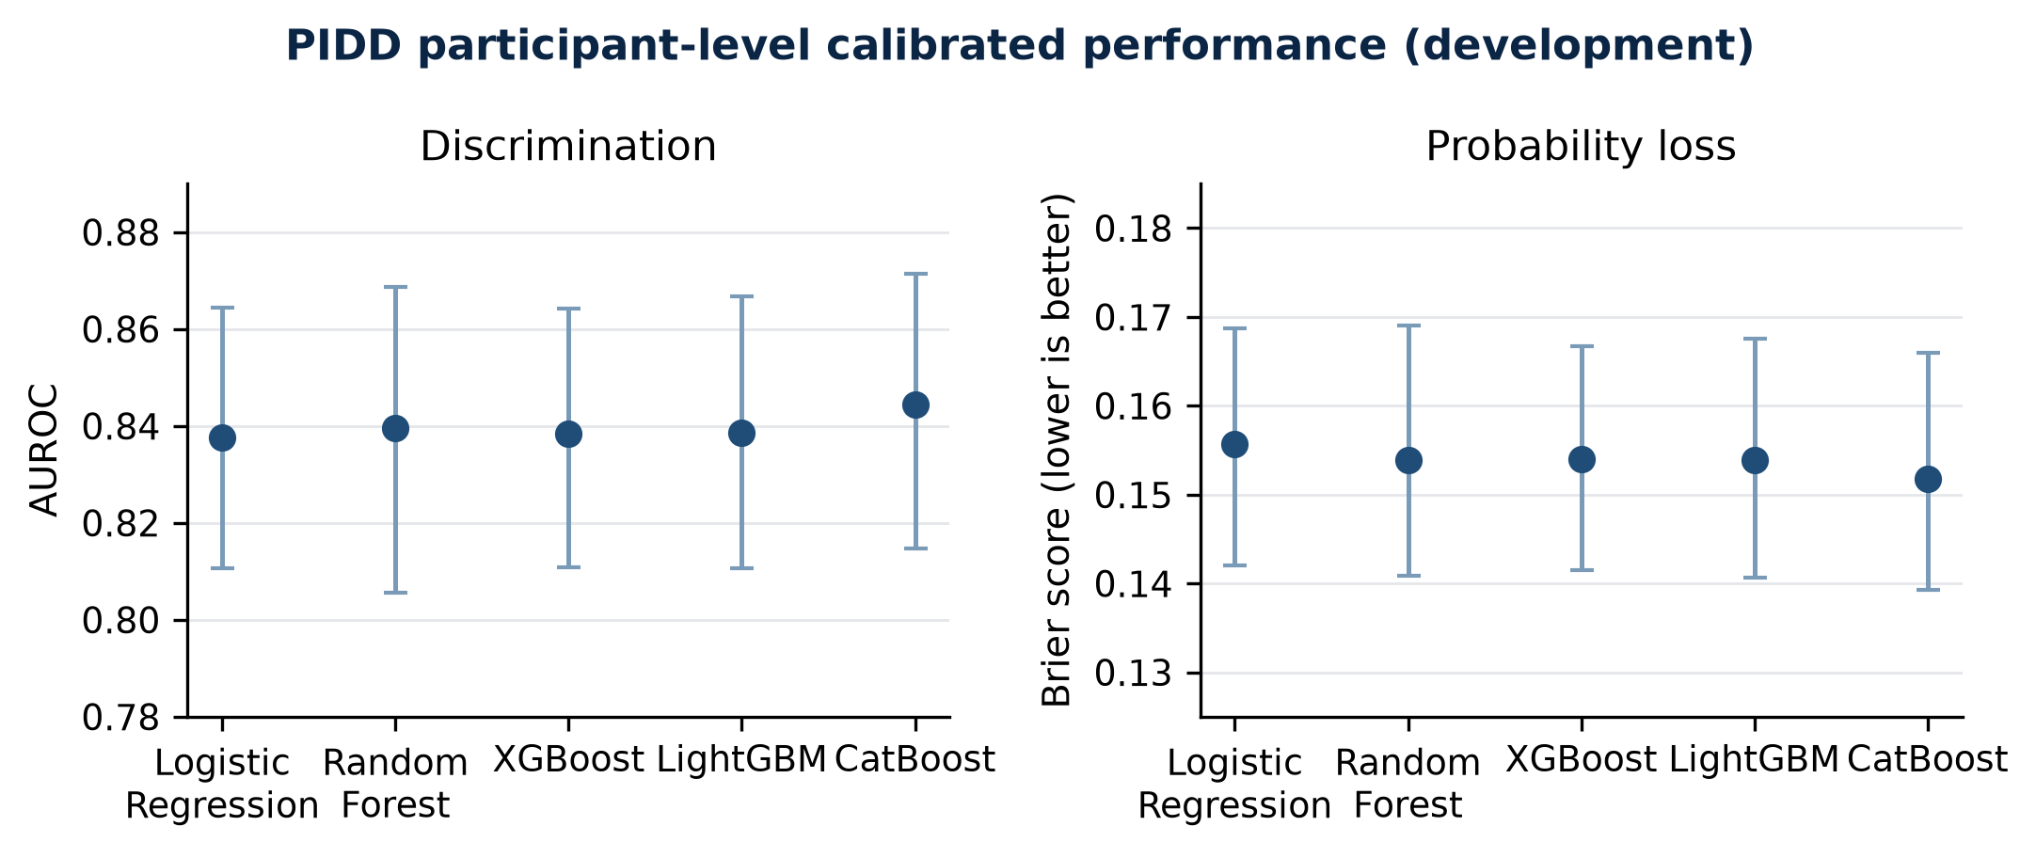
Figure 1. PIDD calibrated development performance across five model families. Error bars show 95% participant-bootstrap confidence intervals for participant-level estimates.

3.2 Feature availability and routing
At participant level, the full-panel availability router achieved AUROC 0.843, average precision 0.706, Brier 0.152, and log loss 0.464. The robust fixed-model baseline achieved AUROC 0.843, average precision 0.709, Brier 0.152, and log loss 0.463. The practically sized core-metabolic router achieved AUROC 0.839 and Brier 0.154; the two-feature glucose-plus-age router achieved AUROC 0.809 and Brier 0.166; the non-laboratory router achieved AUROC 0.756 and Brier 0.186.
Matched full-versus-reduced contrasts were estimated within model family on the same participants. None of the 80 metric-panel-model comparisons had a Holm-adjusted p-value below 0.05. The smallest adjusted value was approximately 0.080 for CatBoost AUROC degradation on the glucose-plus-age panel. This is evidence of limited precision and multiplicity, not evidence of equivalence.
Separately training Random Forest and XGBoost for each reduced panel rather than masking unavailable inputs in a full-panel model produced several nominal improvements, including a 0.009 AUROC gain for XGBoost on glucose-plus-age and a 0.034 average-precision gain for Random Forest on the non-laboratory panel. However, none of the 40 paired comparisons survived Holm correction; the minimum adjusted p-value was 0.120. Panel-specific fitting is therefore not supported as a superiority claim.

3.3 Selective prediction and subgroup coverage
For the full-panel router, lowering coverage from 100% to 70% improved Brier score from 0.152 to 0.110 and AUROC from 0.843 to 0.882. However, only 149 of 268 positive events were retained (55.6%), compared with 389 of 500 negative cases (77.8%). The apparent performance improvement therefore came with asymmetric case retention and cannot be presented without event coverage.
Age-group analysis showed heterogeneous acceptance at 70% overall coverage: 81.3% of participants younger than 30 were accepted, compared with 60.3% aged 30-44, 55.4% aged 45-59, and 50.0% aged 60 or older. The oldest group contained only 32 participants and was suppressed for performance estimation. These findings make probability certainty unsuitable as an unqualified clinical abstention rule.
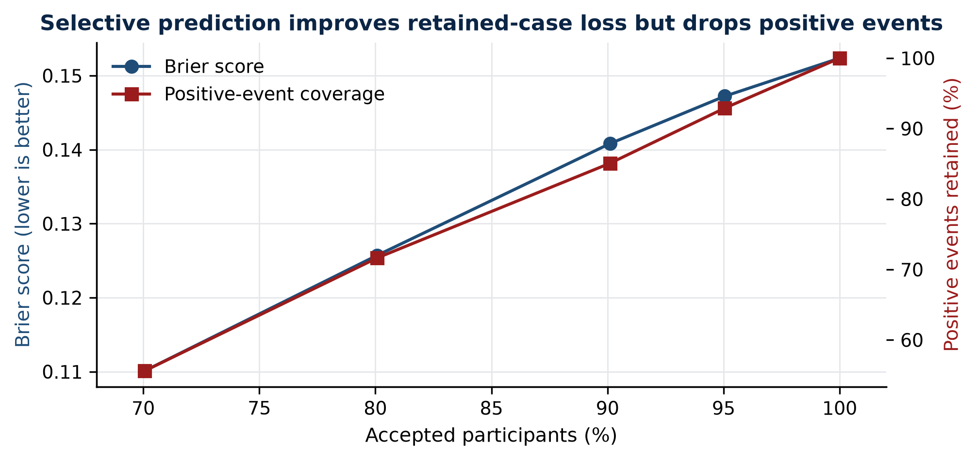
Figure 2. Full-panel PIDD availability-router probability loss and positive-event retention across selective-prediction coverage levels.

3.4 Missingness stress and explanations
Under 75% MCAR-like feature dropout, supported-panel coverage was 6.6%, Random Forest Brier score increased from 0.156 to 0.208, and XGBoost Brier score increased from 0.157 to 0.210. Under 75% structured-block dropout, supported-panel coverage fell to 4.8%, with Brier scores of 0.208 and 0.211, respectively. The results support fail-closed applicability checks rather than unconditional prediction under arbitrary missingness.
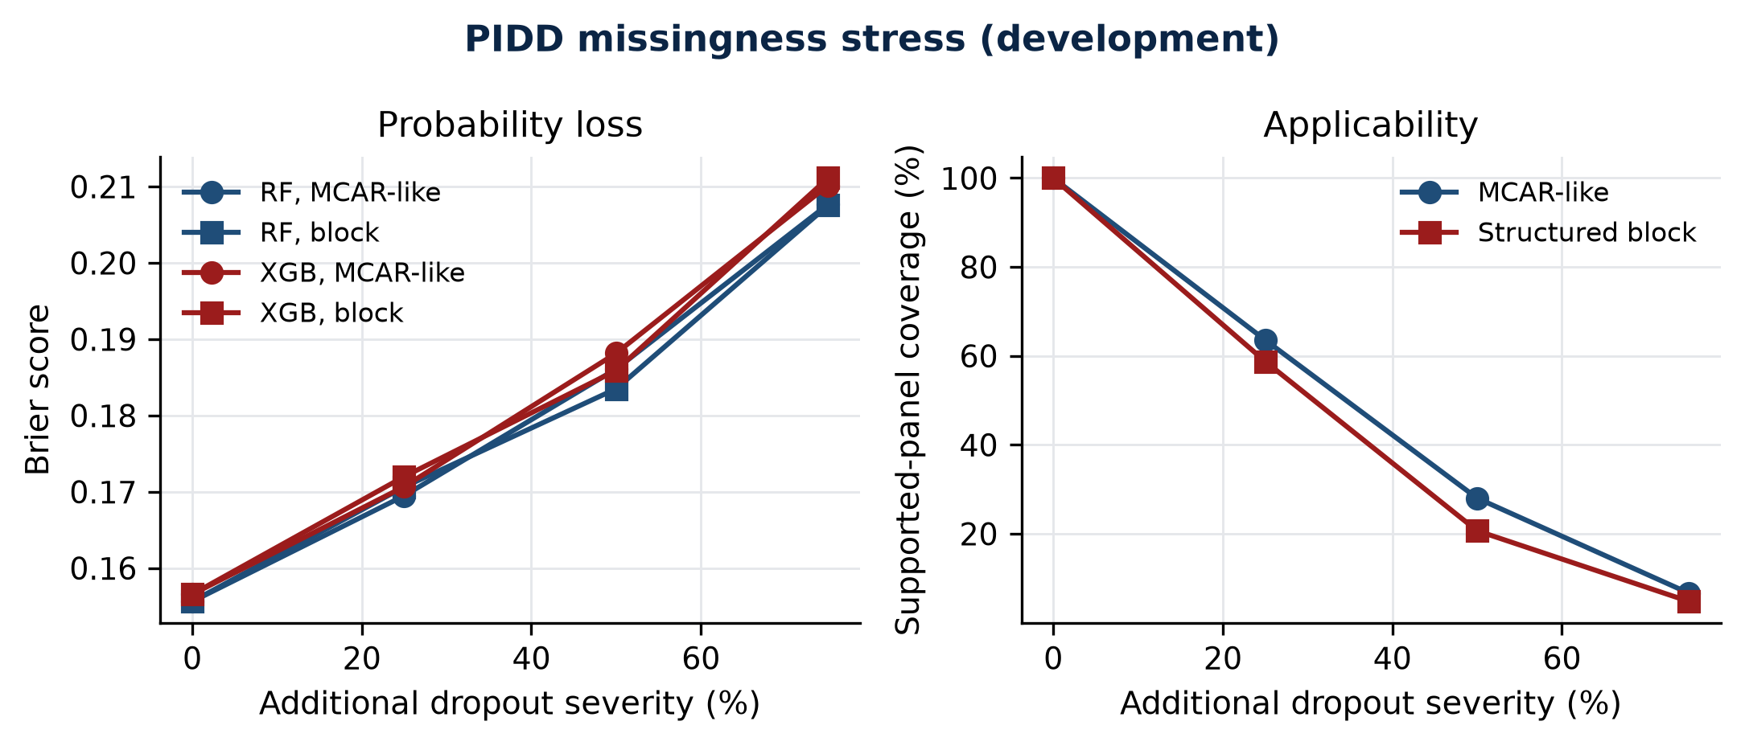
Figure 3. PIDD probability loss and supported-panel coverage under simulated feature dropout. Points summarize five-replicate stress evidence; mechanisms are sensitivity analyses rather than real-world MNAR validation.
Held-out SHAP artifacts were produced for every completed model-fold and grouped to original features. The reporting ablation retains original-feature grouping as primary because it avoids splitting clinical concepts into preprocessing and missing-indicator fragments.
In the full 25-fold retraining ablation, enabling missingness indicators did not produce a Holm-corrected improvement for Logistic Regression or Random Forest on AUROC, average precision, Brier score, or log loss; all adjusted p-values were at least 0.200. Indicator handling therefore remains an implementation choice, not a supported performance contribution.

3.5 Grouped Sylhet development results
The full-budget Sylhet study contained 25 outer evaluations for each model. Each participant's five held-out probabilities was averaged before primary metrics, and uncertainty resampled complete identical-profile clusters. CatBoost had the lowest participant-level Brier score (0.061) and highest AUROC (0.970), followed by Random Forest (Brier 0.067; AUROC 0.968). Participant-level calibration slopes were 1.01 and 1.13, respectively. High internal discrimination still does not establish transportability beyond this small symptom-enriched cohort.
Table 2. Sylhet calibrated participant-level development performance with identical-profile cluster inference
Model | AUROC | Average precision | Brier | Log loss | Calibration slope | ECE
CatBoost | 0.970 | 0.984 | 0.061 | 0.213 | 1.010 | 0.038
Random Forest | 0.968 | 0.981 | 0.067 | 0.226 | 1.126 | 0.034
XGBoost | 0.961 | 0.977 | 0.075 | 0.245 | 1.057 | 0.021
LightGBM | 0.961 | 0.978 | 0.072 | 0.245 | 0.931 | 0.029
Logistic Regression | 0.955 | 0.974 | 0.081 | 0.262 | 0.989 | 0.024

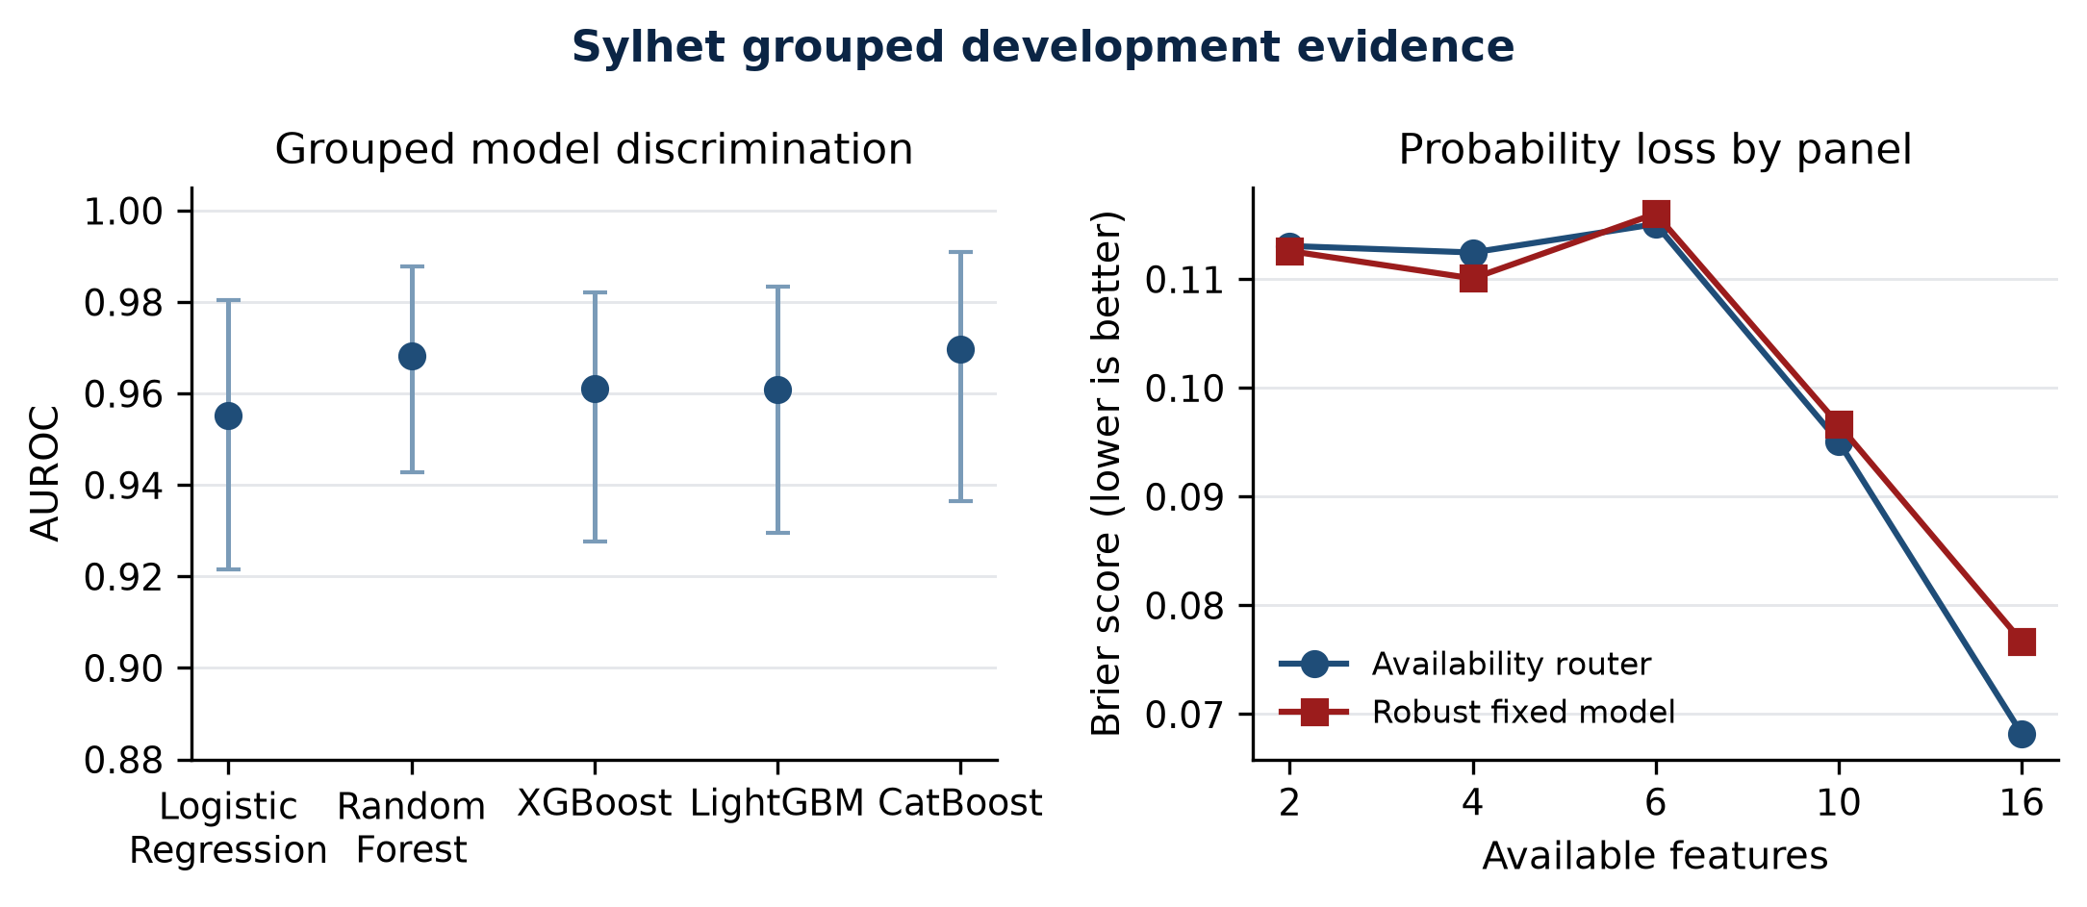
Figure 4. Sylhet participant-level model discrimination and panel-specific probability loss under grouped development validation. Intervals use identical- profile cluster resampling.
At participant level, the full-panel router achieved AUROC 0.965 and Brier 0.068, whereas the robust fixed model achieved AUROC 0.960 and Brier 0.077. The paired router-versus-fixed interval crossed no improvement after cluster resampling, and no routing ablation survived Holm correction. Reduced panels showed descriptive loss: the 10-feature core questionnaire router had AUROC 0.945 and Brier 0.095, while the two-feature polyuria-polydipsia router had AUROC 0.905 and Brier 0.113. None of 64 matched full-versus-reduced contrasts survived Holm correction; the minimum adjusted p-value was 0.064.
Separately tuned panel-specific Random Forest and XGBoost pipelines were also compared with masked full-panel inference across all four reduced panels and all 25 grouped outer splits. The analysis produced 41,600 held-out prediction rows and 32 participant-paired, profile-cluster-resampled metric contrasts. No contrast survived metric-wise Holm correction (minimum adjusted p=0.064). The largest descriptive Brier improvement was 0.006 for XGBoost on the 10-feature core questionnaire panel, with its interval crossing zero. Panel-specific training therefore remains an inconclusive engineering option rather than a supported superiority result.
The full missing-indicator retraining comparison likewise found no Holm-corrected benefit. Random Forest predictions were numerically equivalent with indicators on and off, while Logistic Regression differences were small and all adjusted p-values were 1.000. This is expected because the Sylhet questionnaire does not contain applicable numeric missingness for the indicator transformer.
At 70% selective coverage, the full-panel router Brier score improved from 0.062 to 0.025 while retaining 76.9% of positive events. Subgroup support remained a major caveat: the accepted female cell contained no negative events and was suppressed, as were the youngest and oldest age groups. Under 75% simulated dropout, supported-panel coverage fell to 4.0%-6.2% and Brier score rose to 0.278-0.289 across Random Forest and XGBoost.

3.6 Full BRFSS development results
The full BRFSS development study brfss_development_holdout_56407ef53bba used all 429,360 retained respondents: 343,488 for five-fold development tuning and cross-fitted selection and 85,872 in the pre-existing seed-42 development test role (11,451 positives; prevalence 13.3%). This partition had already been inspected and is permanently ineligible as a concealed final test. All model, calibration, threshold, and champion choices were locked from development data before test prediction.
Table 3. BRFSS calibrated full-development performance on the development test partition
Model | AUROC | Average precision | Brier | Log loss | Calibration slope | ECE
XGBoost | 0.843 | 0.444 | 0.0915 | 0.2958 | 1.008 | 0.0023
CatBoost | 0.843 | 0.442 | 0.0915 | 0.2958 | 1.008 | 0.0018
LightGBM | 0.843 | 0.443 | 0.0915 | 0.2960 | 1.016 | 0.0020
Random Forest | 0.840 | 0.437 | 0.0921 | 0.2981 | 0.997 | 0.0022
Logistic Regression | 0.833 | 0.404 | 0.0940 | 0.3031 | 0.976 | 0.0033

Development OOF Brier score selected LightGBM as champion (0.091391 versus 0.091395 for XGBoost and CatBoost). On the development test, XGBoost had the numerically lowest Brier score (0.091497; 95% interval 0.090817-0.092218), but the top-three pairwise Brier, log-loss, AUROC, and average-precision differences were not Holm-significant. The champion was not reselected using test outcomes.
The descriptive 0.5 threshold had high specificity (0.980-0.987) but low sensitivity (0.113-0.179). Development sensitivity-constrained thresholds near 0.14 achieved 0.802-0.814 sensitivity with 0.704-0.726 specificity. This large operating-point change reinforces that 0.5 is not an implied clinical cutoff.
The availability router selected LightGBM for the full 21-feature panel and XGBoost for each reduced panel using development cross-fitted Brier score. Test Brier score increased from 0.0915 for the full panel to 0.0924 for 12 routine survey features, 0.0927 for nine cardiometabolic/health features, 0.0945 for six health-status features, 0.1016 for five demographic/health features, and 0.1020 for general health plus age. These are development degradation estimates, not optimized deployment rules. All 80 same-participant, same-family reduced-panel contrasts had degradation intervals excluding zero, but none survived the metric-wise Holm family (minimum adjusted p=0.080); this resolution limit must not be rewritten as equivalence or as a corrected significance claim.
Certainty-based selective prediction was particularly unfavorable to positive cases. At 70% coverage, full-panel Brier score fell from 0.0915 to 0.0430, but only 2,859 of 11,451 positive events remained (25.0% event coverage), accepted prevalence fell to 4.8%, AUROC fell to 0.784, and average precision fell to 0.128. The improved retained-case loss primarily reflects rejection of higher- risk cases and does not support an unqualified abstention benefit.
All 30 prespecified age- and sex-stratified coverage cells met the minimum size and event counts. At the 70% target, observed acceptance ranged from 69.7% to 70.3% across the four age groups and two sex groups. Within-group positive-event retention nevertheless fell sharply, with accepted prevalences of 4.6%-4.8% and average precision of 0.125-0.133. The subgroup results therefore reinforce the case-mix warning; they do not establish population fairness.
The model-family ablation found that every tree family improved on Logistic Regression for AUROC, average precision, Brier score, and log loss after Holm correction (adjusted p=0.016 for the reported 500-replicate family). This is a development contrast, not a final superiority result. Selector-metric variants did not produce corrected differences, and the router-versus-robust-single-model family did not support a routing advantage. Calibration materially improved CatBoost probability loss because its raw scores required correction; LightGBM selected identity calibration and therefore showed no calibration change.
Held-out SHAP analysis explained 1,000 development-test respondents per model using a 100-row development background. General health, high blood pressure, age, BMI, and high cholesterol occupied the top five original-feature positions for four model families; CatBoost used the same set with a different order. Additive reconstruction error was at most 5.6e-6. These explanations describe model behavior and must not be interpreted as causal effects.
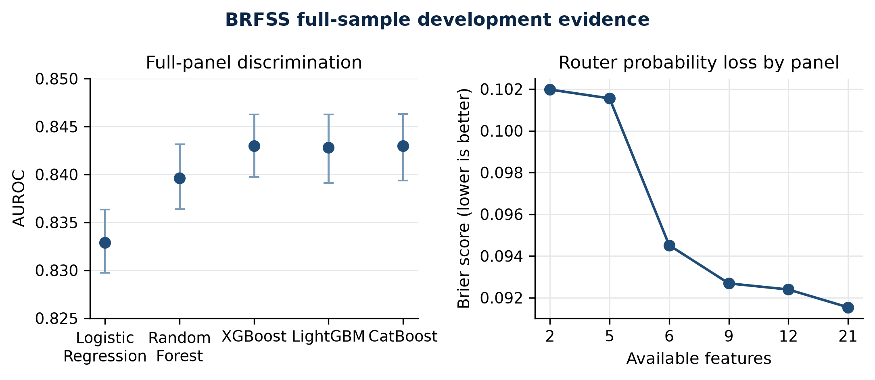
Figure 5. BRFSS model discrimination and router probability loss under the full-sample development protocol. AUROC intervals use 500 participant-bootstrap replicates.
Survey-weighted sensitivity analysis represented 53 reporting areas and 1,292 strata; the Kish effective sample size was 21,165.5. Weighted prevalence was 10.9% rather than 13.3%. Weighted XGBoost AUROC was 0.871 (95% PSU-bootstrap interval 0.864-0.877) and Brier score was 0.0752 (0.0730-0.0778). These estimates are secondary sensitivity analyses because the random respondent holdout was not designed as an official survey-analysis partition.
Historical 10,000-row BRFSS smoke studies remain engineering evidence. A future final estimate still requires a different prespecified concealed manifest and one authorized execution after protocol freeze.

3.7 Separate Hospital130 readmission development analysis
Hospital130 remains outside the diabetes-screening result family because its endpoint is readmission within 30 days. After excluding death and hospice dispositions, 99,343 encounters from 69,990 patients remained (11,314 positive; 11.39% prevalence). Patient-grouped splitting assigned 79,475 encounters to five development folds and 19,868 encounters from 14,003 patients to the development test role, with no patient crossing the partitions or development folds.
Table 4. Hospital130 calibrated full-development performance on the patient-grouped development test partition
Model | AUROC | Average precision | Brier | Log loss | Calibration slope | ECE
LightGBM | 0.679 | 0.229 | 0.0958 | 0.3327 | 1.019 | 0.0066
XGBoost | 0.678 | 0.227 | 0.0959 | 0.3331 | 1.029 | 0.0053
CatBoost | 0.678 | 0.229 | 0.0959 | 0.3330 | 1.028 | 0.0070
Random Forest | 0.673 | 0.228 | 0.0960 | 0.3339 | 1.020 | 0.0047
Logistic Regression | 0.661 | 0.201 | 0.0971 | 0.3377 | 0.979 | 0.0070

Development OOF Brier score selected sigmoid-calibrated LightGBM. Its 95% patient-cluster intervals were 0.667-0.691 for AUROC, 0.213-0.245 for average precision, and 0.0918-0.0992 for Brier score. None of the four tree families differed from another after metric-wise Holm correction. Each tree family did improve over Logistic Regression across the four artifact-ablation metrics after correction; these are development comparisons, not final superiority claims.
The router retained LightGBM for the full 46-feature and nine-feature admission-clinical panels, and selected Random Forest for the nine-feature encounter-utilization, five-feature prior-utilization, and two-feature minimal-history panels. Full-panel Brier was 0.0958; reduced-panel Brier ranged from 0.0982 to 0.0994. At 80% full-panel selective coverage, accepted prevalence fell to 7.62% while rejected prevalence rose to 26.45%, demonstrating substantial case-mix shift. Prespecified age, sex, and race estimates were generated, with small cells suppressed. Held-out SHAP for the selected LightGBM model ranked prior inpatient encounters and discharge disposition highest; maximum additive reconstruction error was 1.2e-14. These findings describe internal development behavior and do not establish clinical utility or external validity.

4. Discussion
The development study changes the likely paper narrative. The strongest result is not algorithm superiority: five model families produced very similar PIDD probability performance, and the availability router was nearly indistinguishable from a robust fixed model on the full panel. The contribution is instead an evaluation framework that quantifies what is lost under specific availability patterns and refuses unsupported prediction.
The reduced-panel results are clinically interpretable. Core metabolic features retained most full-panel performance, whereas a non-laboratory panel and an extreme two-feature panel showed larger losses. Yet multiplicity-adjusted matched comparisons were imprecise in this small dataset. The correct conclusion is that panel degradation can be measured and may be operationally modest for selected panels, not that the panels are statistically equivalent.
Selective prediction illustrates why coverage must accompany accuracy. A simple probability-certainty rule produced better retained-case metrics but discarded a large fraction of positive cases and accepted age groups at different rates. Likewise, missingness stress showed rapid collapse in supported-panel coverage at high severity. A safe system needs an applicability layer and explicit abstention reason, not only a calibrated score.
The full BRFSS study adds precision but does not change the negative algorithm- superiority narrative: the three boosted-tree models were practically indistinguishable at reported precision, and the development-selected champion was not the numerical test leader on every metric. Survey weighting materially changed prevalence and performance, so population-weighted sensitivity results must remain separate from sample-conditional estimates.
The separate Hospital130 analysis reached a similar methodological conclusion: tree-family performance was close, reduced panels degraded probability quality, and certainty-based deferral preferentially rejected higher-risk encounters. It supports the pipeline's endpoint and applicability safeguards, not a diabetes- status claim and not a clinically validated readmission tool.
The study has important limitations. All primary datasets are public and mostly cross-sectional; they do not measure future incidence or age of onset. PIDD and Sylhet are small, and public benchmark reuse limits transportability. BRFSS uses self-reported status and requires careful survey-design interpretation. The current selective score is a baseline rather than an optimized clinical deferral policy. Hospital130 is retrospective, lacks external or temporal validation, and its development-test outcomes have been inspected. No matched cohort contains all PIDD, Sylhet, and BRFSS attributes for the same individuals, so mixed-input routing is not efficacy-validated fusion. External or temporal validation remains necessary for clinical-generalization claims.

5. Conclusion
An availability-aware, calibrated diabetes-screening pipeline can provide traceable within-environment probabilities from prespecified feature panels and abstain when no evaluated route is supported. In PIDD development evidence, the router did not materially outperform a robust fixed model, while reduced panels, selective acceptance, and simulated missingness changed both probability quality and population coverage. The conference contribution should therefore be framed around reliability under incomplete inputs, endpoint safety, survey-estimand transparency, and negative findings. The full BRFSS study remains development evidence because its seed-42 test role was already inspected. Locked evaluation on a genuinely new concealed manifest and independent review are required before submission.

Declarations
Ethics: The study uses de-identified public datasets; dataset-specific terms and institutional requirements must be confirmed by the authors before submission. Funding: To be completed by the authors. Conflicts of interest: To be completed by the authors. Data and code availability: Repository URL, release tag, and archived DOI to be inserted after protocol freeze and artifact review. Author contributions: To be completed using the venue's required taxonomy.

References requiring final bibliographic formatting
- TRIPOD+AI statement. BMJ. 2024;385:e078378.
- PROBAST+AI. BMJ. 2025;388:e082505.
- Evaluation of clinical prediction models, part 2. BMJ. 2024;384:e074820.
- Vickers AJ, Elkin EB. Decision curve analysis. Med Decis Making. 2006.
- UCI Machine Learning Repository. Early Stage Diabetes Risk Prediction dataset.
- Handling missing predictor values when validating and applying a prediction model. BMC Med Res Methodol. 2020.
- Missing data and prediction: the pattern submodel. Biostat Epidemiol. 2021.
- Real-time imputation of missing predictor values in clinical practice. J Clin Epidemiol. 2022.
- Building type 2 diabetes prediction models using the 2014 BRFSS. Prev Chronic Dis. 2019.
- Original PIDD/ADAP study and dataset provenance record.
The reference list is a development placeholder. Titles, authors, volume, pages, DOI, and venue style must be verified against full text before submission.

