(Edit post)

This version is the latest upgrade from the date 16/12/2016. V2.0.1

Chip LCD st7565 sized screen 128x64 pixels, type is lcd graphic multi-use for many projects.

In our country the purchase of new lcd is quite difficult due to not being unpopular, the reason for this is perhaps due to the lack of documentation and tutorials related.

Modern lcd of this type can only dabble from the phone homephone or buy old ..

If you are in arm this lcd, then the article below will help you to use it with arduino.

A: PREPARE

1. 1 arduino chip atm328 back up, here I select arduino uno r3
2. 1 lcd screen homephone st7565 10 feet, is you also can buy old it on the website sales.
3. Ic cascaded relay (low voltage) 4050 bridge to communicate the arduino with the lcd.
4. If there is no ic, you need to have 5 resistors 10k and 5 resistors of 4.7 k;
5. And the utensils needed for assembly circuit: wire, welding machine,...

B: FIND OUT YET VIA

The same comparison with lcd type are popular most KS0108

|  |  |
| --- | --- |
| Ks0108-128x64 | St7565-128x64 |
| Pair 2 ic ks0108,  Have 2x512=1024 bytes ram for 2 ic, used to store pixel data. Can read and write data. | Ic controller st7565  No memory left( only shows up only);  Just write. Must take 1024 bytes ram from arduino to do caching. |
| Compatible with the arduio his early life. | Arduino chip atm328 above |
| 18 pin (1 pin, contrast, 3 pin controller, 8 pin data in parallel, 2 pin chip-select 2 pin power, 1 battery reset, 1 battery Vee) | 7 pin ( 2 pin power 5 pin communication Spi) |
| Power supply: 5v  voltage logic levels: 0-5v | voltage source: a 3.5v  voltage logic levels: 0-3,3 v |
|  |  |
|  |  |

Focus article is to share the source code, let's learn more about lcd this at the site below:

<http://www.ladyada.net/learn/lcd/st7565.html>

<http://edeca.net/wp/electronics/the-st7565-display-controller/>

C: CONNECT

Connect SPI shortened (4 wire) use resistor bridge stools pressure, attention jointed legs shortened CS (Chip Select) at the sound source GND okay.

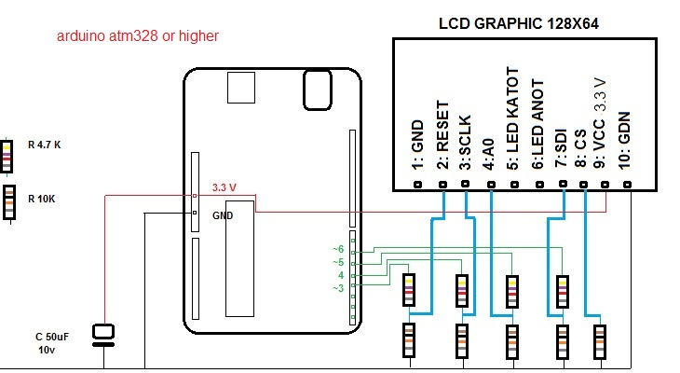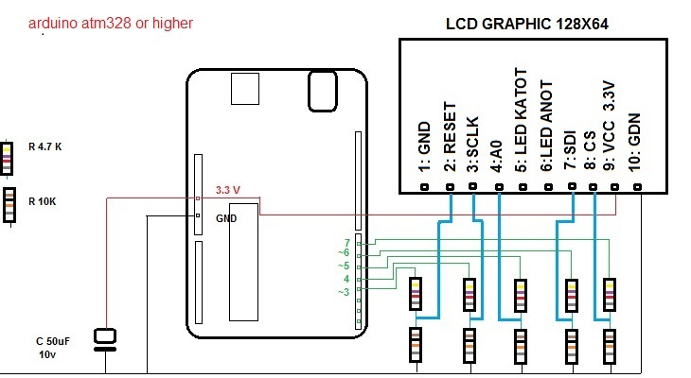

Connect SPI full:

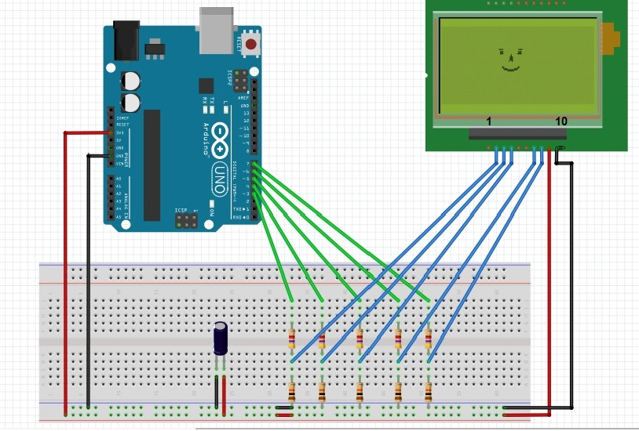

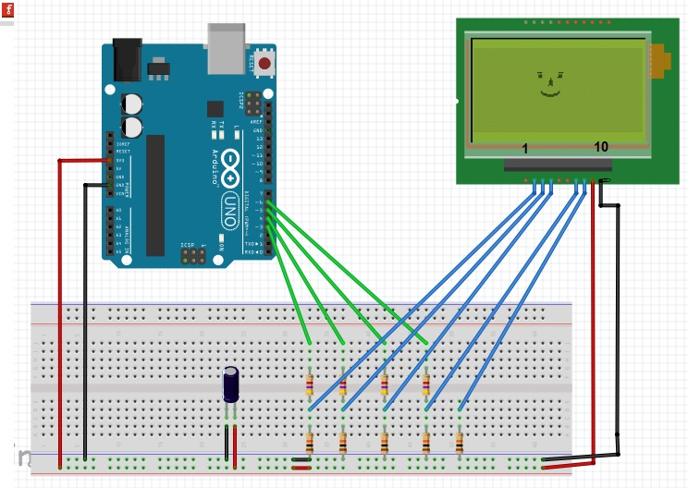

If user ic4050, then you pay attention connector with the correct polarity and source for ic, voltage source for ic 4050 is 5v

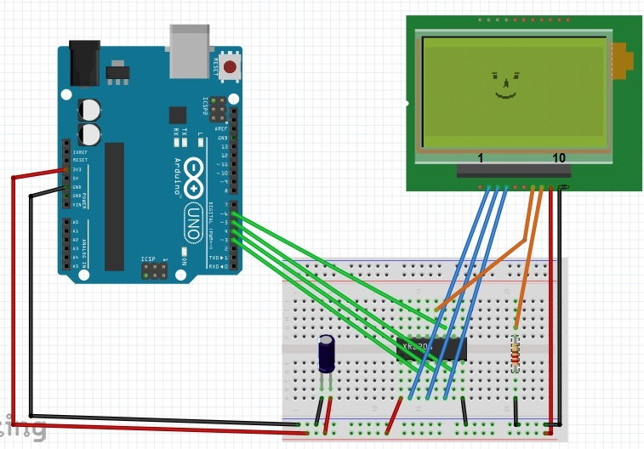

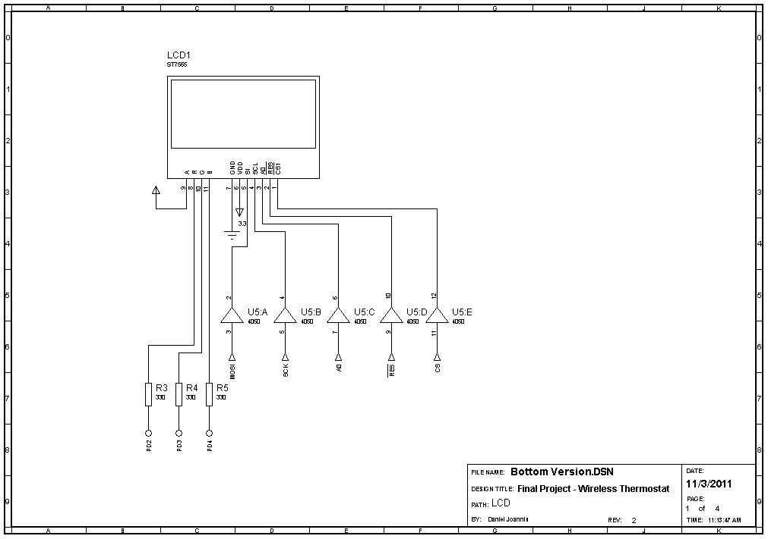

C:THE CONVENTION TO REMEMBER

1:Pixel as pixel-the smallest components of “photo”.

2:Size size screen is the total number of pixels that the screen can display.

3: width write, height following article (vd:128x64, 320x240..).

4: quadrants mode : truc horizontal (x), vertical axis (y),

5:the Original coordinates is the point with coordinates (0,0) is located in the top left corner of the screen.

6: the size of the image( rectangle) key is the number of pixel of the image.

7:Coordinates of squares, rectangles are the coordinates of the vertex located at the top left corner of that picture

8:Located in the circle is precisely the coordinates of the

9:Angle of rotation in the direction of the coordinate system Decac have way counter-clockwise

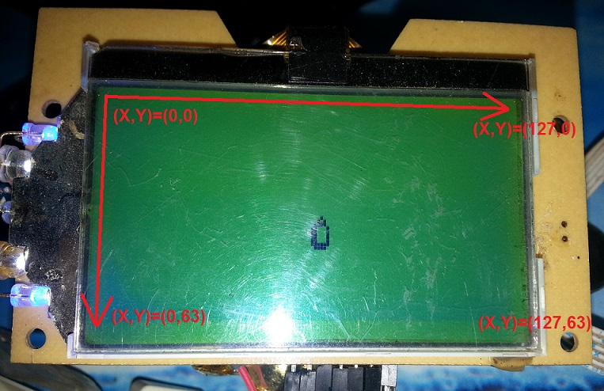

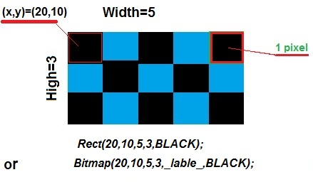

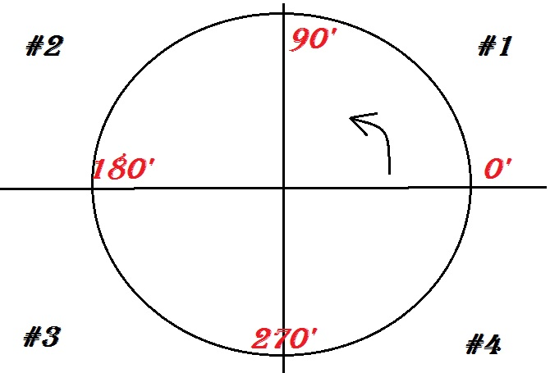

D: USE THE FUNCTION

After the connection complete and successful installation, two letter hospital , the same open IDE and test it!

: Structure declaration letter hospital

<

#include "ST7565_homephone.h"//a

ST7565 lcd(3,4,5,6);//b

void setup() {

lcd.ON();//c

lcd.SET(22,0,0,0,4); //d

}

void loop(){

} >

Because this is the procedure you must perform enough 4 manipulation:

a : Add library

b : set pin connector

c: Turn on the screen

d : Installation configuration interface

In step b:

|  |  |  |
| --- | --- | --- |
| Pin | order pin | Pin corresponds want to use |
| Using 4 pin | lcd( RST, SCLK, A0, SID) | lcd(3,4,5,6); |
| Taking 5 pin | lcd( RST, SCLK, A0, SID,CS) | lcd(3,4,5,6,7); |

1:**void ON();**

Call this function only once to turn on the screen.

2: **void SET(byte contrast, bool negative, bool rotation, bool mirror, byte tyledientro);**

Settings interface. This function can be called multiple times with the other parameters.

* contrast - contrast - value from 0->63 (0x00 become at 0x3f)

* negative- showing negative - value-0 or 1

* rotation- reverse the screen - the value 0 or 1

* mirror - show mirror - the value 0 or 1

* tyledientro- by R1/R2 - set voltage operation - 0->6( 0x0 to 0x6)

<//Write A screen

#include "ST7565_homephone.h"

ST7565 lcd(3,4,5,6);

void setup() {

lcd.ON();

lcd.SET(22,0,0,0,4);

}

void loop(){

lcd.Asc_Char(60,30,'A',BLACK);

lcd.Display();

}

>

3:

Boolean color: only accept 3 types of following BLACK (1), WHITE(0),DELETE(0),

void Display();: is a function that allows the screen showing what had been drawing

void Clear(); : delete all of the screen

// from here I will not write the configuration settings again. you can keep the default configuration in the example above, we will change the function loop

<

void loop(){

lcd.Rect( 60,30,20,20,BLACK);// draw hcn A black

lcd.Display();

delay(1000);

lcd.Rect( 60,30,20,20,DELETE);// delete hcn A

lcd.Display();

delay(1000);

lcd.Rect( 40,30,20,20,BLACK);// draw hcn B black

lcd.Display();

delay(1000);

lcd.Rect( 40,30,20,20,WHITE);//draw hcn B color white

lcd.Display();

delay(1000);

lcd.Clear();// clear the entire screen

}

>

4: void DrawPixel(int x,int y, bool color);

// draw 1 point with coordinates x,y

<

void loop(){

lcd.DrawPixel(60,30,BLACK);//draw the point with coordinates (60,30)

lcd.Display();

}

>

5: bool GetPixel( int x, int y);

// test function points in the coordinates x,y can be plotted( car ) or not

//returns 1 ( true) if true, otherwise it returns false

6: void DrawLine(int x0,int y0,int x1,int y1, bool color);

// draw the line

// x0,y0: coordinates of the first point

// x1,y1: coordinates of points Monday

<

void loop(){

lcd.DrawLine(0,0,60,30,BLACK);

lcd.Display();

}

>

7:void Rect(int x,int y, int w, int h, bool color);

// draw the four rectangle

//x,y: coordinates of the top left corner on the same

//w,h: length of the horizontal axis and the vertical axis(size)

<

void loop(){

lcd.Rect(40,30,30,20,BLACK);

lcd.Display();

}

>

8: void FillRect(int x,int y, int w, int h, bool color);

//color rectangles

<

void loop(){

lcd.FillRect(40,30,40,20,BLACK);

lcd.Display();

}

>

9: void Corner( int x,int y, int w, int h,int r, bool color);

// rectangle with effect bo corner

// x,y: coordinates of the top left ,on the same

//w,h: width, height;

//r : radius of the circle rounded corners

<

void loop(){

lcd.Corner( 30,20,60,30,8,BLACK);

lcd.display();

}

>

10: void FillCorner( int x,int y,int w,int h, int r, bool color);

// draw hcn Corner coloring

<

void loop(){

lcd.FillCorner( 40,20, 40,30,5,BLACK);

lcd.Display();

}

>

11: void Tri (int x1,int y1,int x2,int y2,int x3,int y3, bool color);

//draw triangle has 3 vertices A(x1,y1) B(x2,y2), C(x3,y3)

<

void loop(){

lcd.Prophet(60,10,30,40,90,40,BLACK);

lcd.Display();

}

>

12: void FillTri(int x1,int y1,int x2,int y2 ,int x3,int y3, bool color);

// draw triangle coloring

<

void loop(){

lcd.FillTri( 30,20,90,40,60,10,BLACK);

lcd.Display();

}

>

13: void Circle(int x0,int y0,int r, bool color);

// x0,y0: coordinates of mind

// r: radius

<

void loop(){

lcd.Circle( 60,30,20,BLACK);

lcd.Display();

}

>

14: void FillCircle(int x0,int y0, int r, bool color);

// draw a circle coloring

<

void loop(){

lcd.FillCircle( 60,30,20,BLACK);

lcd.Display(); }

>

15: void Ellipse( int x, int y, int xRadius, int yRadius, bool color);

//draw ellipse

// x,y: center, ellipse

// xRadius,yRadius: radius of vertical axis and horizontal axis

<

void loop(){

lcd.Ellipse( 60,30,20,10,BLACK);

lcd.Display();

}

>

16: void FillElip(int x0, int y0 , int xRadius, int yRadius, bool color);

//draw ellipse color

// x0,y0: center, ellipse

// xRadius, yRadius: radius x and y axis

<

void loop(){

lcd.FillElip( 63,31, 50,20,BLACK);

lcd.Display();

}

>

17: void Asc_Char(int x1, int y1,unsigned char c, bool color);

//write 1 character in the ASCII table, the variable passed to the pass (unsigned char)

// x1,y1: coordinates of the cursor

///unsigned char domain is value (0->255);

<

void loop(){

//c1:

char text ='A';

text='A';

lcd.Asc_Char(10,10,text,BLACK);

lcd.Display();

//c2:

lcd.Asc_Char(20,10,'B',BLACK);

lcd.Display();

//c3:

lcd.Asc_Char(30,10,67,BLACK);

lcd.Display();

}

>

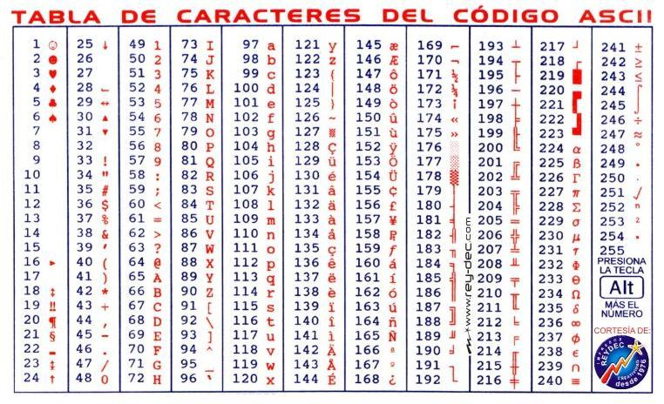

18: void Asc_String(int x1, int y1,unsigned char c[] , bool color);

//x1,y1: coordinates of the cursor of the first letter

// c: array of characters format string

<

void loop(){

//c1:

lcd.Asc_String(10,15,Asc(" Update 1"), BLACK);

//c2:

const static unsigned char text[] PROGMEM =" Cach 2";

lcd.Asc_String(10,35,text, BLACK);

lcd.display();

}

>

19: void Uni_Char(int x1, int y1, char16_t c, bool color);

//set the type UNIKEY in mode "unicode c string" , click "Close"and then type as usual, okay

// write 1 letter word Vietnamese

// x,y: coordinates pointer alignment

// char16_t : type char 16bit, enter the word standard Unicode encoding

// attention, money factor : u

<

void loop(){

//c1:

lcd.Uni_Char(63,10,u'A',BLACK);//A

//c2:

const static char16_t text=u'\x1ED8';//R,

lcd.Uni_Char(63,31,text,BLACK);

lcd.display();

}

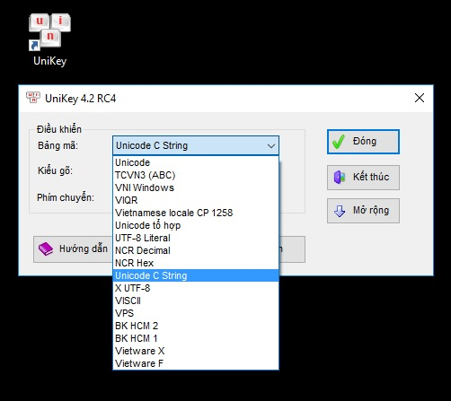>

20: void Uni_String(int x, int y, char16_t c[] , bool color);

// write 1 sequence word Vietnamese

// x,y: coordinates pointer alignment

// char16_t : type char 16bit, enter the word standard Unicode encoding

//PROGMEM: save the constants in Flash

// attention, money factor : u" "

<

void loop(){

//c1:

lcd.Uni_String( 30, 15,Uni( u"\x111\x1ECF"), BLACK);//red

//c2:

const static char16_t text[] PROGMEM =u"\x111\x65n";//black

lcd.Uni_String( 30, 35,text, BLACK);

lcd.Display();

}

>

**//All the ways to declare string on are saved to Flash, so you can tang length chain that does not need to worry about lack of Ram, rest assured, alright.**

21:

//void Number_Long(int x, int y,long a,byte select_font, bool color);

//void Number_Ulong(int x, int y,unsigned long a,byte select_font, bool color);

//void Number_Float(int x, int y, float a,byte n, byte select_font,bool color);

//write digits

//x,y :position the cursor

//a: parameters with variable type matching

// select_font: select font

//ASCII_NUMBER (or any number)

//CASIO_NUMBER (or number 1)

//STYLE_NUMBER (or number 2)

// n: Nmax=10 (the number of digits want to show after the period( only for type float))

<

int k=0;// int , long,...

byte l=0;// bytes, unsigned int, unsigned long,...

float m=0.123;

void loop(){

lcd.Number_Long(10,10,k,STYLE_NUMBER,BLACK);

lcd.Number_Ulong(10,28,l,CASIO_NUMBER,BLACK);

lcd.Number_Float(10, 50,m,3,ASCII_NUMBER,BLACK);

lcd.Display();

k++;

l++;

m++;

lcd.Clear();

}

>



22: void Bitmap(int x, int y, unsigned int w, unsigned int h,const uint8_t *bitmap , bool color);

// draw the image bitmap

//x,y: coordinates, w,h: size of the bitmap that

//*bitmap: address name of the file bitmap

<

#ifdef __AVR__

#include <avr/io.h>

#include <avr/pgmspace.h>

#endif

/** bitmap logo 16x 16

*/

const static unsigned char __attribute__ ((progmem)) logo16_glcd_bmp[]= {

0x30, 0xf0, 0xf0, 0xf0, 0xf0, 0x30, 0xf8, 0xbe, 0x9f, 0xff, 0xf8, 0xc0, 0xc0, 0xc0, 0x80, 0x00,

0x20, 0x3c, 0x3f, 0x3f, 0x1f, 0x19, 0x1f, 0x7b, 0xfb, 0xfe, 0xfe, 0x07, 0x07, 0x07, 0x03, 0x00, };

void loop(){

lcd.drawbitmap( 60,30,16,16,logo16_glcd_bmp,BLACK);

lcd.display();

}

>

23: void Plus_Bitmap(int x0, int y0, unsigned int w, unsigned int h,const uint8_t *bitmap , int goc, bool mirror, bool color);

// rotate the bitmap:

//x0,y0: coordinates, w,h: size of the bitmap that

//*bitmap: address name of the file bitmap

// goc: only accept 4 swivel angle: 0-90-180-270;

// mirror: MIRROR / NO_MIRROR or 1/0 or true/false...

24: int Keep_Angle(int goc);

// keep the angle is increased _luôn belongs to the range 0 -> 360

<

void setup() {

Serial.begin(9600); // open the monitor to see

}

void loop(){

int keep;

for( int goc=-720; goc<3600; goc++){

Serial.print( goc);

Serial.print("_");

keep=lcd.Keep_Angle(goc);// hold the corner

Serial.println( keep);

delay(10);

}

}>

25:

// void Find_XY_Ellipse(int x0, int y0, int a, int b,int goc_alpha) ;

//FIND THE SET OF POINTS WHOSE ORBITS BELONGING TO THE ELLIPSE

//int X_Ellipse();

//int Y_Ellipse();

// RETURNS THE COORDINATES (X,Y) OF THE POINTS BELONGING TO THE ELLIPSE

// goc_alpha: angle ( degrees) created by that point with the horizontal axis ( see illustration right);

// slight angle alpha min=-32768, alpha max=32767

<

void loop(){

byte x,y;

byte x0=60, y0=30, a=30,b=20;

for( int sm=0; sm<360; goc++){

lcd.Find_XY_Elip(x0,y0,a,b,goc);

x=lcd.X_Ellipse();

y=lcd.Y_Ellipse();

lcd.DrawPixel( x,y,BLACK);

lcd.Display();

delay(100);

}

lcd.Clear();

}

>

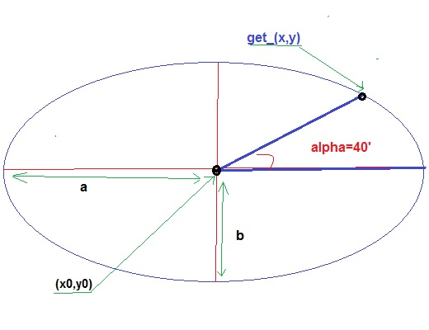

26:

// void Find_XY_Sphere(int x0, int y0, int a, int b, int goc_alpha, int goc_beta);

//int X_Sphere();

///int Y_Sphere();

// find the coordinates of point A(x,y) have the calls is a global

// horizontal plane through the center cut half-sphere is 1 ellipse whose center x0,y0, radius a,b

//on a horizontal surface, image, perpendicular projection of the point A is A' dead-axis angle alpha

//on a vertical surface through the center contains A corner case by points A and A' is the angle beta

// alpha : 0->360 (min -32768 ->32767)

// beta: 0->360 (min -32768 -> 32767);

<

void loop(){

byte x0=63,y0=31,a=40,b=10;

byte x,y;

for(int beta=0; beta<360; beta+=10){

for( int alpha=0; alpha<360; alpha++){

lcd.Find_XY_Sphere(x0,y0,a,b,alpha,beta);

x=lcd.X_Sphere();

y=lcd.Y_Sphere();

lcd.DrawPixel( x,y,BLACK);

lcd.Display();

}

}

}

>

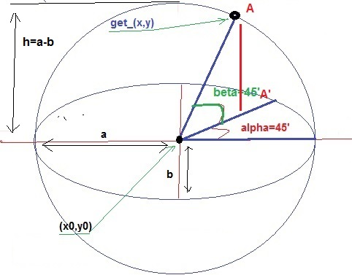

27: void AllPixel( byte color);

// pressed displays the entire pixel

< void loop(){

lcd.AllPixel(BLACK);

lcd.display();

}

>

26:

// mail library that supports macro extension, you can function declaration under 2 type the following:

/*

allpixel AllPixel

drawline DrawLine

drawpixel DrawPixel

getpixel GetPixel

fillcircle FillCircle

circle Circle

corner Corner

fillcorner FillCorner

rect Rect

fillrect FillRect

tri Tri

filltri FillTri

elliptic Elliptic

fillelip FillElip

bitmap Bitmap

plus_bitmap Plus_Bitmap

asc_char Asc_Char

asc_string Asc_String

uni_char Uni_Char

uni_string Uni_String

runstatus RunStatus

number_long Number_Long

number_ulong Number_Ulong

number_float Number_Float

keep_angle Keep_Angle

find_xy_elip Find_XY_Elip

x_elip X_Elip

y_elip Y_Elip

find_xy_sphere Find_XY_Sphere

x_sphere X_Sphere

y_sphere Y_Sphere

analog Analog

pullup_4 Pullup_4

clear Clear

display Display

asc Asc

uni Uni

*/

<

void loop() {

lcd.Circle(30,30,20,BLACK);

lcd.circle(90,30,20,BLACK);

lcd.display();

}>

27: byte Pullup_4(byte right_pin, byte up_pin, byte left_pin, byte down_pin);

//the function has the function returns the index of the corresponding buttons when they are pressed

//=0 if no buttons are pressed

//=1 right

//=2 up

//=3 left

//=4 down

//1*2=20 right and up

//1*3=30 right and left

//1*4=40 right and down

//2*3=60 up and left

//2*4=80 up and down

//3*4=120 left and down

/*

* calculated according to the length of the 4 quadrants

_______[2]

___[3]_____[1]

_______[4]

*/

< // code full

#include "ST7565_homephone.h"

ST7565 lcd(3,4,5,6);

//footer settings input is 4 feet analog

//note: 4 buttons connected in the mode PULL-Up ( find out how to connect before continuing);

#define right_b A3

#define up_b A2

#define left_b A1

#define down_b A0

void setup() {

Serial.begin(9600);

lcd.SET(23,0,0,0,4);

pinMode(left_b,INPUT_PULLUP);

pinMode(down_b,INPUT_PULLUP);

pinMode(right_b,INPUT_PULLUP);

pinMode(up_b,INPUT_PULLUP);

}

void loop(){

byte value;

value=lcd.Pullup_4(right_b, up_b, left_b, down_b);

Serial.println(value);// open the monitor window to see

}

>

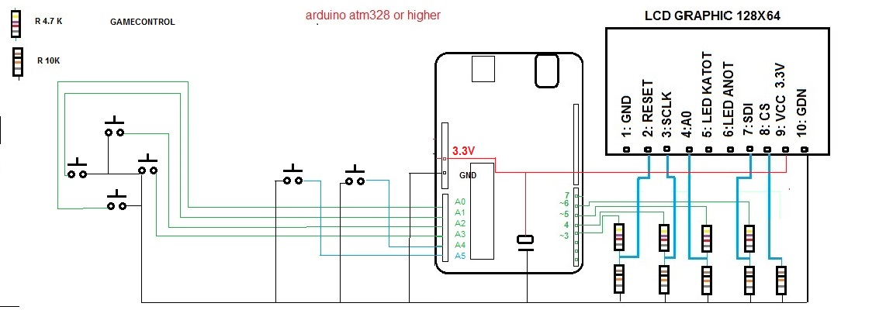

15/12/2016 support to change font sizes.Great owl.

* void Asc_Char(int16_t x1, int16_t y1,unsigned char c PROGMEM byte he_so_phong_to, bool color);
* void Asc_String(int16_t x1, int16_t y1,PGM_CHAR s , byte he_so_phong_to, bool color);
* void Uni_Char(int16_t x1, int16_t y1, char16_t c, byte he_so_phong_to, bool color);
* void Uni_String(int16_t x1, int16_t y1,PGM_CHAR16T s , byte he_so_phong_to, bool color);
* void Number_Long(int16_t x, int16_t y,long a,byte select_font, byte he_so_phong_to, bool color);
* void Number_Ulong(int16_t x, int16_t y,unsigned long a,byte select_font, byte he_so_phong_to, bool color);
* void Number_Float(int16_t x, int16_t y, float a,byte n, byte select_font, byte he_so_phong_to, bool color);

<

#include "ST7565_homephone.h"

ST7565 lcd(3,4,5,6);

void setup() {

lcd.ON();

lcd.SET(23,0,0,0,4);

}

void loop(){

lcd.Asc_Char(10,10,'A',2,BLACK);

lcd.Asc_Char(22,10,'B',3,BLACK);

lcd.Asc_Char(40,10,'C',4, BLACK);

lcd.Asc_Char(67,10,'D',5, BLACK);

lcd.Asc_Char(96,10,'E',6, BLACK);

lcd.Display();

}

>

A few photos

: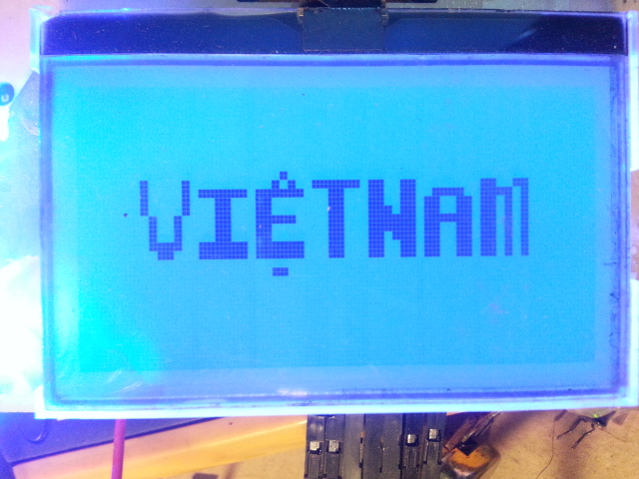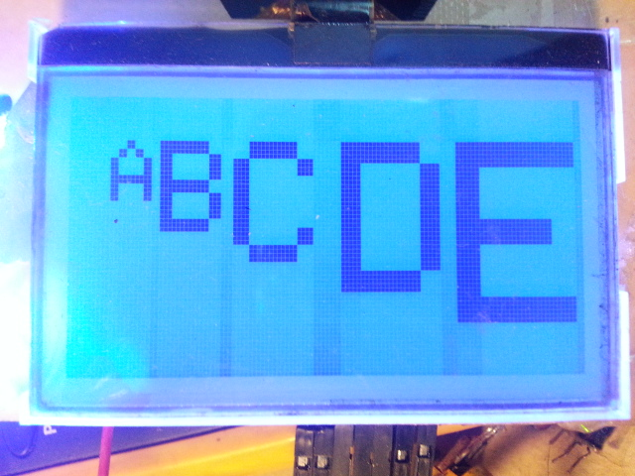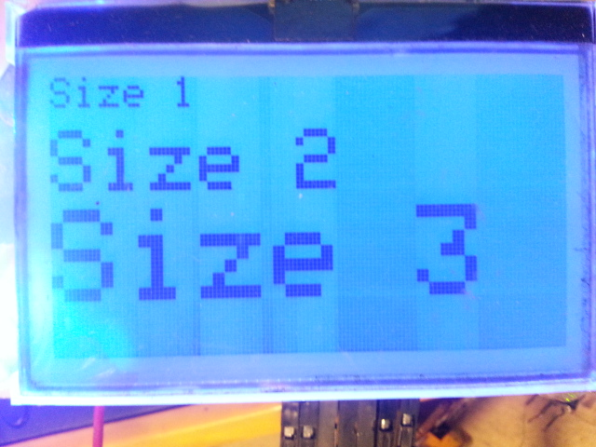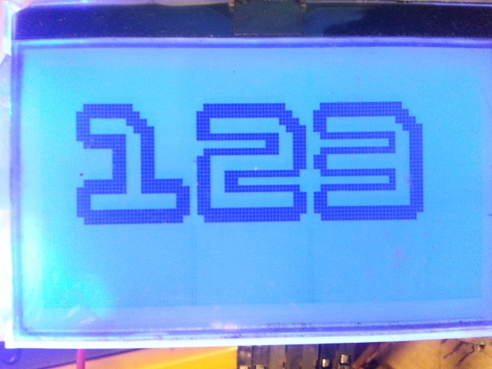

Vwith a zoom factor greater than or equal to 1.

E: Download letter hospital

Describei and add in the inventory letter hospital 2 following file:

1: avr.zip (letter library support)

2: st7565_homephone.zip (letter hospital main)

Video tutorial.

Video trailer.

(Paint.)