Project Management Plan

| Project Sponsor | Donon Y. |
| --- | --- |
| Project Manager | Rodin I. |
| Author | Gordeev P. |
| Classification | Not classified |
| Status | approved |
|  |  |

List of Changes

| Date | Version | Changes | Author |
| --- | --- | --- | --- |
| 29.03.2019 | 1.1 | Init | Gordeev P. |
|  |  |  |  |
|  |  |  |  |

List of Contents

1. Project Description 3
2. Scenario with Phases and Milestones 3
3. Organization 3
4. Structural Plan of Project Outcomes 4
5. Scenario with Project Breakdown Structure 4
   1. Phases, Modules, Tasks, Outcomes, and Roles 4
   2. Interdependencies 5
6. Test Plan 5
7. Schedule 6
8. Cost Projection 6
9. Resource Projection 6
10. Procurement Plan 7
11. Communication Plan 7
12. Reporting 7
13. Requirements, Methods, and Tools 7
14. Appendix 8
    1. Quality Assurance 8
    2. Risk Management 8
    3. Document Management 9
       1. Document Storage 9
       2. Naming Conventions 9
       3. Document Versions 10
    4. Change Management 10

# Project Description

It would be 3D graphics renderer, that transforms .obj files to flat png pictures.

# Scenario with Phases and Milestones

Initiation

Concept

Implementation

Deployment

Project initiation order

27.03.19

Project init

01.04.19

Phase release

05.04.19

Phase release

19.04.19

Project release

28.04.19

Launching operation

25.04.19

# Organization

| Role in the Project Organization | Name | Ref. | Function/Organizational Unit |
| --- | --- | --- | --- |
| *Project Sponsor* | *Donon Yann* |  | *Head of money Department* |
| *Steering committee* | Pashina Tatiana | Connect with PS |  |
| *Project Manager* | Rodin Ilya | Connect with PS |  |
| *ISDP manager* | Posokha Kirill |  |  |
| *Specialist: User representative* | Zdornov Maxim |  |  |
| *Specialist: Business process owner* | Posokha Kirill | Connect with PS |  |
| Quality and Risk Manager | Pashina Tatiana | Connect with PS |  |
| Sub-Project Manager | Rodin Ilya |  |  |
| Project Support | Rodin Ilya |  |  |
| Member of Technical Advisory Committee | Zdornov Maxim |  |  |
| Product Owner | Posokha Kirill | Connect with PS |  |
| Operations Manager | Pashina Tatiana |  |  |
| Business Analyst | Gordeev Pavel | Connect with PS |  |
| Developer | Gordeev Pavel |  |  |
| IT Architect | Posokha Kirill |  |  |
| Test Manager | Zdornov Maxim |  |  |
| Tester | Zdornov Maxim |  |  |

# Structural Plan of Project Outcomes

Mindmap, hierarchical illustration

The structural plan of project outcomes is a hierarchically structured illustration of the project content (product breakdown structure).

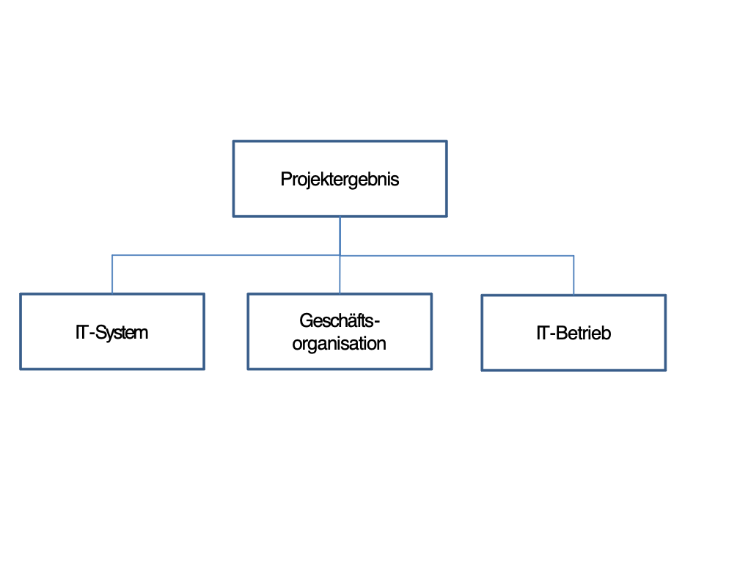

# Scenario with Project Breakdown Structure

## Phases, Modules, Tasks, Outcomes, and Roles

Project breakdown structure (HERMES Online) or reference to separate document

## Interdependencies

|  |  |
| --- | --- |
| Phase / module / task / outcome | Responsible |
| INITIATION |  |
| PROJECT STEERING |  |
| Commission and Steer the Initiation | Project Sponsor |
| Project Initiation Order | Project Manager |
| Decide on Project Release | Project Sponsor |
| Checklist | Project Manager |
| Project Charter | Project Manager, Business Process Owner |
| Project Decision Steering | Project anager, Steering Committee Member |
| PROJECT MANAGEMENT |  |
| Manage and Control Initiation | Project Manager |
| Work Order | Project Manager |
| Project Status Report | Project Manager |
| Minutes | Project Manager |
| Stakeholder List | Project Sponsor, Business Analyst,  Business Process Owner |
| Decide on an Option | Project Manager |
| Checklist | Project Manager |
| Project Decision Management / Execution | Quality and Risk Manager |
| Create a Project Charter | Project Manager |
| Project Management Plan | Project Manager |
| Project Charter | Project Manager, Business Process Owner |
| PROJECT FOUNDATIONS |  |
| Analyze the Legal Framework | Project Manager |
| Analysis of Legal Framework | Business Process Owner |
| Analyze Protection Needs | ISDP Manager |
| Protection Needs Analysis | Project Manager, Business Process Owner |

| Project / Undertaking | Interdependency |
| --- | --- |
| Project-Relevant Issues |  |
| Project-Relevant Outcome/Decision/Fact |  |
| Deadline |  |
| Impact on Project |  |
| Contact Person | *Project manager* |

# Test Plan

Adopting outcomes from project breakdown structure

| Phase /  Outcome | Test method | Person in Charge | Tester | Deadline | Status |
| --- | --- | --- | --- | --- | --- |
| **Initiation** |  |  |  |  |  |
| *Project release* | *Review* | *Project sponsor* | *Donon Y.* | *01.04.19* |  |
| **Concept** |  |  |
| *Phase release* | *05.04.19* |  |
| **Implementation** |  |  |
| *Phase release* | *19.04.19* |  |
| **Deployment** |  |  |
| *Launching operation* | *25.04.19* |  |
| *Project release* | *28.04.09* |  |

# Schedule

|  |  |
| --- | --- |
| Initiation | Date |
| Commission and Steer the Initiation | 07.03.19 |
| Decide on Project Release | 10.03.19 |
| Manage and Control Initiation | 13.03.19 |
| Decide on an Option | 16.03.19 |
| Create a Project Charter | 19.03.19 |
| Analyze the Legal Framework | 22.03.19 |
| Analyze Protection Needs | 25.03.19 |

# Cost Projection

Takes 3 months.

# Resource Projection

**Human Resources Required**

| Role / Person | Month 1 | Month 2 | Month 3 | Approval of Direct Superior |
| --- | --- | --- | --- | --- |
| Gordeev P. | All time | | |  |
| Rodin Y. |  |
| Zdornov M. |  |
| Posoho K. |  |
| Pashina T. |  |

**Other Resources**

some beer, apartments, money for casino.

# Procurement Plan

| Need / Description | Volume | Amount in CHF | Time Period | Procurement Method |
| --- | --- | --- | --- | --- |
|  |  |  |  |  |

# Communication Plan

| Person to Be Informed | Person Responsible for Communication | Content | Objective | Means/Medium | Deadline |
| --- | --- | --- | --- | --- | --- |
| *All employees* | *Project sponsor* | *Launching new solution* | *All employees know the procedure, the deadlines, and the support organization* | *Flyer (by e-mail)* | *12.3.2015* |
| *Project sponsor* | Project Manager | Initiation phase | Finish initiation phase | Presentation | 30.03.19 |

# Reporting

| Outcome | Periodicity | Person in Charge | Recipient | Deadline |
| --- | --- | --- | --- | --- |
| *Project status report* | *Monthly* | *Project manager* | *Project sponsor* | *First working day of the month* |
| *Phase report* | *End of Concept phase* | *Project manager* | *Project sponsor* | *See planning* |

# Requirements, Methods, and Tools

| Title | Requirement / Method / Tool | Version |
| --- | --- | --- |
| *Project management* | *HERMES* | *HERMES 5* |
| *Development* | *PyCharm – IDE for python development* | *2019.1* |

# Appendix

## Quality Assurance

The testing details are set out in the test concept.

The tests to be carried out are listed in the Test Plan section of the project management plan.

The following test methods are used in the project.

| Test Method | Description |
| --- | --- |
| *Written Review*  *(WR)* | *Testers receive the test results by e-mail. They review the test results independently and produce a test report with their findings. The findings are either revised by the author or rejected by means of a written explanation which is sent to the tester by e-mail.* |
| *Verbal Review*  *(VR)* | *A review meeting is held to discuss the findings of the written review. At the meeting, the necessary adaptations/measures are decided and assigned, and deadlines are set.*  *A written review (WR) is always the basis for a verbal review (VR).*  *A VR results in a review report, which must be signed by all VR participants.* |
| *Walk-Through*  *(WT)* | *A walk-through is less formal than a review. By reviewing the test results available at a specific point in time, the tester tries to get a clear picture of the current state of the work to be done.* |

*If test results are to be reviewed by a group of specialists, the test is conducted by written review.*

## Risk Management

Project risks are listed in the status report.

To evaluate the risks, every risk must be assessed in terms of the probability of its occurrence and its level of impact. The respective variables are set out here.

**Assessment Scale: Probability of Occurrence**

| Assessment | Description of Probability of Occurrence |
| --- | --- |
| 1 = low | *Improbable or below 20%* |
| 2 = medium | *Somewhat probable or 20-50%* |
| 3 = high | *Highly probable or above 50%* |

**Assessment Scale: Level of Impact**

| Assessment | Impact on Project Outcome | Impact on Deadline | Impact on Cost |
| --- | --- | --- | --- |
| 1 = low | *Minor defects* | *Up to 1 month or minor* | *None* |
| 2 = medium | *Major defects* | *1-3 months or major* | *5-20% or major* |
| 3 = high | *Critical defects* | *More than 3 months or critical* | *More than 20% or critical* |

This data are then used as the coordinates of a matrix to visualize the risk. The arrow (example: Risk 2) shows the change from the previous assessment.

**Risk Matrix**

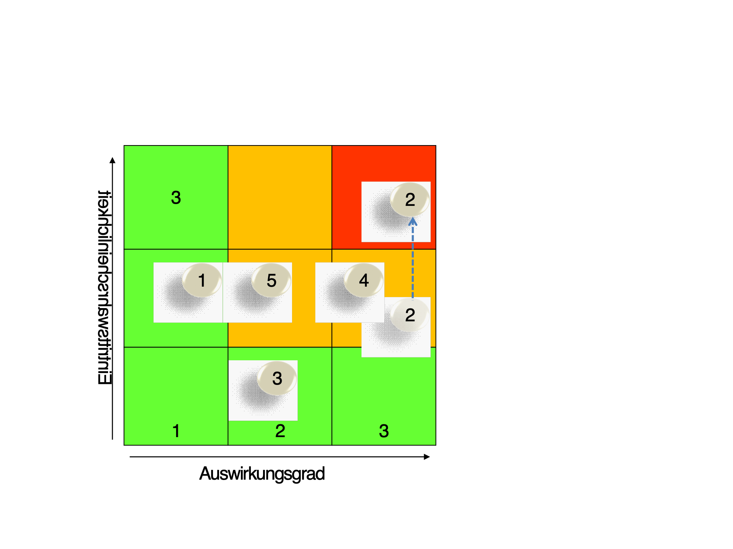

Project risks that have been identified and assessed are listed in a table (such as the one shown below) in the project status report. Measures are planned to deal with every risk.

| No. | LI | PO | RN | Description | Measure | Person in Charge | Deadline |
| --- | --- | --- | --- | --- | --- | --- | --- |
| 1 | 3 | 3 | 9 |  |  |  |  |
| 2 | 2 | 2 | 4 |  |  |  |  |

## Document Management

### Document Storage

Tools, file location, access management

### Naming Conventions

In order for project-related documents to be clearly identifiable and easy to find, the following naming conventions are used for file names:

*Project_name_document_name.file_type*

Example:

*HMH­_project_charter.doc*

### Document Versions

Changes made to documents should be listed in that document's list of changes.

Use of Version Numbers

Version numbers V0.1, V0.2, V0.3... refer to versions of pending documents.

Version number V1.0 is the first accepted version of that particular document.

Version number v.1.1 is the first changed version of the document after its acceptance.

Version number V2.0 is the second accepted version of the document.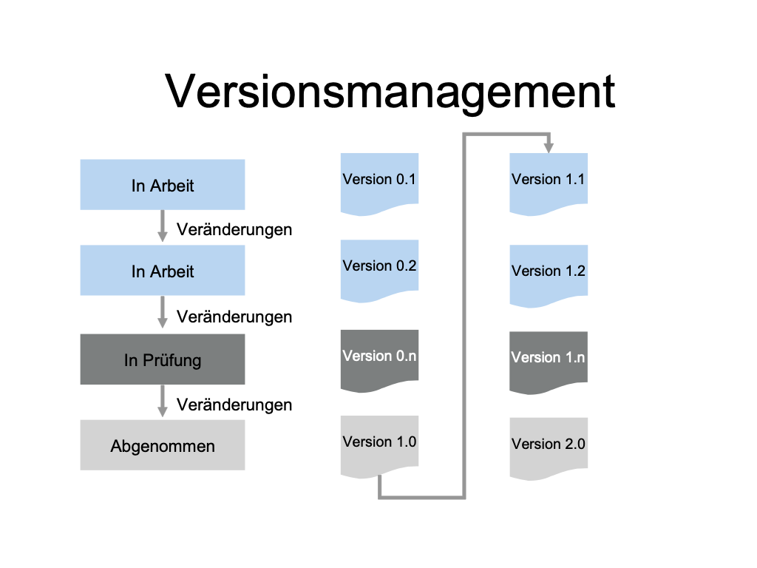

**Documents with a Time Reference**

If a document has a clear time reference, that date is included in the file name.

Example for Minutes of a Meeting:

*HMH_minutes_core_team_meeting_2011-12-05.doc*

Dates used in file names should always have a YYYY-MM-DD format to enable the files to be sorted by date.

## Change Management

*Use Microsoft PowerPoint to make changes (right mouse click - Object Presentation - edit)*

